Joint Video Team (JVT) of ISO/IEC MPEG & ITU-T VCEG  (ISO/IEC JTC1/SC29/WG11 and ITU-T SG16 Q.6)  17th Meeting: Nice, FR, 14-21 October, 2005 | Document: JVT-Q091  Filename: input.doc

Title: | Simple Numbering of Key Pictures
Status: | Input Document to JVT
Purpose: | Proposal
Author(s) or  Contact(s): | Seyoon Jeong*, Min Woo Park,  Gwang Hoon Park**, Kyuheon Kim  *ETRI, 161 Gajeong-dong Yusung-gu  Daejeon, Korea.  **Kyung Hee University. 1, Seochun, Kiheung  Youngin, Kyunggi, Korea. | Tel:  Email: | +82 (42) 860-5724  jsy@etri.re.kr  parkmw@khu.ac.kr
Source: | ETRI*, Kyung Hee University**
_____________________________

Abstract

In the current JSVM the interval of key pictures, i.e. GOP size, can be fixed or can be variable. If the temporal scalability is used, this interval is variable. JSVM uses the numbering scheme for all pictures by its displaying order. Therefore, it is difficult to detect the drop of key pictures. When the proposed numbering scheme for key pictures is used, it is easy to detect the drop or lost error of key pictures. Furthermore it is possible to conceal the error by the dropped key picture at the decoder.

Introduction

SVC uses one key picture for each GOP, the other pictures in the GOP reference the key picture. Thus, a key picture must be required to decode a GOP.
In the Current JSVM, the interval of key pictures, i.e. GOP size, is normally fixed. If Adaptive GOP Structure (AGS) is used, it is varying [1]. Also, the interval of the extracted bit-stream
differs from original bit-stream when the temporal scalability is applied at the extractor.
JSVM uses the frame numbering of AVC|H.264 as is [1, 2]. It increases the frame number according to the display order. It is not easy to detect a key picture drop or a GOP drop on the network transmission in the current JSVM. The key picture is not dropped by the extractor.
If the key picture numbering scheme in Section 2 of this document is used, it is possible to detect the key picture or GOP drop with only the frame number proposed in the same section.

Simple Numbering of Key Pictures

In the general test condition (Munich and Palma) of SVC, the minimum frame rate at QCIF and CIF is 7.5 Hz [3]. In the case of CIF 30 Hz sequence, the minimal GOP size is 4 because 3-level temporal scalability is required. The random access point shall not exceed 1.2 second in the test scenario 1 of the general test condition. The period of I is 32 pictures. And the number of GOP is 8 between two I pictures. There is one key picture in a GOP. Thus, the required number of bits for a simple numbering for the key picture is 3.
The numbering scheme of key pictures is just to increase the number with 8 modulo operation for each key picture. It is easy to detect the loose or drop of a key picture by evaluating the difference between current and previous key picture number. If the difference is not ‘1’ or ‘-7’, it means there are one or more lost or dropped key pictures. The numbering of key picture is only used in the spatial enhance layers because the transmission of Base Layer is guaranteed. Figure 1 illustrates the proposed numbering scheme of key pictures.

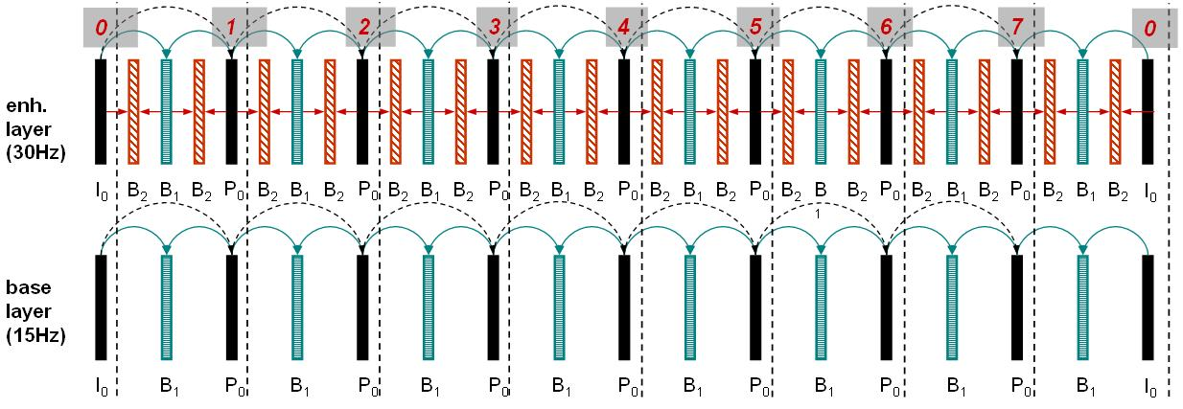

Figure 1. Proposed numbering of Key pictures

2. 1. Error Detection and Concealment in the case of (P) Key picture dropping

If the proposed numbering scheme of key pictures is used, it is possible to detect the error of key picture by checking the difference between current and previous key picture number. If the difference is not 1 or -7, it means that error of key pictures exist.
In general, JSVM assumes the transmission of Base Layer is guaranteed and in this case, it is easy to conceal the key picture error.
When the drop of a key picture is detected by checking the key picture number, the inter macroblock of the current p key picture conceal the error by using the macroblock of Base Layer with the same temporal location.
If the network has small probability of occurring errors, the error concealment may not be needed. In this case, the key picture numbering uses selectively according to the flag bit in SPS. This selective option can save a certain amount of bits.

2.2 Error Concealment in the case of below 7.5 Hz when Adaptive GOP Structure used

The proposed key picture numbering scheme can be useful when Adaptive GOP Structure (AGS) is used. AGS in current JSVM can’t support the temporal scalability below 7.5 Hz. There is no information about this matter for AGS in current JSVM. However, the extractor can support temporal scalability below 7.5 Hz in Spatial Enhance Layer.
If AGS is used and the extractor applies the temporal scalability below 7.5 Hz, it is possible that the drop of key pictures can occur, and this case it is similar when the key picture is dropped in the network transmission in section 2.1.

Therefore, it is also possible to detect the drop of a key picture by using proposed key picture numbering scheme and also to conceal the error. Figure 2 illustrates the error concealment in the case of the bit-stream extracted form 30 Hz to 3.75Hz and AGS was used. The Adaptive GOP Structure is [8,4,2,2] in Figure 2. Figure 3 shows decoded pictures which have the error in the case of Figure 2. Figure 4 shows the result of error concealment by using proposed key picture numbering method.

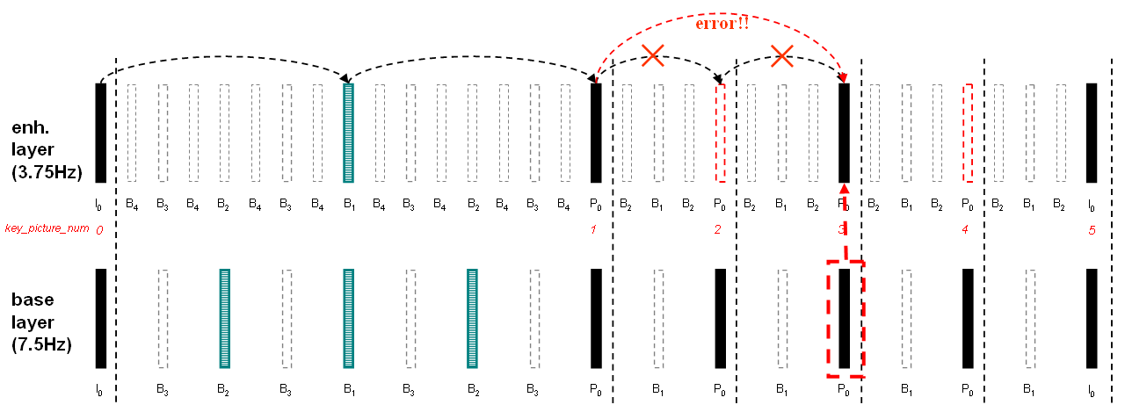
Figure 2. Detecting of key picture error and concealment by key picture numbering in [8,4,2,2] when AGS is used.

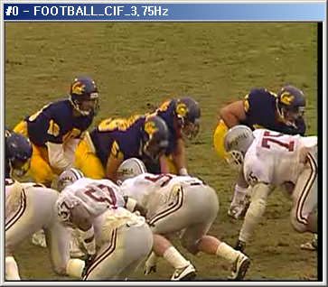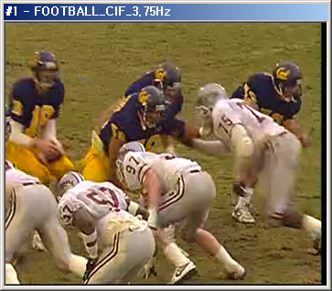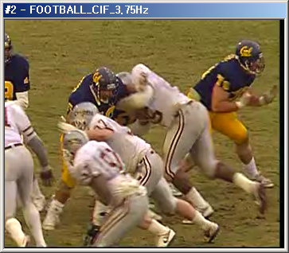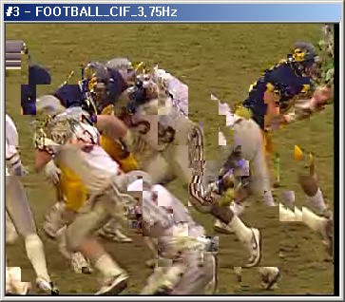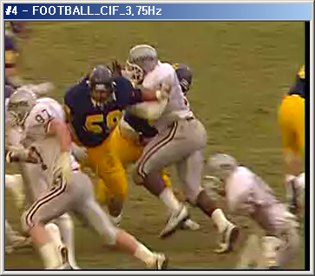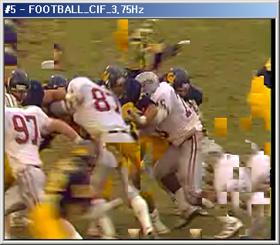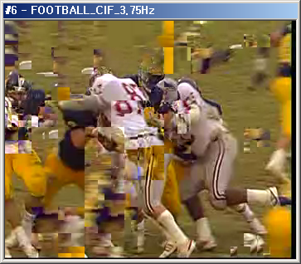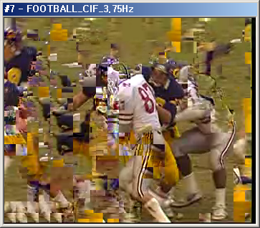
Figure 3. Error Propagation Example by Extractor when AGS is used : Football CIF 3.75 Hz (0~7)

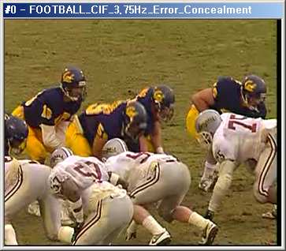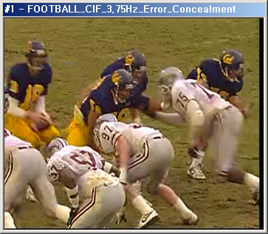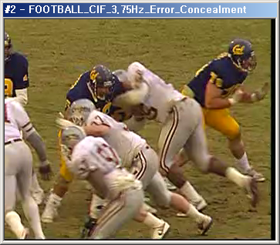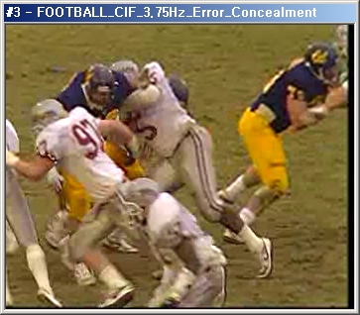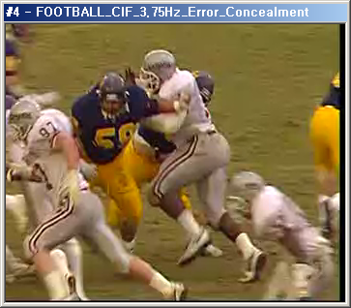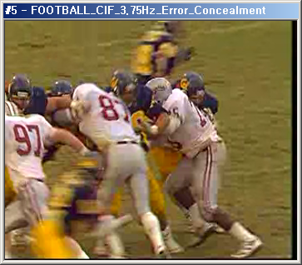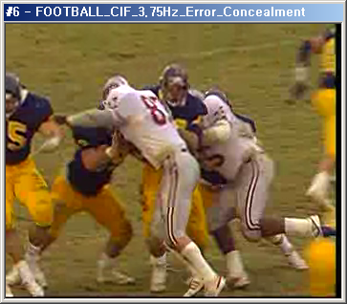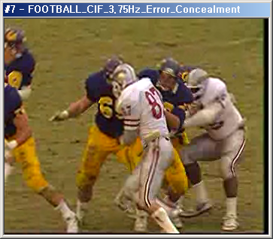
Figure 4. Error Concealment Example: Football CIF 3.75 (0~7th frame)

3. The Proposed Syntax, Semantics Modification

The modification on the slice header in scalable extension is required for the proposed numbering scheme of key pictures.

Slice header in scalable extension

- Syntax

slice_header_in_scalable_extension( ) { | C | Descriptor
first_mb_in_slice | 2 | ue(v)
slice_type | 2 | ue(v)
pic_parameter_set_id | 2 | ue(v)
if( slice_type = = PR ) {
num_mbs_in_slice_minus1 | 2 | ue(v)
luma_chroma_sep_flag | 2 | u(1)
}
frame_num | 2 | u(v)
if( !frame_mbs_only_flag ) {
field_pic_flag | 2 | u(1)
if( field_pic_flag )
bottom_field_flag | 2 | u(1)
}
if( nal_unit_type = = 21 )
idr_pic_id | 2 | ue(v)
if(error_concealment_flag = = 1 && (slice_type = = EP || slice_type = = EI)) {
key_picture_num | 2 | u(3)
}
if( pic_order_cnt_type = = 0 ) {
pic_order_cnt_lsb | 2 | u(v)
if( pic_order_present_flag && !field_pic_flag )
delta_pic_order_cnt_bottom | 2 | se(v)
}
if( pic_order_cnt_type = = 1 && !delta_pic_order_always_zero_flag ) {
delta_pic_order_cnt[ 0 ] | 2 | se(v)
if( pic_order_present_flag && !field_pic_flag )
delta_pic_order_cnt[ 1 ] | 2 | se(v)
}
if( slice_type != PR ) {
if( redundant_pic_cnt_present_flag )
redundant_pic_cnt | 2 | ue(v)
if( slice_type = = EB )
direct_spatial_mv_pred_flag | 2 | u(1)
key_picture_flag | 2 | u(1)
decomposition_stages | 2 | ue(v)
base_id_plus1 | 2 | ue(v)
if( base_id_plus1 != 0 ) {
adaptive_prediction_flag | 2 | u(1)
}
if( slice_type = = EP | | slice_type = = EB ) {
num_ref_idx_active_override_flag | 2 | u(1)
if( num_ref_idx_active_override_flag ) {
num_ref_idx_l0_active_minus1 | 2 | ue(v)
if( slice_type = = EB )
num_ref_idx_l1_active_minus1 | 2 | ue(v)
}
}
ref_pic_list_reordering( ) | 2
for( decLvl = temporal_level; decLvl < decomposition_stages; decLvl++ )
{
num_ref_idx_update_l0_active[ decLvl + 1 ] | 2 | ue(v)
num_ref_idx_update_l1_active[ decLvl + 1 ] | 2 | ue(v)
}
if( ( weighted_pred_flag && slice_type = = EP ) | |
( weighted_bipred_idc = = 1 && slice_type = = EB ) )
pred_weight_table( ) | 2
if( nal_ref_idc != 0 )
dec_ref_pic_marking( ) | 2
if( entropy_coding_mode_flag && slice_type != EI )
cabac_init_idc | 2 | ue(v)
}
slice_qp_delta | 2 | se(v)
if( deblocking_filter_control_present_flag ) {
disable_deblocking_filter_idc | 2 | ue(v)
if( disable_deblocking_filter_idc != 1 ) {
slice_alpha_c0_offset_div2 | 2 | se(v)
slice_beta_offset_div2 | 2 | se(v)
}
}
if( slice_type != PR )
if( num_slice_groups_minus1 > 0 &&
slice_group_map_type >= 3 && slice_group_map_type <= 5)
slice_group_change_cycle | 2 | u(v)
if( slice_type != PR && extended_spatial_scalability > 0 ) {
if ( chroma_format_idc > 0 ) {
base_chroma_phase_x_plus1 | 2 | u(2)
base_chroma_phase_y_plus1 | 2 | u(2)
}
if( extended_spatial_scalability = = 2 ) {
scaled_base_left_offset | 2 | se(v)
scaled_base_top_offset | 2 | se(v)
scaled_base_right_offset | 2 | se(v)
scaled_base_bottom_offset | 2 | se(v)
}
}
SpatialScalabilityType = spatial_scalability_type( )
}

Semantics

key_picture_num represents the key picture number of this slice, it shall be in the range of 0 to 7. Because key_picture_num is just to increase the number with 8 modulo operation for each key picture.

Sequence Parameter Set

If there is a flag bit for error concealment in SPS, the proposed key picture numbering scheme can be used selectively. This selective option can save a certain amount of bits. Also this flag bit is used when Adaptive GOP Structure (AGS) is used.

Syntax

if ( profile_idc = = 83 ){
error_concealment_flag | 0 | u(1)
extended_spatial_scalability | 0 | u(2)
if( extended_spatial_scalability > 0 ) {
if ( chroma_format_idc > 0 ) {
chroma_phase_x_plus1 | 0 | u(2)
chroma_phase_y_plus1 | 0 | u(2)
}
if( extended_spatial_scalability = = 1 ) {
scaled_base_left_offset | 0 | se(v)
scaled_base_top_offset | 0 | se(v)
scaled_base_right_offset | 0 | se(v)
scaled_base_bottom_offset | 0 | se(v)
}
}
}

Semantics

error_concealment_flag is set to ‘1 ‘ when the error concealment is used. Also, it is set as ‘1’ when Adaptive GOP Structure is used.

4. Conclusion

The numbering scheme of key pictures is proposed for easy detecting of the drop of a key picture. If the transmission of Base Layer is guaranteed, it is also possible to conceal the key picture error. The simple example of the concealment was described.

Reference
[1] ITU-T and ISO/IEC JTC 1, “Joint Scalable Video Model JSVM-3”, JVT-P202, Jul 2005
[2] ITU-T and ISO/IEC JTC 1, “Advanced video coding for generic audiovisual service,” ITU-T Recommendation H.264, Mar. 2005
[3] ISO/IEC SC29WG11 W6193 “Call for Proposals on Scalable Video Coding Technology”, Dec. 2003.
(Append for Proposal Documents)

JVT Patent Disclosure Form

International Telecommunication Union  Telecommunication Standardization Sector | International Organization for Standardization | International Electrotechnical Commission
 |  | 
Joint Video Coding Experts Group - Patent Disclosure Form
(Typically one per contribution and one per Standard | Recommendation)

Please send to:
JVT Rapporteur Gary Sullivan, Microsoft Corp., One Microsoft Way, Bldg. 9, Redmond WA 98052-6399, USA
Email (preferred): Gary.Sullivan@itu.int Fax: +1 425 706 7329 (+1 425 70MSFAX)

This form provides the ITU-T | ISO/IEC Joint Video Coding Experts Group (JVT) with information about the patent status of techniques used in or proposed for incorporation in a Recommendation | Standard. JVT requires that all technical contributions be accompanied with this form. Anyone with knowledge of any patent affecting the use of JVT work, of their own or of any other entity (“third parties”), is strongly encouraged to submit this form as well.

This information will be maintained in a “living list” by JVT during the progress of their work, on a best effort basis. If a given technical proposal is not incorporated in a Recommendation | Standard, the relevant patent information will be removed from the “living list”. The intent is that the JVT experts should know in advance of any patent issues with particular proposals or techniques, so that these may be addressed well before final approval.

This is not a binding legal document; it is provided to JVT for information only, on a best effort, good faith basis. Please submit corrected or updated forms if your knowledge or situation changes.

This form is not a substitute for the ITU ISO IEC Patent Statement and Licensing Declaration, which should be submitted by Patent Holders to the ITU TSB Director and ISO Secretary General before final approval.

Submitting Organization or Person:
Organization name | ETRI* & Kyung Hee University**
Mailing address | 161 Gajeong-Dong Yusoung-Gu Daejeon*  1, Seochun, Kiheung, Youngin, Kyunggi**
Country | Republic of Korea
Contact person | Seyoon Jeong*
Telephone | +82-42-860-5724
Fax | +82-42-860-5724
Email | jsy@etri.re.kr
Place and date of submission | Nice, France (Oct. 2005)
Relevant Recommendation | Standard and, if applicable, Contribution:
Name (ex: “JVT”) |  | JSVC
Title |  | Simple Numbering of Key Pictures
Contribution number |  | JVT-Q091

(Form continues on next page)

Disclosure information – Submitting Organization/Person (choose one box)
2.0 The submitter is not aware of having any granted, pending, or planned patents associated with the technical content of the Recommendation | Standard or Contribution.

or,
The submitter (Patent Holder) has granted, pending, or planned patents associated with the technical content of the Recommendation | Standard or Contribution. In which case,

 | 2.1 The Patent Holder is prepared to grant – on the basis of reciprocity for the above Recommendation | Standard – a free license to an unrestricted number of applicants on a worldwide, non-discriminatory basis to manufacture, use and/or sell implementations of the above Recommendation | Standard.
2.2 The Patent Holder is prepared to grant – on the basis of reciprocity for the above Recommendation | Standard – a license to an unrestricted number of applicants on a worldwide, non-discriminatory basis and on reasonable terms and conditions to manufacture, use and/ or sell implementations of the above Recommendation | Standard.

Such negotiations are left to the parties concerned and are performed outside the ITU | ISO/IEC.
 | 2.2.1 The same as box 2.2 above, but in addition the Patent Holder is prepared to grant a “royalty-free” license to anyone on condition that all other patent holders do the same.
2.3 The Patent Holder is unwilling to grant licenses according to the provisions of either 2.1, 2.2, or 2.2.1 above. In this case, the following information must be provided as part of this declaration:
- patent registration/application number;
- an indication of which portions of the Recommendation | Standard are affected.
- a description of the patent claims covering the Recommendation | Standard;
In the case of any box other than 2.0 above, please provide the following:
Patent number(s)/status |  | In processing
Inventor(s)/Assignee(s) |  | Gwang Hoon Park**, Min Woo Park**, Seyoon Jeong*, Kyuheon Kim*, Jinwoo Hong*/ETRI & Kyung Hee University
Relevance to JVT
Any other remarks:
(please provide attachments if more space is needed)

(form continues on next page)
Third party patent information – fill in based on your best knowledge of relevant patents granted, pending, or planned by other people or by organizations other than your own.

Disclosure information – Third Party Patents (choose one box)
3.1 The submitter is not aware of any granted, pending, or planned patents held by third parties associated with the technical content of the Recommendation | Standard or Contribution.

3.2 The submitter believes third parties may have granted, pending, or planned patents associated with the technical content of the Recommendation | Standard or Contribution.

For box 3.2, please provide as much information as is known (provide attachments if more space needed) - JVT will attempt to contact third parties to obtain more information:

3rd party name(s)
Mailing address
Country
Contact person
Telephone
Fax
Email
Patent number/status
Inventor/Assignee
Relevance to JVT

Any other comments or remarks:

