Joint Video Team (JVT) of ISO/IEC MPEG & ITU-T VCEG  (ISO/IEC JTC1/SC29/WG11 and ITU-T SG16 Q.6)  17th Meeting: Nice, FR, 14-21 October, 2005 | Document: JVT-Q089  Filename: JVT-Q089.doc

Title: | Comments on Motion Estimation Algorithms in Current JM Software
Status: | Input Document to JVT
Purpose: | Proposal
Author(s) or  Contact(s): | Xiaozhong Xu,  Yun He  Department of Electronic Engineering,  Tsinghua University, Beijing, China  100084 | Tel:  Email: | 86-10-6278-1413  xxz@  video.mdc.tsinghua.edu.cn  hey@ video.mdc.tsinghua.edu.cn
Source: | Tsinghua University, Beijing, China
_____________________________

Abstract

This proposal submits a comprehensive analysis and comparison of the existing Fast Motion Estimation algorithms in the JM software. The capacity of speeding up Motion Estimation process, the influence on R-D performance that fast algorithms may bring in, and the complexity of algorithms both for software and hardware design are the main concerns. Because FME [1][2] and SFME[3] don’t support Bi-directional ME in current JM, and EPZS [4] doesn’t support Fractional-Pel ME, for the fair apple to apple comparison, we only compare the Integer-Pel ME for those three techniques. The test results can be seen in JVT-Q089.xls files, and the conclusions are in the end of this proposal.

- Introduction

Motion Estimation (ME for short) has been a hot issue since JVT meeting started. Because of too heavy computational burden that Full Search strategy (FS for short) has carried, several valuable Fast Motion Estimation algorithms [1] [2] [3][4][5][6] were proposed and a great portion of ME time reduction (up to more than 90%) and total JM encoding time was reduced by 60% on average.
To qualify the speed accelerated by Fast Motion Estimation, we should bare in mind that how much PSNR loss or bit rate increasing fast algorithms cost.

- Review of Existing Fast Motion Estimation algorithms

In this section we are going to have a brief review of the four existing Fast Motion Estimation methods adopted in the previous JVT meetings. The introduction will not go into detail and for more information about the algorithms, please see the reference JVT documents.

  - Search Range Prediction

Different from the following three other algorithms, Search Range Prediction or Dynamic Search Range (DSR for short) tried to decrease the input search window size so as to reduce ME time. The search range decision is made mainly from the Motion Vector information from the spatial nearby coded blocks. The main algorithm is composed by the following steps:[5][7][8]

As is shown in Fig 1, block E is current macro-block under Motion Estimation and the neighborhood 4x4 block is A, B, C and D.
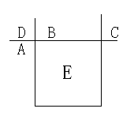
Fig 1: Reference block location for search range prediciton

Also, we assume that motion vectors of A, B, and C are (MV_A_x, MV_A_y), (MV_B_x, MV_B_y), and (MV_C_x, MV_C_y), and input search range is defined as input_search_range. With the condition, a new search range decision is determined as :

- step 1: check the number of neighboring 4×4 blocks. If the number of available neighboring blocks is more than 1, go to step 2, otherwise go to step 4.

- step 2: from the given motion vectors of neighboring blocks, determine the local maximum absolute horizontal and vertical component value of motion vector, respectively. It is
$$\text{max_MV_E_i}=\text{max}(\text{abs}(\text{MV_A_i})\text{,max}(\text{abs}(\text{MV_B_i})\text{,abs}(\text{MV_C_i}))\text{ for i}=\text{x,y }(1)$$

If a neighboring block is not available, ‘0’ is assigned to a vector component.

- step 3: determine a local statistics of the neighboring blocks. The statistics is written as
$$\text{local_search_range_i}=\text{max}(\text{k_i, 2}×\text{max_MV_E_i})\text{, }(2)$$
where local statistics, $k_{i}$is defined as
$$\begin{aligned}\text{k_i}= \\ \end{aligned}$$

- step 4: The proposed algorithm has a constraint such in a way that the maximum search range is subject to input search range, and therefore, the motion search range is constrained as
$$\text{new_search_range_i}=\text{min}(\text{input_search_range, local_search_range_i}) (4)$$

when the number of the available neighboring blocks is more than 1. Otherwise, the ‘new_search_range_i’ is defined as
$$\text{new_search_range_i}=\text{input_search_range }(5)$$

The original DSR technique has some problems when combined with other Fast Motion Estimation algorithm [6]. So at this JVT meeting a modified version of DSR is proposed, the main changes from the original one are:

1) Only one new search range instead of two is used. We define
new_search_range =max (new_search_range_x, new_search_range_y);
2) New motion search range is decided at block level instead of macroblock level;
3) If block C is not available, it is replaced by block D at upper-left position.

The proposed modified DSR achieved great ME time reduction while maintaining almost the same PSNR that FFS could achieve. And it can be combined with all other Fast Motion Estimation algorithms without any extra modifications.

  - UMHexagonS + CBFPS, FME

UMHexagonS + CBFPS are short for the adopted “hybrid Unsymmetrical-cross Multi-Hexagon-grid Search (for Integer-Pel ME) and Center-Biased Fractional Pel Search (for Fractional-Pel ME)” algorithm since JM7.6, it is named FME in JM software(including Integer-Pel and Fractional-Pel ME) [1] [2] [9] [10].

    - Integer-Pel ME, UMHexagonS

The following is a step by step review of the “UMHexagonS + CBFPS” FME algorithm for JVT [1] [2]. There are mainly four steps in the fast integer pel search algorithm:

Step 1: Initial search point prediction: Spatial median prediction, upper layer prediction, neighboring reference frame prediction, and temporal prediction are used to predict current block’s motion vector (MV);

Step 2: Asymmetrical cross search. It is followed by an early termination scheme;

Step 3: Uneven multi-hexagon-grid search. Two sub-steps include a square search pattern and a 16 points hexagon search pattern;

Step 4: Extended hexagon-based search. Two sub-steps include a hexagon search pattern and a diamond search pattern. Early termination scheme is also applied during the search process.
The early termination scheme is based on three cost prediction modes, namely, median prediction, upper layer prediction, and neighboring reference frame prediction.

For each step mentioned above, the best search point (which means a minimum cost so far) generated by the previous step is used as a search centre for the current search step.
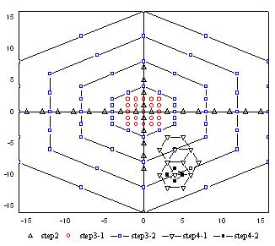
Fig 2: Search process of UMHexagonS algorithm, W=16

    - Fractional-Pel ME, CBFPS

Following the Integer-Pel search, a fast Fractional-Pel search is performed for 8×8, 4×8, 8×4 and 4x4 blocks and a full sub-pel search is also performed for other larger sub-partition blocks. Diamond search pattern has been proved to be simple and efficient in many fast integer pel motion estimation algorithms. Here in the CBFPS algorithm the diamond search pattern is also chosen. The entire fast Fractional-Pel ME algorithm can be summarized as the following four steps: [1]

Step 1. Predict the motion vector of the current block by equation (1) and (2), the predicted motion vector is (Pred_x, Pred_y);

Step 2. Cost of the original search center (0, 0) and (Pred_x, Pred_y) are compared. The point with the minimum matching error is chosen as the search center;

Step 3. If the Minimum Block Distortion (MBD) point is located at the center, go to step 4; otherwise choose the MBD point in this step as the center of next search, then iterate this search step;

Step 4. Choose the MBD point as the motion vector.
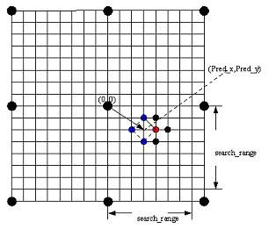
Fig 3:. Implementation of CBFPS algorithm

  - Simplified UMHexagonS + modified CBFPS, SFME

As UMHexagonS + CBFPS is adopted FME algorithm in JVT, the simplified UMHexagonS + CBFPS algorithm is called SFME for short. The main changes in SFME from adopted FME are as follows: [2]

    - Integer-Pel ME, Simplified UMHexagonS

For MV prediction, only spatial median and up layer predictors are used. Note that median For SAD prediction, only up layer predictor, namely, pred_SAD_uplayer is used instead of the four predictions used by UMHexagonS.

For early termination techniques, a simpler threshold based strategy is used instead of quantization parameter based strategy used in adopted FME. After the predictors’ search, if the convergence condition is satisfied, then go to the convergence step and stop the search. If the intensive search condition is satisfied, do the intensive searches to avoid being trapped into local optima, otherwise, check up layer predictor and its surrounding points, and then check the convergence condition again.

In the intensive search, the main search patterns are maintained as UMHexagonS does except for the “Uneven multi-hexagon-grid search” described in step 3 of the UMHexagonS.

The whole Integer ME process of SFME is exemplified in the flowchart below:

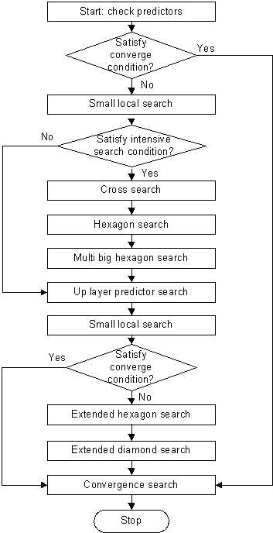

Fig 4: Flow chart of the SFME Integer-Pel search. CMV: center MV
    - Fractional-Pel ME, Modified CBFPS

The above changes are in Integer-Pel ME part. For Fractional ME part, SFME provides a fast full sub-pel search for blocksize of 16x16 and a fast sub-pel search for other blocksizes. The entire Fractional ME process is exemplified in the following two flowcharts clearly.

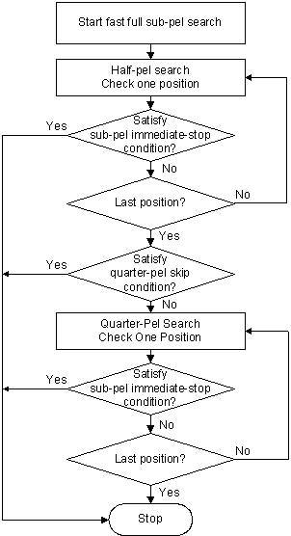 | 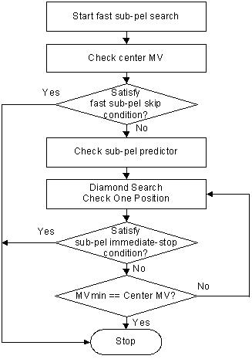
Flow chart of fast full sub-pel search | Flow chart of fast sub-pel search

Fig 5: Flow chart of the fractional ME in SFME. MVmin: MV has the minimum cost.
Compared with CBFPS proposed by adopted FME, the Fractional ME process of SFME is a more refined one and fast algorithm covers all the possible block types that exist in JM software.

  - Enhanced Predictive Zonal Search, EPZS

EPZS is short for Enhanced Predictive Zonal Search [3], which concerns only Integer ME part and sets Fractional ME process as the original full search scheme provided by FFS in JM. The main points of this algorithm are as follows:

Step 1: Check Median Predicted points and terminate if stop criterion is satisfied.

Step 2: Predictor Selection
“The predictor selection can easily be considered as the key feature of EPZS”[3]. There are five main different kinds of prediction provided in the algorithm. They are “Spatial Predictors”, “Spatial Memory-consumed Predictors”, “Temporal Predictors”, “Window Predictors” and “Block Type Predictors”. All the generated predicted search points will be checked and the best position with minimum cost is stored.

Step 3: Motion Vector Refinement
“If the early termination criteria are not satisfied, motion estimation is refined further by using an iterative search pattern localized at the best predictor within prediction set that is mentioned above. [3]” In this step, various diamond search patterns are chosen and flexible judgments are used to avoid inessential search points.

- Test results and analysis

In following paragraphs and tables, FME, SFME, and EPZS are used for their Integer-Pel search only for simplicity. And we use Fast ME to represent FME, SFME, or EPZS.

Table 1: Fast ME without DSR
 | Total Time of Enc. Saved | Time saved for Integer-Pel ME | Fast ME aver. Bitrate increase | Fast ME aver. dB loss | Worst case Bitrate increase | Worst case PSNR loss (dB)
FME vs FFS | 59.99% | 91.69% | 0.43% | 0.028 | 1.17% | 0.073
SFME vs FFS | 62.60% | 95.84% | 1.03% | 0.066 | 2.98% | 0.187
EPZS vs FFS | 61.36% | 94.07% | 0.40% | 0.025 | 0.51% | 0.042

In Table 1,
- For the time used by the three Fast MEs compared with that of FFS, FME used about 8% of the time compared with that of FFS, SFME used 4% and EPZS used 6%.
- Because Integer-Pel ME is only one part of the total encoder, the time saving for the whole encoder, Fast ME saved 59%, SFME saved 62% and EPZS saved 61%, all around 60% saving.
- FME and EPZS both have good coding performance on PSNR loss or bit rate increase; they retained an averaging PSNR loss less than 0.05dB and the worst PSNR loss less than 0.1dB.
- SFME’s PSNR worst case was about 0.187dB.

Table 2: Fast ME + DSR
 | Total Time of Enc. Saved | Time saved for Integer-Pel ME | Fast ME aver. Bitrate increase | Fast ME aver. dB loss | Worst case Bitrate increase | Worst case PSNR loss (dB)
FFS+dsr vs FFS | 8.30% | 13.00% | 0.27% | 0.016 | 0.42% | 0.022
FME+dsr vs FFS | 61.88% | 94.24% | 0.57% | 0.035 | 1.42% | 0.086
SFME+dsr vs FFS | 63.13% | 96.37% | 1.34% | 0.084 | 3.22% | 0.202
EPZS+dsr vs FFS | 61.89% | 94.58% | 0.57% | 0.034 | 0.81% | 0.048

In table 2, DSR is added to FFS, FME, SFME, and EPZS,
- For three Fast ME, the time saving differences become smaller than that without DSR, FME and EPZS were both 94% saving for Integer-Pel ME, and 61% saving for total ending time. SFME saved 96% for Integer-Pel ME and 63% for total time.
- For coding performance, FME and EPZS retained good R-D properties.
- SFME’s worst PSNR loss was 0.0202 dB.
- Though FFS + DSR saved not much time, but it showed a good R-D performance, and it is welcome in some cases. For example, for hardware or programming simplicity, applications may just use FS or FFS. Adding DSR to FS or FFS, the original ME calculation structure will not be touched.

Test conditions:

The test sequence set is acquired from recommended Simulation Common Conditions [11], and the main test conditions are as follows:

GOP structure | IPPPP
QP | 8/18/28/38
NumberReferenceFrames | 2
SearchRange | 32
DisableSubpelME | on
Sequence Size | qcif
RDOptimization | on(1)
SymbolMode | CAVLC
FrameSkip | container_qcif | 2
 | news_qcif | 2
 | foreman_qcif | 2
 | silent_qcif | 1
 | paris_cif | 1
 | mobile_cif | 0
 | tempete_cif | 0

For some other more results with other test conditions and sequences please see JVT-Q089.xls in detail.

- Conclusion

Based on above test results, we conclude that, with DSR, FME and EPZS have the same speed for Integer-Pel ME and the same R-D performance. SFME showed worse R-D performance. FME has two early termination switches for one block, while EPZS has one more, i.e three, similar early terminations as FME and an extra early termination in the diamond search loop, that means the switching times are depending on how many diamonds are required.

We suggest keep the FME Integer-Pel ME stable, and add the modified DSR into JM to give users a Fast Motion Estimation platform with a good R-D performance, and with less conditional switches.

- Reference

[1] Zhibo Chen, Peng Zhou, Yun He, “Fast Integer Pel and Fractional Pel Motion estimation in for JVT”, JVT-F017r1.doc, Joint Video Team (JVT) of ISO/IEC MPEG & ITU-T VCEG, 6th meeting, Awaji, Island, JP, 5-13 December, 2002
[2] Zhibo Chen, Peng Zhou, Yun He, “Fast Motion Estimation for JVT”, JVT-G016, March, 2003
[3] Xiaoquan Yi, Jun Zhang, Nam Ling, and Weijia Shang, “Improved and simplified fast motion estimation for JM”, JVT-P021, July, 2005
[4] Alexis Michael Tourapis, Hye-Yeon Cheong and Pankaj Topiwala, “Fast ME in the JM reference software”, JVT-P026, July, 2005
[5] M.-C. Hong and H. H. Oh, “Range Decision for Motion Estimation of VCEG-N33,’’ JVT-B022, Feb. 2002.
[6] Xiaozhong Xu and Yun He, “Modification of Dynamic Search Range for JVT”, JVT-Q088, Oct, 2005
[7] M.-C. Hong ,Chul-Woo Kim and Sang Woo Rhie, “Further Improvement of Motion Search Range”, JVT-C065, May, 2002
[8] M.-C. Hong ,Chul-Woo Kim and Kyoung Seok In, “Further Improvement of Motion Search Range”,JVT-D117, July, 2002
[9] Zhibo Chen, JianFeng Xu, Yun He, GuoZhong Wang “Simplifications on fast motion estimation”, JVT-H026, Joint Video Team (JVT) of ISO/IEC MPEG & ITU-T VCEG (ISO/IEC JTC1/SC29/WG11 and ITU-T SG16 Q.6), Geneva, Switzerland, May, 2003
[10] Jianfeng Xu, Ping Yang, Yun He,“Modification of Fast Motion Estimation", JVT-J027, Joint Video Team (JVT) of ISO/IEC MPEG & ITU-T VCEG (ISO/IEC TC1/SC29/WG11 and ITU-T SG16 Q.6), 10th Meeting: Waikoloa, HI, USA, 7-12 December, 2003
[11] Gary Sullivan and Gisle Bjontegaard, “Recommended Simulation Common Conditions for H.26L Coding Efficiency Experiments on Low-Resolution Progressive-Scan Source Material”, VCEG-N81, Sep., 2001

(Append for Proposal Documents)

JVT Patent Disclosure Form

International Telecommunication Union  Telecommunication Standardization Sector | International Organization for Standardization | International Electrotechnical Commission
 |  | 
Joint Video Coding Experts Group - Patent Disclosure Form
(Typically one per contribution and one per Standard | Recommendation)

Please send to:
JVT Rapporteur Gary Sullivan, Microsoft Corp., One Microsoft Way, Bldg. 9, Redmond WA 98052-6399, USA
Email (preferred): Gary.Sullivan@itu.int Fax: +1 425 706 7329 (+1 425 70MSFAX)

This form provides the ITU-T | ISO/IEC Joint Video Coding Experts Group (JVT) with information about the patent status of techniques used in or proposed for incorporation in a Recommendation | Standard. JVT requires that all technical contributions be accompanied with this form. Anyone with knowledge of any patent affecting the use of JVT work, of their own or of any other entity (“third parties”), is strongly encouraged to submit this form as well.

This information will be maintained in a “living list” by JVT during the progress of their work, on a best effort basis. If a given technical proposal is not incorporated in a Recommendation | Standard, the relevant patent information will be removed from the “living list”. The intent is that the JVT experts should know in advance of any patent issues with particular proposals or techniques, so that these may be addressed well before final approval.

This is not a binding legal document; it is provided to JVT for information only, on a best effort, good faith basis. Please submit corrected or updated forms if your knowledge or situation changes.

This form is not a substitute for the ITU ISO IEC Patent Statement and Licensing Declaration, which should be submitted by Patent Holders to the ITU TSB Director and ISO Secretary General before final approval.

Submitting Organization or Person:
Organization name
Mailing address
Country
Contact person
Telephone
Fax
Email
Place and date of submission
Relevant Recommendation | Standard and, if applicable, Contribution:
Name (ex: “JVT”)
Title
Contribution number

(Form continues on next page)

Disclosure information – Submitting Organization/Person (choose one box)
2.0 The submitter is not aware of having any granted, pending, or planned patents associated with the technical content of the Recommendation | Standard or Contribution.

or,
The submitter (Patent Holder) has granted, pending, or planned patents associated with the technical content of the Recommendation | Standard or Contribution. In which case,

2.1 The Patent Holder is prepared to grant – on the basis of reciprocity for the above Recommendation | Standard – a free license to an unrestricted number of applicants on a worldwide, non-discriminatory basis to manufacture, use and/or sell implementations of the above Recommendation | Standard.
2.2 The Patent Holder is prepared to grant – on the basis of reciprocity for the above Recommendation | Standard – a license to an unrestricted number of applicants on a worldwide, non-discriminatory basis and on reasonable terms and conditions to manufacture, use and/ or sell implementations of the above Recommendation | Standard.

Such negotiations are left to the parties concerned and are performed outside the ITU | ISO/IEC.
2.2.1 The same as box 2.2 above, but in addition the Patent Holder is prepared to grant a “royalty-free” license to anyone on condition that all other patent holders do the same.
2.3 The Patent Holder is unwilling to grant licenses according to the provisions of either 2.1, 2.2, or 2.2.1 above. In this case, the following information must be provided as part of this declaration:
- patent registration/application number;
- an indication of which portions of the Recommendation | Standard are affected.
- a description of the patent claims covering the Recommendation | Standard;
In the case of any box other than 2.0 above, please provide the following:
Patent number(s)/status
Inventor(s)/Assignee(s)
Relevance to JVT
Any other remarks:
(please provide attachments if more space is needed)

(form continues on next page)
Third party patent information – fill in based on your best knowledge of relevant patents granted, pending, or planned by other people or by organizations other than your own.

Disclosure information – Third Party Patents (choose one box)
3.1 The submitter is not aware of any granted, pending, or planned patents held by third parties associated with the technical content of the Recommendation | Standard or Contribution.

3.2 The submitter believes third parties may have granted, pending, or planned patents associated with the technical content of the Recommendation | Standard or Contribution.

For box 3.2, please provide as much information as is known (provide attachments if more space needed) - JVT will attempt to contact third parties to obtain more information:

3rd party name(s)
Mailing address
Country
Contact person
Telephone
Fax
Email
Patent number/status
Inventor/Assignee
Relevance to JVT

Any other comments or remarks:

