Joint Video Team (JVT) of ISO/IEC MPEG & ITU-T VCEG  (ISO/IEC JTC1/SC29/WG11 and ITU-T SG16 Q.6)  17th Meeting: Nice, FR, 14-21 October, 2005 | Document: JVT-Q080  Filename: input.doc

Title: | The Rate Distortion Function of H.264 Transform Coefficients
Status: | Input Document to JVT
Purpose: | Information
Author(s) or  Contact(s): | Zhou Heng,  Zhao Haiwu  SVA (Group) Co., Ltd.,  Central Research Academy  Shanghai China | Tel:  Email: | 86-21-54975588-3211/3207  zhou_h@sva.com.cn  zhou_heng@yahoo.com  zhao_hw@sva.com.cn
Source: | SVA (Group) Co., Ltd., Central Research Academy
_____________________________

Abstract
In recent literatures on H.264 rate control, a quadratic model is widely used [2-9]. This model was first introduced in [1] where the source is assumed to be continuous. But we can see that the transform coefficients of H.264 are actually discrete random variables, thus the conclusions of continuous source may not hold. This article derives the R-D function of H.264 transform coefficients by first obtaining the R-D function of simple discrete sources with unique alphabet step, and then composing these simple cases to a product source. Results reveal that the continuous and discrete source has different R-D function form and the latter can approximate to a logarithmic form as that of the former one.

Section 1: Introduction
Rate control algorithm is crucial when developing an encoder product. As a common approach, R-Q model is often used to calculate QP in order to achieve accurate rate. These models are based on the rate distortion function of the source in question. In [1], a quadratic model is derived from the R-D function of a continuous source, which takes a logarithmic form, i.e.
$R(D)=\text{log}\left(\frac{1}{αD}\right)$ (1)
where the distortion measure is the absolute difference.

This logarithmic model is also adopted in JM and many other H.264 rate control algorithms [2]-[9]. Although practically applicable, it is not theoretically reliable because the model (1) is based on the assumption that the source is continuous. However, as for H.264, the transform coefficient to be modeled is not continuous, but discrete, as will illustrated in later section. Generally speaking, the conclusion of continuous source may not hold water for discrete source. To solve this problem, this contribution will derive an R-D function for the discrete H.264 transform coefficients to establish a solid theoretical basis for the logarithmic model mentioned above.

In the following, Section 2 will first briefly recall the H.264 integer transform and demonstrates the discrete characteristics of the transform coefficients. Section 3 and 4 is the main parts of this contribution which derive the R-D function of H.264 transform coefficients, and verify the logarithmic form in an approximate sense. An experimental verification will be conducted in Section 5 and a conclusion is drawn in Section 6.

Section 2: Statistical characteristics of H.264 transform coefficients.
To overcome the mismatch problem and reduce the implementation cost, H.264 adopted a 4x4 integer DCT technique [10]. In this technique, transform is performed by:
$$Y=\left(\left[\begin{matrix}1 & 1 & 1 & 1 \\ 2 & 1 & −1 & −2 \\ 1 & −1 & −1 & 1 \\ 1 & −2 & 2 & −1\end{matrix}\right]\left[X\right]\left[\begin{matrix}1 & 2 & 1 & 1 \\ 1 & 1 & −1 & −2 \\ 1 & −1 & −1 & 2 \\ 1 & −2 & 1 & −1\end{matrix}\right]\right)⊗\left[\begin{matrix}a^{2} & {\text{ab}}/2 & a^{2} & {\text{ab}}/2 \\ {\text{ab}}/2 & {b^{2}}/4 & {\text{ab}}/2 & {b^{2}}/4 \\ a^{2} & {\text{ab}}/2 & a^{2} & {\text{ab}}/2 \\ {\text{ab}}/2 & {b^{2}}/4 & {\text{ab}}/2 & {b^{2}}/4\end{matrix}\right]$$
(2)
where $⊗$ denotes element-by-element multiplication. We can see the results of the left part before $⊗$ are all integers which are obviously discrete. After $⊗$ operation with the scaling matrix, although the results are non-integer values, they are still discrete. Because the criteria to distinguish discrete source from continuous source is not the value the source assumes, but whether any probability of a value assumed is zero. For continuous r. v., whatever the value it takes, the probability of this value is always 0. Figure 1 is a histogram of H.264 transform coefficients.

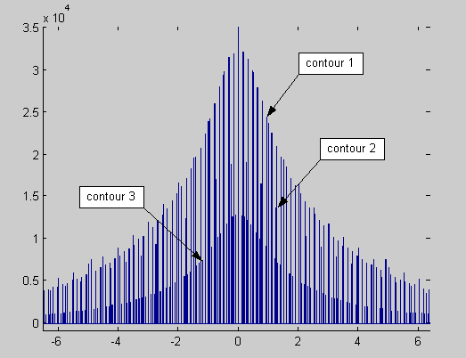
Figure 1: A histogram of H.264 transform coefficients

From the figure we can see several contours which represent different scaling factors, or alphabet steps. If we extract coefficients scaled by one unique factor and redraw its histogram (Figure 2), we can see the discrete characteristic very clearly.

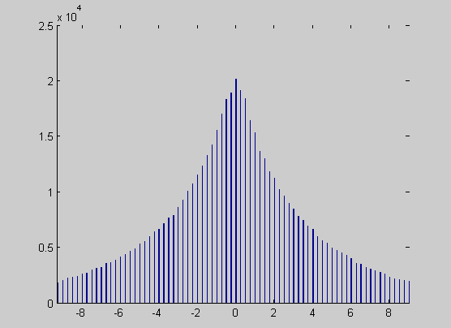
Figure 2: Histogram of H.264 transform coefficients with unique alphabet step (a²=0.25 in this case).

As is often assumed in the analysis of DCT coefficients, we also assume the integer results before $⊗$ to be Laplacian distributed. Note however that we are discussing here a discrete Laplacian distribution, as opposed to [1] where continuous Laplacian distribution is addressed.

The probabilities of discrete Laplacian distribution are:
$P(X=n)=\frac{e^{α}−1}{e^{α}+1}e^{−α|n|}, n=0, ±1, ±2, ⋯$ (3)
where α is the distribution parameter.

In order to get the final R-D function of H.264 coefficients, we’d like to first get the R-D function in Section 3 of the above simple case, i.e. discrete r. v. having unique alphabet step with Laplacian distribution satisfying (3). Then in Section 4 We’ll regard H.264 coefficients as a product source composed of these simple cases.

Section 3: Derivation of R-D function of discrete r. v. having unique alphabet step with Laplacian distribution
The following notations will be used for the derivation:
x_{i} : an element indexed by i in the source alphabet X
y_{j} : an element indexed by j in the reproducing alphabet Y
p_{i} : probability of source letter x_{i}
q_{j} : probability of reproduced letter y_{j}
s : parameter of the parametric R-D function; it’s the derivative of R-D function
δ : alphabet step, the step between successive letters in source alphabet.

Here we also use the absolute difference as distortion measure:
$d_{\text{ij}}=\left|x_{i}−y_{j}\right|$ (4)

Since the source and reproducing alphabet is infinite, the derivation process follows an idea similar to deriving R-D function of continuous source [11, 12].

For all Λ_{s}={λ_{i}} that is associated with a tentative solution, i.e.:
$c_{j}=\sum_{i}{λ_{i}p_{i}\text{exp}({\text{sd}}_{\text{ij}})}=1$ (5)
where
$λ_{i}=\frac{1}{\sum_{j}{q_{j}\text{exp}({\text{sd}}_{\text{ij}})}}$ (6)
and q_{j}>0, we can choose a particular set of Λ_{s} such that the product of λ_{i} and p_{i} depends only on s, i.e.
$λ_{i}p_{i}=k(s)$ (7)
As will be demonstrated in Section 5, this particular set of Λ_{s} satisfying tentative solution definition (5) is existent.

Combining (5) and (7) we obtain
$k(s)={\left[\sum_{i}{\text{exp}({\text{sd}}_{\text{ij}})}\right]}^{−1}$ (8)
It also follows that the parametric form of distortion function is
$\begin{aligned}D(s)=\sum_{i,j}{d_{\text{ij}}p_{i}q_{j}λ_{i}\text{exp}({\text{sd}}_{\text{ij}})} \\ =\sum_{i,j}{[d_{\text{ij}}k(s)\text{exp}({\text{sd}}_{\text{ij}})]q_{j}}\end{aligned}$ (9)
Here both i and j go from -∞ to +∞. For a fixed j, the d_{ij} is illustrated in Figure 3:

Figure 3: relations between d_{ij} and x_{i}, y_{j}

Because the alphabet step δ is very small (0.25 for a², 0.1 for b²/4 and about 0.16 for ab/2), the summation along i in the square bracket of the 2nd equality in (9) can be considered constant with respect to j (except some small error caused by the phase error which will become negligible if |s| is small enough, which is often the case), we then have
$D(s)=k(s)\sum_{i}{\text{exp}({\text{sd}}_{\text{ij}})d_{\text{ij}}}$ (10)
The parametric form of rate function is
$R(s)=\text{sD}(s)+\text{log}(k(s))+H(X)$ (11)
Now, for the discrete Laplacian distributed source, we’ll derive its R-D function as follows:
First let’s calculate the k(s). According to (8)
$k(s)={\left[\sum_{i}{\text{exp}[s\left|x_{i}−y_{j}\right|]}\right]}^{−1}$ (12)
As is known to us all that integral is a limit of Riemann sum when the mesh of the partition converges to zero, which implies that we can therefore calculate the summation in (12) by approximating it through integral, i.e.
$\sum_{i}{f(x_{i})}≈\frac{1}{δ}\int{f(x)\text{dx}}$ (13)
Then we can get k(s) as
$\begin{aligned}k(s)={\left[\frac{1}{δ}\int{\text{exp}[s\left|x−y_{j}\right|]\text{dx}}\right]}^{−1} \\ ={\left[\frac{1}{δ}\int{e^{s|x|}\text{dx}}\right]}^{−1} \\ =−\frac{s}{2}δ\end{aligned}$ (14)
By similar approach, the parametric distortion function (10) can be derived by
$\begin{aligned}D(s)=k(s)⋅\frac{1}{δ}\int{\text{exp}[s\left|x−y_{j}\right|]⋅\left|x−y_{j}\right|}\text{dx} \\ =−\frac{s}{2}δ⋅\frac{1}{δ}\int{e^{s|x|}⋅|x|}\text{dx} \\ =−\frac{1}{s}\end{aligned}$ (15)
Equation (15) gives the relationship between s and D. By eliminating the parameter s in (11) and (15) and referring to (14), the R-D function can be obtained as follows.
$R(D)=−1+\text{log}(\frac{δ}{2D})+H(X)$ (16)
where H(X) is the entropy of the discrete Laplacian distributed source (3), which can be worked out as
$H(\text{aX})=H(X)=\frac{2{αe}^{α}}{e^{2α}−1}−\text{log}\frac{e^{α}−1}{e^{α}+1}$ (17)
The leftmost equality indicates the fact that discrete entropy only depends on statistic distribution, so (17) holds for all sources with different alphabet step δ. Then we have
$R(D)=−1+\text{log}(\frac{δ}{2D})+\frac{2{αe}^{α}}{e^{2α}−1}−\text{log}\frac{e^{α}−1}{e^{α}+1}$ (18)
Equation (18) is the accurate closed expression of the rate distortion function of discrete Laplacian distributed r. v. Compared with (1) derived for continuous source, it is clear that the two R-D function is by no means of identical form.

Next we’ll show that, by approximation, the R-D function of discrete source can also take a logarithmic form. To this end, let’s observe the third term in (18). We can see this term is very close to 1 because the distribution parameter α is generally very close to 0, and in turn e^{α} approaches α+1. So the R-D function can be approximated as:
$\begin{aligned}R(D)≈\text{log}(\frac{δ}{2D})−\text{log}\frac{e^{α}−1}{e^{α}+1} \\ =\text{log}\left(\frac{δ}{2p_{0}D}\right) \\ =−\text{log}D+\text{log}\left(\frac{δ}{2p_{0}}\right)\end{aligned}$ (19)
where $p_{0}=\frac{e^{α}−1}{e^{α}+1}$ is the peak probability of the discrete Laplacian source at zero.

The first equality above shows, when approximated, the R-D function of discrete source has the same logarithmic form as that of the continuous source. The second equality shows the R-D function can be expressed as a linear combination of logD.

The D_{max} is derived as follows. Supposing the reconstructed value y_{j} is jΔ, then
$D_{j}=\sum_{i}{p_{i}d_{\text{ij}}=\sum{p_{i}\left|δi−jΔ\right|}}$ (20)
By applying integral approximation again, we can get
$D_{j}=\frac{2δ}{α^{2}}⋅\frac{e^{α}−1}{e^{α}+1}⋅\left(e^{−|j|Δ\frac{α}{δ}}+\frac{α}{δ}\left|j\right|Δ\right)$ (21)
When x equals 0, the function $e^{−|x|}+|x|$ takes minimum value. As a result the maximum D having non-zero corresponding R value is
$D_{\text{max}}=\frac{2δ}{α^{2}}⋅\frac{e^{α}−1}{e^{α}+1}$ (22)
, and the maximum derivative of the R-D function s_{max}, according to (15), is
$s_{\text{max}}=\frac{α^{2}}{2δ}⋅\frac{1+e^{α}}{1−e^{α}}$ (23)

Now we have obtained the R-D function of the simplest case, i.e. discrete r. v. with unique alphabet step. But H.264 transform coefficients have different alphabet steps as can be seen in equation (2), such as a², ab/2 and b²/4. Section 4 will solve this problem by consider the transform coefficients as a product source.

Section 4: Derivation of R-D function of H.264 transform coefficients
As mentioned at the end of precious section, transform coefficients in different positions in transform matrix will produce sources with different alphabet step, so the conclusions derived in the precious section for unique alphabet step can not be used directly as the final R-D function of H.264 transform coefficients. Noting however that the location pattern of the three alphabet steps a², ab/2 and b²/4 is regular (see Figure 4). This lead us to group every four adjacent positions together to form a 4-fold product source, (X₁, X₂, X₃, X₄), with each alphabet step being a² ab/2, ab/2, b²/4, respectively.
Figure 4: Location pattern of the alphabet steps. Every four adjacent positions are grouped together to form a product source

Similar to conventional DCT transform, the integer transform before $⊗$ in (2) also has a effect of de-correlation, so we can assume that the four elements in the product source is statistically independent of each other and memoryless. By employing conclusions on product source in [12], the final R-D function of H.264 transform coefficients is the summation of R-D functions of four integral components of the product source. Therefore, upon referring to (19) with rate and distortion measured on a per-component basis, we get the final R-D function of H.264 transform coefficients to be
$R(D)=\text{log}\left(\frac{a}{D}\right)$ (24)
where $a=\sqrt[4]{\frac{δ_{a^{2}}δ_{{b^{2}}/4}δ_{{\text{ab}}/2}^{2}}{\text{16}p_{a^{2}}(0)p_{{b^{2}}/4}(0)p_{{\text{ab}}/2}^{2}(0)}}$, $δ_{a^{2}}$= a²=0.25, $δ_{{\text{ab}}/2}={\text{ab}}/2≈0\text{.}\text{16}$, $δ_{{b^{2}}/4}$= b²/4=0.1, $p_{a^{2}}(0)$, $p_{{b^{2}}/4}(0)$ and $p_{{\text{ab}}/2}(0)$ is the peak probability of the composing r. v. with alphabet step being a², b²/4 and ab/2, respectively. In addition, the D_{max} of this 4-fold product source is the maximum of four D_{max}’s of each composing component.

Equation (24) tell us that the R-D function of the discrete H.264 transform coefficients also take a logarithmic form similar to that of the continuous source. This forms the theoretical basis for H.264 rate control algorithms which use quadratic model as their footstone. Although in engineering practice, we can use the logarithmic form without regard to whether the source is discrete or continuous, but in strict and accurate academic research, emphasis should be laid to the difference between these two different kinds of sources.

Section 5: Experiment verification
In this section the conclusions derived in foregoing sections will be verified, First we’d like to verify the R-D function of discrete Laplacian distributed r. v. with unique alphabet steps. Figure 5 shows the results of source with alphabet step being b²/4=0.1. The blue line is the theoretical R-D function according to (19), while the green dotted line is obtained by a numerical iterative algorithm introduced in [11]. We can see that these two lines are very close to each other.

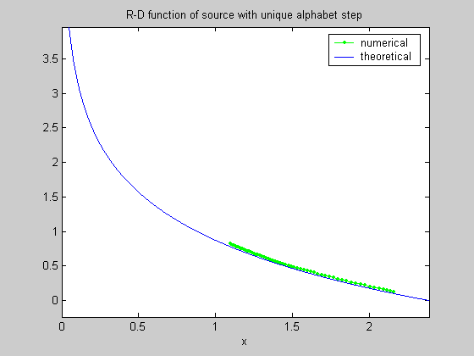
Figure 5: R-D function of source with unique alphabet step b²/4=0.1

In Section 3 we assumed that the production of λ_{i} and p_{i} is constant with respect to i, and at the same time the set Λ_{s} satisfies the tentative solution definition. Figure 6 verifies these assumptions. In both figure the alphabet step is 0.1 and s is -0.61, in which case the theoretical value of k(s) should be 0.0305 according to (14). The red dashed line in (a) marked this value. It can be clearly shown in (b) that the tentative solution criteria (5) also hold considerably well.

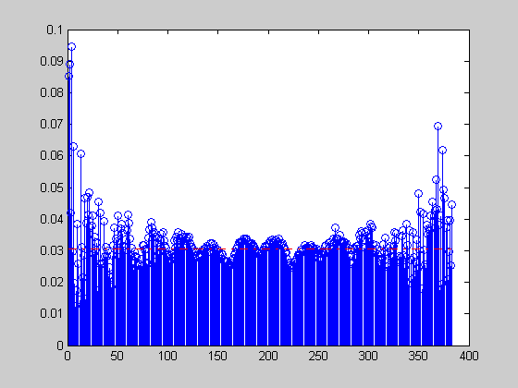
(a)
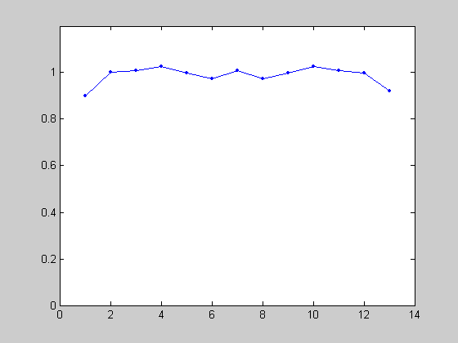
(b)
Figure 6: (a) k(s) with respect to i. (b) c_{j} with respect to j.

The result of the product source is verified as follows. To reduce the calculation cost of the numerical algorithm, only two-fold product source is composed. In Figure 7, the red line is produced by adding two R-D functions with same derivative where the alphabet steps of two sources is 0.1 and 0.25, and the blue line is obtained directly by numerical iterative algorithm. Like the experiment for the unique alphabet step, this time two lines overlap each other all the same, particularly at low D region.
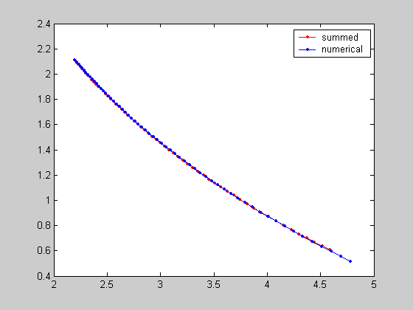
Figure 7: R-D function of product source composed of two sources with alphabet step being 0.1 and 0.25 respectively

Section 6: Conclusion
This contribution points out that it is not academically strict and accurate to apply the R-D function of continuous source to H.264 transform coefficients which is actually a discrete source. To solve this problem, this article first derives the R-D function of discrete r. v. with unique alphabet step. After composing these simple cases to a product source, the R-D function of H.264 transform coefficients was finally obtained by taking advantage of properties of product source. Experiment results provided verify these conclusions. We believe this contribution will form a solid theoretical basis when using logarithmic R-D model in H.264 rate control algorithm research.

References
[1] Tihao Chiang, Ya-Qin Zhang, “A New Rate Control Scheme Using Quadratic Rate Distortion Model”, IEEE Trans. CSVT, Vol. 7, No. 1, Feb 1997, pp 246-250
[2] Z. G. Li, et.al, “Adaptive Rate Control with HRD Consideration”, JVT- H014, 8th Meeting: Geneva, May 20-26,2003
[3] Z. G. Li, Lin Xiao, C. Zhu, Pan Feng. “A Novel Rate Control Scheme for Video Over the Internet”. In Proceedings ICASSP 2002, Florida, USA, pp 2065--2068, May 13-17, 2002
[4] Yuan Wu, et.al, “Optimum Bit Allocation and Rate Control for H.264/AVC”, JVT-O016, 15th Meeting: Busan, KR, 16-22 April, 2005
[5] Shuai Wan , Yilin Chang, Fuzheng Yang,” Frame-layer rate control For JVT video coding using improved quadratic rate distortion model”, Proc. of SPIE Vol. 5960, Visual Communications and Image Processing 2005, 12–15 July 2005, Beijing, China, pp 1053-1060
[6] Minqiang Jiang, Xiaoquan Yi, Nam Ling, ”Improved Frame-Layer Rate Control for H.264 Using MAD Ratio”, In Proceedings of 2004 International Symposium on Circuit and System, Vol 3, 23-26 May 2004, pp 813-816
[7] Minqiang Jiang, Xiaoquan Yi, Nam Ling, “On Enhancing H.264 Rate Control by PSNR-Based Frame Complexity Estimation”, International Conference on Consumer Electronics 2005, 8-12 Jan 2005, pp 231-232
[8] Minqiang Jiang, Nam Ling,” Frame-Layer H.264 Rate Control Improvement Using
Lagrange Multiplier and Quantizer”, International Symposium on Circuit and System 2005, 23-26 May 2005, pp 4396-4372
[9] Hongtao Yu, Feng Pan, Zhiping Lin, “A New Bit Estimation Scheme for H.264 Rate Control”, International Symposium on Consumer Electronics 2004, 1-3 Sept. 2004, pp 396-399
[10] Antti Hallapuro, Marta Karczewicz, Henrique Malvar, ”Low Complexity Transform and Quantization – Part I: Basic Implementation”, JVT-B038, 2nd Meeting: Geneva, CH, Jan. 29 - Feb. 1, 2002
[11] Jiongpan Zhou, “Basic Information Theory”, Posts & Telecom Press, China, 1983
[12] T. Berger, “Rate Distortion Theory”. Englewood Cliffs, NJ: Prentice Hall, 1971

(Append for Proposal Documents)

JVT Patent Disclosure Form

International Telecommunication Union  Telecommunication Standardization Sector | International Organization for Standardization | International Electrotechnical Commission
 |  | 
Joint Video Coding Experts Group - Patent Disclosure Form
(Typically one per contribution and one per Standard | Recommendation)

Please send to:
JVT Rapporteur Gary Sullivan, Microsoft Corp., One Microsoft Way, Bldg. 9, Redmond WA 98052-6399, USA
Email (preferred): Gary.Sullivan@itu.int Fax: +1 425 706 7329 (+1 425 70MSFAX)

This form provides the ITU-T | ISO/IEC Joint Video Coding Experts Group (JVT) with information about the patent status of techniques used in or proposed for incorporation in a Recommendation | Standard. JVT requires that all technical contributions be accompanied with this form. Anyone with knowledge of any patent affecting the use of JVT work, of their own or of any other entity (“third parties”), is strongly encouraged to submit this form as well.

This information will be maintained in a “living list” by JVT during the progress of their work, on a best effort basis. If a given technical proposal is not incorporated in a Recommendation | Standard, the relevant patent information will be removed from the “living list”. The intent is that the JVT experts should know in advance of any patent issues with particular proposals or techniques, so that these may be addressed well before final approval.

This is not a binding legal document; it is provided to JVT for information only, on a best effort, good faith basis. Please submit corrected or updated forms if your knowledge or situation changes.

This form is not a substitute for the ITU ISO IEC Patent Statement and Licensing Declaration, which should be submitted by Patent Holders to the ITU TSB Director and ISO Secretary General before final approval.

Submitting Organization or Person:
Organization name | SVA (Group) Co., Ltd., Central Research Academy
Mailing address | 757 Yishan Road, Shanghai, China. Postcode: 200233
Country | China
Contact person | Zhou Heng, Zhao Haiwu
Telephone | 86-21-54975588-3211/3207
Fax | 86-21-54975058
Email | zhou_h@sva.com.cn  zhou_heng@yahoo.com  zhao_hw@sva.com.cn
Place and date of submission | 2005.10.10
Relevant Recommendation | Standard and, if applicable, Contribution:
Name (ex: “JVT”) |  | JVT
Title |  | The Rate Distortion Function of H.264 Transform Coefficients
Contribution number |  | Qxxx

(Form continues on next page)

Disclosure information – Submitting Organization/Person (choose one box)
X | 2.0 The submitter is not aware of having any granted, pending, or planned patents associated with the technical content of the Recommendation | Standard or Contribution.  or,
The submitter (Patent Holder) has granted, pending, or planned patents associated with the technical content of the Recommendation | Standard or Contribution. In which case,

 | 2.1 The Patent Holder is prepared to grant – on the basis of reciprocity for the above Recommendation | Standard – a free license to an unrestricted number of applicants on a worldwide, non-discriminatory basis to manufacture, use and/or sell implementations of the above Recommendation | Standard.
2.2 The Patent Holder is prepared to grant – on the basis of reciprocity for the above Recommendation | Standard – a license to an unrestricted number of applicants on a worldwide, non-discriminatory basis and on reasonable terms and conditions to manufacture, use and/ or sell implementations of the above Recommendation | Standard.

Such negotiations are left to the parties concerned and are performed outside the ITU | ISO/IEC.
 | 2.2.1 The same as box 2.2 above, but in addition the Patent Holder is prepared to grant a “royalty-free” license to anyone on condition that all other patent holders do the same.
2.3 The Patent Holder is unwilling to grant licenses according to the provisions of either 2.1, 2.2, or 2.2.1 above. In this case, the following information must be provided as part of this declaration:
- patent registration/application number;
- an indication of which portions of the Recommendation | Standard are affected.
- a description of the patent claims covering the Recommendation | Standard;
In the case of any box other than 2.0 above, please provide the following:
Patent number(s)/status
Inventor(s)/Assignee(s)
Relevance to JVT
Any other remarks:
(please provide attachments if more space is needed)

(form continues on next page)
Third party patent information – fill in based on your best knowledge of relevant patents granted, pending, or planned by other people or by organizations other than your own.

Disclosure information – Third Party Patents (choose one box)
3.1 The submitter is not aware of any granted, pending, or planned patents held by third parties associated with the technical content of the Recommendation | Standard or Contribution.

3.2 The submitter believes third parties may have granted, pending, or planned patents associated with the technical content of the Recommendation | Standard or Contribution.

For box 3.2, please provide as much information as is known (provide attachments if more space needed) - JVT will attempt to contact third parties to obtain more information:

3rd party name(s)
Mailing address
Country
Contact person
Telephone
Fax
Email
Patent number/status
Inventor/Assignee
Relevance to JVT

Any other comments or remarks:

