Joint Video Team (JVT) of ISO/IEC MPEG & ITU-T VCEG  (ISO/IEC JTC1/SC29/WG11 and ITU-T SG16 Q.6)  17th Meeting: Nice, FR, 14-21 October, 2005 | Document: JVT-Q078  Filename: input.doc

Title: | Simplification of up-sampling process of IntraBL mode
Status: | Input Document
Purpose: | Information & Proposal
Author(s) or  Contact(s): | Ci-Xun Zhang, Lu Yu  Zhejiang University  ZheDa Road 38, 310027 Hangzhou, China  Lianhuan Xiong  Multimedia Product Line  Huawei Technologies Co., Ltd.  Shenzhen 518129, P.R.China | Tel:  Email: | +86 571 87953107  cixunzhang@hotmail.com  yul@zju.edu.cn  lh_xiong@huawei.com
Source: | Zhejiang University, Huawei Technologies Co., Ltd., China
_____________________________

Abstract
In the current JSVM, a 6-tap interpolation filter (1, -5, 20, 20, -5, 1)/32 is used in the up-sampling process of IntraBL mode coding both for luma and chroma components and the complexity of this interpolation is even higher than the half-pel interpolation of reference frames in AVC. Considering that the spatial correlation may be different from the temporal correlation, experiments are carried out and it is proved that the complexity can be reduced without obvious penalty by using more simple interpolation filter.

We have tested the following schemes:
1. Bilinear: Bilinear filter is used for up-sampling of both luma and chroma components.
2. 5_1: (-1, 5, 5, -1)/8 is used for up-sampling of both luma and chroma components.
3. Org_bilinear: (1, -5, 20, 20, -5, 1)/32 is used for up-sampling of luma components and bilinear filter is used for up-sampling of chroma components.
4. 5_1_bilinear: (-1, 5, 5, -1)/8 is used for up-sampling of luma components and bilinear filter is used for up-sampling of chroma components.

Experiments are conducted to compare the above schemes with the latest JSVM reference software. In the test, each sequence is coded as a spatially scalable bit-stream with the base layer resolution equal to half the enhancement layer resolution. All frames in the sequence are coded with only I-pictures at fixed QP (8, 12, 16, 20, 24, 28, 32, 36.). FRExt is disabled in the base layer and optional in the enhancement layer. The CIF/QCIF sequences we tested are Bus (75 frames), Football (130 frames), Foreman (150 frames) and Mobile (150 frames), all at 15fps. The 4CIF/CIF sequences we tested are City (300 frames), Crew (300 frames), Harbour (300 frames) and Soccer (300 frames), all at 30fps. The simulation condition and test results are given in the following tables. More results are included in the accompanying Excel file. At the end of this contribution, some subjective results are presented.

From the experimental results, we can see that the performance is: Org_bilinear > 5_1 > 5_1_bilinear > Bilinear, which is expected. For the case of Org_bilinear, the average BD-PSNR drop is within 0.04 dB, which can be neglected. Even for the case 5_1_bilinear, the BD-PSNR penalty in the low bit rates (30-40 dB) is only about 0.05 dB and on average about 0.10 dB in high bit rates (40-50 dB). When comparing to the case of Org_bilinear, the loss of the case 5_1_bilinear is even lower. What is more, when comparing anchor and Org_bilinear, 5_1 and 5_1_bilinear, similar loss in BD-PSNR is observed, which is neglectable. Since the complexity of IntraBL mode is generally higher than other intra modes and relatively more frequently used, we believe the simplification would be meaningful.

Based on the experimental results, we propose
- Bilinear interpolation filter is used for chroma components in the up-sampling process of IntraBL coding in order to reduce complexity without loss in performance.
- (-1, 5, 5, -1)/8 is used for luma components in the up-sampling process of IntraBL coding process of IntraBL coding to further reduce the complexity especially in medium-quality applications.
- (1, -5, 20, 20, -5, 1)/32 and (-1, 5, 5, -1)/8 can also be chosen according to different requirements.

Table 1 Simulation condition
Number of Layers | 2
GOP Size | 1
Intra Period | 1
Base Layer
Resolution | QCIF/CIF
Frame Rate | 15Hz/30Hz
AVC Compatible | Yes
FRExt Mode | No
Intra mode Usage | On
Adaptive QP | Not Used
QP | 8, 12, 16, 20, 24, 28, 32, 36
NumFGSLayers | 0
InterLayerPred | 0 (No)
Enhancement Layer
Resolution | CIF/4CIF
Frame Rate | 15Hz/30Hz
AVC Compatible | No
FRExt Mode | No/Yes
Intra mode Usage | On
Adaptive QP | Not Used
QP | 8, 12, 16, 20, 24, 28, 32, 36
NumFGSLayers | 0
InterLayerPred | 2 (Adaptive)

Table 2: QP=8, 12, 16, 20. Frext disabled
 | Bilinear | 5_1 | Org_bilinear | 5_1_bilinear
Bus | -0.1106 | -0.0313 | -0.0127 | -0.0477
City | -0.4006 | -0.0803 | -0.0030 | -0.0832
Crew | -0.4042 | -0.0697 | -0.0651 | -0.1295
Football | -0.3431 | -0.0920 | -0.0617 | -0.1403
Foreman | -0.1663 | -0.0414 | -0.0267 | -0.0685
Harbour | -0.7663 | -0.1461 | -0.0230 | -0.1643
Mobile | -0.1352 | -0.0465 | -0.0733 | -0.1019
Soccer | -0.5071 | -0.0978 | -0.0239 | -0.1189
Average | -0.3542 | -0.0757 | -0.0362 | -0.1068

Table 3: QP=24, 28, 32, 36. Frext disabled
 | Bilinear | 5_1 | Org_bilinear | 5_1_bilinear
Bus | -0.0886 | -0.0269 | -0.0014 | -0.0271
City | -0.2475 | -0.0350 | -0.0005 | -0.0352
Crew | -0.1501 | -0.0092 | -0.0049 | -0.0177
Football | -0.1899 | -0.0481 | -0.0076 | -0.0586
Foreman | -0.1114 | -0.0238 | -0.0041 | -0.0294
Harbour | -0.7034 | -0.1151 | -0.0012 | -0.1163
Mobile | -0.1446 | -0.0456 | -0.0475 | -0.0885
Soccer | -0.1855 | -0.0236 | -0.0024 | -0.0268
Average | -0.2276 | -0.0409 | -0.0087 | -0.0500

Table 4: QP=8, 12, 16, 20. Frext enabled
 | Bilinear | 5_1 | Org_bilinear | 5_1_bilinear
Bus | -0.1617 | -0.0428 | -0.0177 | -0.0612
City | -0.5077 | -0.1050 | -0.0029 | -0.1079
Crew | -0.4554 | -0.0927 | -0.0701 | -0.1530
Football | -0.3999 | -0.1027 | -0.0610 | -0.1519
Foreman | -0.1921 | -0.0487 | -0.0301 | -0.0737
Harbour | -0.9165 | -0.1895 | -0.0223 | -0.2093
Mobile | -0.1589 | -0.0495 | -0.0726 | -0.1042
Soccer | -0.6006 | -0.1358 | -0.0252 | -0.1561
Average | -0.4241 | -0.0958 | -0.0377 | -0.1272

Table 5: QP=24, 28, 32, 36. Frext enabled
 | Bilinear | 5_1 | Org_bilinear | 5_1_bilinear
Bus | -0.1394 | -0.0280 | -0.0015 | -0.0341
City | -0.2994 | -0.0428 | -0.0005 | -0.0430
Crew | -0.1602 | -0.0143 | -0.0052 | -0.0232
Football | -0.2277 | -0.0482 | -0.0095 | -0.0592
Foreman | -0.1184 | -0.0218 | -0.0054 | -0.0273
Harbour | -0.7789 | -0.1364 | -0.0012 | -0.1377
Mobile | -0.1896 | -0.0471 | -0.0487 | -0.0957
Soccer | -0.1918 | -0.0268 | -0.0026 | -0.0302
Average | -0.2632 | -0.0457 | -0.0093 | -0.0563

Subjective result: Reconstructed 10th Frame of Harbour Sequence (Frext Enabled, QP=12)
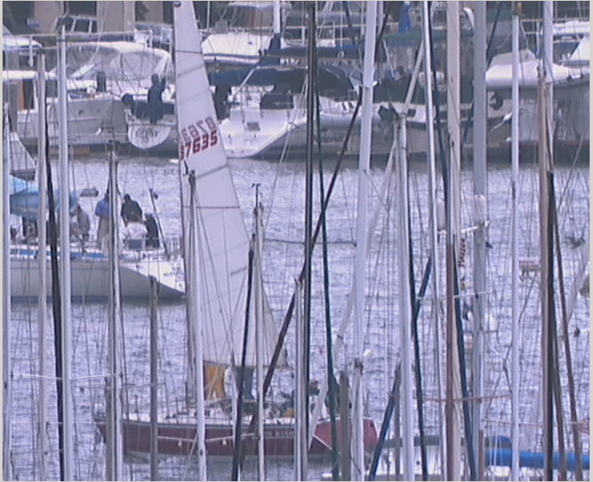
Original Sequence
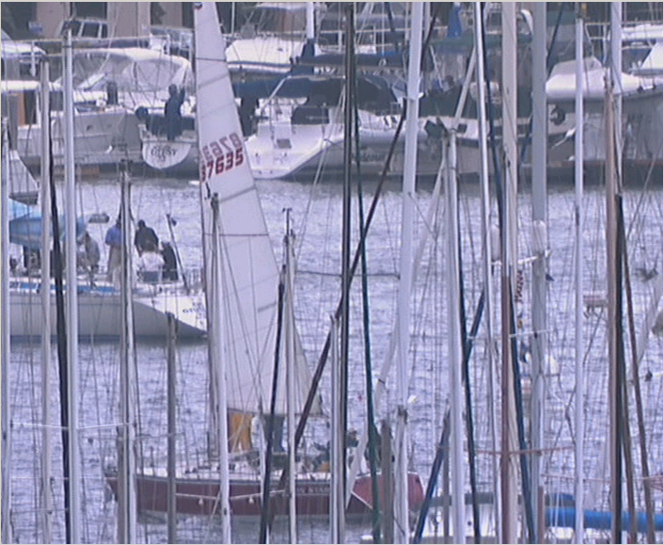
Anchor (Y 49.4159 dB U 50.9550 dB V 51.6921 dB)
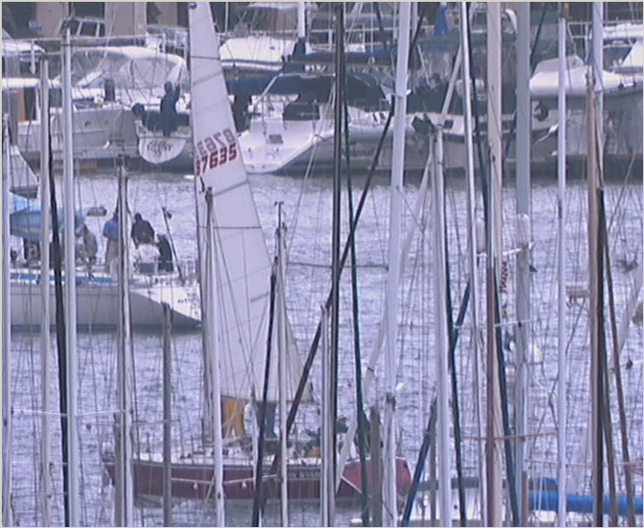
Bilinear (Y 49.4297 dB U 50.9645 dB V 51.7075 dB)
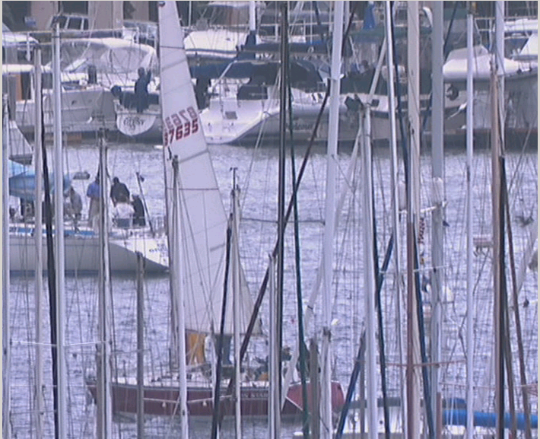
5_1 (Y 49.4024 dB U 50.9573 dB V 51.7030 dB)
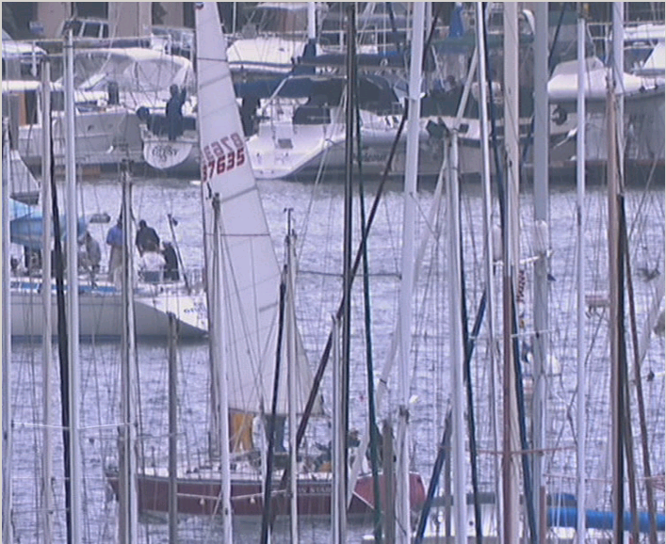
Org_bilinear (Y 49.4166 dB U 50.9213 dB V 51.6738 dB)
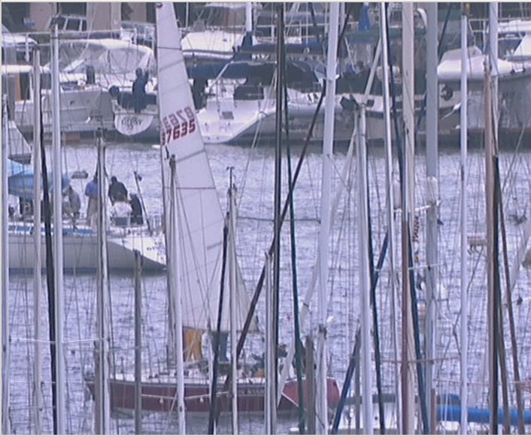
5_1_bilinear (Y 49.4016 dB U 50.9206 dB V 51.6795 dB)

(Append for Proposal Documents)

JVT Patent Disclosure Form

International Telecommunication Union  Telecommunication Standardization Sector | International Organization for Standardization | International Electrotechnical Commission
 |  | 
Joint Video Coding Experts Group - Patent Disclosure Form
(Typically one per contribution and one per Standard | Recommendation)

Please send to:
JVT Rapporteur Gary Sullivan, Microsoft Corp., One Microsoft Way, Bldg. 9, Redmond WA 98052-6399, USA
Email (preferred): Gary.Sullivan@itu.int Fax: +1 425 706 7329 (+1 425 70MSFAX)

This form provides the ITU-T | ISO/IEC Joint Video Coding Experts Group (JVT) with information about the patent status of techniques used in or proposed for incorporation in a Recommendation | Standard. JVT requires that all technical contributions be accompanied with this form. Anyone with knowledge of any patent affecting the use of JVT work, of their own or of any other entity (“third parties”), is strongly encouraged to submit this form as well.

This information will be maintained in a “living list” by JVT during the progress of their work, on a best effort basis. If a given technical proposal is not incorporated in a Recommendation | Standard, the relevant patent information will be removed from the “living list”. The intent is that the JVT experts should know in advance of any patent issues with particular proposals or techniques, so that these may be addressed well before final approval.

This is not a binding legal document; it is provided to JVT for information only, on a best effort, good faith basis. Please submit corrected or updated forms if your knowledge or situation changes.

This form is not a substitute for the ITU ISO IEC Patent Statement and Licensing Declaration, which should be submitted by Patent Holders to the ITU TSB Director and ISO Secretary General before final approval.

Submitting Organization or Person:
Organization name | Zhejiang University
Mailing address | ZheDa Road 38, 310027 Hangzhou
Country | China
Contact person | Lu Yu
Telephone | +86 571 87953107
Fax | +86 571 87953107
Email | yul@zju.edu.cn
Place and date of submission | Nice, France  Oct. 2005
Relevant Recommendation | Standard and, if applicable, Contribution:
Name (ex: “JVT”) |  | JVT
Title |  | Simplification of up-sampling process of IntraBL mode
Contribution number |  | JVT-Q078

(Form continues on next page)

Disclosure information – Submitting Organization/Person (choose one box)
2.0 The submitter is not aware of having any granted, pending, or planned patents associated with the technical content of the Recommendation | Standard or Contribution.

or,
The submitter (Patent Holder) has granted, pending, or planned patents associated with the technical content of the Recommendation | Standard or Contribution. In which case,

2.1 The Patent Holder is prepared to grant – on the basis of reciprocity for the above Recommendation | Standard – a free license to an unrestricted number of applicants on a worldwide, non-discriminatory basis to manufacture, use and/or sell implementations of the above Recommendation | Standard.
2.2 The Patent Holder is prepared to grant – on the basis of reciprocity for the above Recommendation | Standard – a license to an unrestricted number of applicants on a worldwide, non-discriminatory basis and on reasonable terms and conditions to manufacture, use and/ or sell implementations of the above Recommendation | Standard.

Such negotiations are left to the parties concerned and are performed outside the ITU | ISO/IEC.
2.2.1 The same as box 2.2 above, but in addition the Patent Holder is prepared to grant a “royalty-free” license to anyone on condition that all other patent holders do the same.
2.3 The Patent Holder is unwilling to grant licenses according to the provisions of either 2.1, 2.2, or 2.2.1 above. In this case, the following information must be provided as part of this declaration:
- patent registration/application number;
- an indication of which portions of the Recommendation | Standard are affected.
- a description of the patent claims covering the Recommendation | Standard;
In the case of any box other than 2.0 above, please provide the following:
Patent number(s)/status
Inventor(s)/Assignee(s)
Relevance to JVT
Any other remarks:
(please provide attachments if more space is needed)

(form continues on next page)
Third party patent information – fill in based on your best knowledge of relevant patents granted, pending, or planned by other people or by organizations other than your own.

Disclosure information – Third Party Patents (choose one box)
3.1 The submitter is not aware of any granted, pending, or planned patents held by third parties associated with the technical content of the Recommendation | Standard or Contribution.

3.2 The submitter believes third parties may have granted, pending, or planned patents associated with the technical content of the Recommendation | Standard or Contribution.

For box 3.2, please provide as much information as is known (provide attachments if more space needed) - JVT will attempt to contact third parties to obtain more information:

3rd party name(s)
Mailing address
Country
Contact person
Telephone
Fax
Email
Patent number/status
Inventor/Assignee
Relevance to JVT

Any other comments or remarks:

