Joint Video Team (JVT) of ISO/IEC MPEG & ITU-T VCEG  (ISO/IEC JTC1/SC29/WG11 and ITU-T SG16 Q.6)  16th Meeting: Poznań, PL, 24-29 July, 2005 | Document: JVT-P093  Filename: JVT-P093.doc

Title: | CE02: Deblocking Filter Adaptation for Open-Loop Coding
Status: | Input Document to JVT
Purpose: | Proposal
Author(s) or  Contact(s): | Markus Beermann, Konstantin Hanke, Mathias Wien  Melatener Str. 23  52056 Aachen, GERMANY | Tel:  Email: | +49-241-8027681  {beermann,hanke,wien}@ient.rwth-aachen.de
Source: | RWTH Aachen University
_____________________________

Abstract
The H.264|AVC deblocking filter has been designed and tuned for closed-loop application. The SVC extension contains an open-loop structure. This fundamental difference has not yet been considered in the necessary adaptations of the deblocking filter for its use in the scalable extension.
In this contribution, we discuss the differences that evolve from the open-loop situation. The resulting modifications to the deblocking filter are compared to a very simple adaptation of the deblocking filter through available slice-header syntax. This comparison includes rate-distortion results as well as visual coding results.

Deblocking Filter Adaptation

Closed-loop Deblocking
Deblocking filtering is necessary for block-wise lossy coding at high compression ratios. Two neighboring image pixels that are coded in two different blocks or macroblocks may describe the same image content. The independent prediction and coding in the two pixels may result in different reconstruction values on both sides of the block boundary. Since these differences are often correlated along the block boundary, they can become annoyingly perceptible. The deblocking filter alleviates such reconstruction differences at block boundaries adaptively according to their estimated magnitude. Since the difference is caused by quantization, its magnitude is related to the quantization noise. Consequently, the deblocking filter parameters Alpha and C0 in the H.264|AVC are proportional to the quantization-step size, , and thus to the square root of the noise variance, . In the deblocking filter, Alpha and C0 determine the allowable impact of the filter. The deblocking parameter Beta is more conservatively increasing with the quantization step-size. It determines the signal flatness near the block boundary and is related to visibility, while Alpha and C0 are related to the magnitude of blocking.

Closed-loop vs. Open-loop
For decoded frames that are used for prediction in a closed-loop scenario, there is no mismatch between encoder and decoder. For each frame, noise is only introduced during quantization of the residual for this frame. After reconstruction of a lossily coded frame, its perfect knowledge at encoder and decoder side allows for a perfect reconstruction of a subsequent frame if its residual is not quantized.
The situation is different for open-loop coding. Here, the references used for prediction at the decoder contain quantization noise that is not known in advance at the encoder. This noise adds to the noise that is introduced by quantizing the residual, . It can be assumed that noise contained in the residual is independent from the noise in the prediction and therefore their noise variances add up, . Consequently, appropriate scaling of the deblocking filter parameters Alpha and C0 can be obtained by e.g. Alpha² = Alpha_{P}² + Alpha_{H}². This behavior in general can not be reflected by an offset in the QP-domain, since Alpha. For one operating point, a reasonable approximation may be possible and may be realized e.g. by table look-up for QP.

Application to MCTF (and open-loop UMCTF)
The temporal decomposition structure of MCTF calls for different frame-QP settings for different temporal layers. The resulting variation of decoded quality of different temporal bands carries through the MCTF-reconstruction and results in a observable varying quality of decoded frames. Frames co-located with coarse temporal bands usually have a higher decoded quality than frames that are co-located with temporal bands of a finer temporal band.
Consider e.g. the last temporal reconstruction step. While one of the two prediction-references usually is co-located with a band of the next-coarser temporal level, the other reference may be co-located with a band of the coarsest temporal level. These two references usually have significantly different quality. Consequently, quantization noise contained in a prediction from these two references may significantly vary depending on whether prediction is performed from left, right or bi-directional. We observed that the frame-QPs of left and right predictors usually differ by 0…5 and can for some frames differ by up to 10.

Syntax of H.264|AVC allows for an adaptation of the coding QP for each macroblock. (This may be extensively used in SVC, e.g. [JVT-P095].) Such QP variations may occur for the coding of the residual as well as in the prediction-references. In general, there does not exist one operating point (in terms of QP, see above) for larger parts of a frame.

From above discussion it follows that it is necessary to employ an adaptive increase of deblocking filter parameters for open-loop INTER predicted blocks. INTRA-coded blocks do not require modifications of deblocking filter parameters. The filter already is well adapted for this means.

The strength of deblocking filtering can be increased with available slice-header syntax by setting an offset that adds to the coding-QP(s) of the block-edge prior to determining the filter parameters. This does not in general reflect the behavior that is necessary for appropriate adaptation of deblocking. It has to be noted that it is also unnecessarily applied to all INTRA-coded blocks.

Experiments
Due to lack of time we were not able to fully meet the initial plans for this CE. The following results shall highlight the potential in the adaptation of the deblocking filter and motivate an extension of the CE.
The following experiments were performed using JSVM1 including the adopted deblocking bug-fix [JVT-O067] and using Palma testing conditions.

In our experiments, we compared three different kinds of deblocking:
- (Ref): JSVM1 including bug-fix
- (SH): same as (Ref), but using slice-header syntax to have stronger deblocking
- (Ad): adaptive deblocking that uses QP-settings from references and residual to locally adapt filter parameters by combining Alphas, C0s and Betas as described in [JVT-O067] for adaptation on macroblock basis.

Firstly, it can be observed (see also examples below), that (SH) and (Ad) both show better deblocking performance than (Ref). This is especially true for all complex-motion sequences. With (Ad), the deblocking performance can be said to be comparable to the deblocking in closed-loop h.264|AVC.

Secondly comparing (SH) and (Ad), it can be observed that in some areas, (SH) introduces blurring where (Ad) does not. At the same time, the deblocking performance of (SH) in some areas is not as good as (Ad). Below, some example frames are shown. The discussed drawbacks of using the deblocking-filter offsets in the slice headers compared to an improved adaptation can be observed in most sequences when complex motion is present. The mismatch between the adaptive settings for deblocking and the syntactically possible settings allowed by slice header syntax become obvious and visible in this comparison.

Conclusion & Proposal
The deblocking filter, specified in H.264|AVC, is a tool that is optimized for a closed-loop situation. It needs adaptation when it is to be transferred to open-loop coding. This adaptation is not sufficiently implemented by the available slice-header syntax since a) it does not provide the adequate adaptation behavior for different noise sources and b) it also applies to INTRA blocks that are not concerned with the closed-/open-loop issue.
An adaptive deblocking filter (Ad) has been realized which shows good deblocking performance in all situations. Software and description are available and could be provided.
We expect that the same deblocking performance as shown with (Ad) can be achieved by using simplified adaptation rules, resulting in small changes to the current deblocking filter specification. We propose to continue this CE by one meeting period.

Results

R/D Results

Visual Examples
Below, some visual examples are provided. To demonstrate the effect of the various deblocking configurations, we selected frames, where too much and too little deblocking can be observed in the same slice, when using slice header offsets. For guidance, we marked a view example points in the frames as follows:
- yellow circle: successfull deblocking
- red circle: blurring
- blue circle: insufficient deblocking
FOOTBALL_352x288_15_384, 2nd Frame
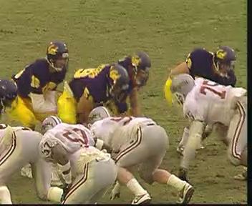(Ref)
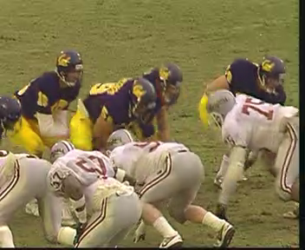(Ad)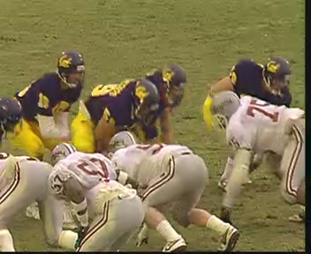(SH)
FOOTBALL_352x288_15_384, 11th Frame
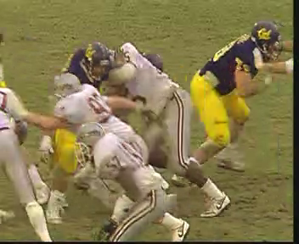(Ref)
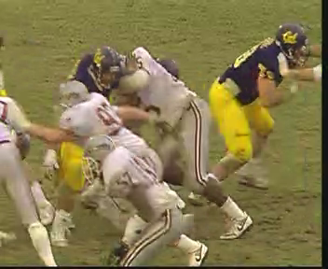 (Ad)
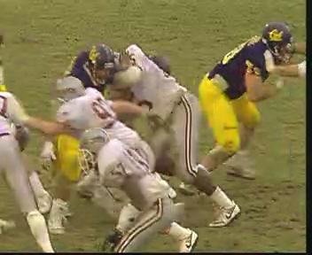 (SH)
CREW_352x288_30 142nd frame
(Ref)
(Ad)
(SH)
FOREMAN_352x288_30 7th frame
 (Ref)
 (Ad)
 (SH)

(Append for Proposal Documents)

JVT Patent Disclosure Form

International Telecommunication Union  Telecommunication Standardization Sector | International Organization for Standardization | International Electrotechnical Commission
 |  | 
Joint Video Coding Experts Group - Patent Disclosure Form
(Typically one per contribution and one per Standard | Recommendation)

Please send to:
JVT Rapporteur Gary Sullivan, Microsoft Corp., One Microsoft Way, Bldg. 9, Redmond WA 98052-6399, USA
Email (preferred): Gary.Sullivan@itu.int Fax: +1 425 706 7329 (+1 425 70MSFAX)

This form provides the ITU-T | ISO/IEC Joint Video Coding Experts Group (JVT) with information about the patent status of techniques used in or proposed for incorporation in a Recommendation | Standard. JVT requires that all technical contributions be accompanied with this form. Anyone with knowledge of any patent affecting the use of JVT work, of their own or of any other entity (“third parties”), is strongly encouraged to submit this form as well.

This information will be maintained in a “living list” by JVT during the progress of their work, on a best effort basis. If a given technical proposal is not incorporated in a Recommendation | Standard, the relevant patent information will be removed from the “living list”. The intent is that the JVT experts should know in advance of any patent issues with particular proposals or techniques, so that these may be addressed well before final approval.

This is not a binding legal document; it is provided to JVT for information only, on a best effort, good faith basis. Please submit corrected or updated forms if your knowledge or situation changes.

This form is not a substitute for the ITU ISO IEC Patent Statement and Licensing Declaration, which should be submitted by Patent Holders to the ITU TSB Director and ISO Secretary General before final approval.

Submitting Organization or Person:
Organization name | RWTH Aachen University
Mailing address | Melatener Str. 23  52056 Aachen
Country | GERMANY
Contact person | Mathias Wien
Telephone | +49-241-8017681
Fax
Email
Place and date of submission
Relevant Recommendation | Standard and, if applicable, Contribution:
Name (ex: “JVT”)
Title
Contribution number

(Form continues on next page)

Disclosure information – Submitting Organization/Person (choose one box)
2.0 The submitter is not aware of having any granted, pending, or planned patents associated with the technical content of the Recommendation | Standard or Contribution.

or,
The submitter (Patent Holder) has granted, pending, or planned patents associated with the technical content of the Recommendation | Standard or Contribution. In which case,

2.1 The Patent Holder is prepared to grant – on the basis of reciprocity for the above Recommendation | Standard – a free license to an unrestricted number of applicants on a worldwide, non-discriminatory basis to manufacture, use and/or sell implementations of the above Recommendation | Standard.
2.2 The Patent Holder is prepared to grant – on the basis of reciprocity for the above Recommendation | Standard – a license to an unrestricted number of applicants on a worldwide, non-discriminatory basis and on reasonable terms and conditions to manufacture, use and/ or sell implementations of the above Recommendation | Standard.

Such negotiations are left to the parties concerned and are performed outside the ITU | ISO/IEC.
2.2.1 The same as box 2.2 above, but in addition the Patent Holder is prepared to grant a “royalty-free” license to anyone on condition that all other patent holders do the same.
2.3 The Patent Holder is unwilling to grant licenses according to the provisions of either 2.1, 2.2, or 2.2.1 above. In this case, the following information must be provided as part of this declaration:
- patent registration/application number;
- an indication of which portions of the Recommendation | Standard are affected.
- a description of the patent claims covering the Recommendation | Standard;
In the case of any box other than 2.0 above, please provide the following:
Patent number(s)/status
Inventor(s)/Assignee(s)
Relevance to JVT
Any other remarks:
(please provide attachments if more space is needed)

(form continues on next page)
Third party patent information – fill in based on your best knowledge of relevant patents granted, pending, or planned by other people or by organizations other than your own.

Disclosure information – Third Party Patents (choose one box)
3.1 The submitter is not aware of any granted, pending, or planned patents held by third parties associated with the technical content of the Recommendation | Standard or Contribution.

3.2 The submitter believes third parties may have granted, pending, or planned patents associated with the technical content of the Recommendation | Standard or Contribution.

For box 3.2, please provide as much information as is known (provide attachments if more space needed) - JVT will attempt to contact third parties to obtain more information:

3rd party name(s)
Mailing address
Country
Contact person
Telephone
Fax
Email
Patent number/status
Inventor/Assignee
Relevance to JVT

Any other comments or remarks:

