Joint Video Team (JVT) of ISO/IEC MPEG & ITU-T VCEG  (ISO/IEC JTC1/SC29/WG11 and ITU-T SG16 Q.6)  16th Meeting: Poznań, PL, 24-29 July, 2005 | Document: JVT-P085  Filename: JVT-P085.doc  NOTE – That first character after the dash up there in the document number is an "O", not a zero.

Title: | Smoothed reference prediction for single-loop decoding
Status: | Input Document to JVT
Purpose: | Proposal
Author(s) or  Contact(s): | Woo-Jin Han  Yeongtong-Gu Suwon-City Gyeonggi-Do South Korea  Digital Media R&D Center  Samsung Electronics Co., Ltd. | Email: | wjhan.han@samsung.com
Source: | Samsung Electronics Co., Ltd.
_____________________________

Abstract

Single-loop decoding is a very useful technique to reduce the decoding complexity in the multi-layer structure, however, the restrictions of the intra-base prediction sometimes degrades the performance especially for the fast-motion sequences. In this contribution, we add the new prediction mode based on the residual prediction process to simulate the intra-base prediction by adding the smoothing function to the prediction signal with consideratiosn of the residual prediction process. As a result, we can obtain the clear performance improvements in Football, Crew, and Soccer sequence within the context of the low-complexity decoding mode.

Single-loop decoding in JSVM2

Concept of single-loop decoding [1] is very useful technique to reduce the decoding complexity in the multi-layer video coding such as the H.264 scalable extension. Basically, the single-loop decoding is realized to limit the prediction modes in the encoder-side. For the single-loop decoding mode, the intra_base prediction mode, which uses the base-layer texture information, can be used only if the corresponding base-layer macroblock mode is one of the intra prediction modes. It enables the decoder to perform the quarter-pel interpolation and the motion compensation operation only in the current layer. However, the limitation of the use of intra_base prediction mode sometimes degrades the performance by a clear margin. Figure 1 shows a PSNR curve of FOOTBALL sequence.
Figure 1 PSNR curves of FOOTBALL sequence for JSVM1-multi-loop and JSVM1 single-loop decoding.
As shown in Figure 1, the performance difference is up to 0.5 dB, which is not negligible, and the performance impact is most clear when the resolution between layers changes.

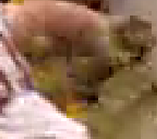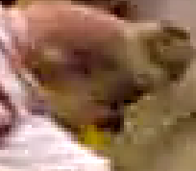
(a) (b)
Figure 2 11th frame of FOOTBALL CIF@15Hz, 512kbps: (a) single-loop decoding (b) multi-loop decoding.
Figure 2 shows an example of the visual quality. It is clear that the less blocked artifacts can be observed in the multi-loop decoding mode. It comes from the lack of the intra-base prediction mode in the single-loop decoding mode since these regions cannot be predicted well by the temporal prediction.

Let's assume that a macroblock of the base-layer has relatively weak temporal correlation, but the inter-prediction is better than the directional intra-prediction. For many cases, the same macroblock position in the enhancement layer will be an intra-base prediction mode since this region does not have strong temporal correlation. However, in the single-loop decoding mode, these kinds of macroblock should be treated by the inter-prediction or possibly inter-prediction with residual prediction, which degrades the coding efficiency.

In this contribution, we will present a new prediction mode to simulate the intra-base prediction by modifying the residual prediction. It reduces the penalty not to use the intra-base prediction in the single-layer decoding.

New tool: smoothed reference prediction

Residual prediction versus intra-base prediction

Since we cannot use the intra-base prediction if the corresponding base-layer macroblock is not an intra-mode, we should find the right "replacement" of the intra-base prediction within the context of the single-loop decoding. The residual prediction [2] has been proven to be a very useful tool to predict the high-pass residual signal. It predicts the current layer residual by the decoded base-layer residual signal.

The major gain of the residual signal is obtained by fixing the motion mismatch. For regions to have very strong temporal correlation, the original inter-prediction works perfectly, however, it generates the high energy residual signal for regions to have relatively weak temporal correlation. In this case, if the motion vectors of the current and base-layers are similar, the similar form of the residual signal remains in both the current and the base-layers. Therefore, the high energy residual signal in the current layer can be cancelled by the base-layer residual signal.

Let O_{F}, P_{F}, and R_{F} be the original, the prediction, and the residual signals of the current layer, and let O_{B}, P_{B}, and R_{B} be the original, the prediction, and the residual signals of the base-layer. Now the residual prediction process can be written as:

$R_{F}=O_{F}−P_{F}−R_{B}=O_{F}−(P_{F}+R_{B})$. (1)

Furthermore, the intra-base prediction can be written as:

$R_{F}=O_{F}−O_{B}$. (2)

It should be noted that Equation (1) uses inter-predicted residual information of the base-layer whereas Equation (2) uses the base-layer texture information, thus it seems to be different. However, since the O_{B} in Equation (2) can be partitioned into two difference terms, P_{B}, and R_{B}, it can be rewritten as

$R_{F}=O_{F}−[U]⋅B(P_{B}+R_{B})$. (3)

where U(⋅) is an optional upsampling filter and B(⋅) is a deblocking filter. By comparing two equations, Equation (1) and Equation (3), it can be found that two equations seem to have very similar form except two notable differences between them as the followings:

- Residual prediction uses the current layer prediction signal, P_{F}, and intra-base prediction uses the base-layer prediction signal, P_{B}.
- Intra-base prediction uses upsampling and deblocking filters before prediction, while residual prediction does not.

Since the base-layer prediction signal cannot be utilized in the single-loop decoding mode, we focus on the second item for the previous finding: upsampling and deblocking filters.

Smoothed reference prediction

In the previous section, we have shown that the most significant differences between residual prediction and intra-base prediction are upsampling and deblocking filters. Thus, we define a third prediction option: smoothed reference prediction:

$R_{F}=O_{F}−S(P_{F}+R_{B})$. (4)

where S(⋅) is a smoothing function. Equation (4) uses the current layer prediction and the base-layer residual as the residual prediction. It should be noted that the R_{B} can be omitted according to the residual prediction flag. The additional smoothing function S can be defined as the combination of the upsampling and deblocking function just like the intra-base prediction, which means S(⋅) = U⋅B(⋅). However, it increases the complexity, since both upsampling and deblocking filters require complexity. Here, we apply the simplest smoothing filter, which tab coefficients are defined as 1, 2, and 1 to the 4x4 block edges as shown in Figure 3.

Figure 3 Simplified smoothing function.
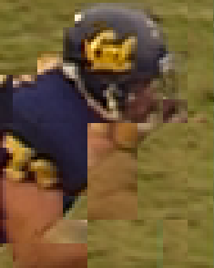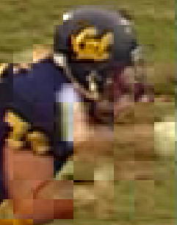

(a) (b)

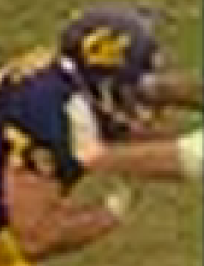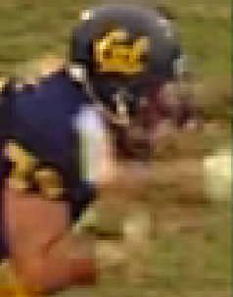

(c) (d)
Figure 4 Comparison of prediction signals: (a) inter-prediction (b) inter-prediction with residual prediction (c) intra-base prediction (c) smoothed reference prediction
Figure 4 shows comparison results of prediction signals. Due to the very fast motion, the inter-prediction (a) is simply failed for many regions. In this case, the residual energy has very high energy, which degrades the coding efficiency. The residual prediction (b) improves the prediction signal by adding the base-layer residual, but due to the inherent mismatch between the current and the base-layer, many blocking artifacts can be observed. The intra-base prediction (c) has almost no blocking artifacts, but the texture details are much blurred due to the upsampling and deblocking effects. Finally, the proposed smoothed reference prediction (d) has almost no blocking artifacts as well as maintaining reasonable texture details, since it uses the current-layer prediction signal instead of the base-layer prediction signal in intra-base prediction. Furthermore, the use of the simple 1:2:1 filter instead of the upsampling and deblocking filter can not only maintain the texture detail but reduce the computational complexity.

It should be noted that there is an encoder-decoder mismatch in the proposed smoothed reference prediction. Due to the open-loop structure of JSVM2, the reference frames are decoded in the encoder-side while the decoder always uses the decoded frames. Therefore, the result of smooth is slightly different between the encoder side and decoder one. Although it does not seem to make serious drift, the closed-loop prediction concept may be useful for this kind of prediction mode. In the future, we will try to combine the smoothed reference prediction with the closed-loop prediction.

Macroblock-based adaptive selection between modes

The new prediction mode, smoothed reference prediction, is adaptively chosen by R-D optimization criteria. New flag called as smoothed_prediction_flag is added in the macroblock syntax. It is encoded only if the current macroblock mode is one of the inter-prediction modes. Since it is independently encoded with the residual prediction flag, it can be used when the value a residual_prediction_flag is zero.

Experimental results

PSNR results

We use JSVM1 software [3] as the base-line system. Munich test-points were used for the performance verification. The single-layer decoding feature is applied to the anchor frames just like to the JSVM1 implementation. If we apply the new method to the JSVM2, which supports the single-loop decoding even in the anchor frames, the more PSNR gain can be achieved.
Figure 5 PSNR curves of BUS sequence.
For the BUS sequence, there is no big difference between all systems.
Figure 6 PSNR curves of FOREMAN sequence.
Although the PSNR gain is below 0.1 dB, the new method can eliminate the PSNR drop of the low-complexity decoding.
Figure 7 PSNR curves of FOOTBALL sequence.
In FOOTBALL sequence, there is a clear performance improvement up to 0.3 dB. As a result, the performance gap to the multi-loop version of JSVM1 is significantly reduced. It indicates the new prediction mode can improve the performance by compensating the penalty of the low-complexity decoding mode.
Figure 8 PSNR curves of MOBILE sequence.
Figure 9 PSNR curves of CITY sequence.
There is no PSNR difference for all systems in MOBILE and CITY sequences.
Figure 10 PSNR curves of CREW sequence.
In CREW sequence, up to 0.15 dB PSNR improvements can be achieved, however, there is a room to be improved.

Figure 11 PSNR curves of HARBOUR sequence.
Figure 12 PSNR curves of SOCCER sequence.
In SOCCER sequence, max PSNR gain is up to 0.15 dB compared to the JSVM1.

As shown in the figures, it is clear that the proposed method is effective for the sequences that the low-complexity decoding mode has a significant penalty compared to the multi-loop decoding. It is a natural result because the proposed method modifies the residual prediction to simulate the intra-base prediction, which is suitable for the sequences having fast-motion or scene changes.

Visual examples

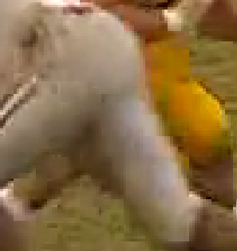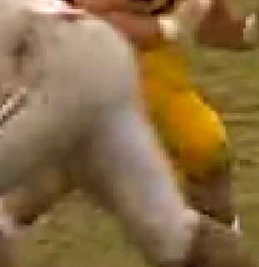

(a) (b)
Figure 13 Visual example of 7th frame of FOOTBALL CIF@15Hz:
(a) JSVM1 (b) JSVM1 with smoothed prediction.
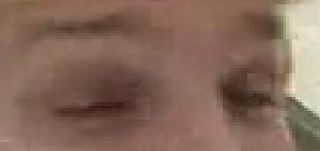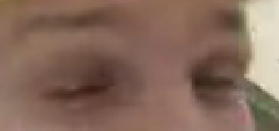

(a) (b)
Figure 14 Visual example of 36th frame of FOREMAN CIF@15Hz:
(a) JSVM1 (b) JSVM1 with smoothed prediction.
As shown in Figure 13 – 14, the proposed technique effectively eliminates the most blocking artifacts while maintaining the texture details. Although the similar effects may be obtained by the stronger deblocking filter, the main difference between two approaches is that the proposed method uses R-D optimization based selection before the motion compensation, whereas the deblocking process uses the symbol-based decision rules after the motion compensation. Since low-complexity decoding artifact is totally dependent on the degree of mismatch between the base-layer and current-layer residual signals, which are not available in the decoder-side, the encoder-side selection is more preferable to solve this issue.

Syntax, semantics, and decoding process changes

Syntax changes

New flag (smoothed_prediction_flag) is added into the macroblock syntax just after the residual prediction flag as the followings: (added area is marked yellow).

residual_in_scalable_extension( ) { | C | Descriptor
if( base_id_plus1 != 0 && adaptive_prediction_flag &&
MbPartPredType( mb_type, 0 ) != Intra_16x16 &&
MbPartPredType( mb_type, 0 ) != Intra_8x8 &&
MbPartPredType( mb_type, 0 ) != Intra_4x4 &&
MbPartPredType( mb_type, 0 ) != Intra_Base )
residual_prediction_flag | 3 | 4 | ae(v)
if( MbPartPredType( mb_type, 0 ) != Intra_16x16 &&
MbPartPredType( mb_type, 0 ) != Intra_8x8 &&
MbPartPredType( mb_type, 0 ) != Intra_4x4 &&
MbPartPredType( mb_type, 0 ) != Intra_Base )
smoothed_prediction_flag | 3 | 4 | ae(v)

For the CABAC context, we re-use the context model of the residual prediction flag. It should be noted that the smoothed_prediction_flag is encoded even in the base_id_plus1 == 0 or adaptive_prediction_flag == 0 for the macroblock adaptive selection for those cases.

Semantics changes

smoothed_prediction_flag specifies the parameter how to modify the inter-predicted prediction signal. If it has a value of zero, no additional processing is applied. Otherwise, 1:2:1 smoothing filter is applied to the 4x4 block edges of the inter-predicted signal.

Decoding process changes

When smoothed_prediction_flag has a value of zero, sub clause 8.4.2 shall apply. Otherwise, the inter-predicted prediction signal is smoothed by a 1:2:1 smoothing filter after applying sub clause 8.4.2.

Conclusion

New prediction mode, smoothed reference prediction, is proposed. The proposed mode can be considered as a hybrid between residual prediction and intra-base prediction. As a result, the proposed method is effective for sequences where the low-complexity decoding has a significant penalty.

References

- Heiko Schwarz, Detlev Marpe, and Thomas Wiegand, "Further results on constrained inter-layer prediction," 15th JVT meeting, JVT-O073, Busan, Korea.
- Julien Reichel, Heiko Schwarz, and Mathias Wien, "Joint Scalable Video Model JSVM-2," 15th JVT meeting, JVT-O202, Busan, Korea.
- Julien Reichel, Heiko Schwarz, and Mathias Wien, "Joint Scalable Video Model (JSVM) 1.0 Reference Encoding Algorithm Description," N6899, Hongkong, China.
- (Append for Proposal Documents)

JVT Patent Disclosure Form

International Telecommunication Union  Telecommunication Standardization Sector | International Organization for Standardization | International Electrotechnical Commission
 |  | 
Joint Video Coding Experts Group - Patent Disclosure Form
(Typically one per contribution and one per Standard | Recommendation)

Please send to:
JVT Rapporteur Gary Sullivan, Microsoft Corp., One Microsoft Way, Bldg. 9, Redmond WA 98052-6399, USA
Email (preferred): Gary.Sullivan@itu.int Fax: +1 425 706 7329 (+1 425 70MSFAX)

This form provides the ITU-T | ISO/IEC Joint Video Coding Experts Group (JVT) with information about the patent status of techniques used in or proposed for incorporation in a Recommendation | Standard. JVT requires that all technical contributions be accompanied with this form. Anyone with knowledge of any patent affecting the use of JVT work, of their own or of any other entity (“third parties”), is strongly encouraged to submit this form as well.

This information will be maintained in a “living list” by JVT during the progress of their work, on a best effort basis. If a given technical proposal is not incorporated in a Recommendation | Standard, the relevant patent information will be removed from the “living list”. The intent is that the JVT experts should know in advance of any patent issues with particular proposals or techniques, so that these may be addressed well before final approval.

This is not a binding legal document; it is provided to JVT for information only, on a best effort, good faith basis. Please submit corrected or updated forms if your knowledge or situation changes.

This form is not a substitute for the ITU ISO IEC Patent Statement and Licensing Declaration, which should be submitted by Patent Holders to the ITU TSB Director and ISO Secretary General before final approval.

Submitting Organization or Person:
Organization name | Samsung Electronics
Mailing address | 416, Maetan 3-dong, Paldal-gu, Suwon-si, Gyeonggi-do, 442-742
Country | Korea
Contact person | Woo-Jin Han
Telephone | +82-31-200-9319
Fax | +82-31-200-3427
Email | wjhan.han@samsung.com
Place and date of submission
Relevant Recommendation | Standard and, if applicable, Contribution:
Name (ex: “JVT”) |  | JVT
Title |  | Smoothed reference prediction for single-loop decoding
Contribution number

(Form continues on next page)

Disclosure information – Submitting Organization/Person (choose one box)
2.0 The submitter is not aware of having any granted, pending, or planned patents associated with the technical content of the Recommendation | Standard or Contribution.

or,
The submitter (Patent Holder) has granted, pending, or planned patents associated with the technical content of the Recommendation | Standard or Contribution. In which case,

 | 2.1 The Patent Holder is prepared to grant – on the basis of reciprocity for the above Recommendation | Standard – a free license to an unrestricted number of applicants on a worldwide, non-discriminatory basis to manufacture, use and/or sell implementations of the above Recommendation | Standard.
 | 2.2 The Patent Holder is prepared to grant – on the basis of reciprocity for the above Recommendation | Standard – a license to an unrestricted number of applicants on a worldwide, non-discriminatory basis and on reasonable terms and conditions to manufacture, use and/ or sell implementations of the above Recommendation | Standard.  Such negotiations are left to the parties concerned and are performed outside the ITU | ISO/IEC.
 | 2.2.1 The same as box 2.2 above, but in addition the Patent Holder is prepared to grant a “royalty-free” license to anyone on condition that all other patent holders do the same.
2.3 The Patent Holder is unwilling to grant licenses according to the provisions of either 2.1, 2.2, or 2.2.1 above. In this case, the following information must be provided as part of this declaration:
- patent registration/application number;
- an indication of which portions of the Recommendation | Standard are affected.
- a description of the patent claims covering the Recommendation | Standard;
In the case of any box other than 2.0 above, please provide the following:
Patent number(s)/status
Inventor(s)/Assignee(s)
Relevance to JVT
Any other remarks:
(please provide attachments if more space is needed)

(form continues on next page)
Third party patent information – fill in based on your best knowledge of relevant patents granted, pending, or planned by other people or by organizations other than your own.

Disclosure information – Third Party Patents (choose one box)
3.1 The submitter is not aware of any granted, pending, or planned patents held by third parties associated with the technical content of the Recommendation | Standard or Contribution.

3.2 The submitter believes third parties may have granted, pending, or planned patents associated with the technical content of the Recommendation | Standard or Contribution.

For box 3.2, please provide as much information as is known (provide attachments if more space needed) - JVT will attempt to contact third parties to obtain more information:

3rd party name(s)
Mailing address
Country
Contact person
Telephone
Fax
Email
Patent number/status
Inventor/Assignee
Relevance to JVT

Any other comments or remarks:

