Joint Video Team (JVT) of ISO/IEC MPEG & ITU-T VCEG  (ISO/IEC JTC1/SC29/WG11 and ITU-T SG16 Q.6)  16th Meeting: Poznań, PL, 24-29 July, 2005 | Document: JVT-P080  Filename: input.doc

Title: | Flag bit in Scalable Information SEI for adaptive GOP structure
Status: | Input Document to JVT
Purpose: | Information & Proposal
Author(s) or  Contact(s): | Seyoon Jeong*, Min Woo Park,  Gwang Hoon Park**, Kyuheon Kim  *ETRI, 161 Gajeong-dong Yusung-gu  Daejeon, Korea.  **Kyung Hee University. 1, Seochun, Kiheung  Youngin, Kyunggi, Korea. | Tel:  Email: | +82 (42) 860-5724  jsy@etri.re.kr  parkmw@khu.ac.kr
Source: | ETRI*, Kyung Hee University**
_____________________________

ABSTRACT

Adaptive GOP Structure was adopted into JSVM as non-normative because it dose not require any modification for the decoder. It is claimed that it requires a modification on the extractor. In order to use Adaptive GOP structure in JSVM, the information whether Adaptive GOP Structure is used or not is required. Therefore, a flag bit in Scalable Information is proposed in order to notify whether Adaptive GOP Structure is used or not to the extractor. This flag bit is added into Scalable Information SEI, because it used only at the extractor.

1. Introduction

Adaptive GOP Structure (AGS) [1] was adopted into JSVM 2.0 as non-normative part of JSVM.
AGS needs a difference method for temporal scalability in the extractor. AGS affects temporal scalability extraction; therefore, the information whether Adaptive GOP Structure is used or not should be transmitted to the extractor. Thus, we propose a flag bit in Scalable Information SEI.

2. The related history with Adaptive GOP Structure in JSVM S/W

The extraction scheme for AGS has been changed as SVC reference S/W upgraded. This section describes the extraction scheme for AGS for SVM 3.0 S/W and JSVM S/W. In the following section, Section 3, the syntax and semantics of proposed method are presented.

AGS was proposed at the 71st MPEG meeting, and the reference software used at that time was SVM 3.0 S/W. [3] Even though AGS requires a new extraction algorithm to support full temporal scalability, it possesses 100% compatibility with the decoder. Therefore, it was classified as non-normative tool.
In the 71st MPEG meeting, the standardization of SVC became JVT. JSVM 0 and JSVM 1 were released after the 71st Meeting. JSVM 0 and JSVM 1 S/W are on the basis of “Proposed SVM 3.0 software Update” [4]. The transition from SVM 3.0 S/W to JSVM S/W affects the ordering method of ‘temporal_level’ of NAL unit header for AGS.

In SVM 3.0 S/W, ‘temporal_level’ value increases according to its temporal level as illustrated in Figure 1. The figure shows an example of ’temporal_level’ when GOP size is 16.

For temporal scalability with 1/2k (where k=1,…,N and the size of GOP is 2N), the extractor of SVM 3.0 drops pictures whose ‘temporal_level’ ≤k. Figure 2 shows an example of ‘temporal_level’ when the size of GOP is 16 and AGS is used. If AGS is used, the temporal scalability is supported up to 1/2l (where l=1..N-3). As illustrated in Figure 2, the extractor of SVM 3.0 can successfully process without any modification even if AGS is used.

In JSVM 0.0 S/W, the ordering method of ‘temporal_level’ became descending order as illustrated in Figure 3. Thus, the extracting method was changed as following.
Extractor of JSVM S/W drops pictures whose ‘temproal_level’ ≥N-k+1 in order to provide temporal scalability with 1/2k (where k=1,…,N and the size of GOP is 2N). N is recoded in ‘max_decomposition_stage’ of Scalable Information SEI.

Figure 4 shows temporal_level when AGS is used in JSVM. In this case, the existing extractor cannot extract properly; therefore, a new extracting method is required. However, the existing method can be used if “temporal_level” is modified to temporal_level_AGS_TS as shown in Figure 5.
If AGS is used, the extractor uses temporal_level_AGS _TS instead of temporal_level.
The temporal_level_AGS_TS is derived as following.
- Calculate “d” of current slice. d is a difference between α and “decomposition_stages” in the current slice header.
d = α- decomposition_stages
where, α= max_decompostion_stage – temporal_resolution_factor[depency_id]
- Calculate temporal_level_AGS_TS
temporal_level_AGS_TS = temporal_level +d

Also, d is always ‘0’ when AGS is not used. Thus this method can be applied whether AGS is used or not.

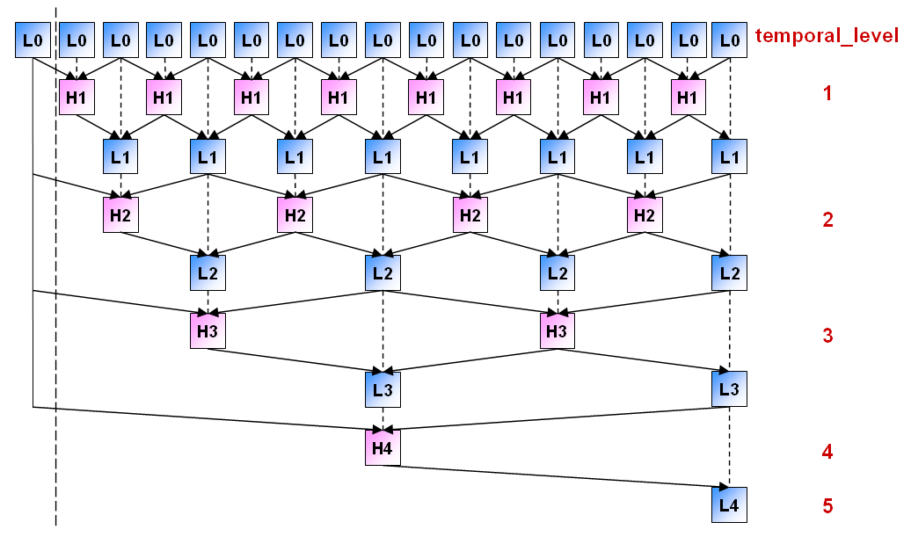
Figure 1. “temporal_level” of GOP size 16 for SVM 3.0

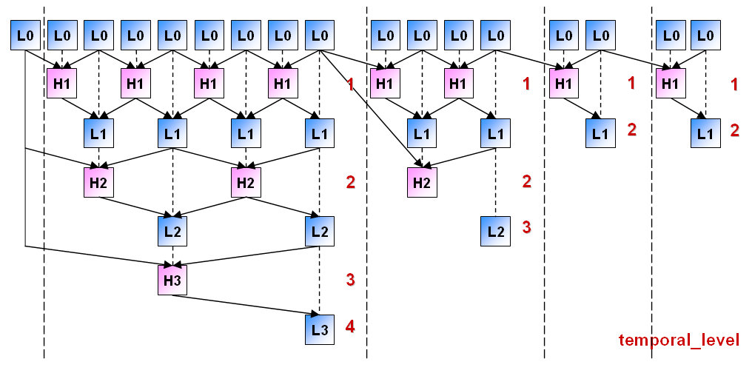
Figure 2. “temporal_level” of GOP size 16 for SVM 3.0 using AGS with sub-GOP [8,4,2,2]

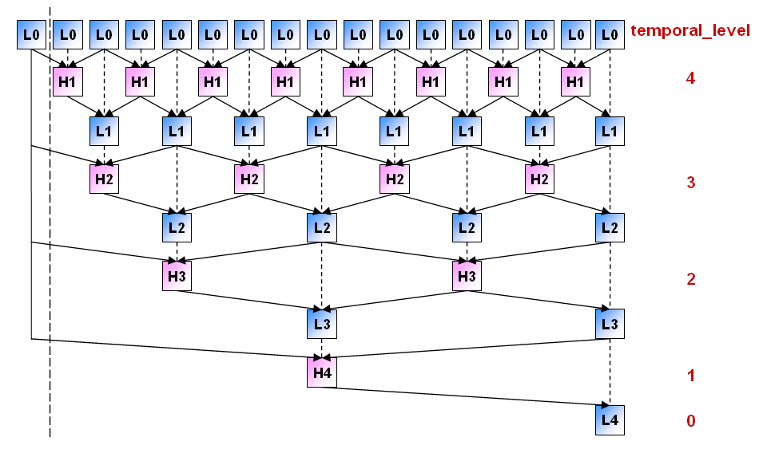

Figure 3. “temporal_level” of GOP size 16 for JSVM

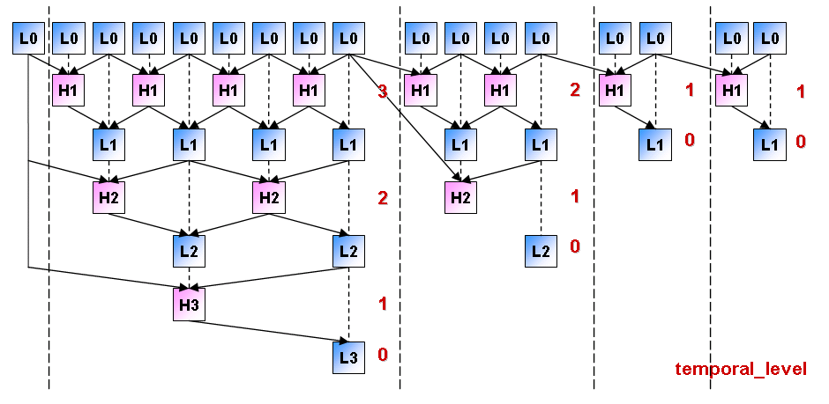
Figure 4. “temporal_level” of GOP size 16 for JSVM using AGS with sub-GOP [8,4,2,2]

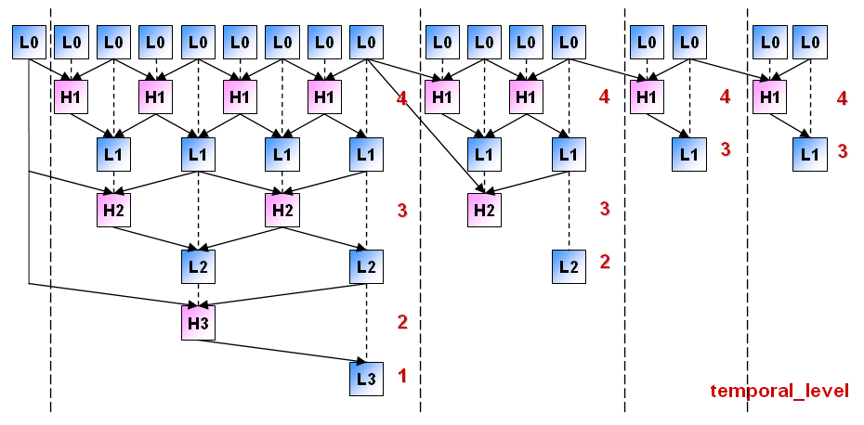
Figure 5. modified “temporal_level” (= temporal_level_AGS_TS)

3. Flag bit for SI SEI for Adaptive GOP Structure

3.1 High level Syntax
High level Syntax was proposed in order to reduce complexity and effective transmission in Busan Meeting. Scalability Information SEI message might have all information for extractor to notify the scalability range of encoded bit stream.
Current JSVM has not information for scalability range for AGS in Scalability Information SEI message. If temporal scalability is not required under 7.5Hz, the extractor can work normally without information for scalability range for AGS. However, JSVM is designed to support under 7.5Hz. In this situation, the information for AGS is needed.

3.2 Sub-GOP Level
Sub-GOP Level k means that AGS used k sub-GOP size ( 2^{N},2^{N-1},…, 2^{N-k+1})
Temporal Scalability range of encoded bitstream by using AGS can be known by sub-GOP level because it is related to the smallest sub-GOP size in Sub-GOP Level. Table 1 illustrates the scalability range when AGS is used.

Table 1. the scalability range
Sub-GOP Level | Sub-GOP types | Scalability Range
4 | 2^{N}, 2^{N-1}, 2^{N-2},2^{N-3} | 1/2^{N-3} = 7.5Hz
3 | 2^{N}, 2^{N-1}, 2^{N-2} | 1/2^{N-2 =} 3.75 Hz
2 | 2^{N}, 2^{N-1} | 1/2^{N-4} = 1.875Hz

3.3 Modification of syntax from JSVM 2.0

Syntax of Scalability Information SEI message
scalability_information( payloadSize ) { | C | Descriptor
max_mb_number_in_row | 5 | ue(v)
max_mb_number_in_column | 5 | ue(v)
frame_rate_unit_nominator | 5 | ue(v)
frame_rate_unit_denominator | 5 | ue(v)
max_decomposition_stages | 5 | ue(v)
num_spatial_layers | 5 | ue(v)
avc_base_layer_flag | 5 | u(1)
if( avc_base_layer_flag ) {
base_layer_decomposition_stages | 5 | ue(v)
}
use_adaptive_gop_structure_flag | 5 | u(1)
if( use_adaptive_gop_structure_flag) {
sub_gop_level | 5 | ue(v)
}
non_dyadic_spatial_scalability_flag | 5 | u(1)
for( i = 0; i < num_spatial_layers; i++ ) {
if( extended_spatial_scalability_flag) {
frame_width_in_mbs_minus1[ i ] | 5 | ue(v)
frame_height_in_mbs_minus1[ i ] | 5 | ue(v)
}
else
spatial_resolution_factor[ i ] | 5 | ue(v)
temporal_resolution_factor[ i ] | 5 | ue(v)
}
}

3.4 Modification of semantics from JSVM 2.0

use_adaptive_gop_structure_flag indicates whether AGS is used or not.
sub_gop_level specifies sub gop level of Adaptive GOP Structure. This syntax element is used to notice extractor the temporal scalability range of Adaptive GOP Structure.
Value | Sub GOP level | Range of Temporal Scalability
0 | 4 | 7.5Hz
1 | 3 | 3.75Hz
2 | 2 | 1.875Hz

4. Conclusion

In this document, we propose possible method for adaptation JSVM for AGS. Also syntax and semantics for AGS in Scalability Information SEI is proposed in order to keep consistency of the JSVC architecture and complexity reduce in High level syntax.

References

[1] “Improve SVC Coding Efficiency by Adaptive GOP Structure (SVC CE2)” G. Park, M. Park, S. Jeong, K. Kim and J. Hong, JVT-O018, April 2005, Busan, Korea
[2] “Adaptive GOP Structure for SVC”, G. Park, M. Park, S. Jeong, K. Kim and J. Hong, ISO/IEC JTC1/SC29/WG11 M11563, January 2005, Hong Kong, China.
[3] “SVM 3.0 Software”, ISO/IEC JTC1/SC29/WG11 N6717, October 2004, Palma de Mallorca, Spain.
[4] “Scalable Video Model Version 3.0”, J. Reichel, M. Wien, H. Schwarz, ISO/IEC JTC 1/SC 29/WG 11 N6716, October 2004, Palma de Mallorca, Spain.
[5] “Proposed SVM 3.0 Software Update”, H. Schwarz, ISO/IEC JTC1/SC29/WG11 M11740, January 2005, Hong Kong, China.
[6] “JSVM 0.0 Software”, JVT-N022, January 2005, Hong King, China.
[7] “Scalability information SEI for SVC”, JVT-O012, April 2005, Busan, Korea

(Append for Proposal Documents)

JVT Patent Disclosure Form

International Telecommunication Union  Telecommunication Standardization Sector | International Organization for Standardization | International Electrotechnical Commission
 |  | 
Joint Video Coding Experts Group - Patent Disclosure Form
(Typically one per contribution and one per Standard | Recommendation)

Please send to:
JVT Rapporteur Gary Sullivan, Microsoft Corp., One Microsoft Way, Bldg. 9, Redmond WA 98052-6399, USA
Email (preferred): Gary.Sullivan@itu.int Fax: +1 425 706 7329 (+1 425 70MSFAX)

This form provides the ITU-T | ISO/IEC Joint Video Coding Experts Group (JVT) with information about the patent status of techniques used in or proposed for incorporation in a Recommendation | Standard. JVT requires that all technical contributions be accompanied with this form. Anyone with knowledge of any patent affecting the use of JVT work, of their own or of any other entity (“third parties”), is strongly encouraged to submit this form as well.

This information will be maintained in a “living list” by JVT during the progress of their work, on a best effort basis. If a given technical proposal is not incorporated in a Recommendation | Standard, the relevant patent information will be removed from the “living list”. The intent is that the JVT experts should know in advance of any patent issues with particular proposals or techniques, so that these may be addressed well before final approval.

This is not a binding legal document; it is provided to JVT for information only, on a best effort, good faith basis. Please submit corrected or updated forms if your knowledge or situation changes.

This form is not a substitute for the ITU ISO IEC Patent Statement and Licensing Declaration, which should be submitted by Patent Holders to the ITU TSB Director and ISO Secretary General before final approval.

Submitting Organization or Person:
Organization name | ETRI* & Kyung Hee University**
Mailing address | 161 Gajeong-Dong Yusoung-Gu Daejeon*  1, Seochun, Kiheung, Youngin, Kyunggi**
Country | Republic of Korea
Contact person | Seyoon Jeong*
Telephone | +82-42-860-5724
Fax | +82-42-860-5724
Email | jsy@etri.re.kr
Place and date of submission | Busan, Korea (April 2005)
Relevant Recommendation | Standard and, if applicable, Contribution:
Name (ex: “JVT”) |  | JSVC
Title |  | Improve SVC Coding Efficiency by Adaptive GOP Structure (SVC CE2)
Contribution number |  | JVT-O018

(Form continues on next page)

Disclosure information – Submitting Organization/Person (choose one box)
2.0 The submitter is not aware of having any granted, pending, or planned patents associated with the technical content of the Recommendation | Standard or Contribution.

or,
The submitter (Patent Holder) has granted, pending, or planned patents associated with the technical content of the Recommendation | Standard or Contribution. In which case,

 | 2.1 The Patent Holder is prepared to grant – on the basis of reciprocity for the above Recommendation | Standard – a free license to an unrestricted number of applicants on a worldwide, non-discriminatory basis to manufacture, use and/or sell implementations of the above Recommendation | Standard.
2.2 The Patent Holder is prepared to grant – on the basis of reciprocity for the above Recommendation | Standard – a license to an unrestricted number of applicants on a worldwide, non-discriminatory basis and on reasonable terms and conditions to manufacture, use and/ or sell implementations of the above Recommendation | Standard.

Such negotiations are left to the parties concerned and are performed outside the ITU | ISO/IEC.
 | 2.2.1 The same as box 2.2 above, but in addition the Patent Holder is prepared to grant a “royalty-free” license to anyone on condition that all other patent holders do the same.
2.3 The Patent Holder is unwilling to grant licenses according to the provisions of either 2.1, 2.2, or 2.2.1 above. In this case, the following information must be provided as part of this declaration:
- patent registration/application number;
- an indication of which portions of the Recommendation | Standard are affected.
- a description of the patent claims covering the Recommendation | Standard;
In the case of any box other than 2.0 above, please provide the following:
Patent number(s)/status |  | In processing
Inventor(s)/Assignee(s) |  | Gwang Hoon Park**, Min Woo Park**, Seyoon Jeong*, Kyuheon Kim*, Jinwoo Hong*/ETRI & Kyung Hee University
Relevance to JVT
Any other remarks:
(please provide attachments if more space is needed)

(form continues on next page)
Third party patent information – fill in based on your best knowledge of relevant patents granted, pending, or planned by other people or by organizations other than your own.

Disclosure information – Third Party Patents (choose one box)
3.1 The submitter is not aware of any granted, pending, or planned patents held by third parties associated with the technical content of the Recommendation | Standard or Contribution.

3.2 The submitter believes third parties may have granted, pending, or planned patents associated with the technical content of the Recommendation | Standard or Contribution.

For box 3.2, please provide as much information as is known (provide attachments if more space needed) - JVT will attempt to contact third parties to obtain more information:

3rd party name(s)
Mailing address
Country
Contact person
Telephone
Fax
Email
Patent number/status
Inventor/Assignee
Relevance to JVT

Any other comments or remarks:

