Joint Video Team (JVT) of ISO/IEC MPEG & ITU-T VCEG  (ISO/IEC JTC1/SC29/WG11 and ITU-T SG16 Q.6)  15th Meeting: Busan, KR, 16-22 April, 2005 | Document: JVT-O067  Filename: input.doc  NOTE – That first character after the dash up there in the document number is an "O", not a zero.

Title: | Improved deblocking filter for open-loop MCTF in the JSVM
Status: | Input Document to JVT
Purpose: | Proposal
Author(s) or  Contact(s): | Konstantin Hanke, Steffen Kamp, Thomas Rusert, Mathias Wien  RWTH Aachen University  Melatener Str. 23  52074 Aachen, Germany | Tel:  Email: | +49 241 8027678  hanke@ient.rwth-aachen.de
Source: | RWTH Aachen University
_____________________________

Introduction
JSVM 1.0 employs the AVC deblocking filter [1] which is highly optimized for closed-loop predictive coding. Regarding its new application in open-loop motion-compensated temporal filtering (MCTF), our observations have shown a suboptimal deblocking effect. In this document, we first give an overview of the JSVM deblocking and our observations. Then we propose a correction of the boundary strength (Bs) decision for non-zero coded residuals in inter-spatial prediction, and finally we introduce a frame- or blockwise adjustment of the JSVM deblocking filter when applied in the inverse MCTF process at the decoder side. In this case, due to the encoder-decoder mismatch of the reference frames that is inherent to open-loop MCTF, additional quantization noise is introduced to the frame being deblocked. We therefore propose offsets to the alpha, beta, and clipping thresholds that are derived from the quantization parameter (QP) values of the neighboring frames used for temporal prediction.

Overview and observations
In the JSVM, the AVC deblocking filter serves various applications [3]: for inter-layer intra texture prediction, for in-loop predictive coding of the lowpass frames on the coarsest temporal decomposition stage and for the open-loop inverse MCTF (see Fig. 1).
During our tests, we found out that the decoded lowpass frames of the coarsest temporal level (“anchor frames”) are nearly artifact-free, while frames reconstructed during the inverse MCTF show significant blocking artifacts, especially for the test sequences Foreman and Crew. Thus, we assume that blocking artifacts are mainly introduced during the inverse temporal prediction step, while the deblocking filter yields a good performance with regard to its default closed-loop application, i.e. the predictive coding of the anchor frames.
gives a visual example of this effect for the highest rate point of Foreman. While the frames reconstructed at time indices t = 0 and t = 32 correspond to the temporal positions of the anchor frames (L_{t} and L_{t+2} in Fig. 1), frame 16 is located at the highpass position of the first inverse temporal prediction step (H_{t+1} in Fig. 1). It can be seen that the anchor frames of this example do not show blocking artifacts in contrast to frames located at temporal highpass positions.
Going into more detail, we further observed that the blocking artifacts occur at inter macroblocks (MB) boundaries, while the deblocking filter works well in case of intra MBs.

Fig. 1: Different applications of the AVC deblocking filter in JSVM 1.0.
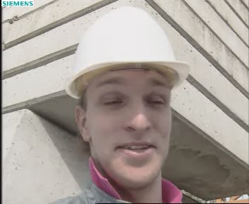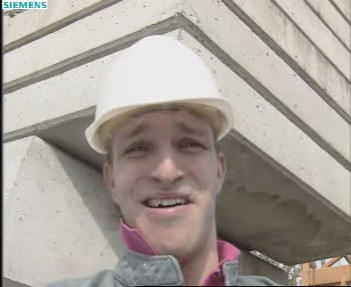
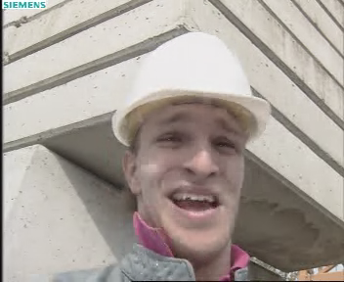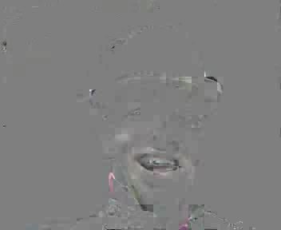

Fig. 2: Visual example of Foreman (CIF 30Hz, 256kbps, 5 temporal levels): Reconstructed Frames 0, 32 (top), frame 16 and its corresponding decoded highpass (bottom).
Therefore, we assume that the AVC deblocking filter only needs adjustment of the filter conditions that are related to inter MBs. These conditions are [1]:

- one of the blocks at the current block boundary has non-zero coded residuals in the temporal highpass frame (if true, then Bs = 2),
- the difference between the motion vectors of two adjacent blocks is higher than one integer pixel (if true, then Bs = 1),
- the MCTF process of two adjacent blocks is done using different reference frames for temporal prediction (if true, then Bs = 1).

Following this assumption, in the next section we correct a bug in the JSVM 1.0 software occurring in connection with the first filter condition for Bs = 2. Since even in spite of this bug-fix the deblocking effect is not sufficient, section 4 presents a frame- and blockwise approach to increase the filter strength in order to consider the impact of the quantization distortion of the reference frames in open-loop MCTF.

Correction of boundary strength decision
As also illustrated in (bottom), we can see a correspondence between high-variant coded residuals in the temporal highpass frame and blocking artifacts in the reconstruction. A second example is shown in Fig. 3 for Crew, where in addition to the reconstructed frames the boundary strength decision of the filter is visualized for default decoding and for the corrected Bs = 2 decision, respectively. Here, the black areas indicate block edges where Bs = 0 is applied and the filter is switched off independent from the following alpha / beta thresholds. A comparison between the depicted highpass frame and the Bs frames leads to the conclusion that in the current JSVM the filter is often not activated for blocks that have non-zero residuals.
This suspected bug is related to the currently in the JSVM implemented filter inquiry which is based on the coded block pattern (CBP). We found out that the filter only applies Bs = 2 if the highpass CBP of the current spatial layer is set, while the CBP of the spatial base layer does not have any impact on the filter decision. However, these blocks may contain non-zero values when applying a residual inter-layer texture prediction.
In order to remove this bug, the inquiry can be modified by testing of the temporal highpass frame for non-zero residuals. Therefore, we propose the following changes:

In subclause 8.7.2.1 of AVC the paragraph
- Otherwise, if the following condition is true, a value of bS equal to 2 shall be the output:
- the luma block containing sample p₀ or the luma block containing sample q₀ contains non-zero transform coefficient levels

shall be replaced with:
- Otherwise, if the following condition is true, a value of bS equal to 2 shall be the output:
- the luma block containing sample p₀ or the luma block containing sample q₀ contains non-zero transform coefficient levels, or nal_unit_type is equal to 20 and residual_prediction_flag is equal to 1 for the luma block containing sample p0 or the luma block containing sample q0 and the corresponding base layer macroblock contains non-zero transform coefficient levels.

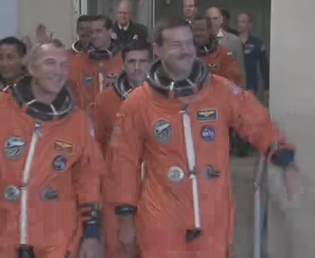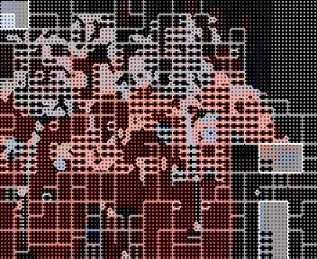
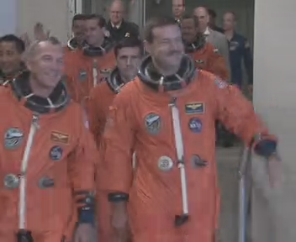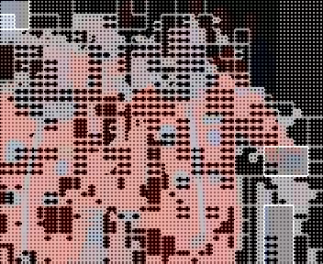
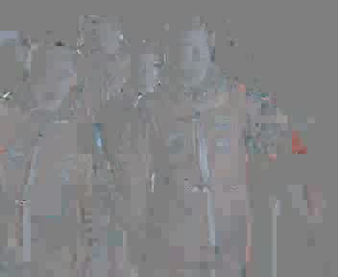

Fig. 3: Visual example for Crew (CIF 30Hz, 512kbps): Frame 174 and corresponding Bs decision (black: Bs=0, non-filtered edges) coded by default JSVM (top), after correction of the filter decision for blocks with non-zero residuals (middle), highpass frame at location 174 (bottom).

Proposed changes to deblocking filter in open-loop MCTF

Fig. 4: Impact of the additional quantization noise of the reference frames in open-loop MCTF.
In predictive closed-loop coding the quantization noise is not propagated from one en-/decoded frame to the other. Since the decoding process is integrated to the encoder-loop, we use the same reference frames as predictors at both the encoder and decoder side and do not have to consider the impact of the predictor quantization itself.
In contrast to the closed-loop application, the propagation of the quantization noise must be regarded in open-loop MCTF if we want to suitably choose the alpha / beta and clipping (C0) thresholds. As described in [2], these thresholds have been found by subjective evaluation, but are clearly related to the maximum quantization distortion that might occur at block boundaries in the reconstruction. Therefore, the threshold tables have a direct connection to the applied quantization step size and are also doubled every 6 QP.
depicts the influence of quantization noise to the reconstruction according to the applied temporal filter weights. In the figure, the case of bi-directional prediction is shown. For the uni-directional case, our model performs a boundary extension and doubles the respective filter weight. Assuming equal quantization noise of and in the spatially reconstructed frames L_{t} and H_{t}, it can be seen that the lowpass noise is introduced to the reference frames A_{t} during the inverse temporal update step and then further propagated into the reconstructed frames B_{t} that get deblocked. Due to the use of the adaptive update step which locally disables or reduces the impact of the update for many cases, and in order to simplify our model, we neglect the feedback of the highpass quantization noise to B_{t} via the reference frames A_{t}. Thus, our model implies that we have to consider three different quantization errors to determine the total maximum distortion and to suitably adjust the deblocking filter thresholds, i.e. the quantization errors of the two predictor frames and the distortion of the corresponding highpass frame.
Based on the described model, we propose two different modifications to the JSVM deblocking filter for its application in the inverse MCTF process: a frame-wise and a block-wise approach. Since only inter MBs are problematic with respect to the increased quantization noise, these modifications are only applied if the deblocking filter has chosen Bs = 2 or Bs = 1 according to the three filter conditions mentioned above.
For both the frame-wise and the block-wise approach, we first determine the slice or MB QPs (iQpA0 and iQpA1) of the respective reference frames or blocks in A_{t}. Then these QP values must be associated with the QP value of the current MB to adjust the thresholds. Since the threshold tables have a direct connection to the maximum quantization noise, it is intuitive to use the given tables to estimate the influence of the additional predictor quantization.
Therefore, we calculate the frame- or block-wise offset for the different deblocking thresholds by:

During the filtering of one respective block boundary, these offsets are added to the absolute determined thresholds and clipped to the maximum value of the corresponding table:

Following our model, the quantization error of the two reference frames is considered with the multipliers (1/2, 1/2) in the bi-directional case, while in case of uni-directional connection, we use the factors (1, 0) or (0, 1).
Regarding the two proposed methods, the block-wise approach is much more complex than the frame-wise adaptation, since for each decoded block the corresponding QPs of the reference blocks and its new thresholds must be determined.

Experimental results
For our simulations, the complete test set was encoded once applying the current JSVM 1.0 in default configuration, and decoded with all presented methods: a) the default decoder, b) with the corrected Bs = 2 decision, c) performing a frame-wise, and d) a block-wise offset of the threshold tables.

 |  | Y-PSNR difference to default case
 |  | Corrected Bs | Frame Offset | Block Offset
BUS | max. gain | 0,0136 | 0,0445 | 0,0492
 | max. loss | -1E-04 | -0,0246 | -0,0232
FOOTBALL | max. gain | 0,0246 | 0,0569 | 0,0563
 | max. loss | 0 | -0,0076 | -0,0047
FOREMAN | max. gain | 0,0286 | 0,0497 | 0,048
 | max. loss | -1E-04 | -0,049 | -0,0462
MOBILE | max. gain | 0,008 | 0,0174 | 0,0147
 | max. loss | 0 | -0,014 | -0,0141
CITY | max. gain | 0,0042 | 0 | 0
 | max. loss | -0,0023 | -0,1929 | -0,1979
CREW | max. gain | 0,0287 | 0,0341 | 0,032
 | max. loss | -0,0003 | -0,0603 | -0,0651
HARBOUR | max. gain | 0,0128 | 0 | 0
 | max. loss | -0,0037 | -0,199 | -0,1976
SOCCER | max. gain | 0,0275 | 0,0547 | 0,0557
 | max. loss | 0 | -0,048 | -0,0492
Tab. 1: Maximum gain and loss for the different test sequences and methods.

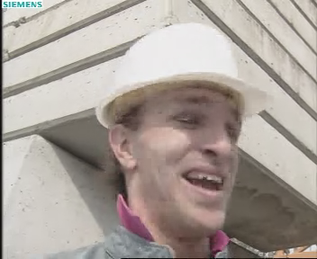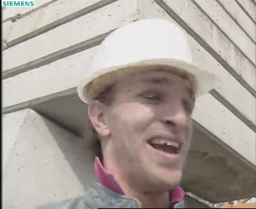
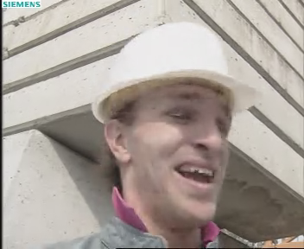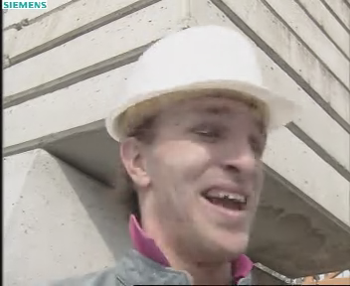

Fig. 5: Visual comparison for Foreman (CIF 30Hz, 256kbps, frame 12): Default (top left), corrected Bs decision (top right), frame-based (bottom left) and block-based threshold offset (bottom right).

In Tab. 1, the PSNR performance of the different tested methods is compared to the default case presenting only the maximum gain and loss with respect to all target rate points. For a detailed comparison, all PSNR results are given in the attached excel sheets of this document (see Annex A).
From the table, it can be derived that the overall coding performance is nearly identical for all sequences and all methods with exception of few target rate points of City and Harbour where a small loss of ~0.2 dB can be observed in case of the frame- or block-wise offset.
A comparison of the visual coding performance is shown in Fig. 5 for Foreman. It can be seen that the visual quality can be significantly increase when the proposed correction of the Bs decision is applied, but the deblocking effect is not sufficient to remove all block artifacts of the scene. A further reduction of the occurring artifacts can be achieved by the introduction of the frame- or block-wise threshold offsets (Fig. 5 bottom) whose results are nearly identical.
Altogether, the corrected Bs condition yields a better visual performance for most of the sequences compared to the default case (for Bus, Football, Foreman, Crew, and Soccer), but at least the results are visually identical (for Mobile, City, and Harbour).
In spite of the Bs correction, the reconstruction still contains visible blocking artifacts. By the introduction of threshold offsets an additional slight improvement of the visual quality can be achieved mainly observed for the sequences Foreman, Football and Crew.

Conclusion
In this document, we have proposed three different modifications of the JSVM deblocking filter applied during the inverse MCTF process at the decoder side. The first one corrects the boundary strength decision for non-zero residuals in the temporal highpass frame yielding a significantly better or identical visual quality compared to default decoding, and an almost identical PSNR performance.
Based on a simplified propagation model of the quantization noise in open-loop MCTF, the two other approaches are presented that try to consider the impact of the additional quantization of the reference frames. The two methods frame- and block-wisely introduce offsets to the given alpha, beta and clipping thresholds of the filter in order to increase the deblocking effect. For these modifications, a slight improvement of visual quality can be achieved for the sequences Foreman, Football and Crew.
However, the results show that deblocking filter needs a further fine tuning of the employed threshold tables with regard to its application in open-loop MCTF. Thus, we suggest to initiate a core experiment relating to this topic.

References
- P. List, A. Joch, J. Lainema, G. Bjontegaard, M. Karczewicz, “Adaptive Deblocking Filter”, IEEE Trans. Circuits and Systems for Video Technology, vol. 13, pp. 614 – 619, July 2003.
- G. Sullivan, T. Wiegand, D. Marpe, A. Luthra, "Text of ISO/IEC 14496 10 Advanced Video Coding 3rd Edition", document MPEG-N6540, Redmond, WA, USA, July 2004.
- J. Reichel, H. Schwarz, M. Wien, “Scalable Video Coding - Working Draft 1”, document JVT-N020, Joint Video Team (JVT) of ISO/IEC MPEG & ITU-T VCEG, Hong Kong, CN, 17 –21 January, 2005.
- A. Joch, “Improved Loop-Filter Tables and Variable-Shift Table Indexing”, document JVT-D038, Joint Video Team (JVT) of ISO/IEC MPEG & ITU-T VCEG, Klagenfurt, Austria, 22 –26 July, 2002.

Annex A – PSNR results

(Append for Proposal Documents)

JVT Patent Disclosure Form

International Telecommunication Union  Telecommunication Standardization Sector | International Organization for Standardization | International Electrotechnical Commission
 |  | 
Joint Video Coding Experts Group - Patent Disclosure Form
(Typically one per contribution and one per Standard | Recommendation)

Please send to:
JVT Rapporteur Gary Sullivan, Microsoft Corp., One Microsoft Way, Bldg. 9, Redmond WA 98052-6399, USA
Email (preferred): Gary.Sullivan@itu.int Fax: +1 425 706 7329 (+1 425 70MSFAX)

This form provides the ITU-T | ISO/IEC Joint Video Coding Experts Group (JVT) with information about the patent status of techniques used in or proposed for incorporation in a Recommendation | Standard. JVT requires that all technical contributions be accompanied with this form. Anyone with knowledge of any patent affecting the use of JVT work, of their own or of any other entity (“third parties”), is strongly encouraged to submit this form as well.

This information will be maintained in a “living list” by JVT during the progress of their work, on a best effort basis. If a given technical proposal is not incorporated in a Recommendation | Standard, the relevant patent information will be removed from the “living list”. The intent is that the JVT experts should know in advance of any patent issues with particular proposals or techniques, so that these may be addressed well before final approval.

This is not a binding legal document; it is provided to JVT for information only, on a best effort, good faith basis. Please submit corrected or updated forms if your knowledge or situation changes.

This form is not a substitute for the ITU ISO IEC Patent Statement and Licensing Declaration, which should be submitted by Patent Holders to the ITU TSB Director and ISO Secretary General before final approval.

Submitting Organization or Person:
Organization name | RWTH Aachen University
Mailing address | Melatener Str. 23  52074 Aachen
Country | Germany
Contact person | Konstantin Hanke
Telephone | +49 241 8027678
Fax | +49 241 8022196
Email | hanke@ient.rwth-aachen.de
Place and date of submission | Aachen, 2005-04-13
Relevant Recommendation | Standard and, if applicable, Contribution:
Name (ex: “JVT”) |  | JVT
Title |  | Improved deblocking filter for open-loop MCTF in the JSVM
Contribution number |  | JVT-O067

(Form continues on next page)

Disclosure information – Submitting Organization/Person (choose one box)
x | 2.0 The submitter is not aware of having any granted, pending, or planned patents associated with the technical content of the Recommendation | Standard or Contribution.  or,
The submitter (Patent Holder) has granted, pending, or planned patents associated with the technical content of the Recommendation | Standard or Contribution. In which case,

 | 2.1 The Patent Holder is prepared to grant – on the basis of reciprocity for the above Recommendation | Standard – a free license to an unrestricted number of applicants on a worldwide, non-discriminatory basis to manufacture, use and/or sell implementations of the above Recommendation | Standard.
2.2 The Patent Holder is prepared to grant – on the basis of reciprocity for the above Recommendation | Standard – a license to an unrestricted number of applicants on a worldwide, non-discriminatory basis and on reasonable terms and conditions to manufacture, use and/ or sell implementations of the above Recommendation | Standard.

Such negotiations are left to the parties concerned and are performed outside the ITU | ISO/IEC.
 | 2.2.1 The same as box 2.2 above, but in addition the Patent Holder is prepared to grant a “royalty-free” license to anyone on condition that all other patent holders do the same.
2.3 The Patent Holder is unwilling to grant licenses according to the provisions of either 2.1, 2.2, or 2.2.1 above. In this case, the following information must be provided as part of this declaration:
- patent registration/application number;
- an indication of which portions of the Recommendation | Standard are affected.
- a description of the patent claims covering the Recommendation | Standard;
In the case of any box other than 2.0 above, please provide the following:
Patent number(s)/status
Inventor(s)/Assignee(s)
Relevance to JVT
Any other remarks:
(please provide attachments if more space is needed)

(form continues on next page)
Third party patent information – fill in based on your best knowledge of relevant patents granted, pending, or planned by other people or by organizations other than your own.

Disclosure information – Third Party Patents (choose one box)
3.1 The submitter is not aware of any granted, pending, or planned patents held by third parties associated with the technical content of the Recommendation | Standard or Contribution.

3.2 The submitter believes third parties may have granted, pending, or planned patents associated with the technical content of the Recommendation | Standard or Contribution.

For box 3.2, please provide as much information as is known (provide attachments if more space needed) - JVT will attempt to contact third parties to obtain more information:

3rd party name(s)
Mailing address
Country
Contact person
Telephone
Fax
Email
Patent number/status
Inventor/Assignee
Relevance to JVT

Any other comments or remarks:

This work has been realized within IST European co-funded project DANAE under contract IST-1-507113.

