Joint Video Team (JVT) of ISO/IEC MPEG & ITU-T VCEG  (ISO/IEC JTC1/SC29/WG11 and ITU-T SG16 Q.6)  15th Meeting: Busan, KR, 16-22 April, 2005 | Document: JVT-O056  Filename: JVT-O056.doc  NOTE – That first character after the dash up there in the document number is an "O", not a zero.

Title: | Perceptual Region-of-interest (ROI) based Scalable Video Coding
Status: | Input Document to JVT
Purpose: | Proposal
Authors or  Contacts: | Zhongkang Lu  Institute for Infocomm Research,  21 Heng Mui Keng Terrace, Singapore 119613  Weisi Lin  Institute for Infocomm Research,  21 Heng Mui Keng Terrace, Singapore 119613  Zhengguo Li  Institute for Infocomm Research,  21 Heng Mui Keng Terrace, Singapore 119613  Keng Pang Lim  Institute for Infocomm Research,  21 Heng Mui Keng Terrace, Singapore 119613  Keng Pang Lim  Institute for Infocomm Research,  21 Heng Mui Keng Terrace, Singapore 119613  Xiao Lin  Institute for Infocomm Research,  21 Heng Mui Keng Terrace, Singapore 119613  Susanto Rahardja  Institute for Infocomm Research,  21 Heng Mui Keng Terrace, Singapore 119613  Ee Ping Ong  Institute for Infocomm Research,  21 Heng Mui Keng Terrace, Singapore 119613  Susu Yao  Institute for Infocomm Research,  21 Heng Mui Keng Terrace, Singapore 119613 | Tel:  Email: | +65 6874 6720  zklu@i2r.a-star.edu.sg  +65 6874 8527  wslin@i2r.a-star.edu.sg  +65 6874 6774  ezgli@i2r.a-star.edu.sg  +65 6874 4303  kplim@i2r.a-star.edu.sg  +65 6874 4303  kplim@i2r.a-star.edu.sg  +65 6874 1946  linxiao@i2r.a-star.edu.sg  +65 6874 8221  rsusanto@i2r.a-star.edu.sg  +65 6874 6856  epong@i2r.a-star.edu.sg  +65 6874 6720  ssyao@i2r.a-star.edu.sg
Source: | Institute for Infocomm Research
_____________________________

Abstract

Human eyes are highly selective sensors. The selectivity depends on not only local contents, but also global cognitive (high-level) contents. The global selectivity, or visual attention, reflects on the resource allocation competition on both low-level and high-level visual contents. It is believed that because the computational resources in the human brain are limited, visual attention is a mechanism developed in brains to effectively allocate resources on visual field. More resources are allocated to important areas than less important areas. One of the most important aftereffects of visual attention is its modulatory effect on visual sensitivity and visual quality evaluation. The noise or distortions in attentional (important) areas are easier to be detected or bring more annoyance to human eyes. Perceptually, a perfect compression technique should follow the mechanisms of the human visual system. It should have the ability to balance the distortions inside and outside of ROI (attentional) areas, so that they bring the same visibility or annoyance to human eyes. To simulate the mechanism of human brain, a perceptual ROI scalable video coding scheme is given in the proposal.

Introduction

Human eyes are not perfect sensors, and not all information is visible to human eyes. The term “Just-Noticeable-Difference (JND)” indicates the tolerance that has a 50% possibility being able to be perceived by human eyes under certain conditions (visual sensitivity is the inverse of the modulated JND). Moreover, human eyes are also highly selective sensors. Their selectivity depends on not only local contents, but also global cognitive (high-level) contents; it reflects the resource allocation competition on both low-level and high-level visual contents. It is believed that because the computational resources in the human brain are limited, visual attention is a mechanism developed in brains to effectively allocate resources on visual field. Visual attention may be regarded as a set of strategies to reduce the computational cost of the search process inherent in visual perception. With this mechanism, human brains allocate more resources to one or more locations on visual field, which contain the most important contents to human eyes. Determining what content is more important than others is a competition process.

Visual attention is a very important and complex mechanism of human brains. It brings about many aftereffects. One of the most important aftereffects of visual attention is its modulatory effect on visual sensitivity and visual quality evaluation. The characteristics of visual attention’s aftereffect on visual sensitivity can be outlined as:

- Generally, visual sensitivity is high in the area of high visual attention;
- Visual sensitivity is also determined by local complexity of contents;
- The difference of sensitivity thresholds between focus areas and out-of-focus areas can reach 9 dB in maximum;
- The sensitivity difference is controlled by visual attention level, which is a result of both top-down stimuli (high-level contents, knowledge and experience) and bottom-up stimuli (low-level contents: contrast, color, orientation, etc);
- Human eyes are not blind out of focus;
- There exists gradient for sensitivity between focus areas and out-of-focus areas;
- The gradient width is flexible and it is controlled by the visual attention level in focus area; when visual attention level is high, the gradient width is small, and vice verse;
- The movement of object brings about motion suppression:
  - Motion suppression only exists in out-of-focus areas;
  - Motion suppression is strong when the moving offset is big;
  - Motion suppression can reach 6 dB in maximum.

Moreover, the previous research on perceptual quality significance map (PQSM) [1,2] reveals that the map is smooth and can be represented sparsely on spatial resolution.

A good compression technique should follow the mechanisms of the human visual system that it has the ability to balance the distortions inside and outside of ROI (Region-of-interest) areas, with minimum annoyance to human eyes. By using the proposal perceptual ROI based scalable video coding, a video communication system can either re-allocate bits or other computational resources (calculation ability, power, and protections, etc) to achieve the best perceptual quality.

Region-of-Interest (ROI) technique [5,6] is an attempting to achieve the goal, and publications [7,8] are trying to introducing psychophysical factors into the ROI technique. However, they all are facing three problems:
- Accurate foreground segmentation;
- How to control the distortion inside and outside of ROI; and
- Gradient.

Perceptual ROI representation

The perceptual ROI (PROI) is represented as follows:

    - $R$: ROI mask, with $R(x,y)=1$ indicating that the block $(x,y)$ belongs to ROI, and $R(x,y)=0$ indicating that the block $(x,y)$ is out-of-ROI. The block can be either , , , or another size.
    - $P^{\text{va}}$: a parameter indicating a measure (maximum/average/minimum) of PQSM in ROI. In all cases, we have$P^{\text{va}}>1$.
    - : the type of gradient function.
    - : a measure of gradient width, which is .

So, the proposed perceptual ROI representation is: . Experimental results shown in the experiments show that the block size of R has a small effect on subjective quality of decompressed video, which gives a high tolerance on foreground segmentation. $P^{\text{va}}$ and the size of ROI controls the distortion distribution inside and outside of ROI. Gradient is controlled by gradient function and .

As shown in Figure 1, a simplified PQSM is generated by a given ROI mask $R$ and parameter$P^{\text{va}}$, and then the is used to modulate quantization parameters, shifting values and other resources for video/image compression and communication. Simplified PQSM can be obtained by the following equations:

(1)
(2)
(3)
(4)
where , and represent the quantization steps inside, outside of ROI and on gradient belt, respectively. is the gradient function, and function controls the width of the gradient belt.

Perceptual ROI based Control for QP and

Based on the simplified PQSM , the QP value $Q(x,y)$ can be obtained by:
(5)
(6)
where is a constant, which can be obtained by equation (6). Equation (6) normalizes the quantization steps into an appropriate range, so that the generated bits by proposed ROI scheme are close to those without ROI. With Equation (6), the proposed method can be easily integrated with current frame-based rate-control schemes, which control the parameter $Q^{\text{init}}$. is an exponential parameter.
For MCTF, the control of by is very similar to the control of QP.

Perceptual ROI based Temporal Scalability

Simplified PQSM can be used to control temporal sampling, or frame rate. Assume that the frame rate is outside ROI, where is the original frame rate and . Then, the frame rate in ROI area can be:
(7)
where , are pre-defined threshold.

Perceptual ROI based Spatial Scalability

For motion coding, each spatial resolution should have an independent motion vector field (MVF) in the ROI. Each MVF is generated by rate distortion optimization (RDO) with utilization of the corresponding $Q_{\text{ROI}}$. However, motion coding may not be compatible with the spatial scalability out of the ROI, i.e. two or more spatial resolutions may share one MVF out of the ROI. The MVF at low resolution can also be derived from that at high resolution out of the ROI. Moreover, the MVF and the residual image are always matched in the ROI while there may be mismatch out of the ROI.

Let denotes each spatial layer, and then can be either an interpolated low resolution or a sub-region of , or a combination of both. In the case that is a sub-region of , the generated simplified PQSM can be used to select the best by:
(8)
The selected provides the most important spatial information to viewers.

Perceptual ROI based SNR Scalability

Let $U$ and $L$ denote the upper bound and the lower bound of bit rate range at a fixed spatial level and temporal level. When the bit rate range is wide, i.e. $U/L$ is greater than a threshold $θ$, two (or more) MVFs are required. In the case of two MVFs, one MVF is generated at low bit rate and the other one is generated at high bit rate.

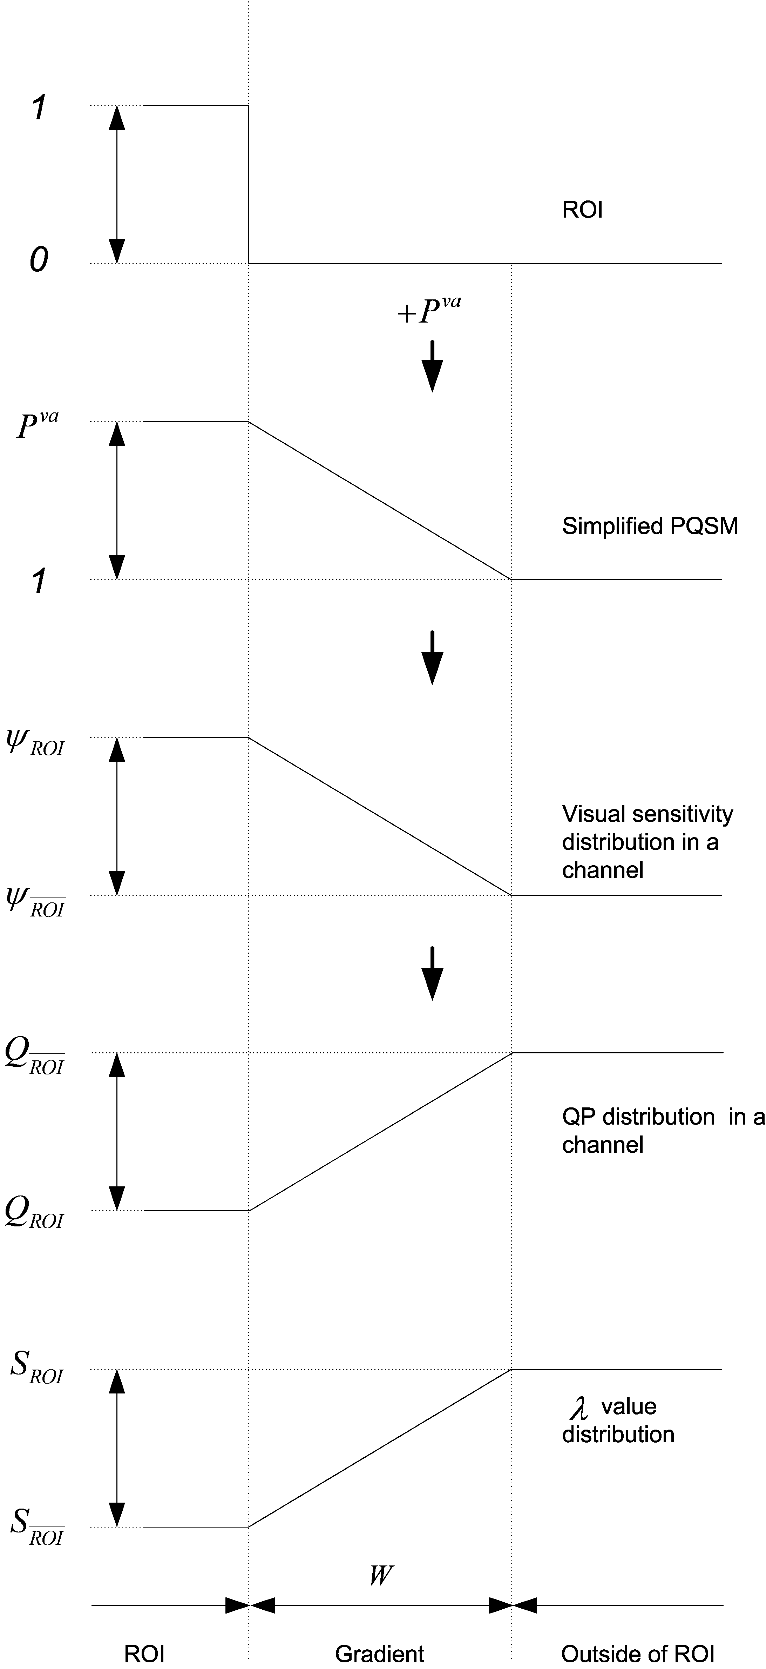

Figure 1. A flowchart of generating QP profile and value profile.

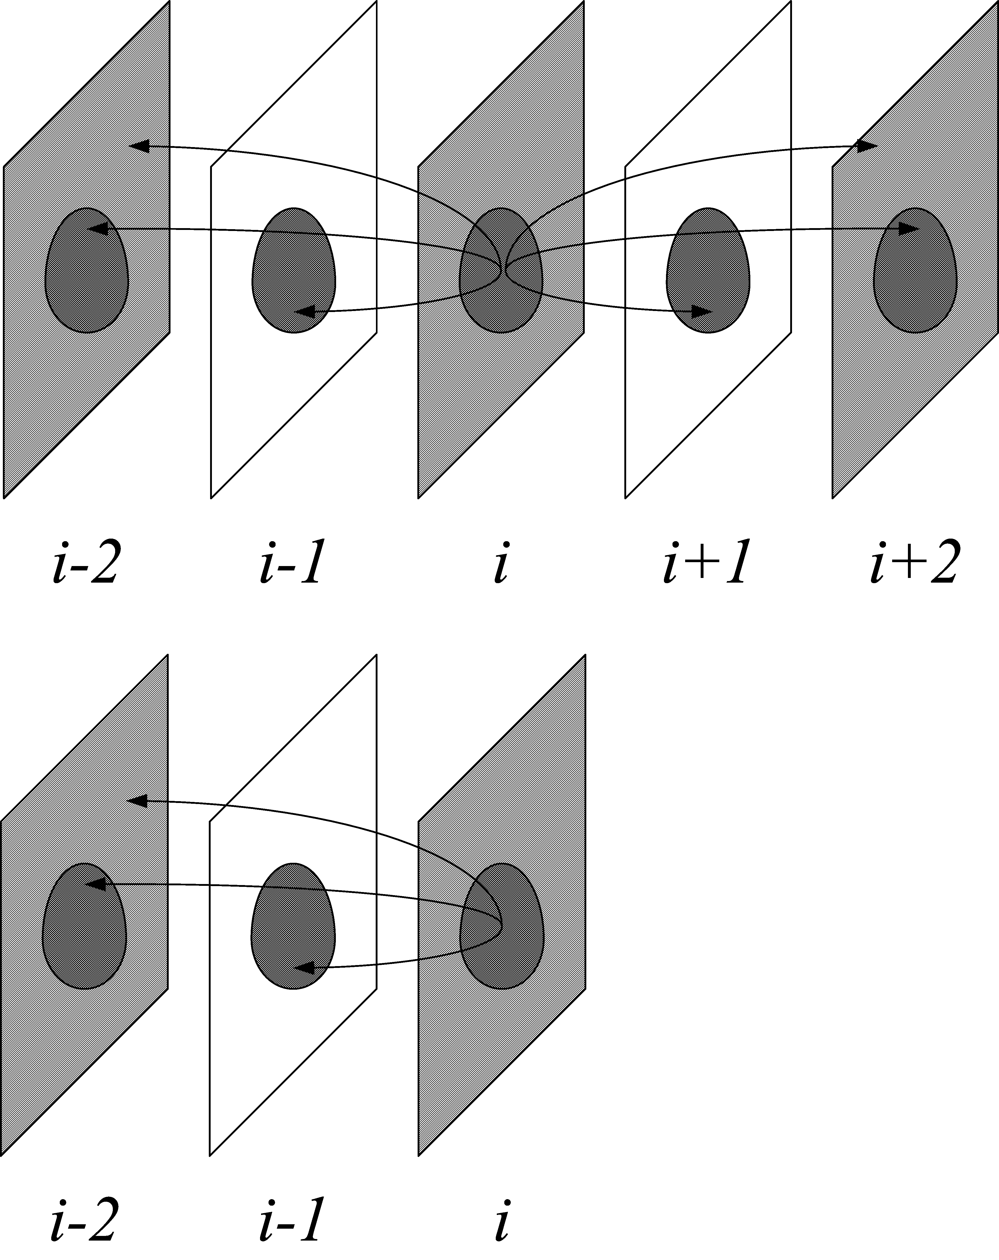

Figure 2. Two diagrams of ROI-based adaptive framerate scheme: bi-directional motion estimation (upper) and backward motion estimation (lower), n=2.
For the proposed ROI-based SNR scalability, when $P^{\text{va}}U/L$ is greater than $θ$, two (or more) MVFs are required in the ROI. Each MVF is generated by RDO with utilization of the corresponding $Q_{\text{ROI}}$. When $θ/{P^{\text{va}}}≤U/L<θ$, an MVF may be shared outside the ROI. The MVF at low bit rate can also be derived from that at high bit rate outside the ROI. When $U/L$ is greater than $θ$, two (or even more) MVFs are required outside the ROI, the MVFs in the ROI can be further refined. In other words, we can have up to η MVFs in the ROI and up to ϕ ( ϕ <η) MVFs outside the ROI in the whole bit rate range. Moreover, MVF and residual image are always matched in the ROI where there may be mismatch outside the ROI.

Figure 2 shows the examples when n=2. Because some areas are discarded and cannot be used as reference for motion estimation, a labeling technique should be used to label the available searching areas. In Figure 2, patterned areas are labeled as the reference area and the blank areas are not.

Actually, a new SNR scalability scheme is also provided for generation and coding of motion information by our ROI-based SNR scalability. Specially, each frame is divided into two parts: ROI and out-of-ROI, ROI is assigned a priority . The ROI part can have up to three MVFs and out-of-ROI can only have up to two MVFs. Overall, we can have up to three MVFs for each frame in the whole SNR range.

We can have a similar SNR scalability for generation and coding of motion information by dividing each frame into $N(N≥1)$ parts, which can be described by () ROIs (multiple ROIs). For simplicity, we assume that ROI $i$ has priority , and ROI $N$ has the highest priority. ROI $i$ $(1≤i≤(N−1))$ can have up to $(i+2)$ MVFs in the whole bit rate range, and out-of-ROI can only have up to two MVFs. Overall, we can have up to $(N+1)$ MVFs for each frame in the whole bit rate range.

Experimental Result

Some primary experiments are conducted on H.264 JVM6.0 software. At present, only QP values are modified and controlled based on the PROI representation. The binary ROI mask are generated by its foreground masks and reduced into , and resolutions, respectively. We have tested 3 standard video sequences (‘Stephan’, ‘Foreman’ and ‘Singer’) under different low bit rates (219, 146 and 79 kbits/s), and confirmed the improvement on perceptual coding quality with the proposed ROI based scheme. Table 1, 2 and 3 show the experimental conditions between the experiment with ROI and without ROI, for CIF test sequence ‘Stephan’, ‘Foreman’ and ‘Singer’, respectively. Figure 3 shows the visual comparison for the reconstructed 10th frame of CIF test sequence ‘Stephan’ with and without ROI consideration. As can be easily seen, the proposed ROI based compression achieves better perceptual quality (more spatial details have been preserved in the face, and so on). Figure 4 shows the ROI mask R in , , and block size. Figure 5 and 6 show the other two examples of visual comparison for the reconstructed 10^{h} frame of CIF test sequence ‘Foreman’ and ‘Singer’, with the test conditions listed in Table 2 and 3.
Table 1. The setups of experimental comparison on CIF test sequence ‘Stephan’.
Without ROI | With ROI
Fix QP: | Fix QP:
 | Linear gradient
No RDO | No RDO
No rate-control | No rate-control
bitrate=219.12 Kbit/s | bitrate=196.60 Kbit/s ( block size)  bitrate=195.86 Kbit/s ( block size)  bitrate=196.00 Kbit/s ( block size)  (excluding ROI masks and values)

Table 2. The setups of experimental comparison on CIF test sequence ‘Foreman’.
Without ROI | With ROI
Fix QP: | Fix QP:
 | Linear gradient
No RDO | No RDO
No rate-control | No rate-control
bitrate= 146.41 Kbit/s | bitrate=145.23 Kbit/s ( block size)  bitrate=144.86 Kbit/s ( block size)  bitrate=145.10Kbit/s ( block size)  (excluding ROI masks and values)

Table 3. The setups of experimental comparison on CIF test sequence ‘singer’.
Without ROI | With ROI
Fix QP: | Fix QP:
 | Linear gradient
No RDO | No RDO
No rate-control | No rate-control
bitrate=78.87 Kbit/s | bitrate=78.05 Kbit/s ( block size)  bitrate=77.57 Kbit/s ( block size)  bitrate=77.70 Kbit/s ( block size)  (excluding ROI masks and values)
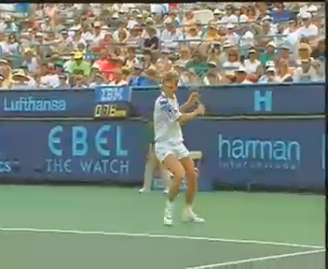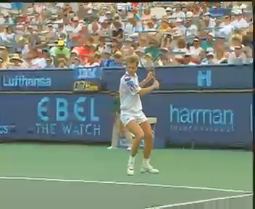
(a) (b)

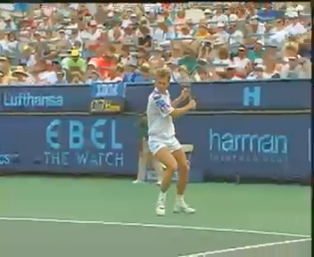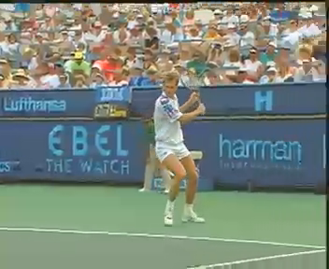
(c) (d)

Figure 3. An example of experimental comparison on the 10th frame of CIF test sequence ‘Stephan’: (a) without ROI, (b) with ROI in block size, (c) with ROI in block size, and (d) with ROI in block size.


(a) (b) (c)

Figure 4. ROI R on the 10th frame of CIF test sequence ‘Stephan’: (a) in block size, (b) in block size, and (c) in block size.


(a) (b)


(c) (d)

Figure 5. An example of experimental comparison on the 10th frame of CIF test sequence ‘foreman’: (a) without ROI, (b) with ROI in block size, (c) with ROI in block size, and (d) with ROI in block size.


(a) (b)


(c) (d)

Figure 6. An example of experimental comparison on the 10th frame of CIF test sequence ‘singer’: (a) without ROI, (b) with ROI in block size, (c) with ROI in block size, and (d) with ROI in block size.

References:
- Zhongkang Lu, W. S. Lin, E. P. Ong, Susu Yao and S. Rahardja, “Modelling Global modulatory factors in Just-Noticeable-Distortion Estimation”, First International Workshop on Video Processing and Quality Metrics for Consumer Electronics, Scottsdale, Arizona, Jan. 2005.
- Zhongkang Lu, Lin Weisi, Yao Susu and Ong Eeping, “A method for generating a quality oriented significance map for assessing the quality of an image or video”, PCT Patent Application No PCT/SG02/00259, Patent number WO2004043054.
- Nister David and Christopoulos Charilaos, “Method and Device for Lossless Region of Interest Coding”, WO9919839.
- Diamond Peter, “Method and Apparatus for Compressing Background and Region of Interest A Digital Image at Different Resolutions”, WO2005004062.
- ISO/ISC JTC 1/SC 29/WG 1 (ITU-T SG8) JPEG2000 Part I Final Committee Draft Version 1.0, Mar. 2000.
- ISO/ISC JTC 1/SC 29/WG 1 (ITU-T SG8) JPEG2000 Part II Final Committee Draft Version 1.0, Dec. 2000.
- Z. Wang, L. Lu, and A. C. Bovik, “Foveation scalable video coding with automatic fixation selection,” IEEE Transactions on Image Processing, vol. 12, no. 2, Feb. 2003.
- Lijie Liu and Guoliang Fan, “A New JPEG2000 Region-of-Interest Image Coding Method: Partial Signi_cant Bitplanes Shift” IEEE Signal Processing Letters, Vol. 10, No. 2, pp. 35-38, Feb. 2003.
- W. Han, “Response of Call for Proposal for Scalable Video Coding,” ISO/IEC JTC1/SC29 WG11 MPEG2004/M10569/S17,Munchen, Germany, March 2004.
- Heiko Schwarz, Detlev Marpe and Thomas Wiegand, “Scalable Extension of H.264/AVC,” ISO/IEC JTC1/SC29 WG11 MPEG2004/M10569/S03,Munchen, Germany, March 2004.
- Heiko Schwarz, Detlev Marpe and Thomas Wiegand, “SVC Core Experiment 2.1: Inter-layer Prediction of Motion and Residual Data,” ISO/IEC JTC1/SC29 WG11 MPEG2004/M11043, USA, July 2004.
- D. S. Turaga, Mihaela Van del Schaar, “Unconstrained Motion Compensated Temporal Filtering,” ISO/IEC JTC1/SC29/WG11 MPEG03/M8838, 2002.
- Z. G. Li, X. K. Yang, K. P. Lim, X. Lin, S. Rahardja and F. Pan. Customer Oriented Scalable Video Coding. ISO/IEC JTC1/SC29 WG11 MPEG2004/M11187, Spain, Oct 2004.
- Z. Li, S. Rahardja, X. Lin, K. P. Lim and W. Yao. New Coding Modes for Scalable Video Coding. ISO/IEC JTC1/SC29 WG11 MPEG2004/M11511, Hong Kong, Jan. 2005.
- ISO/IEC JTC1/SC29/WG11, “Applications and Requirements for Scalable Video Coding, ” MPEG Document N5880, Brisbane, October 2003.
- ISO/IEC JTC1/SC29/WG11, “Description of Core Experiments in SVC, ” MPEG Document N6719, Palma, October 2004.

(Append for Proposal Documents)

JVT Patent Disclosure Form

International Telecommunication Union  Telecommunication Standardization Sector | International Organization for Standardization | International Electrotechnical Commission
 |  | 
Joint Video Coding Experts Group - Patent Disclosure Form
(Typically one per contribution and one per Standard | Recommendation)

Please send to:
JVT Rapporteur Gary Sullivan, Microsoft Corp., One Microsoft Way, Bldg. 9, Redmond WA 98052-6399, USA
Email (preferred): Gary.Sullivan@itu.int Fax: +1 425 706 7329 (+1 425 70MSFAX)

This form provides the ITU-T | ISO/IEC Joint Video Coding Experts Group (JVT) with information about the patent status of techniques used in or proposed for incorporation in a Recommendation | Standard. JVT requires that all technical contributions be accompanied with this form. Anyone with knowledge of any patent affecting the use of JVT work, of their own or of any other entity (“third parties”), is strongly encouraged to submit this form as well.

This information will be maintained in a “living list” by JVT during the progress of their work, on a best effort basis. If a given technical proposal is not incorporated in a Recommendation | Standard, the relevant patent information will be removed from the “living list”. The intent is that the JVT experts should know in advance of any patent issues with particular proposals or techniques, so that these may be addressed well before final approval.

This is not a binding legal document; it is provided to JVT for information only, on a best effort, good faith basis. Please submit corrected or updated forms if your knowledge or situation changes.

This form is not a substitute for the ITU ISO IEC Patent Statement and Licensing Declaration, which should be submitted by Patent Holders to the ITU TSB Director and ISO Secretary General before final approval.

Submitting Organization or Person:
Organization name | Institute for Infocomm Research
Mailing address | 21 Heng Mui Keng Terrace, Singapore 119613
Country | Singapore
Contact person | Zhongkang Lu
Telephone | +65 6874 6720
Fax | +65 6774 4998
Email | zklu@i2r.a-star.edu.sg
Place and date of submission | Singapore, 13th April 2005
Relevant Recommendation | Standard and, if applicable, Contribution:
Name (ex: “JVT”) |  | JVT
Title |  | Perceptual Region-of-interest (ROI) based Scalable Video Coding
Contribution number |  | JVT-O056

(Form continues on next page)

Disclosure information – Submitting Organization/Person (choose one box)
2.0 The submitter is not aware of having any granted, pending, or planned patents associated with the technical content of the Recommendation | Standard or Contribution.

or,
The submitter (Patent Holder) has granted, pending, or planned patents associated with the technical content of the Recommendation | Standard or Contribution. In which case,

2.1 The Patent Holder is prepared to grant – on the basis of reciprocity for the above Recommendation | Standard – a free license to an unrestricted number of applicants on a worldwide, non-discriminatory basis to manufacture, use and/or sell implementations of the above Recommendation | Standard.
2.2 The Patent Holder is prepared to grant – on the basis of reciprocity for the above Recommendation | Standard – a license to an unrestricted number of applicants on a worldwide, non-discriminatory basis and on reasonable terms and conditions to manufacture, use and/ or sell implementations of the above Recommendation | Standard.

Such negotiations are left to the parties concerned and are performed outside the ITU | ISO/IEC.
2.2.1 The same as box 2.2 above, but in addition the Patent Holder is prepared to grant a “royalty-free” license to anyone on condition that all other patent holders do the same.
2.3 The Patent Holder is unwilling to grant licenses according to the provisions of either 2.1, 2.2, or 2.2.1 above. In this case, the following information must be provided as part of this declaration:
- patent registration/application number;
- an indication of which portions of the Recommendation | Standard are affected.
- a description of the patent claims covering the Recommendation | Standard;
In the case of any box other than 2.0 above, please provide the following:
Patent number(s)/status
Inventor(s)/Assignee(s)
Relevance to JVT
Any other remarks:
(please provide attachments if more space is needed)

(form continues on next page)
Third party patent information – fill in based on your best knowledge of relevant patents granted, pending, or planned by other people or by organizations other than your own.

Disclosure information – Third Party Patents (choose one box)
3.1 The submitter is not aware of any granted, pending, or planned patents held by third parties associated with the technical content of the Recommendation | Standard or Contribution.

3.2 The submitter believes third parties may have granted, pending, or planned patents associated with the technical content of the Recommendation | Standard or Contribution.

For box 3.2, please provide as much information as is known (provide attachments if more space needed) - JVT will attempt to contact third parties to obtain more information:

3rd party name(s)
Mailing address
Country
Contact person
Telephone
Fax
Email
Patent number/status
Inventor/Assignee
Relevance to JVT

Any other comments or remarks:

