Joint Video Team (JVT) of ISO/IEC MPEG & ITU-T VCEG  (ISO/IEC JTC1/SC29/WG11 and ITU-T SG16 Q.6)  15th Meeting: Busan, KR, 16-22 April, 2005 | Document: JVT-O049  Filename: JVT-0049.doc  NOTE – That first character after the dash up there in the document number is an "O", not a zero.

Title: | Proposal for SVC streams storage and transport with MGS support
Status: | Input Document to JVT
Purpose: | Proposal
Author(s) or  Contact(s): | Gérard Babonneau  Bertrand Berthelot  Stéphanie Relier  Isabelle Amonou  Nathalie Cammas  Sylvain Kervadec  Stéphane Pateux  France Telecom Division R&D  4, rue du clos Courtel – BP 59  35 512 Cesson Sevigne Cedex  FRANCE | Tel:  Email: | +33 2 99 12 44 77  gerard.babonneau@francetelcom.com  bertrand.berthelot@francetelcom.com  Stephanie.relier@francetelecom.com  Isabelle.amonou@francetelecom.com  Nathalie.cammas@francetelecom.com  Sylvain.kervadec@francetelecom.com  Stephane.pateux@francetelecom.com
Source: | France Telecom Division R&D
_____________________________

Introduction
We believe that the current NAL cutting policy in the JSVC VM is not efficient enough to perform in all cases the required SVC medium-grained quality scalability (10% bit rate steps).
This document first presents some applications where the MGS 10% bit-rate steps are necessary and then a modification in the SVC NAL header format in order to allow a finer granularity through the signalling of more quality levels than provided with the current JSVM within SVC NAL Units.

Examples of applications
A network can not always ensure the end-to-end required bit-rate for the delivery of a video stream, as well in unicast applications as in multicast broadcasting.
In unicast applications, the source can easily adjust the bit-rate to the capabilities of the end-user and of the network using RTCP for example.
But in a multicast context, where a single source is sent to numerous users, the goal is to not penalize all of the users because of a few users which would not correctly receive the video stream.
The scalable concepts provided by SVC would allow reducing the impact of bit rate losses if the granularity of the scalability is enough.

Bit rate control by the source provider
This concept is based on a global quality of service criterion. Thus a slight decrease of the bit rate of a multicast stream could give the access to a group of users whose receipt characteristics are lower than the required bit rate. Such a decrease would be interesting if it allows serving a significant number of new users.
The concept is the same for a scalable codec, the bit rate of each level can be adapted with for example a low bit rate group, a SD (Standard Definition) service group, and an HD (High Definition) service group. Each group has a nominal bit rate and a minimum bit rate which should ensure a minimum required quality for the group. Depending on the global quality of service, the source can provide a given bit rate enclosed between nominal and minimal bit rates.

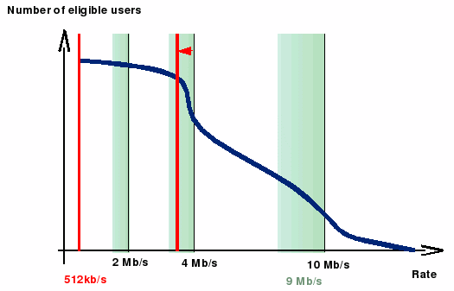
Fig. 1 – An example of the distribution of users according to their line rate

With this kind of control, a mechanism in the source drives the choice of the coded information to assign to each level. The reports (RTCP for example) coming from users are collected and feed a decision algorithm which sets the bit rates for each level according to pre-definite rules. The finer the decrease, the better is the quality of service. For example, for a nominal bit rate of 4Mbps, it could be very interesting to allow decreasing the bit rate step by step down to 3,6Mbps according to the decision algorithm.
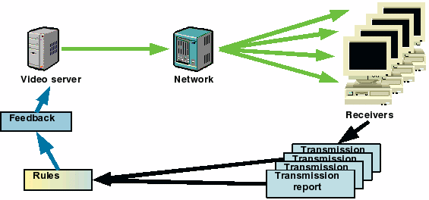
Fig. 2 – Source driven decision mechanism in a multicast environment

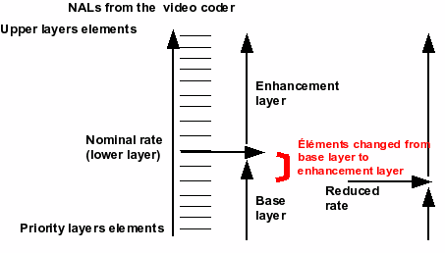
Fig. 3 – Example of an Adaptative streaming in a multicast environment

Example in Figure 3 shows how the rate control mechanism acts on server side. If the SD layer bit rate has to decrease, some NALs are removed from the SD layer, and are added to the upper layer, because they are essential for higher quality NALs.

It is important to note here that if the removed parts from the base layer were not in distinct NALs, there is no defined mechanism to recover these truncated parts into the enhancement layer.
The proposed MGS is essential in order to efficiently truncate FGS NALs and to be able to recover and concatenate the truncated FGS levels.

Bit rate control in the network
Equipments in the network become more intelligent. When a congestion point exists in the network, it is now possible to use QoS mechanisms integrated in routers, to allow selective removal of packets according to a ToS-like mark. The specificity of such mechanisms is to remove packets close to the users in order to maintain the best quality in the widest part of the network For example, for streaming of a scalable SVC content, a higher priority is given to lower layers, and a decreasing priority is given to each layer that refines a little more the quality furnished to the users. When congestion occurs, the mechanism selects losses first in the upper layer, and progressively goes down in the other layers until the rate is acceptable for the output link. The service's provider is responsible to define the part of the rate he wants to control. For instance, on a 4Mb/s stream, he can differentiate priorities corresponding to 4, 3.8, 3.6 and 3.2Mb/s, with the same structure of layers in Fig 3

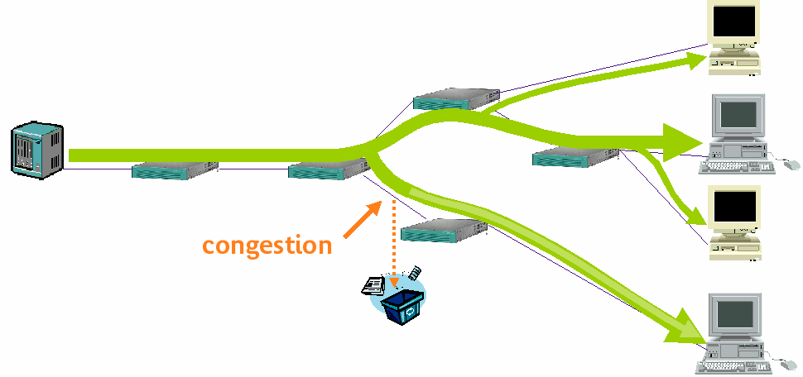
Fig. 4 – Control in the network

This mechanism is compliant with the multicast facilities on the network, regarding to the mutualization of the resource and the duplication of the stream closest to the end-user. It also allows an instantaneous adaptation in the network with an upholding of the quality of service because at least the lower layers will remain.

Quality Levels signaling

The current NAL header syntax allows to signal up to 4 different quality (FGS) levels and therefore does not enable efficient medium-grained quality scalability (e.g. 10% bit rate steps).
With the current version of the JSVM, at the transport level, bit rate adaptation could be performed by selecting or dropping NAL units. However rate scalability evaluation has been performed by truncating NALs. Unfortunately it is not possible to control truncation of NALs at the transport level. A solution is then to split current NAL units in several NALs associated to a fraction of an FGS level.

The SVC NAL header format needs to be modified in order to complete the quality levels information for the resulting several NALs associated to a fraction of an FGS level.
This modification consists in extending the NAL header when medium grain scalability has been performed, and then in signalling the quality levels information in the extension field (quality_level_extension).
We propose three alternatives for extending the NAL header and for signalling the quality levels information.

Solution 1

In this solution, we propose to add an extension flag, to the detriment of one bit of the DependencyId field, in the NAL header field in order to indicate the presence of a quality_level_extension field.

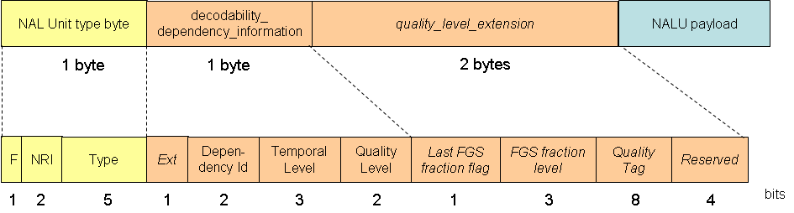
Fig. 5 – FGS fraction level signaling (solution 1)

The semantics of the header fields become:

NAL Unit type byte
F, NRI and Type as defined in current WD.

Decodability_dependency_information field (one byte)
- Ext (1 bit): Indicates whether a quality_level_extension is present or not
- DependencyId (2 bits): indicates dependency ID (as defined in current WD, but only on two bits instead of three)
- TemporalLevel (3 bits): indicates temporal level (as defined in current WD)
- QualityLevel (2 bits): indicates quality level (as defined in current WD)

quality_level_extension field (two bytes)
- LastFGSFractionFlag (1 bit): Indicates whether the indicated FGS fraction level is the last for the NALU
- FGSFractionLevel (3 bits): indicates FGS quality level
- QualityTag (6 bits): indicates quality level weight as proposed for example in M11704. This additional flag allows to select what are the indices of FGS levels' fraction that should be incorporated in the bit-stream (not all FGS fraction are necessarily equivalent in quality or in percentage of the NAL splitted)

The variables Ext, DependencyId, TemporalLevel, and QualityLevel are derived as follows:
- Ext = ( decodability_dependency_information >> 7 )
- DependencyId = ( decodability_dependency_information >> 5 ) & 3
- TemporalLevel = ( decodability_dependency_information >> 2 ) & 7
- QualityLevel = decodability_dependency_information & 3

The variables LastFGSFractionFlag, FGSFractionLevel, and QualityTag are derived as follows:
- LastFGSFractionFlag = (quality_level_extension >> 15 ) & 0x0001
- FGSFractionLevel = (quality_level_extension >> 12 ) & 0x0007
- QualityTag = (quality_level_extension >> 4 ) & 0x00FF

This solution limits the number of possible dependency ID from 8 levels to 4.

Solution 2

The second solution consists in reserving value of "111" of DependencyId field for indicating the presence of a quality_level_extension field.

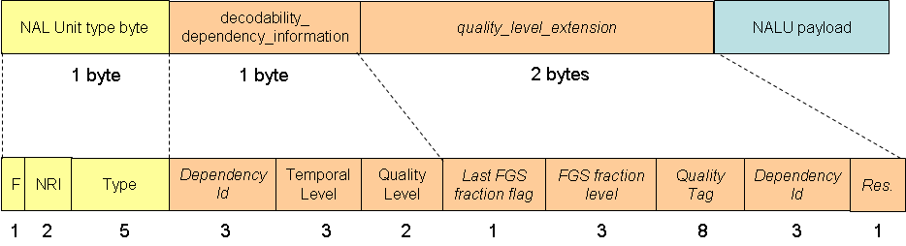
Fig. 6 – FGS fraction level signaling (solution 2)

The semantics of the header fields are the same as for the solution 1, except for the DependencyId field for which:
A value less than 7 indicates the dependency ID. The value 7 is an escape value that indicates the presence of two extension bytes containing additional quality information and the DepedencyId value.

The variables LastFGSFractionFlag, FGSFractionLevel, and QualityTag, DependencyId are derived as follows:
- LastFGSFractionFlag = (quality_level_extension >> 15 ) & 0x0001
- FGSFractionLevel = (quality_level_extension >> 12 ) & 0x0007
- QualityTag = (quality_level_extension >> 4 ) & 0x00FF
- DependencyId = (quality_level_extension >> 1 ) & 0x0007

This solution limits the number of possible dependency ID from 8 levels to 7 if the quality_level_extension field is not used.

Solution 3
The third solution consists in reserving value of "11" of QualityLevel field for indicating the presence of a quality_level_extension field.

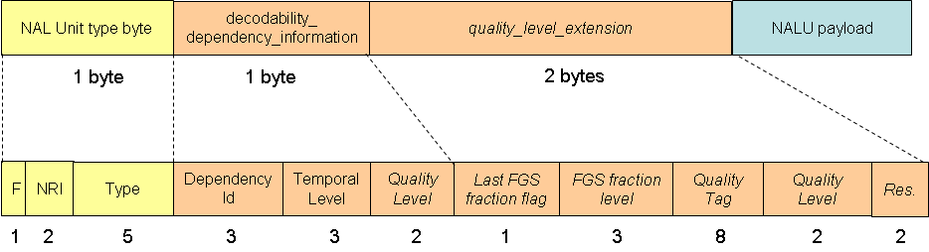
Fig. 7 – FGS fraction level signaling (solution 3)

The semantics of the header fields are the same as for the solution 1, except for the QualityLevel field for which:
A value less than 3 indicates the FGS level. The value 3 is an escape value that indicates the presence of two extension bytes containing additional quality information and the QualityLevel value.

The variables LastFGSFractionFlag, FGSFractionLevel, and QualityTag, DependencyId are derived as follows:
- LastFGSFractionFlag = (quality_level_extension >> 15 ) & 0x0001
- FGSFractionLevel = (quality_level_extension >> 12 ) & 0x0007
- QualityTag = (quality_level_extension >> 4 ) & 0x00FF
- QualityLevel = (quality_level_extension >> 2 ) & 0x0003

This solution limits the number of possible quality (FGS) levels from 4 to 3 if the quality_level_extension field is not used.

SVC transport over RTP

In order to perform bit rate adaptation at the transport level, it is necessary to be able on a network node to filter the packets according to the layer (spatial, temporal or quality) to which they belong.
Concerning RTP transport, we have to be compliant with AVC payload as defined by [2]. The NALUs are transmitted without any additional information but an extension header including the quality_level_extension field (as described in solution 1 in the figure 8). This extension header allows fine adaptation operations by selecting RTP packets according to the FGS fraction level and can also support the fully scalable representation of the SVC streams and allow very efficient configurable transmission according to network characteristics.
We propose the followed syntaxes for the three RTP packet types as defined by [2] :
- for a Single NAL Unit packets, one of the headers as defined § 3 would be used,
- for Fragmented Unit packets, one of the headers (except the NAL Unit Type byte which is reconstructed with FU_Indicator and FU_Header) as defined § 3 would be present if the reserved bit R in FU Header is set to 1 and this extension is only set for the first fragmented part (when E bit is set in FU Header)
- for Aggregation packets, one of the headers defined § 3 would first be present with an escape Type (we propose to use the type 0x30 or 0x31 in order to be compatible with AVC receivers which will ignore such RTP packets), then it would be followed by another NAL Unit Type Byte indicating the type of the aggregation packet (STAP-A, STAP-B, MTAP16 or MTAP24). All the NALU contained in the same aggregation packet shall have the same dependency information level characteristics.
The figure 8 shows such an aggregation packet header for a STAP-A packet. The SVC header will be followed by several complete NALUs (NALU size + NALU type byte + NALU payload).

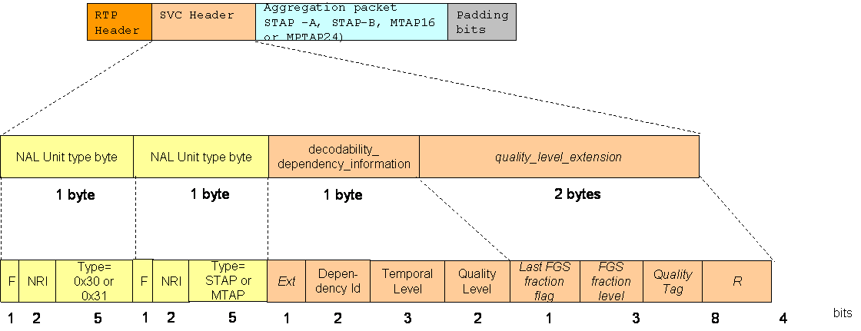

Fig. 8 – RTP extension header for a STAP-A aggregation packet

References
[1] ITU-T and ISO/IEC JTC1, “Scalable Video Coding - Working Draft 1”, JVT-N020, Jan 2005
[2] RFC 3984 - RTP Payload Format for H.264 Video – Feb. 2005 - S. Wenger, M.M.
Hannuksela, T. Stockhammer, M. Westerlund, M. Westerlund

(Append for Proposal Documents)
France Telecom as a member of ITU-T has already filled a general agreement statement with ITU-T implying that France Telecom is prepared to grant – on the basis of reciprocity for the above Recommendation | Standard – a license to an unrestricted number of applicants on a worldwide, non-discriminatory basis and on reasonable terms and conditions to manufacture, use and/ or sell implementations of the above Recommendation | Standard.

JVT Patent Disclosure Form

International Telecommunication Union  Telecommunication Standardization Sector | International Organization for Standardization | International Electrotechnical Commission
 |  | 
Joint Video Coding Experts Group - Patent Disclosure Form
(Typically one per contribution and one per Standard | Recommendation)

Please send to:
JVT Rapporteur Gary Sullivan, Microsoft Corp., One Microsoft Way, Bldg. 9, Redmond WA 98052-6399, USA
Email (preferred): Gary.Sullivan@itu.int Fax: +1 425 706 7329 (+1 425 70MSFAX)

This form provides the ITU-T | ISO/IEC Joint Video Coding Experts Group (JVT) with information about the patent status of techniques used in or proposed for incorporation in a Recommendation | Standard. JVT requires that all technical contributions be accompanied with this form. Anyone with knowledge of any patent affecting the use of JVT work, of their own or of any other entity (“third parties”), is strongly encouraged to submit this form as well.

This information will be maintained in a “living list” by JVT during the progress of their work, on a best effort basis. If a given technical proposal is not incorporated in a Recommendation | Standard, the relevant patent information will be removed from the “living list”. The intent is that the JVT experts should know in advance of any patent issues with particular proposals or techniques, so that these may be addressed well before final approval.

This is not a binding legal document; it is provided to JVT for information only, on a best effort, good faith basis. Please submit corrected or updated forms if your knowledge or situation changes.

This form is not a substitute for the ITU ISO IEC Patent Statement and Licensing Declaration, which should be submitted by Patent Holders to the ITU TSB Director and ISO Secretary General before final approval.

Submitting Organization or Person:
Organization name
Mailing address
Country
Contact person
Telephone
Fax
Email
Place and date of submission
Relevant Recommendation | Standard and, if applicable, Contribution:
Name (ex: “JVT”)
Title
Contribution number

(Form continues on next page)

Disclosure information – Submitting Organization/Person (choose one box)
2.0 The submitter is not aware of having any granted, pending, or planned patents associated with the technical content of the Recommendation | Standard or Contribution.

or,
The submitter (Patent Holder) has granted, pending, or planned patents associated with the technical content of the Recommendation | Standard or Contribution. In which case,

2.1 The Patent Holder is prepared to grant – on the basis of reciprocity for the above Recommendation | Standard – a free license to an unrestricted number of applicants on a worldwide, non-discriminatory basis to manufacture, use and/or sell implementations of the above Recommendation | Standard.
2.2 The Patent Holder is prepared to grant – on the basis of reciprocity for the above Recommendation | Standard – a license to an unrestricted number of applicants on a worldwide, non-discriminatory basis and on reasonable terms and conditions to manufacture, use and/ or sell implementations of the above Recommendation | Standard.

Such negotiations are left to the parties concerned and are performed outside the ITU | ISO/IEC.
2.2.1 The same as box 2.2 above, but in addition the Patent Holder is prepared to grant a “royalty-free” license to anyone on condition that all other patent holders do the same.
2.3 The Patent Holder is unwilling to grant licenses according to the provisions of either 2.1, 2.2, or 2.2.1 above. In this case, the following information must be provided as part of this declaration:
- patent registration/application number;
- an indication of which portions of the Recommendation | Standard are affected.
- a description of the patent claims covering the Recommendation | Standard;
In the case of any box other than 2.0 above, please provide the following:
Patent number(s)/status
Inventor(s)/Assignee(s)
Relevance to JVT
Any other remarks:
(please provide attachments if more space is needed)

(form continues on next page)
Third party patent information – fill in based on your best knowledge of relevant patents granted, pending, or planned by other people or by organizations other than your own.

Disclosure information – Third Party Patents (choose one box)
3.1 The submitter is not aware of any granted, pending, or planned patents held by third parties associated with the technical content of the Recommendation | Standard or Contribution.

3.2 The submitter believes third parties may have granted, pending, or planned patents associated with the technical content of the Recommendation | Standard or Contribution.

For box 3.2, please provide as much information as is known (provide attachments if more space needed) - JVT will attempt to contact third parties to obtain more information:

3rd party name(s)
Mailing address
Country
Contact person
Telephone
Fax
Email
Patent number/status
Inventor/Assignee
Relevance to JVT

Any other comments or remarks:

