Joint Video Team (JVT) of ISO/IEC MPEG & ITU-T VCEG  (ISO/IEC JTC1/SC29/WG11 and ITU-T SG16 Q.6)  15th Meeting: Bussan, KR, 16-22 April, 2005 | Document: JVT-O027  Filename: input.doc  NOTE – That first character after the dash up there in the document number is an "O", not a zero.

Title: | Scalable Video Coding – Memory Management Control Operation for Picture Duplication
Status: | Input Document to JVT
Purpose: | Proposal
Author(s) or  Contact(s): | ChinPhek Ong  MenHuang Lee  ChongSoon Lim  ShengMei Shen  Yoshimasa Honda | Tel:  Email: | cpong@psl.com.sg  mhlee@psl.com.sg  cslim@psl.com.sg  shen@psl.com.sg  honda.yoshimasa@jp.panasonic.com
Source: | Panasonic Singapore Laboratories Pte. Ltd.
_____________________________
- Introduction

In AVC, MMCO (memory management control operation) commands are used to control the memory buffers used to store reference pictures. This ensure conformance between the encoded bitstream and a decoder having a finite amount of memory.
- Problems

MCTF (Motion Compensated Temporal Filtering) is different from the typical MCP (motion compensated prediction) video coding scheme such as MPEG-1/2/4/AVC in several ways. Firstly, MCTF uses hierarchical level-by-level prediction and update steps, as opposed to single level prediction used in MCP. Secondly, for MCTF residual pictures, intermediate pictures, and decoded pictures are all used as reference pictures. For MCP only the decoded pictures are used as reference pictures.

In the current JSVM [2], the lowpass picture of the previous GOP is used as a reference picture for the coding of the current GOP. During decoding, the lowpass picture has to be duplicated and stored in the memory, so that the next GOP can use it as a reference. Otherwise, the content will be overwritten once inverse MCTF is carried out.

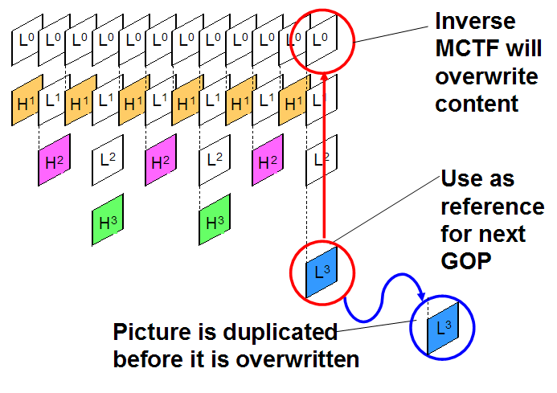

The same can be said for low-delay mode operation [3], where encoding and decoding is performed partition by partition. Certain pictures in the current partition have to be duplicated and stored so that the next partition can use it as reference for inverse MCTF.

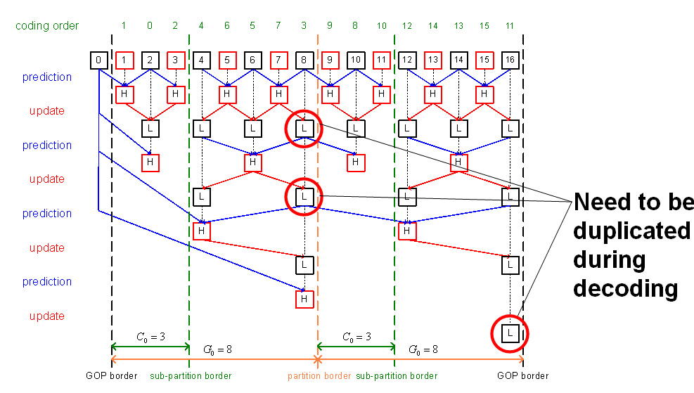

Currently, there is no mechanism to tell the decoder which picture to duplicate and when to duplicate. To a certain extent, this problem is also mentioned in editorial remarks 8 [1].

- MMCO for duplication

We proposed that a new MMCO command is defined to “mark a short-term reference picture as requiring duplication”. The proposed changes to WD [1] are provided in chapter 4.

The proposed MMCO command can be used to ensure conformance between encoded bitstream and a decoder having a finite amount of memory, for the case where the lowpass picture of the previous GOP is used as reference for the current GOP.

The proposed MMCO command can also be used to realize the low memory, low delay mode operation proposed in [3]. Optionally, it can also support multi-level prediction as proposed in [3].
- Proposed changes to syntax/semantics/decoding process.

S.7.3.3.3 Decoded reference picture marking syntax

The specification of this subclause in AVC shall be replaced by the following specification.

dec_ref_pic_marking( ) { | C | Descriptor
if( nal_unit_type = = 5 ) {
no_output_of_prior_pics_flag | 2 | 5 | u(1)
long_term_reference_flag | 2 | 5 | u(1)
} else {
adaptive_ref_pic_marking_mode_flag | 2 | 5 | u(1)
if( adaptive_ref_pic_marking_mode_flag )
do {
memory_management_control_operation | 2 | 5 | ue(v)
if( memory_management_control_operation = = 1 | |
memory_management_control_operation = = 3 | |
memory_management_control_operation = = 7 )
difference_of_pic_nums_minus1 | 2 | 5 | ue(v)
if(memory_management_control_operation = = 2 )
long_term_pic_num | 2 | 5 | ue(v)
if( memory_management_control_operation = = 3 | |
memory_management_control_operation = = 6 )
long_term_frame_idx | 2 | 5 | ue(v)
if( memory_management_control_operation = = 4 )
max_long_term_frame_idx_plus1 | 2 | 5 | ue(v)
} while( memory_management_control_operation != 0 )
}
}

S.7.4.3.3 Decoded reference picture marking semantics

The specification of this subclause in AVC shall apply with the following modifications.

1) Replace Table 7-9 of this subclause in AVC with the following table (new MMCO command is highlighted)

memory_management_control_operation | Memory Management Control Operation
0 | End memory_management_control_operation syntax element loop
1 | Mark a short-term reference picture as  “unused for reference”
2 | Mark a long-term reference picture as  “unused for reference”
3 | Mark a short-term reference picture as  "used for long-term reference" and assign a long-term frame index to it
4 | Specify the maximum long-term frame index and mark all long-term reference pictures having long-term frame indices greater than the maximum value as "unused for reference"
5 | Mark all reference pictures as  "unused for reference" and set the MaxLongTermFrameIdx variable to  "no long-term frame indices"
6 | Mark the current picture as  "used for long-term reference" and sssign a long-term frame index to it
7 | Mark a short-term reference picture as “requiring duplication”

S.8.2.5.4.7 Marking process of a short-term reference picture as “requiring duplication”

This process is invoked when memory_management_control_operation is equal to 7.

For this process, only pictures with a variable DependencyId that is equal to the value of the variable DependencyId of the current picture are considered.

Given the syntax element difference_of_pic_nums_minus1, the variable picNumX is obtained as specified in subclause Error: Reference source not found.

Depending on field_pic_flag the value of picNumX is used to mark a short-term reference picture as “requiring duplication” as follows.
- If field_pic_flag is equal to 0, the short-term reference frame or short-term complementary reference field pair specified by picNumX and both of its fields are marked as “requiring duplication”.
- Otherwise (field_pic_flag is equal to 1), the short-term reference field specified by picNumX is marked as “requiring duplication”. When that reference field is part of a reference frame or a complementary reference field pair, the frame or complementary field pair is also marked as "requiring duplication ", but the marking of the other field is not changed.

- References

[1] “Scalable Video Coding – Working Draft 1”, JVT-N020, 14th Meeting: Hong Kong, CN, 17-21 January, 2005.
[2] “Joint Scalable Video Model JSVM 1”, JVT-N023, 14th Meeting: Hong Kong, CN, 17-21 January 2005.
[3] “Proposal for SVC CE1 – Low Delay”, MPEG M11616, January 2005, Hong Kong, China.

(Append for Proposal Documents)

JVT Patent Disclosure Form

International Telecommunication Union  Telecommunication Standardization Sector | International Organization for Standardization | International Electrotechnical Commission
 |  | 
Joint Video Coding Experts Group - Patent Disclosure Form
(Typically one per contribution and one per Standard | Recommendation)

Please send to:
JVT Rapporteur Gary Sullivan, Microsoft Corp., One Microsoft Way, Bldg. 9, Redmond WA 98052-6399, USA
Email (preferred): Gary.Sullivan@itu.int Fax: +1 425 706 7329 (+1 425 70MSFAX)

This form provides the ITU-T | ISO/IEC Joint Video Coding Experts Group (JVT) with information about the patent status of techniques used in or proposed for incorporation in a Recommendation | Standard. JVT requires that all technical contributions be accompanied with this form. Anyone with knowledge of any patent affecting the use of JVT work, of their own or of any other entity (“third parties”), is strongly encouraged to submit this form as well.

This information will be maintained in a “living list” by JVT during the progress of their work, on a best effort basis. If a given technical proposal is not incorporated in a Recommendation | Standard, the relevant patent information will be removed from the “living list”. The intent is that the JVT experts should know in advance of any patent issues with particular proposals or techniques, so that these may be addressed well before final approval.

This is not a binding legal document; it is provided to JVT for information only, on a best effort, good faith basis. Please submit corrected or updated forms if your knowledge or situation changes.

This form is not a substitute for the ITU ISO IEC Patent Statement and Licensing Declaration, which should be submitted by Patent Holders to the ITU TSB Director and ISO Secretary General before final approval.

Submitting Organization or Person:
Organization name | Matsushita Electric Industrial Co., Ltd. (Panasonic)
Mailing address | AV Core Technology Development Center  Matsushita Electric Industrial Co., Ltd.  Shinagawa Panasonic Building 6F  4-5-15, Higashi-Shinagawa, Shinagawa-ku, Tokyo 140-8632 Japan
Country | Japan
Contact person | Yoshimasa Honda
Telephone | (03)5460-2740
Fax | (03)5460-2737
Email | honda.yoshima@jp.panasonic.com
Place and date of submission | Busan, Korea, 16~22 April 2005
Relevant Recommendation | Standard and, if applicable, Contribution:
Name (ex: “JVT”) |  | JVT
Title |  | Scalable Video Coding – Memory Management Control Operation for Picture Duplication
Contribution number |  | JVT-O027

(Form continues on next page)

Disclosure information – Submitting Organization/Person (choose one box)
2.0 The submitter is not aware of having any granted, pending, or planned patents associated with the technical content of the Recommendation | Standard or Contribution.

or,
The submitter (Patent Holder) has granted, pending, or planned patents associated with the technical content of the Recommendation | Standard or Contribution. In which case,

 | 2.1 The Patent Holder is prepared to grant – on the basis of reciprocity for the above Recommendation | Standard – a free license to an unrestricted number of applicants on a worldwide, non-discriminatory basis to manufacture, use and/or sell implementations of the above Recommendation | Standard.
X | 2.2 The Patent Holder is prepared to grant – on the basis of reciprocity for the above Recommendation | Standard – a license to an unrestricted number of applicants on a worldwide, non-discriminatory basis and on reasonable terms and conditions to manufacture, use and/ or sell implementations of the above Recommendation | Standard.  Such negotiations are left to the parties concerned and are performed outside the ITU | ISO/IEC.
 | 2.2.1 The same as box 2.2 above, but in addition the Patent Holder is prepared to grant a “royalty-free” license to anyone on condition that all other patent holders do the same.
2.3 The Patent Holder is unwilling to grant licenses according to the provisions of either 2.1, 2.2, or 2.2.1 above. In this case, the following information must be provided as part of this declaration:
- patent registration/application number;
- an indication of which portions of the Recommendation | Standard are affected.
- a description of the patent claims covering the Recommendation | Standard;
In the case of any box other than 2.0 above, please provide the following:
Patent number(s)/status
Inventor(s)/Assignee(s)
Relevance to JVT
Any other remarks:
(please provide attachments if more space is needed)

(form continues on next page)
Third party patent information – fill in based on your best knowledge of relevant patents granted, pending, or planned by other people or by organizations other than your own.

Disclosure information – Third Party Patents (choose one box)
3.1 The submitter is not aware of any granted, pending, or planned patents held by third parties associated with the technical content of the Recommendation | Standard or Contribution.

3.2 The submitter believes third parties may have granted, pending, or planned patents associated with the technical content of the Recommendation | Standard or Contribution.

For box 3.2, please provide as much information as is known (provide attachments if more space needed) - JVT will attempt to contact third parties to obtain more information:

3rd party name(s)
Mailing address
Country
Contact person
Telephone
Fax
Email
Patent number/status
Inventor/Assignee
Relevance to JVT

Any other comments or remarks:

