Joint Video Team (JVT) of ISO/IEC MPEG & ITU-T VCEG  (ISO/IEC JTC1/SC29/WG11 and ITU-T SG16 Q.6)  15th Meeting: Busan, KR, 16-22 April, 2005 | Document: JVT-O018  Filename: JVT-O018.doc

Title: | Improve SVC Coding Efficiency by Adaptive GOP Structure (SVC CE2).
Status: | Input Document to JVT
Purpose: | Proposal to the response of the SVC CE 2
Author(s) or  Contact(s): | Gwang Hoon Park*, Min Woo Park*  Kyung Hee University. 1, Seochun, Kiheung  Youngin, Kyunggi, Korea.  Seyoon Jeong**, Kyuheon Kim**, Jinwoo Hong**  ETRI, 161 Gajeong-dong Yusung-gu  Daejeon, Korea. | Tel:  Email: | +82 (42) 860-5724  jsy@etri.re.kr
Source: | ETRI**, Kyung Hee University*
_____________________________

ABSTRACT

This is a contribution to respond to SVC CE 2. This technique was originally proposed in M11563[1]. SVC CE 2 was set up and performed according to the CE Description in JVT-N025. The proposed technique is currently 100% decoder compatibility with JSVM 1.0. By introducing the adaptive modification of the size of GOP based on the image characteristics of video sequence, the adaptive GOP structure (AGS) improves the coding efficiency up to 0.62dB in comparison with the current SVC JSVM reference software 1.0.

1. Overview

This document presents the ETRI and Kyunghee University technical contribution of Adaptive GOP Structure, which aims to improve the coding efficiency of JSVM 1.0. This document is a response to the SVC CE 2. This technique was originally proposed in M11563 [1]. SVC CE 2 was set up and performed according to the CE Description in JVT-N025.

2. Background

The SVC (Scalable Video Coding), which is currently under standardization process, uses 8 or 16 picture frames for one GOP (Group of Picture) and provides the temporal scalability through the MCTF (Motion Compensated Temporal Filtering) structure on that GOP unit. In order to keep the compatibility with H.264, the base layer of the SVC uses the hierarchical B-Picture structure that excludes the “update” process on the MCTF procedure [3].
In this contribution we propose the adaptive GOP Structure (AGS) in order to provide the enhanced coding efficiency according to the properties of video sequences in time axis.

3. Adaptive GOP Structure (AGS)

It is evident that the coding efficiency improves if a coding can be performed with an adaptively selected GOP size by considering the temporal image characteristics of the video sequence.
In order to understand the proposed AGS, we will show same instances that adaptively-adjusted GOP structure for the improvement of coding efficiency from the fixed 16 full-GOP structure. Various AGS’s that are combinations of the groups of sub-GOP’s, such as [16], [8,8], [8,4,4], [4,4,8], [4,4,4,4], [2,2,4,8], [4,4,2,2,8], [2,2,2,2,8], [2,2,4,4,4], [2,2,2,2,4,4], and [2,2,2,2,2,2,2,2] can be applicable as shown in the figure 1. The coding efficiency improves by changing the full-sized fixed GOP structure into the proper AGS structure using these available groups of sub-GOP structures.

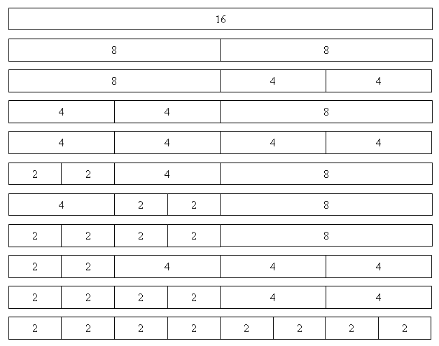
Fig. 1. Several instances of the possible adaptive GOP structures when the full-GOP size is as 16.

For the instances to show the coding structure variations, the figure 2 shows the MCTF procedure with the fixed full-size GOP as 16 and the figure 3 illustrates the MCTF procedure based on the AGS when the one full-size GOP (16 frames) is converted into the combination of the sub-GOP’s of [8, 4, 2, 2].
As shown in figure 2, the encoded bitstream of the MCTF for JSVM 1.0 consists of the encoded data of “L4(0)”, “H4(1)”, “H3(2)”, “H3(3)”, “H2(4)”, “H2(5)”, “H2(6)”, “H2(7)”, “H1(8)”, “H1(9)”, “H1(10)”, “H1(11)”, “H1(12)”, “H1(13)”, “H1(14)”, “H1(15)” frame information.
As also shown in figure 3, the encoded bitstream of the MCFT for JSVM 1.0 using the combination of the sub-GOP’s of [8, 4, 2, 2] consists of the encoded data of “L3(0)”, “H3(1)”, “H2(2)”, “H2(3)”, “H1(4)”, “H1(5)”, “H1(6)”, “H1(7)”, “L2(8)”, “H2(9)”, “H1(10)”, “H1(11)”, “L1(12)”, “H1(13)”, “L1(14)”, “H1(15)” frame information.
The Low frequency frame, Li(j), is encoded by the intra coding algorithm and the High frequency frame, Hu(v), is encoded by B picture coding which performs bidirectional prediction among interframe coding used by H.264 (or AVC).

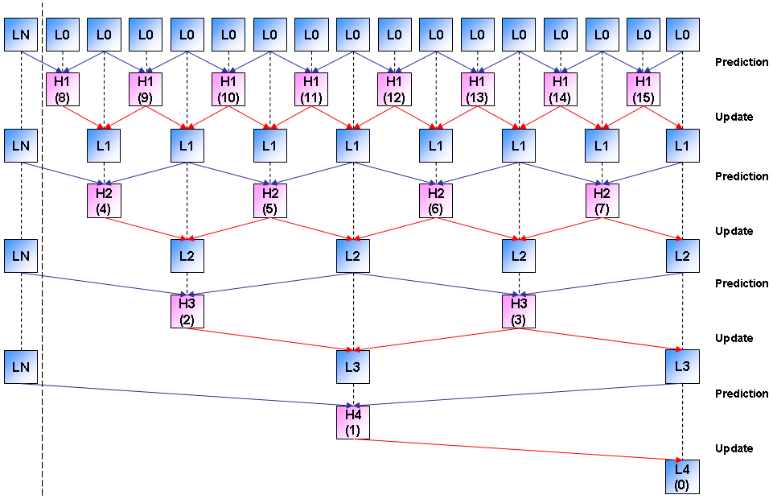
Fig. 2. The MCTF structure of the SVM 3.0 using 16 frames as one full-size GOP.

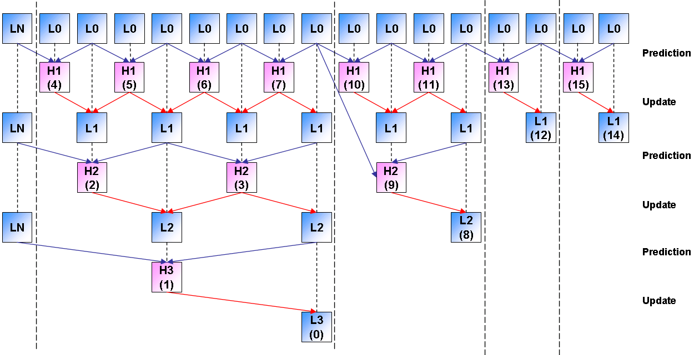
Fig. 3. The MCTF structure of the SVM 3.0 using the Adaptive GOP Structure that is divided into Sub-GOP’s as [8, 4, 2, 2].

Figure 4 depicts an algorithm of the selection mechanism for the AGS. Pre-encoding is performed by varying the GOP size as 16, 8, 4, and 2. The MSE (Mean Square Error) of each sub-GOP is calculated in one full-sized GOP structure (full size is fixed as 16 frame-sized interval)
The “Mode Decision” procedure selects the best combination of the sub-GOP structure that produces the minimum MSE in each full-sized GOP structure. Bitstream is finally generated based on selected sub-GOP structure. This procedure is repeated for each full-sized GOP interval of the video sequence.

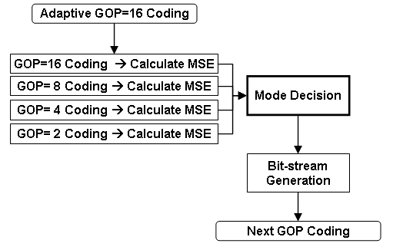

Fig. 4. The algorithm for selecting Adaptive GOP Structure

Fig. 5. The detailed mode decision procedure

In the “Mode Decision” procedure, the MSE of each frame is calculated by the equation (1).
, (1)
Where k indicates the number of pixels of one frame, F(i) is the pixel value of temporally-filtered image frame after performing the MCTF procedure, G(i) is the pixel value of reconstructed temporally-filtered image frame after encoding is performed.

Figure 5 illustrates the detailed mode decision procedure shown in Figure 4.
Figure 6 shows the conceptual locations where to calculate the MSE of each sub-GOP used in mode decision for selecting the adaptive GOP sizes among one full-size GOP structure.
The full 16 frame-sized GOP is encoded based on the various sub-GOP size of 16, 8, 4 and 2 respectively. Then the MSE of each sub-GOP is calculated and then followed by the mode decision.

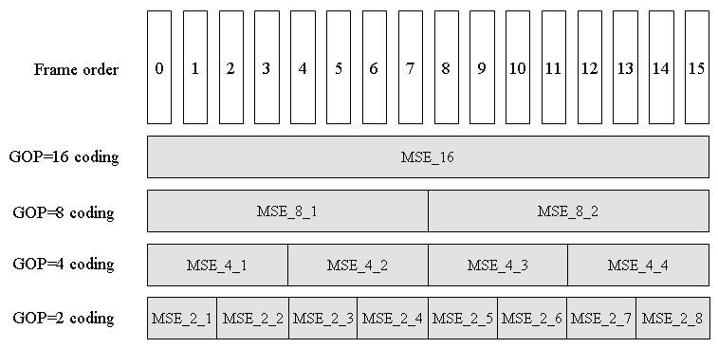
Fig. 6. The conceptional locations where to calculate the MSE of each Sub-GOP for selecting the AGS size.

The following is the Pseudo Code for the mode decision procedure.

gop_mode = min { MSE_16, (MSE_8_1 + MSE_8_2)/2, (MSE_4_1 + MSE_4_2 + MSE_4_3 + MSE_4_4)/4,
(MSE_2_1 + MSE_2_2 + MSE_2_3 + MSE_2_4 + MSE_2_5 + MSE_2_6 + MSE_2_7 + MSE_2_8)/8 }
If (gop_mode == MSE _16) {
Select 16 frame size GOP structure
End of mode Decision
}
Else {
gop_mode = min { MSE_8_1, (MSE_4_1 + MSE_4_2)/2, (MSE_2_1 + MSE_2_2 + MSE_2_3 + MSE_2_4)/4 }
If (gop_mode == MSE_8_1) Select 8 frame size sub-GOP structure
Else
{
gop_mode = min { MSE_4_1, (MSE_2_1 + MSE_2_2)/2 }
If (gop_mode == MSE_4_1) Select 4 frame size sub-GOP structure

Else {
Select 2 frame size sub-GOP structure (Front)
Select 2 frame size sub-GOP structure (Rear)
}
gop_mode = min { MSE_4_2, (MSE_2_3 + MSE_2_4)/2 }
If (gop_mode == MSE_4_2) Select 4 frame size sub-GOP structure

Else {
Select 2 frame size sub-GOP structure (Front)
Select 2 frame size sub-GOP structure (Rear)
}
}
gop_mode = min { MSE_8_2, (MSE_4_3 + MSE_4_4)/2, (MSE_2_5 + MSE_2_6 + MSE_2_7 + MSE_2_8)/4 }
If (gop_mode == MSE_8_1) {
Select 8 frame size sub-GOP structure
End of mode decision
}
Else {
gop_mode = min { MSE_4_3, (MSE_2_5 + MSE_2_6)/2 }
If (gop_mode == MSE_4_3) Select 4 frame size sub-GOP structure

Else {
Select 2 frame size sub-GOP structure (Front)
Select 2 frame size sub-GOP structure (Rear)
}
gop_mode = min { MSE_4_4, (MSE_2_7 + MSE_2_8)/2 }
If (gop_mode == MSE_4_4) {
Select 4 frame size sub-GOP structure
End of mode decision
}
Else {
Select 2 frame size sub-GOP structure (Front)
Select 2 frame size sub-GOP structure (Rear)
End of mode decision
}
}
}

In order to implement the procedure of the fully-satisfied temporal scalability in AGS, we need to modify the current SVM extractor algorithm.
The SVM extractor can recognize the usage of AGS based on ‘one’ bit assigned to the ‘SEI message’ as “UseAGS.”

4. Experimental Results

In order to estimate the coding efficiency of the proposed AGS, we carried out computer simulations according to the test set in JVT-N025.This test set is the same as the test scenario 1 and 2 defined in the 69th Redmond meeting. We had fully implemented the proposed Adaptive GOP Structure (AGS) into JSVM 1.0. Then we compared the results of JSVM 1.0 with AGS and the original JSVM 1.0. Additionaly, we attached the comparison results between the SVM 3.0 with AGS and the SVM 3.0.
The size of GOP in Base Layer is fixed as 16 frames for QCIF 15Hz sequence. The sizes of GOP in the Spatial Enhanced Layer are fixed as 32 frames for CIF 30Hz sequence and 64 frames for 4-CIF 60Hz sequence.
Figure 7 shows the comparisons of PSNR results at QCIF and CIF for “Crew” video sequence. As shown in the figure, the AGS improves the PSNR’s up to 0.33dB in comparison with the results of the JSVM 1.0 reference codec.

Fig. 7. Comparison of PSNR results at QCIF and CIF in “Crew”
(JSVM 1.0 vs. JSVM 1.0+AGS vs. SVM 3.0 vs. SVM 3.0+AGS)

Figure 8 shows the comparison of PNSR results at 4-CIF in “Crew” sequence. AGS improves the PSNR up to 0.62dB.

Fig. 8. Comparison of PSNR results at 4-CIF in “Crew
(JSVM 1.0 vs. JSVM 1.0+AGS vs. SVM 3.0 vs. SVM 3.0+AGS)

Figure 9 shows the selected GOP size in encoding of “Crew” sequence by JSVM 1.0 with proposed AGS. From this information, we could know the variation of image characteristic of this sequence.
As shown in the figure, the temporal variation between pictures is small at the begining of the “Crew” sequence. The temporal variation increases as the sequence number increases and it reaches the highest in the intervals which are the 7th ~ 9th GOP intervals.

GOP | Proposed GOP Structure
0 | 16
1 | 4 |  | 4 |  | 4 |  | 2 | 2
2 | 4 |  | 4 |  | 4 |  | 4
3 | 2 | 2 | 2 | 2 | 4 |  | 4
4 | 4 |  | 4 |  | 4 |  | 4
5 | 4 |  | 2 | 2 | 2 | 2 | 4
6 | 4 |  | 2 | 2 | 4 |  | 2 | 2
7 | 2 | 2 | 2 | 2 | 2 | 2 | 2 | 2
8 | 2 | 2 | 4 |  | 2 | 2 | 2 | 2
9 | 2 | 2 | 2
Fig. 9. Selected GOP size using AGS in “Crew”

Figure 10 shows the comparison of PNSR results at QCIF in “Football” sequence. AGS improves the PSNR up to 0.3dB.
Fig. 10. Comparison of PSNR results at QCIF in “Football”
(JSVM 1.0 vs. JSVM 1.0+AGS vs. SVM 3.0 vs. SVM 3.0+AGS)

Figure 11 shows the comparison of PNSR results at CIF in “Football” sequence. AGS improves the PSNR up to 0.2dB.

Fig. 11. Comparison of PSNR results at CIF in “Football”
(JSVM 1.0 vs. JSVM 1.0+AGS vs. SVM 3.0 vs. SVM 3.0+AGS)

Figure 12 shows the selected GOP size in Adaptive GOP Structure for “Football” sequence. From this figure it is understood that the characteristic of “Football” sequence is very dynamic.

GOP | Proposed GOP Structure
0 | 4 |  | 2 | 2 | 2 | 2 | 2 | 2
1 | 2 | 2 | 2 | 2 | 2 | 2 | 2 | 2
2 | 2 | 2 | 2 | 2 | 8
3 | 8 |  |  |  | 8
4 | 8 |  |  |  | 8
5 | 2 | 2 | 2 | 2 | 8
6 | 8 |  |  |  | 8
7 | 8 |  |  |  | 8
8 | 2
Fig. 12. Selected GOP size using AGS in “Football”

Figure 13 shows the comparison of PNSR results at QCIF in “Bus” sequence. AGS improves the PSNR up to 0.15dB.

Fig. 13. Comparison of PSNR results at QCIF in “Bus”
(JSVM 1.0 vs. JSVM 1.0+AGS vs. SVM 3.0 vs. SVM 3.0+AGS)

Figure 14 shows the comparison of PNSR results at CIF in “Bus” sequence. AGS improves the PSNR up to 0.1dB.

Fig. 14. Comparison of PSNR results at CIF in “Bus”
(JSVM 1.0 vs. JSVM 1.0+AGS vs. SVM 3.0 vs. SVM 3.0+AGS)

Figure 15 shows the selected GOP size in Adaptive GOP Structure for “Bus” sequence. From this figure, it is analyzed that the variation of pictures is very small in “Bus” sequence, so all selected GOP size is 16 except the 4th GOP in Original JSVM 1.0. The selected sizes of sub-GOP for the 4th GOP are [8, 4, ]. Figure 26 shows the little improvement which PSNR gain is 0.1dB by replacing the 4th GOP as proposed [8, 4, -] sub-GOP’s.

GOP | Proposed GOP Structure
0 | 16
1 | 16
2 | 16
3 | 16
4 | 8 | 4
Fig. 15. Selected GOP size using AGS in “Bus”

Figure 16 shows the comparison graphs between JSVM 1.0 and Adaptive GOP in QCIF and CIF for “Soccer” sequence. Figure 39 shows the same comparison graphs in 4CIF of “Soccer” sequence.
Fig. 16. Comparison of PSNR results at QCIF and CIF in “Soccer
(JSVM 1.0 vs. JSVM 1.0+AGS vs. SVM 3.0 vs. SVM 3.0+AGS)

Fig. 17. Comparison of PSNR results at 4-CIF in “Soccer”
(JSVM 1.0 vs. JSVM 1.0+AGS vs. SVM 3.0 vs. SVM 3.0+AGS)

Figure 18 shows the selected GOP size in Adaptive GOP Structure for “Soccer” sequence.

GOP | Proposed GOP Structure
0 | 16
1 | 16
2 | 16
3 | 8 |  |  |  | 8
4 | 16
5 | 16
6 | 16
7 | 16
8 | 16
9 | 2 | 2 | 2
Fig. 18. Selected GOP size using AGS in “Soccer”

Figure 19 shows the comparison graphs between the JSVM 1.0 and the adaptive GOP in QCIF and CIF for “Foreman” sequence.

Fig. 19. Comparison of PSNR results at QCIF and CIF in “Foreman”
(JSVM 1.0 vs. JSVM 1.0+AGS vs. SVM 3.0 vs. SVM 3.0+AGS)

Figure 20 shows the selected GOP size in Adaptive GOP Structure for “Foreman” sequence.

GOP | Proposed GOP Structure
0 | 16
1 | 16
2 | 16
3 | 16
4 | 16
5 | 8 | 4 | 2 | 2
6 | 16
7 | 16
8 | 16
9 | 8
Fig. 20. Selected GOP size using AGS in “Foreman”

Figure 21 shows the comparison graphs between JSVM 1.0 and AGS in QCIF and CIF for “City” Sequence. Figure 22 shows the same comparison graphs in 4CIF of “City” sequence. As shown in Figure 21 and 22, the PSNR results are same for both JSVM 1.0 and AGS because the selected GOP mode in AGS is the same as one in JSVM 1.0.

Fig. 21. Comparison of PSNR results at QCIF and CIF in “City”
(JSVM 1.0 vs. JSVM 1.0+AGS vs. SVM 3.0 vs. SVM 3.0+AGS)

Fig. 22. Comparison of PSNR results at 4-CIF in “City”
(JSVM 1.0 vs. JSVM 1.0+AGS vs. SVM 3.0 vs. SVM 3.0+AGS)

Figure 23 shows the comparison graphs between JSVM 1.0 and Adaptive GOP in QCIF and CIF for “Mobile” sequence. As shown in the figure, the PSNR results are the same for both JSVM 1.0 and AGS, because the selected GOP mode in Adaptive GOP Structure is the same as in JSVM 1.0.
Fig. 23. Comparison of PSNR results at QCIF and CIF in “Mobile”
(JSVM 1.0 vs. JSVM 1.0+AGS vs. SVM 3.0 vs. SVM 3.0+AGS)

Figure 24 shows the comparisons of the PSNR results between the JSVM 1.0 and the adaptive GOP in QCIF and CIF for “Harbor” sequence. Figure 25 shows the same comparison graphs in 4-CIF for Harbor sequence.
Fig. 24. Comparison of PSNR results at QCIF and CIF in “Harbour”
(JSVM 1.0 vs. JSVM 1.0+AGS vs. SVM 3.0 vs. SVM 3.0+AGS)

Fig. 25. Comparison of PSNR results at 4-CIF in “Harbour”
(JSVM 1.0 vs. JSVM 1.0+AGS vs. SVM 3.0 vs. SVM 3.0+AGS)

Figure 26 shows the selected GOP size in Adaptive GOP Structure for “Harbour” sequence.

GOP | Proposed GOP Structure
0 | 8 |  | 8
1 | 8 |  | 8
2 | 8 |  | 8
3 | 16
4 | 8 |  | 8
5 | 16
6 | 8 |  | 8
7 | 8 |  | 8
8 | 8 |  | 8
9 | 4 | 4
Fig. 26. Selected GOP size using AGS in “Harbour”

5. Conclusion

In this contribution, we proposed the adaptive GOP structure for adoption to the SVC JSVM. The proposed scheme is currently 100% decoder compatibility with JSVM 1.0. By introducing the adaptive modification of the size of GOP based on the image characteristics of video sequence, the proposed AGS improves the coding efficiency up to 0.62dB in comparison with the current SVC JSVM 1.0.

References

[1] G.H. Park, M.W. Park, S Jeong, J. Cha, K. Kim, and J. Hong, "Adaptive Gop Structure for SVC", MPEG standards contribution m11563, Hong Kong, January, 2005.
[2] JVT "Description of Core Experiments in SVC", JVT standards output docment JVT-N025, Hong Kong, January, 2005.
[3] J. Reichel, M. Wien, H. Schwarz, "Scalable Video Model 3.0," ISO/IEC JTC1/ SC29/ WG11 N6716, October 2004.

