Joint Video Team (JVT) of ISO/IEC MPEG & ITU-T VCEG  (ISO/IEC JTC1/SC29/WG11 and ITU-T SG16 Q.6)  15th Meeting: Busan, KR, 16-22 April, 2005 | Document: JVT-O016  Filename: JVT-O016.DOC  NOTE – That first character after the dash up there in the document number is an "O", not a zero.

Title: | Optimum Bit Allocation and Rate Control for H.264/AVC
Status: | [Input Document to JVT]
Purpose: | [Proposal]
Author(s) or  Contact(s): | Yuan Wu, Lin Shouxun, Zhang Yongdong, Luo Haiyong  DTL ,Institute of Computing Technology, Acedemy of Science,China  Yuan Wen  Institute of Geographical Sciences and Natural Resources Research, Chinese Academy of Sciences,China | Tel:  Email: | +86-10-62565533 ext 9604  wyuan@ict.ac.cn
Source: | [Institute of Computing Technology, Acedemy of Science,China]

INTRODUCTION
The objective of rate control is to regulate the coded bit stream to satisfy certain given conditions, such as buffer over- or underflow prevention, variable and/or low bandwidth constraints. As one of the key problems in regard of coding performance, rate control has drawn significant research attention, though it is currently left out of the specification scope of most hybrid video coding standards, such as MPEG-2 Visual [1], H.263 [2], MPEG-4 Visual [3] and H.264/AVC [4].

Brief Review of Rate Control Schemes
General speaking, a typical rate control scheme consists of two basic operations, bit allocation and bit allocation achievement, namely bit rate control. Optimal rate control can be achieved jointly by optimum bit allocation and accurate bit rate control.
The task of optimum bit allocation is to efficiently distribute the bits budget among image blocks, so that the best video quality is achieved. The problem of optimum bit allocation can be formulated as the following:

(1)
where denotes the overall distortion, denotes the bit budget and denotes the number of bits used to encode the frame.
To achieve the target bit rate, the rate control scheme appropriately chooses a quantization parameter. For accuracy, it is of importance to exactly model or estimate the coding bit rate in terms of the quantization parameter, namely rate-quantization (R-Q) functions. Together with distortion-quantization (D-Q) functions, R-Q functions characterize the rate-distortion (R-D) behavior of video encoding, which is the key issue of optimum bit allocation.
Many R-Q and D-Q functions have been reported in previous studies [5-13] in the literature. Various bit allocation schemes are simultaneously presented based on these R-Q and R-D functions. Some of them have been adopted in various standard-compliant video coders, such as TM-5 [12], the test model for MPEG-2, TMN-8 [11], the test model for H.263, and VM-8 [13], the verification model for MPEG-4. However, among these standardized rate control algorithms, only TMN-8 achieves optimum bit allocation at a macroblock-by-macroblock basis.

Rate Control in H.264/AVC
H.264/AVC is a recently approved video-coding standard, jointly developed by ISO and ITU, and achieves a significant improvement in coding performance in relation to prior coding standards [14]. H.264/AVC contains many new features, which impose great challenges to the operative coder control. One challenge is to efficiently distribute the bits budget between the texture coding and the overhead coding of the selected macroblock mode and motion vectors, which is neglected in the conventional coder control method. As a way out, the Lagrangian coder control method is incorporated into the H.264/AVC coder.
However, the Lagrangian coder control method demands the quantization parameter be evaluated before intra/inters prediction, thus leading to a dilemma because until the end of intra/inters prediction, the rate control scheme cannot access the exact coding characteristics, which is indispensable for the calculation of the quantization parameter. Such a dilemma prevents the rate control scheme from directly accessing the coding characteristic in advance.
To circumvent the dilemma, a two-pass scheme is proposed in JVT-D030, where a TM-5-alike method is used in each pass [15]. If the first pass fails to obtain an appropriate quantization parameter, then a second pass will be conducted as a refinement, which consequently increases the computational complexity. Moreover, JVT-D030 uses an extremely simplified R-D function, and therefore, fails to achieve accurate and robust rate control_
Because of its’ disadvantages, JVT-D030 was replaced by JVT-G012 [16] as the standardized rate control scheme for H.264/AVC. In JVT-G012, spatio-temporal correlations are exploited to circumvent the dilemma, wherein a linear MAD model is employed to predict the coding complexity, and the conventional MPEG-4 Q2 function is employed to calculate the quantization parameter. Nevertheless, spatio-temporal correlations are not sufficiently well utilized, and so results in a weak prediction for the coding characteristic.
Both in the two aforementioned rate control schemes, a sub-optimal bit allocation schemes is employed, where the total target bits are distributed just proportionally to the coding complexity of each image block.

Proposed Optimum Bit Allocation and Bit Rate Control Scheme for H.264/AVC
The RDO of the Lagrangian coder control method is substantively restricted within the scope of a macroblock and therefore achieves only a finite gain in coding performance. To further improve the coding performance of H.264/AVC, it is an obvious resort to extending RDO from macroblock–layer to frame-layer, namely, achieving an optimum bit allocation at frame-layer, which is the main purpose of this work. However, it is a very hard task because the Lagrangian coder control method stands in the way to touch true coding characteristic while the optimal solution requires explicit knowledge of the video source properties and the encoder operation effects.
To circumvent the obstacle, we resort to spatio-temporal correlations, and achieve a novel adaptable prediction scheme to accurately estimate the coding characteristic of the video content. In the context of the proposed prediction scheme, linear regress analysis is improved by appropriately selecting data points with a spatio-temporal continuity criterion. Moreover, the proposed prediction scheme suggests that R-D models be used according to spatio-temporal continuities, when estimating the coding characteristic. Using the two methods together significantly increase the accuracy of R-D models. The proposed prediction scheme promises another simple way to utilize correlations, by using temporal history as a straightforward substitute or a scaling factor when estimating R-D characteristics. Such a way is used in predictions for the overhead bit counts and the distortions.
To achieve a close-form solution to the problem of optimum bit allocation, we present a linear distortion model and a novel Q2 function. By using Lagrange optimization, we minimize the total distortion under the bit budget constraint and obtain formulas for the best quantization parameters.
We implement our new rate control scheme based on JM-8.5 [17], and compare its performance to that of JVT-G012 rate control scheme. The experimental results show that the proposed scheme performs an effective bit allocation while demanding less bandwidth. In comparison to JVT-G012 rate control, our method significantly increases the video quality up to 0.89 dB per frame.

GLOBAL ENCODING CHARICTERISTICS PREDICTION
General speaking, the variations of the video content can be typically viewed as the results of movements of video objects relative to the imaging plane. The movements of real-world video objects intrinsically possess high spatio-temporal correlations/dependents, accordingly, which are also revealed in the video content. In this section, we first give a brief review about the past exploitations on spatio-temporal correlations in the video coder control, and then concentrate on these works related to rate control. Ultimately, we conclude to the adaptive coding characteristics prediction scheme, which significantly improve R-D modeling.

Brief Review of the Past Work
By taking advantage of the large amount of spatio-temporal correlations in the video content, various algorithms have been proposed in the past for different purposes in the literature.
For high-quality compression, several schemes such as intra prediction, motion compensation and DCT transform, have been created and construct the foundation of currently prevailing compression techniques in hybrid video coding.
Apart from these works, additional attentions to improve coding performance, with respect to the operational control of the source coder, have been given to spatial and/or temporal correlations and we can classify them into two general categories, according to their purposes.
1) Motion Compensation — In spatially and temporally adjacent macroblocks, the video content varies often slowly and continuously, and hence it is highly probable that the neighboring macroblocks, in time and space, take similar values for the set of coding parameters, including macroblock mode and motion vector, etc. Several algorithms have been proposed to speed up motion-compensated prediction, by using spatio-temporal correlations [18-21].
2) Rate Control — In previous works on rate control, various R-D functions are derived from entropy theory or based on empirical observation, and often suffer from significant deviations of empirical R-D curves from the theoretic assumption, which are unacceptable for accurate rate control. Several rate control schemes resort to spatio-temporal correlations to enhance the accuracy of R-D models, by using statistical regress analysis for dynamical model parameters update. Typical of them are the well-known MPEG-4 Q2 [10], and the linear MAD models [22], wherein model parameters are updated by linear regression method from previous coded parameters.

Imperfectness of Previous Methods of Rate Control
Previous exploitations on spatio-temporal correlations with respect to rate control heavily depend on linear regress methods. The data point selection scheme is the key issue problem to linear regress analysis for a certain model. In general case, improper exploitations on spatio-temporal correlations often lead to bad selection of data points and therefore inaccurate R-D modeling, and ultimately result in large prediction errors. Unfortunately, the previous methods just do in an imperfective way. After a careful and considerate study, we list three major disadvantages of previous methods in the following.
1) Exclusively Exploiting Spatial and Temporal Correlations
In previous methods, the spatial and the temporal correlations are exclusively taken into consideration when estimating the coding characteristics. In the regress analysis for the MPEG-4 Q2 model, data points are selected from recently coded picture blocks, which are situated in a same frame except at the very early stage in the whole encoding process for a certain frame. In such a case, only spatial correlation is in use. However, only using spatial correlation cannot guarantee the accuracy of R-D models, because it often occurs in actual video coding that there are no spatial correlations available but temporal correlations. As a consequence, previous methods often suffer from relative large prediction errors.
2) Improper Segmentation
To achieve an adaptive and robust prediction, we should derive R-D models based on data set with high spatio-temporal correlations, and a spatio-temporal continuity criterion should be used to ensure that only these data points with high spatio-temporal correlations be selected.
In the context of hybrid video coding, macroblocks are processed along a simple raster scan. And in previous methods used in the MPEG-4 Q2 and linear MAD model, data points used in linear regress analysis are collected along the scanning path, which often is spatially linear-shaped. Such a scheme to select data point is too simple to comply with the actual spatial continuity. It is a high probability that data points with low spatial correlation are involved, and therefore weaken the accuracy of R-D models.
3) Ill-use of R-D models in Prediction
By linear regress analysis, a certain R-D model can be dynamically determined, which reflects the statistics of only these data points used in the linear regress analysis. The result model is temporally and spatially volatilizable. We can use the resulted R-D model to estimate the coding characteristics for macroblocks with the same spatio-temporal continuity. It is worthy to point out that the usage of the resulted R-D model is only valid in predictions for blocks with the same spatio-temporal continuity. Ill-use of the resulted R-D models without compliancy to spatio-temporal continuity will lead to significant prediction errors.
Unfortunately, in JVT-G012 the resulted MAD model has to be used in predictions for all macroblocks, even for spatially remote ones at the risk of low spatial correlations. The prediction error might be very large.
Above analysis provide the insight into current exploitation on spatio-temporal correlations with respect to rate control. We can see that all behind these disadvantages is insufficiently well exploiting spatio-temporal correlations. Next, we will improve the utility of spatio-temporal correlations, basically arming to improve the accuracy of R-D models.

The Proposed Prediction Scheme
Via extensive experiments, we find out that for various coding characteristics, including the distortions, the R-D behaviors, the coding complexity and the motion compensation decision, there exist extensive correlations in spatially and temporally adjacent macroblocks. Based on the observations, we present a heuristic coding characteristic prediction scheme.
General speaking, the principle we follow to improve the exploitations on spatio-temporal correlations is to efficiently and exactly segment the video content according to spatio-temporal continuities, and make full use of spatial and temporal correlations in combination as more comprehensive as possible.
The proposed scheme consists of two types of methods to exploit spatio-temporal correlations in R-D modeling. One is via a linear regress analysis, and the other is via a straightforward substitute.
1) The Linear Regress Analysis Method
This type of methods is applied in the coding complexity modeling and the R-Q modeling, of which we will give a detailed description in the subsequent sect. In the following, improvements are proposed respectively for the three disadvantages we have previously occluded.
- Exploit Spatial and Temporal Correlations In Combination
General speaking, temporal correlations are ubiquitous throughout the whole video content for all P-frames except the first one of each GOP, while high spatial correlations maybe only present in neighboring blocks. It often occurs that no spatial but temporal correlations available when estimating coding characteristics for spatially remote blocks, and necessitates integrative exploitations on spatial and temporal correlations. For this purpose, additional memory should be allocated for the storage of temporal history information. Accordingly, the data point selection should be modified to accommodate both temporal and spatial history information simultaneously. Such a scheme of data point selection is more adaptive and robust, especially for the scenario of no spatial but temporal correlations available.
- Segment Video Content According to Spatio-Temporal Continuities
The quality and quantity of the data set used for regress analysis are critical to accuracy of the model and should qualify at least enough to differentially illustrate a variety of spatio-temporal continuities. For accurate modeling, it is critical to well select a set of data points, which are strongly convergent, namely, high correlated. The accuracy and robustness of R-D models, is significantly determined by exactly segmenting the video content according to spatio-temporal continuity. In general case, video blocks with a same spatio-temporal continuity are irregular-shaped. Exactly segmenting the video content demands an intensive computable complexity, and also a complicated search algorithm.
We observe that spatio-temporal correlation depends on the spatial and temporal distance between blocks. The closer the distance, the more possible a high correlation and verse vice. Based on the observations, a simple solution is addressed here, which are very similar with the slide widow technique [22] with the only difference in the preliminary selection of data points.
At the preliminary stage, only these data points are collected with a spatial distance not exceeding a certain threshold from the coded blocks in the current and previous P frames, while in the slide widow method, data points are collected from recently coded blocks. However, only spatial and temporal neighborhoods are too insufficient to promise a high correlation. A refinement is further performed against the preliminary data set, by removing all outliner data points in the same way as the slide widow method does. It must be noted that at the preliminary stage there are little spatial correlations for spatially remote picture blocks, in such a case, only temporal correlations are used. Linear regress analysis is performed with the least-mean-square (LMS) criterion.
- Adaptively Use the resulted R-D model
For not yet coded macroblocks, we cannot make certain what a spatio-temporal continuity they belong to. Nevertheless, it is observed that spatially or temporally adjacent macroblocks are high correlated at a relative high probability. Therefore we propose an empirical method wherein the resulted R-D models are used in prediction only for spatially and temporally adjacent macroblocks. This method ensures that exact R-D models are derived, and adaptively used in predictions of R-D characteristics for macroblocks of different spatio-temporal continuities.

2) The Simple Substituted Method
It is very hard to exactly model the overhead bit rate and the distortions. Nevertheless, extensive experiments show that there exist high similarities among consecutive P frames with regard to the overhead bits count and the distortions. We can use the temporal history information as a substitute or a scaling factor in prediction. We will give a detailed description of this simple method in the subsequent sect.

RATE DISTORTION Models
Since the complicated coding structure in H.264/AVC demands a lager portion of the overall bit stream used for overhead encoding, overhead bits prediction becomes significant to the design of a rate control scheme. Considering the dilemma by the Lagrangian coder control method, how to approximate R-D behaviors is the key issue. Based on above consideration, we decompose the rate control problem into four substantial components, coding complexity prediction, R-Q modeling, D-Q modeling and overhead bit rate prediction. In the following, we will give a detail description about overhead bit rate prediction, coding complexity prediction, R-D behavior prediction and distortion prediction.

Overhead Bitrate Prediction
The overall bitstream generated by the source coder is mainly comprised of the texture coding bits plus the bits used to coding prediction syntax overhead, including macroblock mode, motion vector and quantization parameter. For most of the conventional rate control algorithms, it is a common approach to regard prediction syntax overhead bits as a fixed-size component in the overall bitstream, and a post-coding update at a macroblock/frame-level is often used. However, the coding structure has become very complicated recently in the literature, which leads to a possible dramatic change in the number of bits required to encoding side information, especially in H.264/AVC. The JVT-G012 rate control scheme adopts the conventional method of fixed-size estimation for overhead bit-rate, making it infeasible to achieve an accurate prediction.
In this work, good exploitations on spatio-temporal correlations are conducted to improve the accuracy of the overhead bit-rate prediction. As previously mentioned, extensive correlations exist among motion vectors of spatially and temporal adjacent macroblocks. Furthermore, it can be also observed that similar mode selections are preferred among adjacent picture blocks in consecutive frames.
All these observations strongly suggest that the overhead bit counts maybe similar among spatially and temporal adjacent macroblocks. Therefore, the overhead bit rate can be predicted by that of coding history. A simple prediction method we proposed is to just directly substitute the overhead bit count of not yet coded blocks by that at the co-located position in the previous P frame. It is formulated as the following:

(2)
where denotes the overhead bit count of the macroblock in current P frame, and denotes the overhead bit count of the macroblock in the previous P frame.
Compared with JVT-G012, the new formula makes use of temporal correlations of coding parameter decisions among consecutive P frames, and is more accurate and robust.

Coding Complexity Prediction
Coding complexity is a valuable tool used to predict the texture bit count prior to encoding a frame or macroblock. In most R-D models, coding complexity is often involved to reflect the substantial of the video content. Various statistics measures can be used as indications of coding complexity, such as mean absolute difference (MAD) and mean square error (MSE). For examples, the coding complexity is usually substituted by MAD in the quadratic R-Q model, while in TMN-8 by MSE.
In the prior video coding standards, the actual coding complexity is accessible immediately after intra/inters prediction, and can be used in the subsequent rate control process. However, it is not the case for H.264/AVC, because the Lagrangian coder control method desires the rate control operation happen in advance. To circumvent the obstacle, a linear MAD model is proposed in JVT-G012, which attempts to approximate the temporal variation of coding complexity. By using the linear MAD model, MAD of not yet coded blocks can be predicted by that in the co-located position in the previous P frame. The linear MAD model is formulated as following:

(3)
where denotes the predicted MAD of current block, the actual MAD of the picture block in the co-located position of the previous P frame, and and denote the two model parameters.
However, as previously stated, the prediction performance of the linear MAD model is weakened by the fact of insufficiently well use of spatio-temporal correlations in linear regress analysis. We improve it by applying the proposed prediction scheme.

R-D Behavior Prediction
It is a well-known assumption that the DCT coefficients of the motion-compensated difference frame are approximately uncorrelated and Laplacian distributed alike (4).

(4)

If the distortion measure is defined as, we can get a closed-form solution for the R-D functions as (5) according to mathematics derivation in [23].

(5)

We assume the quantization step as the distortion measure, and then expand the resulted equation using Taylor series. We can obtain a formula as the follow.

(6)

If is neglected in (6), a simple quadric equation (7) can be obtained to specify the R-D function, where is substituted by MAD.

(7)
where the two parameters a and b are calculated using statistical linear regression analysis. The linear regress analysis for this Q2 model, involves two types of data points, and .
According to the adaptive coding characteristics prediction scheme, the selection of data points maybe cover yet not coded region in current P frame, in this case, data points are replaced by that at the same spatial location in previous P frame. Though (7) is a simple mathematics formula, but we cannot use it to get a close-form solution to R-D optimized rate control problem. In the following, we further derive a new Q2 model from (7).
In general case, the admittable quantizer parameter in a frame is restricted to a narrow range in order to maintain the smoothness of visual quality. Moreover, the quantizer parameters between adjacent macroblocks cannot be change rapidly and abruptly. For simplicity, we assume that for current P frame, the available quantizer step size varies in a range of, and is the midpoint, which is often set to the quantizer step size related to the mean of quantizer parameters used in previous frames. Using Taylor series expansion at the point of, (7) can be transformed into (8). Because the variation of quantizer size in a same P frame is small, the error introduced by the transformation from (7) to (8) can be neglected.

(8)
where ,，and.
Combing (4) and (8), a rate model for the macroblock coding is presented in the following.

(10)

Distortion Prediction
The distortion in the macroblock is introduced by uniformly quantizing its DCT coefficients with a quantizer of step size. In practice, highly imperfect distortion models such as sum of absolute differences (SAD)or its equivalents known as mean absolute error(MAD), sum of squared differences (SSD) or its equivalents known as mean squared error (MSE) or peak signal-to-noise ratio (PSNR) are used in most actual comparisons.
In this work, MAD is adopted as a measurement of coding distortion. We assume that coding distortion is uniformity distributed, and its standard error is, in which only the quantizer step size is involved. But indeed the DCT coefficients also are key issues to determine the coding distortion. Because of the spatio-temporal correlations in the variety of image content of the consecutive pictures, distortions are similar in spatially and temporally adjacent picture blocks. A simple adjustment is proposed to the distortion model by scaling it with a factor of, where denotes the distortion of themacroblock in the previous P frame (MSE is often used), and denotes the quantizer step used for the macroblock in the previous P frame. Considering that no distortion exists if the value of is set to one, we obtain a distortion model depicted as the follow.

(11)

RATE DISTORTION OPTIMIZATION
Based on above rate mode and distortion model, a mathematics close-form solution to R-D optimized rate control is addressed in the following. We want to find an expression for the quantization parameters that minimizes the distortion in (11) subject to the constraint that the total number of bits, i.e., the sum of the macroblock ’s (4), must be equal to T:

(12)

Observe that, since we are minimizing a convex, differentiable function on a convex set, there is a unique solution that can be obtained using Lagrange theory [24]. To do this, we define and , as respectively, the Lagrange multiplier and its optimal value, and write the optimization problem in (12) in its equivalent form:

(13)
where we replaced with (10) in the last step. By setting partial derivatives to zero in (13), we obtain the following expression:

(14)

By computing the above simultaneous equations, we can obtain (15).

(15)

Equation (15) is the key formula in the novel proposed rate control scheme. It is worthy to note that in some cases, we cannot achieve a numerical solution to (15).
Case A: If, the Q2 R-Q model falls back to a first-order model and even a constant model in case that. If the R-D model falls back to a constant one, the macroblock is excluded from RDO. If, we can conduct an adjustment on the model parameters, and, so that we obtain a second-order model.
Case B: If, the calculation on (15) led to a complex solution, it is because that the frame target is too small or too large.

RATE CONTROLL
In the proposed rate control algorithm, we adopt bit allocation strategy at GOP-level and frame-level in JVT-G012.

Brief Summary of Frame-level Bit Allocation
A fluid traffic model based on linear tracking theory is employed to estimate target bits for the current frame. Let denote the total number of frames in a group of picture (GOP), denote the frame in the GOP, and denote the occupancy of virtual buffer after coding the frame. The fluid traffic model is stated as the follows.

where is the number of bits generated by the frame in the GOP, is the available channel bandwidth, is the predefined frame rate, and is the buffer size. The determination of target bits for current P frame is composed of two steps.
- Budget allocation among pictures.
Since the quantization parameter of the first P frame is given at the GOP layer, we only need to predefine target buffer levels for other P frames in each GOP. After coding the first P frame in the GOP, we reset the initial value of target buffer level as.

where is the actual buffer occupancy after coding the first P frame in the GOP. Then the target buffer levels of other P frames in the GOP are predefined by using the following function.

where is the total number of P frames in the GOP.
- Target bit rate computation.
By using linear tracking theory [6], the target bits allocated for the frame in the GOP is determined based on the target buffer level, the frame rate, the available channel bandwidth and the actual buffer occupancy as follows:

wherein is a constant and its typical value is 0.75. Meanwhile, the number of remaining bits is computed as:

where is the number of bits remaining for encoding this sequence, and is the number of P frames remaining for encoding. The final target bit is a weighted combination of and :

wherein is a constant and its typical value is 0.5.

Macroblock-Layer Rate Control
In this layer, the quantization step sizes are optimally evaluated for all of the macroblocks in a frame, so that the overall bit counts generated is close to the frame target. The following is a step-by-step description of this method.
- Initialization.
  - Initialize quantization step size
  - Initialize frame counters
- Compute for Macroblock
  - If the current frame is the first P frame in the current GOP, is set to a same value of for all of the macroblocks in the frame. Please refer to JVT-G012 for the detail description of computation of . Then the execution jumps to Step 8;
  - Otherwise, let macroblock index k=i, continue the following iteration of process;
  - set SD2_A=0, SC=0, SB2_A=0, SO=0, SL=0, and SU=0;
  - Compute the conventional Q2 model parameters and , compute the linear MAD model parameters and . In each computation, data points are first selected according to spatial and temporal distance, and then outliers are removed. Compute MAD.
  - Compute the proposed Q2 model parameters ,and, according to (9);
  - if , adjust the values of，so that ;
  - if, set , Otherwise, set , ;
  - set=，=;
  - Loop Condition—set , if N, goes back to Step 3, or, jumps to Step 2.2.2;
- In case of, if , set , otherwise set . Then jumps to Step 6;
- In case of , if , set , or, set , jumps to Step 6;
- Otherwise, set , derive from ;
- Adjust according to JVT-G012;
- Macroblock Encoding;
- Post-Encoding
To update various history data, including the bit count of prediction syntax overhead coding, distortion ratio, and ，，whereis the texture bit rate. If the current P frame is the first one in the current GOP, then ,,or,,.
Set, if the total number of macroblocks in the current frame, it comes to the end of current frame encoding, otherwise, return to Step 2.

Computational and Memory Complexity Analysis
The proposed rate control proceeds over macroblocks in one-pass, and its computational complexity is comparative to that of JVT G012.
The computational complexity can be reduced by only selecting data points from the history data set of the previous P frame at the sacrifice of spatial correlation. And another method to speed up computation is to apply the concept of basic unit, which is first proposed in JVT-G012.
Extra memory is needed to implement the proposed rate control scheme, for coding history storage for previous P frame, including two arrays for Q2 function, two arrays for linear MAD model, one array for distortion model and one array for overhead model. The total memory size is proportional to macroblock number in a frame, and is acceptable for a real coder system.

EXPERIMENTAL RESULTS
In this section, the performance assessment will be carried out at frame-level, in which JVT reference software JM 8.5 [23] serves as a test benchmark. For a fair play, the proposed rate control algorithm is implemented also based on JM 8.5, so that all parts of the execution binary except for rate control are the same.
Test conditions are listed in Table 1. Test sequences are Akiyo, flower, Singer and Silent, in format of CIF(4:2:0). Input frame rate is 30 f/s, encoded frame rate is 30f/s. QP for the first I picture is 26.

MV resolution | 1/4 pel | Reference Frames | 5
Hadamard | ON | Symbol Mode | CABAC
RD optimization | ON | GOP structure | IPPP
Search Range | ±32 | IntraPeriod | 100
Restrict Search Range | 2
Table 1 Test Conditions

Our test is carried out twice over different target bandwidths of 512kbps and 1024 kbps, respectively.
In the following, we list PNSR results for every test sequence.

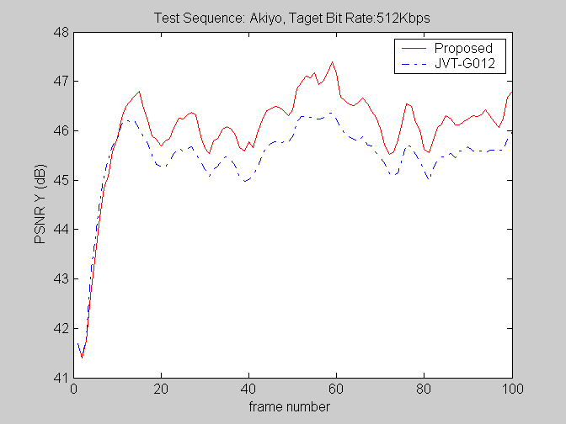

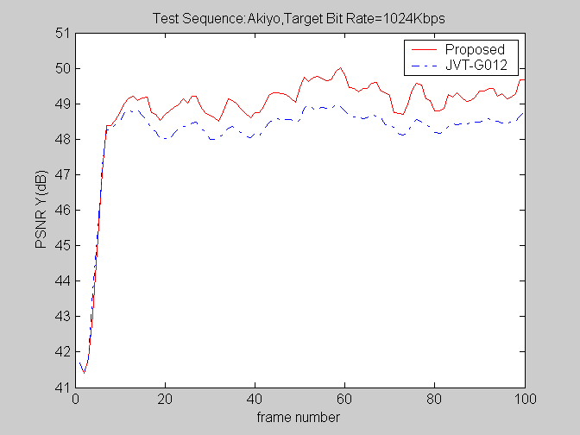

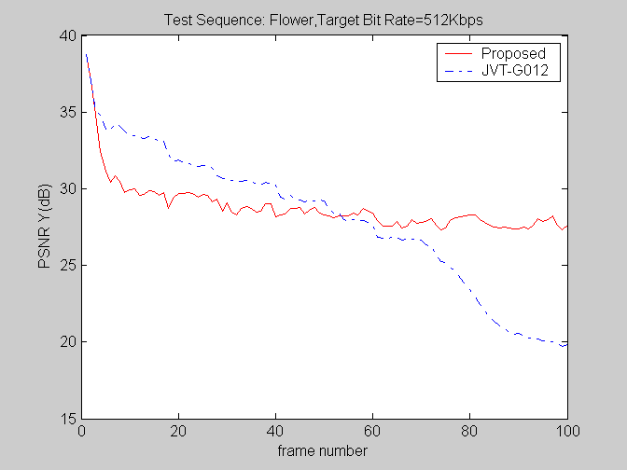

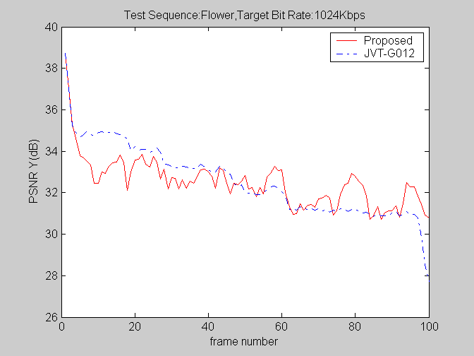

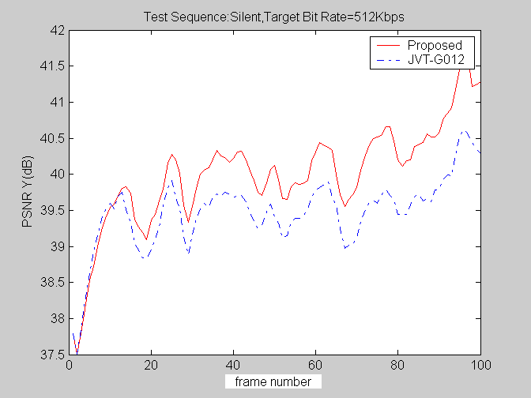
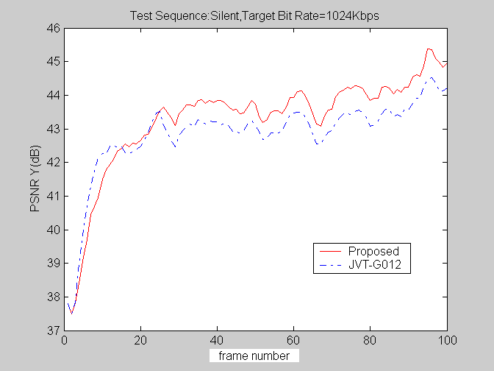

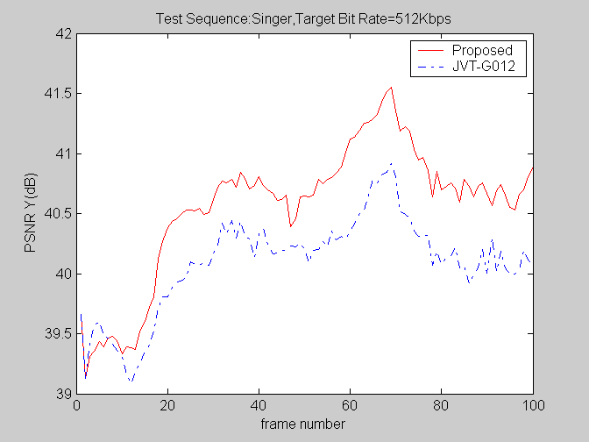
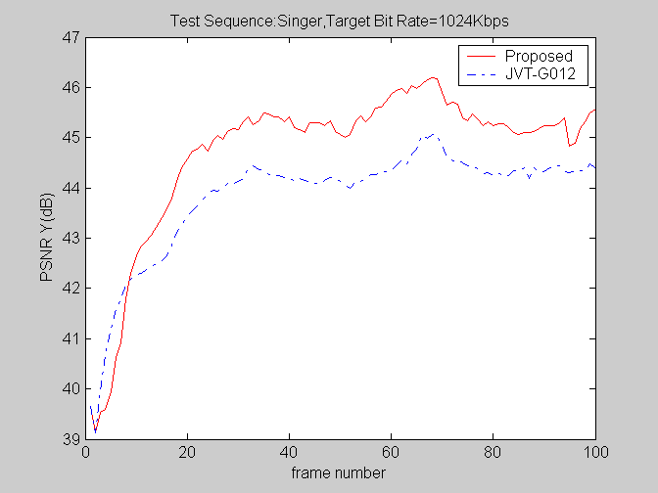

To give a further comparison between JVT-G012 and the proposed rate control schemes, we list experimental results in Table 2, where , where denotes the actual rate, while denotes the predicted rate.

Video  Sequences | encoder | SNR Y | SNR U | SNR V | Rate Prediction Error | Bit rate  (kbit/s) | Video  Sequences | encoder | SNR Y | SNR U | SNR V | Rate Prediction Error | Bit rate  (kbit/s)
Akiyo | JVT-G012 | 45.45 | 47.41 | 48.43 | 8.7407% | 512.64 | Silent | JVT-G012 | 39.48 | 42.82 | 43.74 | 8.169% | 512.75
Akiyo | Proposed | 46.01 | 47.86 | 48.77 | 6.239% | 512.17 |  | Proposed | 40.00 | 43.37 | 44.19 | 6.342% | 512.39
Akiyo | Improve | 0.56 | 0.45 | 0.34 | 2.5017% | 0.47 |  | Improve | 0.52 | 0.55 | 0.45 | 1.827% | 0.36
Akiyo | JVT-G012 | 48.16 | 49.22 | 50.00 | 7.2654% | 1024.84 |  | JVT-G012 | 42.85 | 45.20 | 45.94 | 2.609% | 1024.33
Akiyo | Proposed | 48.81 | 49.77 | 50.46 | 5.8999% | 1024.36 |  | Proposed | 43.27 | 45.75 | 46.45 | 9.375% | 1023.23
Akiyo | Improve | 0.65 | 0.55 | 0.46 | 1.3655% | 0.48 |  | Improve | 0.42 | 0.55 | 0.51 | -6.766% | 1.1
Flower | JVT-G012 | 28.00 | 33.77 | 36.51 | 550.8866% | 517.08 | Singer | JVT-G012 | 40.09 | 40.88 | 40.82 | 18.673% | 513.05
Flower | Proposed | 28.80 | 34.10 | 36.74 | 14.2098% | 513.82 |  | Proposed | 40.55 | 41.58 | 41.40 | 5.146% | 512.57
Flower | Improve | 0.8 | 0.33 | 0.23 | 536.6768% | 3.26 |  | Improve | 0.46 | 0.7 | 0.58 | 13.527% | 0.48
Flower | JVT-G012 | 32.57 | 35.88 | 37.69 | 220.3917% | 1033.75 |  | JVT-G012 | 43.82 | 44.24 | 44.23 | 19.04% | 1026.63
Flower | Proposed | 32.50 | 36.04 | 37.95 | 11.7862% | 1025.61 |  | Proposed | 44.71 | 45.25 | 45.06 | 7.167% | 1025.31
Flower | Improve | -0.07 | 0.16 | 0.26 | 208.6048 % | 8.14 |  | Improve | 0.89 | 1.01 | 0.83 | 11.873% | 1.32
Table 2 Comparison results

It is demonstrated in Table 2 that the proposed rate control scheme achieves higher coding performance in comparison with JVT-G012, with the gain up to 0.89 dB per frame. Meanwhile, the proposed rate control scheme reduces the average rate prediction errors, and also gains a mild save of the average bandwidth
The simulation results strongly show that the proposed algorithm provides a much more robust and accurate rate control than JVT-G012.

CONCLUDING REMARKS
There are several major contributions in this work. First, we have proposed a novel adaptive prediction scheme about coding-characteristic, by which the accuracy of R-D models is significantly improved, and therefore succeed to circumvent the dilemma caused by Lagrangian coder control.
Second, we proposed a new Q2 model, and a linear distortion model. A more precise overhead bit rate prediction is also presented here.
Third, based on these R-D models, a computational feasible solution to optimum bit allocation is achieved, by using Lagrangian optimization.
Experimental results show that the proposed rate control scheme outperforms JVT-G012, the current standardized rate control scheme. It is more accurate and robust.
Our work on rate control in the future will be concentrated on the following two aspects:
1) Exact segment video content according to spatio-temporal continuities.
2) Find a close-form solution to optimum bit allocation problem subject to constraints strengthened by the substantial requirements that the quantization parameter must vary slowly in a limited range.
Acknowledgment
This work was supported by National Nature Science Foundation of China under grant number 60302028.
References
- ITU-T and ISO/IEC JTC1, “Generic coding of moving pictures and associated audio information – Part 2: Video,” ITU-T Recommendation H.262 – ISO/IEC 13818-2 (MPEG-2), Nov. 1994..
- ITU-T, “Video coding for low bitrate communication,” ITU-T Recommendation H.263; version 1, Nov. 1995; version 2, Jan. 1998; version 3, Nov. 2000.
- ISO/IEC JTC1, “Coding of audio-visual objects – Part 2: Visual,” ISO/IEC 14496-2 (MPEG-4 visual version 1), Apr. 1999; Amendment 1 (version 2), Feb. 2000; Amendment 4 (streaming profile), Jan. 2001.
- T. Wiegand and G. J. Sullivan, “Draft ITU-T Recommendation H.264 and Final Draft International Standard of Joint Video Specification (ITU-T Recommendation H.264 | ISO/IEC 14496-10 AVC)”, Joint Video Team of ISO/IEC JTC1/SC29/WG11 and ITU-T SG16/Q.6 Doc. JVT-G050, Pattaya, Thailand, Mar. 2003.
- H.-M. Hang and J.-J. Chen, “Source model for transform video coder and its application—Part I: Fundamental theory,” IEEE Trans. Circuits Syst. Video Technol., vol. 7, pp. 287–298, Apr. 1997.
- J. Ribas-Corbera and S. Lei, “Rate control in DCT video coding for low-delay communications,” IEEE Trans. Circuits Syst. Video Technol.,vol. 9, pp. 172–185, Feb. 1999.
- B. Tao, H. A. Peterson, and B. W. Dickinson, “A rate–quantization model for MPEG Encoders,” in Proc. 1997 Int. Conf. Image Processing, Oct. 1997, pp. 338–341.
- W. Ding and B. Liu, “Rate control of MPEG video coding and recording by rate–quantization modeling,” IEEE Trans. Circuits Syst. Video Technol., vol. 6, pp. 12–20, Feb. 1996.
- L.-J. Lin and A. Ortega, “Bit-rate control using piecewise approximated rate–distortion characteristics,” IEEE Trans. Circuits Syst. Video Technol., vol. 38, pp. 82–93, Jan. 1990.
- T. Chiang and Y.-Q. Zhang, “A new rate control scheme using quadratic rate distortion model,” IEEE Transactions on Circuits and Systems for Video Technology, vol. 7, pp. 246–250, Feb. 1997.
- “Video Codec Test Model,” ITU-T/SG15, TMN8, Portland, OR, June, 1997.
- MPEG-2, Test Model 5, Doc. ISO/IEC JTC1/SC29 WG11/93-225b. Test Model Editing Committee,Apr.1993.
- Video Group, “Text of ISO/IEC 14496-2 MPEG-4 Video VM-Version 8.0,” ISO/IEC JTC1/SC29/WG11 Coding of Moving Pictures and Associated Audio MPEG 97/W1796, Stochholm, Sweden, July 1997.
- Wiegand T, Schwarz H, Joch A, Sullivan G, “Rate Constrained Coder Control and Comparison of Video Coding Standards,” IEEE Transactions on Circuits and Systems for Video Technology, vol. 13, pp. 688-703, July 2003.
- S.W. Ma, W. Gao, Y. Lu and H. Q. Lu, “Proposed draft description of rate control on JVT standard,” JVTF086, 6th meeting, Awaji, Japan, 5-13, December, 2002.
- Z.G. Li, F. Pan, K.P. Lim, G.N. Feng, X. Lin and S. Rahardaj, “Adaptive basic unit layer rate control for JVT,” JVT-G012, 7th meeting, Pattaya II, Thailand, 7-14, March, 2003.
- JM8.5, http://iphome.hhi.de/suehring/tml/download/old_jm/jm85.zip.
- J Chalidabhongse, C.-C. Jay Kuo, "Fast Motion Vector Estimation Using Multiresolution-Spatio-Temporal Correlations" IEEE Transactions on Circuits and Systems for Video Technology,, vol. 7, no. 3, pp. 477-488, 1997
- S. Zafar, Y.-Q. Zhang, and J. S. Baras, “Predictive block-matching motion estimation for TV coding—Part I: Inter-block prediction,” IEEE Trans. Broadcast., vol. 37, pp. 97–101, Sept. 1991.
- S. Zafar, Y. Q. Zhang, and B. Jabbari, “Multiscale video representation using multiresolution motion compensation and wavelet decomposition,” IEEE J. Select. Areas Commun., vol. 11, pp. 24–35, Jan. 1993.
- Y.-Q. Zhang and S. Zafar, “Predictive block-matching motion estimation for TV coding—Part II: Inter-frame prediction,” IEEE Trans. Broadcast.,vol. 37, pp. 102–105, Sept. 1991.
- H. J. Lee, T. Chiang, andY. Q. Zhang, “Scalable rate control for MPEG-4 video,” IEEE Trans. Circuits Syst. Video Technol., vol. 10, pp. 878–894, Sept. 2000.
- A. Viterbi and J. Omura, Principles of Digital Communication and Coding. New York: McGraw-Hill Electrical Engineering Series, 1979.
- D. A. Pierre, Optimization Theory with Applications. New York: Dover, 1986.

(Append for Proposal Documents)

JVT Patent Disclosure Form

International Telecommunication Union  Telecommunication Standardization Sector | International Organization for Standardization | International Electrotechnical Commission
 |  | 
Joint Video Coding Experts Group - Patent Disclosure Form
(Typically one per contribution and one per Standard | Recommendation)

Please send to:
JVT Rapporteur Gary Sullivan, Microsoft Corp., One Microsoft Way, Bldg. 9, Redmond WA 98052-6399, USA
Email (preferred): Gary.Sullivan@itu.int Fax: +1 425 706 7329 (+1 425 70MSFAX)

This form provides the ITU-T | ISO/IEC Joint Video Coding Experts Group (JVT) with information about the patent status of techniques used in or proposed for incorporation in a Recommendation | Standard. JVT requires that all technical contributions be accompanied with this form. Anyone with knowledge of any patent affecting the use of JVT work, of their own or of any other entity (“third parties”), is strongly encouraged to submit this form as well.

This information will be maintained in a “living list” by JVT during the progress of their work, on a best effort basis. If a given technical proposal is not incorporated in a Recommendation | Standard, the relevant patent information will be removed from the “living list”. The intent is that the JVT experts should know in advance of any patent issues with particular proposals or techniques, so that these may be addressed well before final approval.

This is not a binding legal document; it is provided to JVT for information only, on a best effort, good faith basis. Please submit corrected or updated forms if your knowledge or situation changes.

This form is not a substitute for the ITU ISO IEC Patent Statement and Licensing Declaration, which should be submitted by Patent Holders to the ITU TSB Director and ISO Secretary General before final approval.

Submitting Organization or Person:
Organization name | Institute of Computing Technology
Mailing address | Ke Xue Yuan South Road 6.  Haidian, Beijing, 100080, China
Country | China
Contact person | Yuan Wu
Telephone | (86-10) 62565533 ext 9604
Fax
Email | wyuan@ict.ac.cn
Place and date of submission | 4/12/2005
Relevant Recommendation | Standard and, if applicable, Contribution:
Name (ex: “JVT”) |  | JVT
Title |  | Optimum Bit Allocation and Rate Control for H.264/AVC
Contribution number |  | O016

(Form continues on next page)

Disclosure information – Submitting Organization/Person (choose one box)
2.0 The submitter is not aware of having any granted, pending, or planned patents associated with the technical content of the Recommendation | Standard or Contribution.

or,
The submitter (Patent Holder) has granted, pending, or planned patents associated with the technical content of the Recommendation | Standard or Contribution. In which case,

2.1 The Patent Holder is prepared to grant – on the basis of reciprocity for the above Recommendation | Standard – a free license to an unrestricted number of applicants on a worldwide, non-discriminatory basis to manufacture, use and/or sell implementations of the above Recommendation | Standard.
2.2 The Patent Holder is prepared to grant – on the basis of reciprocity for the above Recommendation | Standard – a license to an unrestricted number of applicants on a worldwide, non-discriminatory basis and on reasonable terms and conditions to manufacture, use and/ or sell implementations of the above Recommendation | Standard.

Such negotiations are left to the parties concerned and are performed outside the ITU | ISO/IEC.
2.2.1 The same as box 2.2 above, but in addition the Patent Holder is prepared to grant a “royalty-free” license to anyone on condition that all other patent holders do the same.
2.3 The Patent Holder is unwilling to grant licenses according to the provisions of either 2.1, 2.2, or 2.2.1 above. In this case, the following information must be provided as part of this declaration:
- patent registration/application number;
- an indication of which portions of the Recommendation | Standard are affected.
- a description of the patent claims covering the Recommendation | Standard;
In the case of any box other than 2.0 above, please provide the following:
Patent number(s)/status
Inventor(s)/Assignee(s)
Relevance to JVT
Any other remarks:
(please provide attachments if more space is needed)

(form continues on next page)
Third party patent information – fill in based on your best knowledge of relevant patents granted, pending, or planned by other people or by organizations other than your own.

Disclosure information – Third Party Patents (choose one box)
3.1 The submitter is not aware of any granted, pending, or planned patents held by third parties associated with the technical content of the Recommendation | Standard or Contribution.

3.2 The submitter believes third parties may have granted, pending, or planned patents associated with the technical content of the Recommendation | Standard or Contribution.

For box 3.2, please provide as much information as is known (provide attachments if more space needed) - JVT will attempt to contact third parties to obtain more information:

3rd party name(s)
Mailing address
Country
Contact person
Telephone
Fax
Email
Patent number/status
Inventor/Assignee
Relevance to JVT

Any other comments or remarks:

