Joint Video Team (JVT) of ISO/IEC MPEG & ITU-T VCEG  (ISO/IEC JTC1/SC29/WG11 and ITU-T SG16 Q.6)  11th Meeting: Munich, DE, 15-19 March, 2004 | Document: JVT-K0  Filename: input.doc

Title: | Performance Evaluation of the 8x8 Transform vs. Coefficient Adaptive Deadzone Consideration
Status: | Input Document to JVT
Purpose: | Information
Author(s) or  Contact(s): | Alexis Michael Tourapis  Jill Boyce  Thomson Corporate Research  2 Independence Way,  Princeton, NJ, 08540, USA | Tel: | 609-987-7329  609-987-7303
Author(s) or  Contact(s): |  | Email: | alexandros.tourapis@thomson.net  jill.boyce@thomson.net
Source: | Thomson
_____________________________

Introduction
In this document we present an evaluation of the recently proposed 8x8 intra prediction and transform compared to the original JM software, but also with an alternative approach which does not require any modification to the H.264 standard.

8x8 Prediction/Transform vs. JM Software
The 8x8 intra prediction and transform were recently proposed [1] to the H.264 (MPEG-4 AVC) standard as tools for the Professional Extensions profile, due to great concern that the standard could not perform well for High Definition material, and more specifically for Film Content. This approach demonstrated improvements of up to 10% in terms of bitrate reduction compared to the then most recent reference software, while also claiming better subjective quality on Film Content. Apparently though, all previous comparisons on the subjective and objective quality performance of H.264 for such content appear to have all been based on the JM reference software which is far from optimized. In particular, the software makes certain assumptions to reduce bitrate while not considering the impact in quality. These include the consideration of thresholding during the encoding of inter residues (either for 8x8 blocks or the entire Macroblock), the consideration of SKIP and Direct-SKIP Modes during Rate Distortion Optimization, but also with an increase in the deadzone used during quantization. Basically quantization of a coefficient W is performed as follows:

$$Z=\text{int}\left(\left\{\left|W\right|+f×(1\text{<<}q_{\text{bits}})\right\}\text{>>}\text{qbits}\right)⋅\text{sgn}\left(W\right)$$

where Z is the final quantized value, while q_bits is based on the current Macroblock’s quantizer QP. The term f×(1<<q_bits) serves as a rounding term for the quantization process, which “optimally” should be equal to 1/2×(1<<q_bits). Nevertheless, it is well known that the introduction of a deadzone during this process (i.e. reduction of the f term) can usually allow of an additional bitrate reduction, while having small impact in quality. This is especially true for lower resolution content which lack the details (and the film grain information) of higher resolution material. More specifically, for the reference JM software the values of f=1/3 for intra slices and f=1/6 for inter P and B slices were selected. Unfortunately though no consideration for higher resolution content was made during the selection of these parameters. Although f=1/2 could be used, this could also have a rather significant increase in bitrate, thus reducing the Rate Distortion performance of the JM reference software compared to the current method.

Considering that different frequencies are more important than others, we have instead evaluated a different approach. Instead of using a fixed f value on all transform coefficients, we have selected using a matrix approach where each deadzone parameter is selected based on position. Thus now $Z=\text{int}\left(\left\{\left|W\right|+f(i,j)×(1\text{<<}q_{\text{bits}})\right\}\text{>>}\text{qbits}\right)⋅\text{sgn}\left(W\right)$, where i and j correspond to the current column or row within the block transform coefficients. More specifically table f(.,.) was selected as :

 | 0 | 1 | 2 | 3
0 | 1/2 | 3/7 | 2/5 | 1/3
1 | 3/7 | 2/5 | 1/3 | 1/4
2 | 2/5 | 1/3 | 1/4 | 1/5
3 | 1/3 | 1/4 | 1/5 | 1/5
for intra slices, and:

 | 0 | 1 | 2 | 3
0 | 1/3 | 2/7 | 4/15 | 2/9
1 | 2/7 | 4/15 | 2/9 | 1/6
2 | 4/15 | 2/9 | 1/6 | 1/7
3 | 2/9 | 1/6 | 1/7 | 2/15

for inter slices. For example, for the DC term within intra slices, we will use f(0,0)=1/2, while for the AC term at position (3,3) f(0,0)=1/5 will be used instead. We have observed that this process could considerably improve both subjective and objective quality, and with a standard compliant modification within an encoder achieve comparable results to the 8x8 transform.

We need to point out that these matrices were selected empirically, and better or adaptive design (based on picture, slice, macroblock, or even block) could yield even better performance. For certain cases also it might be better instead of truncating to even round up a coefficient during quantization. This process nevertheless does not impact at all the decoder, and is fully compliant with the current standard specifications. We also need to point out that adaptation of the quantization parameters is an additional method of improving subjective or even objective quality, which has not yet been carefully explored within the evaluation of H.264.

References
- Gordon, S. et. al. Simplified Use of 8x8 Transforms – An Update, JVT-J029.
- Gordon, S. et. al. Simplified Use of 8x8 Transforms – Results, JVT-J030.
- Gordon, S. et. al. Simplified Use of 8x8 Transforms – JM Software Implementation Notes, JVT-J031.

Simulation Results
The 8x8 prediction and transform as was described in [1] and implemented in [3] were re-implemented within the latest JM reference software (JM7.5c). Similar testing conditions as were presented in [2] were selected to evaluate the performance of this new feature, although due to availability of some of the sequences we had to replace some of the sequences used. Furthermore, we have also implemented the adaptive quantization matrices in the same software to evaluate its impact in performance. We have performed two different experiments for our evaluation. For the first experiment (Table 1) we have used the following test conditions and sequences:

Entropy coding: CABAC
Search Range: +/-48
RDOpt: On
Hadamard: On
QP Settings: 20, 24, 28, 32 (QPI=QPP=QP)
Frame Coding
Loop Filter On
GOP Structure: IPPP
Frames Coded: 1 second
I Frame Period: ½ second
Reference Frames: 1

HD Test Sequences:
- one film sequence (1920x1080 @ 24P)
- Riverbed Black – 1920x1080 @ 24P video. MPEG test sequence.
- Rolling Tomatoes – 1920x1080 @24P video. MPEG test sequence.
- City – 1280x720 @ 60P video. MPEG test sequence
- Crew – 1280x720 @ 60P video. MPEG test sequence
- Harbour – 1280x720 @ 60P video. MPEG test sequence
- Raven – 1280x720 @ 60P video. MPEG test sequence

For the second experiment we selected from the above the film sequences and the sequences City, and Crew, and coded them with QP values 8, 12, 16, 20, and 24, while having the deblocking filter disabled (Table 2).
We immediately observe from the following figures and from Table 1 that the usage of the 8x8 prediction+transform can considerably improve performance compared to the original JM software. Nevertheless, we observe that the inclusion of the adaptive quantization matrices, reduces the performance gap considerably, and in some cases even outperforms the 8x8 transform. It should also be pointed out that these matrices were selected based on simple tests and were not designed optimally. Better selection or even dynamic adaptation of such matrices could yield even better results.

From Table 2, on the other hand, we observe that the benefit of 8x8 in the existing JM implementation tends to reduce as QP decreases. The consideration of the coefficient deadzoning mechanism, nevertheless, tends to instead yield higher performance at such bitrates.

In figures 11 and 12 we show portions from the generated frames for sequence rolling tomatoes using the three different encoders. Although the frame generated using the 8x8 transform appears slightly better than the one generated by the original encoder, it is slightly worse compared to the one generated by the Deadzone based encoder. This is more evident during playback where we have more severe quality variation of the 8x8 compared to the deadzone mechanism. Nevertheless, this should improve considerably with a deadzone mechanism adapted to the 8x8 transform.

To summarize, although the original benefit of the 8x8 transform was around 5.79% in terms of bitrate reduction (or equivalently 0.21dB increase in PSNR), this has been considerably reduced down to 2.52% in terms of bitrate (0.08dB increase in PSNR). A better deadzone mechanism could very likely improve performance better, while there are also several other normative tools already available in the encoder, that we will not describe here, which could provide further benefits. At the moment, we cannot quantify the impact that a different deadzone would have to either the 4x4 but also the 8x8 transform.
Table 1: Performance evaluation of the 8x8 Prediction + Transform compared to original and “Deadzone” modified JM (QP 20-32)
 |  |  | Original |  | 8x8 |  | Deadzone |  | 8x8 vs  Original JM  Average Δbitrate | 8x8 vs  Original JM  Average ΔPSNR | 8x8 vs  Deadzone JM  Average Δbitrate | 8x8 vs  Deadzone JM  Average ΔPSNR
Sequence | frames | QP | PSNR-Y | Bitrate | PSNR-Y | Bitrate | PSNR-Y | Bitrate
City | 60 | 20 | 41.715 | 33986960 | 41.789 | 32717656 | 42.083 | 35767624 | -5.02% | 0.162 | -3.10% | 0.089
City | 60 | 24 | 38.592 | 14187056 | 38.932 | 14837520 | 39.147 | 16741912
City | 60 | 28 | 35.881 | 5471760 | 36.151 | 5769576 | 36.321 | 6238992
City | 60 | 32 | 33.261 | 2331024 | 33.442 | 2381528 | 33.677 | 2556584
Crew | 60 | 20 | 43.039 | 24630712 | 43.113 | 24376528 | 43.521 | 27785096 | -4.44% | 0.112 | -0.74% | 0.012
Crew | 60 | 24 | 40.679 | 9786936 | 40.843 | 9943432 | 41.092 | 11285560
Crew | 60 | 28 | 38.853 | 4344808 | 38.923 | 4311080 | 39.21 | 4828376
Crew | 60 | 32 | 37.058 | 2203576 | 37.099 | 2146400 | 37.384 | 2375632
Raven | 60 | 20 | 44.011 | 13454976 | 44.093 | 13339848 | 44.406 | 15376944 | -7.10% | 0.235 | -3.49% | 0.115
Raven | 60 | 24 | 41.800 | 6005832 | 42.043 | 5992920 | 42.251 | 6743728
Raven | 60 | 28 | 39.634 | 2923728 | 39.854 | 2894680 | 40.091 | 3205784
Raven | 60 | 32 | 37.196 | 1557136 | 37.427 | 1537760 | 37.616 | 1681288
Rolling  Tomatoes | 24 | 20 | 42.344 | 21035440 | 42.252 | 20481800 | 42.708 | 24128144 | -1.00% | 0.031 | 0.25% | -0.012
Rolling  Tomatoes | 24 | 24 | 40.688 | 4945376 | 40.743 | 5036976 | 40.837 | 5936640
Rolling  Tomatoes | 24 | 28 | 40.107 | 2000264 | 40.163 | 1975528 | 40.195 | 2163336
Rolling  Tomatoes | 24 | 32 | 39.374 | 1138384 | 39.452 | 1161360 | 39.474 | 1182272
Harbour | 60 | 20 | 41.877 | 50288800 | 41.930 | 47063896 | 42.539 | 54160416 | -7.64% | 0.341 | -4.31% | 0.180
Harbour | 60 | 24 | 38.904 | 27300968 | 39.237 | 27101064 | 39.631 | 30981816
Harbour | 60 | 28 | 36.239 | 13981232 | 36.566 | 14073608 | 36.965 | 16227040
Harbour | 60 | 32 | 33.416 | 6847904 | 33.710 | 6829816 | 34.055 | 7759248
Riverbed | 30 | 20 | 42.478 | 71489936 | 42.375 | 67857560 | 42.971 | 73791792 | -9.23% | 0.425 | -1.76% | 0.076
Riverbed | 30 | 24 | 40.203 | 45218008 | 40.247 | 41878144 | 40.738 | 46833952
Riverbed | 30 | 28 | 38.024 | 28918560 | 38.105 | 26154568 | 38.559 | 30020144
Riverbed | 30 | 32 | 35.975 | 18360408 | 36.119 | 16488184 | 36.437 | 18922656
Movie1 | 24 | 20 | 43.574 | 10222064 | 43.572 | 9901312 | 43.919 | 12761672 | -6.10% | 0.178 | -4.50% | 0.132
Movie1 | 24 | 24 | 42.351 | 3319400 | 42.490 | 3180088 | 42.506 | 3696696
Movie1 | 24 | 28 | 41.424 | 1674704 | 41.581 | 1584760 | 41.569 | 1772720
Movie1 | 24 | 32 | 40.157 | 987248 | 40.382 | 965856 | 40.322 | 1025320
Average |  |  |  |  |  |  |  |  | -5.79% | 0.212 | -2.52% | 0.084

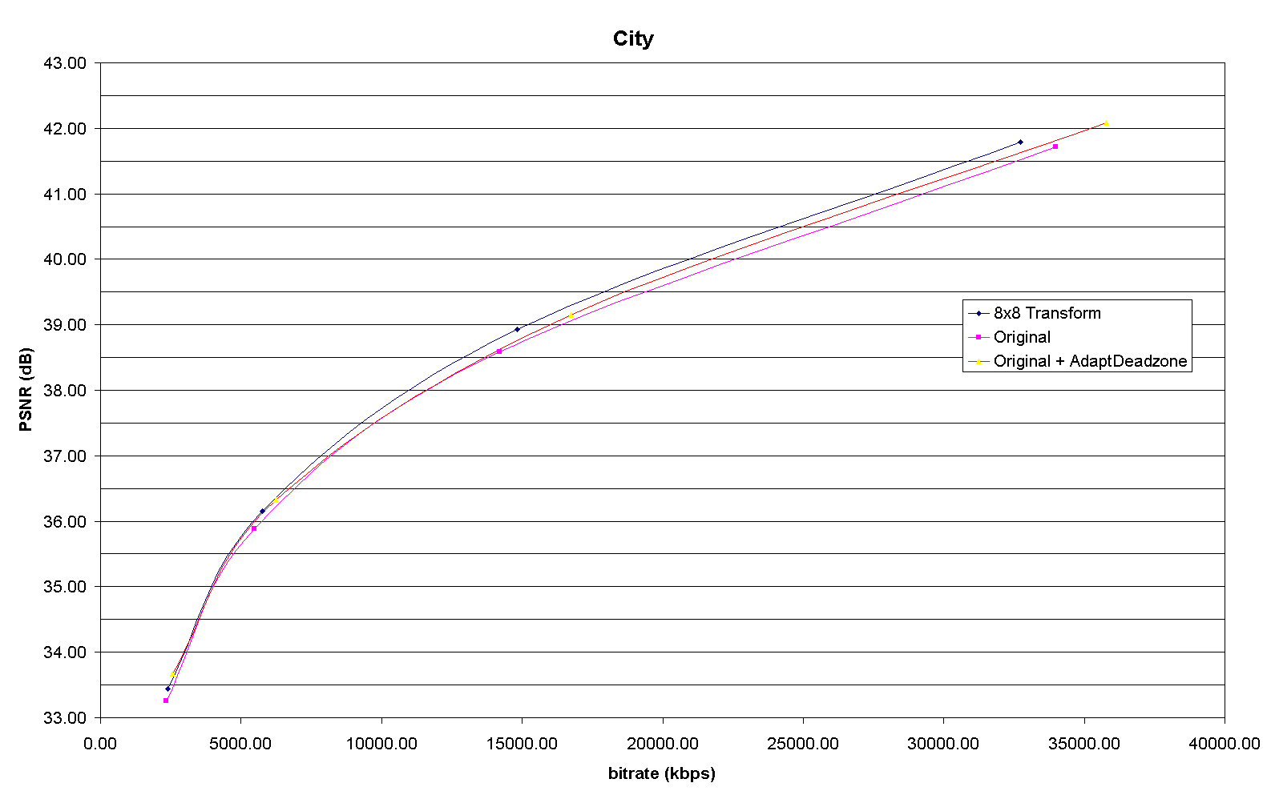
Figure 1. RD performance for Sequence City (QP 20-32)
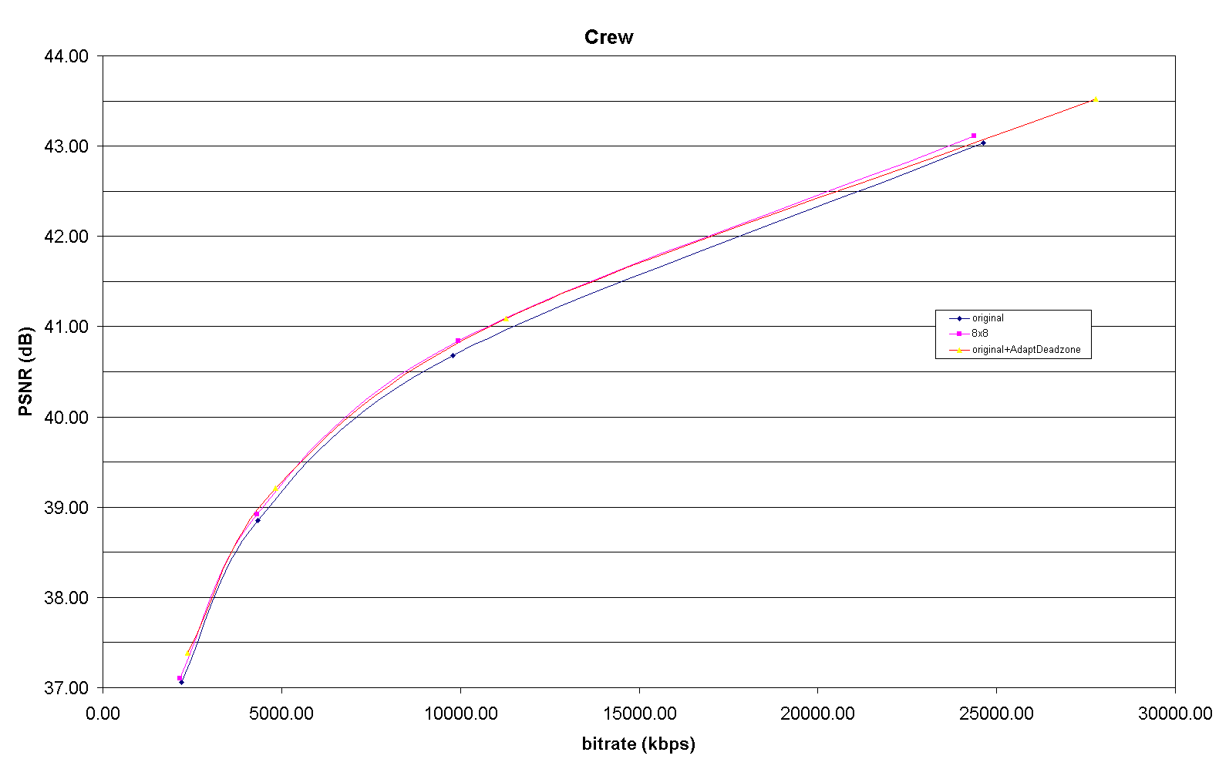
Figure 2. RD performance for Sequence Crew (QP 20-32)
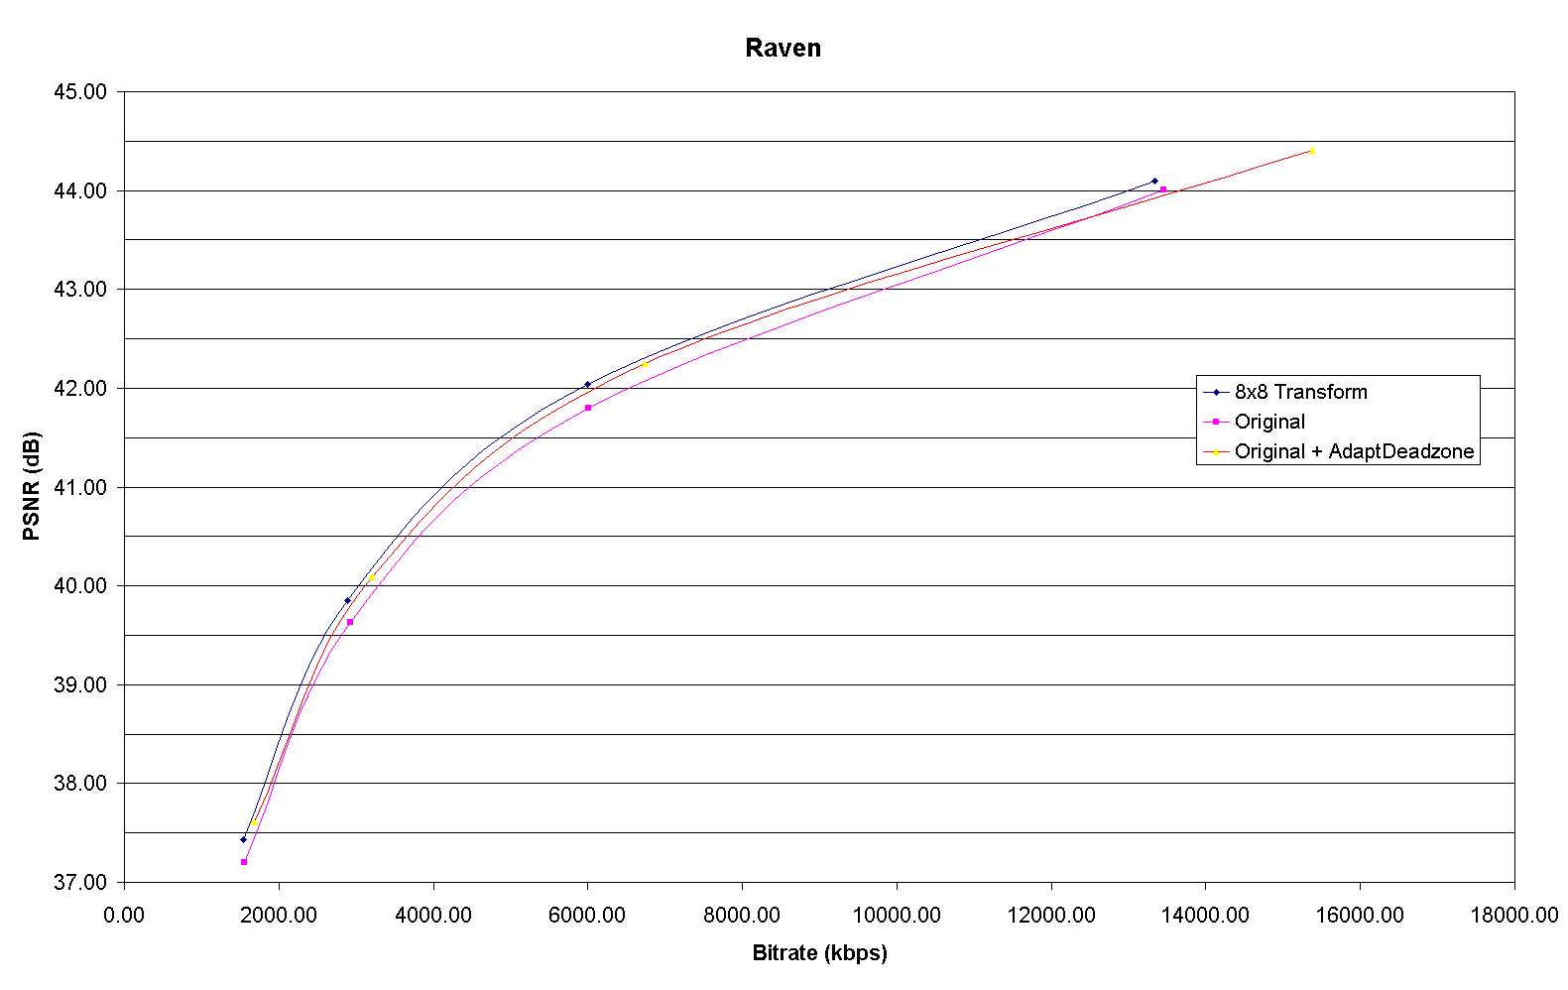
Figure 3. RD performance for Sequence Raven (QP 20-32)

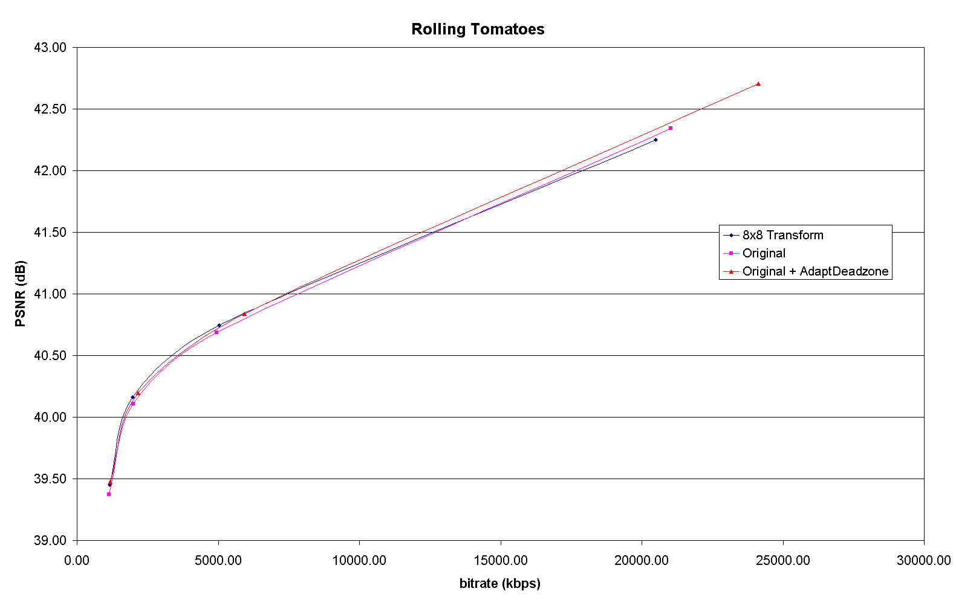
Figure 4. RD performance for Sequence Rolling Tomatoes (QP 20-32)

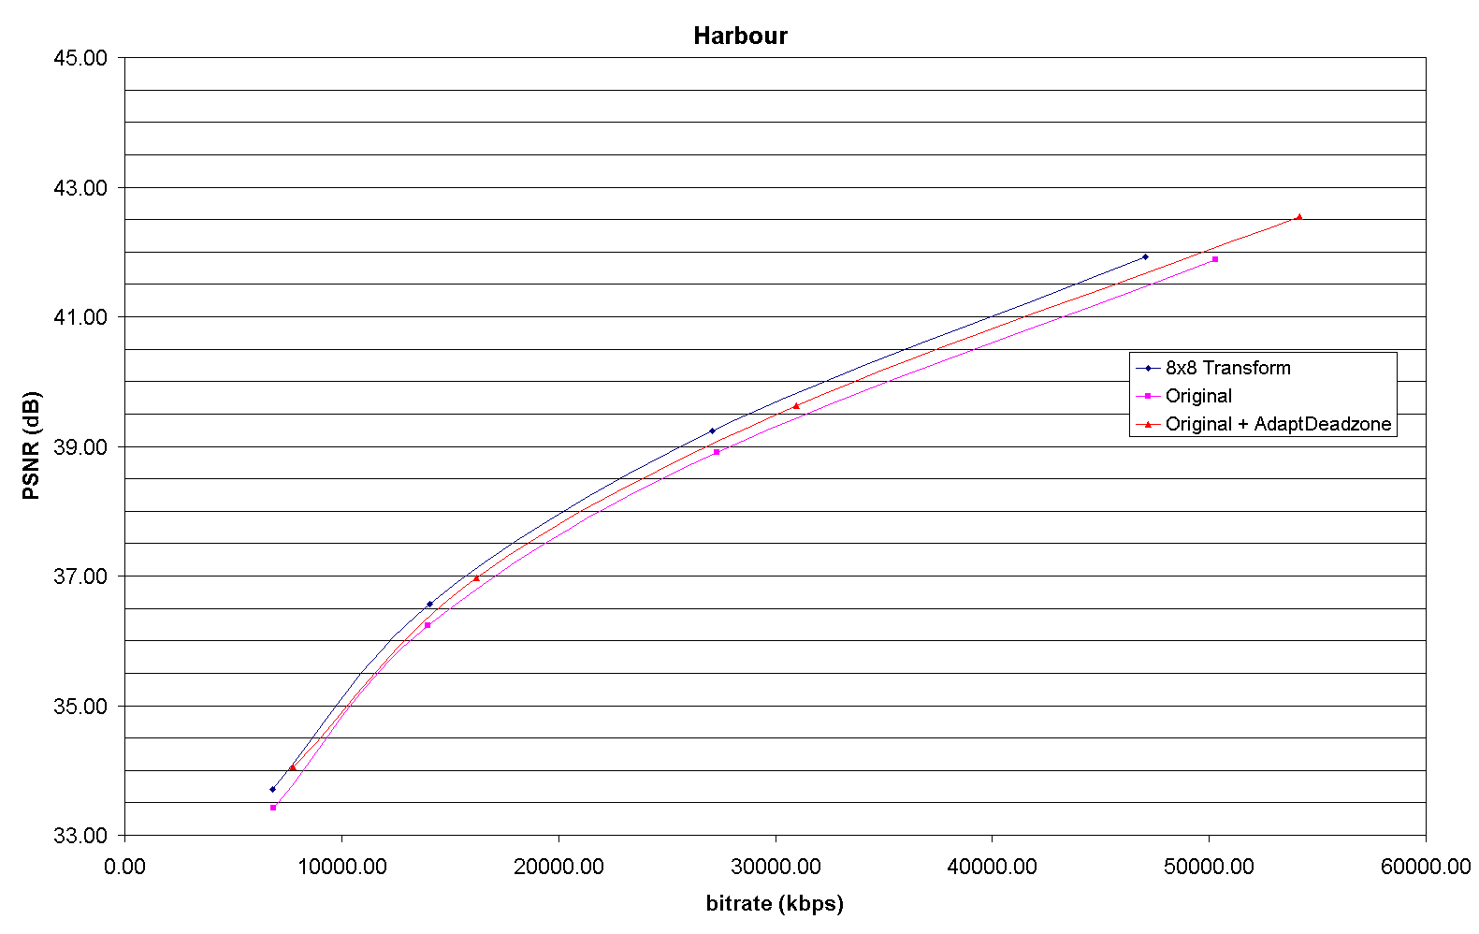
Figure 5. RD performance for Sequence Harbour (QP 20-32)
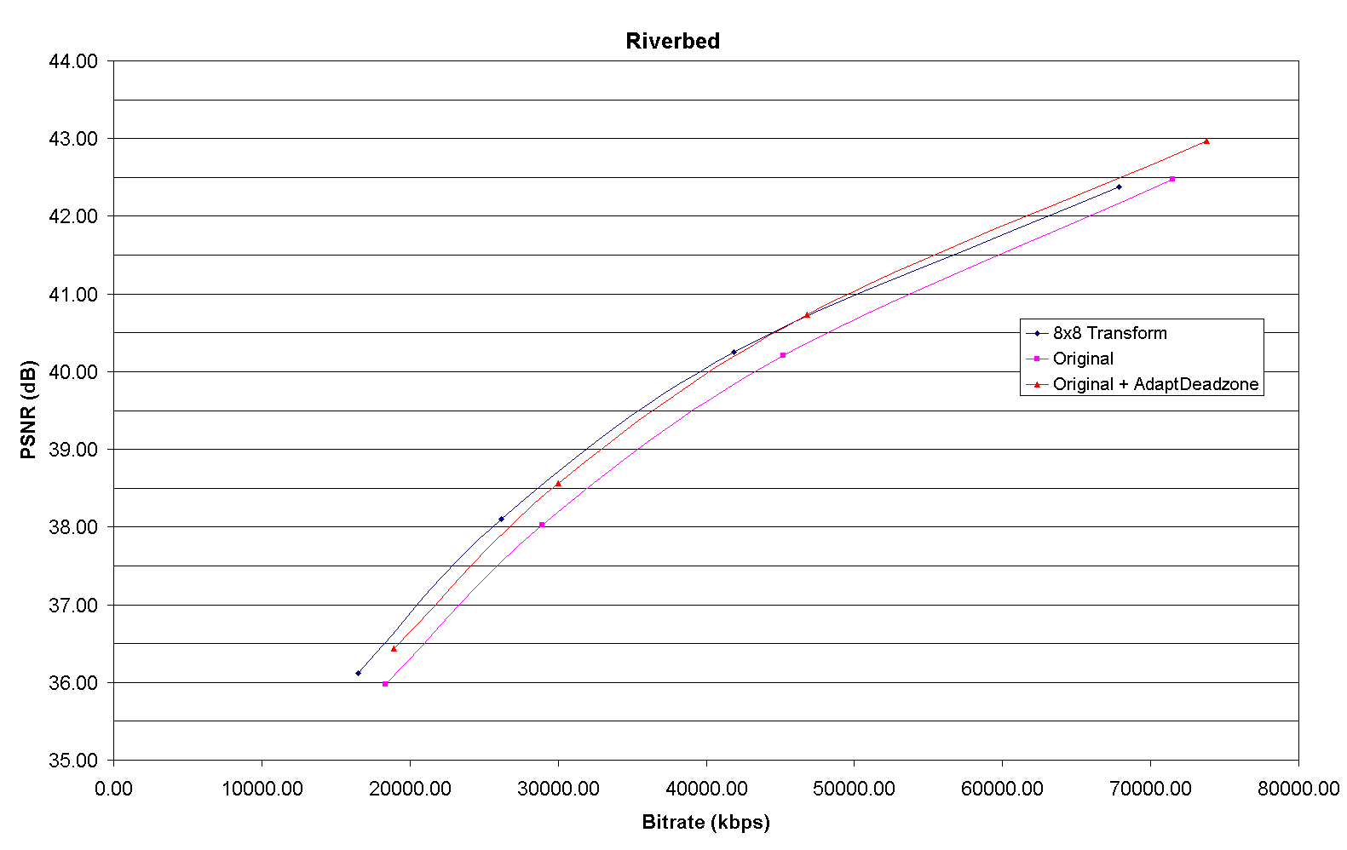
Figure 6. RD performance for Sequence Riverbed (QP 20-32)

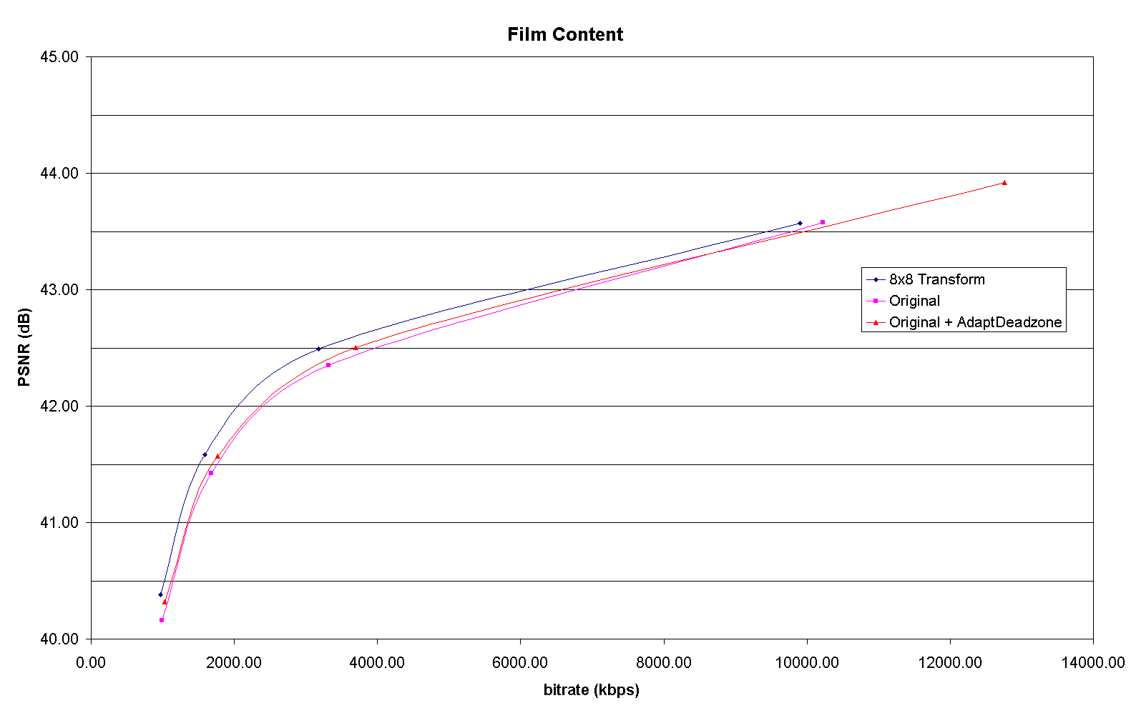
Figure 7. RD performance for Film Content (QP 20-32)

Table 2: Performance evaluation of the 8x8 Prediction + Transform compared to original and “Deadzone” modified JM (QP 8-24)
 |  |  | Original |  | 8x8 |  | Deadzone |  | 8x8 vs Original JM Average Δbitrate | 8x8 vs Original JM Average ΔPSNR | 8x8 vs Deadzone JM Average Δbitrate | 8x8 vs Deadzone JM Average ΔPSNR
Sequence | frames | QP | PSNRY | bitrate (kbps) | PSNRY | bitrate (kbps) | PSNRY | bitrate (kbps)
city | 60 | 8 | 51.70 | 144280.19 | 51.50 | 139746.30 | 52.32 | 145649.95 | -4.28% | 0.313 | 0.36% | -0.039
city | 60 | 12 | 48.28 | 99498.94 | 48.21 | 95142.20 | 48.91 | 102023.96
city | 60 | 16 | 45.07 | 64155.50 | 45.06 | 60682.64 | 45.69 | 67456.74
city | 60 | 20 | 41.70 | 34418.94 | 41.78 | 33041.00 | 42.29 | 37888.21
city | 60 | 24 | 38.53 | 14486.77 | 38.86 | 15153.65 | 39.15 | 16759.71
Crew | 60 | 8 | 52.78 | 136783.70 | 52.42 | 129372.98 | 53.30 | 138000.43 | -4.80% | 0.289 | -0.28% | 0.017
Crew | 60 | 12 | 49.51 | 90259.92 | 49.30 | 83175.97 | 49.99 | 91864.72
Crew | 60 | 16 | 46.36 | 54199.01 | 46.41 | 50833.24 | 46.90 | 56909.20
Crew | 60 | 20 | 43.20 | 25574.04 | 43.36 | 25130.65 | 43.65 | 27785.10
Crew | 60 | 24 | 40.67 | 10280.04 | 40.87 | 10377.16 | 41.12 | 11286.07
movie1 | 24 | 8 | 52.55 | 115590.03 | 52.47 | 114668.98 | 52.97 | 117304.09 | -4.59% | 0.181 | 2.75% | -0.113
movie1 | 24 | 12 | 49.17 | 68458.46 | 49.07 | 66750.03 | 49.56 | 70440.66
movie1 | 24 | 16 | 46.20 | 34003.70 | 46.17 | 33044.90 | 46.64 | 36969.71
movie1 | 24 | 20 | 43.62 | 11455.89 | 43.69 | 10821.74 | 43.94 | 12761.67
movie1 | 24 | 24 | 42.08 | 3762.33 | 42.34 | 3528.54 | 42.43 | 3697.61
Average |  |  |  |  |  |  |  |  | -4.55% | 0.261 | 0.94% | -0.045

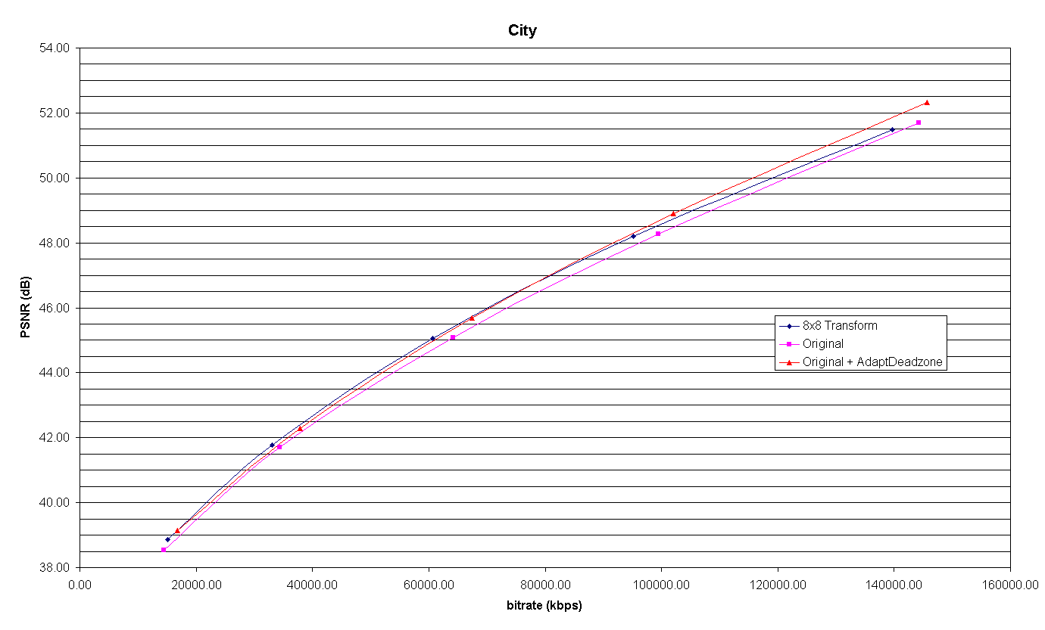
Figure 8. RD performance for Sequence City (QP 8-24)
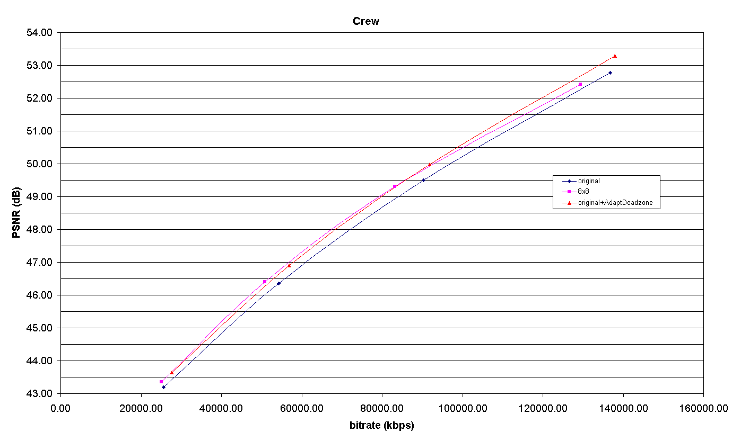
Figure 9. RD performance for Sequence Crew (QP 8-24)

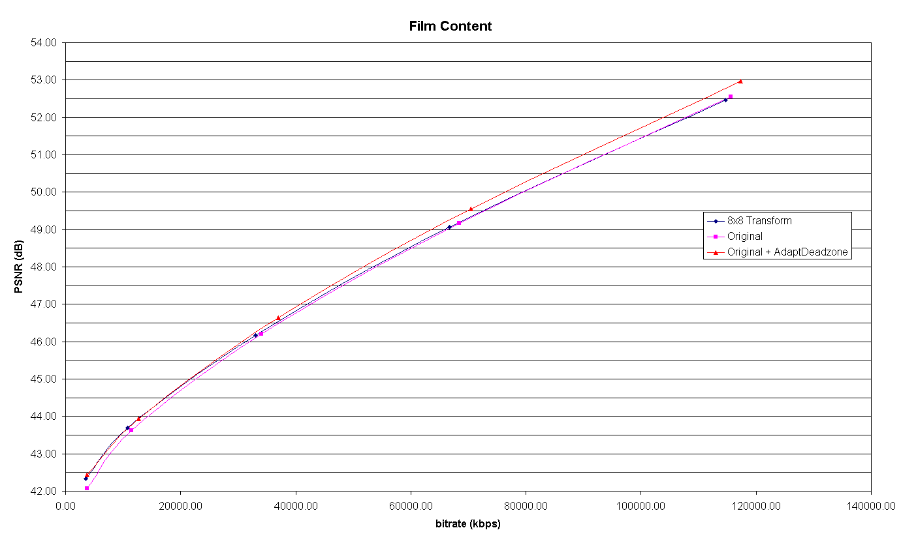
Figure 10. RD performance for Film Content (QP 8-24)

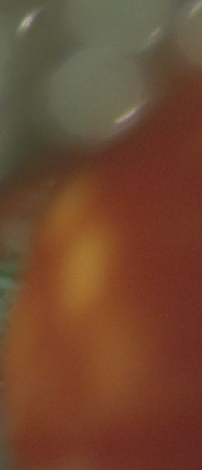 | 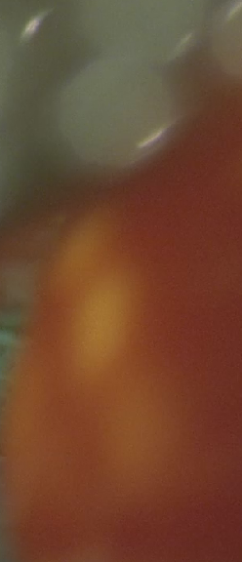 | 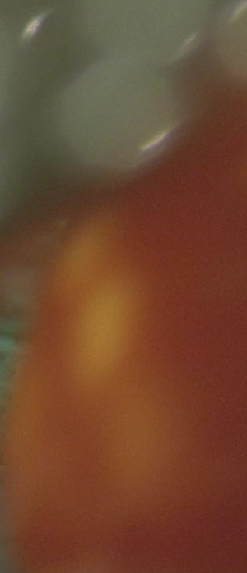
(a) | (b) | (c)
Figure 11. Film Grain Generation for rolling tomatoes frame 21 using (a) Original JM, (b) 8x8 transform, (c) Deadzone JM
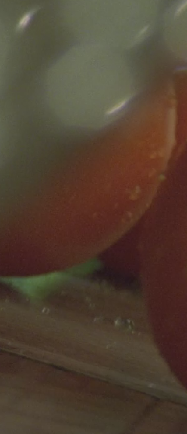 | 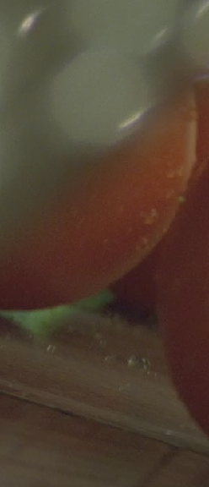 | 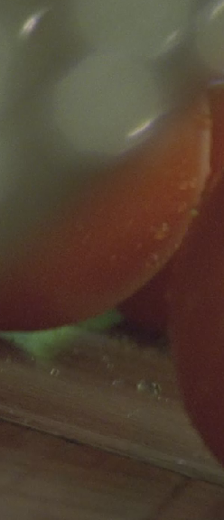
(a) | (b) | (c)
Figure 12. Film Grain Generation for rolling tomatoes frame 5 using (a) Original JM, (b) 8x8 transform, (c) Deadzone JM

(Append for Proposal Documents)

JVT Patent Disclosure Form

International Telecommunication Union  Telecommunication Standardization Sector | International Organization for Standardization | International Electrotechnical Commission
 |  | 
Joint Video Coding Experts Group - Patent Disclosure Form
(Typically one per contribution and one per Standard | Recommendation)

Please send to:
JVT Rapporteur Gary Sullivan, Microsoft Corp., One Microsoft Way, Bldg. 9, Redmond WA 98052-6399, USA
Email (preferred): Gary.Sullivan@itu.int Fax: +1 425 706 7329 (+1 425 70MSFAX)

This form provides the ITU-T | ISO/IEC Joint Video Coding Experts Group (JVT) with information about the patent status of techniques used in or proposed for incorporation in a Recommendation | Standard. JVT requires that all technical contributions be accompanied with this form. Anyone with knowledge of any patent affecting the use of JVT work, of their own or of any other entity (“third parties”), is strongly encouraged to submit this form as well.
This information will be maintained in a “living list” by JVT during the progress of their work, on a best effort basis. If a given technical proposal is not incorporated in a Recommendation | Standard, the relevant patent information will be removed from the “living list”. The intent is that the JVT experts should know in advance of any patent issues with particular proposals or techniques, so that these may be addressed well before final approval.
This is not a binding legal document; it is provided to JVT for information only, on a best effort, good faith basis. Please submit corrected or updated forms if your knowledge or situation changes.

This form is not a substitute for the ITU ISO IEC Patent Statement and Licensing Declaration, which should be submitted by Patent Holders to the ITU TSB Director and ISO Secretary General before final approval.

Submitting Organization or Person:
Organization name | Thomson
Mailing address | Thomson Corporate Research  2 Independence Way  Princeton, NJ, 08540
Country | USA
Contact person | Alexis Michael Tourapis
Telephone | 609-987-7329
Fax | 609-987-7299
Email | alexandros.tourapis@thomson.net
Place and date of submission | Munich, Germany, 3/10/2004
Relevant Recommendation | Standard and, if applicable, Contribution:
Name (ex: “JVT”) |  | VCEG
Title |  | Performance Evaluation of the 8x8 Transform vs. Coefficient Adaptive Deadzone Consideration
Contribution number |  | JVT-K0xx

(Form continues on next page)

Disclosure information – Submitting Organization/Person (choose one box)
2.0 The submitter is not aware of having any granted, pending, or planned patents associated with the technical content of the Recommendation | Standard or Contribution.

or,
The submitter (Patent Holder) has granted, pending, or planned patents associated with the technical content of the Recommendation | Standard or Contribution. In which case,

2.1 The Patent Holder is prepared to grant – on the basis of reciprocity for the above Recommendation | Standard – a free license to an unrestricted number of applicants on a worldwide, non-discriminatory basis to manufacture, use and/or sell implementations of the above Recommendation | Standard.
2.2 The Patent Holder is prepared to grant – on the basis of reciprocity for the above Recommendation | Standard – a license to an unrestricted number of applicants on a worldwide, non-discriminatory basis and on reasonable terms and conditions to manufacture, use and/ or sell implementations of the above Recommendation | Standard.

Such negotiations are left to the parties concerned and are performed outside the ITU | ISO/IEC.
2.2.1 The same as box 2.2 above, but in addition the Patent Holder is prepared to grant a “royalty-free” license to anyone on condition that all other patent holders do the same.
2.3 The Patent Holder is unwilling to grant licenses according to the provisions of either 2.1, 2.2, or 2.2.1 above. In this case, the following information must be provided as part of this declaration:
- patent registration/application number;
- an indication of which portions of the Recommendation | Standard are affected.
- a description of the patent claims covering the Recommendation | Standard;
In the case of any box other than 2.0 above, please provide the following:
Patent number(s)/status
Inventor(s)/Assignee(s)
Relevance to JVT
Any other remarks:
(please provide attachments if more space is needed)

(form continues on next page)
Third party patent information – fill in based on your best knowledge of relevant patents granted, pending, or planned by other people or by organizations other than your own.

Disclosure information – Third Party Patents (choose one box)
3.1 The submitter is not aware of any granted, pending, or planned patents held by third parties associated with the technical content of the Recommendation | Standard or Contribution.

3.2 The submitter believes third parties may have granted, pending, or planned patents associated with the technical content of the Recommendation | Standard or Contribution.

For box 3.2, please provide as much information as is known (provide attachments if more space needed) - JVT will attempt to contact third parties to obtain more information:

3rd party name(s)
Mailing address
Country
Contact person
Telephone
Fax
Email
Patent number/status
Inventor/Assignee
Relevance to JVT

Any other comments or remarks:

