Joint Video Team (JVT) of ISO/IEC MPEG & ITU-T VCEG  (ISO/IEC JTC1/SC29/WG11 and ITU-T SG16 Q.6)  11th Meeting: Munich, US, 15-19th March, 2004 | Document: JVT-K017  Filename: JVT-K017.doc

Title: | Verification of JVT-J024
Status: | Input Document to JVT
Purpose: | Information
Author(s) or  Contact(s): | Ce Zhu  School of EEE  Nanyang Ave  Nanyang Technological University  Singapore 639798  Weisong Qi  School of EEE  Nanyang Ave  Nanyang Technological University  Singapore 639798 | Tel:  Email:  Tel:  Email: | (65) 67906041  eczhu@ntu.edu.sg  (65) 67906547  p144471215@ntu.edu.sg
Source: | Nanyang Technological University, Singapore
_____________________________

Purpose
In document JVT-J024, a method for objective video quality measurements has been designed and implemented (See JVT-J024 for more details). This document provides a cross-verification of the results presented in JVT-J024.

Test Conditions
The results presented in JVT-J024 will be verified in this document. The test data consists of 90 test video sequences (in both CIF and QCIF video formats) and 12 original undistorted CIF and QCIF video sequences (namely “Container”, “Coast Guard”, “Japan League”, “Foreman”, “News”, and “Tempete” in both CIF and QCIF formats). Each of the video sequence consists of 250 frames.

Test Results
Table 1 shows the results of the video quality measurement method presented in JVT-J024 with respect to PSNR. The upper bound and lower bound of Pearson correlation were obtained with a confidence interval of 95%.
Figure 1 shows the scatterplot of subjective ratings versus the PSNR values, while Figure 2 shows the scatterplot of subjective ratings versus the video quality ratings estimated using the method presented in JVT-J024. In these two figures, the middle solid line portrays the logistic fit using a 4-parameter cubic polynomial, while the upper dotted curve and the lower dotted curve portray the upper bound and lower bound respectively obtained with a confidence interval of 95%.

 | Pearson-Correlation |  |  | Spearman-Correlation
 |  | Upper Bound | Lower Bound
PSNR | 0.701 | 0.793 | 0.578 | 0.676
JVT-J024 | 0.894 | 0.929 | 0.843 | 0.900

Table 1: Results of video quality measurement method presented in JVT-J024 and that given by PSNR

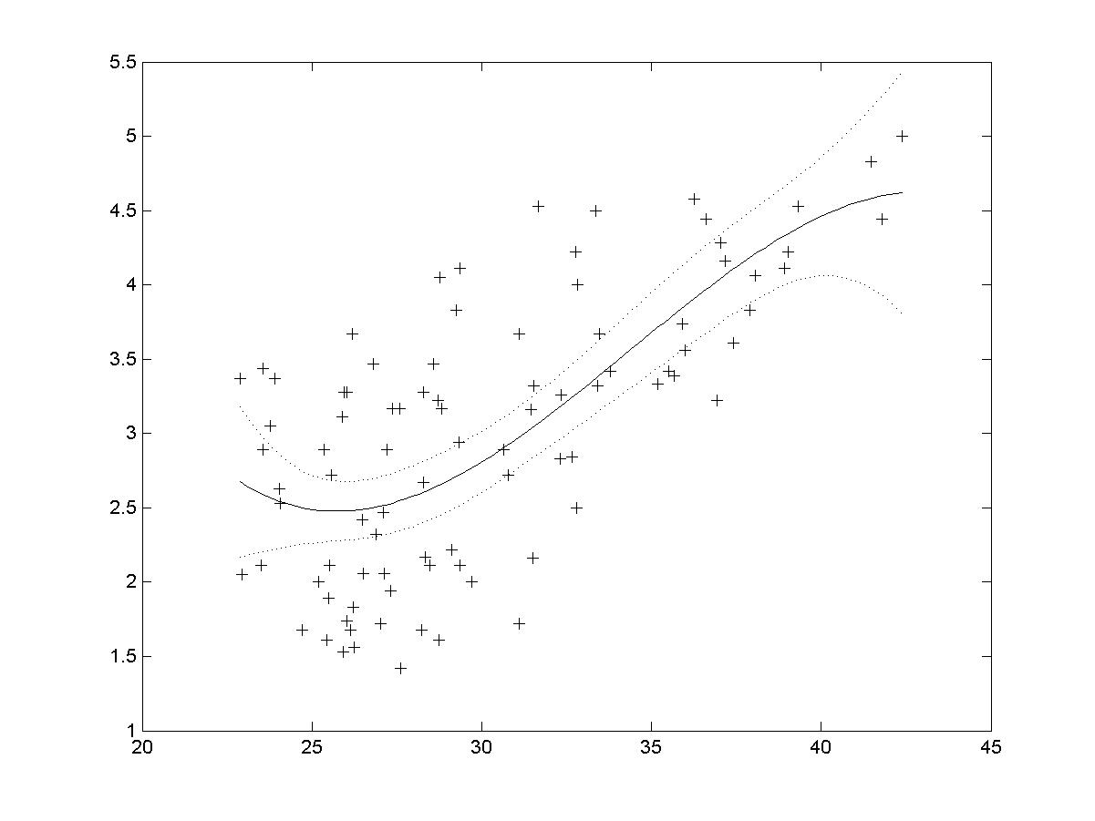

Figure 3: Scatterplot of subjective ratings vs PSNRs

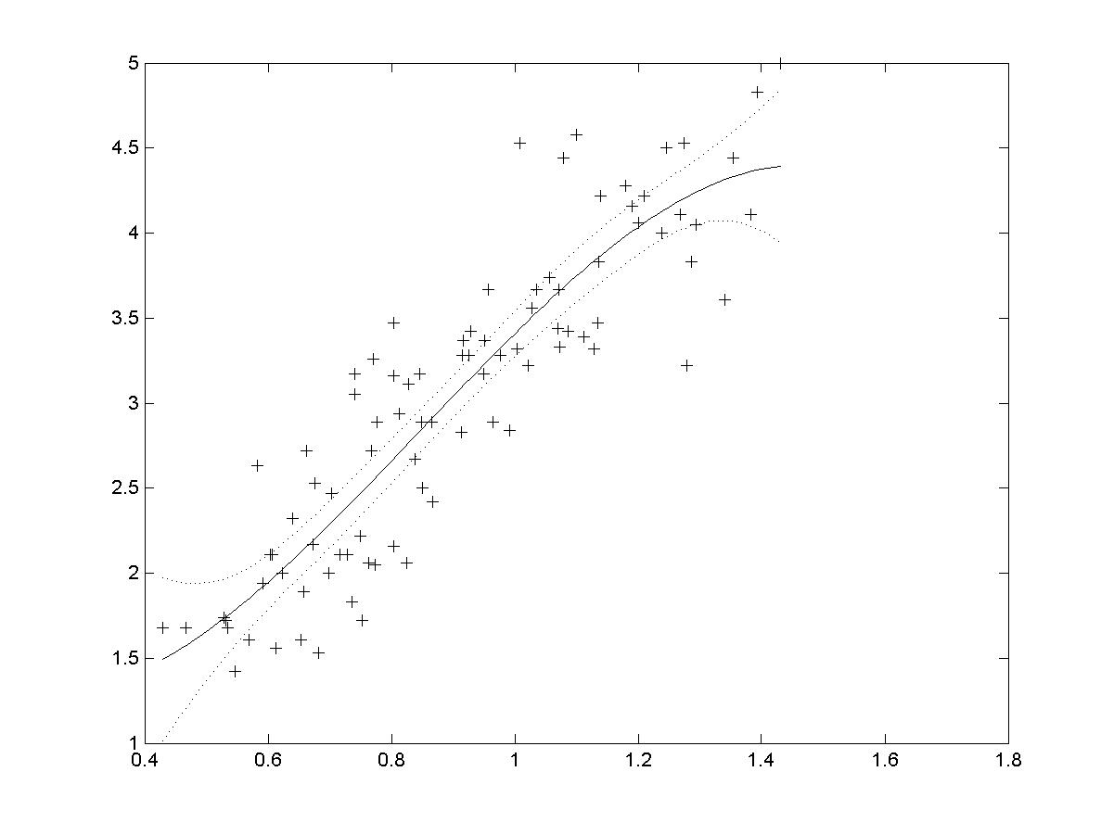

Figure 4: Scatterplot of subjective ratings vs metric outputs of the method proposed in JVT-J024

Conclusion
The results presented in the document JVT-J024 have been verified in this document. The results obtained here are found to be similar to that presented in JVT-J024 document.

(Append for Proposal Documents)
JVT Patent Disclosure Form

International Telecommunication Union  Telecommunication Standardization Sector | International Organization for Standardization | International Electrotechnical Commission
 |  | 
Joint Video Coding Experts Group - Patent Disclosure Form
(Typically one per contribution and one per Standard | Recommendation)

Please send to:
JVT Rapporteur Gary Sullivan, Microsoft Corp., One Microsoft Way, Bldg. 9, Redmond WA 98052-6399, USA
Email (preferred): Gary.Sullivan@itu.int Fax: +1 425 706 7329 (+1 425 70MSFAX)

This form provides the ITU-T | ISO/IEC Joint Video Coding Experts Group (JVT) with information about the patent status of techniques used in or proposed for incorporation in a Recommendation | Standard. JVT requires that all technical contributions be accompanied with this form. Anyone with knowledge of any patent affecting the use of JVT work, of their own or of any other entity (“third parties”), is strongly encouraged to submit this form as well.

This information will be maintained in a “living list” by JVT during the progress of their work, on a best effort basis. If a given technical proposal is not incorporated in a Recommendation | Standard, the relevant patent information will be removed from the “living list”. The intent is that the JVT experts should know in advance of any patent issues with particular proposals or techniques, so that these may be addressed well before final approval.

This is not a binding legal document; it is provided to JVT for information only, on a best effort, good faith basis. Please submit corrected or updated forms if your knowledge or situation changes.

This form is not a substitute for the ITU ISO IEC Patent Statement and Licensing Declaration, which should be submitted by Patent Holders to the ITU TSB Director and ISO Secretary General before final approval.

Submitting Organization or Person:
Organization name
Mailing address
Country
Contact person
Telephone
Fax
Email
Place and date of submission
Relevant Recommendation | Standard and, if applicable, Contribution:
Name (ex: “JVT”)
Title
Contribution number

(Form continues on next page)

Disclosure information – Submitting Organization/Person (choose one box)
2.0 The submitter is not aware of having any granted, pending, or planned patents associated with the technical content of the Recommendation | Standard or Contribution.

or,
The submitter (Patent Holder) has granted, pending, or planned patents associated with the technical content of the Recommendation | Standard or Contribution. In which case,

2.1 The Patent Holder is prepared to grant – on the basis of reciprocity for the above Recommendation | Standard – a free license to an unrestricted number of applicants on a worldwide, non-discriminatory basis to manufacture, use and/or sell implementations of the above Recommendation | Standard.
2.2 The Patent Holder is prepared to grant – on the basis of reciprocity for the above Recommendation | Standard – a license to an unrestricted number of applicants on a worldwide, non-discriminatory basis and on reasonable terms and conditions to manufacture, use and/ or sell implementations of the above Recommendation | Standard.

Such negotiations are left to the parties concerned and are performed outside the ITU | ISO/IEC.
2.2.1 The same as box 2.2 above, but in addition the Patent Holder is prepared to grant a “royalty-free” license to anyone on condition that all other patent holders do the same.
2.3 The Patent Holder is unwilling to grant licenses according to the provisions of either 2.1, 2.2, or 2.2.1 above. In this case, the following information must be provided as part of this declaration:
patent registration/application number;
an indication of which portions of the Recommendation | Standard are affected.
a description of the patent claims covering the Recommendation | Standard;
In the case of any box other than 2.0 above, please provide the following:
Patent number(s)/status
Inventor(s)/Assignee(s)
Relevance to JVT
Any other remarks:
(please provide attachments if more space is needed)

(form continues on next page)
Third party patent information – fill in based on your best knowledge of relevant patents granted, pending, or planned by other people or by organizations other than your own.

Disclosure information – Third Party Patents (choose one box)
3.1 The submitter is not aware of any granted, pending, or planned patents held by third parties associated with the technical content of the Recommendation | Standard or Contribution.

3.2 The submitter believes third parties may have granted, pending, or planned patents associated with the technical content of the Recommendation | Standard or Contribution.

For box 3.2, please provide as much information as is known (provide attachments if more space needed) - JVT will attempt to contact third parties to obtain more information:

3rd party name(s)
Mailing address
Country
Contact person
Telephone
Fax
Email
Patent number/status
Inventor/Assignee
Relevance to JVT

Any other comments or remarks:

