Joint Video Team (JVT) of ISO/IEC MPEG & ITU-T VCEG  (ISO/IEC JTC1/SC29/WG11 and ITU-T SG16 Q.6)  10th Meeting: Waikoloa, Hawaii, USA, 8-12 December, 2003 | Document: JVT-J039  Filename: JVT-J039.doc  Revision Date: 5 Dec 03

Title: | Introduction to the Viper Dataset
Status: | Input Document to JVT
Purpose: | Information
Author(s) or  Contact(s): | Pankaj Topiwala, Chengjie Tu  FastVDO LLC  7150 Riverwood Dr.  Columbia, MD 21046 USA | Tel:  Email: | 410-309-6066  pnt@fastvdo.com
Source: | FastVDO LLC
_____________________________
Abstract: This brief document serves to introduce the new, non-film, high-definition Viper dataset, acquired using Thomson’s VIPER HD camera. Characteristics of the VIPER camera have been presented in a Powerpoint document by Dave Bancroft of Thomson [1]. Here we present some elementary facts about the data, the test clips selected for testing for JVT Prof Extensions, and present examples of those clips.

1. Viper Camera

This section will be added later.

2. Viper Test Clips

The Viper data provided by Thomson has two files, one with just over 10,000 frames and over 80 GB in size, and a second one that is approximately half that size. The data conforms to the larger progressive (1080p) HD format: 1920 x 1080. We initially selected five clips of length 300 frames from this data, all from the long sequence. Immediately afterwards, it was suggested that the clips be reduced to only 60 frames, for convenience in testing – a suggestion we accepted, given time limitations. The criteria we used for clip selection included: high action, variation of lighting conditions (e.g., some daylight, some night), and color. However, we were unable to find any segments with fully saturated colors, a slight deficiency of this set.

Seq Name | Start Fr | End Fr | Total Fr | Description
Waves | 2100 | 2159 | 60 | Aerial view of ocean near land, sunset
Plane | 2505 | 2564 | 60 | Airplane taking off
KungFu | 3031 | 3090 | 60 | Two men in martial arts combat
Breeze | 3276 | 3335 | 60 | Woman in silky fabrics in a breeze
Night | 8400 | 8459 | 60 | Night scene over city.

Table 1. List of test sequences from the Viper Dataset. Clips were reduced in length to only 60 frames for initial convenience in testing. We believe that the 300 frame sequences we initially selected (with the same starting frame numbers) provide for a better test.

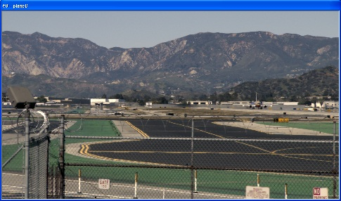

Figure 1. Plane sequence, here reduced to 960 x 536. This sequence has panning as well as focus on a moving jet. (The shortening to 60 frames has unfortunately reduced the higher action portion where the plane is in closer view.)

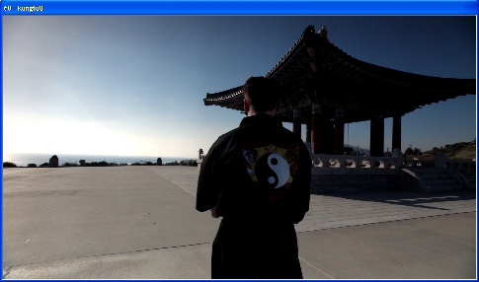

Figure 2. KungFu sequence (960x536). The camera follows the man in the foreground, and there is a martial arts battle in the scene. Vivid sky blues, but not many other colors.

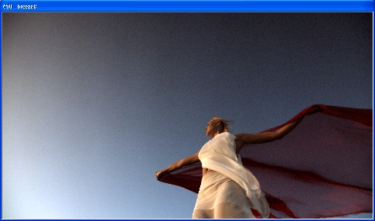

Figure 3. Breeze sequence. This may be the most interesting sequence in the test set. A breeze keeps the light clothes on the model flowing constantly. The cape is red, the sky is deep blue, her clothes are white, and there is exposed skin for accurate skin tone testing. Note that with the camera pointing skyward, there is visible sensor noise in the background.

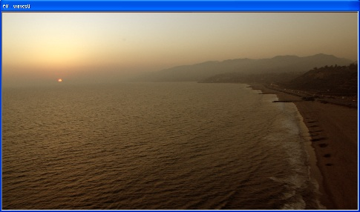

Figure 4. Waves sequence. This sequence is taken from a plane flying over the waves. The motion of the waves and the sensor platform make for difficult coding, although the colors are are soft. The sun is a yellow/orange, and accurate coding of that can be tested.

(Append for Proposal Documents)

JVT Patent Disclosure Form

International Telecommunication Union  Telecommunication Standardization Sector | International Organization for Standardization | International Electrotechnical Commission
 |  | 
Joint Video Coding Experts Group - Patent Disclosure Form
(Typically one per contribution and one per Standard | Recommendation)

Please send to:
JVT Rapporteur Gary Sullivan, Microsoft Corp., One Microsoft Way, Bldg. 9, Redmond WA 98052-6399, USA
Email (preferred): Gary.Sullivan@itu.int Fax: +1 425 706 7329 (+1 425 70MSFAX)

This form provides the ITU-T | ISO/IEC Joint Video Coding Experts Group (JVT) with information about the patent status of techniques used in or proposed for incorporation in a Recommendation | Standard. JVT requires that all technical contributions be accompanied with this form. Anyone with knowledge of any patent affecting the use of JVT work, of their own or of any other entity (“third parties”), is strongly encouraged to submit this form as well.

This information will be maintained in a “living list” by JVT during the progress of their work, on a best effort basis. If a given technical proposal is not incorporated in a Recommendation | Standard, the relevant patent information will be removed from the “living list”. The intent is that the JVT experts should know in advance of any patent issues with particular proposals or techniques, so that these may be addressed well before final approval.

This is not a binding legal document; it is provided to JVT for information only, on a best effort, good faith basis. Please submit corrected or updated forms if your knowledge or situation changes.

This form is not a substitute for the ITU ISO IEC Patent Statement and Licensing Declaration, which should be submitted by Patent Holders to the ITU TSB Director and ISO Secretary General before final approval.

Submitting Organization or Person:
Organization name | FastVDO LLC
Mailing address | 7150 Riverwood Dr., Columbia, MD 21046 USA
Country | USA
Contact person | Dr. Pankaj Topiwala
Telephone | 410-309-6066
Fax | 410-290-8050
Email | pnt@fastvdo.com
Place and date of submission | Waikoloa, Hawaii, USA 12/05/03
Relevant Recommendation | Standard and, if applicable, Contribution:
Name (ex: “JVT”) |  | JVT
Title
Contribution number |  | JVT-J039

(Form continues on next page)

Disclosure information – Submitting Organization/Person (choose one box)
X | 2.0 The submitter is not aware of having any granted, pending, or planned patents associated with the technical content of the Recommendation | Standard or Contribution.  or,
The submitter (Patent Holder) has granted, pending, or planned patents associated with the technical content of the Recommendation | Standard or Contribution. In which case,

 | 2.1 The Patent Holder is prepared to grant – on the basis of reciprocity for the above Recommendation | Standard – a free license to an unrestricted number of applicants on a worldwide, non-discriminatory basis to manufacture, use and/or sell implementations of the above Recommendation | Standard.
2.2 The Patent Holder is prepared to grant – on the basis of reciprocity for the above Recommendation | Standard – a license to an unrestricted number of applicants on a worldwide, non-discriminatory basis and on reasonable terms and conditions to manufacture, use and/ or sell implementations of the above Recommendation | Standard.

Such negotiations are left to the parties concerned and are performed outside the ITU | ISO/IEC.
 | 2.2.1 The same as box 2.2 above, but in addition the Patent Holder is prepared to grant a “royalty-free” license to anyone on condition that all other patent holders do the same.
2.3 The Patent Holder is unwilling to grant licenses according to the provisions of either 2.1, 2.2, or 2.2.1 above. In this case, the following information must be provided as part of this declaration:
- patent registration/application number;
- an indication of which portions of the Recommendation | Standard are affected.
- a description of the patent claims covering the Recommendation | Standard;
In the case of any box other than 2.0 above, please provide the following:
Patent number(s)/status
Inventor(s)/Assignee(s)
Relevance to JVT
Any other remarks:
(please provide attachments if more space is needed)

(form continues on next page)
Third party patent information – fill in based on your best knowledge of relevant patents granted, pending, or planned by other people or by organizations other than your own.

Disclosure information – Third Party Patents (choose one box)
x | 3.1 The submitter is not aware of any granted, pending, or planned patents held by third parties associated with the technical content of the Recommendation | Standard or Contribution.
 | 3.2 The submitter believes third parties may have granted, pending, or planned patents associated with the technical content of the Recommendation | Standard or Contribution.
For box 3.2, please provide as much information as is known (provide attachments if more space needed) - JVT will attempt to contact third parties to obtain more information:

3rd party name(s)
Mailing address
Country
Contact person
Telephone
Fax
Email
Patent number/status
Inventor/Assignee
Relevance to JVT

Any other comments or remarks:

