Joint Video Team (JVT) of ISO/IEC MPEG & ITU-T VCEG  (ISO/IEC JTC1/SC29/WG11 and ITU-T SG16 Q.6)  10th JVT Meeting 8-12 December, 2003, Hawaii | Document: JVT-J018  Filename: JVT-J018.doc

Title: | Proposal for the unsolved issues in Professional Extensions II
Status: | Input Document to JVT
Purpose: | Proposal
Author(s) or  Contact(s): | Woo-Shik Kim,  Dae-Sung Cho,  Hyun Mun Kim  Multimedia Lab. Samsung AIT  P.O.Box 111, Suwon 440-600  Korea | Tel:  Email: | 82-31-280-9204  hyunmun27.kim@samsung.com
Source: | Samsung AIT
_____________________________
- Introduction

This proposal addresses issues that were not resolved from the previous meeting in San Diego [1]. It includes the intra Chroma prediction, MC interpolation method, CBP coding for 4:4:4 Chroma formats. We also propose a mathematically lossless RGB coding for archive uses and XYZ coding. For each of this issue we propose solutions that need minimal syntax changes while giving better compression efficiency. In the subsequent sections we describe the proposed methods in detail.

- Proposed Methods

In this section, we summarize the proposed methods for the issues aforementioned.

  - Lossless RGB Coding

The lossless coding is required for the archive usage. To support mathematically lossless coding, we propose to use the same Inter-Plane Prediction (IPP) coding in [2] without transformation and quantization part to guarantee lossless coding. To compare the coding efficiency, we compared our lossless coding method with the YCoCg-R method that guarantees the reversibility using lifting scheme [3]. The simulation results are summarized in Section 3.

  - Intra Chroma Prediction

Two methods were proposed for intra Chroma prediction for 4:4:4 format.
In [4], only Intra_16x16 prediction was used for the intra Chroma prediction even though there are two modes (4x4 and 16x16 prediction) for Luma cases. It will decrease the coding efficiency since there are many cases where 16x16 intra prediction is not good enough due to the local characteristics of Chroma plane.
On the other hand, we proposed to use two modes for the Chroma cases as in the Luma cases. To further exploit the texture correlation between the Luma and the Chroma components, we used the same intra prediction for the Luma and Chroma cases [2]. For example, when Intra_4x4 Horizontal prediction is selected, all components use the same Intra_4x4 Horizontal prediction. This single mode can reduce the encoder complexity while slightly sacrificing the coding efficiency when compared with the case that relaxes the condition of single mode. Figure 1 compares the coding efficiency when using single mode against the one proposed in [4]. The R-D curves are almost identical. We can always relax the single mode constraint so that we have different intra prediction modes for each component. It becomes the super set of only 16x16 prediction mode for the Chroma components. So we can always achieve the better coding efficiency than the one in [4].

Figure 1: comparison between single mode and independent mode. The Blue line is the one proposed in [4] and the purple line is the one using single mode.

  - MC Interpolation for 4:4:4 Chroma formats

We conducted an extensive simulation to compare the performances between 6-tab filter and bilinear transform for various 4:4:4 chroma format contents both in YUV and RGB spaces. Table 1 shows the summary of MC interpolation results when we apply the filtering to high resolution images and low resolution images in both spaces.

Table1: Selection of best performance for MC interpolation method.
 | High Resolution (HD) | Low Resolution (SD)
RGB space | Bilinear Transform (BT) | 6-tab filter
YUV space | BT | Y:6-tab UV:BT

It shows that bilinear transform gives better performance for more correlated images such as high resolution images or UV components. For low resolution images, 6-tab shows better results for RGB images while 6-tab for Y and bilinear transform for UV shows better performance. In RGB space each component shows the similar characteristics among components. But in YUV space Y component and UV components show the different characteristics.
For 4:2:0 Chroma format, JVT uses bilinear transform for Chroma components [5]. To compare the spectral characteristics of downsampled image, we plot the power spectrum magnitude of football image between full resolution and subsampled image. It shows that subsampled image contains more high frequency terms due to decimation. So we propose to use bilinear transform since the 4:4:4 format Chroma components contain less high frequency terms than 4:2:0 format Chroma components do.

Based on this observation we propose to use bilinear transform for 4:4:4 format Chroma components.

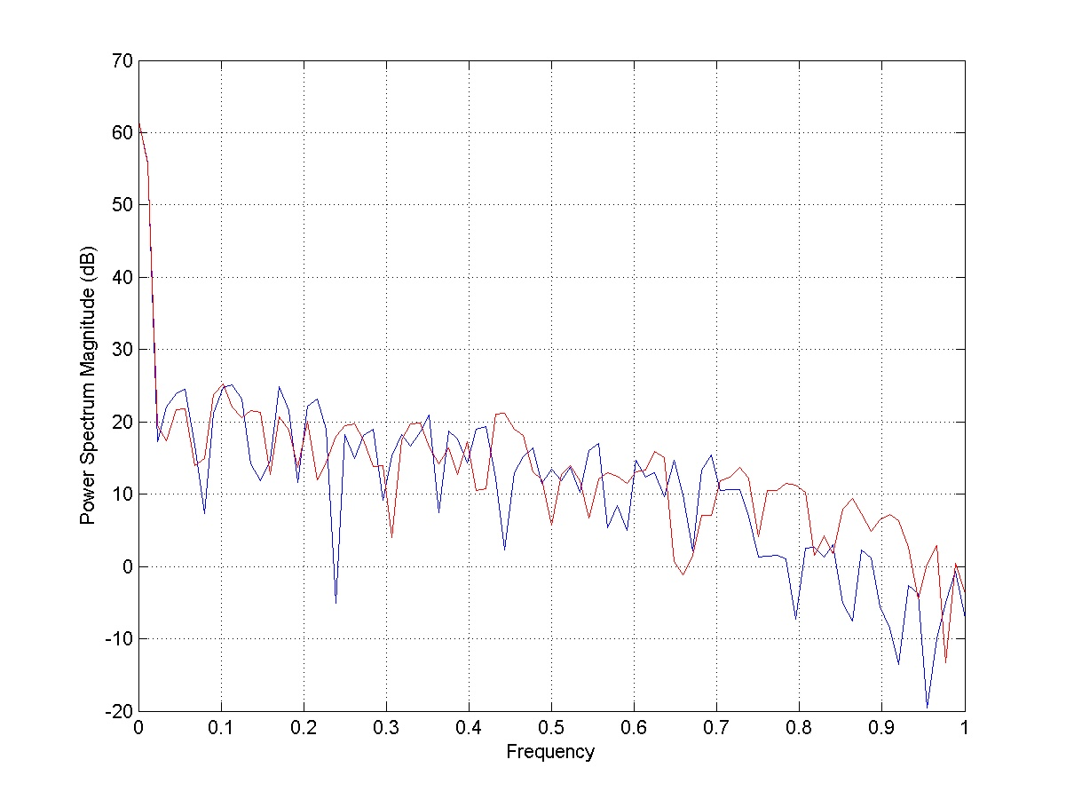

Figure 2: Plot of power spectral density function. The red one is obtained by subsampling the original full resolution image. It shows that downsampled image contains more high frequency terms than the full resolution image.

  - CBP Coding for 4:4:4 Chroma formats

In this application we propose how to code the coded_block_pattern efficiently for 4:4:4 chroma format. Depending on partitions, the bit saving gain differs. For example as shown in Figure 3, we can assign coded_block_pattern bit independently for each 8x8 block from YUV components. In this case we have $2^{\text{12}}$ different cases to code the coded_block_pattern. On the other hand, we can combine the coded_block_pattern bit for the collocated 8x8 blocks in UV components as shown in Figure 4. In this case there are $2^{8}$ different cases. To compare the coding efficiency we need to estimate the bit saving gain for each possible partition.

Figure 3: 12 independent Coded Block Pattern coding

Figure 4: 8 independent Coded Block Pattern coding (4 for Y and 4 for UV components)

For this purpose, we formulate the bit saving gain as follows:

$\text{Gain}=4×A×1−H×N$ (1)

where A is the number of not coded 8x8 blocks in a frame, H is the entropy of the coded_block_pattern and N is the number of macroblocks in a frame. Here we assume that we need H bits to code the coded_block_pattern for each macroblock and 1 bit per 4x4 block to code a coded_block_flag. The number of not coded 8x8 blocks differs depending on the partitions. For example in Figure 3, any block that is not coded is counted while in Figure 4, both of the collocated 8x8 blocks in UV components should not be coded to be counted as not coded blocks. Using this method, we estimated the bit saving gain for the following partitions.
- 12x1 (combined coding using 12 8x8 blocks)
- 4+8 (separate coding for Y and UV components using 12 8x8 blocks)
- 4+4+4 (separate coding for YUV components using 12 8x8 blocks)
- 8x1 (combined coding using 8 8x8 blocks)
- 4+4 (separate coding for Y and UV components using 8 8x8 blocks)
- 6x1 (current scheme for 4:2:0 format)

For cases 1-3 we use the partition in Figure 3 while for cases 4-5 we use the partition in Figure 4. The difference between case 1 and 2 is that we use separate codebooks between Y component and UV component in case (2) while we use one codebook to represent the $2^{\text{12}}$ cases in case (1). We use the following formula if separate coding is involved as in cases 2, 3 and 5.

$\text{Gain}=4×A−N×\sum_{i}{H_{i}}$ (2)

where i is the number of independent cases and $H_{i}$.is the corresponding entropy for that case.

Using (1) and (2) we run the test for several images. The simulation results show that case 1 shows the best performance followed by case (4). For cases 2 and 3, their gain is decreased due to the increased entropy for separate coding. It is more efficient to generate codewords for groups or sequences of symbols rather than generating a separate codeword for each symbol in a sequence.
To compare the case 1 and 4 we need to consider the several factors other than the coding gain. The current JVT coding uses the either context adaptive arithmetic coding (CABAC) or Exp-Golomb code. The CABAC is not affected by the long sequence of symbols because we don’t have to generate codewords for all sequences of the given length. But the Exp_Golomb code should generate codewords for all sequences of the given length (12 for case 1). But this approach is impractical when we try to obtain codewords for long sequences of symbols. Another factor is that as we decrease the quantization step size, the number of not coded blocks decreases more rapidly than the entropy. So the coding gain order is reversed between (1) and (4). For 4:4:4 chroma formats, we assume that the popular quantization step size will be lower than that of 4:2:0 formats. So we propose case (4) for coded_block_pattern coding in 4:4:4 chroma formats. It will give the better coding efficiency for lower quantization step sizes along with the compressed codebook for Exp-Golomb code. The 6-bit assignment for the coded_block_pattern as in the 4:2:0 chroma format case [5] shows poor performance due to the increased resolution of the UV components.

So we propose to use 8 bit as shown in Figure 4.

  - XYZ Coding

The XYZ coding was addressed in the call for proposal [6]. We coded XYZ data using IPP method treating Y component as a pivot component. So it shares the same coding method with IPP based RGB coding. Since we do not have original XYZ data we converted the RGB film material into XYZ. The PSNR value was obtained using the converted XYZ as original. It shows the efficiency of IPP method for XYZ color space.

- Experimental Results

This section summarizes the simulation results of lossless RGB coding and XYZ coding.
The test condition is as follows:

- Entropy coding: CABAC
- RD-optimized mode selection: On
- Number of reference frames: 3
- GOP structure: N 30, M 3 (IBBP…)

Figure 5 summarizes the lossless coding simulation results. It clearly shows the efficiency of the inter-plane prediction.

Figure 5: Comparison of coding efficiency between IPP and YCoCg-R lossless coding. For all the tested images, IPP shows better compression.

Figure 6 summarizes the simulation results for XYZ data. It also shows the efficiency of the inter-plane prediction. We tested the XYZ coding using the 6 image sequences from the film material 5 from Viper material and all showed the similar characteristics. The complete test results are available in the accompanying excel file (JVT-J018.xls).

Figure 6: Comparison of coding efficiency when IPP option was applied to XYZ data. It shows the efficiency of IPP for color space other than RGB.

- Conclusions

We provided solutions for the unsolved issues from the previous meeting [1]. We also proposed mathematically lossless RGB coding and XYZ coding using the Inter Plane Prediction. The proposed methods either improve the coding efficiency or add functionality.
The comparison of lossless coding results indicate that the theoretical coding gain using KL transform as a benchmark does not indicate much since coding involves more than color transform. Also to fully exploit the energy compaction property, we need to code Y component more since it has the largest eigen value (energy).

References
[1] T. McMahon, T. Wiegand and G. Sullivan, “Report - Prof. Ext. Issues of Investigation,” ITU-T SG16 Q.6 Document JVT-I048, September 2003
[2] W.-S. Kim, D. Cho and H. M. Kim, “Color Format Extension,” ISO/IEC JTC1/SC29/WG11 and ITU-T Q6/SG16, Document JVT-H018, May 2003.
[3] H. Malvar and G. Sullivan, “YCoCg-R: A Color Space with RGB Reversibility and Low Dynamic Range,” ISO/IEC JTC1/SC29/WG11 and ITU-T Q6/SG16,JVT-I014, September 2003.
[4] G. Bjøntegaard, “Extension for 4:2:2 and 4:4:4 YUV coding,” ISO/IEC JTC1/SC29/WG11 and ITU-T Q6/SG16,Document JVT-H032, May 2003
[5] “Final Draft International Standard Joint Video Specification (ITU-T Rec. H.264 | ISO/IEC 14496-10 AVC)”, ISO/IEC JTC1/SC29/WG11 and ITU-T Q6/SG16,Document JVT-G050r1, May 2003
[6] WG11 Requirements Group, “Call for Proposals for Extended Sample Bit Depth and Chroma Format Support in the Advanced Video Coding Standard (ITU-T H.264 & ISO/IEC 14496-10)”, ISO/IEC JTC1/SC29/WG11 N5523, Mar. 2003.

(Append for Proposal Documents)

JVT Patent Disclosure Form

International Telecommunication Union  Telecommunication Standardization Sector | International Organization for Standardization | International Electrotechnical Commission
 |  | 
Joint Video Coding Experts Group - Patent Disclosure Form
(Typically one per contribution and one per Standard | Recommendation)

Please send to:
JVT Rapporteur Gary Sullivan, Microsoft Corp., One Microsoft Way, Bldg. 9, Redmond WA 98052-6399, USA
Email (preferred): Gary.Sullivan@itu.int Fax: +1 425 706 7329 (+1 425 70MSFAX)

This form provides the ITU-T | ISO/IEC Joint Video Coding Experts Group (JVT) with information about the patent status of techniques used in or proposed for incorporation in a Recommendation | Standard. JVT requires that all technical contributions be accompanied with this form. Anyone with knowledge of any patent affecting the use of JVT work, of their own or of any other entity (“third parties”), is strongly encouraged to submit this form as well.

This information will be maintained in a “living list” by JVT during the progress of their work, on a best effort basis. If a given technical proposal is not incorporated in a Recommendation | Standard, the relevant patent information will be removed from the “living list”. The intent is that the JVT experts should know in advance of any patent issues with particular proposals or techniques, so that these may be addressed well before final approval.

This is not a binding legal document; it is provided to JVT for information only, on a best effort, good faith basis. Please submit corrected or updated forms if your knowledge or situation changes.

This form is not a substitute for the ITU ISO IEC Patent Statement and Licensing Declaration, which should be submitted by Patent Holders to the ITU TSB Director and ISO Secretary General before final approval.

Submitting Organization or Person:
Organization name | Samsung Elctronics. Co. Ltd.
Mailing address | POBox 111 Suwon Samsung AIT Multimedia
Country | Korea
Contact person | Hyun Mun Kim
Telephone | 82-31-280-9204
Fax | 82-31-280-9207
Email | hyunmun27.kim@samsung.com
Place and date of submission | Hawaii, USA, 8-12 December, 2003
Relevant Recommendation | Standard and, if applicable, Contribution:
Name (ex: “JVT”) |  | JVT
Title |  | Proposal for the unsolved issues in Professional Extensions II
Contribution number |  | JVT-J018

(Form continues on next page)

Disclosure information – Submitting Organization/Person (choose one box)
2.0 The submitter is not aware of having any granted, pending, or planned patents associated with the technical content of the Recommendation | Standard or Contribution.

or,
The submitter (Patent Holder) has granted, pending, or planned patents associated with the technical content of the Recommendation | Standard or Contribution. In which case,

 | 2.1 The Patent Holder is prepared to grant – on the basis of reciprocity for the above Recommendation | Standard – a free license to an unrestricted number of applicants on a worldwide, non-discriminatory basis to manufacture, use and/or sell implementations of the above Recommendation | Standard.
2.2 The Patent Holder is prepared to grant – on the basis of reciprocity for the above Recommendation | Standard – a license to an unrestricted number of applicants on a worldwide, non-discriminatory basis and on reasonable terms and conditions to manufacture, use and/ or sell implementations of the above Recommendation | Standard.

Such negotiations are left to the parties concerned and are performed outside the ITU | ISO/IEC.
X | 2.2.1 The same as box 2.2 above, but in addition the Patent Holder is prepared to grant a “royalty-free” license to anyone on condition that all other patent holders do the same.
2.3 The Patent Holder is unwilling to grant licenses according to the provisions of either 2.1, 2.2, or 2.2.1 above. In this case, the following information must be provided as part of this declaration:
- patent registration/application number;
- an indication of which portions of the Recommendation | Standard are affected.
- a description of the patent claims covering the Recommendation | Standard;
In the case of any box other than 2.0 above, please provide the following:
Patent number(s)/status
Inventor(s)/Assignee(s)
Relevance to JVT
Any other remarks:
(please provide attachments if more space is needed)

(form continues on next page)
Third party patent information – fill in based on your best knowledge of relevant patents granted, pending, or planned by other people or by organizations other than your own.

Disclosure information – Third Party Patents (choose one box)
X | 3.1 The submitter is not aware of any granted, pending, or planned patents held by third parties associated with the technical content of the Recommendation | Standard or Contribution.
 | 3.2 The submitter believes third parties may have granted, pending, or planned patents associated with the technical content of the Recommendation | Standard or Contribution.
For box 3.2, please provide as much information as is known (provide attachments if more space needed) - JVT will attempt to contact third parties to obtain more information:

3rd party name(s)
Mailing address
Country
Contact person
Telephone
Fax
Email
Patent number/status
Inventor/Assignee
Relevance to JVT

Any other comments or remarks:

