Joint Video Team (JVT) of ISO/IEC MPEG & ITU-T VCEG  (ISO/IEC JTC1/SC29/WG11 and ITU-T SG16 Q.6)  JVT Meeting: Waikoloa, Hawaii, USA, 7-12 December, 2003 | Document: JVT-J014  Filename: JVT-J014.doc

Title: | Some comments and proposals to support 4:2:2 for PExt
Status: | Input Document to JVT
Purpose: | Proposal
Author(s) or  Contact(s): | Teruhiko Suzuki  Gate City Osaki East Tower 20 F  1-11-1 Osaki, Shinagawa-ku  Tokyo, 141-0032, Japan  Kyohei Koyabu and Atsuo Yada  4-14-1 Asahicho, Atsugishi, Kanagawa, 243-0014, Japan | Tel:  Email: | +81-3-5435-3669  teruhiko@av.crl.sony.co.jp  +81-46-230-6126  koyabu@vns.cpg.sony.co.jp  yada@vns.cpg.sony.co,jp
Source: | Sony Corp.
_____________________________

Introduction
We found some fundamental issues are not explicitly defined in the draft of professional extension, when we implemented the software. In this contribution, some methods to fix those problems are proposed.

Block order
Block order(number) is not defined in the draft explicitly. The order must be specified in the spec explicitly. For example, MPEG-2 4:2:2 profile and MPEG-4 studio profile uses the following block order.

Figure 2-1: Block order for 4:2:2 specified in MPEG-2 and MPEG-4

Figure 2-2:Block order for 4:4:4 specified in MPEG-4
We propose the same block order for professional extension. In this case, the data in the bitstream for 4:2:2 is as follows.

1. 2x4 DC of Cb4 and Cb6
2. 2x4 DC of Cr5 and Cr7
3. AC of Cb4
4. AC of Cr5
5. AC of Cb6
6. AC of Cr7

The alternative approach is to transmit all of the data for each component at the same time.

Monochrome
Monochrome format is included in the table of chroma_format_idc, however, normative decoding procedure is not defined for this chroma format. It should be defined in explicitly in the spec. Since many application uses monochrome format in studio, this format should be supported by professional extension. Therefore we propose to define normative decoding procedures and syntax for this format.

In order to support the format, the following issues must be extended.

- Syntax of picture parameter set
- Syntax of
- Syntax of mb_pred
- Syntax of residual data
- Semantics of mb_type
- Semantics of coded_block_pattern

Picture parameter set
The syntax of picture parameter set should be changed as follows.

if ( profile_idc != ??? )
chroma_qp_index_offset | 1 | se(v)
else if (chroma_format_idc !=0) {
cb_qp_index_offset | 1 | se(v)
cr_qp_index_offset | 1 | se(v)
}

Prediction weight table
The syntax for the prediction weight table should be changed as follows.

pred_weight_table( ) { | C | Descriptor
luma_log2_weight_denom | 2 | ue(v)
chroma_log2_weight_denom | 2 | ue(v)
for( i = 0; i <= num_ref_idx_l0_active_minus1; i++ ) {
luma_weight_l0_flag | 2 | u(1)
if( luma_weight_l0_flag ) {
luma_weight_l0[ i ] | 2 | se(v)
luma_offset_l0[ i ] | 2 | se(v)
}
if(chroma_format_idc != 0) {
chroma_weight_l0_flag | 2 | u(1)
if( chroma_weight_l0_flag )
for( j =0; j < 2; j++ ) {
chroma_weight_l0[ i ][ j ] | 2 | se(v)
chroma_offset_l0[ i ][ j ] | 2 | se(v)
}
}
}
if( slice_type = = B )
for( i = 0; i <= num_ref_idx_l1_active_minus1; i++ ) {
luma_weight_l1_flag | 2 | u(1)
if( luma_weight_l1_flag ) {
luma_weight_l1[ i ] | 2 | se(v)
luma_offset_l1[ i ] | 2 | se(v)
}
if(chroma_format_idc != 0) {
chroma_weight_l1_flag | 2 | u(1)
if( chroma_weight_l1_flag )
for( j = 0; j < 2; j++ ) {
chroma_weight_l1[ i ][ j ] | 2 | se(v)
chroma_offset_l1[ i ][ j ] | 2 | se(v)
}
}
}
}

mb_pred
The syntax of mb_pred should be changed as follows.

Macroblock prediction syntax

mb_pred( mb_type ) { | C | Descriptor
if( MbPartPredMode( mb_type, 0 ) = = Intra_4x4 | |
MbPartPredMode( mb_type, 0 ) = = Intra_16x16 ) {
if( MbPartPredMode( mb_type, 0 ) = = Intra_4x4 )
for( luma4x4BlkIdx=0; luma4x4BlkIdx<16; luma4x4BlkIdx++ ) {
prev_intra4x4_pred_mode_flag[ luma4x4BlkIdx ] | 2 | u(1) | ae(v)
if( !prev_intra4x4_pred_mode_flag[ luma4x4BlkIdx ] )
rem_intra4x4_pred_mode[ luma4x4BlkIdx ] | 2 | u(3) | ae(v)
}
if(chroma_format_idc != 0)
intra_chroma_pred_mode | 2 | ue(v) | ae(v)
} else if( MbPartPredMode( mb_type, 0 ) != Direct ) {
for( mbPartIdx = 0; mbPartIdx < NumMbPart( mb_type ); mbPartIdx++)
if( ( num_ref_idx_l0_active_minus1 > 0 | |
mb_field_decoding_flag ) &&
MbPartPredMode( mb_type, mbPartIdx ) != Pred_L1 )
ref_idx_l0[ mbPartIdx ] | 2 | te(v) | ae(v)
for( mbPartIdx = 0; mbPartIdx < NumMbPart( mb_type ); mbPartIdx++)
if( ( num_ref_idx_l1_active_minus1 > 0 | |
mb_field_decoding_flag ) &&
MbPartPredMode( mb_type, mbPartIdx ) != Pred_L0 )
ref_idx_l1[ mbPartIdx ] | 2 | te(v) | ae(v)
for( mbPartIdx = 0; mbPartIdx < NumMbPart( mb_type ); mbPartIdx++)
if( MbPartPredMode ( mb_type, mbPartIdx ) != Pred_L1 )
for( compIdx = 0; compIdx < 2; compIdx++ )
mvd_l0[ mbPartIdx ][ 0 ][ compIdx ] | 2 | se(v) | ae(v)
for( mbPartIdx = 0; mbPartIdx < NumMbPart( mb_type ); mbPartIdx++)
if( MbPartPredMode( mb_type, mbPartIdx ) != Pred_L0 )
for( compIdx = 0; compIdx < 2; compIdx++ )
mvd_l1[ mbPartIdx ][ 0 ][ compIdx ] | 2 | se(v) | ae(v)
}
}

Syntax of residual data
The syntax of residual data should be changed as follows.
Residual data syntax

residual( ) { | C | Descriptor
if( !entropy_coding_mode_flag )
residual_block = residual_block_cavlc
else
residual_block = residual_block_cabac
if( MbPartPredMode( mb_type, 0 ) = = Intra_16x16 )
residual_block( Intra16x16DCLevel, 16 ) | 3
for( i8x8 = 0; i8x8 < 4; i8x8++ ) /* each luma 8x8 block */
for( i4x4 = 0; i4x4 < 4; i4x4++ ) /* each 4x4 sub-block of block */
if( CodedBlockPatternLuma & ( 1 << i8x8 ) ) {
if( MbPartPredMode( mb_type, 0 ) = = Intra_16x16 )
residual_block( Intra16x16ACLevel[ i8x8 * 4 + i4x4 ], 15 ) | 3
else
residual_block( LumaLevel[ i8x8 * 4 + i4x4 ], 16 ) | 3 | 4
} else {
if( MbPartPredMode( mb_type, 0 ) = = Intra_16x16 )
for( i = 0; i < 15; i++ )
Intra16x16ACLevel[ i8x8 * 4 + i4x4 ][ i ] = 0
else
for( i = 0; i < 16; i++ )
LumaLevel[ i8x8 * 4 + i4x4 ][ i ] = 0
}
if(chroma_format_idc!=0) {
for( iCbCr = 0; iCbCr < 2; iCbCr++ )
if( CodedBlockPatternChroma & 3 ) /* chroma DC residual present */
residual_block( ChromaDCLevel[ iCbCr ], 4 ) | 3 | 4
else
for( i = 0; i < 4; i++ )
ChromaDCLevel[ iCbCr ][ i ] = 0
for( iCbCr = 0; iCbCr < 2; iCbCr++ )
for( i4x4 = 0; i4x4 < 4; i4x4++ )
if( CodedBlockPatternChroma & 2 )
/* chroma AC residual present */
residual_block( ChromaACLevel[ iCbCr ][ i4x4 ], 15 ) | 3 | 4
else
for( i = 0; i < 15; i++ )
ChromaACLevel[ iCbCr ][ i4x4 ][ i ] = 0
}
}

coded_block_pattern
It should be explicitly specify the restriction on coded_block_pattern for monochrome format. For example,

If chroma_format_idc is equal to zero, CodedBlockPatternChroma shall be equal to zero.

mb_type
If CodedBlockPatternChroma is restricted to be zero, mb_type should be restricted in the same way. For example, mb_type for I slice should be restricted as follows.

If chroma_format_idc is equal to zero, mb_type for I slice shall be the value from 1 to 4 and from 13 to 16.

Table 7-1 – Macroblock types for I slices
mb_type | Name of mb_type | MbPartPredMode  ( mb_type, 0 ) | Intra16x16PredMode | CodedBlockPatternChroma | CodedBlockPatternLuma
0 | I_4x4 | Intra_4x4 | na | na | na
1 | I_16x16_0_0_0 | Intra_16x16 | 0 | 0 | 0
2 | I_16x16_1_0_0 | Intra_16x16 | 1 | 0 | 0
3 | I_16x16_2_0_0 | Intra_16x16 | 2 | 0 | 0
4 | I_16x16_3_0_0 | Intra_16x16 | 3 | 0 | 0
5 | I_16x16_0_1_0 | Intra_16x16 | 0 | 1 | 0
6 | I_16x16_1_1_0 | Intra_16x16 | 1 | 1 | 0
7 | I_16x16_2_1_0 | Intra_16x16 | 2 | 1 | 0
8 | I_16x16_3_1_0 | Intra_16x16 | 3 | 1 | 0
9 | I_16x16_0_2_0 | Intra_16x16 | 0 | 2 | 0
10 | I_16x16_1_2_0 | Intra_16x16 | 1 | 2 | 0
11 | I_16x16_2_2_0 | Intra_16x16 | 2 | 2 | 0
12 | I_16x16_3_2_0 | Intra_16x16 | 3 | 2 | 0
13 | I_16x16_0_0_1 | Intra_16x16 | 0 | 0 | 15
14 | I_16x16_1_0_1 | Intra_16x16 | 1 | 0 | 15
15 | I_16x16_2_0_1 | Intra_16x16 | 2 | 0 | 15
16 | I_16x16_3_0_1 | Intra_16x16 | 3 | 0 | 15
17 | I_16x16_0_1_1 | Intra_16x16 | 0 | 1 | 15
18 | I_16x16_1_1_1 | Intra_16x16 | 1 | 1 | 15
19 | I_16x16_2_1_1 | Intra_16x16 | 2 | 1 | 15
20 | I_16x16_3_1_1 | Intra_16x16 | 3 | 1 | 15
21 | I_16x16_0_2_1 | Intra_16x16 | 0 | 2 | 15
22 | I_16x16_1_2_1 | Intra_16x16 | 1 | 2 | 15
23 | I_16x16_2_2_1 | Intra_16x16 | 2 | 2 | 15
24 | I_16x16_3_2_1 | Intra_16x16 | 3 | 2 | 15
25 | I_PCM | na | na | na | na

Deblocking Filter
The method to extend Deblocking Filter to 4:4:4 is described in JVT-I047d2 to a certain extent. However, it is not explicitly specified to support 4:2:2. This proposal proposes how to extend deblocking filter to support 4:2:2.

Proposal

Edge
In the case of 4:2:2, a boundary becomes as it is shown in Figure 5-3.

Figure 5-3 Boundaries in a macroblock to be filtered
(luma boundaries shown with solid lines and chroma boundaries shown with dashed lines)

Although the filtering to vertical edge might be the same as 4:2:0, filtering of chroma to horizontal edge could be considered in the same way applying to luminance. We believe the natural extension is to apply the luma deblocking filter to the horizontal edge of chroma. Therefore, we compared two method. The results are reported in the following sections. If the method for 4:4:4 in JVT-I047d2 was verified and if the subjective quality is improved, the same method should be taken into account for the horizontal edge of chorma block boundary.

Simulation
In order to verify the proposal, the results are reported.

Test Conditions
The following test conditions are used for our experiments. The software to support 4:2:2 is implemented based on JM61e.

Software: JM61e + 4:2:2 extensions
GOP: n 15 m 3
Entropy coding: CABAC
RD optimization: On
Picture coding Type: frame
Bitdepth: 8 bit
Chroma format: 4:2:2
Color space: YUV
Sequence: src13, src15(mobile), src19(football), src22(tempete)
Number of frames: 118 frames

Results (snr)
 | QP | chroma filter |  |  |  | luma filter
 | QP | snr Y  (dB) | snr U  (dB) | snr V  (dB) | bit rate  (Kbps) | snr Y  (dB) | snr U  (dB) | snr V  (dB) | bit rate  (Kbps)
src13 | 28 | 35.39 | 36.58 | 38.72 | 3996 | 35.38 | 36.53 | 38.69 | 4000
src13 | 40 | 27.42 | 32.36 | 33.86 | 667 | 27.42 | 32.37 | 33.86 | 669
src15 | 28 | 32.95 | 36.43 | 37.09 | 5469 | 32.95 | 36.36 | 37.01 | 5483
src15 | 40 | 24.58 | 32.62 | 32.99 | 835 | 24.58 | 32.57 | 32.95 | 838
src19 | 28 | 35.57 | 38.59 | 40.03 | 3850 | 35.56 | 38.55 | 40 | 3848
src19 | 40 | 28.23 | 33.74 | 36.69 | 691 | 28.23 | 33.78 | 36.71 | 691
src22 | 28 | 34.08 | 36.81 | 37.49 | 3008 | 34.08 | 36.67 | 37.36 | 3025
src22 | 40 | 26.78 | 33.25 | 34.83 | 457 | 26.77 | 33.18 | 34.78 | 457
The comparison of luma filtering method and chroma filtering method is summarized in the following table.

Table 2: Comparison of the filtering methods for the chroma horizontal edge

Result (quality of image)
The reconstructed picture that applied the filter of chroma, and the picture that applied the filter of luminance are shown in Figure 5-4 and Figure 5-5. Figure 5-5 of the smoothness of red balloon and the form of blue balloon is better.

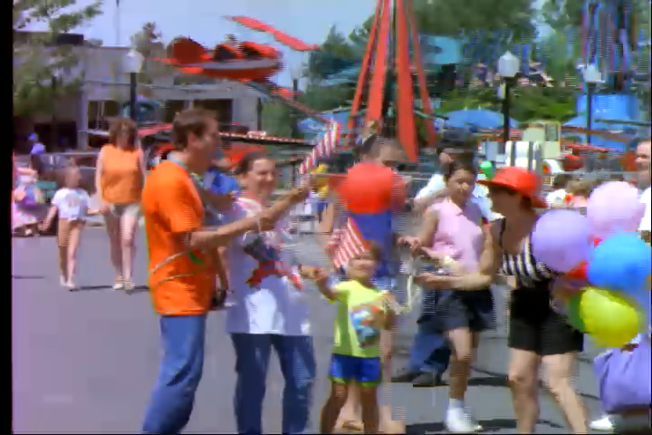
Figure 5-4 applied filter of chroma

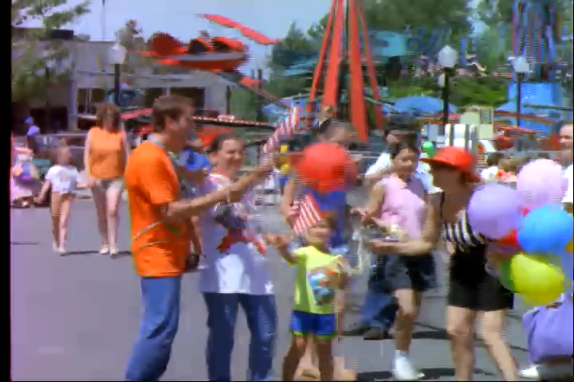
Figure 5-5 applied filter of luminance

JVT Patent Disclosure Form

International Telecommunication Union  Telecommunication Standardization Sector | International Organization for Standardization | International Electrotechnical Commission
 |  | 
Joint Video Coding Experts Group - Patent Disclosure Form
(Typically one per contribution and one per Standard | Recommendation)

Please send to:
JVT Rapporteur Gary Sullivan, Microsoft Corp., One Microsoft Way, Bldg. 9, Redmond WA 98052-6399, USA
Email (preferred): Gary.Sullivan@itu.int Fax: +1 425 706 7329 (+1 425 70MSFAX)

This form provides the ITU-T | ISO/IEC Joint Video Coding Experts Group (JVT) with information about the patent status of techniques used in or proposed for incorporation in a Recommendation | Standard. JVT requires that all technical contributions be accompanied with this form. Anyone with knowledge of any patent affecting the use of JVT work, of their own or of any other entity (“third parties”), is strongly encouraged to submit this form as well.

This information will be maintained in a “living list” by JVT during the progress of their work, on a best effort basis. If a given technical proposal is not incorporated in a Recommendation | Standard, the relevant patent information will be removed from the “living list”. The intent is that the JVT experts should know in advance of any patent issues with particular proposals or techniques, so that these may be addressed well before final approval.

This is not a binding legal document; it is provided to JVT for information only, on a best effort, good faith basis. Please submit corrected or updated forms if your knowledge or situation changes.

This form is not a substitute for the ITU ISO IEC Patent Statement and Licensing Declaration, which should be submitted by Patent Holders to the ITU TSB Director and ISO Secretary General before final approval.

Submitting Organization or Person:
Organization name | Sony Corp.
Mailing address | Atsugi Tec, 4-14-1, Asahi-cho, Atsugi-shi,  Kanagawa, 243-0014, japan
Country | Japan
Contact person | Kyohei Koyabu
Telephone | +81-46-230-6126
Fax | +81-46-230-5559
Email | koyabu@vns.cpg.sony.co.jp
Place and date of submission
Relevant Recommendation | Standard and, if applicable, Contribution:
Name (ex: “JVT”) |  | JVT
Title |  | Some comments and proposals to support 4:2:2 for PExt
Contribution number |  | JVT-J014

(Form continues on next page)

Disclosure information – Submitting Organization/Person (choose one box)
X | 2.0 The submitter is not aware of having any granted, pending, or planned patents associated with the technical content of the Recommendation | Standard or Contribution.  or,
The submitter (Patent Holder) has granted, pending, or planned patents associated with the technical content of the Recommendation | Standard or Contribution. In which case,

 | 2.1 The Patent Holder is prepared to grant – on the basis of reciprocity for the above Recommendation | Standard – a free license to an unrestricted number of applicants on a worldwide, non-discriminatory basis to manufacture, use and/or sell implementations of the above Recommendation | Standard.
2.2 The Patent Holder is prepared to grant – on the basis of reciprocity for the above Recommendation | Standard – a license to an unrestricted number of applicants on a worldwide, non-discriminatory basis and on reasonable terms and conditions to manufacture, use and/ or sell implementations of the above Recommendation | Standard.

Such negotiations are left to the parties concerned and are performed outside the ITU | ISO/IEC.
 | 2.2.1 The same as box 2.2 above, but in addition the Patent Holder is prepared to grant a “royalty-free” license to anyone on condition that all other patent holders do the same.
2.3 The Patent Holder is unwilling to grant licenses according to the provisions of either 2.1, 2.2, or 2.2.1 above. In this case, the following information must be provided as part of this declaration:
- patent registration/application number;
- an indication of which portions of the Recommendation | Standard are affected.
- a description of the patent claims covering the Recommendation | Standard;
In the case of any box other than 2.0 above, please provide the following:
Patent number(s)/status
Inventor(s)/Assignee(s)
Relevance to JVT
Any other remarks:
(please provide attachments if more space is needed)

(form continues on next page)
Third party patent information – fill in based on your best knowledge of relevant patents granted, pending, or planned by other people or by organizations other than your own.

Disclosure information – Third Party Patents (choose one box)
X
3.1 The submitter is not aware of any granted, pending, or planned patents held by third parties associated with the technical content of the Recommendation | Standard or Contribution.

3.2 The submitter believes third parties may have granted, pending, or planned patents associated with the technical content of the Recommendation | Standard or Contribution.

For box 3.2, please provide as much information as is known (provide attachments if more space needed) - JVT will attempt to contact third parties to obtain more information:

3rd party name(s)
Mailing address
Country
Contact person
Telephone
Fax
Email
Patent number/status
Inventor/Assignee
Relevance to JVT

Any other comments or remarks:

