Joint Video Team (JVT) of ISO/IEC MPEG & ITU-T VCEG  (ISO/IEC JTC1/SC29/WG11 and ITU-T SG16 Q.6)  9th Meeting: 2-5 September 2003, San Diego | Document: JVT-I034d2  Filename: JVT-I034d2.doc

Title: | Film grain coding in H.264/AVC
Status: | Input Document to JVT
Purpose: | Proposal for the JVT Professional Extension
Author(s) or  Contact(s): | Martin Schlockermann  Steffen Wittmann  Thomas Wedi  Monzastr. 4c  D-63225 Langen, Germany | Email:  Email:  Email:  Tel: | schlockermann@panasonic.de  wittmann@panasonic.de  wedi@panasonic.de  +49.6103.766-129
 | Shinya Kadono  1006 Kadoma, Kadoma  Osaka 573-8501, Japan | Tel:  Email: | + 81.6.6900-9689  kadono.shinya@jp.panasonic.com
Source: | Panasonic
_____________________________

Introduction

At the last JVT meeting in Geneva, Thomson addressed the problem of encoding film grain for high quality applications [2,3]. In this contribution we propose a different solution to solve this problem that has some advantages compared to the Thomson idea.

Our proposal consists of two parts that can also be used independent from each other:

- Film Grain extraction:
In our proposal the H.264/MPEG-4 AVC encoder itself is used as the film grain removal filter. By subtracting the encoded picture from the original the film grain is calculated and encoded separately similar to the encoding of residual data.
- Film Grain coding:
On the decoder side both kind of data are decoded separately and the film grain will added to the picture content. To reduce the amount of bits for the film grain data only one representative macroblock is encoded and stored in the bitstream. This could be done similar to the Thomson proposal in an SEI message. At the decoder side an intelligent technique is used to duplicate the decoded film grain to all macroblocks.

In section 2, we present a detailed description of our proposal and in section 3 first simulation results are presented.

Film grain coding in H.264/MPEG-4 AVC
The proposal consists of two parts that can also be used independent from each other. The two parts are described in the following two subsections 2.1, 2.2. In subsection 2.3 we give some advantages of our proposal compared to the Thomson approach.

2.1 Film grain removal and extraction
The main idea of our proposal is shown in figure 1.

Figure 1: Use of H.264/AVC as film grain removal filter

On encoder side the H.264/AVC codec itself is used as a film grain removal filter. For this the H.264/AVC codec is used with a coarse quantizer (19 - 25) which fits to typical bit rates of BD or DVD-9. Simulations have shown, that at these QP values film grain is removed only, but no visible fine textures of the picture content.

It is now possible to calculate the film grain by using the input picture and encoded picture.

2.2 Film grain coding and duplication
Due to the high amount of film grain data and its random characteristic, only one representative macroblock of film grain is encoded and transmitted. This can be transmitted per frame, per sequence portion or only once per sequence in a SEI message. The film grain data can be encoded similar as the residual data with a transform codec. Thus, the grain coding scheme is not restricted to a specific grain model.

At the decoder side a film grain mirroring and rotation technique calculates eight different macroblocks with film grain, as shown in figure 2.

Figure 2: Film grain mirroring

Another modification method is the change of the intensity of the grain macroblock:
$${\text{grain}}_{\text{mod}}(x,y)=a⋅{\text{grain}}_{\text{ori}}(x,y)$$
Here the signal of the modified grain macroblock ${\text{grain}}_{\text{mod}}(x,y)$is calculated by multiplying an intensity value $a$ to the signal of the original grain macroblock ${\text{grain}}_{\text{ori}}(x,y)$. The intensity value $a$ can depend on local statistics of the decoded image signal.

The third macroblock modification is a method called cycle shift. It is defined as
${\text{grain}}_{\text{mod}}(x,y)={\text{grain}}_{\text{ori}}\left((x−x_{0}){\%s}_{y},(y−y_{0}){\%s}_{y}\right)$.
Here $x_{0}$ and $y_{0}$ are random variables and $s_{x},s_{y}$ determine the size of the grain macroblock (e.g. $s_{x}=s_{y}=\text{16}$ ).

2.3 Advantages compared to JVT-H022/ JVT-I13
- The complexity of our proposal is much lower than the complexity of H022/I013, because no additional film grain removal filter is necessary.
- Since the film grain itself is coded, our proposal is not restricted to a specific grain model.

Experimental results

In this section, we present the obtained results on rolling_tomatoe sequence from the test set used in the JVT PExt. Due to the short time we encoded 5 pictures (110 – 114) of this sequence with 8 bits (dropping the 2 LSB) using the JM6.1e version of the reference software. The following parameters were selected to configure the JM6.1e encoder:

 | JVT
Bitrate | ~15 Mbps
GOP | IPPPP…
Number of reference frames | 2
Direct mode type | 32
Entropy Coding method | CABAC
RD optimization | 1

The pictures below and subjective evaluations shows that it is impossible to distinguish between the original and the encoded sequence. Film grain intensity is identical in both sequences.
Additional sequences were encoded and shows the same results for 15 Mbps bit rates. Unfortunately we do not have the allowance to show these sequences in this group.

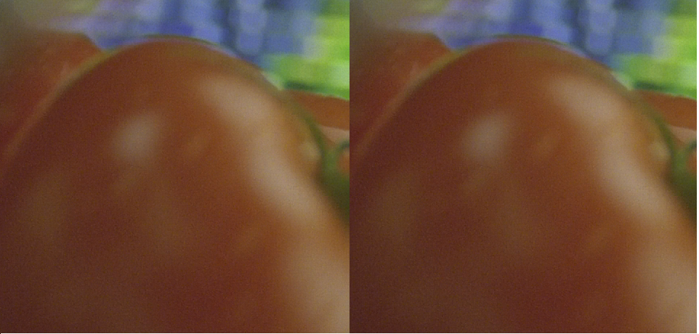
Original Grain added

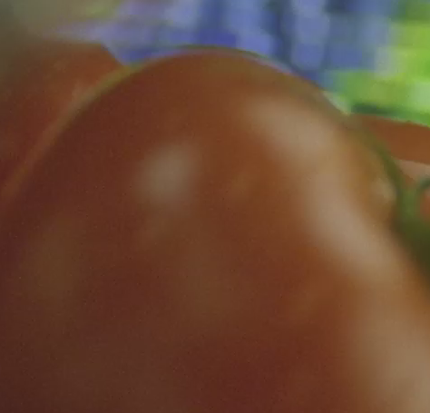
Without grain

4. Conclusions

In this contribution, we presented a technique for film grain coding in H.264/AVC which shows very good results. Before the JVT group decides to adopt an algorithm for film grain coding we would like to have a comparison of both proposals under fair conditions. This means that a subjective comparison under real viewing conditions and a verification test of both proposals is necessary.
Until now nobody in JVT has seen the sequences with the results neither from H022/I013 nor our results under real viewing conditions. But, the subjective evaluation is very important because these proposals are dealing with noise coding. Furthermore, there is no verification test or reference software available.

Although, these proposals are dealing with SEI messages “only”, these techniques can become very important in high-quality applications like Blu Ray Disk or HD-DVD.

Therefore, we think it is to early to make a decision on this topic.

References

[1] Thomas Wiegand, Draft ITU-T Recommendation and Final Draft International Standard, document JVT-G050r1.doc, JVT of ISO/IEC MPEG & ITU-T VCEG, Geneva meeting, Switzerland May 23-28, 2003
[2] C. Gomila and A. Kobilansky, "SEI message for film grain encoding", document JVT-H022.doc, JVT of ISO/IEC MPEG & ITU-R VCEG, Geneva meeting, Switzerland, May 23-27, 2003.
[3] C. Gomila, "SEI message for film grain encoding: syntax and results", document JVT-I013.doc, JVT of ISO/IEC MPEG & ITU-R VCEG, San Diego meeting, September, 2003.

(a) Original
(b) Filtered encoded QP20 + grain ( 3.57 Mbps)
( c) Filtered encoded QP20 ( 3.57 Mbps )
(d) Original encoded QP 24 ( 3.58 Mbps)

Figure 2. - Sequence rolling tomatoes. Crop of 200x200 pixels at position (800,300). Comparison between natural grain (a) and simulated grain (b) added in the RGB colour space to encoded images without grain (c). Comparison at same bit-rate between encoding the original sequence with film grain (d) and encoding a filtered version with film grain added at the end (b).

(Append for Proposal Documents)

JVT Patent Disclosure Form

International Telecommunication Union  Telecommunication Standardization Sector | International Organization for Standardization | International Electrotechnical Commission
 |  | 
Joint Video Coding Experts Group - Patent Disclosure Form
(Typically one per contribution and one per Standard | Recommendation)

Please send to:
JVT Rapporteur Gary Sullivan, Microsoft Corp., One Microsoft Way, Bldg. 9, Redmond WA 98052-6399, USA
Email (preferred): Gary.Sullivan@itu.int Fax: +1 425 706 7329 (+1 425 70MSFAX)

This form provides the ITU-T | ISO/IEC Joint Video Coding Experts Group (JVT) with information about the patent status of techniques used in or proposed for incorporation in a Recommendation | Standard. JVT requires that all technical contributions be accompanied with this form. Anyone with knowledge of any patent affecting the use of JVT work, of their own or of any other entity (“third parties”), is strongly encouraged to submit this form as well.

This information will be maintained in a “living list” by JVT during the progress of their work, on a best effort basis. If a given technical proposal is not incorporated in a Recommendation | Standard, the relevant patent information will be removed from the “living list”. The intent is that the JVT experts should know in advance of any patent issues with particular proposals or techniques, so that these may be addressed well before final approval.

This is not a binding legal document; it is provided to JVT for information only, on a best effort, good faith basis. Please submit corrected or updated forms if your knowledge or situation changes.

This form is not a substitute for the ITU ISO IEC Patent Statement and Licensing Declaration, which should be submitted by Patent Holders to the ITU TSB Director and ISO Secretary General before final approval.

Submitting Organization or Person:
Organization name | Panasonic European Laboratories
Mailing address | Monzastr. 4c  D-63225 Langen
Country | Germany
Contact person | Martin Schlockermann
Telephone | +49.6103.766-129
Fax | +49.6103.766-144
Email | schlockermann@panasonic.de
Place and date of submission | San Diego, US September 2003
Relevant Recommendation | Standard and, if applicable, Contribution:
Name (ex: “JVT”) |  | JVT
Title |  | Film grain coding in H.264/AVC
Contribution number |  | JVT-I034d1

(Form continues on next page)

Disclosure information – Submitting Organization/Person (choose one box)
2.0 The submitter is not aware of having any granted, pending, or planned patents associated with the technical content of the Recommendation | Standard or Contribution.

or,
The submitter (Patent Holder) has granted, pending, or planned patents associated with the technical content of the Recommendation | Standard or Contribution. In which case,

 | 2.1 The Patent Holder is prepared to grant – on the basis of reciprocity for the above Recommendation | Standard – a free license to an unrestricted number of applicants on a worldwide, non-discriminatory basis to manufacture, use and/or sell implementations of the above Recommendation | Standard.
x | 2.2 The Patent Holder is prepared to grant – on the basis of reciprocity for the above Recommendation | Standard – a license to an unrestricted number of applicants on a worldwide, non-discriminatory basis and on reasonable terms and conditions to manufacture, use and/ or sell implementations of the above Recommendation | Standard.  Such negotiations are left to the parties concerned and are performed outside the ITU | ISO/IEC.
 | 2.2.1 The same as box 2.2 above, but in addition the Patent Holder is prepared to grant a “royalty-free” license to anyone on condition that all other patent holders do the same.
2.3 The Patent Holder is unwilling to grant licenses according to the provisions of either 2.1, 2.2, or 2.2.1 above. In this case, the following information must be provided as part of this declaration:
- patent registration/application number;
- an indication of which portions of the Recommendation | Standard are affected.
- a description of the patent claims covering the Recommendation | Standard;
In the case of any box other than 2.0 above, please provide the following:
Patent number(s)/status |  | 2 patents filed
Inventor(s)/Assignee(s) |  | Martin Schlockermann, Thomas Wedi, Steffen Wittmann & Shinya Kadono
Relevance to JVT
Any other remarks:
(please provide attachments if more space is needed)

(form continues on next page)
Third party patent information – fill in based on your best knowledge of relevant patents granted, pending, or planned by other people or by organizations other than your own.

Disclosure information – Third Party Patents (choose one box)
x | 3.1 The submitter is not aware of any granted, pending, or planned patents held by third parties associated with the technical content of the Recommendation | Standard or Contribution.
 | 3.2 The submitter believes third parties may have granted, pending, or planned patents associated with the technical content of the Recommendation | Standard or Contribution.
For box 3.2, please provide as much information as is known (provide attachments if more space needed) - JVT will attempt to contact third parties to obtain more information:

3rd party name(s)
Mailing address
Country
Contact person
Telephone
Fax
Email
Patent number/status
Inventor/Assignee
Relevance to JVT

Any other comments or remarks:

