Joint Video Team (JVT) of ISO/IEC MPEG & ITU-T VCEG  (ISO/IEC JTC1/SC29/WG11 and ITU-T SG16 Q.6)  PExt Ad Hoc Group Meeting 22-24 July, 2003, Trondheim | Document: JVT-I023  Filename: JVT-I023.doc

Title: | Inter-plane Prediction for RGB Coding
Status: | Input Document to JVT
Purpose: | Proposal
Author(s) or  Contact(s): | Woo-Shik Kim,  Dae-Sung Cho,  Hyun Mun Kim  Multimedia Lab. Samsung AIT  P.O.Box 111, Suwon 440-600  Korea | Tel:  Email: | 82-31-280-9204  hyunmun27.kim@samsung.com
Source: | Samsung AIT
_____________________________
- Introduction

In the previous JVT meetings we presented the effectiveness of RGB coding using INTER-PLANE PREDICTION (IPP) coding of residual images [1-2]. The proposed method supports any color space equally well as required in the call for proposal [3] by introducing a flag to signal the IPP coding of residual images. It avoids the color distortion due to the color space conversion involved when coded in YUV space. Simulation results show that due to the color space conversion there exists an achievable PSNR limit and the original color is distorted when coded in YUV space. By applying IPP we achieve significant coding gain when compared with the case without IPP while we preserve the high quality of the original image without the color distortion.
This proposal introduces a new coding technology that supports 4:4:4 format in YCbCr, XYZ and RGB color space while maintaining core technologies of the existing JVT specification [4]. The proposed codec supports YCbCr and XYZ format by extending the 4:2:0 format while treating CbCr components as dependent luminance components. In other words, the full resolution CbCr components use the same mode as the luminance component does . Green and Y components are treated as Luma in RGB and XYZ space respectively. For RGB coding we increased the coding efficiency greatly by applying DPCM coding to the residual images of R and B color components using the G component residual as a predictor. It works well for both the intra and the inter cases. To maintain the decoder compatibility we add a flag to the sequence paramater set to signal the DPCM coding of residual images since only the RGB coding uses this mode among the 4:4:4 formats. In this document we address the effect of IPP for various image set to show the efficiency of it. The results show the comparable coding efficiency as that of the proposed YCbCr 4:4:4 format. So it can avoid the possible information loss due to the color space conversion while maintaining the coding efficiency. This makes the proposed JVT codec a good candidate for applications that require the high fidelity of colors such as digital cinema, digital archives, surveillance and so on.

- Inter-Plane Prediction Coding

2.1 Color distortion due to the color space conversion

This section describes IPP coding in details. Generally RGB space is regarded as a bad space from the compression point of view. Each RGB component contains the color information along with luminance information. This redundancy degrades the coding efficiency. To exploit the inter color redundancy, the RGB space is usually converted into YCbCr space. Also most of the spatial information is in Y component, Cb and Cr components can be subsampled to further compress the data without significant loss of image quality. But in professional purpose such as master scan of digital cinema, it is very essential to maintain the original color fidelity. But the color space conversion from RGB to YCbCr and back to RGB involves rounding error. Due to this rounding error, there is an achievable PSNR limit as analyzed in [5]. Table 1 summarizes these results for 8-bit and 10-bit images.

Table 1: Achievable PSNR when color space conversion RGB->YcbCr->RGB operation is performed using ITU-R Rec. BT.709.

Theoretical analysis | 8-bit | 10-bit
PSNR-G | 56.1 db | 68.2 db
PSNR-R | 52.6 db | 64.7 db
PSNR-B | 51.8 db | 63.9 db

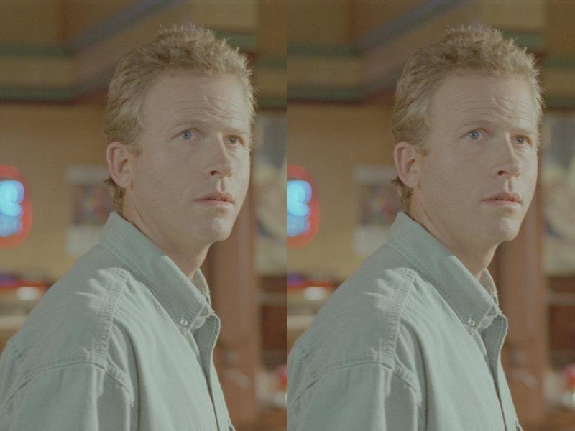

Figure 1: Color distortion due to the color space conversion (Man in Restaurant, 300th frame, 8 bit, clipped from 1920x896 to 400x600). The left side is the original image and the right side is the distorted image due to color space conversion. It shows the distorted color in the face and shirts. The distorted image is obtained by converting the RGB components into YUV components using floating point operation followed by rounding and converted back to RGB space using the same operation without any coding involved. The PSNR values for R, G and B components are 52.23172 dB, 57.14087 dB and 51.53519 dB respectively.

Even though all three PSNRs exceed 50 dB for 8-bit images, the color distortion is still visible as shown in Figure 1. This is very undesirable for professional usage. For example there will be no movie director who doesn’t mind if his original shooting color is distorted due to color space conversion. So PSNR value itself does not seem to be a enough criterion for color distortion measure.
To support this argument, we conducted the mini experiment using the image shown in Figure 2. The original Crew image is distorted by subtracting 10 from all the pixels in R and B components in Figure 3. In Figure 4 we subtracted 10 from all the RGB components to distort the pixel value for all the components. Even though Figure 3 has the infinite PSNR value for G component, but it distorted the color fidelity due to the unbalanced PSNR values for each component. To measure the perceptibility of color differences, we use ${ΔE}_{\text{ab}}^{}$ [6]:

${ΔE}_{\text{ab}}^{}=\sqrt{\left({ΔL}^{{}^{2}}+{Δa}^{{}^{2}}+{Δb}^{{}^{2}}\right)}$ (1)

It measures the Euclidean distance in $L^{}a^{}b^{}$ space. The resulting PSNR values and ${ΔE}_{\text{ab}}^{}$ are summarized in Table 2. As shown in Table 2, Figure 4 shows the smaller ${ΔE}_{\text{ab}}^{}$than that of Figure 3. It coincides with our visual observation.

Table 2: PSNR and ${ΔE}_{\text{ab}}^{}$values for images in Figure 3-5.
Theoretical analysis | Figure 3 | Figure 4
PSNR-G | $$∞$$ | 28.1 db
PSNR-R | 28.1 db | 28.1 db
PSNR-B | 28.1 db | 28.1 db
$${ΔE}_{\text{ab}}^{}$$ | 5.66 | 3.92

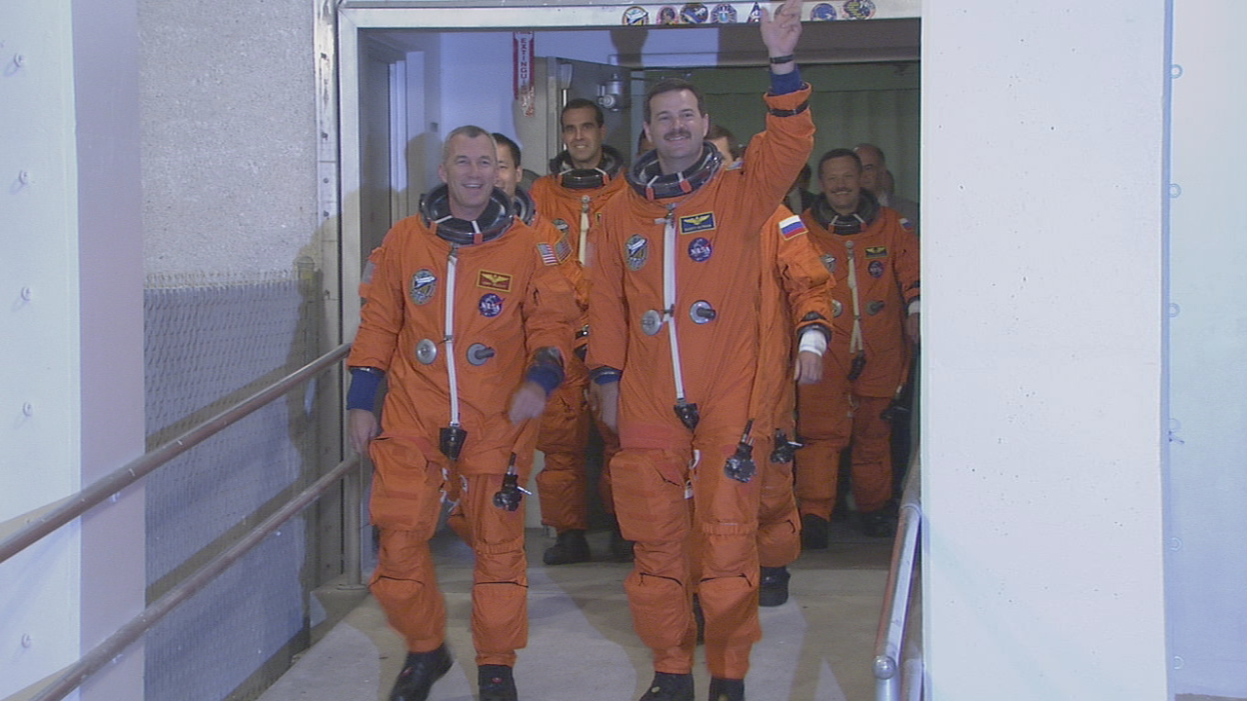

Figure 2: Original Crew image at 170th frame

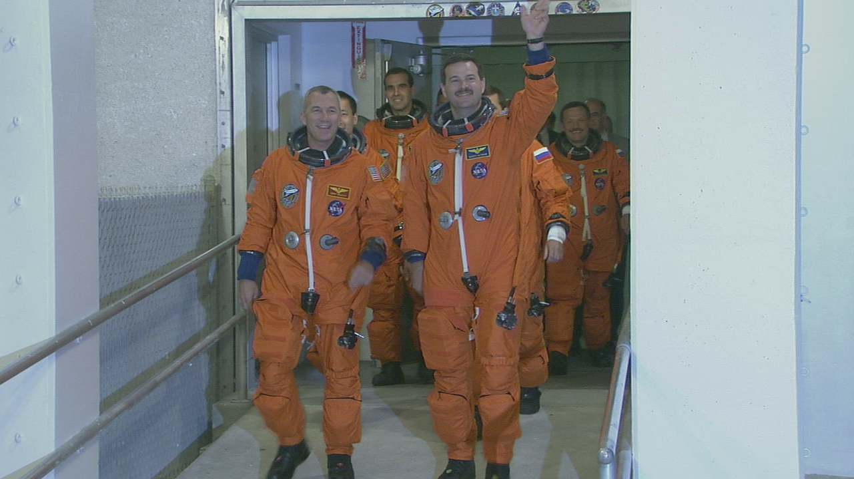

Figure 3: Distorted Crew image by subtracting 10 from all the pixels in R and B components. Even though Figure 4 has the infinite PSNR value for G component but it distorted the color fidelity due to the unbalanced PSNR values for each component.

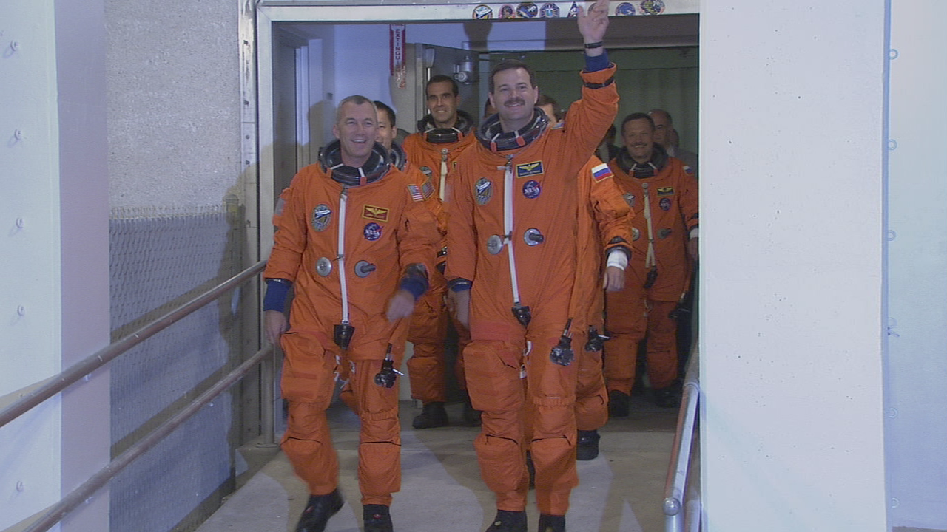

Figure 4: Distorted Crew image by subtracting 10 from all the pixels in G, R and B components.

3.2 Inter-Plane Prediction Coding for RGB Color Space

To maintain the color fidelity discussed in previous section while increasing the coding efficiency in RGB space, we propose to use the inter-plane prediction as shown in Figure 5. This scheme can be easily incorporated into the existing JVT specification [4] since it needs one simple predictor block using the reconstructed G plane residue for each R and B residue. The function $F(⋅)$ in Figure 5 is an identity function. So the predictor is just a simple subtraction. The G-plane predicted R residue and B residue follow the same coding procedure of the existing JVT specification as the G residue does. In the decoder, we just add back the reconstructed G residue to decode R and B residue value.

G plane
F(•)
-
+
G plane
Predicted
R-Residue
Reconstructed
G plane
Spatial/temporal
prediction
G plane
Residue
R plane
Reconstructed
R plane
Spatial/temporal
prediction
B plane
Reconstructed
B plane
Spatial/temporal
prediction
Reconstructed
G plane Residue
-
+
G plane
Predicted
B-Residue
To encoder
To encoder
To encoder
Reconstructed
G plane Residue
F(•)

Figure 5: Block diagram of the proposed Inter-Plane Prediction

- Experimental Results

This section summarizes the simulation results.

To be updated later.

- Conclusions

The introduction of IPP coding for residue images in RGB space achieves great coding efficiency while avoiding the color distortion resulting from the color space conversion. The Chroma_residue_pred_flag that signals the usage of IPP makes the proposed codec universal for any color spaces. It makes the proposed JVT codec a complete package for various needs of video compression.

References
[1] W. Kim, D. Cho and H. M. Kim, “Color Format Extension,” ITU-T SG16 Q.6 Document JVT-H018, May 2003.
[2] W. Kim, D. Cho and H. M. Kim, “Proposal for the unsolved issues in professional extensions,” ITU-T SG16 Q.6 Document JVT-I012, September 2003.
[3] G. Sullivan, A. Luthra and T. Wiegand, “Call for Proposals for Extended Sample Bit Depth and Chroma Format Support in the Advanced Video Coding Standard,” ITU-T SG16 Q.6 Document JVT-G048 and ISO/IEC JTC1/SC29/WG11 MPEG2003/N5523, March 2003
[4] “Final Draft International Standard of Joint Video Specification (ITU-T Rec. H.264 | ISO/IEC 14496-10 AVC),” ISO/IEC JTC1/SC29/WG11 and ITU-T SG16 Q.6 Document JVT-G050, March 2003.
[5] G. Sullivan, “Approximate theoretical analysis of RGB to YCbCr to RGB conversion error,” ITU-T SG16 Q.6 Document JVT-I017, September 2003.
[6] C. Poynton, Digital Video and HD TV Algorithms and Interfaces, Elsivier Science 2003.

(Append for Proposal Documents)

JVT Patent Disclosure Form

International Telecommunication Union  Telecommunication Standardization Sector | International Organization for Standardization | International Electrotechnical Commission
 |  | 
Joint Video Coding Experts Group - Patent Disclosure Form
(Typically one per contribution and one per Standard | Recommendation)

Please send to:
JVT Rapporteur Gary Sullivan, Microsoft Corp., One Microsoft Way, Bldg. 9, Redmond WA 98052-6399, USA
Email (preferred): Gary.Sullivan@itu.int Fax: +1 425 706 7329 (+1 425 70MSFAX)

This form provides the ITU-T | ISO/IEC Joint Video Coding Experts Group (JVT) with information about the patent status of techniques used in or proposed for incorporation in a Recommendation | Standard. JVT requires that all technical contributions be accompanied with this form. Anyone with knowledge of any patent affecting the use of JVT work, of their own or of any other entity (“third parties”), is strongly encouraged to submit this form as well.

This information will be maintained in a “living list” by JVT during the progress of their work, on a best effort basis. If a given technical proposal is not incorporated in a Recommendation | Standard, the relevant patent information will be removed from the “living list”. The intent is that the JVT experts should know in advance of any patent issues with particular proposals or techniques, so that these may be addressed well before final approval.

This is not a binding legal document; it is provided to JVT for information only, on a best effort, good faith basis. Please submit corrected or updated forms if your knowledge or situation changes.

This form is not a substitute for the ITU ISO IEC Patent Statement and Licensing Declaration, which should be submitted by Patent Holders to the ITU TSB Director and ISO Secretary General before final approval.

Submitting Organization or Person:
Organization name | Samsung Elctronics. Co. Ltd.
Mailing address | POBox 111 Suwon Samsung AIT Multimedia
Country | Korea
Contact person | Hyun Mun Kim
Telephone | 82-31-280-9204
Fax | 82-31-280-9207
Email | hyunmun27.kim@samsung.com
Place and date of submission | Geneva, CH, 23-27 May, 2003
Relevant Recommendation | Standard and, if applicable, Contribution:
Name (ex: “JVT”) |  | JVT
Title |  | Color Format Extension
Contribution number |  | JVT-H018

(Form continues on next page)

Disclosure information – Submitting Organization/Person (choose one box)
2.0 The submitter is not aware of having any granted, pending, or planned patents associated with the technical content of the Recommendation | Standard or Contribution.

or,
The submitter (Patent Holder) has granted, pending, or planned patents associated with the technical content of the Recommendation | Standard or Contribution. In which case,

 | 2.1 The Patent Holder is prepared to grant – on the basis of reciprocity for the above Recommendation | Standard – a free license to an unrestricted number of applicants on a worldwide, non-discriminatory basis to manufacture, use and/or sell implementations of the above Recommendation | Standard.
2.2 The Patent Holder is prepared to grant – on the basis of reciprocity for the above Recommendation | Standard – a license to an unrestricted number of applicants on a worldwide, non-discriminatory basis and on reasonable terms and conditions to manufacture, use and/ or sell implementations of the above Recommendation | Standard.

Such negotiations are left to the parties concerned and are performed outside the ITU | ISO/IEC.
X | 2.2.1 The same as box 2.2 above, but in addition the Patent Holder is prepared to grant a “royalty-free” license to anyone on condition that all other patent holders do the same.
2.3 The Patent Holder is unwilling to grant licenses according to the provisions of either 2.1, 2.2, or 2.2.1 above. In this case, the following information must be provided as part of this declaration:
- patent registration/application number;
- an indication of which portions of the Recommendation | Standard are affected.
- a description of the patent claims covering the Recommendation | Standard;
In the case of any box other than 2.0 above, please provide the following:
Patent number(s)/status
Inventor(s)/Assignee(s)
Relevance to JVT
Any other remarks:
(please provide attachments if more space is needed)

(form continues on next page)
Third party patent information – fill in based on your best knowledge of relevant patents granted, pending, or planned by other people or by organizations other than your own.

Disclosure information – Third Party Patents (choose one box)
X | 3.1 The submitter is not aware of any granted, pending, or planned patents held by third parties associated with the technical content of the Recommendation | Standard or Contribution.
 | 3.2 The submitter believes third parties may have granted, pending, or planned patents associated with the technical content of the Recommendation | Standard or Contribution.
For box 3.2, please provide as much information as is known (provide attachments if more space needed) - JVT will attempt to contact third parties to obtain more information:

3rd party name(s)
Mailing address
Country
Contact person
Telephone
Fax
Email
Patent number/status
Inventor/Assignee
Relevance to JVT

Any other comments or remarks:

