Joint Video Team (JVT) of ISO/IEC MPEG & ITU-T VCEG  (ISO/IEC JTC1/SC29/WG11 and ITU-T SG16 Q.6)  9th Meeting: San Diego, CA, 2-5, September, 2003 | Document: JVT-I015r3  Filename: JVT-I015r3.doc  Revision Date: 1 Sept. 2003

Title: | New Invertible Integer Color Transforms Based on Lifting Steps and Coding of 4:4:4 Video
Status: | Input Document to JVT
Purpose: | Proposal
Author(s) or  Contact(s): | Pankaj Topiwala, Chengjie Tu  FastVDO LLC  7150 Riverwood Dr.  Columbia, MD 21046 USA | Tel:  Email: | 410-309-6066  pnt@fastvdo.com
Source: | FastVDO LLC
_____________________________
Abstract: As the draft video coding standard ITU/H.264 | ISO/IEC 14496-10 nears completion, there is interest in extending the domain of application of the standard to meet extended operating requirements. Among possible extensions, the simplest and apparently most direct ones are to support (a) data sources of higher than 8 bits per sample, and (b) color video sources sampled at other than the initial 4:2:0 chroma sampling format. This document proposes methods fulfilling two objectives:
- improved methods of encoding color via innovative color space transforms, and
- new approaches in coding of 4:4:4 video data for enhanced coding efficiency.

- Outline

The current design of the ITU/H.264 | ISO/MPEG-4 AVC video codec has been constructed for the coding of 4:2:0 color format video data. Extensions to other color formats is desirable, and part of the development being currently investigated by the JVT. A valuable goal of high quality coding for professional applications is to use the 4:4:4 color format, since subsampling in the chroma space may be too drastic a reduction in quality for some applications. Another objective for professional applications is the encoding of color video data in very high quality, even in lossless mode. Due to the high correlation between color bands, for efficient coding, color space transformations are required. However, the transformations used to date have mostly been focused on obtaining a separation between luma (for black-and-white) and chroma components; these transforms were significantly motivated by the need for backwards compatibility with black-and-white distribution (such as for TV), rather than for efficient digital data compression. Instead, we propose a novel, integer, fully-invertible color transform that has very high coding gain approximating the Karhunen-Loeve Transform, is an integer-to-integer mapping, has low bit expansion, which has several advantages over the proposal in JVT-I014r3. We provide an abbreviated exposition here, and present a fuller exposition in [3].

2. Innovative Color Transforms

  - Objectives
The use of color transforms for digital image/video compression has to date been motivated by applications such as broadcast, in which compatibility with black-and-white transmission has had a decisive role. In part since the television industry worldwide has been fragmented, this had led to a baffling array of color transformations and formats. These include, among others, the RGB, YUV, YIQ, YCbCr, YDbDr, YPbPr, YUW, XYZ, HSI, HLS, HSV, CMYK, and many other formats [1]. But in the current vision of essentially digital applications, in which the principal focus is on very high-quality, high-rate, high-resolution video for profession applications, the focus can appropriately shift to other more pertinent needs. This is especially true in the context of the current effort to develop Professional Extensions of the H.264/AVC standard. The criteria for selecting new color transforms can therefore be threefold.

Design Selection Criteria for New Color Transforms
  - high decorrelation gain (e.g., high coding gain) for high-quality coding
  - integer-to-integer mapping, with reversibility in integer implementation
  - limited bit expansion

These objectives are roughly in order of importance, which we briefly comment on here.

High Coding Gain. (1) is obviously critical for very high quality applications envisioned for these extensions, such as production, compositing, editing, and distribution, and doesn’t need further analysis. The purpose of these extensions is to facilitate the highest quality of applications. Ideally, the Karhunen-Loeve Transform (KLT) would be used, since it is statistically optimal in decorrelation and provides the best coding gain; but it is data-dependent. We therefore aim to develop a color transform that approximates the KLT in its coding gain as much as possible.

Integer Mapping and Reversability. (2) is important in the context of H.264/AVC, where this standard has pioneered a fully integer (16-bit) structure. While the Professional Extensions of H.264/AVC need not logically be limited by integer-based processing (the quality of video, (1), is of much greater import in this domain), certainly an opportunity to remain in an integer context, if available, would be preferred. More importantly, we claim that integer processing is actually valuable in high-quality processing. In fact, the reversibility in integer processing feature is then central to very high quality lossy and lossless coding in this context, and in any case guarantees idempotency of the color transformations in applications that are repetitive (e.g., editing).

Bit Conservation. The last objective, (3), is of importance specifically in the context of H.264/AVC mainly to facilitate hardware processing, and is not strictly required. With up to 12-bit input data anticipated, if the color transform is conservative in bit-expansion, then even 16-bit processing of the color data may be possible throughout (e.g., the decoder). Ideally, the color transform would add only one or two bits; but this is again not critical, since performance is heavily favored over cost here. While some applications of H.264/AVC will be processing power limited (e.g., cell phone conversational applications, potentially using the Baseline Profile), in the context of Professional Extensions, the application domain is not expected to be processor-limited in the same sense.

A quantum step lower in importance compared to these considerations is the issue of low-complexity implementation, partly for application domain reasons similar to the above. Overemphasis on this issue can lead to loss of performance, which can be prohibitive. In any case a 3x3 color transform is bound to be of negligible complexity in comparison to other more intensive decoding processing components, such as motion interpolation and compensation, deblocking, and CABAC entropy decoding. In fact, the color transform is less complex than even the 4x4 integer spatial transform; it is only 3x3, and it is applied in only one dimension (not in two spatial dimensions, and not in each of three color bands). Chosen intelligently, it can be made of negligible complexity, and even computed in-place, unlike the current spatial transform. Our informal estimate is that an appropriately selected color transform will be less than 1% of the computational load of the decoder. The comparison is even more extreme on the encoding side, where it is immaterial in comparison to motion estimation. Nevertheless, we will maintain a tally of computational complexity for completeness.

  - Design Approach
    - Existing Transforms
The starting point for discovering new transforms is a look at historical transforms to understand their domain of applicability. The well-known RGB-to-YUV analog color space transform, which is the basis of most of the other color transforms, is given by the matrix equation:
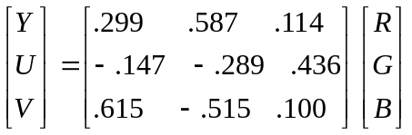. (Eqn. 1)

In particular, the popular digital color transform, RGB-to-YCbCr, part of the ITU-R BT.601, is a close derivative and mainly adds scaling and integer mapping (8-bit to 8-bit), but requires rounding to keep it integer at 8-bits:

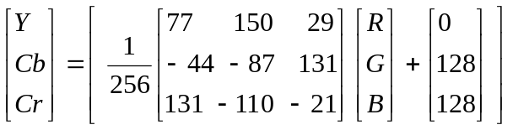, (Eqn. 2)

where the outside square bracket indicates rounding to nearest integer. Naturally, the inverse of this transform is not an exact integer transform either, and also requires rounding, e.g.,

R = [Y + 1.371(Cr –128)]. (Eqn. 3)

For reasons similar to ours, JPEG2000 adopted a reversible integer color transform [6], which is given by the matrix (this is not the standard YCrCb transform of Eqn. 2):

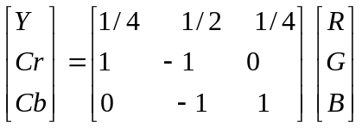. (Eqn. 4)

Similarly to the spirit of the JPEG2000 transform, JVT-I014r3 recently introduced another reversible integer transform, whose performance is quite similar to the JPEG2000 transform:

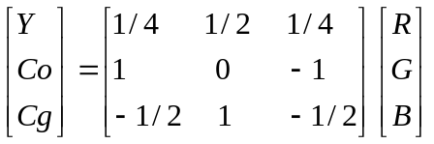. (Eqn. 5)

Finally, noting some shortcomings of the JPEG2000 reversible integer transform, P. Hoa and Q. Shi introduced a more sophisticated reversible integer transform, which they named SHIRCT [6], which has some advantages over these simpler transforms. It is defined as follows:

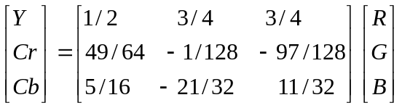 (Eqn. 6)

While these transforms have merit and are worthy of consideration for several applications, we will show that their decorrelation gains can be improved upon significantly, without sacrificing either other desirable properties or incurring high complexity. We therefore require a new definition of a color transform that is purely integer-to-integer, reversible with integer implementation, yet has very high decorrelation (coding) gain. We begin with the last point, which is actually the most important in this application domain.

    - Karhunen-Loeve Transform
In digital signal processing literature, it is well known that several random digital signals can be optimally decorrelated by the so-called Karhunen-Loeve Transform (KLT) [2]. The KLT is the unique unitary transform that diagonalizes the cross-correlation matrix of the random signals. Unfortunately, there are several problems in applying the KLT directly in practice. First and foremost, it is computationally expensive to obtain. Second, once obtained, the KLT is only fixed if the statistical properties of the random signals are fixed (e.g., wide-sense stationarity); but that assumption may be inaccurate in many application domains, and in particular that issue is relevant for our imaging applications. If the statistics of the random signals are time-dependent, then so is the KLT, and it needs to be computed repeatedly. The best approximations would accordingly vary. One has the option of keeping multiple solutions in hand in order to use the best data-dependent model. With this in mind, we develop a general methodology, which is complete and flexible enough to provide good approximations for arbitrary statistical models. Finally, in our context, although the KLT is guaranteed to have maximum coding gain, it is highly unlikely (more precisely, with probability zero) to be an integer-to-integer mapping, let alone reversible within integer computation.

To begin developing a new transform that approximates the KLT, we need a test model of the cross-correlation matrix, which then depends on example color imagery. In JVT-014r3, a correlation matrix derived from a set of example color images of high quality acquired by Kodak [3] was presented and used as the basis for analysis. For convenience of comparison of our proposals, we will also work with the same representative data (and improved model), with the caveat that correlation models are data-dependent. The correlation matrix of the 24 Kodak images, computed by first normalizing all color pixel vectors to be zero mean and unit length, is

Rxx = 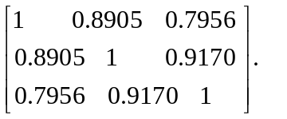 (Eqn. 7)

Note that this correlation matrix disagrees with the unnormalized correlation matrix of Eqn. 7’ below presented in JVT-I014r3. In order to maintain strict comparability, we will use Eqn 7’:

Rxx = 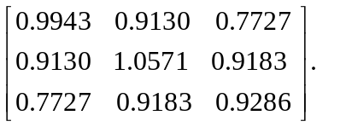 (Eqn. 7’) ]

The KLT for the normalized correlation matrix of Eqn. 7 is the unique orthogonal matrix T that diagonalizes it (T*Rxx*T’ = D, diagonal matrix):

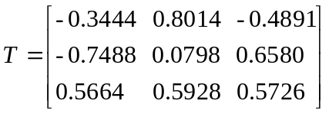. (Eqn. 8)

While the correlation model, eqn. 7, remains valid, the KLT will be the optimal decorrelator. In real signal processing scenarios, the data are often of time-varying statistics, in which case the KLT would be time-varying as well. We are concerned here with developing a fixed transform approximating the KLT. It may be worth considering the option of having multiple transforms available, and selecting from a group based on source data; this would require an additional flag in the bitstream. Note that as expected the KLT matrix T in this case is not an integer mapping. We will set about to develop an integer approximation to it. We begin by reviewing a certain class of approximations of orthogonal transformations in three dimensions.

    - Approximating Orthogonal Transformations

In a real Euclidean space of three dimensions, the group of orthogonal matrices O(3) is the group of real invertible 3x3 matrices with determinant = +/- 1. By changing the orientation of one of the axes (e.g.,a flip, x -> -x), if needed, we can assume that a particular orthogonal transformation is actually special orthogonal, SO(3), that is, a pure rotation (has det = 1). Actually, in our case above, det(T) = 1, as is easy to compute. Now, by a theorem of Euler, a rotation A of 3-space can be decomposed as a concatenation of three axial rotations (called the Euler angles), e.g.:

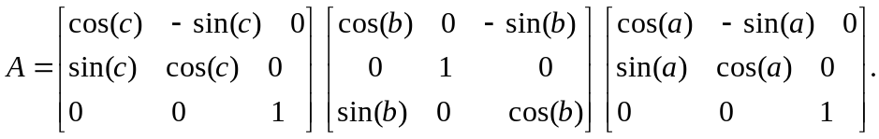 (Eqn. 9)

Note that there may be several such factorizations available, depending on which axes one chooses to rotate around, and in which order. These each lead to different approximations. From the point of view of digital signal processing, we can represent this decomposition in a flow diagram as a ladder structure as follows, where the crossovers are actually rotations by the given angles, a, b, c:
a
b
c
x[0]
x[1]
x[2]
y[0]
y[1]
y[2]

Figure 1. Example of a decomposition of a rotation in 3-space into a concatenation of three (axial) planar rotations. Each of the planar rotations can be further decomposed as below.

As FastVDO has explained on several occasions [4, 5] previously, a plane rotation can be decomposed in terms of three “shears” or “lifting steps”, as in figure 2 and equation 10. What is critical then is that the numbers in the boxes can be decoupled from the rotation angles, and used as independent parameters to be optimized. In particular, they can be chosen to be rational, or even dyadic rational, leading to extremely efficient implementations; see [4, 5].

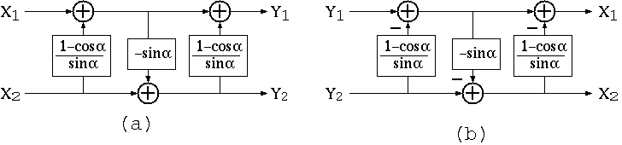
Figure 2. Each planar rotation can be further decomposed into a series of three planar “shears”, which we also recognize as lifting steps in modern terminology. (a) shows the forward transform, (b) shows the inverse transform. Note that for a lifting implementation, the inverse is always the same structure in reverse, and with all constants changing sign (reverse polarity).

The implementation of a rotation as three lifting steps is also representable in matrix form by:

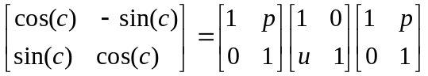 , (Eqn. 10)

where the parameters p, u, are to be selected as in figure 2 for equality. However, the point of departure for our approximation scheme is to select these parameters as rational approximations, avoiding the transcendental function values. With three rotations, and three shears per planar rotation, we can easily develop new color transforms made up of nine lifting steps. In certain cases, these can be further simplified, as developed below.

  - New Color Transforms

    - Brief Resume of Results:
We have investigated continuous parametric families (and hundreds of discrete examples) of new lifting-based color transforms. In particular, we have created numerous examples with dyadic rational coefficients, which satisfy all three design-selection criteria:
- extremely high coding gain (some within 0.04 dB of the KLT)
- integer-to-integer mapping, with exact reversibility with integer processing
- low bit expansion.

In this JVT proposal submission, we will only present a limited exposition of these new results as needed; a fuller exposition is forthcoming in the paper [3].

As a further aid in developing certain good approximations, and to make a specific selection among the wide range of solutions available, we note two additional facts, which we exploit:

- In developing a decomposition of a general 3-D rotation into three planar rotations of various types, one can sometimes find a decomposition in which one of the Euler angles is small, in which case we can approximate it as being zero, eliminating that rotation.

- Similarly, it is a property of planar rotations that they can be approximately represented by just two shears, with somewhat different parameters (they can be exactly represented by three shears). This leads to a further simplification.

2.3.2. Analysis of Coding Gain

The analysis of coding gain of orthogonal transforms such as the KLT and the discrete-cosine transform (DCT) is now in common use. In the current context, we need to analyze the coding gain of more general, biorthogonal transforms (while the KLT is orthogonal, our approximations will be more general – biorthogonal). We will use the following formula for the coding gain, in decibels, adapted from the literature on subband coding [7, 8]:

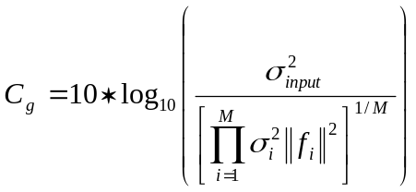 (Eqn. 11)

where 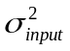 is the variance of the input signal,
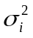 is the variance of the i-th subband (generated by the i-th basis function)
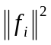 is the norm-squared of the i-th synthesis (inverse transform) basis function,
M is the number of independent basis functions (dimension).

We can normalize the input signal to be of unit variance, =1. Then we can compute the other parameters as follows. For a forward biorthogonal transform T, and an inverse transform of S, we compute:

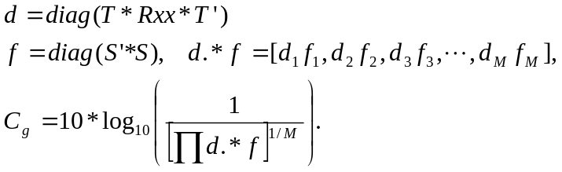 (Eqn. 12)

If the transform T is orthogonal, then so is S = T’, and S * S’ = I, and f = [1, 1, 1, …, 1]. But more generally, T will be biorthogonal in our development, and the more general formula above in Eqn. 12 will be required. In the current problem domain of color space transforms, M = 3.

2.3.3 New Color Transforms

While there are innumerable choices in the 3-D integer transform, we here develop only a specific solution, and hint at some others. We take advantage of the two simplifying assumptions made earlier: that only two Euler angles suffice for a reasonable approximation, and that only two lifting terms are required per rotation for adequate representation. We obtain:
-1 3/8
-1 1/2
R

B

G
Fr

Fb

Y

Figure 3. FastVDO’s proposed color transform, which we call RGB-to-YFrFb. This transform has numerous desirable properties: high coding gain, integer mapping, and low bit expansion.

-3/8 1
-1/2 1
R

B

G
Fr

Fb

Y

Figure 4. The FastVDO inverse color transform YFrFb-to-RGB is the reverse flow diagram, with all coefficients reversed in sign, and has the identical properties and complexity. It is a significant property of lifting based integer transforms that their inverses are trivially computed with a similar logic, and they are exactly invertible in integer arithmetic. The performance of our transform in comparison to some other candidate transforms is given below in Table 1.
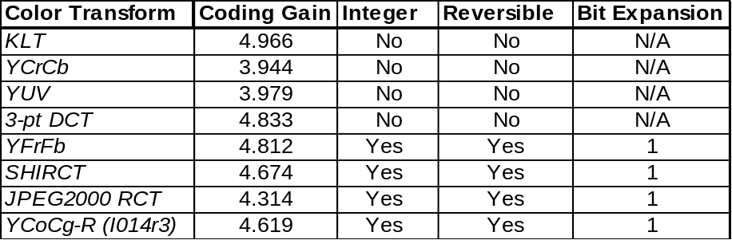

Table 1. Comparison of the KLT and some candidate integer transforms. Our proposed transform, YFrFb, has all the desired features: very high coding gain approaching the KLT, reversible integer transform, and just one bit expansion. It’s coding gain exceeds that of YUV approaches the floating-pt. 3-pt DCT. With just an additional add and shift, we obtain a useful 0.2 dB surplus over the reversible integer transform in I014r3, and a 0.52 dB gain over the related integer transform adopted by JPEG2000. These properties make the proposed transform ideal for inclusion in the JVT Professional Extension.

We now compare our solution against the KLT, the integer color transform in JPEG2000, and the solutions forwarded in I014r3, among other candidate transforms. It is seen that our proposed transform nearly matches the KLT in coding gain, and exceeds traditional transforms such as the YUV and even the 3-pt DCT. By adding just another add and bitshift, we obtain a 0.2 gain dB over the proposed solution in I014r3, as well as the integer solution used by JPEG2000. It is also superior to an integer solution developed in [6]. Finally, it is implementable without any multiplications, making it a lightweight, yet powerful color transform.

In order to test the generalizability of these relative scores for other candidate correlation structures, we have analyzed the complete set of full-color (4:4:4 RGB) video sequences provided recently by Dolby. Our results are given in Appendix A, which confirm the advantages of our proposed transform relative to other candidates.

2.3.4. Bit Expansion

In the above analysis, we note that given an invertible integer transform T with basis vectors , the number of bits that the data is expanded is given by

(Eqn. 13)

In each of the cases above, we find that M*(the L₁-norm of the basis vectors) is always less than two. In particular that is true of our transform. This result is already reflected in Table 1.

2.3.5. Matrix Model

Finally, for completeness, the new forward YFrFb transform, as an integer or floating-point mapping, can also be visualized by the following matrix representation:

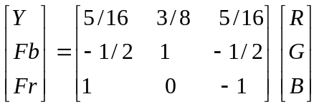. (Eqn. 14)

However, it should be noted that for use as a reversible integer mapping with one-bit expansion the lifting-based implementation detailed above in figures 3 and 4 must be used.

2.4. Conclusions For New Transforms

We have reviewed numerous color transforms in this paper, and considered a variety of new reversible integer transforms. We have developed design selection criteria for such transforms, and developed a systematic methodology for creating such solutions, depending on the statistics of the data. Given a model of color space correlation statistics derived from a well-known color image dataset, we have derived a nearly optimal reversible integer color transform, which moreover has only 1-bit expansion and is computable with only bitshifts and adds. Its properties were shown to be superior to all other available solutions. We therefore propose our new transform for inclusion in the JVT Professional Extension.

3. 4:4:4 Coding

3.1. Approach

In the case of 4:4:4 sampling, if the processing of the chroma channels is strictly aligned with that of the luma channel, the chroma channels could potentially be given too high a relative bitrate. In this situation, we advocate the use of following key functionalities:

  - Separate, independent quantizers for each of the color channels (be they RGB, YCbCr, or some other space).
  - Separate bit-depth for each color channel.

Item (a) is valuable because the quality of reconstruction in the chroma channels, as measured by PSNR as well as visually, is typically higher than that in the luma (Y) channel. This phenomenon holds even in the case of 4:2:0 coding (e.g., the CbCr PSNRs may be 2-3 dB higher than for Y), and becomes more pronounced in the case of 4:2:2 and 4:4:4 coding (e.g., we have observed up to 6 dB differences). For enhanced coding efficiency, it is therefore desirable to be able to quantize each channel independently.

Item (b) is valuable because, similarly to the quantization, it may be more efficient to work with the chroma samples in a lower bit-depth than the luma channel (e.g., 10 or 12 bits luma, 8 bits for chroma channels). Since in 4:4:4 sampling the chroma data comprises 67% of the data stream, it may be valuable for implementation purposes for that data to be treated at a lower bit-depth in some cases.

3.2. Simulations

In figure 5 below we provide a simulation example using a 444 encoder with the above tools. We overlay the objective quality measures for codng the “Night” sequence in three experiments:
- YUV each at 10 bits, quantized with a stepsize of 32
- YUV each at 10 bits, Y with q=30, U and V using q=4,
- YUV, with Y at 10 bits, U and V at 8 bits, and all components with q=28.

In these experiments, the compressed file is approximately the same size for all methods. Note that the PSNR is computed using 10-bit data -- even for item 3, where the 8-bit data is upshifted to 10-bits and compared to the original 10-bit chroma data. Computing PSNR by downshifting to 8-bits in experiment 1 yields similar PSNR numbers, so that in any case we are operating in the very high quality range. Note that in experiment 3, if we were to keep the 8-bit chroma data, and downshift the originals to 8-bits, we should see a roughly 3.5 dB gain in performance, by measuring chroma in 8-bit PSNR.

We note the value of having independent quantizers for the three color components (here YUV). Coding the color channels with independent quantizers allows them to be represented with arbitrarily assigned fidelity. We note also that the use of lower-bit representations of chroma components is valuable, as it permits a more compact represent of 67% of the data during encoding/decoding process, while providing valuable coding efficiencies. It is roughly equivalent to using higher quantization stepsizes for those components. For example, a 2-bit drop in the representation of chroma components (from 10 to 8 bits) roughly corresponds to increasing the quantization by an additional 12 steps (each bit corresponds to a six steps, by the construction of the quantizers). We remark that this test sequence is among the original DPX files released. It has been previously noted that these sequences come from original 420 data, and therefore represent imperfect data for our 444 coding analysis. More tests were conducted after we obtain original 444 data, and the results shown in the following figure substantiate the earlier results.
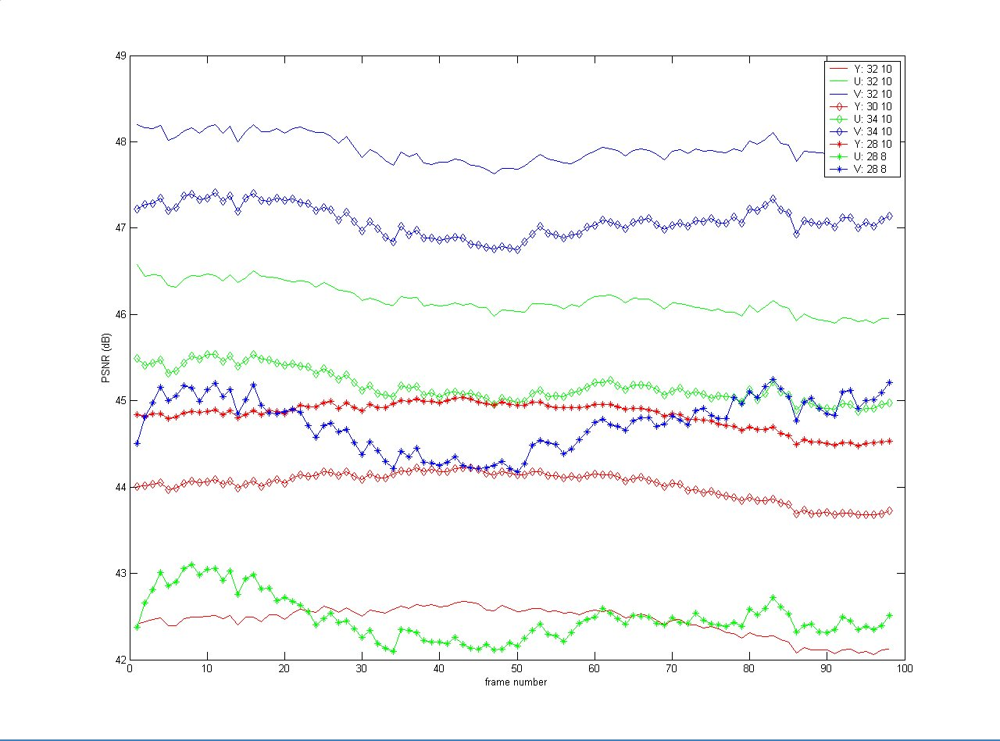

Figure 5. Comparison of three approaches to coding 444 data: (a) all channels of equal bitdepth and quantizers, (b) different quantizers, and (c) different bitdepth. In (c), the Y PSNR is boosted by roughly 2.5 dB, with a corresponding loss for U and V of roughly 3 dB. If chroma PSNR were measured as 8-bit data, these values would be boosted by roughly 3.5 dB compared to their current values (see figure 6).

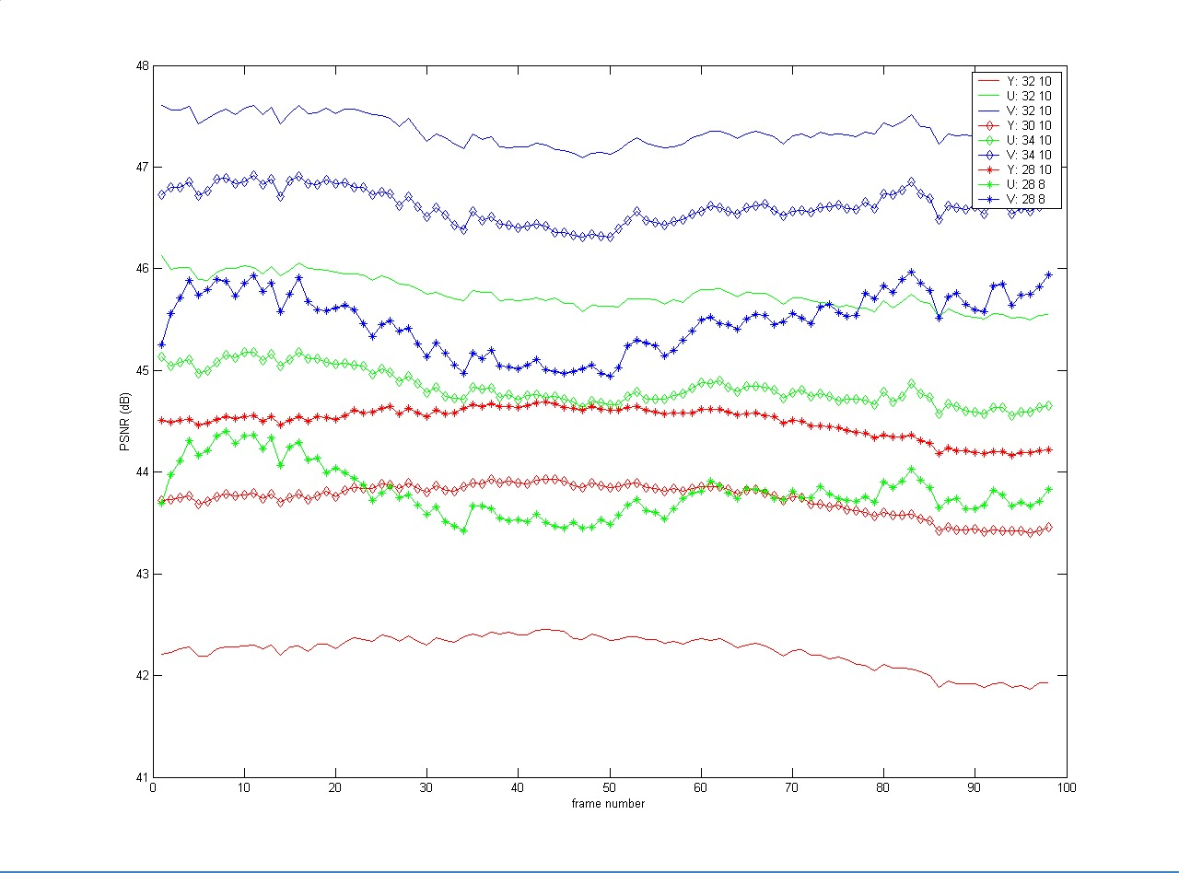

Figure 6. The same experiments, but where the PSNR is measured using 8-bits for all data, regardless of the representation during compression/decompression. With this computation, it becomes clear that, from the point of view of 8-bit analysis (e.g., perhaps from a perceptually meaningful standpoint), treating chroma at 8-bits is significantly valuable, in that the PSNRs are improved for luma, with only moderate loss for chroma, compared to the other methods.

References

[1] Keith Jack, Video Demystified, High-Tech Publications, 1996.

[2] A. Oppenheim, J. Buck, R. Schafer, Discrete-Time Signal Processing, 2nd edition, Prentice-Hall, 1998.

[3] P. Topiwala, C. Tu, “Innovative Invertible, Integer Color Space Transformations for Advanced Image/Video Coding,” FastVDO preprint (in preparation), Aug., 2003.

[4] J. Liang, T. Tran, and P. Topiwala, “A 16-bit architecture for H.26L, treating DCT transforms and quantization,” ITU-T/VCEG Doc. VCEG-M16.doc, Austin, TX Meeting, 2-4 April, 2001.

[5] J. Liang, T. Tran, W. Dai, and P. Topiwala, “Fast Integer Transform and 16-bit Architecture for H.26L,” ITU-T/VCEG Doc. VCEG-N24.doc, Santa Barbara Meeting, 24-28 Sept., 2001.

[6] P. Hao, Q. Shi, “Comparative Study of Color Transforms for Image Coding and Derivation of Integer Reversible Color Transform,” IEEE Int’l Conf. Pat. Recog. (ICPR’00), Vol. 3, Barcelona, Spain, Sept., 2000.

[7] J. Katto and Y. Yasuda, “Performance evaluation of subband coding and optimization o fits filter coefficients,” SPIE Proc. Visual Comm. Image Proc., Boston, MA, Nov. 1991, pp. 95-106.

[8] G. Strang and T. Nguyen, Wavelets and Filter Banks, Wellesley, MA: Wellesley-Cambridge Press, 1997.

Appendix A: Generic Color Correlation Matrix

We have conducted a complete analysis of the correlation structure of the all the full RGB sequences that we obtained from Dolby (batch 1). We note that the video data from this source may not be as color saturated as the Kodak images that we tested with earlier. This may be evidenced by the fact that the correlation between colors is higher than for the Kodak images. (This may be due to several factors: (1) color imaging sensors may be more accurate and saturated than video sensors; (2) in particular, high-frame rate sensors are less accurate/saturated than slower sensors.) Noting this caveat, we have concluded that although there is some variability between the sequences, the correlation matrix can be generalized and simplified for analysis purposes to one of two models:

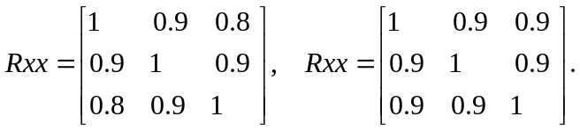 (Eqn. 15a, b)

For these cases, we obtain the following revised tables (Table 2 and 3, respectively) of coding gain performance for the same set of color transforms.

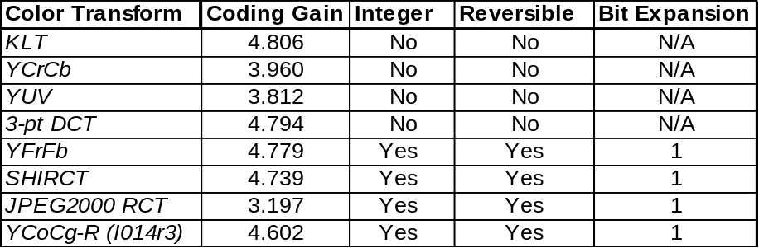

Table 2. Revised coding gain table for candidate color transforms, per the correlation model of equation 15a. This case, which reasonably models the correlation found in the set of RGB video sequences, validates the performance advantages of our transform against other candidate transforms. The relative performance is the same (the 3-pt DCT is now marginally better than ours, by only 0.08 dB!). The performance advantages versus the proposed reversible (lifting) integer transform in I014r3 remain intact.

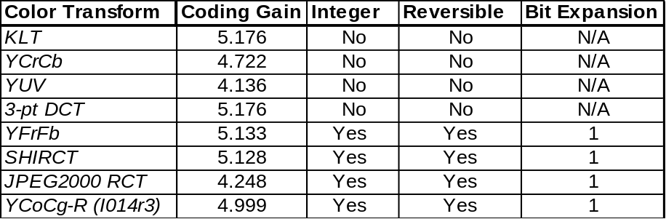

Table 3. Revised coding gain table for candidate color transforms, per the correlation model of equation 15b. This case, which also reasonably models the correlation found in the set of RGB video sequences, validates the performance advantages of our transform against other candidate transforms. Our transform is now within 0.03 dB of the KLT (the 3-pt DCT is now effectively the KLT, since the model of interpixel correlation is similar to 0.95. The performance advantages versus the proposed reversible (lifting) integer transform in I014r3 remain intact.

Appendix B: State of Art Color Transform

If we want to achieve state of the art coding, approaching the KLT, then the following transform can be used

7/8 -17/32
1 -3/8
R

B

G
Fr

Fb

Y

Figure 7. Forward transform, with coding gain of 4.932 dB, within 0.03 dB of the KLT. The computational complexity is 7 adds and 8 bitshifts.
17/32 -7/8
3/8 -1
Fr

Fb

Y
R

B

G

Figure 8. Inverse transform, with computational complexity is 7 adds and 8 bitshifts.

The matrix model of this lifting-based transform is

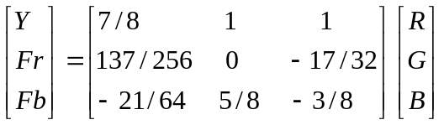.

(Append for Proposal Documents)

JVT Patent Disclosure Form

International Telecommunication Union  Telecommunication Standardization Sector | International Organization for Standardization | International Electrotechnical Commission
 |  | 
Joint Video Coding Experts Group - Patent Disclosure Form
(Typically one per contribution and one per Standard | Recommendation)

Please send to:
JVT Rapporteur Gary Sullivan, Microsoft Corp., One Microsoft Way, Bldg. 9, Redmond WA 98052-6399, USA
Email (preferred): Gary.Sullivan@itu.int Fax: +1 425 706 7329 (+1 425 70MSFAX)

This form provides the ITU-T | ISO/IEC Joint Video Coding Experts Group (JVT) with information about the patent status of techniques used in or proposed for incorporation in a Recommendation | Standard. JVT requires that all technical contributions be accompanied with this form. Anyone with knowledge of any patent affecting the use of JVT work, of their own or of any other entity (“third parties”), is strongly encouraged to submit this form as well.

This information will be maintained in a “living list” by JVT during the progress of their work, on a best effort basis. If a given technical proposal is not incorporated in a Recommendation | Standard, the relevant patent information will be removed from the “living list”. The intent is that the JVT experts should know in advance of any patent issues with particular proposals or techniques, so that these may be addressed well before final approval.

This is not a binding legal document; it is provided to JVT for information only, on a best effort, good faith basis. Please submit corrected or updated forms if your knowledge or situation changes.

This form is not a substitute for the ITU ISO IEC Patent Statement and Licensing Declaration, which should be submitted by Patent Holders to the ITU TSB Director and ISO Secretary General before final approval.

Submitting Organization or Person:
Organization name | FastVDO LLC
Mailing address | 7150 Riverwood Dr., Columbia, MD 21046 USA
Country | USA
Contact person | Dr. Pankaj Topiwala
Telephone | 410-309-6066
Fax | 410-290-8050
Email | pnt@fastvdo.com
Place and date of submission | Geneva, CH 9/1/03
Relevant Recommendation | Standard and, if applicable, Contribution:
Name (ex: “JVT”) |  | JVT
Title
Contribution number |  | JVT-I015d4r1

(Form continues on next page)

Disclosure information – Submitting Organization/Person (choose one box)
 | 2.0 The submitter is not aware of having any granted, pending, or planned patents associated with the technical content of the Recommendation | Standard or Contribution.  or,
The submitter (Patent Holder) has granted, pending, or planned patents associated with the technical content of the Recommendation | Standard or Contribution. In which case,

 | 2.1 The Patent Holder is prepared to grant – on the basis of reciprocity for the above Recommendation | Standard – a free license to an unrestricted number of applicants on a worldwide, non-discriminatory basis to manufacture, use and/or sell implementations of the above Recommendation | Standard.
2.2 The Patent Holder is prepared to grant – on the basis of reciprocity for the above Recommendation | Standard – a license to an unrestricted number of applicants on a worldwide, non-discriminatory basis and on reasonable terms and conditions to manufacture, use and/ or sell implementations of the above Recommendation | Standard.

Such negotiations are left to the parties concerned and are performed outside the ITU | ISO/IEC.
x | 2.2.1 The same as box 2.2 above, but in addition the Patent Holder is prepared to grant a “royalty-free” license to anyone on condition that all other patent holders do the same.
2.3 The Patent Holder is unwilling to grant licenses according to the provisions of either 2.1, 2.2, or 2.2.1 above. In this case, the following information must be provided as part of this declaration:
- patent registration/application number;
- an indication of which portions of the Recommendation | Standard are affected.
- a description of the patent claims covering the Recommendation | Standard;
In the case of any box other than 2.0 above, please provide the following:
Patent number(s)/status
Inventor(s)/Assignee(s)
Relevance to JVT
Any other remarks:
(please provide attachments if more space is needed)

(form continues on next page)
Third party patent information – fill in based on your best knowledge of relevant patents granted, pending, or planned by other people or by organizations other than your own.

Disclosure information – Third Party Patents (choose one box)
x | 3.1 The submitter is not aware of any granted, pending, or planned patents held by third parties associated with the technical content of the Recommendation | Standard or Contribution.
 | 3.2 The submitter believes third parties may have granted, pending, or planned patents associated with the technical content of the Recommendation | Standard or Contribution.
For box 3.2, please provide as much information as is known (provide attachments if more space needed) - JVT will attempt to contact third parties to obtain more information:

3rd party name(s)
Mailing address
Country
Contact person
Telephone
Fax
Email
Patent number/status
Inventor/Assignee
Relevance to JVT

Any other comments or remarks:

