Joint Video Team (JVT) of ISO/IEC MPEG & ITU-T VCEG  (ISO/IEC JTC1/SC29/WG11 and ITU-T SG16 Q.6)  9th Meeting: San Diego, CA, 2-5 September, 2003 | Document: JVT-I015r1  Filename: JVT-I015r1.doc  Revision Date: 18 July 2003

Title: | Coding of 4:4:4 Video in Professional Extension
Status: | Input Document to JVT
Purpose: | Proposal
Author(s) or  Contact(s): | Pankaj Topiwala, Chengjie Tu  FastVDO LLC  7150 Riverwood Dr.  Columbia, MD 21046 USA | Tel:  Email: | 410-309-6066  pnt@fastvdo.com
Source: | FastVDO LLC
_____________________________
Abstract: As the draft video coding standard ITU/H.264 | ISO/IEC 14496-10 nears completion, there is interest in extending the domain of application of the standard to meet extended operating requirements. Among possible extensions, the simplest and apparently most direct ones are to support (a) data sources of higher than 8 bits per sample, and (b) color video sources sampled at other than the initial 4:2:0 chroma sampling format. This document will propose objectives and approaches in coding of 4:4:4 video data for enhanced coding efficiency.

- Outline

The current design of the ITU/H.264 | ISO/MPEG-4 AVC video codec has been constructed for the coding of 4:2:0 color format video data. Extensions to other color formats is desirable, and part of the development being currently investigated by the JVT. A valuable goal of high quality coding for professional applications is to use the 4:4:4 color format, since subsampling in the chroma space may lead be too drastic a reduction in quality for some applications. However, in the case of 4:4:4 sampling, if the processing of the chroma channels is strictly aligned with that of the luma channel, the chroma channels could potentially be given too high a relative bitrate. In this situation, we advocate the use of following key functionalities:

  - Separate, independent quantizers for each of the color channels (be they RGB, YCbCr, or some other space).
  - Separate bit-depth for each color channel.

Item (a) is valuable because the quality of reconstruction in the chroma channels, as measured by PSNR as well as visually, is typically higher than that in the luma (Y) channel. This phenomenon holds even in the case of 4:2:0 coding (e.g., the CbCr PSNRs may be 2-3 dB higher than for Y), and becomes more pronounced in the case of 4:2:2 and 4:4:4 coding (e.g., we have observed up to 6 dB differences). For enhanced coding efficiency, it is therefore desirable to be able to quantize each channel independently.

Item (b) is valuable because, similarly to the quantization, it may be more efficient to work with the chroma samples in a lower bit-depth than the luma channel (e.g., 10 or 12 bits luma, 8 bits for chroma channels). Since in 4:4:4 sampling the chroma data comprises 67% of the data stream, it may be valuable for implementation purposes for that data to be treated at a lower bit-depth in some cases.

These changes to the current structure require some modifications in the entropy coding structures.

- Simulations

In figure 1 below we provide a simulation example using a 444 encoder with the above tools. We overlay the objective quality measures for codng the “Night” sequence in three experiments:
- YUV each at 10 bits, quantized with a stepsize of 32
- YUV each at 10 bits, Y with q=30, U and V using q=4,
- YUV, with Y at 10 bits, U and V at 8 bits, and all components with q=28.

In these experiments, the compressed file is approximately the same size for all methods. Note that the PSNR is computed using 10-bit data -- even for item 3, where the 8-bit data is upshifted to 10-bits and compared to the original 10-bit chroma data. Computing PSNR by downshifting to 8-bits in experiment 1 yields similar PSNR numbers, so that in any case we are operating in the very high quality range. Note that in experiment 3, if we were to keep the 8-bit chroma data, and downshift the originals to 8-bits, we should see a roughly 3.5 dB gain in performance, by measuring chroma in 8-bit PSNR.

We note the value of having independent quantizers for the three color components (here YUV). Coding the color channels with independent quantizers allows them to be represented with arbitrarily assigned fidelity. We note also that the use of lower-bit representations of chroma components is valuable, as it permits a more compact represent of 67% of the data during encoding/decoding process, while providing valuable coding efficiencies. It is roughly equivalent to using higher quantization stepsizes for those components. For example, a 2-bit drop in the representation of chroma components (from 10 to 8 bits) roughly corresponds to increasing the quantization by an additional 12 steps (each bit corresponds to a six steps, by the construction of the quantizers). We remark that this test sequence is among the original DPX files released. It has been previously noted that these sequences come from original 420 data, and therefore represent imperfect data for our 444 coding analysis. More tests will be conducted once we obtain original 444 data, and this document will be updated.

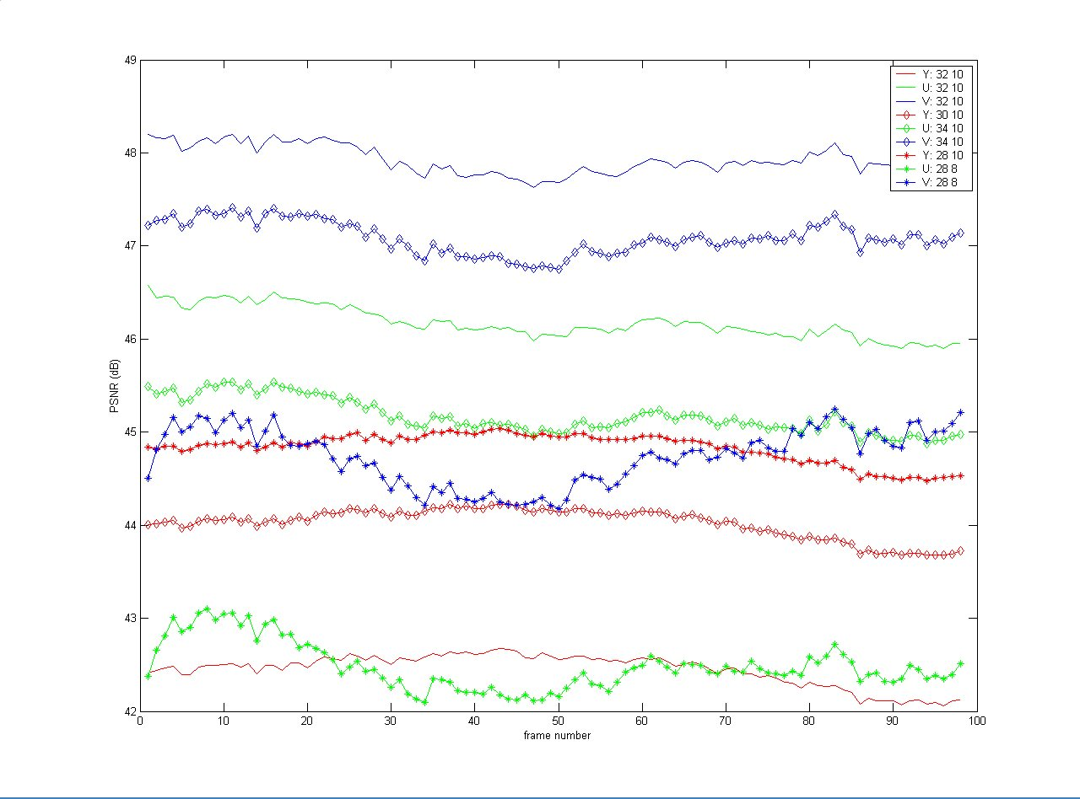

Figure 1. Comparison of three approaches to coding 444 data: (a) all channels of equal bitdepth and quantizers, (b) different quantizers, and (c) different bitdepth. In (c), the Y PSNR is boosted by roughly 2.5 dB, with a corresponding loss for U and V of roughly 3 dB. If chroma PSNR were measured as 8-bit data, these values would be boosted by roughly 3.5 dB compared to their current values (see figure 2).

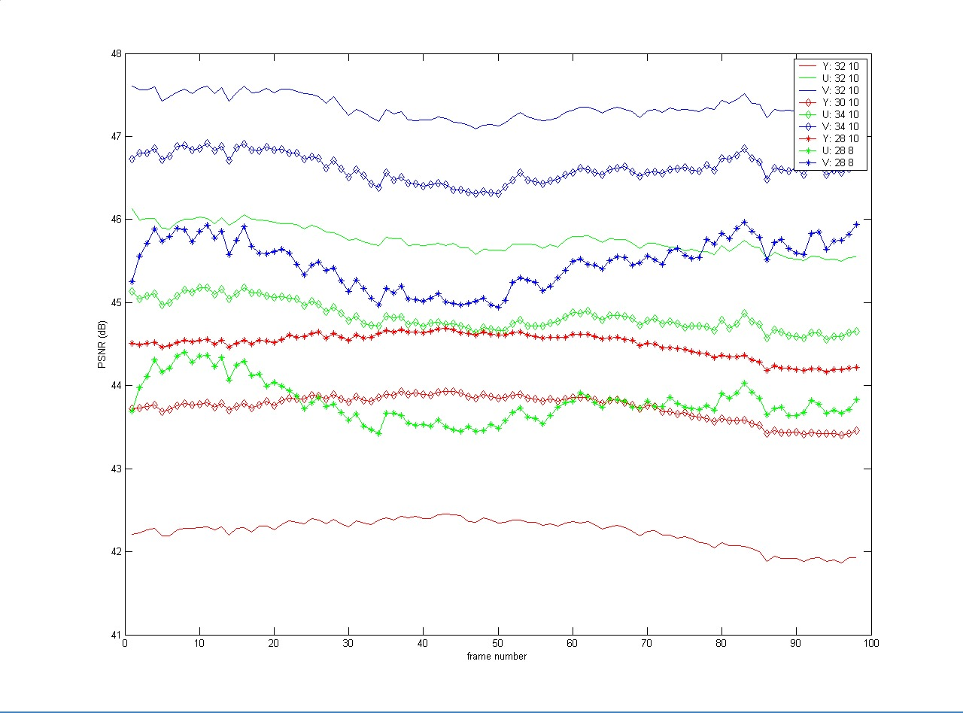

Figure 2. The same experiments, but where the PSNR is measured using 8-bits for all data, regardless of the representation during compression/decompression. With this computation, it becomes clear that, from the point of view of 8-bit analysis (e.g., perhaps from a perceptually meaningful standpoint), treating chroma at 8-bits is significantly valuable, in that the PSNRs are improved for luma, with only moderate loss for chroma, compared to the other methods.

(Append for Proposal Documents)

JVT Patent Disclosure Form

International Telecommunication Union  Telecommunication Standardization Sector | International Organization for Standardization | International Electrotechnical Commission
 |  | 
Joint Video Coding Experts Group - Patent Disclosure Form
(Typically one per contribution and one per Standard | Recommendation)

Please send to:
JVT Rapporteur Gary Sullivan, Microsoft Corp., One Microsoft Way, Bldg. 9, Redmond WA 98052-6399, USA
Email (preferred): Gary.Sullivan@itu.int Fax: +1 425 706 7329 (+1 425 70MSFAX)

This form provides the ITU-T | ISO/IEC Joint Video Coding Experts Group (JVT) with information about the patent status of techniques used in or proposed for incorporation in a Recommendation | Standard. JVT requires that all technical contributions be accompanied with this form. Anyone with knowledge of any patent affecting the use of JVT work, of their own or of any other entity (“third parties”), is strongly encouraged to submit this form as well.

This information will be maintained in a “living list” by JVT during the progress of their work, on a best effort basis. If a given technical proposal is not incorporated in a Recommendation | Standard, the relevant patent information will be removed from the “living list”. The intent is that the JVT experts should know in advance of any patent issues with particular proposals or techniques, so that these may be addressed well before final approval.

This is not a binding legal document; it is provided to JVT for information only, on a best effort, good faith basis. Please submit corrected or updated forms if your knowledge or situation changes.

This form is not a substitute for the ITU ISO IEC Patent Statement and Licensing Declaration, which should be submitted by Patent Holders to the ITU TSB Director and ISO Secretary General before final approval.

Submitting Organization or Person:
Organization name | FastVDO LLC
Mailing address | 7150 Riverwood Dr., Columbia, MD 21046 USA
Country | USA
Contact person | Dr. Pankaj Topiwala
Telephone | 410-309-6066
Fax | 410-290-8050
Email | pnt@fastvdo.com
Place and date of submission | Geneva, CH 5/26/03
Relevant Recommendation | Standard and, if applicable, Contribution:
Name (ex: “JVT”) |  | JVT
Title
Contribution number |  | JVT-H024r4

(Form continues on next page)

Disclosure information – Submitting Organization/Person (choose one box)
2.0 The submitter is not aware of having any granted, pending, or planned patents associated with the technical content of the Recommendation | Standard or Contribution.

or,
The submitter (Patent Holder) has granted, pending, or planned patents associated with the technical content of the Recommendation | Standard or Contribution. In which case,

 | 2.1 The Patent Holder is prepared to grant – on the basis of reciprocity for the above Recommendation | Standard – a free license to an unrestricted number of applicants on a worldwide, non-discriminatory basis to manufacture, use and/or sell implementations of the above Recommendation | Standard.
2.2 The Patent Holder is prepared to grant – on the basis of reciprocity for the above Recommendation | Standard – a license to an unrestricted number of applicants on a worldwide, non-discriminatory basis and on reasonable terms and conditions to manufacture, use and/ or sell implementations of the above Recommendation | Standard.

Such negotiations are left to the parties concerned and are performed outside the ITU | ISO/IEC.
x | 2.2.1 The same as box 2.2 above, but in addition the Patent Holder is prepared to grant a “royalty-free” license to anyone on condition that all other patent holders do the same.
2.3 The Patent Holder is unwilling to grant licenses according to the provisions of either 2.1, 2.2, or 2.2.1 above. In this case, the following information must be provided as part of this declaration:
- patent registration/application number;
- an indication of which portions of the Recommendation | Standard are affected.
- a description of the patent claims covering the Recommendation | Standard;
In the case of any box other than 2.0 above, please provide the following:
Patent number(s)/status
Inventor(s)/Assignee(s)
Relevance to JVT
Any other remarks:
(please provide attachments if more space is needed)

(form continues on next page)
Third party patent information – fill in based on your best knowledge of relevant patents granted, pending, or planned by other people or by organizations other than your own.

Disclosure information – Third Party Patents (choose one box)
3.1 The submitter is not aware of any granted, pending, or planned patents held by third parties associated with the technical content of the Recommendation | Standard or Contribution.

3.2 The submitter believes third parties may have granted, pending, or planned patents associated with the technical content of the Recommendation | Standard or Contribution.

For box 3.2, please provide as much information as is known (provide attachments if more space needed) - JVT will attempt to contact third parties to obtain more information:

3rd party name(s)
Mailing address
Country
Contact person
Telephone
Fax
Email
Patent number/status
Inventor/Assignee
Relevance to JVT

Any other comments or remarks:

