Joint Video Team (JVT) of ISO/IEC MPEG & ITU-T VCEG  (ISO/IEC JTC1/SC29/WG11 and ITU-T SG16 Q.6)  5th Meeting: Geneva, Switzerland, 9-17 October, 2002 | Document: JVT-E114  Filename: : JVT-E114.doc

Title: | Funny Position Filtering
Status: | Input Document to JVT
Purpose: | Information
Author(s) or  Contact(s): | Andrew W Johnson and Paul Haskell | Tel:  Email: | +408 490 6237  awjohnso@harmonicinc.com
Source: | Harmonic Inc.

Introduction
The quarter sample, luma interpolation operation employs 6 tap per phase filters to generate the half sample data. Bi-linear two tap filtering is then applied to the half sample data to generate the remaining quarter sample data. “Funny position”, a peculiar feature of the bi-linear filtering operation, dictates that simple averaging of the four nearest single pixel data values is used to generate the data corresponding to the ¼, ¼ north west direction. All other ¼ sample positions are, however, generated by averaging either ½ sample data or averaging ½ sample and single pixel data. In effect, the data generated for the ¼, ¼ northwest direction is a short filter alternative to the ½, ½ data generated by the 6 tap per phase filter.
The consequences of employing “funny position” filtering are:
- Motion estimation will never be able to provide complete ¼ pixel coverage. Motion in the ¼, ¼ northwest direction will never be captured by motion estimation, hence, coding will NOT be optimal for any sequences which contain motion in that direction.
- Increased complexity is required by a decoder to implement funny position filtering.

Claims have however been made that there are subjective benefits in employing “funny position” filtering.
The purpose of this contribution is to provide insight into the funny position filtering mechanism and argue for the removal of funny position filtering from the JVT specification.
Experiments
Two simple experiments were performed on the sequences “Mobile and Calendar”, “Susie” and “Foreman” to determine:
- The importance of the ¼, ¼ northwest direction when performing motion estimation.
- Why the funny position can yield subjective benefits for some sequences.

The format of the sequence “Mobile and Calendar” was 25 Hz Rec.601.
The format of the sequence “Susie” was 30 Hz Rec.601 .
The format of the sequence “Forman” was CIF.

Experiment 1. Quarter pixel precision motion estimation (ME), was performed to generate motion vectors for all sequences. The ME for the Rec.601 sequences was adaptive field/frame employing an 8x8 block size. The ME for the CIF sequence employed a 4x4 block size. A P-frame only GOP structure was used. The best motion vectors for each macroblock were selected based upon the sum of the SAD metric for that macroblock. Funny filtering was performed for the ¼, ¼ northwest direction as described in the JVT specification. The percentage of blocks using this direction was determined.

Experiment 2. Experiment identical to 1, with the exception that “normal” bi-linear filtering is performed at the funny position (i.e. filtering equivalent to the ¼, ¼ southeast direction)

Results
The results of experiments are plotted in Figure 1.
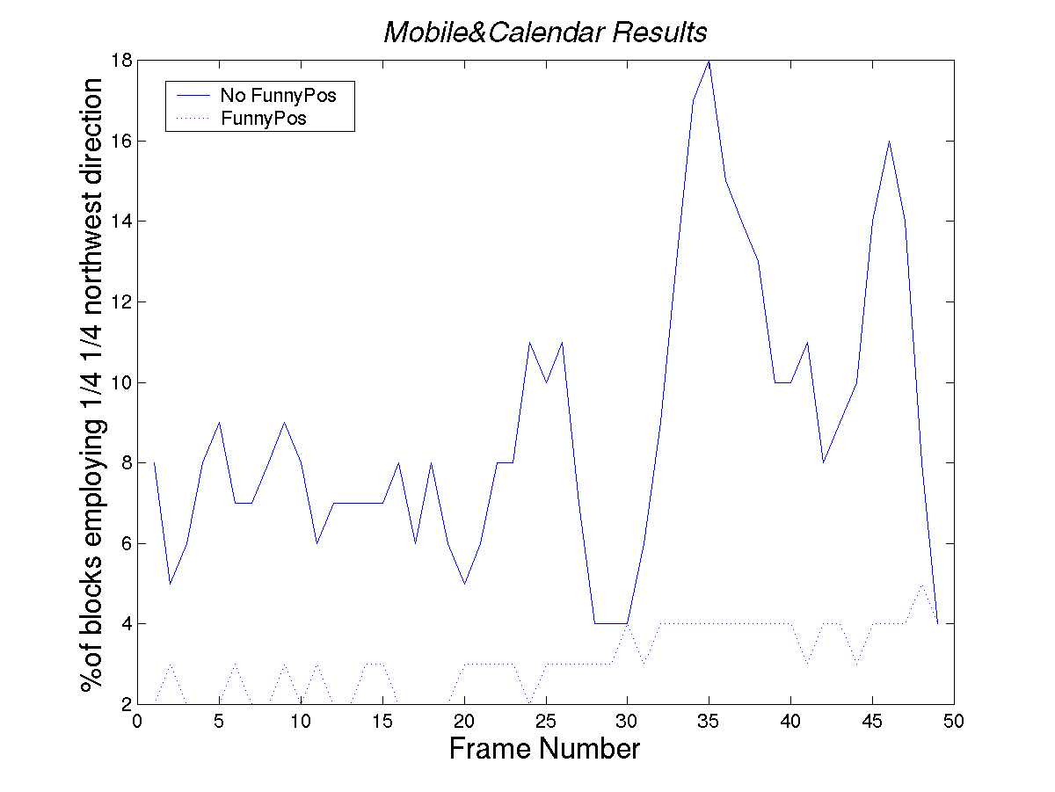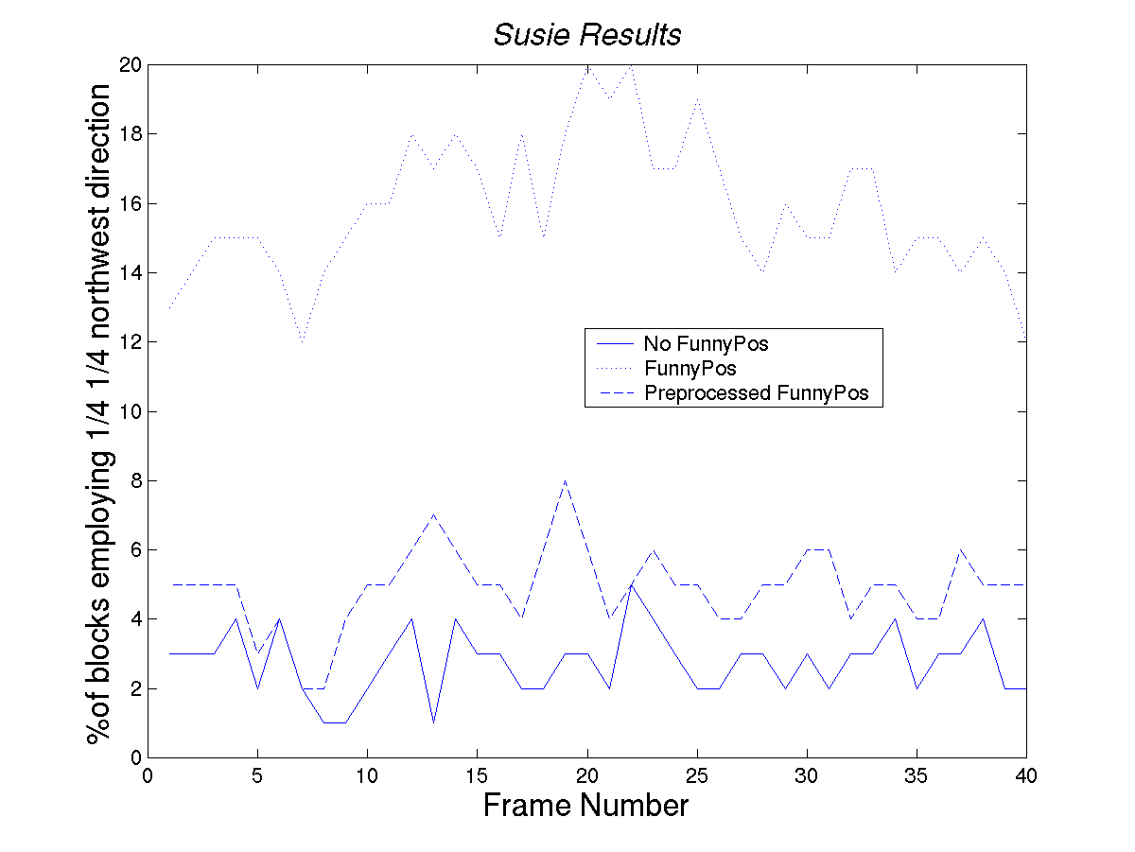
Figure 1. Experimental Results for the Sequences “Mobile&Calendar” and “Susie”

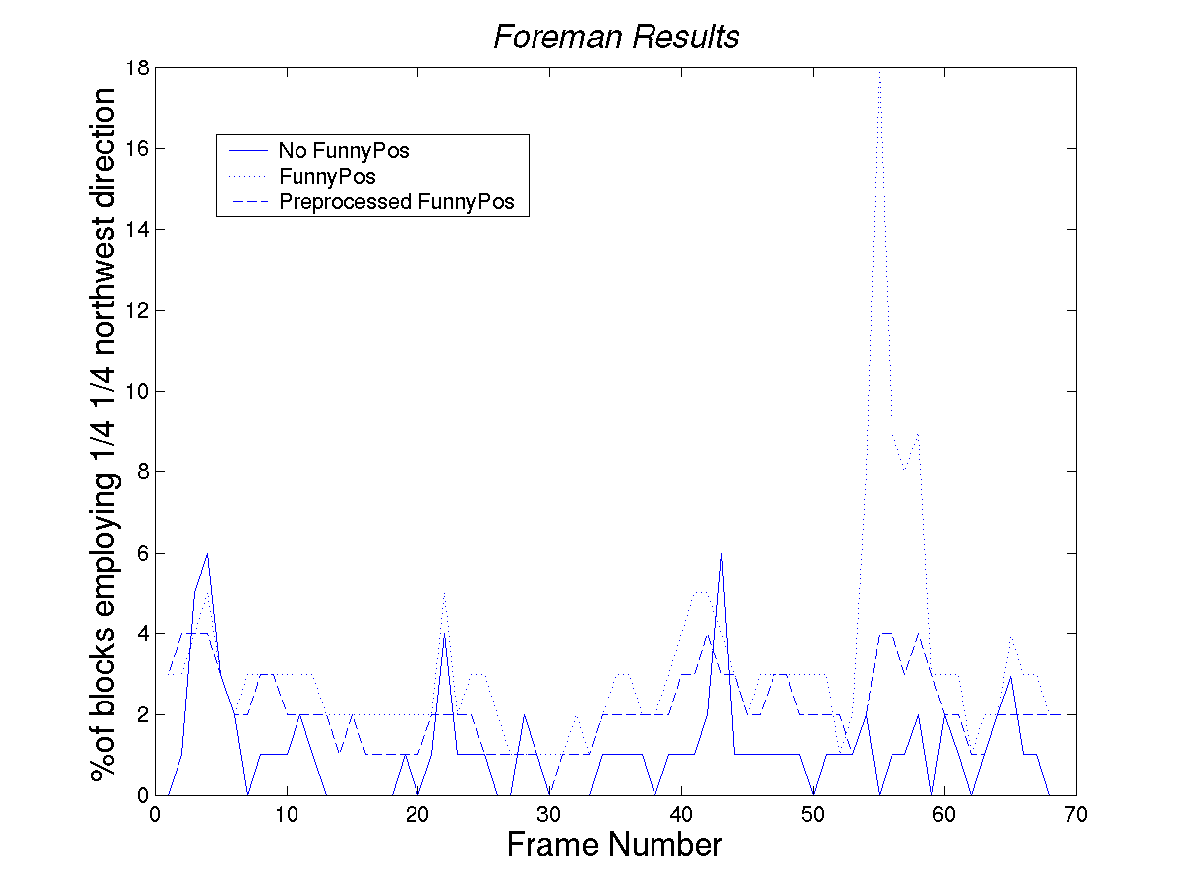
Figure 2. Experimental Results for the Sequence “Foreman”

Mobile and Calendar
- Experiment 1 shows the direction corresponding to the funny position is used on less than 5 % of processed blocks.
- Experiment 2 shows that ¼, ¼ northwest direction is used up to 18 % of the time without funny position filtering.
It is readily apparent that funny position removes from the motion estimation process, a direction that has a significant frequency of occurrence for this sequence. Subsequent coding will not be optimal.
Susie
Results indicate that the Susie sequence benefits from funny position processing. Up to 20% of processed blocks used the direction corresponding to funny position filtering. This is significantly more than the results generated by experiment 2 for the same sequence. Clearly, this sequence has benefited from funny position filtering.
Susie is characterized by a talking head on a stationary background. Frames making up the sequence have little high spatial frequency content. This is particularly the case with the background, which is characterized by noise-like spatial statistics. Inspection of the motion vectors for each frame show, that the majority of the funny position vectors are located on stationary background. Whilst motion estimation selects the funny position direction for the background, the decision making process used for selection has nothing to do with tracking motion in the “funny direction”. Rather, the funny position is chosen because its associated prediction contains less energy in the high spatial frequencies. This is because the funny reference is generated by a filter having a more low pass magnitude response. The funny position benefits some sequences in two ways:
- Less energy is contained in the residual, which may result in it being encoded more efficiently.
- The motion vectors associated with coding noisy background can be coerced into a consistent direction, making motion vector prediction more efficient.
An alternative to funny position noise filtering is to first preprocess the video signal to remove noise. Similar results to funny position filtering on the “Susie” sequence can be achieved using filters designed to remove Gaussian noise. Results for the sequence Susie, shown in figure 1, also include the percentage of blocks employing prediction in the funny direction following noise preprocessing. The percentages per frame are significantly reduced, essentially rendering void the benefits obtained through funny position filtering. The obvious benefits of this approach are that it simplifies the decoder and it allows complete quarter pixel motion estimation coverage.
Foreman
The results for the sequence “Foreman”, shown in figure 2, were similar to those obtained for the “Susie sequence”. An inspection of the generated motion vectors showed that the majority of funny position blocks were located on the concrete walls surrounding the foreman. These blocks are characterised by noise like spatial attributes. No funny position blocks were found on spatial regions that contained edge information of any description. As was the case with the sequence “Susie”, simple preprocessing of the sequence rendered void any benefits obtained through funny position filtering.
Conclusion
This contribution presents the results of experiments on the use of funny position filtering defined in the JVT specification. Experiments have shown that the funny position removes a ME direction that will result in sub-optimum encoding for some sequences. Experiments have also shown that the funny position filtering does offer an advantage when coding sequences that contain blocks, which possess noise-like spatial attributes. This advantage was, however, rendered void when preprocessing the video source to remove noise.
There is therefore no need to include the funny position in the specification.

JVT Patent Disclosure Form

International Telecommunication Union  Telecommunication Standardization Sector | International Organization for Standardization | International Electrotechnical Commission
 |  | 
Joint Video Coding Experts Group - Patent Disclosure Form
(Typically one per contribution and one per Standard | Recommendation)

Please send to:
JVT Rapporteur Gary Sullivan, Microsoft Corp., One Microsoft Way, Bldg. 9, Redmond WA 98052-6399, USA
Email (preferred): Gary.Sullivan@itu.int Fax: +1 425 706 7329 (+1 425 70MSFAX)

This form provides the ITU-T | ISO/IEC Joint Video Coding Experts Group (JVT) with information about the patent status of techniques used in or proposed for incorporation in a Recommendation | Standard. JVT requires that all technical contributions be accompanied with this form. Anyone with knowledge of any patent affecting the use of JVT work, of their own or of any other entity (“third parties”), is strongly encouraged to submit this form as well.

This information will be maintained in a “living list” by JVT during the progress of their work, on a best effort basis. If a given technical proposal is not incorporated in a Recommendation | Standard, the relevant patent information will be removed from the “living list”. The intent is that the JVT experts should know in advance of any patent issues with particular proposals or techniques, so that these may be addressed well before final approval.

This is not a binding legal document; it is provided to JVT for information only, on a best effort, good faith basis. Please submit corrected or updated forms if your knowledge or situation changes.

This form is not a substitute for the ITU ISO IEC Patent Statement and Licensing Declaration, which should be submitted by Patent Holders to the ITU TSB Director and ISO Secretary General before final approval.

Submitting Organization or Person:
Organization name | Harmonic Inc
Mailing address | 549 Baltic Way  Sunnyvale, CA 94089
Country | USA
Contact person | Andrew William Johnson
Telephone | (+1) 408 490 6237
Fax
Email | awjohnso@harmonicinc.com
Place and date of submission | San Jose, CA, October 3 2002
Relevant Recommendation | Standard and, if applicable, Contribution:
Name (ex: “JVT”) |  | JVT
Title |  | Funny Position Filtering
Contribution number |  | JVT-E114

(Form continues on next page)

Disclosure information – Submitting Organization/Person (choose one box)
X | 2.0 The submitter is not aware of having any granted, pending, or planned patents associated with the technical content of the Recommendation | Standard or Contribution.  or,
The submitter (Patent Holder) has granted, pending, or planned patents associated with the technical content of the Recommendation | Standard or Contribution. In which case,

 | 2.1 The Patent Holder is prepared to grant – on the basis of reciprocity for the above Recommendation | Standard – a free license to an unrestricted number of applicants on a worldwide, non-discriminatory basis to manufacture, use and/or sell implementations of the above Recommendation | Standard.
2.2 The Patent Holder is prepared to grant – on the basis of reciprocity for the above Recommendation | Standard – a license to an unrestricted number of applicants on a worldwide, non-discriminatory basis and on reasonable terms and conditions to manufacture, use and/ or sell implementations of the above Recommendation | Standard.

Such negotiations are left to the parties concerned and are performed outside the ITU | ISO/IEC.
 | 2.2.1 The same as box 2.2 above, but in addition the Patent Holder is prepared to grant a “royalty-free” license to anyone on condition that all other patent holders do the same.
2.3 The Patent Holder is unwilling to grant licenses according to the provisions of either 2.1, 2.2, or 2.2.1 above. In this case, the following information must be provided as part of this declaration:
- patent registration/application number;
- an indication of which portions of the Recommendation | Standard are affected.
- a description of the patent claims covering the Recommendation | Standard;
In the case of any box other than 2.0 above, please provide the following:
Patent number(s)/status
Inventor(s)/Assignee(s)
Relevance to JVT
Any other remarks:
(please provide attachments if more space is needed)

(form continues on next page)
Third party patent information – fill in based on your best knowledge of relevant patents granted, pending, or planned by other people or by organizations other than your own.

Disclosure information – Third Party Patents (choose one box)
X | 3.1 The submitter is not aware of any granted, pending, or planned patents held by third parties associated with the technical content of the Recommendation | Standard or Contribution.
 | 3.2 The submitter believes third parties may have granted, pending, or planned patents associated with the technical content of the Recommendation | Standard or Contribution.
For box 3.2, please provide as much information as is known (provide attachments if more space needed) - JVT will attempt to contact third parties to obtain more information:

3rd party name(s)
Mailing address
Country
Contact person
Telephone
Fax
Email
Patent number/status
Inventor/Assignee
Relevance to JVT

Any other comments or remarks:

