Joint Video Team (JVT) of ISO/IEC MPEG & ITU-T VCEG  (ISO/IEC JTC1/SC29/WG11 and ITU-T SG16 Q.6)  5th Meeting: Geneva, Switzerland, October, 2002 | Document: JVT-E113  Filename: JVT-E113.doc

Title: | Improved Transform for ABT
Status: | Input Document
Purpose: | Proposal
Author(s) or  Contact(s): | Pankaj Topiwala  7150 Riverwood Dr.  Columbia, MD 21046 | Tel:  Email: | 301-442-6063  pnt@fastvdo.com
Source: | FastVDO LLC
_____________________________

FastVDO has consistently proposed optimized integer DCT transforms based on lifting factorization of the DCT. Our proposal VCEG-N24 carries our approach in detail. With regard to ABT, we propose that instead of the current 8-pt transform used in ABT, the following lifting transform be substituted, as given in figure 1.

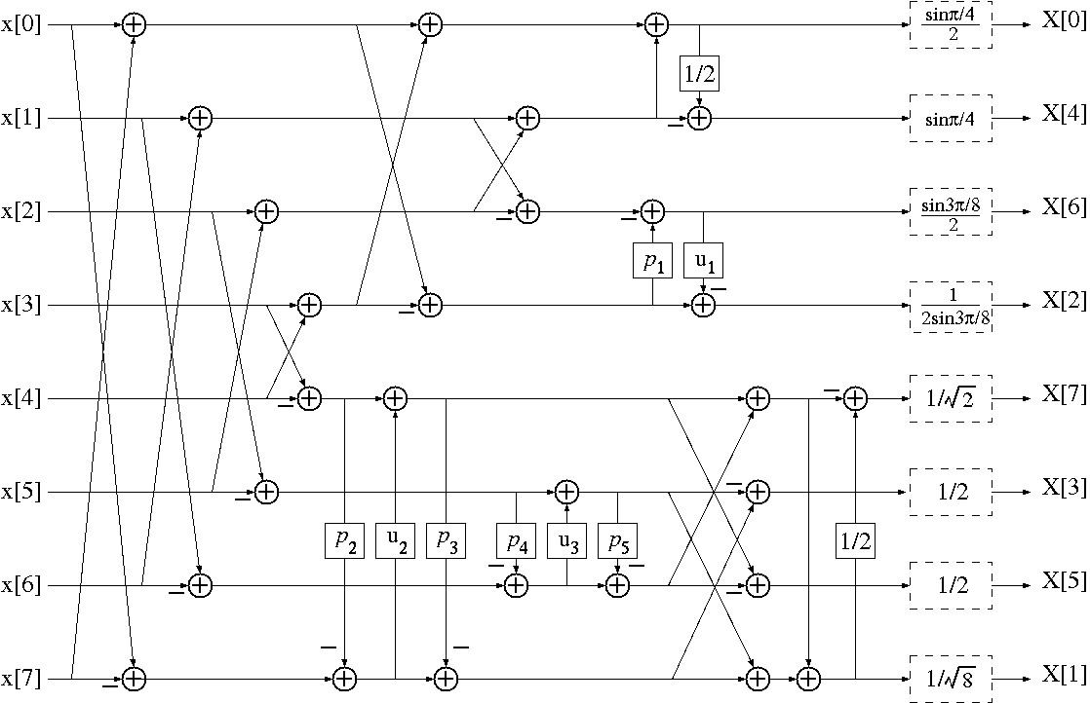

Here, the special constants can be selected in the range [0, 1]. Several key advantages of the lifting transform approach are that:

- The inverse transform is virtually identical to the forward transform, with all signs reversed.
- The system allows exact invertibility for all choices of constants.
- For dyadic constants, it allows computation by shifts and adds only (preferred).
- Higher than 8-bit input is generally permitted, while maintaining 16-bit operation, and exact invertibility. The first basis function, which is generally the DC term, is the key to measuring bit expansion. In this case, for an 8-pt transform, it increases the data by 3 bits for 1D transform, or 6 bits for a 2D transform. In particular, for an 8x8 transform, 10-bit input can be up to 10-bits.
- Special case of interest: all constants = ½.

These extraordinary properties make this transform especially suitable for the adaptive block coding (ABT). An especially valuable set of special coefficients is when they are all set to ½.

(Append for Proposal Documents)

JVT Patent Disclosure Form

International Telecommunication Union  Telecommunication Standardization Sector | International Organization for Standardization | International Electrotechnical Commission
 |  | 
Joint Video Coding Experts Group - Patent Disclosure Form
(Typically one per contribution and one per Standard | Recommendation)

Please send to:
JVT Rapporteur Gary Sullivan, Microsoft Corp., One Microsoft Way, Bldg. 9, Redmond WA 98052-6399, USA
Email (preferred): Gary.Sullivan@itu.int Fax: +1 425 706 7329 (+1 425 70MSFAX)

This form provides the ITU-T | ISO/IEC Joint Video Coding Experts Group (JVT) with information about the patent status of techniques used in or proposed for incorporation in a Recommendation | Standard. JVT requires that all technical contributions be accompanied with this form. Anyone with knowledge of any patent affecting the use of JVT work, of their own or of any other entity (“third parties”), is strongly encouraged to submit this form as well.

This information will be maintained in a “living list” by JVT during the progress of their work, on a best effort basis. If a given technical proposal is not incorporated in a Recommendation | Standard, the relevant patent information will be removed from the “living list”. The intent is that the JVT experts should know in advance of any patent issues with particular proposals or techniques, so that these may be addressed well before final approval.

This is not a binding legal document; it is provided to JVT for information only, on a best effort, good faith basis. Please submit corrected or updated forms if your knowledge or situation changes.

This form is not a substitute for the ITU ISO IEC Patent Statement and Licensing Declaration, which should be submitted by Patent Holders to the ITU TSB Director and ISO Secretary General before final approval.

Submitting Organization or Person:
Organization name | FastVDO LLC
Mailing address | 7150 Riverwood Dr., Columbia, MD 21046
Country | USA
Contact person | Pankaj Topiwala
Telephone | 301-442-6063
Fax
Email | pnt@fastvdo.com
Place and date of submission
Relevant Recommendation | Standard and, if applicable, Contribution:
Name (ex: “JVT”) |  | JVT
Title
Contribution number |  | JVT-E113

(Form continues on next page)

Disclosure information – Submitting Organization/Person (choose one box)
2.0 The submitter is not aware of having any granted, pending, or planned patents associated with the technical content of the Recommendation | Standard or Contribution.

or,
The submitter (Patent Holder) has granted, pending, or planned patents associated with the technical content of the Recommendation | Standard or Contribution. In which case,

2.1 The Patent Holder is prepared to grant – on the basis of reciprocity for the above Recommendation | Standard – a free license to an unrestricted number of applicants on a worldwide, non-discriminatory basis to manufacture, use and/or sell implementations of the above Recommendation | Standard.
2.2 The Patent Holder is prepared to grant – on the basis of reciprocity for the above Recommendation | Standard – a license to an unrestricted number of applicants on a worldwide, non-discriminatory basis and on reasonable terms and conditions to manufacture, use and/ or sell implementations of the above Recommendation | Standard.

Such negotiations are left to the parties concerned and are performed outside the ITU | ISO/IEC.
2.2.1 The same as box 2.2 above, but in addition the Patent Holder is prepared to grant a “royalty-free” license to anyone on condition that all other patent holders do the same.
2.3 The Patent Holder is unwilling to grant licenses according to the provisions of either 2.1, 2.2, or 2.2.1 above. In this case, the following information must be provided as part of this declaration:
- patent registration/application number;
- an indication of which portions of the Recommendation | Standard are affected.
- a description of the patent claims covering the Recommendation | Standard;
In the case of any box other than 2.0 above, please provide the following:
Patent number(s)/status
Inventor(s)/Assignee(s)
Relevance to JVT
Any other remarks:
(please provide attachments if more space is needed)

(form continues on next page)
Third party patent information – fill in based on your best knowledge of relevant patents granted, pending, or planned by other people or by organizations other than your own.

Disclosure information – Third Party Patents (choose one box)
3.1 The submitter is not aware of any granted, pending, or planned patents held by third parties associated with the technical content of the Recommendation | Standard or Contribution.

3.2 The submitter believes third parties may have granted, pending, or planned patents associated with the technical content of the Recommendation | Standard or Contribution.

For box 3.2, please provide as much information as is known (provide attachments if more space needed) - JVT will attempt to contact third parties to obtain more information:

3rd party name(s)
Mailing address
Country
Contact person
Telephone
Fax
Email
Patent number/status
Inventor/Assignee
Relevance to JVT

Any other comments or remarks:

