Joint Video Team (JVT) of ISO/IEC MPEG & ITU-T VCEG  (ISO/IEC JTC1/SC29/WG11 and ITU-T SG16 Q.6)  5th Meeting: Geneva, CH, 9-17 October, 2002 | Document: JVT-E097  Filename: JVT-E097.doc

Title: | Clean up for temporal direct mode
Status: | Input Contribution to JVT
Purpose: | Proposal
Author(s) or  Contact(s): | Byeong-Moon Jeon  16 Woomyeon-Dong, Secho-Gu  LG Electronics Inc. DM research Lab.  Seoul 137-724, Korea | Tel:  Email: | 82-2-526-4415  jeonbm@lge.com
Source: | LG Electronics Inc.
_____________________________
1. Introduction

Direct mode motion vectors are calculated using spatial or temporal methods. This documents describes only temporal direct mode by setting direct_spatial_mv_pred_flag as 0. Figure 1 shows the default index order for list 0 prediction, the default index order for list 1 prediction, and the list 1 reference picture for direct mode at each B picture of IBBBP pattern under the assumption that the short-term buffer size is 6 and the reordering of the reference index lists is not applied.

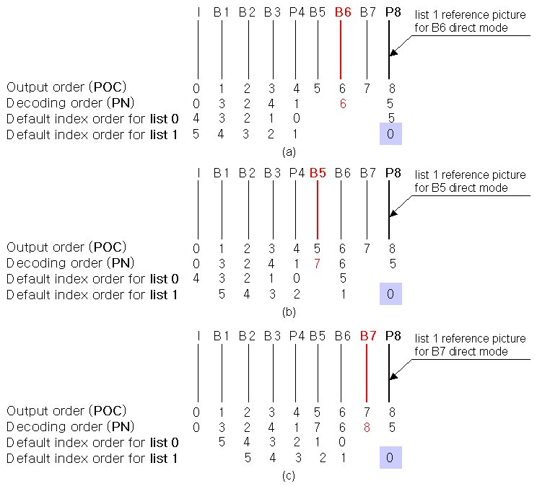
Figure 1. List 1 reference picture for direct mode in IBBBP pattern

Figure 2 also shows the respective indices at each B picture under the same assumption as Figure 1, when all the list 0 and list 1 reference pictures are in the temporally same direction, for example IBBB pattern. In JVT model, IBBB pattern is available because JVT model allows B picture to be used as a reference picture. In Figure 2, the list 1 reference picture is B5 when the target picture is B8 ((a)), the list 1 reference picture is B8 when the target picture is B7 ((b)), and the list 1 reference picture is B7 when the target picture is B9 ((c))

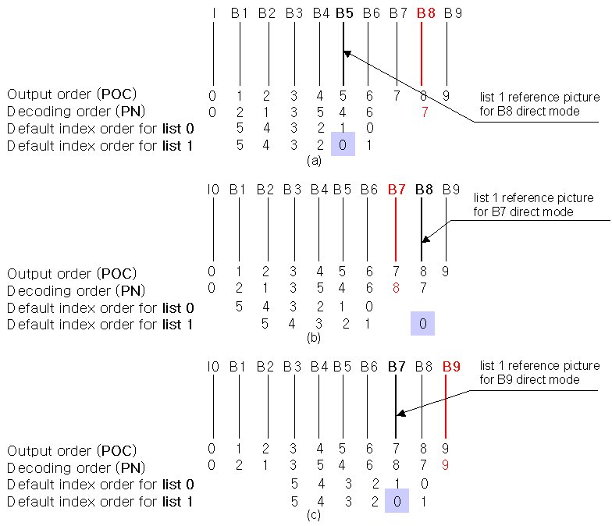
Figure 2. List 1 reference picture for direct mode when all the list 0 and list 1 reference pictures are in the temporally same direction

From Figure 1 and 2, we see that the list 1 reference picture of the direct mode occurs temporally earlier or temporally later than the current B picture and the co-located block in the list 1 reference picture can have the list 0 motion vector, the list 1 motion vector, or both the list 0 and list 1 motion vectors because it exists in P and B picture. Figure 3 and Figure 4 illustrate the available modes that the list 1 co-located block can have, when the list 1 reference picture occurs temporally earlier or later than the current B picture. They also include the cases that the reference index reordering is applied. Besides, even in the conditions that the definition of the list 1 reference picture is changed from the decoded picture at index 0 in list 1 mode to the most recently decoded picture, the cases as shown in Figure 3 and 4 can occur.

In the current FCD, the appropriate procedures for the most cases in Figure 3 and 4 are missed at temporal direct mode. Actually FCD introduced the calculation method for the direct mode motion vector based on the conventional B (bi-directional) picture, not current B (bi-predictive) picture. The object of this document is to make the temporal direct mode clear by providing the solution to the problem, which motion vector will be used for the direct mode motion vector calculation, when the co-located block in the list 1 reference picture has only the list 1 motion vector or both the list 0 and list 1 motion vectors. And this document also shows the reasonable calculation methods for the direct mode motion vectors in the various cases.

2. Temporal technique of obtaining the direct mode motion parameters

As mentioned above, the co-located block in the list 1 reference picture can have one or two motion vectors and we need to decide which motion vector will be used for direct mode motion vector calculation. According to FCD, the direct mode motion vectors are computed from the list 0 motion vector of the co-located block in the list 1 reference picture and so the list 0 reference picture for the direct mode is the same as the list 0 reference picture used for the list 1 co-located block. However, if the co-located block has only the list 1 motion vector, then is it meaningful that the motion vector of the co-located block is regarded as zero and the list 0 reference picture is the most recent temporally preceding picture? The important fact is that the co-located block now has the motion information to be capable of being used for direct mode motion vector calculation, although it has the list 1 motion vector that FCD does not allow. Therefore, this document suggests that the motion vector has to be used for the direct mode motion vectors although it is the list 1 motion vector. As another questionable case, there is a case that the list 1 co-located block has both the list 0 and list 1 motion vectors. The simple solution is to just select the list 0 motion vector.

Consequently, this document proposes that if the list 1 co-located block has only one motion vector, the motion vector is used for the direct mode motion vector calculation regardless of its mode, and if the list 1 co-located block has two motion vectors, then the list 0 motion vector is chosen for the direct mode motion vector calculation. That is, two motion vectors for the direct mode can be calculated as scaled version of the motion vector that the list 1 co-located block has (or selects), regardless of its mode, and thus the list 0 reference picture for the direct mode is the same as the reference picture that the motion vector of the list 1 co-located block points.

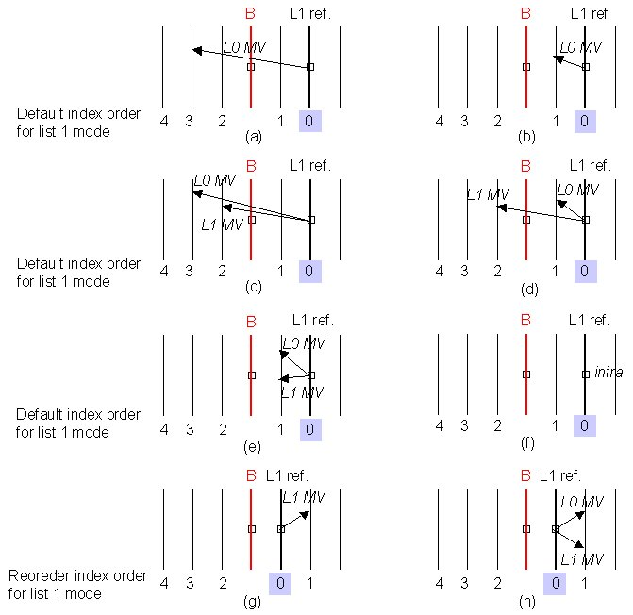
Figure 3. Modes of the list 1 co-located block when the list 1 reference picture occurs temporally later than B picture (L0 MV: list 0 motion vector, L1 MV: list 1 motion vector)

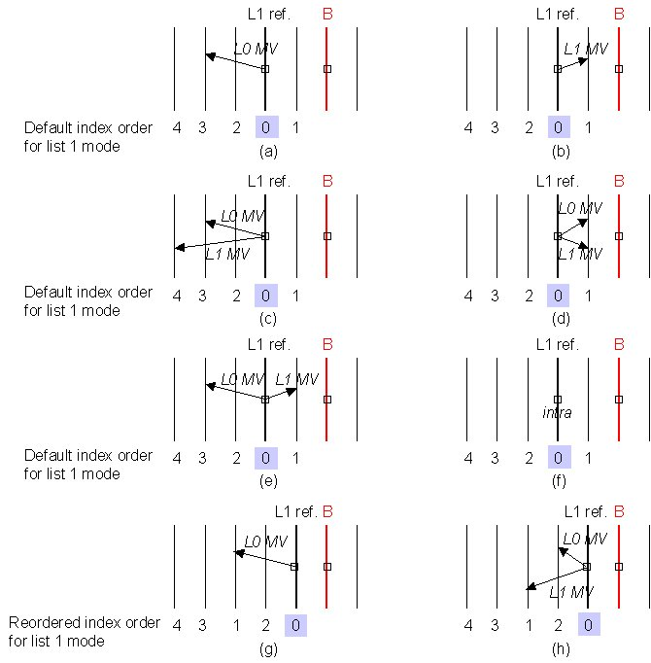
Figure 4. Modes of the list 1 co-located block when the list 1 reference picture occurs temporally earlier than B picture (L0 MV: list 0 motion vector, L1 MV: list 1 motion vector)

2.1 List 1 reference picture for direct mode occurs temporally later than B picture

Case 1: Both the current macroblock and the list 1 co-located macroblock are in frame mode
Figure 3 (a) and (c) are simplified to Figure 5 (a), Figure 3 (b) (d) (e) are simplified to Figure 5 (c), and Figure 3 (g) and (h) are simplified to Figure 5 (b).

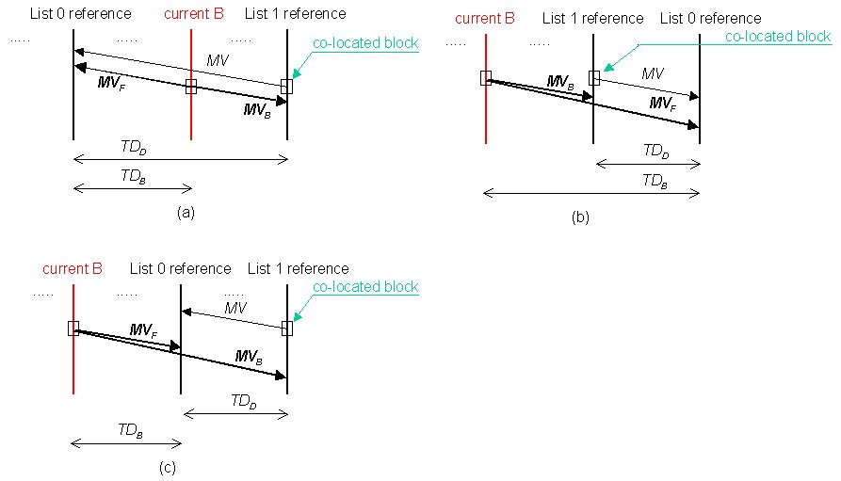
Figure 5. Both the current macroblock and the list 1 co-located macroblock are in frame mode when the list 1 reference picture is in temporally following direction

In Figure 5 (a), the list 0 and list 1 motion vectors (MV_{F}, MV_{B}) for the direct mode are obtained as described in FCD.
If both the list 0 and list 1 reference pictures for the direct mode occur temporally later than the current B picture and the list 0 reference picture occurs temporally later than the list 1 reference picture as shown in Figure 5 (b), then two motion vectors of direct mode block are calculated as follows:
Z = TD_{B} x 256 / TD_{D} MV_{F} = (Z x MV + 128) >> 8
W = Z – 256 MV_{B} = (W x MV + 128) >> 8
If both the list 0 and list 1 reference pictures for the direct mode occur temporally later than the current B picture and the list 0 reference picture occurs temporally earlier than the list 1 reference picture as shown as shown in Figure 5 (c), then two motion vectors of direct mode block are calculated as follows:
Z = -TD_{B} x 256 / TD_{D} MV_{F} = (Z x MV + 128) >> 8
W = Z – 256 MV_{B} = (W x MV + 128) >> 8

Case 2: Both the current macroblock and the list 1 co-located macroblock are in field mode
If the list 0 reference picture for the direct mode occurs temporally earlier than the current B picture and the list 1 reference picture occurs temporally later than the B picture as shown in Figure 6 (a), then the list 0 and list 1 motion vectors (MV_{F,i} , MV_{B,i}) for the direct mode are obtained as described in FCD.
If both the list 0 and list 1 reference pictures for the direct mode occur temporally later than the current B picture and the list 0 reference picture occurs temporally later than the list 1 reference picture as shown in Figure 6 (b), then two motion vectors (MV_{F,i} , MV_{B,i}) for field i of the direct mode block are calculated as follows:
Z = TD_{B,i} x 256 / TD_{D,i} MV_{F,i} = (Z x MV_{i} + 128) >> 8
W = Z – 256 MV_{B,i} = (W x MV_{i} + 128) >> 8
In addition, it is also possible that the list 0 motion vector of the co-located block in field i of the list 1 reference frame points to the field that occurs temporally later than the current B picture as shown in Figure 6 (c) and (d). That is, if both the list 0 and list 1 reference pictures for the direct mode occur temporally later than the current B picture and the list 0 reference picture occurs temporally earlier than the list 1 reference picture, then two motion vectors (MV_{F,i} , MV_{B,i}) for field i of the direct mode block are calculated as follows:
Z = -TD_{B,i} x 256 / TD_{D,i} MV_{F,i} = (Z x MV_{i} + 128) >> 8
W = Z – 256 MV_{B,i} = (W x MV_{i} + 128) >> 8

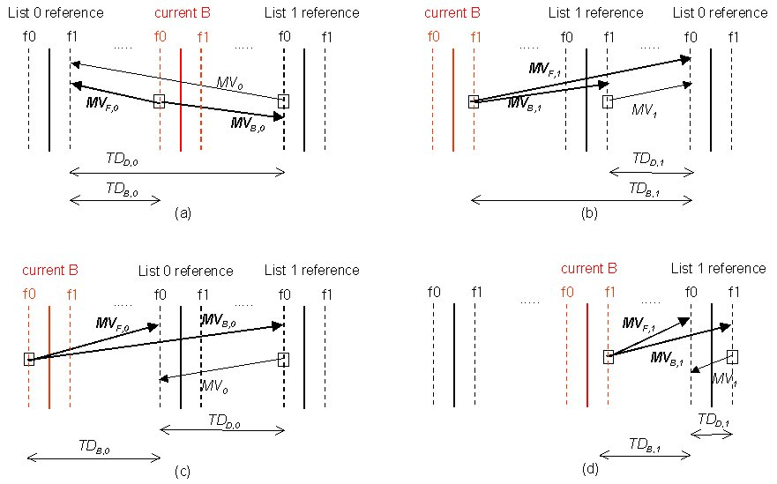
Figure 6. Both the current macroblock and the list 1 co-located macroblock are in field mode when the list 1 reference picture is in temporally following direction

Case 3: The current macroblock is in field mode and the list 1 co-located macroblock is in frame mode
If the list 0 reference picture for the direct mode occurs temporally earlier than the current B picture and the list 1 reference picture occurs temporally later than the B picture as shown in Figure 7 (a), then the list 0 and list 1 motion vectors (MV_{F,i} , MV_{B,i}) for the direct mode block are obtained as described in FCD.
If both the list 0 and list 1 reference pictures for the direct mode occur temporally later than the current B picture and the list 0 reference picture occurs temporally later than the list 1 reference picture as shown in Figure 7 (b), then two motion vectors (MV_{F,i} , MV_{B,i}) for field i of the direct mode block are calculated as follows:
Z = TD_{B,i} x 256 / TD_{D} MV_{F,i} = (Z x MV + 128) >> 8
W = Z – 256 MV_{B,i} = (W x MV + 128) >> 8
In addition, it is also possible that the list 0 motion vector of the co-located block in the list 1 reference frame points to the frame that occurs temporally later than the current B picture as shown in Figure 7 (c). That is, if both the list 0 and list 1 reference pictures for the direct mode occur temporally later than the current B picture and the list 0 reference picture occurs temporally earlier than the list 1 reference picture, then two motion vectors (MV_{F,i} , MV_{B,i}) for field i of the direct mode block are calculated as follows:
Z = -TD_{B,i} x 256 / TD_{D} MV_{F,i} = (Z x MV + 128) >> 8
W = Z – 256 MV_{B,i} = (W x MV + 128) >> 8

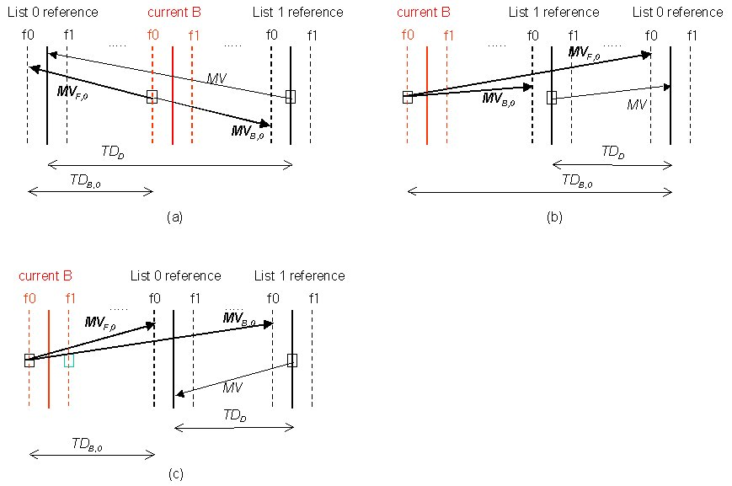
Figure 7. The current macroblock is in field mode and the list 1 co-located macroblock is in frame mode when the list 1 reference picture is in temporally following direction

Case 4: The current macroblock is in frame mode and the list 1 co-located macroblock is in field mode
If the list 0 reference picture for the direct mode occurs temporally earlier than the current B picture and the list 1 reference picture occurs temporally later than the B picture as shown in Figure 8 (a), then the list 0 and list 1 motion vectors (MV_{F} , MV_{B}) for the direct mode block are obtained as described in FCD.
If both the list 0 and list 1 reference pictures for the direct mode occur temporally later than the current B picture and the list 0 reference picture occurs temporally later than the list 1 reference picture as shown in Figure 8 (b), then two motion vectors (MV_{F} , MV_{B}) of the direct mode block are calculated as follows:
Z = TD_{B} x 256 / TD_{D,0} MV_{F} = (Z x MV₀ + 128) >> 8
W = Z – 256 MV_{B} = (W x MV₀ + 128) >> 8
In addition, it is also possible that the list 0 motion vector of the co-located block in filed 0 of the list 1 reference frame points to field of the frame that occurs temporally later than the current B picture as shown in Figure 8 (c). That is, if both the list 0 and list 1 reference pictures for the direct mode occur temporally later than the current B picture and the list 0 reference picture occurs temporally earlier than the list 1 reference picture, then two motion vectors (MV_{F} , MV_{B}) of the direct mode block are calculated as follows:
Z = -TD_{B} x 256 / TD_{D,0} MV_{F} = (Z x MV₀ + 128) >> 8
W = Z – 256 MV_{B} = (W x MV₀ + 128) >> 8

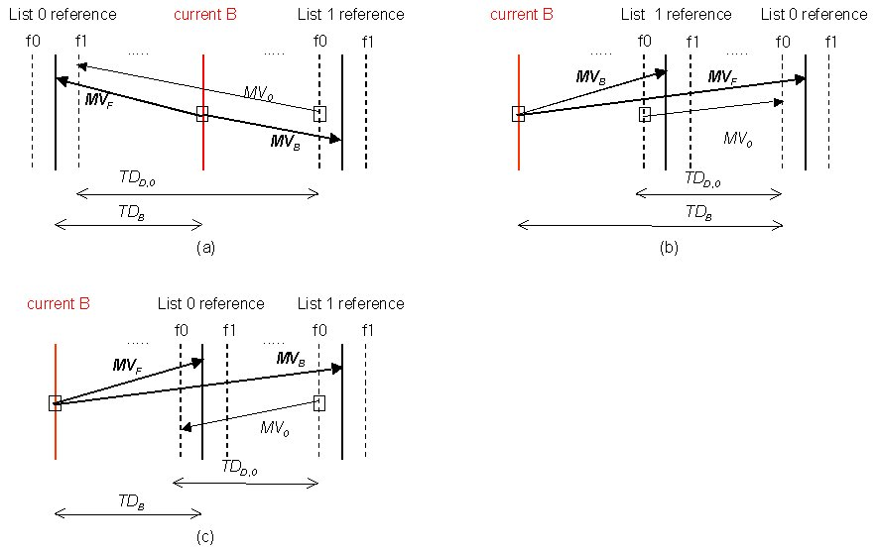
Figure 8. The current macroblock is in frame mode and the list 1 co-located macroblock is in field mode when the list 1 reference picture is in temporally following direction

2.2 List 1 reference picture for direct mode occurs temporally earlier than B picture
In this case, both the list 0 and list 1 reference pictures for the direct mode always occur temporally earlier than the current B picture.

Case 1: Both the current macroblock and the list 1 co-located macroblock are in frame mode
According to our motion vector usage of the co-located block in the list 1 reference picture, Figure 4 (a) (c) (e) (g) (h) are simplified to Figure 9 (a), and Figure 4 (b) (d) are simplified to Figure 9 (b).

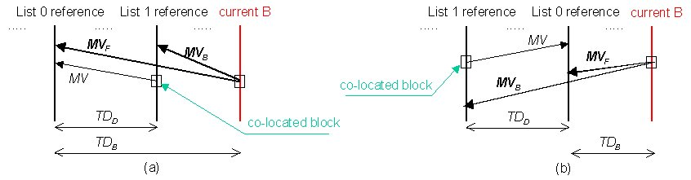
Figure 9. Both the current macroblock and the list 1 co-located macroblock are in frame mode when the list 1 reference picture is in temporally preceding direction

If the list 0 reference picture occurs temporally earlier than the list 1 reference picture as shown in Figure 9 (a), then the list 0 and list 1 motion vectors (MV_{F}, MV_{B}) for the direct mode are calculated as follows:
Z = TD_{B} x 256 / TD_{D} MV_{F} = (Z x MV + 128) >> 8
W = Z – 256 MV_{B} = (W x MV + 128) >> 8
where TD_{B} is the temporal distance between the current B picture and the list 0 reference frame and TD_{D} is the temporal distance between the list 1 reference frame and the list 0 reference frame.
If the list 0 reference picture occurs temporally later than the list 1 reference picture as shown in Figure 9 (b), then two motion vectors (MV_{F}, MV_{B}) of direct mode block are calculated as follows:
Z = -TD_{B} x 256 / TD_{D} MV_{F} = (Z x MV + 128) >> 8
W = Z – 256 MV_{B} = (W x MV + 128) >> 8

Case 2: Both the current macroblock and the list 1 co-located macroblock are in field mode
If the list 0 reference picture occurs temporally earlier than the list 1 reference picture as shown in Figure 10 (a) and (b), then the list 0 and list 1 motion vectors (MV_{F,i} , MV_{B,i}) for filed i of the direct mode block are calculated as follows:
Z = TD_{B,i} x 256 / TD_{D,i} MV_{F,i} = (Z x MV_{i} + 128) >> 8
W = Z – 256 MV_{B,i} = (W x MV_{i} + 128) >> 8
In addition, it is also possible that the list 0 motion vector of the co-located block in field i of the list 1 reference frame points to the field that occurs temporally later than its own filed as shown in Figure 10 (c) and (d). That is, if the list 0 reference picture occurs temporally later than the list 1 reference picture, then two motion vectors (MV_{F,i} , MV_{B,i}) for field i of the direct mode block are calculated as follows:
Z = -TD_{B,i} x 256 / TD_{D,i} MV_{F,i} = (Z x MV_{i} + 128) >> 8
W = Z – 256 MV_{B,i} = (W x MV_{i} + 128) >> 8

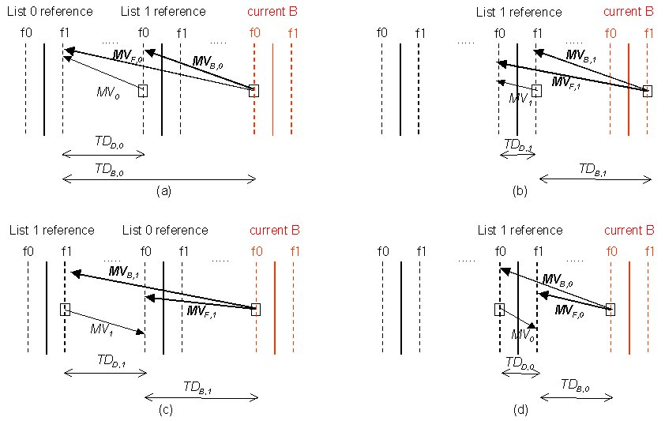
Figure 10. Both the current macroblock and the list 1 co-located macroblock are in field mode when the list 1 reference picture is in temporally preceding direction

Case 3: The current macroblock is in field mode and the list 1 co-located macroblock is in frame mode
If the list 0 reference picture occurs temporally earlier than the list 1 reference picture as shown in Figure 11 (a), then the list 0 and list 1 motion vectors (MV_{F,i} , MV_{B,i}) for filed i of the direct mode block are calculated as follows:
Z = TD_{B,i} x 256 / TD_{D} MV_{F,i} = (Z x MV + 128) >> 8
W = Z – 256 MV_{B,i} = (W x MV + 128) >> 8
In addition, it is also possible that the list 0 motion vector of the co-located block in the list 1 reference frame points to the frame that occurs temporally later than its own frame as shown in Figure 11 (b). That is, if the list 0 reference picture occurs temporally later than the list 1 reference picture, then two motion vectors (MV_{F,i} , MV_{B,i}) for field i of the direct mode block are calculated as follows:
Z = -TD_{B,i} x 256 / TD_{D} MV_{F,i} = (Z x MV + 128) >> 8
W = Z – 256 MV_{B,i} = (W x MV + 128) >> 8

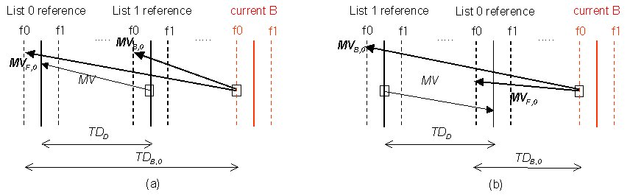
Figure 11. The current macroblock is in filed mode and the list 1 co-located macroblock is in frame mode when the list 1 reference picture is in temporally preceding direction

Case 4: The current macroblock is in frame mode and the list 1 co-located macroblock is in field mode
Since field 1 of the list 1 reference frame is temporally close to the current B picture, it is used in calculating the motion vectors for the direct mode blocks. If the list 0 reference picture occurs temporally earlier than the list 1 reference picture as shown in Figure 12 (a), then the list 0 and list 1 motion vectors (MV_{F} , MV_{B}) for the direct mode block are calculated as follows:
Z = TD_{B} x 256 / TD_{D,1} MV_{F} = (Z x MV₁ + 128) >> 8
W = Z – 256 MV_{B} = (W x MV₁ + 128) >> 8
In addition, it is also possible that the list 0 motion vector of the co-located block in filed 1 of the list 1 reference frame points to field of the frame that occurs temporally later than its own frame as shown in Figure 12 (b). That is, if the list 0 reference picture occurs temporally later than the list 1 reference picture, then two motion vectors (MV_{F} , MV_{B}) of the direct mode block are calculated as follows:
Z = -TD_{B} x 256 / TD_{D,0} MV_{F} = (Z x MV₀ + 128) >> 8
W = Z – 256 MV_{B} = (W x MV₀ + 128) >> 8

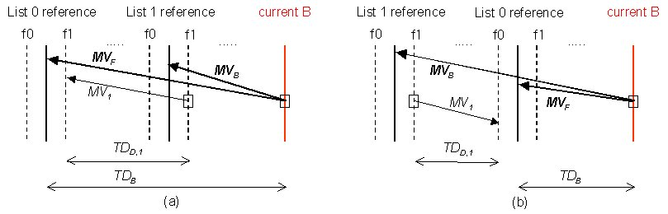
Figure 12. The current macroblock is in frame mode and the list 1 co-located macroblock is in field mode when the list 1 reference picture is in temporally preceding direction

(Append for Proposal Documents)

JVT Patent Disclosure Form

International Telecommunication Union  Telecommunication Standardization Sector | International Organization for Standardization | International Electrotechnical Commission
 |  | 
Joint Video Coding Experts Group - Patent Disclosure Form
(Typically one per contribution and one per Standard | Recommendation)

Please send to:
JVT Rapporteur Gary Sullivan, Microsoft Corp., One Microsoft Way, Bldg. 9, Redmond WA 98052-6399, USA
Email (preferred): Gary.Sullivan@itu.int Fax: +1 425 706 7329 (+1 425 70MSFAX)

This form provides the ITU-T | ISO/IEC Joint Video Coding Experts Group (JVT) with information about the patent status of techniques used in or proposed for incorporation in a Recommendation | Standard. JVT requires that all technical contributions be accompanied with this form. Anyone with knowledge of any patent affecting the use of JVT work, of their own or of any other entity (“third parties”), is strongly encouraged to submit this form as well.

This information will be maintained in a “living list” by JVT during the progress of their work, on a best effort basis. If a given technical proposal is not incorporated in a Recommendation | Standard, the relevant patent information will be removed from the “living list”. The intent is that the JVT experts should know in advance of any patent issues with particular proposals or techniques, so that these may be addressed well before final approval.

This is not a binding legal document; it is provided to JVT for information only, on a best effort, good faith basis. Please submit corrected or updated forms if your knowledge or situation changes.

This form is not a substitute for the ITU ISO IEC Patent Statement and Licensing Declaration, which should be submitted by Patent Holders to the ITU TSB Director and ISO Secretary General before final approval.

Submitting Organization or Person:
Organization name | LG Electronics Inc.
Mailing address | 16 Woomyeon-Dong, Seocho-Gu, Seoul 137-724, Korea
Country | Korea
Contact person | Byeong-Moon Jeon
Telephone | 82-2-526-4415
Fax | 82-2-3461-1347
Email | jeonbm@lge.com
Place and date of submission | 04/10/2002
Relevant Recommendation | Standard and, if applicable, Contribution:
Name (ex: “JVT”) |  | JVT
Title |  | Clean up of temporal direct mode
Contribution number |  | JVT-E097

(Form continues on next page)

Disclosure information – Submitting Organization/Person (choose one box)
2.0 The submitter is not aware of having any granted, pending, or planned patents associated with the technical content of the Recommendation | Standard or Contribution.
X

or,
The submitter (Patent Holder) has granted, pending, or planned patents associated with the technical content of the Recommendation | Standard or Contribution. In which case,

2.1 The Patent Holder is prepared to grant – on the basis of reciprocity for the above Recommendation | Standard – a free license to an unrestricted number of applicants on a worldwide, non-discriminatory basis to manufacture, use and/or sell implementations of the above Recommendation | Standard.
2.2 The Patent Holder is prepared to grant – on the basis of reciprocity for the above Recommendation | Standard – a license to an unrestricted number of applicants on a worldwide, non-discriminatory basis and on reasonable terms and conditions to manufacture, use and/ or sell implementations of the above Recommendation | Standard.

Such negotiations are left to the parties concerned and are performed outside the ITU | ISO/IEC.
2.2.1 The same as box 2.2 above, but in addition the Patent Holder is prepared to grant a “royalty-free” license to anyone on condition that all other patent holders do the same.
2.3 The Patent Holder is unwilling to grant licenses according to the provisions of either 2.1, 2.2, or 2.2.1 above. In this case, the following information must be provided as part of this declaration:
- patent registration/application number;
- an indication of which portions of the Recommendation | Standard are affected.
- a description of the patent claims covering the Recommendation | Standard;
In the case of any box other than 2.0 above, please provide the following:
Patent number(s)/status
Inventor(s)/Assignee(s)
Relevance to JVT
Any other remarks:
(please provide attachments if more space is needed)

(form continues on next page)
Third party patent information – fill in based on your best knowledge of relevant patents granted, pending, or planned by other people or by organizations other than your own.

Disclosure information – Third Party Patents (choose one box)
3.1 The submitter is not aware of any granted, pending, or planned patents held by third parties associated with the technical content of the Recommendation | Standard or Contribution.

3.2 The submitter believes third parties may have granted, pending, or planned patents associated with the technical content of the Recommendation | Standard or Contribution.

For box 3.2, please provide as much information as is known (provide attachments if more space needed) - JVT will attempt to contact third parties to obtain more information:

3rd party name(s)
Mailing address
Country
Contact person
Telephone
Fax
Email
Patent number/status
Inventor/Assignee
Relevance to JVT

Any other comments or remarks:

