Joint Video Team (JVT) of ISO/IEC MPEG & ITU-T VCEG  (ISO/IEC JTC1/SC29/WG11 and ITU-T SG16 Q.6)  5th Meeting: Geneva, CH, 9-17 October, 2002 | Document: JVT-E079r2  Filename: JVT-E079r2.doc

Title: | A performance comparison of CABAC and VCL-based entropy coders for SD and HD sequences
Status: | Input Document to JVT
Purpose: | Information
Author(s) or  Contact(s): | - Iole Moccagatta  560 Cottonwood Dr.  Milpitas, CA 95035 | Tel:  Email: | iole.moccagatta@lsil.com
 | - Krishna Ratakonda  Route 134 & Taconic Pkwy, Tel:  Yorktown Heights, NY 10598 Email: ratakond@us.ibm.com |  |  | Email: | iole.moccagatta@lsil.com
_____________________________

Summary

This document analyzes the performance of CABAC and the VLC-based entropy coders over a large number of test sequences and using two encoder configurations. In both configurations and for all the 21 test sequences used, CABAC achieves a large bitrate reduction, ranging from 6.3 to 31.2%, when compared with the VLC-based entropy coders. In light of these results, and taking into account the considerations presented in JVT-E116, we recommend the removal of the VLC-based entropy coders from the AVC Main profile.

Introduction

This document analyzes the performance of CABAC and the VLC-based entropy coders over a large number of test sequences and using two encoder configurations. The results of this analysis are presented in Sec.1. Our conclusions and recommendations are reported in Sec. 2.

1. Performance comparison of CABAC and VLC-bases entropy coders

To compare the performance of CABAC and the VLC-based entropy coders that are currently adopted in the AVC Main profile we have chosen two possible testing scenarios. The first test scenario uses a IBBP GOP structure with periodical Intra refresh and uses either picture bases frame or field coding mode. Results for this first test scenario are reported in Sec. 1.1. The second test scenario uses a IP GOP structure with no periodical Intra refresh and without interlaced coding. Results for this second test scenario are reported in Sec. 1.2.

In addition, we have tested a large number of test sequences, varying both in format (CIF, SD interlaced, SD progressive, HD interlaced) and in content (movie, sports, natural content, and computer graphic).

First test scenario: IBBP GOP structure with periodical Intra refresh

JM 4.0c has been used in this first set of simulations. The AVC encoder configuration is as follows:

- IBBP GOP structure, one Intra every 1 sec. for interlaced (a.k.a. 30 fps) sequences, one Intra every 1.25 sec. for progressive (a.k.a. 24 fps) sequences.
- The interlaced sequences are coded in field mode, and the progressive sequences are coded in frame mode.
- Fixed Qp, no rate control, rate distortion optimization on (this causes a very minor difference in quality between the CABAC and CA-VLC encoded sequences).
- Four sets of quantization scales are used for each sequence:
- 40(I), 40(P), 43(B)
- 32(I), 32(P), 33(B)
- 24(I), 24(P), 26(B)
- 20(I), 20(P), 22(B)
- 1/4 pel motion vector resolution, search range of 16, 3 reference frames, and inter motion estimation down to 4x4.
- No ABT, no SI/SP pictures, no error resilience tools, and one slice per picture (frame or field).

The following test sequences has been used in the first test:

- Three interlaced SD test sequences (720x480, 4:2:0, 30fps):
- “Opening'' (151 pictures): a shot from the opening of the Olympic games in Barcelona showing puppets and children in costumes performing in a crowded stadium. Category: spatially and temporally tough.
- “Football'' (142 pictures): the standard test sequence.
- “Basket'' (235 pictures): a shot from a basket game. Category: spatially and temporally tough.

- Three progressive SD test sequences (720x480, 4:2:0, 24fps) in letter box format:
- “Golden1'' (76 pictures): a shot from an action movie showing two people running across a library with flashes from shooting. Category: spatially and temporally medium difficulty.
- “Golden2'' (118 pictures): a different shot from an same action movie as “Golden1” showing a person caught while falling. Category: spatially medium difficulty, temporally tough.
- “Blackrain'' (103 pictures) a shot from a movie showing a fast motorcycle chase on the background of the NYC port. Category: spatially medium difficulty, temporally tough.

- Two interlaced HD test sequences (1920x1056, 4:2:0, 30fps):
- “Hawaii1'' (177 pictures): a shot showing rain falling over a tropical forest. Category: spatially medium difficulty, temporally easy.
- “Hawaii2'' (216 pictures): a complex shot showing i) two background scenes with people and nature with one scene change and ii) a large foreground panning text containing additional nature scenes. Category: spatially and temporally very tough.

The performance of CABAC and the VLC-based entropy coders when compressing the above listed test sequences are reported in Table 1, , and Table 3. The resulting rate distortion curves are plotted in Figure 1, Figure 2 and Figure 3.

Table 1: Comparison of CABAC and CA-VLC performance using interlaced SD (720x480, 4:2:0, 30fps) test sequences. PSNR-Y values are averaged over the entire sequence length.
Test Sequences | Qp |  |  | CABAC |  | CA-VLC |  | CABAC vs CA-VLC (% bitrate)
Test Sequences | I | P | B | PSNR-Y (dB) | Bitrate  (Mbits/s) | PSNR-Y (dB) | Bitrate  (Mbits/s) | CABAC vs CA-VLC (% bitrate)
“Opening” | 40 | 40 | 43 | 24.21 | 1.01 | 24.14 | 1.12 | -10.1
“” | 32 | 32 | 33 | 30.21 | 4.48 | 30.16 | 4.83 | -7.2
“” | 24 | 24 | 26 | 35.81 | 12.65 | 35.80 | 13.50 | -6.3
“” | 20 | 20 | 22 | 39.10 | 20.84 | 39.08 | 22.15 | -5.9
“Football” | 40 | 40 | 43 | 28.81 | 0.559 | 28.74 | 0.656 | -14.8
“” | 32 | 32 | 33 | 33.49 | 1.50 | 33.35 | 1.68 | -10.6
“” | 24 | 24 | 26 | 37.99 | 4.84 | 37.91 | 5.34 | -9.4
“” | 20 | 20 | 22 | 40.52 | 8.28 | 40.48 | 9.09 | -8.8
“Basket” | 40 | 40 | 43 | 24.76 | 0.933 | 24.65 | 1.058 | -11.8
“” | 32 | 32 | 33 | 30.78 | 3.42 | 30.73 | 3.74 | -8.6
“” | 24 | 24 | 26 | 36.55 | 8.77 | 36.53 | 9.50 | -7.7
“” | 20 | 20 | 22 | 39.82 | 13.97 | 39.80 | 15.02 | -6.98

Table 2: Comparison of CABAC and CA-VLC performance using progressive SD (720x480, 4:2:0, 24fps) test sequences. PSNR-Y values are averaged over the entire sequence length.
Test Sequences | Qp |  |  | CABAC |  | CA-VLC |  | CABAC vs CA-VLC (% bitrate)
Test Sequences | I | P | B | PSNR-Y (dB) | Bitrate  (Kbits/s) | PSNR-Y (dB) | Bitrate  (Kbits/s) | CABAC vs CA-VLC (% bitrate)
Golden1 | 40 | 40 | 43 | 32.34 | 225.38 | 32.30 | 280.31 | -19.6
"" | 32 | 32 | 33 | 37.31 | 679.15 | 37.30 | 785.57 | -13.5
"" | 24 | 24 | 26 | 41.44 | 1611.3 | 41.41 | 1775.6 | -9.2
"" | 20 | 20 | 22 | 43.44 | 2665.9 | 43.42 | 2871.0 | -7.14
Golden2 | 40 | 40 | 43 | 33.94 | 121.62 | 33.69 | 158.25 | -23.1
"" | 32 | 32 | 33 | 38.89 | 368.85 | 38.84 | 453.68 | -18.7
"" | 24 | 24 | 26 | 42.14 | 926.9 | 42.11 | 1062.7 | -12.8
"" | 20 | 20 | 22 | 43.58 | 1635.5 | 43.56 | 1818.9 | -10.08
Blackrain | 40 | 40 | 43 | 34.56 | 156.10 | 34.74 | 227.01 | -31.2
"" | 32 | 32 | 33 | 40.04 | 332.66 | 40.09 | 435.56 | -23.6
"" | 24 | 24 | 26 | 42.71 | 709.7 | 42.70 | 872.75 | -18.7
"" | 20 | 20 | 22 | 43.74 | 1342.5 | 43.74 | 1576.0 | -14.82

Table 3: Comparison of CABAC and CA-VLC performance using interlaced HD (1920x1056, 4:2:0, 30fps) test sequences. PSNR-Y values are averaged over the entire sequence length.
Test Sequences | Qp |  |  | CABAC |  | CA-VLC |  | CABAC vs CA-VLC (% bitrate)
Test Sequences | I | P | B | PSNR-Y (dB) | Bitrate  (Mbits/s) | PSNR-Y (dB) | Bitrate  (Mbits/s) | CABAC vs CA-VLC (% bitrate)
“Hawaii1” | 40 | 40 | 43 | 28.72 | 0.97 | 28.54 | 1.18 | -17.73
"" | 32 | 32 | 33 | 33.26 | 5.18 | 33.16 | 5.95 | -12.95
"" | 24 | 24 | 26 | 37.91 | 22.74 | 37.85 | 25.37 | -10.34
"" | 20 | 20 | 22 | 40.77 | 44.59 | 40.72 | 48.85 | -8.73
“Hawaii2” | 40 | 40 | 43 | 29.59 | 2.43 | 29.51 | 2.92 | -16.88
"" | 32 | 32 | 33 | 34.17 | 7.90 | 34.10 | 8.88 | -11.04
"" | 24 | 24 | 26 | 38.06 | 24.08 | 38.04 | 26.25 | -8.26
"" | 20 | 20 | 22 | 40.61 | 48.80 | 40.59 | 52.48 | -7.00

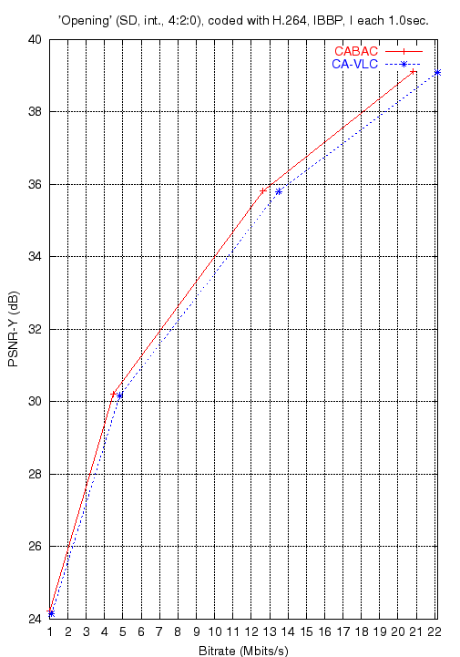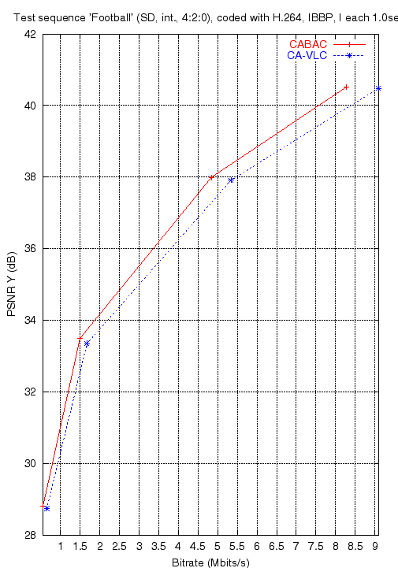
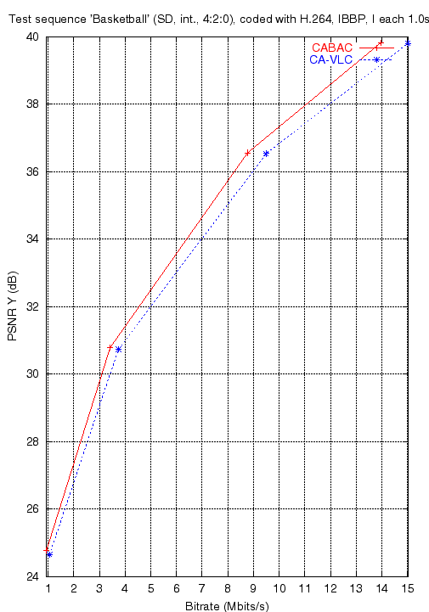
Figure 1: PSNR-Y versus bitrate for the interlaced SD test sequences.

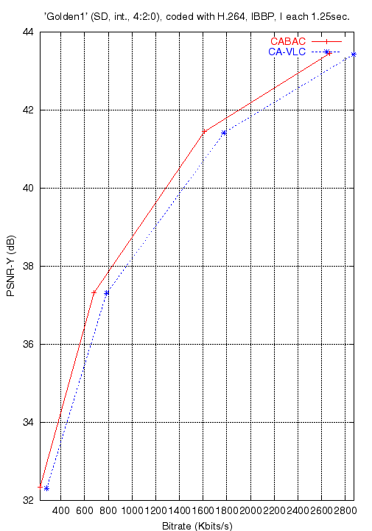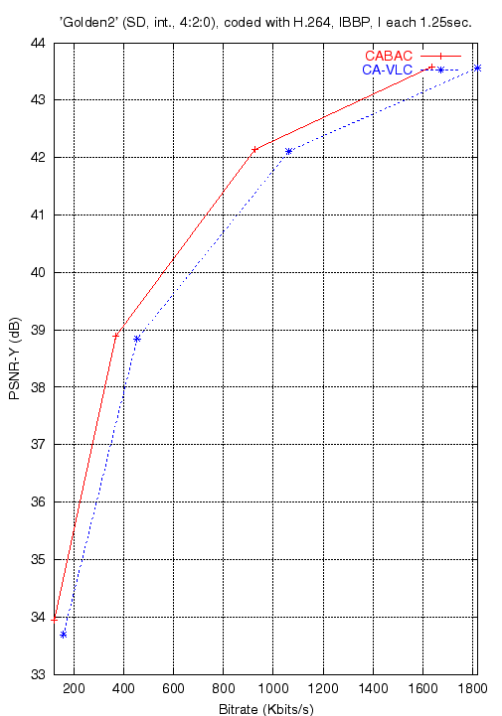
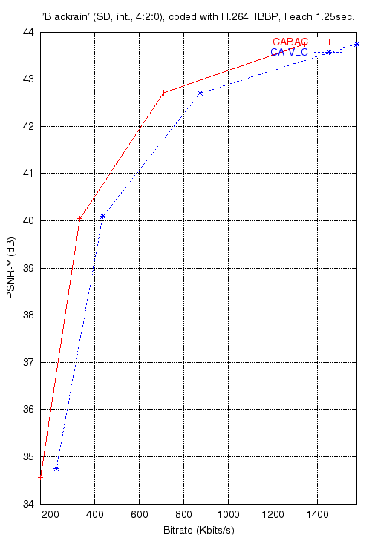
Figure 2: PSNR-Y versus bitrate for the progressive SD test sequences.

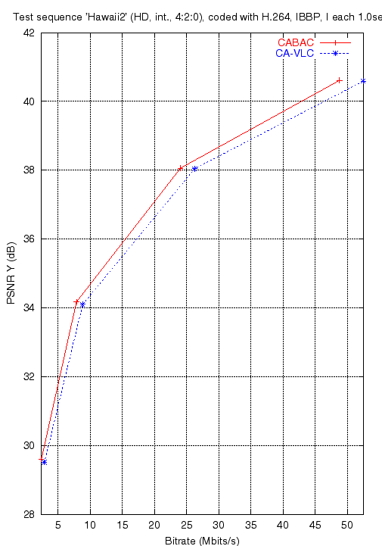
Figure 3: PSNR-Y versus bitrate for the interlaced HD test sequences

Second test scenario: IP GOP structure without interlaced coding

JM 4.2 has been used in this second set of simulations. The AVC encoder configuration is as follows:

- IP GOP structure with only the first frame coded as Intra.
- Fixed Qp, no rate control, rate distortion optimization on.
- Intelaced coding option is not used (i.e. all pictures are coded as frame)
- Three sets of quantizations scales are used for each sequence.
- 36(I), 38(P)
- 24(I), 27(P)
- 16(I), 18(P)
- No ABT, no SI/SP pictures, no error resilience tools and one slice per picture.

The following test sequences (60 to 150 frames each) has been used in the second test:

- Three standard SD interlaced test sequence: “Cheer leaders”, “Mobile & Calendar”, and “Football”.

- Four proprietary SD interlaced and progressive test sequence:

- “Marbles”: fast moving marbles against a white background. Japanese text on the bottom part of the screen scrolls from left to right. Category: spatially easy, temporally tough. Interlaced.
- “Murdock”: commercial combining graphics and some natural images moving quickly. Has a 10 frames fade in the middle of the sequences. Category: spatially medium difficulty, temporally medium difficulty. Progressive.
- “Turtle”: commercial with a still frame in the beginning and a fade to a slowly moving turtle. Category: spatially and temporally easy except for the fade. Progressive.
- “Speedbike”: bikers move towards the camera and flash before the camera. Category: spatially medium difficulty, temporally very tough. Interlaced.

- Three standard and three proprietary CIF test sequences: same as above except a sequence called "Pills" replaces "Marbles". “Pills” is a computer generated animation of medicine pills going through the digestive tract. Category: spatially medium difficulty, temporally tough (smooth regions show blocking artifacts easily). All CIF sequences were obtained by dropping a field and horizontal filtered sub-sampling i.e., they behave like progressive sequences.

- The variation in the PSNR for the same sequence and quantization scale for different entropy coding tools was less than 0.2 dB in all cases.

The performance of CABAC and the VLC-based entropy coders when compressing the above listed test sequences are reported in Table 4.

Table 4: results of the second set of experiments comparing CABAC and CA-VLC
Sequence | Resolution | Frames | Intra QP | Inter QP | CABAC |  |  | CVLC |  |  | Delta PSNR | %Delta Bits
 |  |  |  |  | PSNR | Total Bits | Bitrate | PSNR | Total Bits | Bitrate | Delta PSNR | %Delta Bits
Cheers | 704x480 | 150 | 16 | 18 | 42.61 | 99589192 | 19451 | 42.6 | 105162960 | 20540 | -0.01 | 5.3
 |  |  | 24 | 27 | 35.89 | 37839104 | 7390 | 35.88 | 41229824 | 8053 | -0.01 | 8.22
 |  |  | 36 | 38 | 28.15 | 9925120 | 1939 | 28.08 | 11222920 | 2192 | -0.07 | 11.56
 | 352x240 | 150 | 16 | 18 | 42.34 | 32098992 | 6269 | 42.34 | 32863800 | 6419 | 0 | 2.33
 |  |  | 24 | 27 | 34.73 | 13434216 | 2624 | 34.72 | 13828968 | 2701 | -0.01 | 2.85
 |  |  | 36 | 38 | 26.42 | 3460464 | 676 | 26.39 | 3647712 | 712 | -0.03 | 5.13
Football | 720x480 | 150 | 16 | 18 | 42.79 | 73766664 | 14408 | 42.76 | 82451352 | 16104 | -0.03 | 10.53
 |  |  | 24 | 27 | 36.64 | 23313576 | 4553 | 36.46 | 26654424 | 5206 | -0.18 | 12.53
 |  |  | 36 | 38 | 30.11 | 4969640 | 971 | 29.88 | 5788504 | 1131 | -0.23 | 14.15
 | 352x240 | 150 | 16 | 18 | 42.82 | 18557688 | 3625 | 42.8 | 19628904 | 3834 | -0.02 | 5.46
 |  |  | 24 | 27 | 36.05 | 6110840 | 1194 | 35.98 | 6365608 | 1243 | -0.07 | 4
 |  |  | 36 | 38 | 29.51 | 1312016 | 256 | 29.49 | 1407552 | 275 | -0.02 | 6.79
Marbles | 704x480 | 150 | 16 | 18 | 43.54 | 51928872 | 10142 | 43.52 | 60679360 | 11851 | -0.02 | 14.42
 |  |  | 24 | 27 | 38.51 | 17655024 | 3448 | 38.37 | 22268592 | 4349 | -0.14 | 20.72
 |  |  | 36 | 38 | 31.81 | 4438184 | 867 | 31.33 | 5445520 | 1064 | -0.48 | 18.5
Pills | 352x240 | 150 | 16 | 18 | NA | 19829824 | 3873 | NA | 20775936 | 4058 | NA | 4.55
 |  |  | 24 | 27 | NA | 7300224 | 1426 | NA | 7758016 | 1515 | NA | 5.9
 |  |  | 36 | 38 | NA | 1805560 | 159 | NA | 2007264 | 392 | NA | 10.05
Mobile | 720x480 | 60 | 16 | 18 | 42.28 | 41815232 | 20418 | 42.24 | 45158896 | 22050 | -0.04 | 7.4
 |  |  | 24 | 27 | 35.14 | 14964736 | 7307 | 35.08 | 16354416 | 7986 | -0.06 | 8.5
 |  |  | 36 | 38 | 26.67 | 2284440 | 1115 | 26.62 | 2437968 | 1190 | -0.05 | 6.3
 | 352x240 | 60 | 16 | 18 | 42.42 | 13063352 | 6379 | 42.39 | 14394600 | 7029 | -0.03 | 9.25
 |  |  | 24 | 27 | 34.8 | 5201864 | 2540 | 34.74 | 5834168 | 2849 | -0.06 | 10.84
 |  |  | 36 | 38 | 25.47 | 816328 | 242 | 25.36 | 860824 | 420 | -0.11 | 5.17
Murdock | 704x480 | 150 | 16 | 18 | 45.27 | 18525488 | 3618 | 45.26 | 19890464 | 3885 | -0.01 | 6.86
 |  |  | 24 | 27 | 41.2 | 5974264 | 1167 | 41.23 | 6799512 | 1328 | 0.03 | 12.14
 |  |  | 36 | 38 | 33.22 | 1449904 | 283 | 33.32 | 1859632 | 363 | 0.1 | 22.03
 | 352x240 | 150 | 16 | 18 | 44.31 | 6634376 | 1296 | 44.3 | 6981536 | 1364 | -0.01 | 4.97
 |  |  | 24 | 27 | 38.69 | 2317352 | 453 | 38.71 | 2560544 | 500 | 0.02 | 9.5
 |  |  | 36 | 38 | 31.16 | 494920 | 341 | 31.23 | 600544 | 117 | 0.07 | 17.59
Speedbike | 704x480 | 150 | 16 | 18 | 42.43 | 120247616 | 23486 | 42.33 | 129179320 | 25230 | -0.1 | 6.91
 |  |  | 24 | 27 | 35.16 | 38021840 | 7426 | 35.15 | 42291808 | 8260 | -0.01 | 10.1
 |  |  | 36 | 38 | 28.79 | 8856544 | 1730 | 28.67 | 10425608 | 2036 | -0.12 | 15.05
 | 352x240 | 100 | 16 | 18 | 42.39 | 17997912 | 5273 | 42.41 | 18767872 | 5498 | 0.02 | 4.1
 |  |  | 24 | 27 | 35.35 | 6924848 | 2029 | 35.35 | 7278224 | 2132 | 0 | 4.86
 |  |  | 36 | 38 | 27.97 | 1746168 | 512 | 27.91 | 1899544 | 557 | -0.06 | 8.07
Turtle | 704x480 | 150 | 16 | 18 | 45.01 | 55460080 | 10832 | 44.94 | 63775712 | 12456 | -0.07 | 13.04
 |  |  | 24 | 27 | 38.44 | 7070736 | 1381 | 38.41 | 7855304 | 1534 | -0.03 | 9.99
 |  |  | 36 | 38 | 31.56 | 709160 | 139 | 31.63 | 869072 | 170 | 0.07 | 18.4
 | 352x240 | 150 | 16 | 18 | 44.89 | 10580456 | 2066 | 44.84 | 11958640 | 2336 | -0.05 | 11.52
 |  |  | 24 | 27 | 38.29 | 1857920 | 363 | 38.23 | 2070680 | 404 | -0.06 | 10.27
 |  |  | 36 | 38 | 30.14 | 238352 | 47 | 30.21 | 279384 | 55 | 0.07 | 14.69

2. Conclusions and Recommendations

In both testing scenarios and for all the 21 test sequences used, CABAC achieves a large bitrate reduction when compared with the VLC-based entropy coders.

In the first testing scenario, the bitrate reduction ranges from 6.3 to 14.8% for the interlaced SD test sequence. The reduction is larger for the progressive SD sequences (from 7.14 to 31.2%). In addition, the bitrate reduction ranges from 7 to 17.7% for the interlaced HD test sequences. In general, the gain is larger for easy to code sequences. Also, the gain varies with the bitrate: the higher the bitrate, the smaller the gain.

In the second testing scenario, the bit rate reduction ranges from 5.3% to 22% for DS, and from 2.33% to 17.59% for CIF sequences. For the same sequence, in general we obtain larger percentage gains at higher QPs; however, there are a few sequences that go against this trend to some degree (“Turtle” and “Mobile”).

To conclude, the use of the CABAC entropy coded results in a fairly consistent gain in bitrate. Let consider two possible encoder operation points: 1Mbits/sec for SD and 6Mbits/sec for HD. For all the SD test sequences except “Blackrain” the saving is about 11% when encoding at about 1Mbits/sec. Gain for “Blackrain” is somehow higher. For the HD test sequences, the gain is also about 11% at 6Mbits/sec.

In light of these results, and taking into account the considerations presented in JVT-E116, we recommend the removal of the VLC-based entropy coders from the AVC Main profile.

(Append for Proposal Documents)

JVT Patent Disclosure Form

International Telecommunication Union  Telecommunication Standardization Sector | International Organization for Standardization | International Electrotechnical Commission
 |  | 
Joint Video Coding Experts Group - Patent Disclosure Form
(Typically one per contribution and one per Standard | Recommendation)

Please send to:
JVT Rapporteur Gary Sullivan, Microsoft Corp., One Microsoft Way, Bldg. 9, Redmond WA 98052-6399, USA
Email (preferred): Gary.Sullivan@itu.int Fax: +1 425 706 7329 (+1 425 70MSFAX)

This form provides the ITU-T | ISO/IEC Joint Video Coding Experts Group (JVT) with information about the patent status of techniques used in or proposed for incorporation in a Recommendation | Standard. JVT requires that all technical contributions be accompanied with this form. Anyone with knowledge of any patent affecting the use of JVT work, of their own or of any other entity (“third parties”), is strongly encouraged to submit this form as well.

This information will be maintained in a “living list” by JVT during the progress of their work, on a best effort basis. If a given technical proposal is not incorporated in a Recommendation | Standard, the relevant patent information will be removed from the “living list”. The intent is that the JVT experts should know in advance of any patent issues with particular proposals or techniques, so that these may be addressed well before final approval.

This is not a binding legal document; it is provided to JVT for information only, on a best effort, good faith basis. Please submit corrected or updated forms if your knowledge or situation changes.

This form is not a substitute for the ITU ISO IEC Patent Statement and Licensing Declaration, which should be submitted by Patent Holders to the ITU TSB Director and ISO Secretary General before final approval.

Submitting Organization or Person:
Organization name
Mailing address
Country
Contact person
Telephone
Fax
Email
Place and date of submission
Relevant Recommendation | Standard and, if applicable, Contribution:
Name (ex: “JVT”)
Title
Contribution number

(Form continues on next page)

Disclosure information – Submitting Organization/Person (choose one box)
2.0 The submitter is not aware of having any granted, pending, or planned patents associated with the technical content of the Recommendation | Standard or Contribution.

or,
The submitter (Patent Holder) has granted, pending, or planned patents associated with the technical content of the Recommendation | Standard or Contribution. In which case,

2.1 The Patent Holder is prepared to grant – on the basis of reciprocity for the above Recommendation | Standard – a free license to an unrestricted number of applicants on a worldwide, non-discriminatory basis to manufacture, use and/or sell implementations of the above Recommendation | Standard.
2.2 The Patent Holder is prepared to grant – on the basis of reciprocity for the above Recommendation | Standard – a license to an unrestricted number of applicants on a worldwide, non-discriminatory basis and on reasonable terms and conditions to manufacture, use and/ or sell implementations of the above Recommendation | Standard.

Such negotiations are left to the parties concerned and are performed outside the ITU | ISO/IEC.
2.2.1 The same as box 2.2 above, but in addition the Patent Holder is prepared to grant a “royalty-free” license to anyone on condition that all other patent holders do the same.
2.3 The Patent Holder is unwilling to grant licenses according to the provisions of either 2.1, 2.2, or 2.2.1 above. In this case, the following information must be provided as part of this declaration:
- patent registration/application number;
- an indication of which portions of the Recommendation | Standard are affected.
- a description of the patent claims covering the Recommendation | Standard;
In the case of any box other than 2.0 above, please provide the following:
Patent number(s)/status
Inventor(s)/Assignee(s)
Relevance to JVT
Any other remarks:
(please provide attachments if more space is needed)

(form continues on next page)
Third party patent information – fill in based on your best knowledge of relevant patents granted, pending, or planned by other people or by organizations other than your own.

Disclosure information – Third Party Patents (choose one box)
3.1 The submitter is not aware of any granted, pending, or planned patents held by third parties associated with the technical content of the Recommendation | Standard or Contribution.

3.2 The submitter believes third parties may have granted, pending, or planned patents associated with the technical content of the Recommendation | Standard or Contribution.

For box 3.2, please provide as much information as is known (provide attachments if more space needed) - JVT will attempt to contact third parties to obtain more information:

3rd party name(s)
Mailing address
Country
Contact person
Telephone
Fax
Email
Patent number/status
Inventor/Assignee
Relevance to JVT

Any other comments or remarks:

The interlaced test sequences have been obtained from original CCIR (720x486, 4:2:2, 30fps) by sub-sampling the chroma component and dropping 6 lines.
The progressive test sequences have been obtained from original CCIR (720x486, 4:2:2, 30fps) by inverse telecine, followed by sub-sampling the chroma component and dropping 6 lines.
The interlaced test sequences have been obtained from original 1080p (1920x1080, 4:2:2, 30fps) by sub-sampling the chroma component and dropping 24 lines.

