Joint Video Team (JVT) of ISO/IEC MPEG & ITU-T VCEG  (ISO/IEC JTC1/SC29/WG11 and ITU-T SG16 Q.6)  5th Meeting: Geneva, CH, 9-17 October, 2002 | Document: JVT-E050  Filename: JVT-E050.doc

Title: | Complexity Reduction of Plane mode in Chroma Intra Prediction
Status: | Input Document to JVT
Purpose: | Proposal
Author(s) or  Contact(s): | Woo-Shik Kim  Dae-Sung Cho,  and Kyung-Wook Kim  Multimedia Lab. Samsung AIT  P.O.Box 111, Suwon 440-600  Korea | Tel:  Email: | wskim@sait.samsung.co.kr
Source: | Samsung AIT
_____________________________
- Introduction
In the 4th JVT meeting, the new chroma spatial prediction method for intra coding [1] was adopted into the JVT FCD [2]. It consists of 4 mode, DC, vertical, horizontal, and plane mode, where the prediction is very simple except the plane mode.
We propose a new plane mode in order to reduce the complexity of the plane mode. The simulation results show even better objective quality while the complexity is remarkably reduced.

- Background and the proposed method
The statistical characteristics of luma and chroma components are very different. The variance of the chroma pixel values is much smaller than that of the luma ones. The luma pixel values gradually change according to the angle between the direction of the source light and the surface of the object. On the other hand, the chroma pixel values in a certain area change very little. It is due to the fact that the area has its own color value that is independent of radiance.
Suppose that the color changes in 8x8 block, it is highly unlikely to observe the gradual change in color, which the plane mode in the current chroma intra prediction describes. With the use of the characteristic of color, we would like to propose a simple and efficient prediction method instead of complex plane prediction method.

For simplicity, the area can be divided in two ways as shown in Fig. 1. The dashed lines represent the 8x8 boundaries and the rectangular points indicate the reference pixels in the upper block and the left block. The circular points show the actual pixels in the current block. The 8x8 block area is divided into two areas by the thick line. When it is divided horizontally as shown in Fig. 1 (a), the upper half area is predicted from the upper block and the lower half area is predicted from the left block. When it is divided vertically as shown in Fig. 1 (b), the left half area is predicted from the left block, and the right half area is predicted from the upper block. The prediction scheme in each area is same as the horizontal or vertical prediction scheme.
(a) horizontal area (b) vertical area
Fig. 1. New plane prediction mode

For the determination of horizontal or vertical prediction for the current block, the gradient is calculated in horizontal and vertical direction using the reference pixels in the upper and the left block as follows

dH = | P(0,-1)+P(1,-1)–P(6,-1)–P(7,-1) |
dV = | P(-1,0)+P(-1,1)–P(-1,6)–P(-1,7) |

where dH and dV denote the horizontal and vertical gradient, respectively. If dH and dV are same, the area is vertically divided.

The prediction procedure can be described as follows:

if(dH>dV)
Pred(i,j) = P(i,-1), i=0,…,7, j=0,…,3
Pred(i,j) = P(-1,j), i=0,…,7, j=4,…,7

if(dV>=dH)
Pred(i,j) = P(-1,j), i=0,…,3, j=0,…,7
Pred(i,j) = P(i,-1), i=4,…,7, j=0,…,7.

- Complexity comparison
According to the current JVT FCD, the plane mode prediction is formed as:

Pred(i,j) = Clip1((a+b(I-3)+c(j-3)+16)>>5), I,j=0,…,7

where

a = (P(-1,7)+P(7,-1))<<4
b=(17*H+16)>>5
c=(17*V+16)>>5
$$H=\sum_{i=1}^{4}{i⋅(P(3+\text{i,}−1)−P(3−\text{i,}−1))}$$
$V=\sum_{j=1}^{4}{j⋅(P(−\text{1,3}+j)−P(−\text{1,3}−j))}$.

H, V, a, b, and c is calculated once per 8x8 block and the complexity is expected to have 11 additions, 4 multiplications, and 7 shifts.

Pred(i,j) is calculated 64 times and for each calculation, the complexity comprises 5 additions, 2 multiplications, 1 shifts, and 2 comparisons. In total, the complexity of the current JVT FCD consists of 331 additions, 132 multiplications, 71 shifts, and 128 comparisons.

In our proposed method, the complexity only consists of 6 additions and 3 comparisons.

- Experimental results
  - Test conditions
The common test condition [3] is used except that all frames are coded as intra frame. Both CABAC and UVLC are tested. The Bjontegaard Delta bitrate is calculated for U and V component separately. Additionally, the results for the higher resolution sequences are included in Section 4.3 and the subjective results are shown in Section 4.4. In the Tables below, the negative sign indicates that the bitrate is reduced, which implies the better performance of the proposed method than the current plane mode prediction.

  - Results of the common condition sequences (Bjontegaard Delta bitrate (%))
 |  | Container | Foreman | Mobile | News | Paris | Silent | Tempete | Average
U | CABAC | -1.43 | -2.83 | -0.30 | -1.15 | -1.67 | -1.90 | -1.15 | -1.49
U | UVLC | -3.60 | -5.26 | -0.64 | -1.85 | -2.38 | -3.33 | -2.25 | -2.76
V | CABAC | -3.30 | -4.06 | -0.15 | -2.58 | -2.12 | -3.37 | -1.36 | -2.42
V | UVLC | -6.10 | -6.21 | -0.55 | -4.23 | -2.36 | -2.46 | -2.96 | -3.55

  - Results of the interlace sequences (Bjontegaard Delta bitrate (%))
 |  | Canoa | F1 car | Rugby | Mobile | Football | Tempete | Average
U | CABAC | -0.82 | -0.84 | -2.20 | -0.65 | -1.16 | -1.45 | -1.19
U | UVLC | -11.35 | -9.96 | -7.95 | -1.17 | -6.39 | -2.92 | -6.62
V | CABAC | -0.50 | -1.07 | -1.60 | -0.90 | -1.45 | -1.85 | -1.23
V | UVLC | -11.08 | -7.53 | -7.25 | -1.31 | -6.84 | -3.68 | -6.28

  - Subjective results



(a) JVT FCD (b) The proposed method



(a) JVT FCD (b) The proposed method

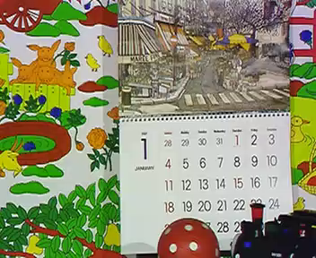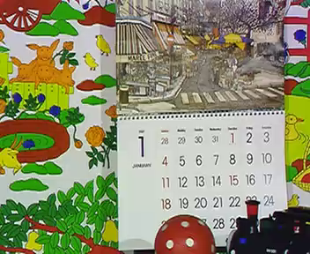

(a) JVT FCD (b) The proposed method

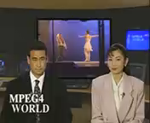

(a) JVT FCD (b) The proposed method

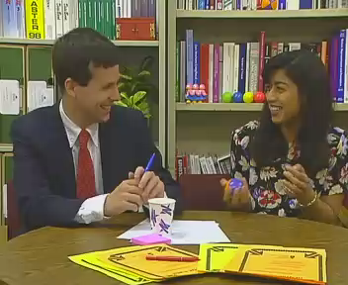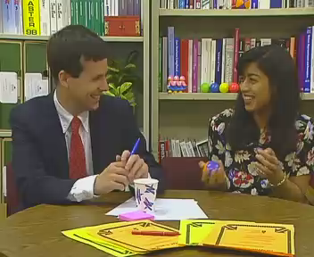

(a) JVT FCD (b) The proposed method



(a) JVT FCD (b) The proposed method

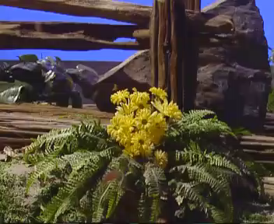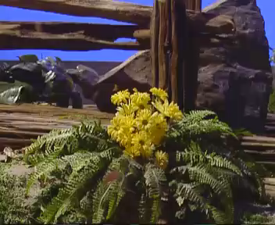

(a) JVT FCD (b) The proposed method

- Conclusions
For the subjective observation, we list the series of tested progressive sequences in Section 4.4. All sequences are encoded and decoded by JVT FCD and the proposed method, respectively. As shown in the subjective comparison in Section 4, it is nearly impossible to notice the differences between the reconstructed sequences based on JVT FCD and the reconstructed sequences based on the proposed method with the naked eyes.

Furthermore, besides the same subjective quality as JVT FCD, it is shown that our proposed method provides a noticeable coding efficiency in most cases of progressive and interlace sequences as shown in Table 4.2 and Table 4.3. While coding efficiency is greatly improved and the quality of the reconstructed sequences maintains the same quality, the complexity of the proposed algorithm compared with the plane mode prediction is significantly reduced.

Currently, the plane mode prediction in JVT FCD needs 331 additions, 132 multiplications, 71 shifts, and 128 comparisons. However, our proposal requires only 6 additions and 3 comparisons. With the remarkably reduced complexity, our scheme produces the even better performance than the plane mode prediction described in the current JVT FCD.

References
[1] D. Hoang, T. Horie, and E. Viscito, “Improved Chroma Spatial Prediction for Intra Coding”, ISO/IEC JTC1/SC29/WG11 and ITU-T Q6/SG16, Document JVT-C118, Fairfax, Virginia, May 2002.
[2] Joint Final Committee Draft (JFCD) of Joint Video Specification, ISO/IEC JTC1/SC29/WG11 and ITU-T Q6/SG16, Document JVT-D157, Jul. 2002.
[3] Recommended Simulation Common Conditions for H.26L Coding Efficiency Experiments on Low-Resolution Progressive-Scan Source Material, ITU-T Q6/SG16, Document VCEG-N81, Santa Barbara, CA, Sep. 2001.

(Append for Proposal Documents)

JVT Patent Disclosure Form

International Telecommunication Union  Telecommunication Standardization Sector | International Organization for Standardization | International Electrotechnical Commission
 |  | 
Joint Video Coding Experts Group - Patent Disclosure Form
(Typically one per contribution and one per Standard | Recommendation)

Please send to:
JVT Rapporteur Gary Sullivan, Microsoft Corp., One Microsoft Way, Bldg. 9, Redmond WA 98052-6399, USA
Email (preferred): Gary.Sullivan@itu.int Fax: +1 425 706 7329 (+1 425 70MSFAX)

This form provides the ITU-T | ISO/IEC Joint Video Coding Experts Group (JVT) with information about the patent status of techniques used in or proposed for incorporation in a Recommendation | Standard. JVT requires that all technical contributions be accompanied with this form. Anyone with knowledge of any patent affecting the use of JVT work, of their own or of any other entity (“third parties”), is strongly encouraged to submit this form as well.

This information will be maintained in a “living list” by JVT during the progress of their work, on a best effort basis. If a given technical proposal is not incorporated in a Recommendation | Standard, the relevant patent information will be removed from the “living list”. The intent is that the JVT experts should know in advance of any patent issues with particular proposals or techniques, so that these may be addressed well before final approval.

This is not a binding legal document; it is provided to JVT for information only, on a best effort, good faith basis. Please submit corrected or updated forms if your knowledge or situation changes.

This form is not a substitute for the ITU ISO IEC Patent Statement and Licensing Declaration, which should be submitted by Patent Holders to the ITU TSB Director and ISO Secretary General before final approval.

Submitting Organization or Person:
Organization name | Samsung Electronics Co. Ltd.
Mailing address
Country | Korea
Contact person | Woo-Shik Kim
Telephone
Fax
Email | wskim@sait.samsung.co.kr
Place and date of submission | Geneva, CH, 9-17 October, 2002
Relevant Recommendation | Standard and, if applicable, Contribution:
Name (ex: “JVT”) |  | JVT
Title |  | Complexity Reduction of Plane mode in Chroma Intra Prediction
Contribution number |  | JVT-E050

(Form continues on next page)

Disclosure information – Submitting Organization/Person (choose one box)
2.0 The submitter is not aware of having any granted, pending, or planned patents associated with the technical content of the Recommendation | Standard or Contribution.

or,
The submitter (Patent Holder) has granted, pending, or planned patents associated with the technical content of the Recommendation | Standard or Contribution. In which case,

 | 2.1 The Patent Holder is prepared to grant – on the basis of reciprocity for the above Recommendation | Standard – a free license to an unrestricted number of applicants on a worldwide, non-discriminatory basis to manufacture, use and/or sell implementations of the above Recommendation | Standard.
2.2 The Patent Holder is prepared to grant – on the basis of reciprocity for the above Recommendation | Standard – a license to an unrestricted number of applicants on a worldwide, non-discriminatory basis and on reasonable terms and conditions to manufacture, use and/ or sell implementations of the above Recommendation | Standard.

Such negotiations are left to the parties concerned and are performed outside the ITU | ISO/IEC.
X | 2.2.1 The same as box 2.2 above, but in addition the Patent Holder is prepared to grant a “royalty-free” license to anyone on condition that all other patent holders do the same.
2.3 The Patent Holder is unwilling to grant licenses according to the provisions of either 2.1, 2.2, or 2.2.1 above. In this case, the following information must be provided as part of this declaration:
- patent registration/application number;
- an indication of which portions of the Recommendation | Standard are affected.
- a description of the patent claims covering the Recommendation | Standard;
In the case of any box other than 2.0 above, please provide the following:
Patent number(s)/status
Inventor(s)/Assignee(s)
Relevance to JVT
Any other remarks:
(please provide attachments if more space is needed)

(form continues on next page)
Third party patent information – fill in based on your best knowledge of relevant patents granted, pending, or planned by other people or by organizations other than your own.

Disclosure information – Third Party Patents (choose one box)
X | 3.1 The submitter is not aware of any granted, pending, or planned patents held by third parties associated with the technical content of the Recommendation | Standard or Contribution.
 | 3.2 The submitter believes third parties may have granted, pending, or planned patents associated with the technical content of the Recommendation | Standard or Contribution.
For box 3.2, please provide as much information as is known (provide attachments if more space needed) - JVT will attempt to contact third parties to obtain more information:

3rd party name(s)
Mailing address
Country
Contact person
Telephone
Fax
Email
Patent number/status
Inventor/Assignee
Relevance to JVT

Any other comments or remarks:

