Joint Video Team (JVT) of ISO/IEC MPEG & ITU-T VCEG  (ISO/IEC JTC1/SC29/WG11 and ITU-T SG16 Q.6)  4rd Meeting: Klagenfurt, Austria, July 22-26, 2002 | Document: JVT-D124r1  Filename: JVT-D124r1-L.doc

Title: | Variable Accuracy Inter-Picture Timing Specification for Video
Status: | Input Document to JVT
Purpose: | Proposal
Author(s): | Barry G. Haskell, David Singer, Adriana Dumitras, Atul Puri  Toby Walker, Ali Tabatabai
 | Apple Computer, Inc.  2 Infinite Loop, MS:302-3KS  Cupertino, CA 95014  United States  Sony Corporation  3300 Zanker Road  San Jose, CA, 95112  USA | Tel:  Fax:  Email:  Tel:  Fax:  Email: | +1 408-974-6333  +1 408-974-1756  bhaskell@apple.com  +1 408-955-4081  +1 408-955-5724  toby.walker@am.sony.com
Source: | Apple Computer, Inc., Sony Corporation
____________________________

INTRODUCTION
The present contribution proposes a simple yet powerful method for transmission of inter-picture display time values. The proposed method, which addresses the case of variable inter-picture display times in video sequences, makes possible obtaining very high coding efficiency and selecting the accuracy such that it meets the requirements of the decoder.

Such a capability is potentially needed in [1] Sec. 11.4.1 & 11.4.2 to compute differential motion vectors, Sec. 11.4.3 to compute Direct Mode motion vectors and in Sec. 11.5.1 to compute Implicit B Prediction Block Weighting.

Addressing the problem of variable inter-picture display times in video sequences is intertwined with that of using temporal references. It is our belief that the derivation of correct pixel values in the output pictures in the JVT codec should be independent of the time at which that picture is decoded or displayed. Hence, timing issues/time references should be resolved outside the codec layer.

There are both coding-related and systems-related reasons underlying our viewpoint, which are briefly discussed next. In the codec, time references are used for two purposes: to establish an ordering for reference picture selection and to interpolate motion vectors. To establish an ordering for reference picture selection, one may simply send, for instance, the difference between the frame position N in decode order and the frame position M in display order, i.e., N – M. Hence, time-stamps or other time references would not be required. To interpolate motion vectors, temporal distances would be useful if they could be related to the interpolation distance. However, this may not be true if the motion is non-linear (for instance). Therefore, sending other parameters than temporal information for motion vector interpolation seems more appropriate.

In terms of systems, one can expect that the JVT coded is part of a system where it coexists with other video (and audio) codecs. In these systems, good system layering and design requires that general functions, which are logically codec-independent such as timing, be handled by the layer outside the codec. The management of timing by the system and not by each codec independently is critical to achieving consistent handling of common functions such as synchronization. For instance, in systems handling more than one stream, such as a video/audio presentation, or handling a stream from a remote system with a different clock, timing adjustments may sometimes be needed in the streams in order to keep synchronization between streams or with the remote system. Such timing adjustments may be achieved, for example, by using the time stamps supplied in RTP in the RTP layer for each stream, which are linked by means of “Sender Reports” from the transmitter. These sender reports take the form

Video RTP TimeStamp X is aligned with reference timestamp Y
Audio RTP TimeStamp W is aligned with reference timestamp Z

The wall-clock rate of the reference timestamps is known, allowing the two streams to be aligned. However, these references arrive both periodically and separately for the two streams, and they may cause some needed re-alignment of the two streams. This is generally achieved by adjusting the video stream to match the audio or vice-versa. System handling of time stamps should not affect the values of the pixels being displayed. More generally, system handling of temporal information should be performed outside the codec.

The rest of this document is organized as follows. Section 2 contains the problem description. Section 3 describes in brief our proposed method. Conclusions and references are included in Sections 4 and 5.

PROBLEM DESCRIPTION
In some video signals the time between successive pictures may not be constant. For example, frames or fields may be dropped because of transmission bandwidth constraints. Times may also vary due to camera irregularity or special effects such as slow or fast motion. Or the video may simply have nonuniform inter-picture times by design as, for example, in synthesized video.

Some video coding standards, such as ITU H.264, use different types of predicted pixelblocks in their coding. Throughout this proposal, we will use the term pixelblock to denote a block of any size (8x8, 8x4, 16x8, 4x4, etc.) that is permissible in JVT. In one scenario, a pixelblock may be one of three types:

- Intra (I) pixelblock that uses no information from preceding pictures in its coding,
- Unidirectionally Predicted (P) pixelblock that uses information from one preceeding picture, and
- Bidirectionally Predicted (B) pixelblock that uses information from one preceeding picture and one future picture.

Let us consider the case where all pixelblocks within a given picture are of the same type. Thus, the sequence of pictures to be coded might be represented as

I₁ B₂ B₃ B₄ P₅ B₆ B₇ B₈ B₉ P₁₀ B₁₁ P₁₂ B₁₃ I₁₄

where I, P, B indicate the picture type, and the number indicates the camera or display order in the sequence. In this scenario, picture I₁ uses no information from other pictures in its coding. P₅ uses information from I₁ in its coding. B₂, B₃, B₄ all use information from both I₁ and P₅ in their coding. This is illustrated in Fig. 1. As stated above the inter-picture times are, in general, not the same.

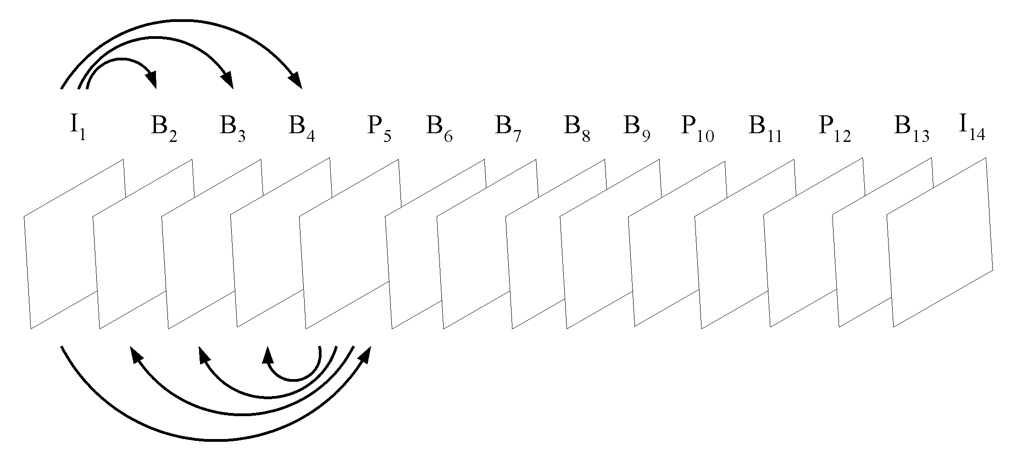
Fig. 1: Display order for a sequence a pictures. Arrows indicate that pixels from a stored picture
(I or P in this case) are used in the motion compensated prediction of other pictures.

Since B-pictures use information from future pictures, the transmission order is usually different than the display order. For the above sequence, the transmission order might be

I₁ P₅ B₂ B₃ B₄ P₁₀ B₆ B₇ B₈ B₉ P₁₂ B₁₁ I₁₄ B₁₃

Thus, when it comes time to decode B₂ for example, the decoder will have already received and stored the information in I₁ and P₅ necessary to decode B₂, similarly B₃ and B₄. This is illustrated in Fig. 2. The receiver then reorders the sequence for proper display. In this operation I and P pictures are often referred to as stored pictures.

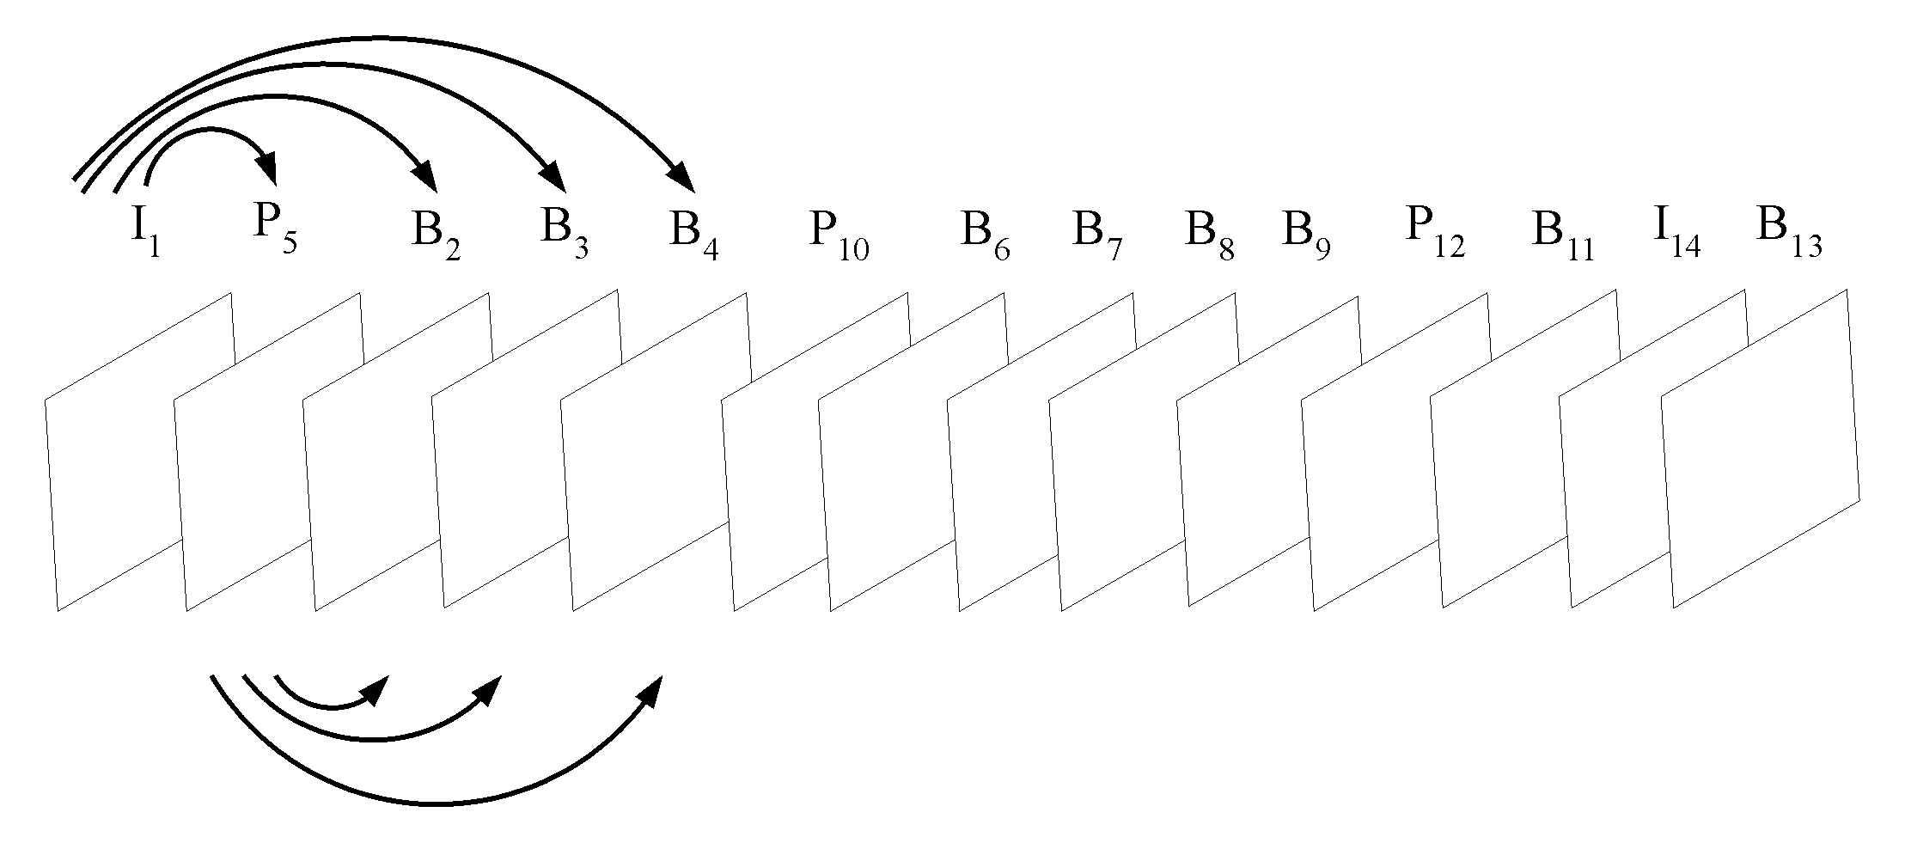

Fig. 2: Transmission order for a sequence a pictures, corresponding to the display order in Fig. 1.
Arrows indicate that pixels from a stored picture (I or P in this case) are used in the motion compensated prediction of other pictures.

- P pictures

The coding of the P pictures typically utilizes Motion Compensation, wherein a Motion Vector (MV) is computed for each pixelblock in the picture. Using the motion vector, a prediction block can be formed by translation of pixels in the aforementioned previous picture. The difference between the actual pixelblock in the P picture and the prediction block is then coded for transmission.

Each motion vector may also be transmitted via predictive coding. That is, a prediction is formed using nearby motion vectors , then the difference between the actual motion vector and the prediction is coded for transmission.

- B pictures

Each B pixelblock uses two motion vectors, one for the aforementioned previous picture and one for the future picture. From these motion vectors, two prediction blocks are computed, which are then averaged together to form the final prediction. As above the difference between the actual pixelblock in the B picture and the prediction block is then coded for transmission.

As with P pixelblocks, each motion vector of a B pixelblock may be transmitted via predictive coding. That is, a prediction is formed using nearby motion vectors, then the difference between the actual motion vector and the prediction is coded for transmission. However, with B pixelblocks the opportunity exists for interpolating the motion vectors from those in the nearest stored picture pixelblock. Such interpolation is carried out both at the coder and decoder. This works particularly well when the camera is slowly panning across a stationary background. In fact, the interpolation may be good enough to be used as is, which means that no differential information need be transmitted for these B pixelblock motion vectors.

To illustrate further, in the above scenario let us represent the inter-picture display time between pictures i and j as D_{ij}. If the display times of the pictures are T_{i} and T_{j}, respectively, then

D_{ij} = T_{i} - T_{j}

from which it follows that

D_{ik} = D_{ij} + D_{jk}

D_{ik} = - D_{ki}

Note that D_{ij} may be negative in some cases,. Also, notation D_{i,j} is used sometimes to avoid confusion.

Thus, if MV₅₁ is a motion vector for a P₅ pixelblock as referenced to I₁, then for the corresponding pixelblocks in B₂, B₃ and B₄ the motion vectors would be interpolated by

MV₂₁ = MV₅₁ * D₂₁/D₅₁
MV₅₂ = MV₅₁ * D₅₂/D₅₁

MV₃₁ = MV₅₁ * D₃₁/D₅₁
MV₅₃ = MV₅₁ * D₅₃/D₅₁

MV₄₁ = MV₅₁ * D₄₁/D₅₁
MV₅₄ = MV₅₁ * D₅₄/D₅₁

This scenario may be generalized, as for example in H.264. In the generalization, a P or B picture may use any previously transmitted picture for its prediction. Thus, in the above case, B₃ may use I₁ and B₂ in its prediction. Moreover, motion vectors may be extrapolated, not just interpolated. Thus, in this case we would have

MV₃₁ = MV₂₁ * D₃₁/D₂₁

Such extrapolation (or interpolation) may also be used in the prediction process for predictive coding of motion vectors.

PROPOSED METHOD
The problem in the case of nonuniform inter-picture times is to transmit the values of D_{ij} to the receiver, and that is the subject of this proposal. In our proposed method, for each picture after the first picture we transmit the display time difference between the current picture and the most recently transmitted stored picture. For error resilience the transmission could be repeated several times within the picture, e.g., in the slice headers of H.264. If all slice headers are lost, then presumably other pictures that rely on the lost picture for decoding information cannot be decoded either.

Thus, in the above scenario we would transmit the following:

D₅₁ D₂₅ D₃₅ D₄₅ D_{10, 5} D_{6, 10} D_{7, 10} D_{8, 10} D_{9, 10} D_{12, 10} D_{11, 12} D_{14, 12} D_{13, 14}

For the purpose of motion vector estimation, the accuracy requirements for D_{ij} may vary. For example, if there is only a single B picture B₆ halfway between two P pictures P₅ and P₇, then it suffices to send only

D₇₅ = 2 and D₆₇ = -1.

However, if B₆ is only one quarter the distance between P₅ and P₇ then the appropriate values to send would be

D₇₅ = 4 and D₆₇ = -1.
The timing accuracy may vary within the sequence. In this case a special signal is sent to indicate simply that previous timing information is obsolete and should not be used in conjunction with subsequent timing information.

In general, motion vector estimation is less complex if divisors are powers of two. This is easily achieved in our method if D_{ij} between any two stored pictures is chosen to be a power of two as shown in Fig. 3. Alternatively, the estimation procedure could be defined to truncate all divisors to a power of two. In the case when an inter-picture time is to be a power of two, bits can be saved if only the integer power is transmitted instead of the full value of the inter-picture time.

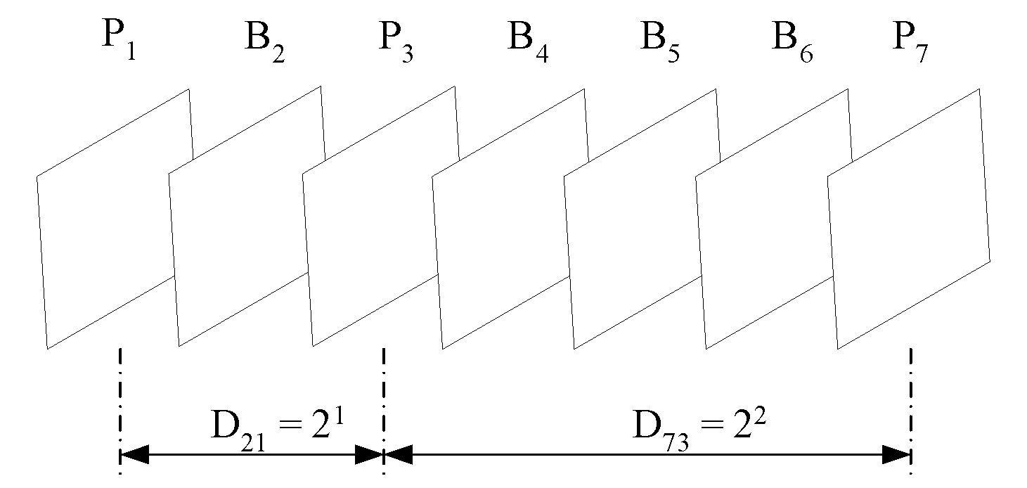

Fig. 3: The display distance between any two stored pictures can be selected to be equal to a power of two

In some cases, motion vector estimation may not be used, but it is still necessary to transmit the display order to the receiver. In this case, simple signed integer values for D_{ij} suffice irrespective of the actual display times. In some applications only the sign is needed.

Thus, the inter-picture times D_{ij} are sent as simple signed integers.

Encoding
Many methods may be used for coding the D_{ij} values. For example, a sign bit followed by a variable length coded magnitude is relatively easy to implement. One such variable length code is the so called UVLC given by the code words

1

0 1 0

0 1 1

0 0 1 0 0

0 0 1 0 1

0 0 1 1 0

0 0 1 1 1

0 0 0 1 0 0 0
…

The pattern of values for D that are sent is often fixed and repeat with in a group of pictures; that is, the pattern of D values is highly regular and periodic:

Pattern 1: I0 P1 P2 P3 P4 P5
Delta 0 +1 +1 +1 +1 +1

This is the simplest is the simplest periodic structure as all values of D will be constant and there is a repetition of the cycle <1>.

Pattern 2: I0 P3 B1 B2 P6 B4 B5 …
Delta: 0 -3 2 1 -3 2 1

The cycle here is of length 3 and repeats as <-3, 2, 1>

Pattern 3: IPBBBBPBBBBP… and so on.

This suggests we should be able to send such information for "free" if we have side information about the structure of such periodically occurring patterns

According to the CD definition of frame numbers, the cyclic counter FN does not advance for non-stored pictures except for the first non-stored pictures. For example in the sequence below note that frame number does not advance between stored pictures.

I0 P3 B1 B2 P6 B4 B5 P9
FN: 0 1 2 2 2 3 3 4

It is not possible for the decoder to distinguish amongst frames B1, and B2 unless timing information is included in each frame. This is currently not the case in the JVT Committee Draft.

The value of D for the first frame at an instantaneous reset starting a group of pictures must always be zero because the frame is always an I frame and is not predicted from any other frame. Therefore, we can ignore this value in encoding the values of D

We would like to take advantage of the repeating patterns of D_{ij} (hereafter abbreviate to D) that will be common in the Group of Picture structures used by most encoders. We present the solution in several stages, starting from the most basic solution and then extending it to cover more difficult cases.

The basic idea is to store information about the repeating patterns of D values in the sequence parameter set. Each slice in a group of picture must reference the same parameter by its parameter id. Suppose we add the following to the definition of the parameter set:

parameter_set_rbsp() { | Category | Descriptor
… | 0 | e(v)
timing_delta_cycle_length | 0 | e(v)
for (i = 0; i < timing_delta_cycle_length; i++)
timing_delta | 0 | e(v)
} | All
…

The value of timing_delta_cycle_length indicates the length of the repeating cycle and the values of timeing_delta indicate the repeating values of D in order of their occurrence. If the value of timeing_delta_signal_length is zero, then the values of D are encoded in the slice header as in the original Apple scheme. If the value of timing_delta_cycle_length is greater than zero, then no such values of D are sent. The

Notice that this structure lets us handle commonly occurring GOP structure that have constant frame rates (the normal case) without sending any information in the stream. Moreover, the scheme is more robust to error loss as the decoder can always determine the value of D for each frame, even if one or more frames is lost. This is because the FN for each picture allows the decoder to always know the decoder order of the current frame it is decoding.

Note: Assuming some patterns are common, we can predefine a set of known patterns and timings and then assign a unique code to each pattern. If the pattern is not amongst those known patterns, then the more general mechanism above to signal arbitrary patterns. For example, constant frame rates with GOP structures like IPPPPP, IPBBPBB are so common we can give them unique identifiers. We can combine this with the above scheme and allow one such code to indicate that a "escape" code where we revert back to explicit signaling of the repeated frame inter-time intervals.

A decoder can use the value in the parameter to determine the value of D for each frame in the GOP as follows. If the cycle in the parameter set is of length zero, then the value of D is signaled explicitly in the slice header, as in the original proposal by Apple. If the cycle length is m, then the value of D for a frame at position k in the GOP (numbering such frames from zero after the first I-frame) is S(k mod m), where S is the sequence of m values stored in the parameter set.

As observed earlier, while frame number counter always advances between two stored pictures, this need not be true for a disposable (non-stored picture) picture. See the example above where for disposable B-frame the FN does not advance. This means given only FN, it is not possible for an decoder to determine what the number of that frame is in decoder order, counting each frame starting from the first frame in the GOP.

Of course, assuming no frames are lost, the decoder can maintain a counter that is incremented by one every time a new frame arrives. However, if frames are lost then such a counter is unreliable. There are two solutions for this problem:

- Assume the chance of an entire picture being lost is sufficiently low that this is not a concern.
- Include a counter for each picture (e.g. inside the slice header) that indicates the count of consecutive disposable pictures the decoder has sent. The encoder sends the number of frames since the last stored picture minus one, i.e., 0 for first non-stored frame, 1 for second consecutive non-stored frame, and so forth. This allows the decoder to determine the frame number for all frames even in the presence of picture loss.

If periodic structures change across GOP boundaries, the a new parameter set can be created and referenced for each such pattern.

Suppose that the pattern of values for D has is irregular. In the solution proposed above this is handled by using the basic Apple scheme and sending a value of D for each picture to the decoder.

Some alternative variations of this scheme include:

- Send the value of D for each stored frame but use the last value as a predictor and signal only the prediction error. This solution has the disadvantage that if a frame is lost, it is not very robust to errors.
- Use parameter sets with periodic patterns and assume relatively minor departures from those patterns. The values of D are predicted from the periodic pattern and only the delta value for D is encoded in the slice header.

CONCLUSIONS
We present a simple but powerful method of sending inter-picture display times. Coding can be made very efficient. Also, accuracy can be chosen to meet the needs of the video decoder, but no more.

REFERENCES
[1] Joint Video Team (JVT) of ISO/IEC MPEG and ITU-T VCEG, Committee Draft of Joint Video Specification (ITU-T Rec. H.264/ISO/IEC 14496-10 AVC), document JVT-C167, Fairfax, Virginia, May 10, 2002.

(Append for Proposal Documents)

JVT Patent Disclosure Form

International Telecommunication Union  Telecommunication Standardization Sector | International Organization for Standardization | International Electrotechnical Commission
 |  | 
Joint Video Coding Experts Group - Patent Disclosure Form
(Typically one per contribution and one per Standard | Recommendation)

Please send to:
JVT Rapporteur Gary Sullivan, Microsoft Corp., One Microsoft Way, Bldg. 9, Redmond WA 98052-6399, USA
Email (preferred): Gary.Sullivan@itu.int Fax: +1 425 706 7329 (+1 425 70MSFAX)

This form provides the ITU-T | ISO/IEC Joint Video Coding Experts Group (JVT) with information about the patent status of techniques used in or proposed for incorporation in a Recommendation | Standard. JVT requires that all technical contributions be accompanied with this form. Anyone with knowledge of any patent affecting the use of JVT work, of their own or of any other entity (“third parties”), is strongly encouraged to submit this form as well.

This information will be maintained in a “living list” by JVT during the progress of their work, on a best effort basis. If a given technical proposal is not incorporated in a Recommendation | Standard, the relevant patent information will be removed from the “living list”. The intent is that the JVT experts should know in advance of any patent issues with particular proposals or techniques, so that these may be addressed well before final approval.

This is not a binding legal document; it is provided to JVT for information only, on a best effort, good faith basis. Please submit corrected or updated forms if your knowledge or situation changes.

This form is not a substitute for the ITU ISO IEC Patent Statement and Licensing Declaration, which should be submitted by Patent Holders to the ITU TSB Director and ISO Secretary General before final approval.

Submitting Organization or Person: Barry G. Haskell, David Singer, Adriana Dumitras, Atul Puri
Organization name | Apple Computer, Inc.
Mailing address | 2 Infinite Loop, MS:302-3KS  Cupertino, CA 95014
Country | United States
Contact person | Barry G. Haskell
Telephone | +1 408-974-6333
Fax | +1 408-974-1756
Email | bhaskell@apple.com
Place and date of submission | Austria, Jully 2002
Relevant Recommendation | Standard and, if applicable, Contribution:
Name (ex: “JVT”) |  | JVT
Title |  | Variable Accuracy Inter-Picture Timing Specification for Video
Contribution number |  | JVT-xxxx

(Form continues on next page)

Disclosure information – Submitting Organization/Person (choose one box)
2.0 The submitter is not aware of having any granted, pending, or planned patents associated with the technical content of the Recommendation | Standard or Contribution.

or,
The submitter may in the future have patents associated with the technical content of the Recommendation | Standard or Contribution. In which case,

 | 2.1 The Patent Holder is prepared to grant – on the basis of reciprocity for the above Recommendation | Standard – a free license to an unrestricted number of applicants on a worldwide, non-discriminatory basis to manufacture, use and/or sell implementations of the above Recommendation | Standard.
2.2 The Patent Holder is prepared to grant – on the basis of reciprocity for the above Recommendation | Standard – a license to an unrestricted number of applicants on a worldwide, non-discriminatory basis and on reasonable terms and conditions to manufacture, use and/ or sell implementations of the above Recommendation | Standard.

Such negotiations are left to the parties concerned and are performed outside the ITU | ISO/IEC.
X | 2.2.1 The same as box 2.2 above, but in addition the Patent Holder is prepared to grant a “royalty-free” license to anyone on condition that all other patent holders do the same.
2.3 The Patent Holder is unwilling to grant licenses according to the provisions of either 2.1, 2.2, or 2.2.1 above. In this case, the following information must be provided as part of this declaration:
- patent registration/application number;
- an indication of which portions of the Recommendation | Standard are affected.
- a description of the patent claims covering the Recommendation | Standard;
In the case of any box other than 2.0 above, please provide the following:
Patent number(s)/status
Inventor(s)/Assignee(s)
Relevance to JVT
Any other remarks:
(please provide attachments if more space is needed)

(form continues on next page)
Third party patent information – fill in based on your best knowledge of relevant patents granted, pending, or planned by other people or by organizations other than your own.

Disclosure information – Third Party Patents (choose one box)
X | 3.1 The submitter is not aware of any granted, pending, or planned patents held by third parties associated with the technical content of the Recommendation | Standard or Contribution.
 | 3.2 The submitter believes third parties may have granted, pending, or planned patents associated with the technical content of the Recommendation | Standard or Contribution.
For box 3.2, please provide as much information as is known (provide attachments if more space needed) - JVT will attempt to contact third parties to obtain more information:

3rd party name(s)
Mailing address
Country
Contact person
Telephone
Fax
Email
Patent number/status
Inventor/Assignee
Relevance to JVT

Any other comments or remarks:

With interlaced video we may have field pictures or frame pictures.
More generally, a picture that contains any B pixelblocks is a B picture. A picture that contains P pixelblocks, but no B pixelblocks, is a P picture. An I picture contains only I pixelblocks.
In some scenarios, B pictures may also be stored and used for predicting subsequent pictures.
The averaging may use equal 50/50 weighting or it may use unequal weighting.
Actual display times would be sent outside the video stream, e.g., by IETF’s RTP.

