Joint Video Team (JVT) of ISO/IEC MPEG & ITU-T VCEG  (ISO/IEC JTC1/SC29/WG11 and ITU-T SG16 Q.6)  4th Meeting: Klagenfurt, Austria, 22-26 July, 2002 | Document: JVT-D113  Filename: JVT-D113.doc

Title: | Filtering Strength for B Pictures
Status: | Input Document to JVT
Purpose: | Proposal
Author(s) or  Contact(s): | Chong-Soon Lim  Block 1022 Tai Seng Avenue  #04-3530  Singapore 534415  Teck-Wee Foo  Block 1022 Tai Seng Avenue  #04-3530  Singapore 534415  Sheng-Mei Shen  Block 1022 Tai Seng Avenue  #04-3530  Singapore 534415  Shinya Kadono  1006 Kadomo, Kadomo, Osaka  573-8501 Japan | Tel:  Email:  Tel:  Email:  Tel:  Email:  Tel:  Email: | (65) 6550-5487  cslim@psl.com.sg  (65) 6550-5474  twfoo@psl.com.sg  (65) 6550-5466  shen@psl.com.sg  +81-6-6900-9689  kadono@drl.mei.co.jp
Source: | Panasonic Singapore Laboratories Pte. Ltd.
_____________________________

Summary

The purpose of this proposal is to present a method to determine the “Boundary Strength” Bs for B pictures. The current semantics described in committee draft of JVT [1] may cover the case for both I and P pictures. But in the case for B pictures, the current semantics does not clearly define the method to determine Bs for all the possible prediction modes of B pictures. B pictures can be predicted using forward, backward, direct or bi-directional. Therefore there is a need for a clear definition on the boundary strength determination for B pictures.

Problem

Figure 1 shows the current flow chart used to determine the boundary strength for the block boundary between two neighbouring blocks p and q. As shown from the flow chart, all the possible cases for B pictures have not been considered in the determining of boundary strength. For example, the case if block p is forward predicted and block q is bi-directional predicted. If both the blocks are not coded and the forward motion vectors are the same, should filtering be skipped (B_{S} = 0)? Or the case when block p is predicted using direct mode and block q is predicted using bi-directional mode, which motion vectors of block p should be used for the comparison if both the blocks are not coded? These issues need to be clearly addressed so that there is no discrepancy between the encoder and the decoder especially in the case when B pictures are used as reference frames.

Figure 1 Current Flow Chart for Determining the Boundary Strength (Bs), for the Block Boundary Between Two Neighbouring Blocks p and q.

New Boundary Strength Flow Chart

Figure 2 shows a modified flow chart to determine Boundary Strength (Bs). In the case for non-Intra blocks in P picture, the number of reference frames is always one for both block p and q. Whereas in the case of blocks in B pictures, the blocks can have two reference frames, one forward reference frame and one backward reference frame. So if two neighbour blocks p and q have different number of reference frames, their prediction modes are different and the block boundary between these two blocks needs to be filtered. In the case for direct mode, the number of reference frames can be one or two depending on whether or not there is a forward reference frame for the co-located block in the backward reference frame index 0. Therefore even if blocks p and q are both predicted using direct mode, if the number of reference frames is different, filtering should still be performed on the block boundary.

Ref(p) != Ref(q)
or
|V(p,x)-V(q,x)|≥1 pel or
|V(p,y)-V(q,y|≥1 pel

Block boundary between blocks p and q
Block p or q Intra coded?
Block p or q is also macroblock boundary?
Yes
No
Yes
No
Yes
Coefficients coded in block p or q?
Block p and q have different number of reference frames?

Yes
No
No
Yes
No
Bs=4
Bs=3
Bs=2
Bs=1
Bs=1
Bs=0
(Skip)

Figure 2 Modified Flow Chart for Determining the Boundary Strength (Bs), for the Block Boundary Between Two Neighbouring Blocks p and q.

Ref(p) is the reference frame(s) or field(s) of block p and V(p) is the motion vector(s) of block p.

In the case where both blocks p and q have two reference frames, filtering of the block boundary is skipped (Bs=0) only when the two reference frames of block p and q are the same and all the forward and backward motion vectors of block p and q are less than one pixel apart. For direct mode, V(p) represents the scaled motion vectors of block p.

Results

Current reference software implementation (JM2.1) does not perform the reference frames comparison for B pictures. This resulted in filtering of block boundary to be skipped based on motion vectors only. The result of this is some blocky effects in B pictures. Some modifications have been made to the reference software to include the reference frames comparison. The results are shown below:


JM 2.1 Modified JM2.1
Figure 3 Foreman, CIF, QP=24

JM 2.1 Modified JM2.1
Figure 4 Foreman, CIF, QP=28

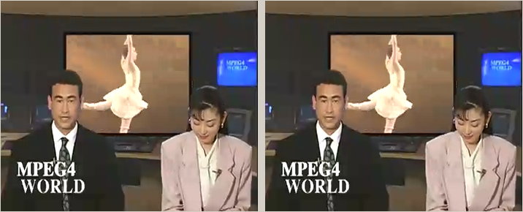

Figure 5 News, CIF, QP=24

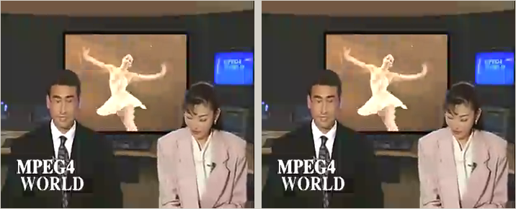

Figure 6 News, CIF, QP=28



Figure 7 Silent, QCIF, QP=24

Conclusion

The results showed an improvement in the subjective quality of B pictures especially for the Foreman sequence. The results in the accompanied excel file show no significant changes in bitrates or PSNR values for the common test conditions even in the case for the Foreman sequence. The improvement is mainly in the subjective quality of the B pictures. Therefore we would like to propose the modifications to the flow chart and the semantics used for the boundary strength determination to handle the case for B pictures as well as the necessary modifications to the reference software to compare reference frames for B pictures.

References

[1] Thomas Wiegand, “Joint Committee Draft (CD) ”, JVT-167, JVT Meeting, Fairfax, Virginia, USA, May 2002.

(Append for Proposal Documents)

JVT Patent Disclosure Form

International Telecommunication Union  Telecommunication Standardization Sector | International Organization for Standardization | International Electrotechnical Commission
 |  | 
Joint Video Coding Experts Group - Patent Disclosure Form
(Typically one per contribution and one per Standard | Recommendation)

Please send to:
JVT Rapporteur Gary Sullivan, Microsoft Corp., One Microsoft Way, Bldg. 9, Redmond WA 98052-6399, USA
Email (preferred): Gary.Sullivan@itu.int Fax: +1 425 706 7329 (+1 425 70MSFAX)

This form provides the ITU-T | ISO/IEC Joint Video Coding Experts Group (JVT) with information about the patent status of techniques used in or proposed for incorporation in a Recommendation | Standard. JVT requires that all technical contributions be accompanied with this form. Anyone with knowledge of any patent affecting the use of JVT work, of their own or of any other entity (“third parties”), is strongly encouraged to submit this form as well.

This information will be maintained in a “living list” by JVT during the progress of their work, on a best effort basis. If a given technical proposal is not incorporated in a Recommendation | Standard, the relevant patent information will be removed from the “living list”. The intent is that the JVT experts should know in advance of any patent issues with particular proposals or techniques, so that these may be addressed well before final approval.

This is not a binding legal document; it is provided to JVT for information only, on a best effort, good faith basis. Please submit corrected or updated forms if your knowledge or situation changes.

This form is not a substitute for the ITU ISO IEC Patent Statement and Licensing Declaration, which should be submitted by Patent Holders to the ITU TSB Director and ISO Secretary General before final approval.

Submitting Organization or Person:
Organization name | Matsushita Electric Industrial Co., Ltd.
Mailing address | 1006 Kadoma, Kadoma, Osaka, 573-8501
Country | Japan
Contact person | Shinya Kadono
Telephone | +81-6-6900-9689
Fax | +81-6-6900-9674
Email | kadono@drl.mei.co.jp
Place and date of submission | Klagenfurt, Austria, 22-26 July, 2002
Relevant Recommendation | Standard and, if applicable, Contribution:
Name (ex: “JVT”) |  | JVT
Title |  | Filtering Strength for B Pictures
Contribution number

(Form continues on next page)

Disclosure information – Submitting Organization/Person (choose one box)
2.0 The submitter is not aware of having any granted, pending, or planned patents associated with the technical content of the Recommendation | Standard or Contribution.

or,
The submitter (Patent Holder) has granted, pending, or planned patents associated with the technical content of the Recommendation | Standard or Contribution. In which case,

2.1 The Patent Holder is prepared to grant – on the basis of reciprocity for the above Recommendation | Standard – a free license to an unrestricted number of applicants on a worldwide, non-discriminatory basis to manufacture, use and/or sell implementations of the above Recommendation | Standard.
2.2 The Patent Holder is prepared to grant – on the basis of reciprocity for the above Recommendation | Standard – a license to an unrestricted number of applicants on a worldwide, non-discriminatory basis and on reasonable terms and conditions to manufacture, use and/ or sell implementations of the above Recommendation | Standard.

Such negotiations are left to the parties concerned and are performed outside the ITU | ISO/IEC.
2.2.1 The same as box 2.2 above, but in addition the Patent Holder is prepared to grant a “royalty-free” license to anyone on condition that all other patent holders do the same.
2.3 The Patent Holder is unwilling to grant licenses according to the provisions of either 2.1, 2.2, or 2.2.1 above. In this case, the following information must be provided as part of this declaration:
- patent registration/application number;
- an indication of which portions of the Recommendation | Standard are affected.
- a description of the patent claims covering the Recommendation | Standard;
In the case of any box other than 2.0 above, please provide the following:
Patent number(s)/status
Inventor(s)/Assignee(s)
Relevance to JVT
Any other remarks:
(please provide attachments if more space is needed)

(form continues on next page)
Third party patent information – fill in based on your best knowledge of relevant patents granted, pending, or planned by other people or by organizations other than your own.

Disclosure information – Third Party Patents (choose one box)
3.1 The submitter is not aware of any granted, pending, or planned patents held by third parties associated with the technical content of the Recommendation | Standard or Contribution.

3.2 The submitter believes third parties may have granted, pending, or planned patents associated with the technical content of the Recommendation | Standard or Contribution.

For box 3.2, please provide as much information as is known (provide attachments if more space needed) - JVT will attempt to contact third parties to obtain more information:

3rd party name(s)
Mailing address
Country
Contact person
Telephone
Fax
Email
Patent number/status
Inventor/Assignee
Relevance to JVT

Any other comments or remarks:

