Joint Video Team (JVT) of ISO/IEC MPEG & ITU-T VCEG  (ISO/IEC JTC1/SC29/WG11 and ITU-T SG16 Q.6)  4th Meeting: Klagenfurt, Austria, 22-26 July, 2002 | Document: JVT-D070  Filename: JVT-D070.doc

Title: | A MAD-based rate control strategy
Status: | [e.g., Input Document to JVT or Output Document Approved by JVT]
Purpose: | [e.g, Draft, Proposed Draft, Proposal, Information, Liaison, Report]
Author(s) or  Contact(s): | Jinghua Wang, Zhibo Chen, Yun He  Dept. of Electronic Engineering, Tsinghua University, Beijing, China  Yidong Chen  SVA Group, Co.Ltd, Shanghai, China | Tel:  Email: | 86-10-62781413  wangjh@video.mdc.tsinghua.edu.cn  hey@tsinghua.edu.cn
Source: | Tsinghua University, China and SVA Group, China
_____________________________
(Begin text of document here: 11-point font is suggested for short documents, 10 for long ones)
Paper [1] proposed a rate control strategy, which has been used in H.263 TMN8 and MPEG-4 VM8. It is also a core technique in TMN11 and VM15. TMN8’s rate control strategy is a variance-based algorithm, it needs to first calculate the DCT residual variance of the MBs of the frame then decide the QP for those MBs. However, Many hardware structures are favorable to execute MAD in parallel, moreover in motion estimation, MAD of block matching is a need-to-do process, so that using MAD to replace variance as a controlling trigger is reasonable. Furthermore, if this MAD can be predicted from previous frames, a low delay encoder can be obtained. In this proposal, we first introduce a MAD-based strategy that has the performance comparable to the variance-based one. Secondly, we will give experimental results of using a predicted MAD in order to reduce the encoding delay.
1. MAD-based rate control strategy
Let’s first derive the method for MB-based rate controlling, which can be easily extended to a slice-based one.
Equation (1) is a linear modeling of the bits and the MAD for a MB,

(1)
where α_{p} and β_{p} are factors of the this linear model for P MB .
The following Figures are simulation results to show the linearity of equation (1).

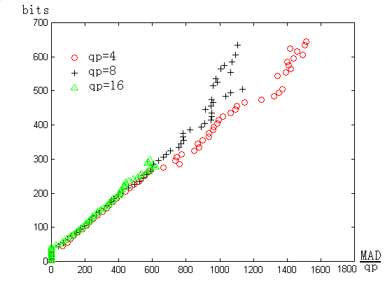
Figure 1, I MB (football)
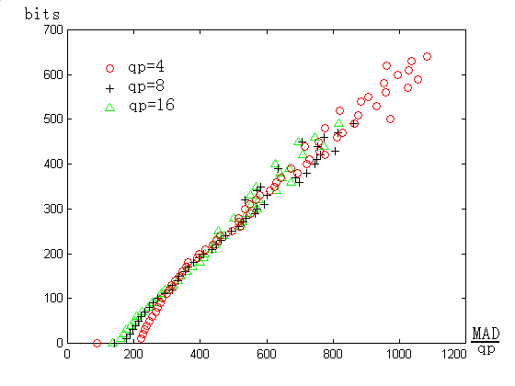
Figure2 P MB (football)

Under the linearity assumption, a bit assigning strategy is described in the following steps:

Step 1: Frame bits assigning
Equation (3) is for updating the bits in the output buffer,
(3)
where,
W is accumulated bits in the buffer;
B’ is the bits used by the previous frame;
R is the target bits;
F is the target frame rate.
While // M is a threshold
{
//skip frame
}
Thus we can assign the bits for current frame as follows:
(4)
where,
is the number of frames need to be skipped;
is a parameter of buffering delay, normally assigned to 0.1;
is the bits assigned to current frame.

Step 2: MB bits assigning
The bits assigned to the transform coefficient of a MB is,
(5)
whereis the bits assigned for a frame, is the overhead bits for current frame, which can be thought to be the same as that of the previous frame, is the total MB number in the frame, and is the averaging MAD in the frame.

Step 3: Obtaining quantization parameter

From equation (1), we get,
(6)
where,
，
is updated from
is the difference between the predicted bits and the actually encoded bits, is a smoothing factor.
(7)

Step 4: Model parameter updating
The linear model parameter updating is done by following equation,

(8)
， represent or and or of the linear model respectively, I and P represent I or P MBs.

Simulation results
The simulation conditions are,
Testing platform: TMN3.2 encoder;
Test sequences: Car Phone, Mother and Daughter, Coast Guard and Tempete;
Format: CIF (4:2:0);
Input frame rate is 30 frames/s, output frame rate is 10 frames/s;
240 frames are used for each sequence;
frame types of encoding are : IPPPPP…;
QP for the first frame is 10;
Figure 3 and 4 show the PSNR and bits of each frame for CarPhone @256Kb/s. It can be seen, the performance are comparable to that of TMN8’s. The results for other sequences are provided in Table 1~4.

Figure 3 PSNR vs frames, Car Phone@256Kb/s
Figure 4 Bits vs frames, Car Phone@256Kb/s
Table 1 Mother and Daughter
 | TMN8’s |  |  |  | Proposed
 | PSNR(dB) |  |  | resulted  （Kb/s） | PSNR(dB) |  |  | resulted  (Kb/s)
 | Y | Cb | Cr | resulted  （Kb/s） | Y | Cb | Cr | resulted  (Kb/s)
128Kb/s | 37.03 | 41.19 | 41.19 | 128.15 | 36.89 | 41.11 | 41.17 | 127.77
256Kb/s | 39.58 | 42.74 | 42.98 | 256.32 | 39.59 | 42.75 | 42.98 | 256.57
384Kb/s | 41.06 | 43.54 | 43.94 | 384.44 | 41.17 | 43.60 | 44.03 | 384.51
Table 2 Coast Guard
 | TMN8’s |  |  |  | Proposed
 | PSNR(dB) |  |  | resulted  （Kb/s） | PSNR(dB) |  |  | resulted  (Kb/s)
 | Y | Cb | Cr | resulted  （Kb/s） | Y | Cb | Cr | resulted  (Kb/s)
128Kb/s | 27.44 | 37.06 | 38.04 | 128.14 | 26.98 | 37.40 | 38.05 | 127.63
256Kb/s | 29.88 | 39.22 | 40.41 | 256.28 | 29.82 | 39.61 | 40.49 | 255.76
384Kb/s | 31.48 | 40.34 | 41.18 | 384.43 | 31.52 | 40.78 | 41.80 | 384.37
Table 3 Tempete
 | TMN8’s |  |  |  | Proposed
 | PSNR(dB) |  |  | resulted  （Kb/s） | PSNR(dB) |  |  | resulted  (Kb/s)
 | Y | Cb | Cr | resulted  （Kb/s） | Y | Cb | Cr | resulted  (Kb/s)
128Kb/s | 26.41 | 31.02 | 33.30 | 128.29 | 26.13 | 30.84 | 33.23 | 128.20
256Kb/s | 28.69 | 32.96 | 35.02 | 256.29 | 28.58 | 32.96 | 35.04 | 256.20
384Kb/s | 30.24 | 34.14 | 36.14 | 384.47 | 30.20 | 34.26 | 36.22 | 384.51

Table 4 Car Phone
 | TMN8 Algorithm |  |  |  | The Proposed Algorithm
 | PSNR(dB) |  |  | resulted  （Kb/s） | PSNR(dB) |  |  | resulted  (Kb/s)
 | Y | Cb | Cr | resulted  （Kb/s） | Y | Cb | Cr | resulted  (Kb/s)
128Kb/s | 35.17 | 39.62 | 40.56 | 128.14 | 34.89 | 39.71 | 40.59 | 128.17
256Kb/s | 38.31 | 41.98 | 42.77 | 256.29 | 38.27 | 41.99 | 42.64 | 256.32
384Kb/s | 40.11 | 43.29 | 44.07 | 384.31 | 40.06 | 43.24 | 43.86 | 384.55

2. Rate control with low encoding delay
TMN8’s strategy needs to calculate the DCT residual variance for all MBs first then a QP for a MB can be decided. Because the variances have to be done after all MBs’ motion estimation, thus it results in encoding delay. In MAD-based strategy, we can use MAD to reduce computation load. In one hand, MAD can be easily conducted by parallel hardware, and in another hand, MAD is an already done value during motion estimation. The good performance has been shown in section 1.
In this section, we will present a new idea of getting the encoding delay further reduced, so as to obtain a low delay rate controlling.
The idea is that we could predict the MAD of the current frame from the previous frames, thus need not to wait until the calculation of MAD to be finished for the current frame. The averaging MAD predicted from the previous frames can be simply used as in equation (9),
(9)
Using equation (9) to replace the MAD of the method in section 1, we get not bad results that are shown in Figure 5 and 6, the bits allocated are slightly worse than that of TMN8’s, the PSNR are similar as that of TMN8’s. The advantage of using predicted MAD is that it enables a forward rate control process.
EMBED Origin50.Graph
Figure 5. 256Kbps, 4：2：0, Car Phone
Figure 6. 4:2:0, CarPhone@256Kbps

3. Summaries
The proposed MAD-based strategy can be used for CBR, and also for VBR. It requires few calculations, it is very simple in implementation and is fairly effective. It can use the MAD, a pre-computed value in ME, and obtains comparable results to that of TMN8’s. Moreover the strategy can be extended to a forward rate controlling by using the predicted MAD from the previous frames, to meet the requirement of a kind of delay sensitive encoders. We are currently testing on JVT platform.

[1] Ribas-Corbera etc., “Rate control in DCT video coding for low-delay communications”, IEEE-CSVT, Vol. 9, No.1, pp.172-185, Feb 1999
[2] Jinghua Wang, “a new low complexity rate control algorithm”,

(Append for Proposal Documents)

JVT Patent Disclosure Form

International Telecommunication Union  Telecommunication Standardization Sector | International Organization for Standardization | International Electrotechnical Commission
 |  | 
Joint Video Coding Experts Group - Patent Disclosure Form
(Typically one per contribution and one per Standard | Recommendation)

Please send to:
JVT Rapporteur Gary Sullivan, Microsoft Corp., One Microsoft Way, Bldg. 9, Redmond WA 98052-6399, USA
Email (preferred): Gary.Sullivan@itu.int Fax: +1 425 706 7329 (+1 425 70MSFAX)

This form provides the ITU-T | ISO/IEC Joint Video Coding Experts Group (JVT) with information about the patent status of techniques used in or proposed for incorporation in a Recommendation | Standard. JVT requires that all technical contributions be accompanied with this form. Anyone with knowledge of any patent affecting the use of JVT work, of their own or of any other entity (“third parties”), is strongly encouraged to submit this form as well.

This information will be maintained in a “living list” by JVT during the progress of their work, on a best effort basis. If a given technical proposal is not incorporated in a Recommendation | Standard, the relevant patent information will be removed from the “living list”. The intent is that the JVT experts should know in advance of any patent issues with particular proposals or techniques, so that these may be addressed well before final approval.

This is not a binding legal document; it is provided to JVT for information only, on a best effort, good faith basis. Please submit corrected or updated forms if your knowledge or situation changes.

This form is not a substitute for the ITU ISO IEC Patent Statement and Licensing Declaration, which should be submitted by Patent Holders to the ITU TSB Director and ISO Secretary General before final approval.

Submitting Organization or Person:
Organization name | Tsinghua University, China and SVA Group, China
Mailing address | 100084 425# East mail building, Tsinghua University, Beijing, China
Country | China
Contact person | Yun He
Telephone | +86-10-62781413
Fax | +86-10-62770317
Email | hey@tsinghua.edu.cn
Place and date of submission | 7/15/2002
Relevant Recommendation | Standard and, if applicable, Contribution:
Name (ex: “JVT”)
Title
Contribution number

(Form continues on next page)

Disclosure information – Submitting Organization/Person (choose one box)
2.0 The submitter is not aware of having any granted, pending, or planned patents associated with the technical content of the Recommendation | Standard or Contribution.

or,
The submitter (Patent Holder) has granted, pending, or planned patents associated with the technical content of the Recommendation | Standard or Contribution. In which case,

2.1 The Patent Holder is prepared to grant – on the basis of reciprocity for the above Recommendation | Standard – a free license to an unrestricted number of applicants on a worldwide, non-discriminatory basis to manufacture, use and/or sell implementations of the above Recommendation | Standard.
2.2 The Patent Holder is prepared to grant – on the basis of reciprocity for the above Recommendation | Standard – a license to an unrestricted number of applicants on a worldwide, non-discriminatory basis and on reasonable terms and conditions to manufacture, use and/ or sell implementations of the above Recommendation | Standard.

Such negotiations are left to the parties concerned and are performed outside the ITU | ISO/IEC.
2.2.1 The same as box 2.2 above, but in addition the Patent Holder is prepared to grant a “royalty-free” license to anyone on condition that all other patent holders do the same.
2.3 The Patent Holder is unwilling to grant licenses according to the provisions of either 2.1, 2.2, or 2.2.1 above. In this case, the following information must be provided as part of this declaration:
- patent registration/application number;
- an indication of which portions of the Recommendation | Standard are affected.
- a description of the patent claims covering the Recommendation | Standard;
In the case of any box other than 2.0 above, please provide the following:
Patent number(s)/status
Inventor(s)/Assignee(s)
Relevance to JVT
Any other remarks:
(please provide attachments if more space is needed)

(form continues on next page)
Third party patent information – fill in based on your best knowledge of relevant patents granted, pending, or planned by other people or by organizations other than your own.

Disclosure information – Third Party Patents (choose one box)
3.1 The submitter is not aware of any granted, pending, or planned patents held by third parties associated with the technical content of the Recommendation | Standard or Contribution.

3.2 The submitter believes third parties may have granted, pending, or planned patents associated with the technical content of the Recommendation | Standard or Contribution.

For box 3.2, please provide as much information as is known (provide attachments if more space needed) - JVT will attempt to contact third parties to obtain more information:

3rd party name(s)
Mailing address
Country
Contact person
Telephone
Fax
Email
Patent number/status
Inventor/Assignee
Relevance to JVT

Any other comments or remarks:

