Joint Video Team (JVT) of ISO/IEC MPEG & ITU-T VCEG  (ISO/IEC JTC1/SC29/WG11 and ITU-T SG16 Q.6)  4th Meeting: Klagenfurt, Austria, 22-26 July, 2002 | Document: JVT-D069  Filename: JVT-D069.doc

Title: | Prediction based Directional Refinement (PDR) algorithm for Fractional Pixel Motion Search Strategy
Status: | Input Document to JVT
Purpose: | Proposal
Author(s) or  Contact(s): | Zhibo Chen, Yun He  Dept. of Electronic Engineering, Tsinghua University, Beijing, China  Yidong Chen  SVA Group, Co.Ltd, Shanghai, China | Tel:  Email: | 86-10-62781413  chenzb@ieee.org  hey@tsinghua.edu.cn
Source: | Tsinghua University, China and SVA Group, China

1. Introduction
Hybrid coding framework has been successfully adopted in various moving picture coding standards, such as H.261, MPEG-1, MPEG-2, H.263, and MPEG-4. Comparing with H.263, some significant changes have been adopted in H.26L[1]: the residue coding is 4x4 block based, the DCT is replaced by integer transform, universal VLC table is used, 1/4 and 1/8 pixel accuracy motion estimation is proposed, etc. A PSNR analysis shows the superiority of the H.26L results of averages more than 2 dB better in luma PSNR across all test cases, relative to ISO-MPEG’s chosen MPEG-4 “Advanced Simple” profile anchor performance. However, H.26L is essentially still based on hybrid coding framework, motion estimation and compensation take even more important parts in achieving the high coding efficiency.
Generally motion estimation is conducted into two steps: the first step is integer-pel motion estimation; and the second is fractional pixel motion estimation. Algorithms on fast motion estimation are always hot research topics, especially the fast integer-pel motion estimation. The fact is that the full 1/2-pel motion estimation which needs eight checking points takes a trivial part in the total computation load of motion estimation. However, the development of the fast integer-pel motion estimation algorithms has decreased the checking points down to ten [2][3]. As a result, the computation load for fractional pixel motion estimation takes a major portion in the total ME, because 16 or 24 checking points are needed each in 1/4 or 1/8 pixel motion estimation if a full search strategy is used. From our knowledge, there may not have relative works investigating the fast fractional pixel motion estimation algorithms in the proposals, hence, this proposal will present the method, test results and shows both necessary and significant on this topic.

By using our proposed method, in any cases (1/4 pixel or 1/8 pixel resolution) the computation load of fractional-pel motion estimation can be reduced to the 17.4%～34.7% of the original full fractional-pel search algorithm. And experimental results show that our method keeps a better performance in preserving image quality and makes little influence on the bit rate.
Technical description and experimental results are given in the following sections.

2. Technical Description
2.1 Full Fractional Pixel Motion Estimation algorithm in H.26L
In H.26L, for each block or macro-block the motion vector is obtained using full search on integer-pel resolution followed by fractional-pel refinement. The fractional-pel refinement is done also by full fractional-pel search algorithm.
To retell the reference method, let’s fist redraw the fractional-pel positions in Fig.1, where the capital letters represent integer pixel positions, the Roma numbers represent 1/2-pel positions, the lower case letters represent 1/4-pel positions and the Arabian numbers represent 1/8-pel positions. In a motion compensated prediction scheme, the motion vector and the block-size pattern (e.g. 16x16, four 8x8, etc.) have to be estimated for each macroblock, which is done by the following 5 steps:
- Make an integer-pel search to find the best integer-pel motion vector;
- Check the eight 1/2-pel candidates, I ~ VIII around the best integer-pel C (correspondent to the integer-pel motion vector) ; decide the best 1/2-pel (correspondent to the 1/2-pel motion vector) V in this case, subject to the minimal cost among the 1/2 -pel candidates;
- Check the eight 1/4-pel candidates, a ~ h around the best 1/2-pel V, decide the best 1/4-pel (correspondent to the 1/4-pel motion vector ) h in this case, subject to the minimal cost among the 1/4-pel candidates;
- Check the eight 1/8-pel candidates, 1 ~ 8 around the best 1/4-pel h, decide the best1/8-pel (correspondent to the 1/8-pel motion vector ), subject to the minimal cost among the 1/8-pel candidates;
- Select the motion vector and block-size pattern, which produces the lowest cost.

In generation of these fractional pixel positions, a 6 tap filter: (1,-5,20,20,-5,1)/32 is used to produce the 1/2-pel positions; 1/4-pel positions is produced by linear interpolation; and an 8-tap filters is used in providing a 1/8-pel accuracy prediction.
Fig.1 Full Fractional Pixel Motion Estimation

2.2 Prediction based Search Strategy for 1/2-pel motion estimation
In H.26L, SAD (Sum of Absolute Difference) is used as the basic cost function, which is described as:
$F(p)=\sum{\left|L(p)−L(c)\right|}$ (1)
where $p$ is an integer-pel or a fractional-pel in the previous reconstructed picture, $c$ is the pixel in the current picture, $L(⋅)$ represents the luma of the pixel. The summation in (1) is executed on the different block-size pattern in H.26L. As Fig.1 shows, suppose C is the best integer-pel, the integer-pels around C are $H_{1}$, $H_{2}$, $V_{1}$, $V_{2}$ and their cost function values are $F(C)$, $F(H_{1})$, $F(H_{2})$, $F(V_{1})$, $F(V_{2})$ respectively. In our method it’s assumed that all these 5 values are available in the integer pixel motion estimation. This assumption can be satisfied by the fast integer pixel motion estimation algorithms with a diamond search pattern such as Advanced Prediction Diamond Search(APDZS)[3], Diamond Search (DS)[4], Nearest-Neighbors Search (NNS)[5] and Unrestricted Center-Biased Diamond Search (UCBDS)[6]. For other algorithms while couldn’t satisfy this assumption, we can calculate the coast functions of required positions.
The strategy can be described in several steps:
1) Obtain the minimum value ${\text{SAD}}_{\text{min}}$ and sub-minimum value ${\text{SAD}}_{\text{sub}}$ among $\text{SAD}(\text{V1})$，$\text{SAD}(\text{V2})$，$\text{SAD}(\text{H1})$and $\text{SAD}(\text{H2})$, $P_{\text{min}}$and$P_{\text{sub}}$are the according pixel positions of ${\text{SAD}}_{\text{min}}$ and ${\text{SAD}}_{\text{sub}}$, where:
$$P_{\text{min}}=\text{arg}\underset{j}{\text{min}}(\text{SAD}(P_{j})){\text{, subject to P}}_{j}∈Ω$$
$P_{\text{sub}}=\text{arg }\underset{j}{\text{min}}(\text{SAD}(P_{j})){\text{, subject to P}}_{j}∈(Ω{\text{-P}}_{\text{min}})$
Ω={V1，V2，H1，H2}
2) if $P_{\text{min}}$and $P_{\text{sub}}$ are in the same horizontal or vertical line, i.e $X_{P_{\text{min}}}=X_{P_{\text{sub}}}$ or $Y_{P_{\text{min}}}=Y_{P_{\text{sub}}}$, select two 1/2-pels on the line segment $P_{\text{min}}$-$P_{\text{sub}}$ as well as C as the 1/2-pel candidates (for example in Fig.1, if V1 and V2 are the minimum and sub-minimum points respectively, II, IIV and C will be the candidates for 1/2-pel motion estimation.)
3) if $X_{P_{\text{min}}}≠X_{P_{\text{sub}}}$ and $Y_{P_{\text{min}}}≠Y_{P_{\text{sub}}}$, a 1/2-pel on line segment $P_{\text{min}}$-$C$, a 1/2 –pel on line segment $P_{\text{sub}}$-$C$, a 1/2-pel between line segments $P_{\text{min}}$-C and $P_{\text{min}}$-$P_{\text{sub}}$, as well as C are chosen as the 1/2-pel candidates (for example in fig.1, if V1 and H1 are the minimum and sub-minimum points respectively, $I$，$\text{II}$，$\text{IV}$ and C will be the candidates for 1/2-pel motion vector decision making).
4) Among the candidates points, choose the 1/2 -pel with the minimum cost function as the best 1/2-pel, and the 1/2-pel with the sub-minimum cost function as the sub-best 1/2-pel.

2.3 Direction Refinement Search Strategy for 1/4- or 1/8-pel motion estimation

As described in the previous section 2.2, the best 1/2-pel and the sub-best 1/2-pel have been chosen. By comparing the relative positions of the best 1/2-pel and the sub-best 1/2-pel, two search patterns are shown up in Fig.2 (a) and (b), where A is the best 1/2-pel and B is the sub-best 1/2-pel. In case (a), A and B are in the same horizontal or vertical line, three 1/4-pels in block font style between A and B can be chosen as the checking pixels or candidates for 1/4-pel motion estimation, in this case they are 1/4 pels 3,5,8. In case (b), A and B are lining in the same diagonal direction, then the three 1/4-pels between A and B, in this case the 1/4-pels 2,3,5 in block font style, can be chosen as the candidates. Then the best 1/4-pel and the sub-best 1/4-pel are obtained from the three 1/4-pel candidates and the best 1/2-pel by minimum and sub-minimum cost calculations. In the same way, the 1/8-pel motion vector can be decided as that of the 1/4-pel.
Fig.2 Two patterns in prediction refinement

2.4 Half-Stop judgment:
In our fractional-pel motion search strategy, we add a half-stop judgment rule to stop the search process when the current minimum cost is below a certain threshold. That is:
$$\text{if} \text{min_cos}t<T\text{ , stop search}$$
Here we should choose different $T$ for different block-size, and this T can be derived from the experiment or from the transform and quantization method in H.26L.

3. Experiment Results:
The proposed algorithm is evaluated on the framework of H.26L JM2.0 encoder. Six widely used test sequences, 4 CIF sequences: Foreman, Stefan, ContainShip and Carphon, 2 QCIF sequences: Suzi and Salesman, are selected in the experiments. The frame rate of the input and output picture is 15f/s. 100 frames are coded in each sequence, the first frame is I frame and all others are P frames. For simplicity, we set Inter block search model to 16x16 only, reference frames number is set as one, and CABAC (context-based adaptive binary arithmetic coding) is set as the entropy coding method, Hadamard transform is not used. These options will not affect the results of our algorithm. And in our experiment $T$ is chosen as 500 for 16x16 inter block search model.
Full search is adopted as the integer-pel motion estimation algorithm first so as to focus our efforts on the fast fractional pixel motion estimation.
Table I ~II and Fig.3~12 shows the performance of our algorithm. Table I shows the computation reduction on the part of fractional-pel motion estimation by using our algorithm in the 1/4-pel motion vector case, and Table II shows the results in the 1/8-pel motion vector case. Totally the computation load of fractional-pel motion estimation can be reduced to the 17.4%～34.7% of the original full fractional-pel search algorithm.
Fig.3 ~ Fig.8 show the rate-distortion performance of our algorithm when the motion vector resolution is chosen as 1/4-pel, and Fig.9 ~ Fig.12 show the rate-distortion performance when the motion vector resolution is chosen as 1/8-pel. It can be seen that our algorithm could keep the rate-distortion performance as well as reduce the computation load of fractional-pel motion estimation.
Table I Computation Reduction of fractional-pel motion estimation in 1/4-pel case
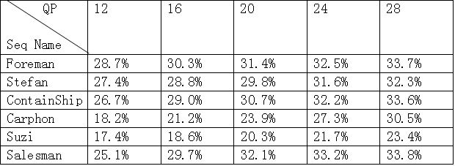
Table II Computation reduction of fractional-pel motion estimation in 1/8-pel case
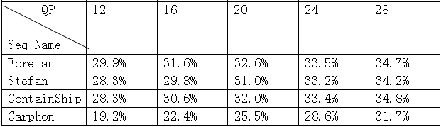

Reference:
[1] “H.26L Test Model Long Term Number 8 (TML-8) draft0”, ITU VCEG, June, 2001
[2] P.I.Hosur and K.K.Ma, “Motion Vector Field Adaptive Fast Motion Estimation”, Second Inter. Conf. On Information Communications and Signal Processing(ICICS’99). Singapore. Dec’99.
[3] Tourapis, A.M.; Au, O.C.; Liou, M.L. “New results on zonal based motion estimation algorithms-advanced predictive diamond zonal search”, Circuits and Systems, 2001. ISCAS 2001. The 2001 IEEE International Symposium on , Volume: 5 , 2001 Page(s): 183 -186 vol.
[4] Shan Zhu and Kai-Kuang Ma, “A New Diamond Search Algorithm for Fast Block-Matching Motion Estimation”, IEEE Trans. Image Processing, vol. 92, no. 2, pp. 287 -290, Feb. 2000
[5] M. Gallant, F. Kossentini, "A computation constrained motion vector search algorithm for block-based motion estimation," IEEE conference on signal, systems, and computers, Nov. 1998
[6] J. Y. Than, S. Ranganath, M. Ranganath, and A. A. Kassim, "A Novel Unrestricted Center-Biased Diamond Search Algorithm for Block Motion Estimation," IEEE Trans. Circuits and System for Video Technology, vol. 8, no. 4, pp. 369-377, Aug. 1998

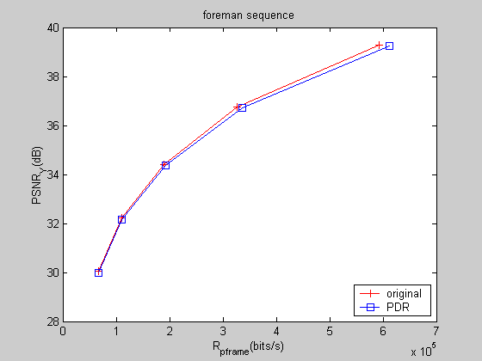

图3. RD-Curve of Foreman(CIF) Sequence (1/4-pel)

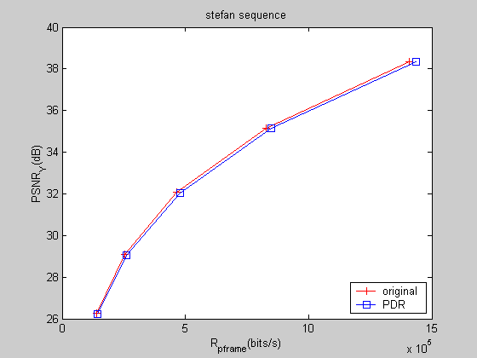

图4. RD-Curve of Stefan(CIF) (1/4-pel)

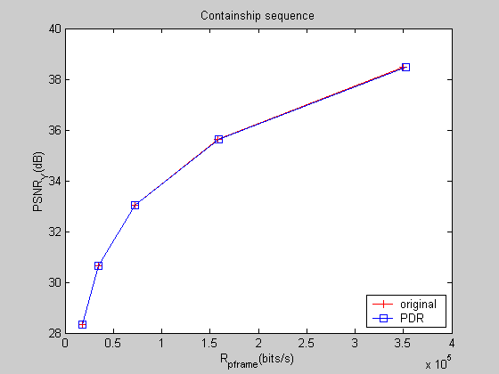

图5. RD-Curve of Foreman(CIF) (1/4-pel)

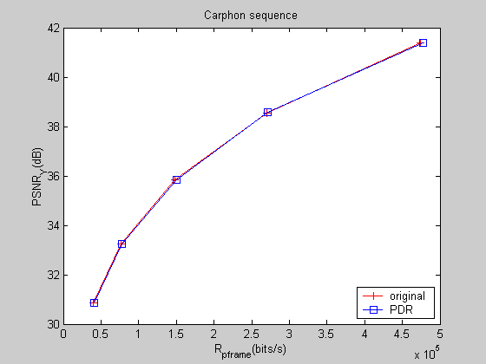

图6. RD-Curve of Carphon(CIF) (1/4-pel)

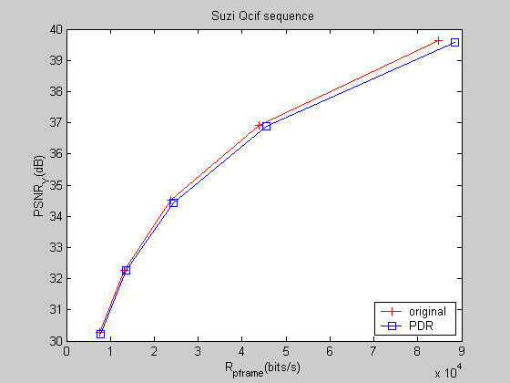

图7. RD-Curve of Suzi(QCIF) (1/4-pel)

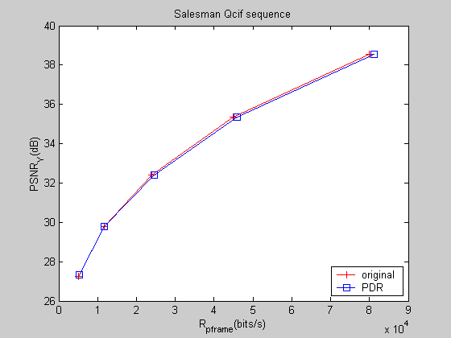

图8. RD-Curve of Salesman(QCIF) (1/4-pel)

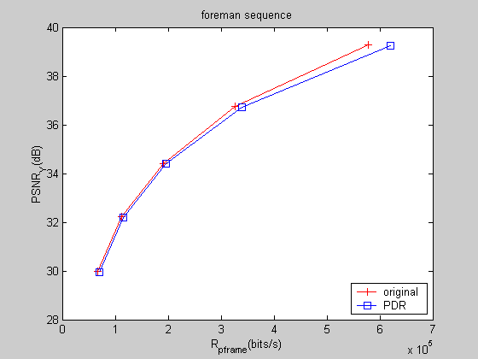

图9. RD-Curve of Foreman(CIF)(1/8-pel)

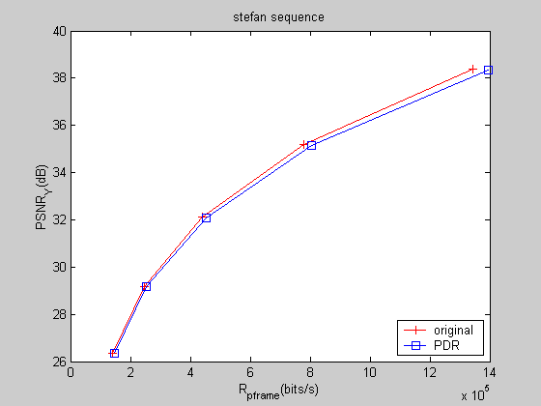

图10. 1 RD-Curve of Stefan(CIF) (1/8-pel)

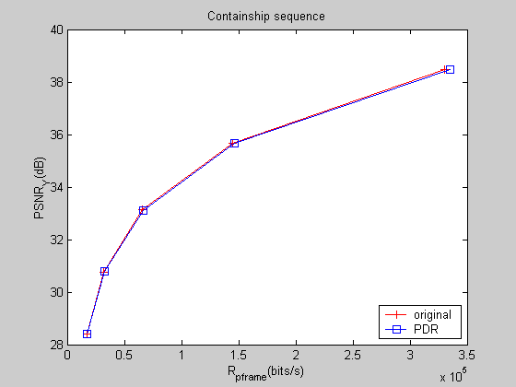

图11. RD-Curve of ContainShip(CIF) (1/8-pel)

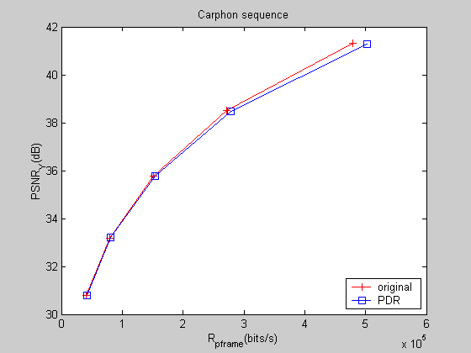

图12. RD-Curve of Carphon(CIF) (1/8-pel)

(Append for Proposal Documents)

JVT Patent Disclosure Form

International Telecommunication Union  Telecommunication Standardization Sector | International Organization for Standardization | International Electrotechnical Commission
 |  | 
Joint Video Coding Experts Group - Patent Disclosure Form
(Typically one per contribution and one per Standard | Recommendation)

Please send to:
JVT Rapporteur Gary Sullivan, Microsoft Corp., One Microsoft Way, Bldg. 9, Redmond WA 98052-6399, USA
Email (preferred): Gary.Sullivan@itu.int Fax: +1 425 706 7329 (+1 425 70MSFAX)

This form provides the ITU-T | ISO/IEC Joint Video Coding Experts Group (JVT) with information about the patent status of techniques used in or proposed for incorporation in a Recommendation | Standard. JVT requires that all technical contributions be accompanied with this form. Anyone with knowledge of any patent affecting the use of JVT work, of their own or of any other entity (“third parties”), is strongly encouraged to submit this form as well.

This information will be maintained in a “living list” by JVT during the progress of their work, on a best effort basis. If a given technical proposal is not incorporated in a Recommendation | Standard, the relevant patent information will be removed from the “living list”. The intent is that the JVT experts should know in advance of any patent issues with particular proposals or techniques, so that these may be addressed well before final approval.

This is not a binding legal document; it is provided to JVT for information only, on a best effort, good faith basis. Please submit corrected or updated forms if your knowledge or situation changes.

This form is not a substitute for the ITU ISO IEC Patent Statement and Licensing Declaration, which should be submitted by Patent Holders to the ITU TSB Director and ISO Secretary General before final approval.

Submitting Organization or Person:
Organization name | Tsinghua University, China and SVA Group, China
Mailing address | 100084 425# East mail building, Tsinghua University, Beijing, China
Country | China
Contact person | Zhibo Chen
Telephone | +86-10-62781413
Fax | +86-10-62770317
Email | chenzb@video.mdc.tsinghua.edu.cn
Place and date of submission | 7/15/2002
Relevant Recommendation | Standard and, if applicable, Contribution:
Name (ex: “JVT”) |  | JVT
Title |  | Prediction based Directional Refinement (PDR) algorithm for Fractional Pixel Motion Search Strategy
Contribution number |  | JVT-C034

(Form continues on next page)

Disclosure information – Submitting Organization/Person (choose one box)
2.0 The submitter is not aware of having any granted, pending, or planned patents associated with the technical content of the Recommendation | Standard or Contribution.

or,
The submitter (Patent Holder) has granted, pending, or planned patents associated with the technical content of the Recommendation | Standard or Contribution. In which case,

2.1 The Patent Holder is prepared to grant – on the basis of reciprocity for the above Recommendation | Standard – a free license to an unrestricted number of applicants on a worldwide, non-discriminatory basis to manufacture, use and/or sell implementations of the above Recommendation | Standard.
2.2 The Patent Holder is prepared to grant – on the basis of reciprocity for the above Recommendation | Standard – a license to an unrestricted number of applicants on a worldwide, non-discriminatory basis and on reasonable terms and conditions to manufacture, use and/ or sell implementations of the above Recommendation | Standard.

Such negotiations are left to the parties concerned and are performed outside the ITU | ISO/IEC.
2.2.1 The same as box 2.2 above, but in addition the Patent Holder is prepared to grant a “royalty-free” license to anyone on condition that all other patent holders do the same.
2.3 The Patent Holder is unwilling to grant licenses according to the provisions of either 2.1, 2.2, or 2.2.1 above. In this case, the following information must be provided as part of this declaration:
- patent registration/application number;
- an indication of which portions of the Recommendation | Standard are affected.
- a description of the patent claims covering the Recommendation | Standard;
In the case of any box other than 2.0 above, please provide the following:
Patent number(s)/status
Inventor(s)/Assignee(s)
Relevance to JVT
Any other remarks:
(please provide attachments if more space is needed)

(form continues on next page)
Third party patent information – fill in based on your best knowledge of relevant patents granted, pending, or planned by other people or by organizations other than your own.

Disclosure information – Third Party Patents (choose one box)
3.1 The submitter is not aware of any granted, pending, or planned patents held by third parties associated with the technical content of the Recommendation | Standard or Contribution.

3.2 The submitter believes third parties may have granted, pending, or planned patents associated with the technical content of the Recommendation | Standard or Contribution.

For box 3.2, please provide as much information as is known (provide attachments if more space needed) - JVT will attempt to contact third parties to obtain more information:

3rd party name(s)
Mailing address
Country
Contact person
Telephone
Fax
Email
Patent number/status
Inventor/Assignee
Relevance to JVT

Any other comments or remarks:

