Joint Video Team (JVT) of ISO/IEC MPEG & ITU-T VCEG  (ISO/IEC JTC1/SC29/WG11 and ITU-T SG16 Q.6)  4th Meeting: Klagenfurt, Austria, 22-26 July, 2002 | Document: JVT-D055  Filename: JVT-D055.doc

Title: | Usage of relative timing information in VCL
Status: | Input Document to JVT
Purpose: | Information
Author(s) or  Contact(s): | Byeong-Moon Jeon  16 Woomyeon-Dong, Secho-Gu  LG Electronics Inc. DM research Lab.  Seoul 137-724, Korea | Tel:  Email: | 82-2-526-4415  jeonbm@lge.com
Source: | LG Electronics Inc.
_____________________________
1. Introduction
Timing information issue has been discussed in the email reflector since Fairfax meeting. In this document, we will not call the timing information used in VCL a TR(temporal reference) because some experts do not want the terms like ‘temporal’ to be used in video layer, instead we will call it a relative timing information. This document shows why the relative timing information is needed in video layer by enumerating the context in current CD related to timing information.

2. Context connected with relative timing information
The relative timing information in video layer indicates display order of each picture which gives the direction information of reference pictures in B pictures, and also helps to get temporal distance between two pictures which is useful to derive motion vectors of direct mode or to scale one motion vector in bi-predictive mode with two motion vectors existing in the same direction. It is essential that current B picture knows which reference picture is in forward direction(i.e., temporally-preceding side) and in backward direction(i.e., temporally-following side). Without the relative timing information, there is no way to resolve the display order of pictures using the normative part of the coded JVT stream. In addition, as noted in the email reflector, the equation of current CD that calculates direct motion vector not by using the actual temporal distance but the set of parameters transmitted in picture level can significantly deteriorate the coding performance of B pictures.
The followings show four contexts that CD uses the display order(direction information) and temporal distance. To begin with, we need to remember that the terms such as ‘forward’ and ‘backward’ in CD have nothing to do with direction or time.

- Subclause 9.2.1.2 defines the default index order for B pictures based on the display order for each reference picture.
9.2.1.2 Default index order for B pictures

The default index order for B frames is defined such that short-term frames that temporally precede the B frame are distinguished from short-term frames that temporally follow the B frame, based on the display order for each reference frame. The default order for forward prediction (subclause 8.2.13.2.1) is specified in a manner that gives a lower index order to short-term frames that temporally precede the current frame, and the default order for backward prediction (subclause 8.2.13.2.1) is specified in a manner that ordinarily gives a lower index order to short-term frames that temporally follow the current frame.

9.2.1.2.1 Forward prediction in B pictures

Within the set of short-term pictures, the default order for B-frame forward prediction shall be for the frames to be ordered starting with the most recently-transmitted temporally-preceding reference frame and proceeding through to the temporally-preceding reference frame in the short-term buffer that was transmitted first. These temporally-preceding frames shall then be followed by the temporally-following reference frames, starting with the most recently-transmitted temporally-following reference frame in the short-term buffer and proceeding through to the temporally-following reference frame in the short-term buffer that was transmitted first.
…

9.2.1.2.2 Backward prediction in B pictures

The default order for B picture backward prediction is defined in a similar manner as for forward prediction, but giving preference in the order for pictures that temporally follow the B picture and swapping the order of the first two pictures if this would result in an identical forward and backward default indexing order.
…
If there is no relative timing information in video, B picture cannot set the default forward and backward index from the reference picture buffer because it does not know which is the temporally-preceding reference picture, and vice versa: for example, if a sequence of pictures is transmitted as P1 P2 B3 B4 B5, the available display order is P1 B3 B4 B5 P2, P1 B4 B3 B5 P2, P1 B5 B4 B3 P2, P1 B5 B3 B4 P2, or P1 P2 B3 B4 B5 and the default forward and backward index assigned to each reference picture are different in each case (as shown in Figure 1) so that decoder side can cause mismatch with encoder side.
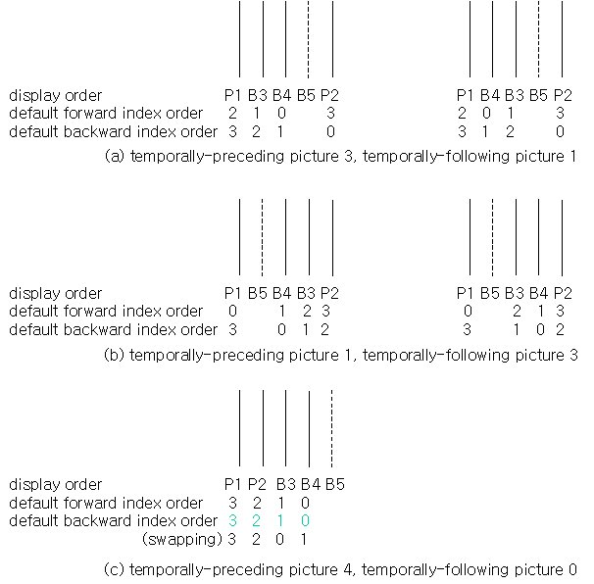
Figure 1. Available display order for P1 P2 B3 B4 B5 decoding order

- Subclause 11.4.1 defines motion vector prediction in B pictures.
11.4.1 Differential motion vectors
…
The only difference is that forward motion vectors are predicted only from forward motion vectors in surrounding macroblocks, and backward motion vectors are predicted only from backward motion vectors in surrounding macroblocks.
…
If a neighbouring macroblock does not have a respective forward and/or backward motion vector candidate predictor for the current block, the predictor is set to zero
In above sentence, the terms such as forward and backward include the direction information. For example, prediction of motion vector with forward direction has to be formed as the median of motion vectors with only forward direction of three adjacent macroblocks. Therefore, each macroblock adjacent to target macroblock needs to know which direction its own motion vector is taking. Especially, if an adjacent macroblock has bi-predictive mode, it is essential to distinguish the directions of two motion vectors. This can be resolved only by referencing the relative timing information that reference pictures have.

- Subclause 11.4.2 describes how to derive two motion vectors taking the same direction in bi-predictive mode.
11.4.2 Motion vector decoding with scaled MV
…
First, the scaled motion vector (scaled mv) is calculated from the coded motion vector for the nearest reference picture r1 (MV1). Then, the motion vector for the farthest reference picture r2 (MV2) is calculated by adding the coded differential motion vector (DMV) to the scaled mv.
$${\text{MV}}_{2}={{\text{picture_distance}}_{1}⋅{\text{MV}}_{1}}/{{\text{picture_distance}}_{2}}+\text{DMV}$$
where picture_distance_1 and picture_distance_2 are motion vector scaling factors for the nearest reference picture (r1) and the farthest reference picture (r2), respectively.
Before anything else, the above equation has to be changed to

MV₂ = picture_distance_2 x MV₁ / picture_distance_1 + DMV

The macroblock having bi-predictive mode usually records the motion vector information into mvd_fwd and mvd_bwd and the reference picture information into ref_idx_fwd and ref_idx_bwd, regardless of directions. For decoding the macroblock having bi-predictive mode, decoder needs to know whether or not two motion vectors (MV1 and MV2) exist in the same direction by looking the relative timing information that their reference pictures have. After confirming that two motion vectors exist in the same direction, MV2 is calculated by adding DMV to scaled MV1, in which the scaled MV1 is used as prediction of MV2. Here, the scaling factors, such as picture_distance_1 and picture_distance_2, are obtained at block layer according to ref_idx_fwd (=r1) and ref_idx_bwd (=r2) as shown in Figure 2. Those scaling factors have to be actually temporal distances measured from current B picture to r1 and r2 because it is an available situation that there is any skipped picture or non-stored B picture between each reference picture and B picture.
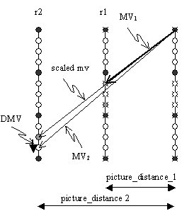
Figure 2. Motion vector scaling and differential MV coding

- Subclause 11.5.1 uses the display order when selecting implicit ABP coefficients.
11.5.1 Implicit B Prediction Block Weighting

Prediction signal generation procedure is specified in the following table. If display order of ref_fwd <= display order of ref_bwd, ABP coefficient (1/2, 1/2, 0) is used. Otherwise, (2, -1, 0) is used.
Literally, display order of ref_idx_fwd and one of ref_idx_bwd can be obtained by referencing the relative timing information of each reference picture.

3. Conclusion
As shown above, the relative timing information is needed at decoding process so we suggest that the relative timing information is kept in video coding layer.

(Append for Proposal Documents)

JVT Patent Disclosure Form

International Telecommunication Union  Telecommunication Standardization Sector | International Organization for Standardization | International Electrotechnical Commission
 |  | 
Joint Video Coding Experts Group - Patent Disclosure Form
(Typically one per contribution and one per Standard | Recommendation)

Please send to:
JVT Rapporteur Gary Sullivan, Microsoft Corp., One Microsoft Way, Bldg. 9, Redmond WA 98052-6399, USA
Email (preferred): Gary.Sullivan@itu.int Fax: +1 425 706 7329 (+1 425 70MSFAX)

This form provides the ITU-T | ISO/IEC Joint Video Coding Experts Group (JVT) with information about the patent status of techniques used in or proposed for incorporation in a Recommendation | Standard. JVT requires that all technical contributions be accompanied with this form. Anyone with knowledge of any patent affecting the use of JVT work, of their own or of any other entity (“third parties”), is strongly encouraged to submit this form as well.

This information will be maintained in a “living list” by JVT during the progress of their work, on a best effort basis. If a given technical proposal is not incorporated in a Recommendation | Standard, the relevant patent information will be removed from the “living list”. The intent is that the JVT experts should know in advance of any patent issues with particular proposals or techniques, so that these may be addressed well before final approval.

This is not a binding legal document; it is provided to JVT for information only, on a best effort, good faith basis. Please submit corrected or updated forms if your knowledge or situation changes.

This form is not a substitute for the ITU ISO IEC Patent Statement and Licensing Declaration, which should be submitted by Patent Holders to the ITU TSB Director and ISO Secretary General before final approval.

Submitting Organization or Person:
Organization name
Mailing address
Country
Contact person
Telephone
Fax
Email
Place and date of submission
Relevant Recommendation | Standard and, if applicable, Contribution:
Name (ex: “JVT”)
Title
Contribution number

(Form continues on next page)

Disclosure information – Submitting Organization/Person (choose one box)
2.0 The submitter is not aware of having any granted, pending, or planned patents associated with the technical content of the Recommendation | Standard or Contribution.

or,
The submitter (Patent Holder) has granted, pending, or planned patents associated with the technical content of the Recommendation | Standard or Contribution. In which case,

2.1 The Patent Holder is prepared to grant – on the basis of reciprocity for the above Recommendation | Standard – a free license to an unrestricted number of applicants on a worldwide, non-discriminatory basis to manufacture, use and/or sell implementations of the above Recommendation | Standard.
2.2 The Patent Holder is prepared to grant – on the basis of reciprocity for the above Recommendation | Standard – a license to an unrestricted number of applicants on a worldwide, non-discriminatory basis and on reasonable terms and conditions to manufacture, use and/ or sell implementations of the above Recommendation | Standard.

Such negotiations are left to the parties concerned and are performed outside the ITU | ISO/IEC.
2.2.1 The same as box 2.2 above, but in addition the Patent Holder is prepared to grant a “royalty-free” license to anyone on condition that all other patent holders do the same.
2.3 The Patent Holder is unwilling to grant licenses according to the provisions of either 2.1, 2.2, or 2.2.1 above. In this case, the following information must be provided as part of this declaration:
- patent registration/application number;
- an indication of which portions of the Recommendation | Standard are affected.
- a description of the patent claims covering the Recommendation | Standard;
In the case of any box other than 2.0 above, please provide the following:
Patent number(s)/status
Inventor(s)/Assignee(s)
Relevance to JVT
Any other remarks:
(please provide attachments if more space is needed)

(form continues on next page)
Third party patent information – fill in based on your best knowledge of relevant patents granted, pending, or planned by other people or by organizations other than your own.

Disclosure information – Third Party Patents (choose one box)
3.1 The submitter is not aware of any granted, pending, or planned patents held by third parties associated with the technical content of the Recommendation | Standard or Contribution.

3.2 The submitter believes third parties may have granted, pending, or planned patents associated with the technical content of the Recommendation | Standard or Contribution.

For box 3.2, please provide as much information as is known (provide attachments if more space needed) - JVT will attempt to contact third parties to obtain more information:

3rd party name(s)
Mailing address
Country
Contact person
Telephone
Fax
Email
Patent number/status
Inventor/Assignee
Relevance to JVT

Any other comments or remarks:

