Joint Video Team (JVT) of ISO/IEC MPEG & ITU-T VCEG  (ISO/IEC JTC1/SC29/WG11 and ITU-T SG16 Q.6)  4th Meeting: Klagenfurt, Austria, 22-26 July, 2002 | Document: JVT-D052  Filename: JVT-D052.doc

Title: | Adaptive Interpolation Filter with Reduced Complexity
Status: | Input Document to JVT
Purpose: | Proposal
Author(s) or  Contact(s): | Thomas Wedi  Institute of Communication Theory and Signal Processing,  University of Hannover, Germany | Tel:  Email: | +49 511 762 5304  wedi@tnt.uni-hannover.de
Source: | University of Hannover
_____________________________

Introduction

In the JVT codec displacement vector resolutions of 1/4- or 1/8-pel are applied in the motion compensated prediction process. In order to estimate and compensate these fractional-pel displacements, interpolation filters are used. So far, these interpolation filters are invariant. The same filter-coefficients are applied for all sequences and for all frames of a sequence. Therefore it is not possible to consider non-stationary statistical properties of video signals (e.g. aliasing, motion) in the interpolation process.

In this proposal an adaptive interpolation scheme is presented. This interpolation scheme is based on filter coefficients that are adapted once per frame to the non-stationary statistical properties of the video signal. The filter-coefficients are coded and transmitted. This technique was also presented in [1] and in VCEG-N28 and JVT-C059.

Compared to the results presented at the last meeting (JVT-C059), the following modifications are introduced:
- The coefficient representation is reduced from 12 bit to 8 bit.
- The interpolation calculation is reduced from 32 bit to 16 bit accuracy.
- B-frames are used.

The adaptive interpolation filter technique was integrated into JM-2. Due to the adaptive interpolation filter a coding gain up to 0.5 dB PSNR is obtained.

Adaptive Interpolation Filter
In this section the filter scheme, the estimation of the filter-coefficients and their transmission is presented. It is assumed that the displacement vector resolution is 1/4-pel.

Filter Scheme
In H.26L the interpolation process of the TML is described as two successive interpolations with two different interpolation filters (Figure 1).

Figure 1: Interpolation process for 1/4-pel displacement vector resolution.
(JM2: Anchor, JM2-AIF: JM2 with Adaptive Interpolation Filter)

In JM2 the first interpolation filter is a symmetric non-adaptive 6-tap filter that interpolates the image signal on 1/2-pel positions (2:1 resolution) and the second one is a bilinear filter that interpolates the image signal on 1/4-pel positions (4:1 resolution).

In JM2-AIF a symmetric Adaptive Interpolation Filter is used for Filter 1. For Filter 2 the same bilinear filter is used than in JM2. In Table 1 the different filters of JM2 and TML-AIF are shown in detail. In this table a_{i} denotes the filter-coefficients that are adapted once per frame.

Codec | Filter 1 | Coefficients
JM2 | Non-adaptive 6-tap filter | ( 1 –5 20 20 –5 1 )/32
JM2-AIF | adaptive 6-tap filter | a₁ a₂ a₃ a₃ a₂ a₁
Table 1: Filter 1 of the non-adaptive (JM2) and the adaptive (JM2-AIF) codec.
a₁,a₂,a₃ denote the filter-coefficients that are adapted once per frame.

Thus, only 3 filter coefficients a₁,a₂,a₃ have to be adapted and transmitted. For a₁=1/32, a₂=-5/32, a₃=20/32 the interpolation schemes of JM2-AIF and JM2 are identical. Therefore the coding efficiency of JM2-AIF is at least as good as the coding efficiency of JM2. Only a very small amount of bits have to be spend for the transmission of the filter coefficient.

Estimation of Filter Coefficients
The scheme of filter-coefficient estimation is not part of this proposal. It is an encoder issue. However, the motion compensated prediction with the filter-coefficient estimation that is used in this contribution, consists of the following steps:

- Displacement vectors are estimated. For this purpose, an initial filter is applied.
- Estimation of filter-coefficients by minimizing the energy of the prediction error when performing the motion compensated prediction with the displacement vectors from step 1. For this purpose a downhill simplex minimization method is used.
- The current frame is predicted by the motion compensated prediction. For this purpose the adapted filter-coefficients of step 2 and the displacement vectors of step 1 are applied.

In step 2 the coefficients of the adaptive interpolation filters are estimated once per frame. The image signal and the displacement vectors of the original frame are taken into account.

Transmission of Filter Coefficients
The filter used is transmitted in the slice header using the following steps:

- A codeword is sent that determines whether the default filter or the adaptive filter is used. In case of the default filter, no further information has to be transmitted. In case of the adaptive filter, the filter coefficients are sent in step 2.
- For the filter coefficient coding, a differential coding scheme is applied. The coefficients are quantized with 8 bit and the differences to the coefficients of the previous frame are transmitted in the slice header.

Validity of filter coefficients:
The estimated and transmitted filter F(t) at time instance t is connected to the most previous reference frame at time instance t-1 in the reference buffer. For older reference frames their already transmitted filter coefficients (F(t-1),...,F(t-3)) are used. In the following figure, this is illustrated.

Figure 2: Current fame to predict and reference frames of the reference buffer with their interpolation filters F(t).

In this figure the current frame to predict at time instance t is shown on the right side. On the left side a reference buffer with already transmitted frames is shown. At time instance t only the interpolation filter coefficients F(t) for the reference frame at time instance t-1 are adapted and transmitted in the slice header. This filter F(t) is connected to this specific frame at time instance t-1. From now on this filter is used to obtain a pixel from this specific frame by interpolation. Thus, the frames at older time instances than t-1 have already filter coefficients (F(t-1),...,F(t-3)) that were transmitted. Note, that in figure 2 a slice is connected to the frame.

Experimental Results

Table 2 shows the test-sequences that are used for the experimental results.

Test-sequence | Res. | Frame rate
Mobile & Calendar | CIF | 30
Tempete | CIF | 30
Paris | CIF | 30
Waterfall (VQEG src18) | CIF | 30
Foreman | CIF | 30
Flower | CIF | 30
Silent Voice | QCIF | 15
Container | QCIF | 10
News | QCIF | 10
Foreman | QCIF | 10
Table 2: Applied test-sequences.

For the experimental results, rate-distortion plots are given in the Appendix. Each rate-distortion plot contains the following curves:

- Anchor, 1 ref.: JM2 with non-adaptive interpolation filter and 1 reference frame
- AIF 6-tap, 1 ref.: JM2 with 6-tap adaptive interpolation filter and 1 reference frame
- AIF 8-tap, 1 ref.: JM2 with 8-tap adaptive interpolation filter and 1 reference frame
- Anchor, 5 ref.: JM2 with non-adaptive interpolation filter and 5 reference frame
- AIF 6-tap, 5 ref.: JM2 with 6-tap adaptive interpolation filter and 5 reference frame
- AIF 8-tap, 5 ref.: JM2 with 8-tap adaptive interpolation filter and 5 reference frame

For the results 1/4-pel displacement vector resolution, 1 and 5 reference frames, CABAC, RDOPT and 2 B-frames are used.

In the following table the bitrate savings measured with method from VCEG-M33 are given.

Sequence | 1 reference frame |  | 5 reference frame
Sequence | AIF 8-tap | AIF 6-tap | AIF 8-tap | AIF 6-tap
Mobile & Calendar | 7.524 | 5.298 | 6.728 | 4.811
Flower Garden | 3.450 | 2.496 | 3.757 | 3.280
Tempete | 1.854 | 1.296 | 2.270 | 1.985
Paris | 1.028 | 1.104 | 1.111 | 0.953
Waterfall | 5.678 | 6.290 | 6.228 | 6.647
Waterfall (no B-frames) | 14.872 | 14.981 | 12.313 | 13.102
Foreman | 2.014 | 2.029 | 2.530 | 2.571
Foreman (no B-frames) | 6.316 | 5.866 | 5.477 | 5.312
Table 3: Bitrate savings due to the adaptive interpolation filter for CIF sequences

Summary
In this proposal an adaptive interpolation filter scheme for the JVT codec is presented. The adaptive interpolation filter is based on filter-coefficients that are estimated during the motion compensated prediction process for each frame. The coefficients are coded and transmitted. Due to this adaptive interpolation filter a coding gain of 0.0-0.8 dB PSNR is obtained. The coding gain is higher for CIF sequences than for QCIF sequences. For CIF sequences bitrate savings between 1 % and 14 % are obtained.

Since the default filter can be switched on with a simple flag that is sent in the slice header, there is no performance loss when using the Adaptive Interpolation Filter technique.

For some sequences (Foreman, Waterfall) the adaptive interpolation filter with 1 reference frame has similar results than the JM2 with 5 reference frames.

Proposal
It is proposed to adopt the adaptive interpolation filter technique in higher complexity profiles.

References

- T. Wedi, "Adaptive Interpolation Filter for Motion Compensated Hybrid Video Coding," Picture Coding Symposium (PCS 2001), Seoul, Korea, April 2001.
(downloadable via ftp://ftp.tnt.uni-hannover.de/pub/papers/2001/PCS2001-TW.pdf )
- T. Wedi, “Adaptive Interpolation Filter for H.26L”, ITU-T SG16/Q6, doc. VCEG-N28, Santa Barbara, CA, USA, Sep. 2001
- T. Wedi,”New Results on Adaptive Interpolation Filter”, Joint Video Team (JVT), doc. JVT-C059, Fairfax, Virginia, USA, May 2002

Appendix

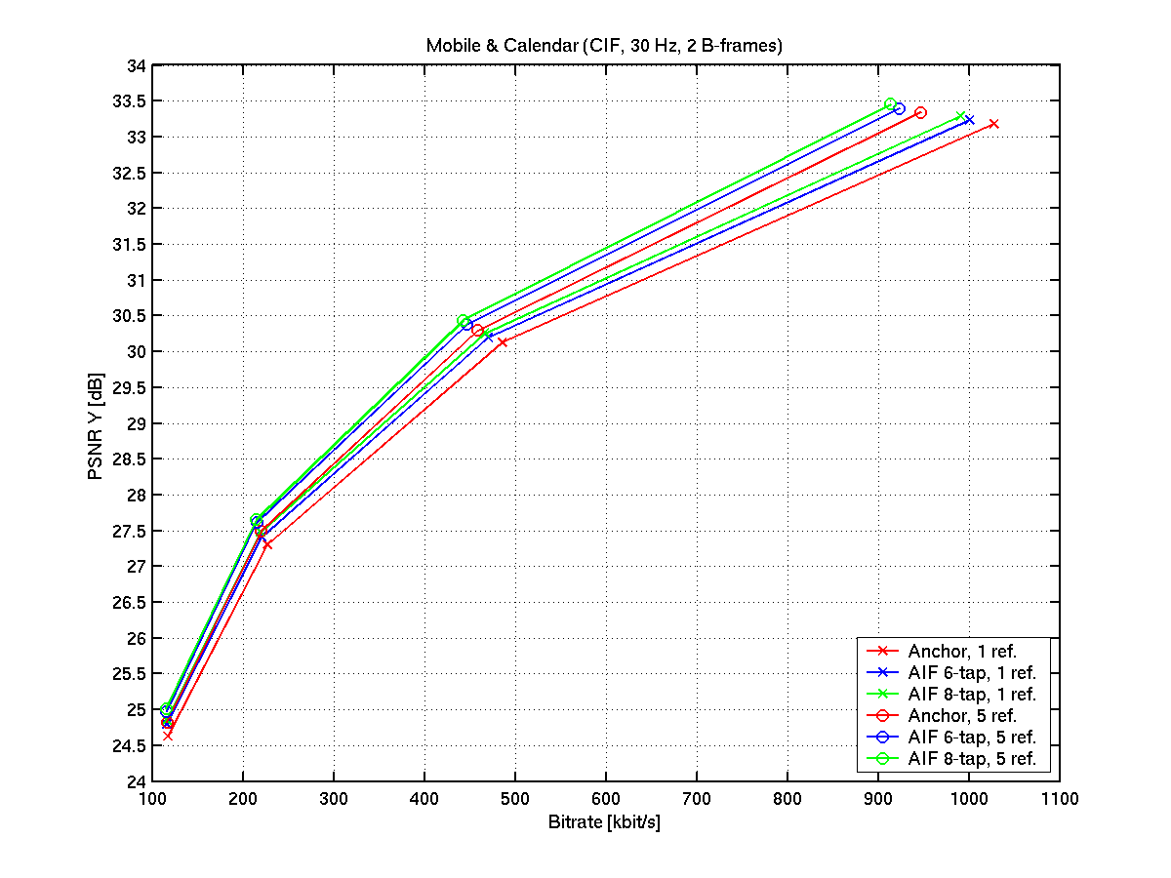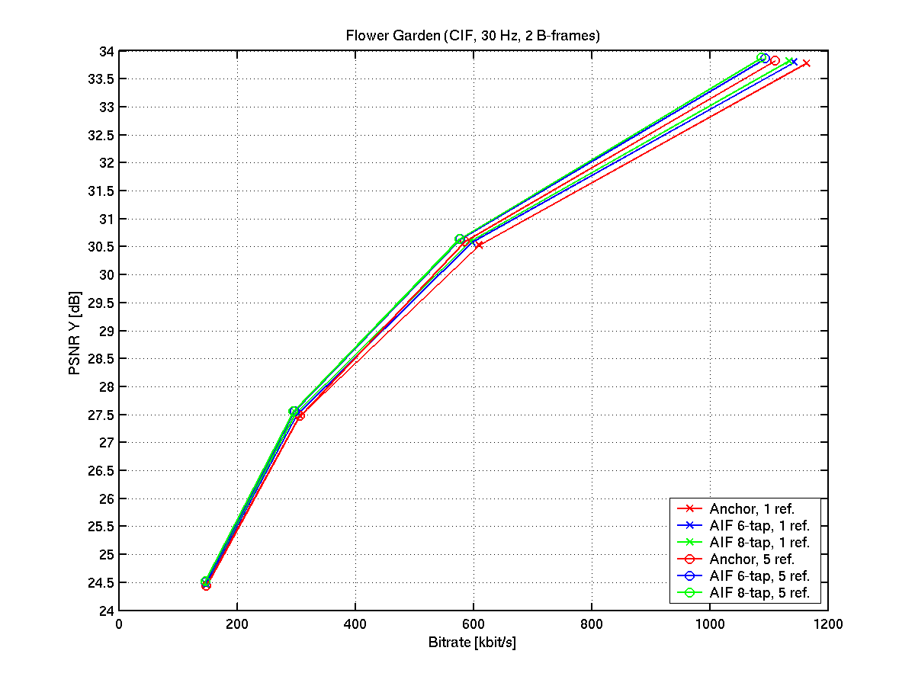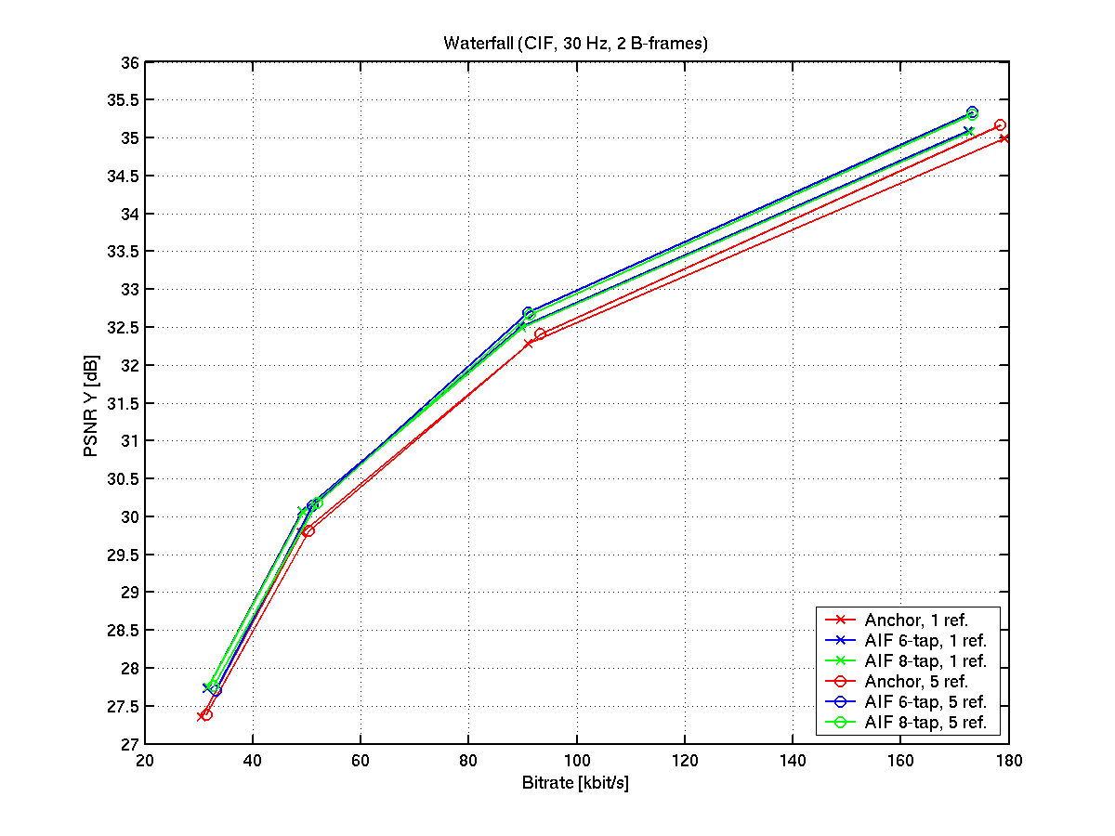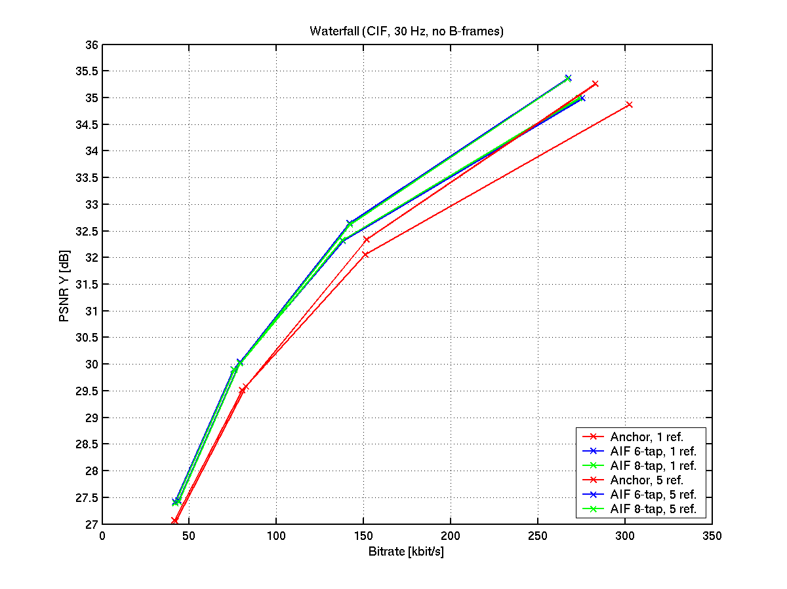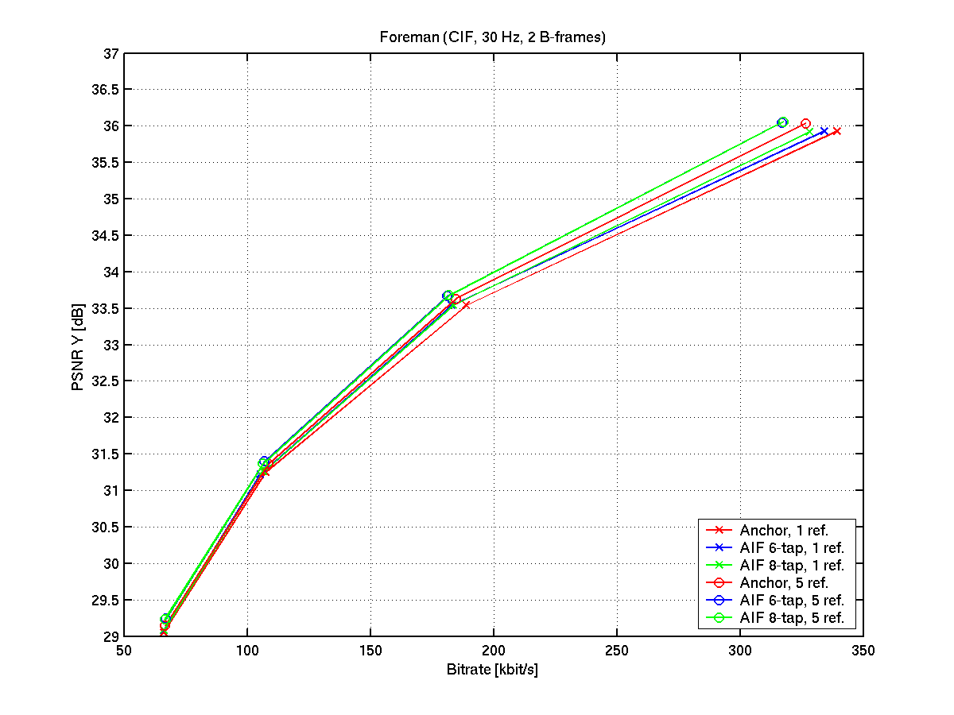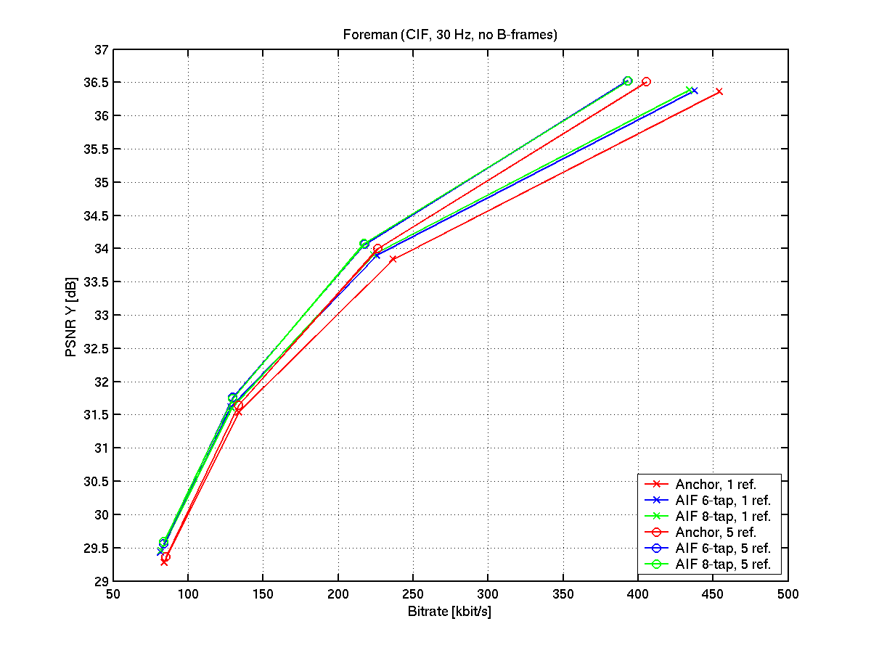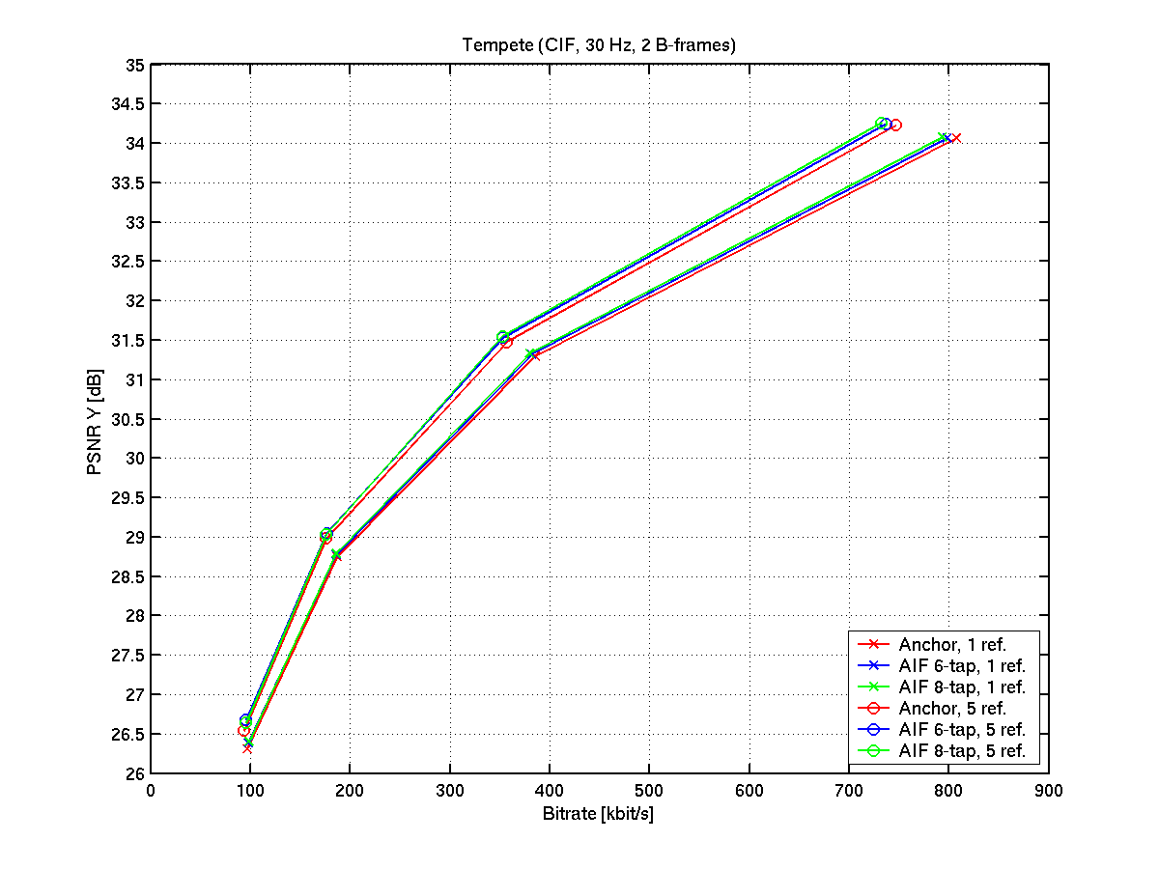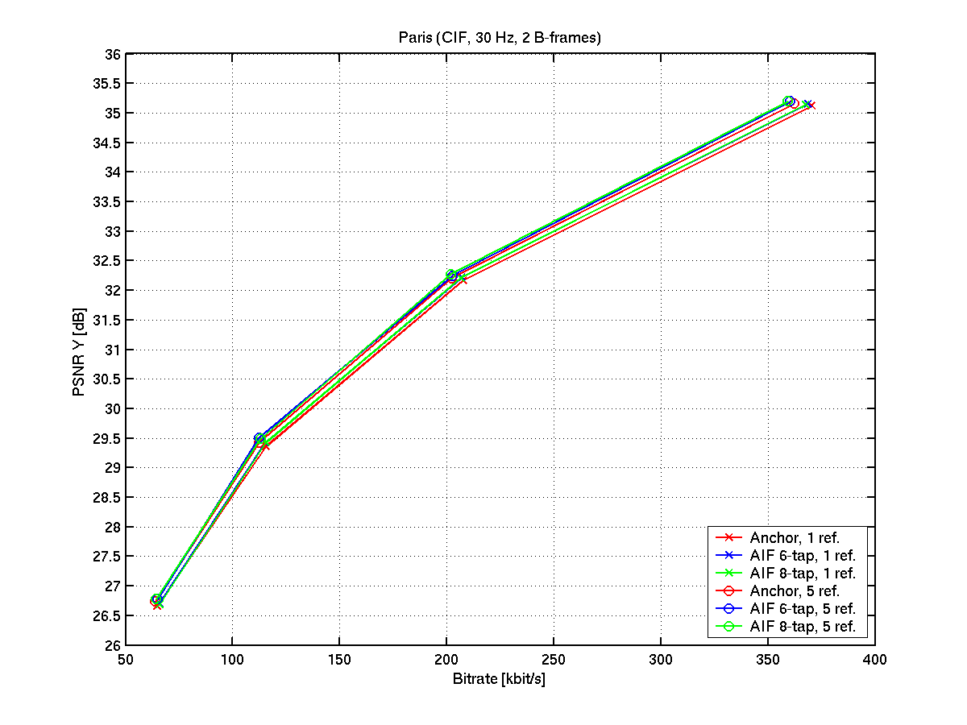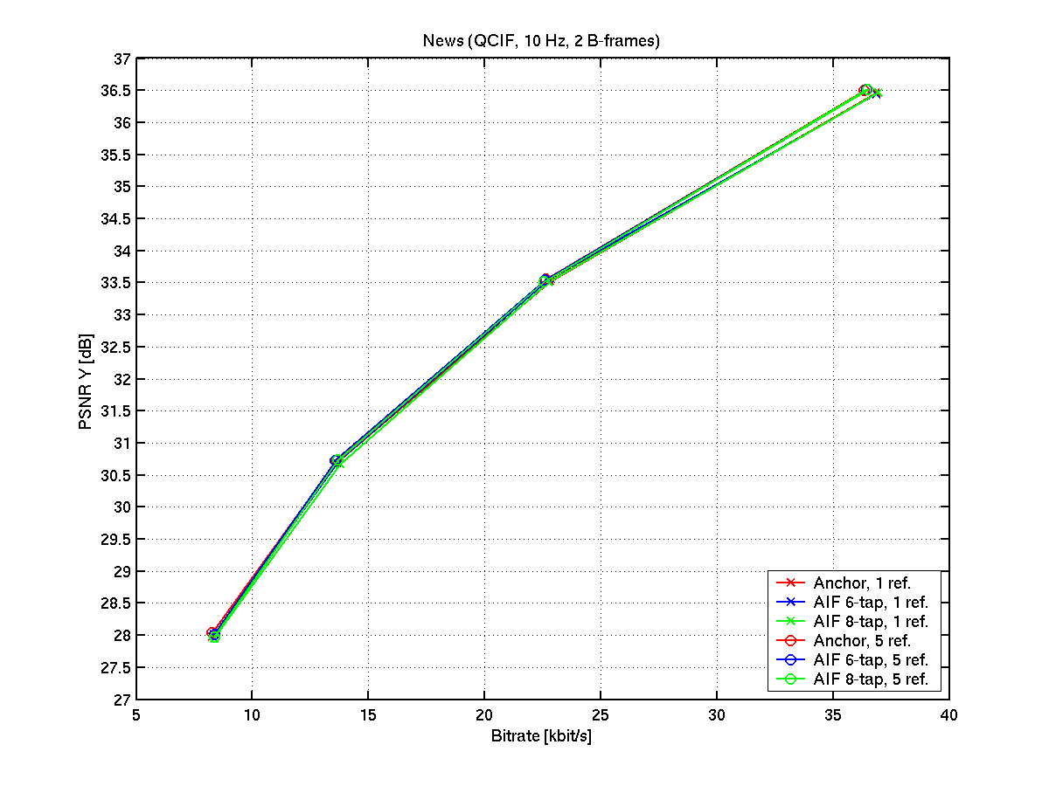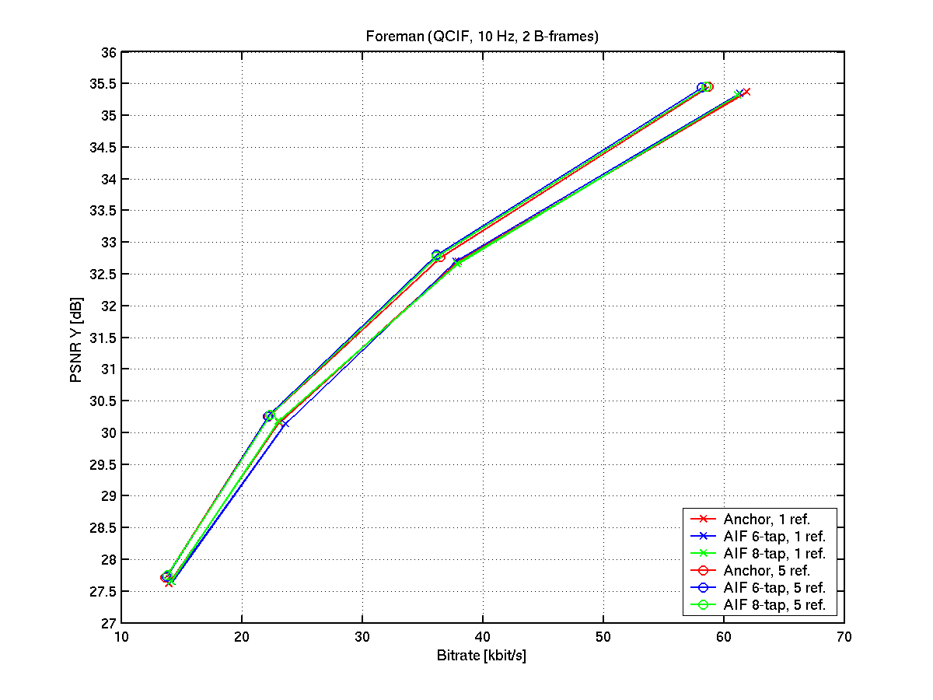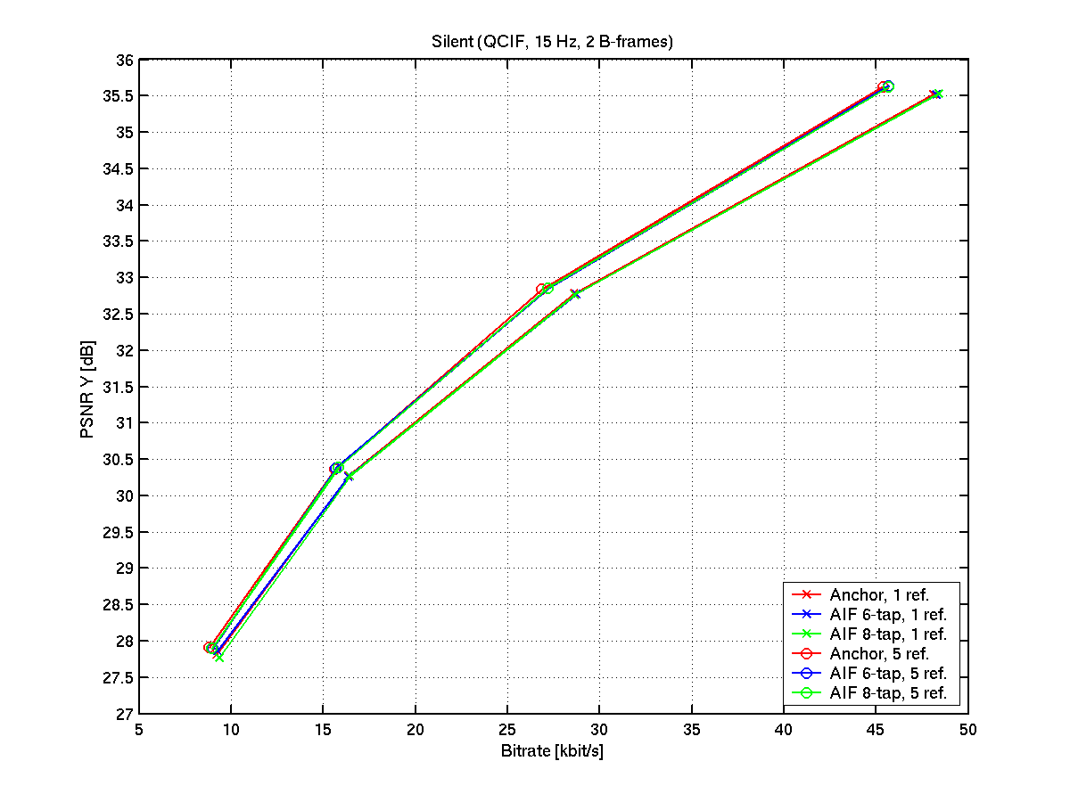

(Append for Proposal Documents)

JVT Patent Disclosure Form

International Telecommunication Union  Telecommunication Standardization Sector | International Organization for Standardization | International Electrotechnical Commission
 |  | 
Joint Video Coding Experts Group - Patent Disclosure Form
(Typically one per contribution and one per Standard | Recommendation)

Please send to:
JVT Rapporteur Gary Sullivan, Microsoft Corp., One Microsoft Way, Bldg. 9, Redmond WA 98052-6399, USA
Email (preferred): Gary.Sullivan@itu.int Fax: +1 425 706 7329 (+1 425 70MSFAX)

This form provides the ITU-T | ISO/IEC Joint Video Coding Experts Group (JVT) with information about the patent status of techniques used in or proposed for incorporation in a Recommendation | Standard. JVT requires that all technical contributions be accompanied with this form. Anyone with knowledge of any patent affecting the use of JVT work, of their own or of any other entity (“third parties”), is strongly encouraged to submit this form as well.

This information will be maintained in a “living list” by JVT during the progress of their work, on a best effort basis. If a given technical proposal is not incorporated in a Recommendation | Standard, the relevant patent information will be removed from the “living list”. The intent is that the JVT experts should know in advance of any patent issues with particular proposals or techniques, so that these may be addressed well before final approval.

This is not a binding legal document; it is provided to JVT for information only, on a best effort, good faith basis. Please submit corrected or updated forms if your knowledge or situation changes.

This form is not a substitute for the ITU ISO IEC Patent Statement and Licensing Declaration, which should be submitted by Patent Holders to the ITU TSB Director and ISO Secretary General before final approval.

Submitting Organization or Person:
Organization name | Institut für Theoretische Nachrichtentechnik und Informationsverarbeitung, University of Hannover
Mailing address | Institut für Theroretische Nachrichtentechnik und Informationsverarbeitung  Universität Hannover  Appelstr. 9a  30167 Hannover, Germany
Country | Germany
Contact person | Thomas Wedi
Telephone | +49 511 762 5304
Fax | +49 511 762 5333
Email | wedi@tnt.uni-hannover.de
Place and date of submission | Hannover, 16. July 02
Relevant Recommendation | Standard and, if applicable, Contribution:
Name (ex: “JVT”) |  | JVT
Title |  | Adaptive Interpolation Filter with reduced comlexity
Contribution number |  | JVT-D

(Form continues on next page)

Disclosure information – Submitting Organization/Person (choose one box)
2.0 The submitter is not aware of having any granted, pending, or planned patents associated with the technical content of the Recommendation | Standard or Contribution.

or,
The submitter (Patent Holder) has granted, pending, or planned patents associated with the technical content of the Recommendation | Standard or Contribution. In which case,

2.1 The Patent Holder is prepared to grant – on the basis of reciprocity for the above Recommendation | Standard – a free license to an unrestricted number of applicants on a worldwide, non-discriminatory basis to manufacture, use and/or sell implementations of the above Recommendation | Standard.
2.2 The Patent Holder is prepared to grant – on the basis of reciprocity for the above Recommendation | Standard – a license to an unrestricted number of applicants on a worldwide, non-discriminatory basis and on reasonable terms and conditions to manufacture, use and/ or sell implementations of the above Recommendation | Standard.

Such negotiations are left to the parties concerned and are performed outside the ITU | ISO/IEC.
2.2.1 The same as box 2.2 above, but in addition the Patent Holder is prepared to grant a “royalty-free” license to anyone on condition that all other patent holders do the same.
2.3 The Patent Holder is unwilling to grant licenses according to the provisions of either 2.1, 2.2, or 2.2.1 above. In this case, the following information must be provided as part of this declaration:
- patent registration/application number;
- an indication of which portions of the Recommendation | Standard are affected.
- a description of the patent claims covering the Recommendation | Standard;
In the case of any box other than 2.0 above, please provide the following:
Patent number(s)/status
Inventor(s)/Assignee(s)
Relevance to JVT
Any other remarks:
(please provide attachments if more space is needed)

(form continues on next page)
Third party patent information – fill in based on your best knowledge of relevant patents granted, pending, or planned by other people or by organizations other than your own.

Disclosure information – Third Party Patents (choose one box)
3.1 The submitter is not aware of any granted, pending, or planned patents held by third parties associated with the technical content of the Recommendation | Standard or Contribution.

3.2 The submitter believes third parties may have granted, pending, or planned patents associated with the technical content of the Recommendation | Standard or Contribution.

For box 3.2, please provide as much information as is known (provide attachments if more space needed) - JVT will attempt to contact third parties to obtain more information:

3rd party name(s)
Mailing address
Country
Contact person
Telephone
Fax
Email
Patent number/status
Inventor/Assignee
Relevance to JVT

Any other comments or remarks:

