Joint Video Team (JVT) of ISO/IEC MPEG & ITU-T VCEG  (ISO/IEC JTC1/SC29/WG11 and ITU-T SG16 Q.6)  4th Meeting: Klagenfurt, Austria 22-26 July, 2002 | Document: JVT-D049  Filename: JVT-D049.doc

Title: | Adjustments for chroma deblocking
Status: | Input Document to JVT
Purpose: | [Proposal]
Author(s) or  Contact(s): | Cristina Gomila  2 Independence Way  Princeton, NJ 08540  USA | Tel:  Email: | + 1 609 734 9505  GomilaC@tce.com
Source: | Thomson multimedia
_____________________________

Overview
The goal of this contribution is to reduce the cost of deblocking by fixing some minimal changes on the set of algorithms currently described in the Committee Draft [1]. The proposed adjustments affect only the treatment of the chroma components and can be summarized in two points:

  - A new condition is added to reduce the large number of 'void' computations.
  - The default filter is simplified to reduce complexity and increase parallelism.

In the following sections we describe the details of both changes and present some experimental results to prove their effectiveness. Results have been generated by updating the JM 2.1 reference software as specified of the CD. Dithering has been excluded because its conditional acceptance has not been confirmed. However, the presence of dithering inside the loop filter would not affect the proposed adjustments.
We have found that more than 65% of chroma deblocking can be avoided without incurring in perceptible quality degradation. On average, this means that the simplified algorithm requires 28.36% fewer line-based computations, even if the luma deblocking not affected by the simplifications.

Proposed simplifications for chroma deblocking
Hereunder we propose two simplifications affecting the chroma deblocking. Both could be implemented independently by introducing some minor changes in the reference software (JM2.1 release).

2.1 Adding a condition to reduce the number of void computations
With the existing algorithms it can be easily observed that, when deblocking chroma, on a large number of cases resulting pixels values are equal (or almost equal) to the original ones. Current conditions of filtering based on α and β thresholds are intended to avoid deblocking real contours and textured zones that could blur the resulting image. However, nothing is done to avoid deblocking transitions that are already smooth. Figure 1 illustrates an example of some type of transitions for which filtering provides no gain in terms of quality.

p1 p0 q0 q1
p1 p0 q0 q1
p1 p0 q0 q1

Figure 1. - Transitions with 'void' deblocking

The number of such transitions is especially high for chroma because of the small dynamic range of the chroma signal in the YUV color space. As a consequence the codec is forced to deal with a huge load of what we called 'void' computations. For sequential implementations this huge load translates into an important waste of resources and processing time. More critically, in the case of mobile applications, the power requirements are also penalized by this overload.

However, based on the analysis we have performed, this problem can be easily fixed by including one additional condition. Thus, the deblocking filter should apply only to those chroma transitions verifying:

| p₀ - q₀ | > 1

This means that only those transitions crossing the edge between two blocks with a gap larger than 1 will be deblocked. It is reasonable to consider that deblocking can be skipped for those no verifying this condition without degrading the visual quality of the resulting image.

According to our experiments, we have found that over 65% of the chroma filtering can be avoided this way. The large number of transitions that do not overcome this condition can be explained given the low dynamic range of the chroma components. Furthermore, the inclusion of this restriction is very significant to those applications for which all frames are intra coded. It has to be noticed that this condition was required in JM1.9 prior strong filtering. However, at the Fairfax meeting, its suppression was accepted to increase parallelism. As a result, the activity of the strong filter increases up to 4 times, which in case of intra coded chroma represents that around 40% of the filtered transitions currently use the strong filter.

Besides, the adjustment we propose adds minimal complexity to the current algorithm since the absolute difference value | p0 - q0 | is already computed for the | p0 - q0 |<α comparison. Hence,

- For hardware architectures, we expect that both comparison with the thresholds α and 1 could be computed in parallel, without increasing the length of the worst-case path (see Figure 2).
- For sequential implementations, our experiments show how the number of avoided computations largely compensates the inclusion of this new comparison (28% less computations in average).
On this basis, the inclusion of this new condition seems to provide a good compromise for both approaches. Furthermore, the visual impact on the resulting images has been considered visually unnoticeable, being the appreciated losses in PSNR for the U and V components <0.01dB.

Figure 2. - Integration of the additional condition in a parallel architecture.

2.2. Simplification of the default filter
The second change we propose attempts the simplification of the default filter. In the current algorithm, the same default filter is defined for luma and chroma, with the only difference that for chroma it applies only to the p₀ and q₀ pixel values. Hereunder we resume the sequence of operations conforming this filtering process:

JM 2.1 - default filter

a_{q} = | q₀ - q₂ | < β
a_{p} = | p₀ - p₂ | < β
c₀ = C₀ + a_{p} + a_{q}
Δ = clip3 ( -c₀, c₀, ( ((q₀ - p₀) << 2) + (q₁ - p₁) + 4) >> 3 )
P₀ = clip3 (0, 255, p₀ + Δ)
Q₀ = clip3 (0, 255, q₀ - Δ)

It should be noticed that when filtering luma both a_{p} and a_{q} values are computed in advance because they are used, not only to obtain the clipping threshold c₀, but also to decide if the pixels p₁ and/or q₁ have to be filtered [1]. However, when deblocking chroma the default filter never extends to p₁ and q₁, and the computation of a_{p} and a_{q} becomes an overload for the algorithm.

To remove this bottleneck and better adapt the algorithm to the requirements of chroma deblocking, we propose to use as default filter the strong filter that currently applies when a_{p}>β and a_{q}>β:
TMM proposal - default filter

P₀ = ( (p₁<<1) + p₀ + q₁ + 2 ) >> 2
Q₀ = ( (q₁<<1) + q₀ + p₁ + 2 ) >> 2

Once more, the implementation of this adjustment can be done by introducing minor changes on the JM 2.1 reference software. The advantage of this change is twofold:

- For hardware architectures, higher parallelism can be achieved and memory requirements are reduced.
- For software implementations, the overall number of operations is strongly reduced.

The visual quality seems not to be affected and the homogeneity of the filter increases. When only two pixels are affected by the deblocking, the same filter applies for the 'strong' or 'default' options.

3. Experimental results

Experimental results are provided on six test sequences using the JM 2.1 reference software (including simplifications accepted at the Fairfax meeting). The following parameters have been selected to configure the encoder:

Intra period: 0
QP: 16, 20, 24, 28
Motion vector resolution: 1/4 pel
Inter block search: all modes enabled
Number of reference frames: 2
Number of B frames: 0
Entropy coding method: CABAC

Test sequences:
- QCIF: Foreman, Silent and Container
- CIF: Mobile, Tempete and Paris

In terms of complexity savings, an average cost reduction of 28% in the number of deblocking line-based operations has been obtained. This means that the system computes 28% less operations on the line-based deblocking algorithms. (The gain obtained on chroma deblocking has been averaged to the total cost of deblocking YUV.) Breaking down this global number, we come to a 22% cost reduction due to the suppression of void computations, and a 6% reduction due to the simplification of the default filter.

CHROMA transitions NOT FILTERED (alpha, beta) | 8.28%
CHROMA transitions NOT FILTERED (|p0-q0|>1, alpha, beta) | 65.83%
Average TOTAL cost reduction | -28.36%

When evaluating the cost reduction the following rules has been observed:

- no cost has been added for loads and stores;
- no operations have been considered 'cost free';
- all the line-based operations have been taken into account, either corresponding to the criteria decision of filtering (α and β) or to the process of filtering itself.

For more details, we are sending jointly with this contribution a summary of our results in a spreadsheet (JVT_D049.xls).

3.1 Objective quality evaluation

Since the proposed changes only affect the chroma deblocking, PSNR for the Y component remains unchanged. PSNRU and PSNRV lose -0.1 dB in average (See Table 1). This loss, mainly related to the simplification of the default filter, is not expected to have a perceptible impact on the quality evaluation since:

- For the objective measures, PSNR values for U and V range between 30 and 40 dB, being always 2 or 8 dB above their equivalent PSNR Y.

- For the visual quality, human perception is less sensitive to chroma than luma, and the luma deblocking is unchanged.

Sequence | Bjontegaard Delta PSNR U (dB) | Bjontegaard Delta PSNR V (dB)
Foreman | -0.149016 | -0.168012
Container | -0.090853 | -0.133741
Silent | -0.053198 | 0.038764
QCIF average | -0.09769 | -0.08766
Mobile | -0.159795 | -0.127221
Paris | -0.184571 | -0.126589
Tempete | -0.131685 | -0.124060
CIF average | -0.15868 | -0.12596
Overall average | -0.12819 | -0.10681

Table 1. − Bjontegaard delta PSNR for QP=16, 20, 24, 28 for the proposed changes compared to JM2.1.

3.2 Subjective quality evaluation

In order to confirm that the proposed changes were not affecting the perceptual quality of the coded sequences, we performed a quality evaluation test. Ten people participated. Sequences were displayed two times side by side (QCIF sequences were zoomed by pixel replication to facilitate their comparison). The observers were asked to give their judgments on a 7-scale: 3 much better; 2 better; 1 slightly better; 0 equal quality; -1 slightly worse; -2 worse; -3 much worse. No clue was given about the possible differences between the sequences under comparison.

Table 2 summarizes the final score obtained for each one of the test sequences. The score was computed by averaging individual evaluations. (The highest and/or lowest peaks were removed whether they exist.)

No preference prevailed for one algorithm. The TMM version of JM 2.1 was preferred on the Container, Foreman and Mobile Calendar sequences. The plain version of JM 2.1 was preferred on Silent, Paris and Tempete. Final scores ranged between ±0.5, reflecting how close the quality of both versions is.

As a result of this subjective quality evaluation test, we should conclude that the adjustments we propose don't have a significant impact in terms of visual quality.

Sequence | Size | QP | Score
Container | QCIF (x2) | 20 | 0.33
Foreman | QCIF (x2) | 24 | 0.12
Silent | QCIF (x2) | 28 | -0.20
Paris | CIF | 20 | -0.30
Mobile | CIF | 24 | 0.44
Tempete | CIF | 28 | -0.44

Table 2. - Results of the subjective quality evaluation test.
No preference prevailed for one algorithm.

Figure 3. - Representation of the subjective quality evaluation scores. Range: 3 much better; 2 better; 1 slightly better; 0 equal quality; -1 slightly worse; -2 worse; -3 much worse.

Figure 4 allows comparing two pairs of images from our test sequences (sizes have been enlarged by pixel replication to facilitate their comparison). In Figure 4 (a) we have picked up one frame inter coded of the Paris sequence (QP=20). In Figure 4 (b) we show the first intra coded frame of the Silent sequence (QP=20) with a zoom on the woman's face. Even on still images, small chroma differences at a pixel level are difficult to distinguish. We have detected no color degradation either in the large zones or on the small details, being the intensity of colors preserved.

The whole video sequences will be displayed at the Klagenfurt meeting.

4. Conclusions

In this contribution we have proposed two possible adjustments of the current deblocking algorithm to improve its performance on chroma.
A first change suggests the inclusion of a new condition to reduce the large number of 'void' computations at present overloading the system. This change has minimal impact on parallelizable hardware, but allows skipping up to 65% of the chroma deblocking operations with the logical benefits for sequential implementations and for mobile applications where the power needs play a key role.
A second change proposes the simplification of the default filter to avoid the complex computation of the clipping values. This change largely reduces the number of computations, the memory requirements as well as increases the parallelism of the algorithm.
With both changes we have measured complexity savings of 28% on average of the line deblocking operations using the JM 2.1 reference software and the algorithm specifications on the CD. A small drop off on the PSNR values was observed for U and V (-0.1dB), with the PSNR for the Y component not affected by the simplifications. Visual quality has been considered to be very close to the original one. On a subjective quality evaluation test a group of ten people was not able to manifest a clear preference for one of both algorithms.

References

[1] Thomas Wiegand, "Joint Committee Draft", document JVT-C167.doc, JVT of ISO/IEC MPEG & ITU-T VCEG, Fairfax meeting, USA, May 10, 2002.

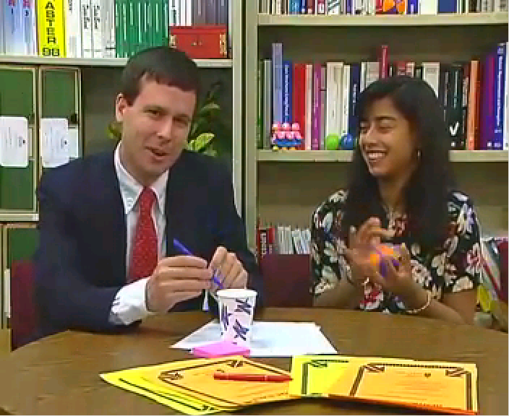
(a1) JM 2.1 encoder: Paris sequence, inter frame 170.

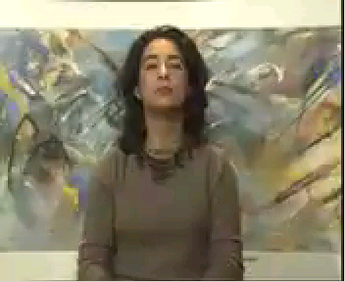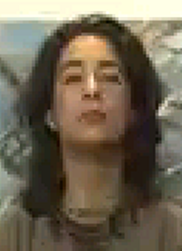
(b1) JM 2.1 encoder: Silent sequence, intra frame 0.

Figure 4. - Comparison of results

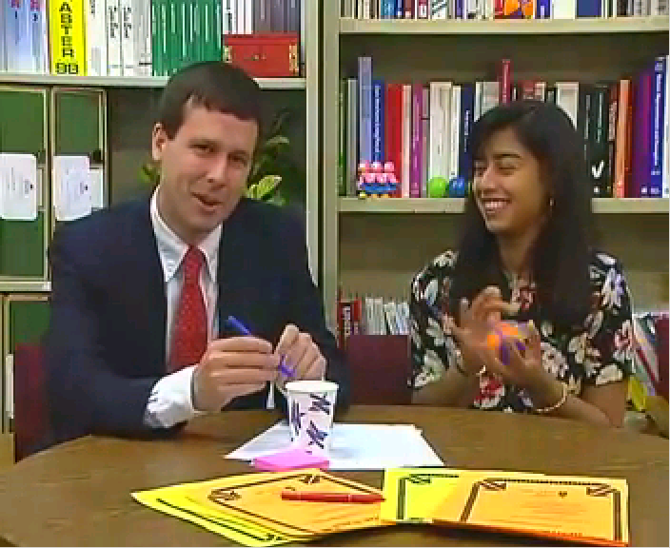
(a2) TMM encoder: Paris sequence, inter frame 170.

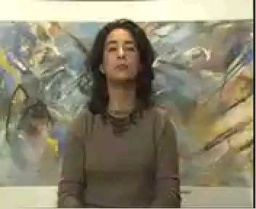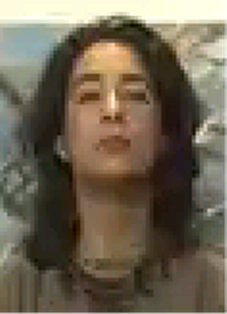
(b2) TMM encoder: Silent sequence, intra frame 0.

Figure 4. - Comparison of results

(Append for Proposal Documents)

JVT Patent Disclosure Form

International Telecommunication Union  Telecommunication Standardization Sector | International Organization for Standardization | International Electrotechnical Commission
 |  | 
Joint Video Coding Experts Group - Patent Disclosure Form
(Typically one per contribution and one per Standard | Recommendation)

Please send to:
JVT Rapporteur Gary Sullivan, Microsoft Corp., One Microsoft Way, Bldg. 9, Redmond WA 98052-6399, USA
Email (preferred): Gary.Sullivan@itu.int Fax: +1 425 706 7329 (+1 425 70MSFAX)

This form provides the ITU-T | ISO/IEC Joint Video Coding Experts Group (JVT) with information about the patent status of techniques used in or proposed for incorporation in a Recommendation | Standard. JVT requires that all technical contributions be accompanied with this form. Anyone with knowledge of any patent affecting the use of JVT work, of their own or of any other entity (“third parties”), is strongly encouraged to submit this form as well.

This information will be maintained in a “living list” by JVT during the progress of their work, on a best effort basis. If a given technical proposal is not incorporated in a Recommendation | Standard, the relevant patent information will be removed from the “living list”. The intent is that the JVT experts should know in advance of any patent issues with particular proposals or techniques, so that these may be addressed well before final approval.

This is not a binding legal document; it is provided to JVT for information only, on a best effort, good faith basis. Please submit corrected or updated forms if your knowledge or situation changes.

This form is not a substitute for the ITU ISO IEC Patent Statement and Licensing Declaration, which should be submitted by Patent Holders to the ITU TSB Director and ISO Secretary General before final approval.

Submitting Organization or Person:
Organization name | Thomson multimedia
Mailing address | 2 Independence Way  Princeton, NJ 08540
Country | USA
Contact person | Cristina Gomila
Telephone | +1 609 734 9505
Fax | +1 609 734 9870
Email | gomilac@tce.com
Place and date of submission | Fairfax, VA, USA May 2002
Relevant Recommendation | Standard and, if applicable, Contribution:
Name (ex: “JVT”) |  | JVT
Title |  | Simplification of JVT Deblocking Filter
Contribution number |  | JVT-D049

(Form continues on next page)

Disclosure information – Submitting Organization/Person (choose one box)
2.0 The submitter is not aware of having any granted, pending, or planned patents associated with the technical content of the Recommendation | Standard or Contribution.

or,
The submitter (Patent Holder) has granted, pending, or planned patents associated with the technical content of the Recommendation | Standard or Contribution. In which case,

 | 2.1 The Patent Holder is prepared to grant – on the basis of reciprocity for the above Recommendation | Standard – a free license to an unrestricted number of applicants on a worldwide, non-discriminatory basis to manufacture, use and/or sell implementations of the above Recommendation | Standard.
x | 2.2 The Patent Holder is prepared to grant – on the basis of reciprocity for the above Recommendation | Standard – a license to an unrestricted number of applicants on a worldwide, non-discriminatory basis and on reasonable terms and conditions to manufacture, use and/ or sell implementations of the above Recommendation | Standard.  Such negotiations are left to the parties concerned and are performed outside the ITU | ISO/IEC.
 | 2.2.1 The same as box 2.2 above, but in addition the Patent Holder is prepared to grant a “royalty-free” license to anyone on condition that all other patent holders do the same.
2.3 The Patent Holder is unwilling to grant licenses according to the provisions of either 2.1, 2.2, or 2.2.1 above. In this case, the following information must be provided as part of this declaration:
- patent registration/application number;
- an indication of which portions of the Recommendation | Standard are affected.
- a description of the patent claims covering the Recommendation | Standard;
In the case of any box other than 2.0 above, please provide the following:
Patent number(s)/status
Inventor(s)/Assignee(s)
Relevance to JVT
Any other remarks:
(please provide attachments if more space is needed)

(form continues on next page)
Third party patent information – fill in based on your best knowledge of relevant patents granted, pending, or planned by other people or by organizations other than your own.

Disclosure information – Third Party Patents (choose one box)
x | 3.1 The submitter is not aware of any granted, pending, or planned patents held by third parties associated with the technical content of the Recommendation | Standard or Contribution.
 | 3.2 The submitter believes third parties may have granted, pending, or planned patents associated with the technical content of the Recommendation | Standard or Contribution.
For box 3.2, please provide as much information as is known (provide attachments if more space needed) - JVT will attempt to contact third parties to obtain more information:

3rd party name(s)
Mailing address
Country
Contact person
Telephone
Fax
Email
Patent number/status
Inventor/Assignee
Relevance to JVT

Any other comments or remarks:

