Joint Video Team (JVT) of ISO/IEC MPEG & ITU-T VCEG  (ISO/IEC JTC1/SC29/WG11 and ITU-T SG16 Q.6)  3rd Meeting: Fairfax, Virginia, USA, 6-10 May, 2002 | Document: JVT-C084  Filename: JVT-C084.doc

Title: | Lagrange Multiplier and RD-characteristics
Status: | Input Document
Purpose: | Information and Proposal
Author(s) or  Contact(s): | Koichi Takagi  2-1-15, Ohara, Kamifukuoka-shi,  Saitama, 356-8502, Japan | Tel:  Email: | +1-81-49-278-7432  ko-takagi@kddilabs.jp
Source: | KDDI Corp.
_____________________________

Introduction
The current JM implements a Rate Distortion Optimization (RDO) tool in order to improve performance. This minimizes the function D+LxR, where D and R denote distortion and bit rate respectively and L is the Lagrange multiplier, in order to select the best macroblock mode and MV. Here, It is important how the Lagrange multiplier L is determined. Up to now, we have used “0.85x2^{QP/3}” as L in case of using SSD as the distortion function. However, the following experimental results show that RD-characteristics hardly change even if this value changes slightly. And from the other experimental results, I propose better value of L.

RD-optimization in JM-2[3]
The RDO tool (high-complexity mode) in current JM is summarized as follows,
For one macroblock s,
- Given the last decoded frames, Lagrange multipliers
$\begin{aligned}L_{\text{MODE}}=0\text{.}\text{85}×2^{{\text{QP}}/3}, \\ L_{\text{MOTION}}=\sqrt{L_{\text{MODE}}},\end{aligned}$
and the macroblock quantisation parameter QP.
(Note: L_{MODE} for B or SP frame is 4 times as much as that for I or P frame.)
- Choose intra prediction modes for the Intra 4x4 macroblock mode by minimizing with
$$\text{IMODE}∈\left\{\text{DC}, \text{HOR}, \text{VERT}, {\text{DIAG}}_{\text{DL}},{\text{DIAG}}_{\text{DR}}, {\text{VERT}}_{R},{\text{VERT}}_{L},{\text{HOR}}_{U},{\text{HOR}}_{D}\right\}$$
- Determine the best Intra16x16 prediction mode by choosing the mode that results in the minimum SATD.
- For each 8x8 sub-partition
Perform motion estimation and reference frame selection by minimizing
SSD + L x Rate(MV, REF)
B frames: Choose prediction direction by minimizing
SSD + L x Rate(MV(PDIR), REF(PDIR))
Determine the coding mode of the 8x8 sub-partition using the rate-constrained mode decision, i.e. minimize
SSD + L x Rate(MV, REF, Luma-Coeff, block 8x8 mode)
Here the SSD calculation is based on the reconstructed signal after DCT, quantization, and IDCT.
- Perform motion estimation and reference frame selection for 16x16, 16x8, and 8x16 modes by minimizing
$$\begin{aligned}J(\text{REF},m(\text{REF})|L_{\text{MOTION}}) \\ \text{SA}(T)D(s,c(\text{REF},m(\text{REF})))+L_{\text{MOTION}}⋅(R(m(\text{REF})−p(\text{REF}))+R(\text{REF}))\end{aligned}$$
for each reference frame and motion vector of a possible macroblock mode.
- B frames: Determine prediction direction by minimizing
$\begin{aligned}J(\text{PDIR}|L_{\text{MOTION}}) \\ \text{SATD}(s,c(\text{PDIR},m(\text{PDIR})))+L_{\text{MOTION}}⋅(R(m(\text{PDIR})−p(\text{PDIR}))+R(\text{REF}(\text{PDIR})))\end{aligned}$
- Choose the macroblock prediction mode by minimizing
$J(s,c,\text{MODE}|\text{QP},L_{\text{MODE}})=\text{SSD}(s,c,\text{MODE}|\text{QP})+L_{\text{MODE}}⋅R(s,c,\text{MODE}|\text{QP})$, (1)
given QP and L_{mode} when varying MODE. MODE indicates a mode out of the set of potential macroblock modes:
I frame: $\text{MODE}∈\left\{\text{INTRA} 4×4, \text{INTRA} \text{16}×\text{16}\right\}$,
P frame: $\text{MODE}∈\begin{aligned}\left\{\text{INTRA} 4×4, \text{INTRA} \text{16}×\text{16}, \text{SKIP}, | \right\}\end{aligned}\left\{\right\}$,
B frame: $\text{MODE}∈\begin{aligned}\left\{\text{INTRA} 4×4, \text{INTRA} \text{16}×\text{16}, \text{DIRECT}, | \right\}\end{aligned}\left\{\right\}$.
The computation of J(s,c,SKIP | QP,L_{mode}) and J(s,c,DIRECT | QP,L_{mode}) is simple. The costs for the other macroblock modes are computed using the intra prediction modes or motion vectors and reference frames, which have been estimated in the previous steps.

Experiment 1
In order to verify the RDO tool, computer simulation was performed under condition [1] using JM-2.0. By way of precaution, the conditions are shown below.

Table 1. Experimental conditions
FramesToBeEncoded, | As written in [1] for each sequence | FrameSkip | As written in [1] for each sequence
IntraPeriod | Only first | MVResolution | 1/4-pel
UseHadamard | Used | SearchRange | 32
NumberReferenceFrames | 1 | MbLineIntraUpdate | Off
InterSearch AxB | All are enable | SliceMode | Off
NumberBFrames | NOT used | SPPicturePeriodicity | NOT used
SymbolMode | UVLC | OutFileMode | Bitstream
PartitionMode | No DP | RDOptimization | On
RestrictSearchRange | No restrictions | RestrictRefFrames | 0
UseConstrainedIntraPred | 0(=not constraint) | LastFrameNumber | No effect
Figure 1 shows Bitrate-PSNR curve varying L_{MODE}. The values described in explanatory note express the value A of equation (2),
$L_{\text{MODE}}=(A/{\text{1000}})×2^{{\text{QP}}/3}$, (2)
i.e. it means A= 850 is used in the current JM. From Figure 1, there is hardly difference in the entire RD-characteristic even if L_{MODE} is changed somewhat. This is applies to all the test sequences used in the experiment.

Experiment 2
The following experiment was conducted in consideration of the future rate constraint mode. The Lagrange multiplier L_{MODE} is fixed and the initial QP value is properly given from the L_{MODE}. For each macroblock,
* to a given QP and L_{MODE}, decide the mode using the conventional method, and
* change the value QP slightly ( |delta_QP| <= 2) and calculate the QP(delta_QP) that minimize equation (1).
The other conditions are same as experiment 1.
Figure 2 shows the relative occurrence probabilities of macroblock QP values (in JM 2.0) for several Lagrange multiplier L_{MODE} settings: 1, 4, 22, … And for each L_{MODE}, the initial value of QP is set to the value calculated from the equation L_{MODE}=0.85x2^{QP/3}, that is, QP=3log₂(L_{MODE}/0.85) (Please refer to the Table 2.). In Figure 2, the macroblock QP values are gathered while coding N frames (N is referred to [1]) of the video sequences Foreman, News, Container and Mobile&Calendar. Note that I confirmed that the given initial QP value does not greatly affect the tendencies of the results as described in [2] (Of course the results are different when QP is changed greatly.)
.
Table 2. Used Lagrange Multipliers L_{MODE} and the initial QP values
L_{MODE} | 1 | 4 | 22 | 54 | 109 | 275 | 550 | 1097
Initial QP | 1 | 7 | 14 | 18 | 21 | 25 | 28 | 31

Figure 3 shows the obtained average macroblock QP (aveQP) gathered when coding the sequences Foreman, News, Container and Mobile&Calendar. And the red curve relates to the function
$L_{\text{MODE}}=0\text{.}\text{68}×2^{{\text{QP}}/3}$ (3)
which approximates the functional relationship between the macroblock QP and the Lagrange multiplier L_{MODE} up to QP value of about 24. This may result from unstable RD-characteristics in the low bit rate (QP is large). Or it may be because a scanning method changes bordering on QP=24. But in either case, this figure shows that equation (3) and the relationship between QP and the Lagrange multiplier is very strong even for several sequences.

Conclusion and Proposals

This contribution verifies the RDO tool in the current JM．As the result of using constant QP value, RD-characteristics hardly change even if L_{MODE} changes slightly. Moreover, when fluctuating quantization step size, equation (3) approximates the relationship between L and QP more properly than the conventional one. And from the result of experiment 1, even if the equation (3) is applied to the case of using fixed quantization step size, the results become almost equivalent to the conventional one. So we can confirm the validity of this equation.

So I propose the following things.
1. The current RDO tool is, of course, non-normative, but core experimental results in regarding to JM Lagrange Multiplier are not available. I think those are required for the following reasons.
* The experimental value “0.85x2^{QP/3}” has been used.
* This technique is strongly relative to coding efficiency.
* Performance evaluation of various methods is performed using the RDO framework.
* The value of L_{MODE} has so far changed a few times
(For example, 0.85x2^{QP/3}, 5xExp(QP/10)x((QP+5)/(34-QP)), etc….).
2. If 1 is accepted, core experiments should also be conducted using these experimental results, that is, equation (3).

References
[1] Gisle Bjontegaard and Gary Sullivan, VCEG-N81, “Recommended Simulation Common Conditions for H.26L Coding Efficiency Experiments on Low-Resolution Progressive-Scan Source Material,” 2001.9.
[2] Gary Sullivan and Thomas Wiegand, Q15-E-26, “Rate-Distortion Optimization for Video Compression,” 1998. 7.
[3]Thomas Wiegand, JVT-B118r8, “Working Draft Number 2, Revision 8 (WD-2 rev 8),”2002.4.
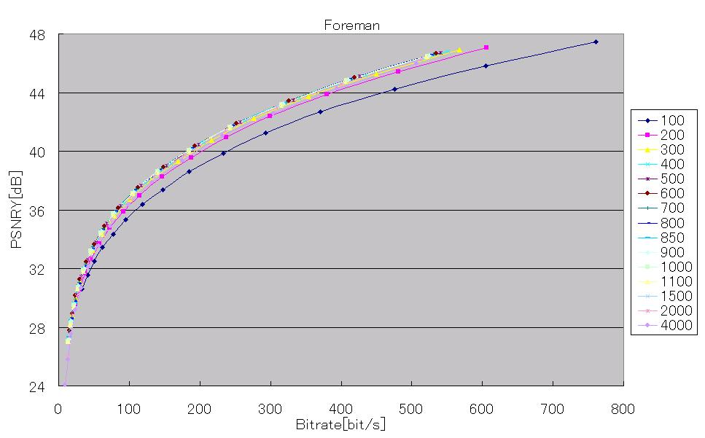

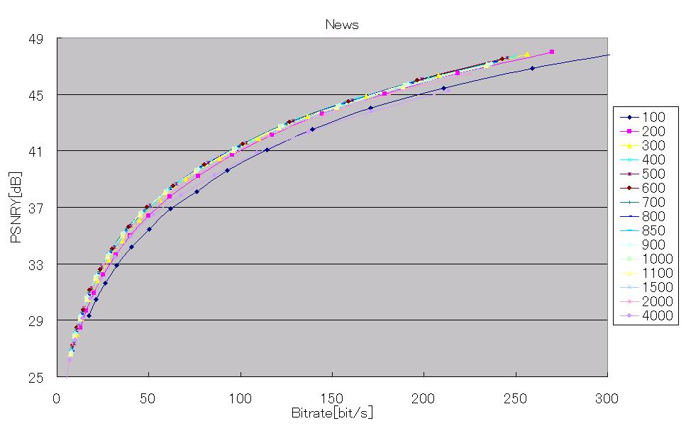

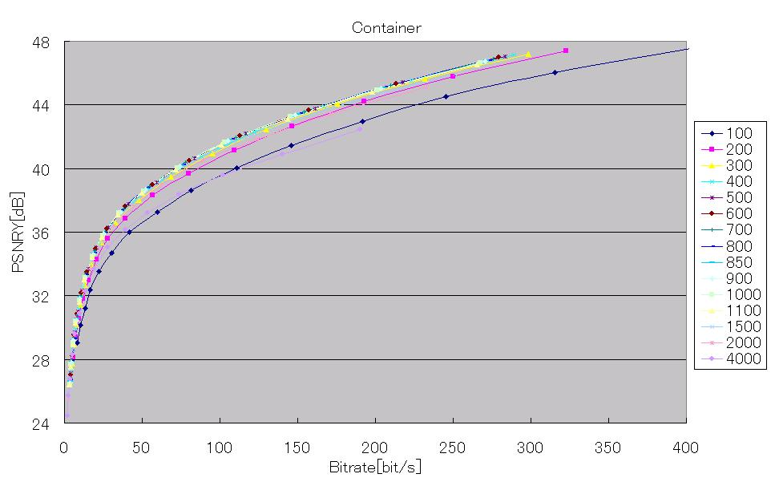
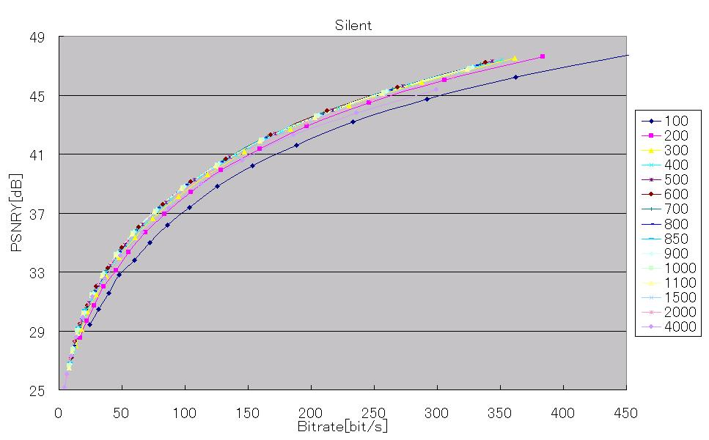

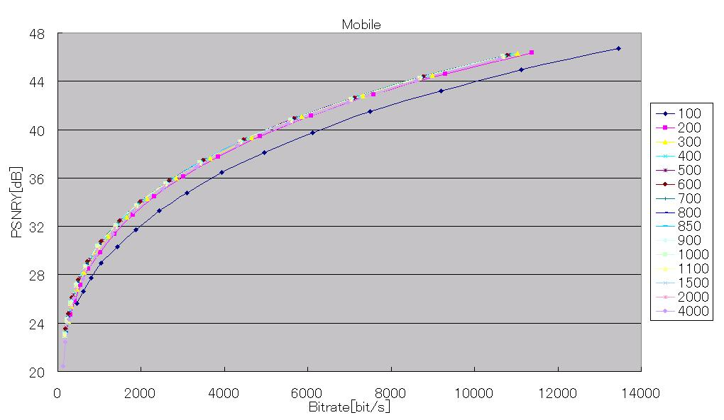
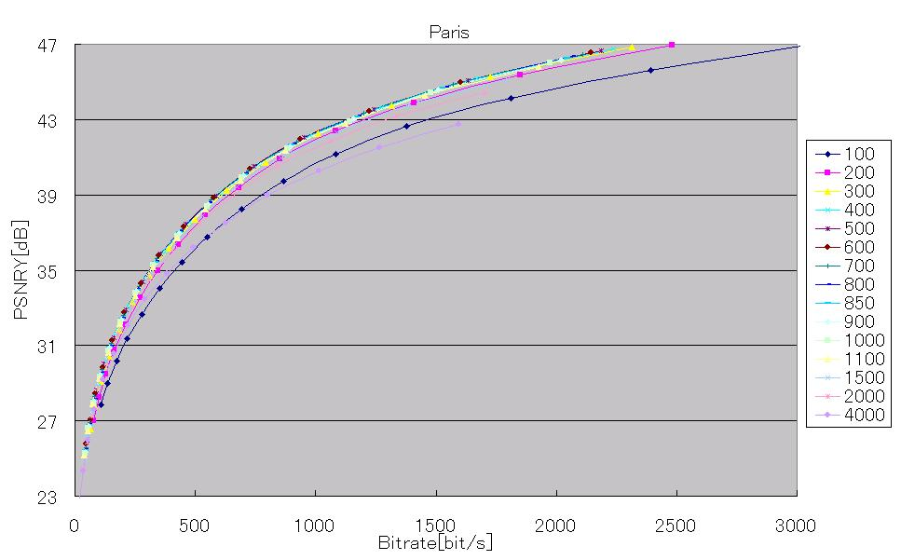

Figure 1. Bitrate-PSNR(Y) curves for several L_{MODE}’s.
（The values described in explanatory note express the value A of equation $L_{\text{MODE}}=(A/{\text{1000}})×2^{{\text{QP}}/3}$.）

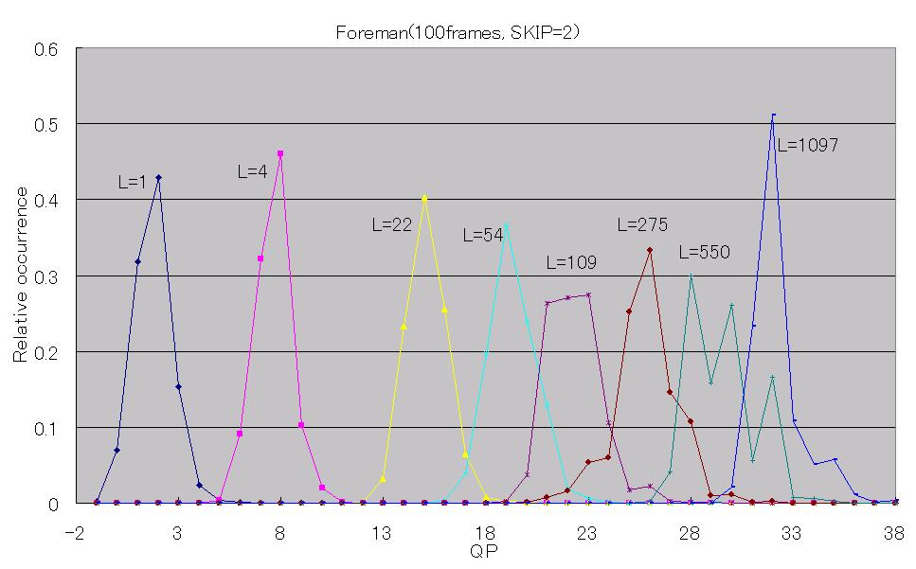
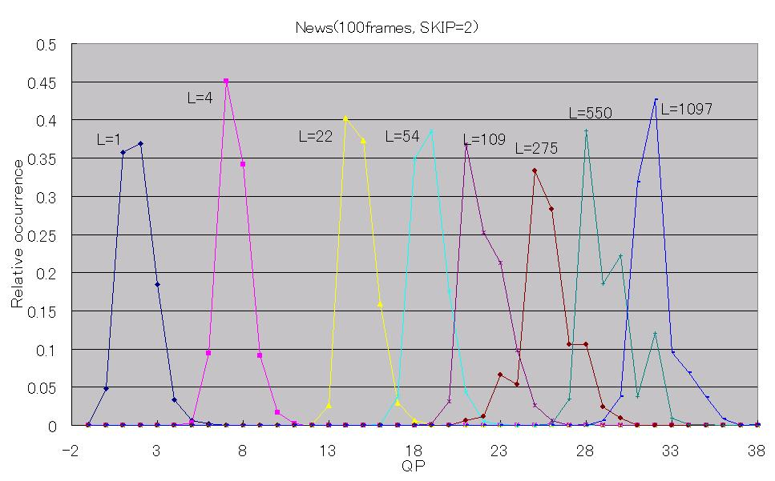
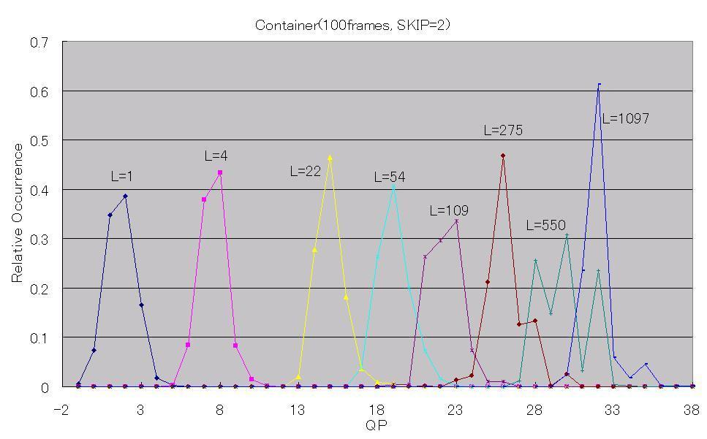
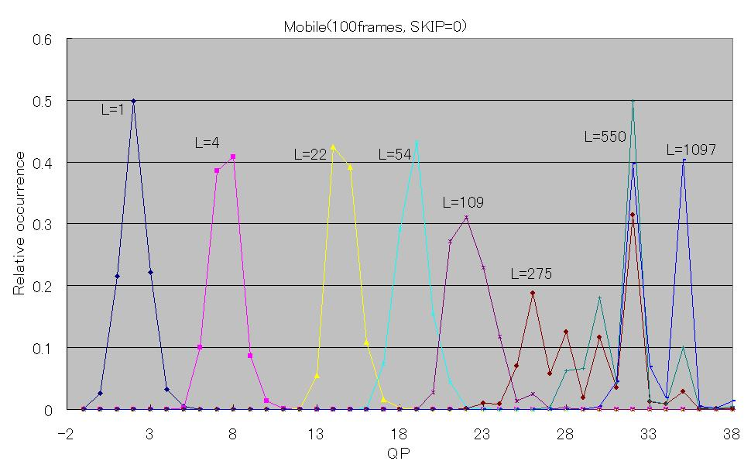
Figure 2. Relative occurrence probabilities of macroblock QP values for several Lagrange multipliers.
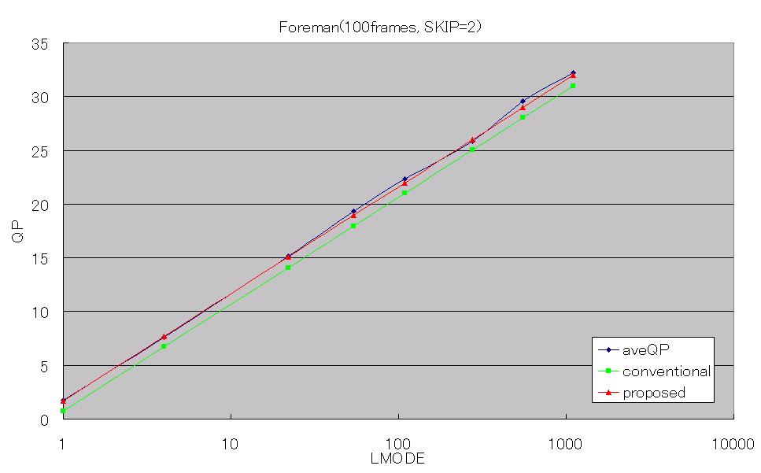
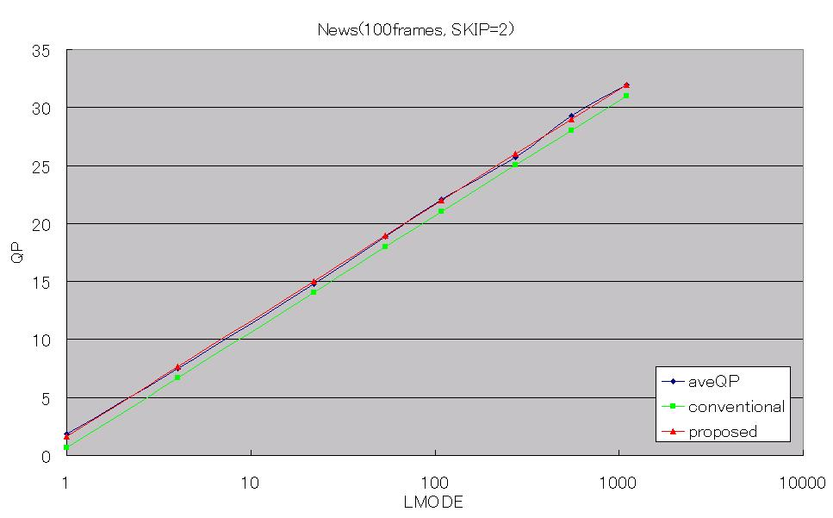

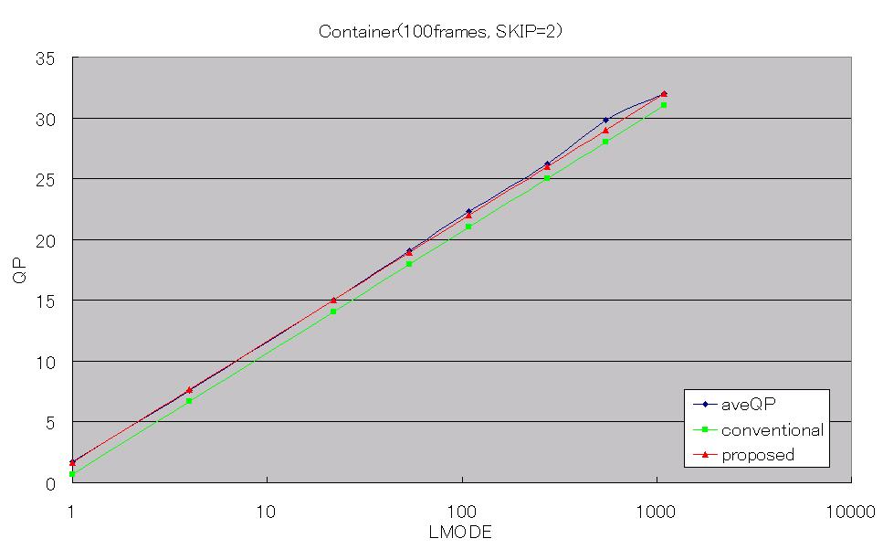
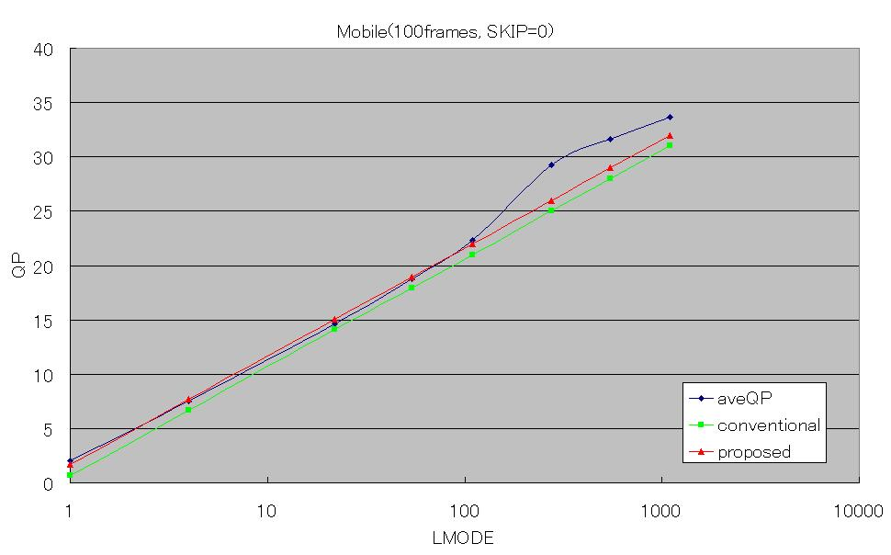
Figure 3 Relationship between the obtained average macroblock QP and L_{MODE.}

(Append for Proposal Documents)

JVT Patent Disclosure Form

International Telecommunication Union  Telecommunication Standardization Sector | International Organization for Standardization | International Electrotechnical Commission
 |  | 
Joint Video Coding Experts Group - Patent Disclosure Form
(Typically one per contribution and one per Standard | Recommendation)

Please send to:
JVT Rapporteur Gary Sullivan, Microsoft Corp., One Microsoft Way, Bldg. 9, Redmond WA 98052-6399, USA
Email (preferred): Gary.Sullivan@itu.int Fax: +1 425 706 7329 (+1 425 70MSFAX)

This form provides the ITU-T | ISO/IEC Joint Video Coding Experts Group (JVT) with information about the patent status of techniques used in or proposed for incorporation in a Recommendation | Standard. JVT requires that all technical contributions be accompanied with this form. Anyone with knowledge of any patent affecting the use of JVT work, of their own or of any other entity (“third parties”), is strongly encouraged to submit this form as well.

This information will be maintained in a “living list” by JVT during the progress of their work, on a best effort basis. If a given technical proposal is not incorporated in a Recommendation | Standard, the relevant patent information will be removed from the “living list”. The intent is that the JVT experts should know in advance of any patent issues with particular proposals or techniques, so that these may be addressed well before final approval.

This is not a binding legal document; it is provided to JVT for information only, on a best effort, good faith basis. Please submit corrected or updated forms if your knowledge or situation changes.

This form is not a substitute for the ITU ISO IEC Patent Statement and Licensing Declaration, which should be submitted by Patent Holders to the ITU TSB Director and ISO Secretary General before final approval.

Submitting Organization or Person:
Organization name | KDDI Corp.
Mailing address | 2-1-15, Ohara, Kamifukuoka, Saitama, 356-8502
Country | Japan
Contact person | Koichi Takagi
Telephone | +81-49-278-7432
Fax | +81-49-278-7439
Email | ko-takagi@kddilabs.jp
Place and date of submission
Relevant Recommendation | Standard and, if applicable, Contribution:
Name (ex: “JVT”) |  | JVT
Title |  | Lagrange Multiplier and RD-characteristics
Contribution number |  | JVT-C084

(Form continues on next page)

Disclosure information – Submitting Organization/Person (choose one box)
2.0 The submitter is not aware of having any granted, pending, or planned patents associated with the technical content of the Recommendation | Standard or Contribution.

or,
The submitter (Patent Holder) has granted, pending, or planned patents associated with the technical content of the Recommendation | Standard or Contribution. In which case,

2.1 The Patent Holder is prepared to grant – on the basis of reciprocity for the above Recommendation | Standard – a free license to an unrestricted number of applicants on a worldwide, non-discriminatory basis to manufacture, use and/or sell implementations of the above Recommendation | Standard.
2.2 The Patent Holder is prepared to grant – on the basis of reciprocity for the above Recommendation | Standard – a license to an unrestricted number of applicants on a worldwide, non-discriminatory basis and on reasonable terms and conditions to manufacture, use and/ or sell implementations of the above Recommendation | Standard.

Such negotiations are left to the parties concerned and are performed outside the ITU | ISO/IEC.
2.2.1 The same as box 2.2 above, but in addition the Patent Holder is prepared to grant a “royalty-free” license to anyone on condition that all other patent holders do the same.
2.3 The Patent Holder is unwilling to grant licenses according to the provisions of either 2.1, 2.2, or 2.2.1 above. In this case, the following information must be provided as part of this declaration:
- patent registration/application number;
- an indication of which portions of the Recommendation | Standard are affected.
- a description of the patent claims covering the Recommendation | Standard;
In the case of any box other than 2.0 above, please provide the following:
Patent number(s)/status
Inventor(s)/Assignee(s)
Relevance to JVT
Any other remarks:
(please provide attachments if more space is needed)

(form continues on next page)
Third party patent information – fill in based on your best knowledge of relevant patents granted, pending, or planned by other people or by organizations other than your own.

Disclosure information – Third Party Patents (choose one box)
3.1 The submitter is not aware of any granted, pending, or planned patents held by third parties associated with the technical content of the Recommendation | Standard or Contribution.

3.2 The submitter believes third parties may have granted, pending, or planned patents associated with the technical content of the Recommendation | Standard or Contribution.

For box 3.2, please provide as much information as is known (provide attachments if more space needed) - JVT will attempt to contact third parties to obtain more information:

3rd party name(s)
Mailing address
Country
Contact person
Telephone
Fax
Email
Patent number/status
Inventor/Assignee
Relevance to JVT

Any other comments or remarks:

