Joint Video Team (JVT) of ISO/IEC MPEG & ITU-T VCEG  (ISO/IEC JTC1/SC29/WG11 and ITU-T SG16 Q.6)  2nd Meeting: Geneva, CH, Jan. 29 - Feb. 1, 2002 | Document: JVT-B099  Filename: JVT-B099.doc  Generated: 2002-01-22

Title: | Reversibility of code
Status: | Input Document
Purpose: | Discussion and Information
Author(s) or  Contact(s): | Koichi Takagi  KDDI Corp., Japan | Tel:  Email: | +81-49-278-7432  ko-takagi@kddilabs.jp
____________________________
1. Usefulness of code with reversibility
In JVT (or VCEG), recently, there was no contribution for the reversibility of code. However, it is expected that reversibility of code work effectively in the following cases.
- To correct error when a packet size is smaller than a slice/partition size (Fig.1).
- To correct error of corrupted packets if they are not discarded at a transport layer and are available in a video decoding layer.
- To correct error in a video stream over circuit switched network such as 3G-324M. In fact, it is described that the property of error resiliency in MPEG-4 is well suited for it [1].
- To improve a random access efficiency.
Furthermore, we showed that reversible VLC (RVLC) worked effectively depending on the decoder implementation regarding the error recovery to packet loss although it was to MPEG-4 VM [2]. So in this contribution, I would like to have a discussion about the usefulness of code with reversibility and introduce the method of producing RVLC systematically as information.
Current UVLC in JM-1 has a simple design and is very easy to deal with. However, it was reported bit errors were possible to cause various problem [3]. It is also pointed that its coding efficiency is not optimal. Therefore there were some contributions about redesigning UVLC. If there is an opportunity to reconsider about UVLC, reversibility should also be taken into account as an option from the above-mentioned reasons.
Decodable

Decodable

Partitions

Packets
(Except for headers)

Error (lost)

Fig.1. Behavior of decoder when packet sizes are short and RVLC is used.

2. Method of RVLC Design

This contribution describes a design procedure of RVLC. It is very difficult to design RVLC generally, however our method can design it in a systematic manner based on the occurrence probability of symbol from given (Huffman) code. Of course it is also applicable to UVLC although the property of self-synchronization is lost.
In addition, there is the former contribution about RVLC [4], but this method described below takes advantage not to need special structure in encoder and decoder.

2.1. Method of Producing asymmetrical RVLC
It is assumed that original code is given (Fig.2 (a)). The steps for producing an asymmetrical RVLC (ARVLC) are as follows. In detail, this flow is described in [5].

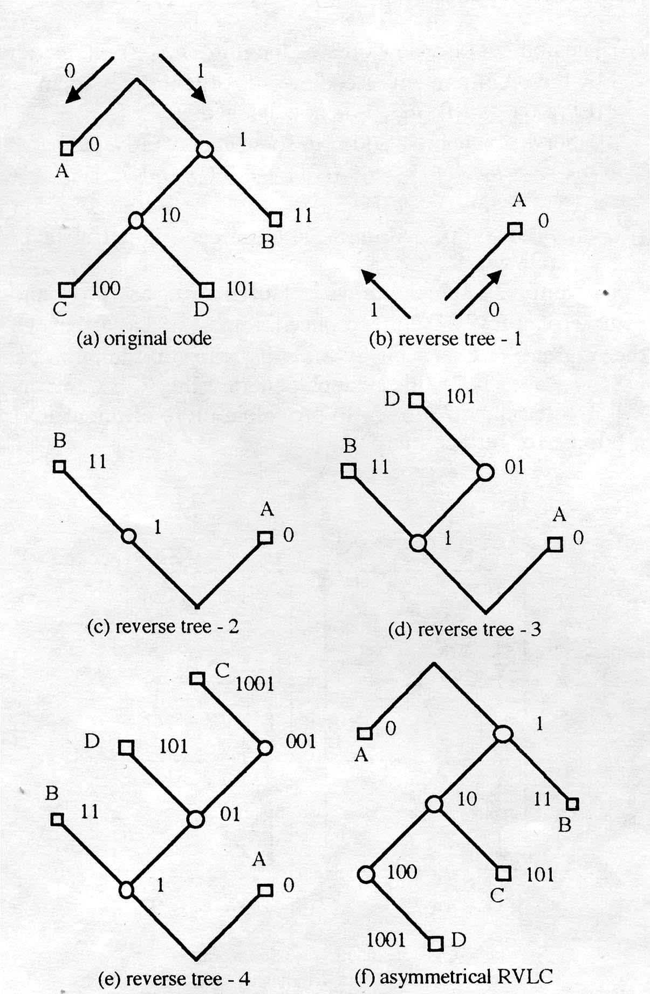
Fig.2. Conversion into asymmetrical RVLC

1) A reverse binary tree is set up in such a way that the end of the code words are placed on the root from shorter code words to longer code words (Fig.2. (b),(c)).
2) When a suffix which is also a prefix in the reverse tree coincide with a shorter code word, another code word with the same bit length is assigned in the reverse tree instead. In Fig.2 (d), “D” is assigned in the reverse tree instead of “C” since the suffix of “C” coincides with “A”.
3) When there is no other code word with the same bit length whose suffix does not coincide with one of the shorter code words, the minimum number of bits required to satisfy the suffix condition are added to the end of the code word. In Fig.2 (e), one bit “1” is attached to the end of “C”.
4) After bit assignment is completed, new code words are sorted by bit length and they are reassigned to the symbols according to their occurrence probabilities (Fig.2 (f)).

2.2. Coding efficiency of ARVLC
ARVLC and the original code are compared from the viewpoint of coding efficiency. Their minimum code lengths are equal. But the maximum code length of ARVLC is longer than that of original code. So their average length codes are a little difference.

References

[1] 3G TS 26.110 version 3.0.1, 1999
[2] ”An evaluation of MPEG-4 error resilience tools”, MPEG2001/M7785, Dec. 2001.
[3] ITU-T SG16 VCEG-L23, “Bit errors within the UVLC,” Eisbee, Germany, Jan., 2001.
[4] ITU-T SG16 Q15-E-32 “Error Correcting RVLC”, Whistler, Canada, July, 1998.
[5]Y. Takishima, et al. “Reversible Variable Length Codes,” IEEE Tr. On Comm., Vol.43., pp. 158-162, 1995

