ITU - Telecommunications Standardization Sector  STUDY GROUP 16 Question 6  Video Coding Experts Group (VCEG)  _________________  15th Meeting: Pattaya, Thailand, 3-7 Dec., 2001 | Document VCEG-O50  Filename: VCEG-O50.doc  Generated: 25 November ’01

Question: | Q.6/SG16 (VCEG)
Source: | Foo Teck-Wee, Shen Sheng-Mei,  Lee Chak-Joo (Panasonic Singapore Laboratories Pte Ltd)  Shinya Kadono (Matsushita Electric Industrial Co., Ltd) | Tel:  Fax:  Email: | +65-5505466  +65-5505459  twfoo@psl.com.sg  shen@psl.com.sg
Title: | Medium Complexity Loop-Filter
Purpose: | Proposal

- Introduction

This document proposes changes to the TML loop filter in order to reduce its complexity and at the same time, maintained as close as possible the quality achieved by the original high complexity loop filter.

- Loop-filter Proposal

A loop filter may reduce the annoying blocking artefacts inherent in low bitrate coding and produces smaller bitstream because of less prediction error from the deblocked reference frame. However, loop filter introduces extra complexity to the codec.

  - Skip Mode

The conditions for checking which block to deblock will be the same as the current conditions in TML8.5 except for additions skipping for certain modes as explained below. The calculation of Strength is also used as criteria for skip mode but will not be used for the clipping as the clipping function is removed.

  - Concurrent checking

Instead of checking separately for the number of pixels to filter on either side, the proposed loop-filter will check for the number of pixels to filter concurrently. Only one check is made to determine the number of pixels to filter. The number of pixel to filter will be the same for both sides. This helps to reduce the complexity of the loop-filter.

dif1 = p0 – q0 // this will be reused for 1 pixel filtering
dif2 = p1 – q1 // this will be reused for 1 pixel filtering
dif1a = | dif1 |
dif2a = | dif2 |

Conditions | Cond. A | Cond. B | n
Cond. 1 | dif1a >= π | dif2a < Ω | 0
Cond. 2 | dif1a >= π | dif2a < Ω * 2 | 0
Cond. 3 | dif1a >= π | dif2a > Ω | 0
Cond. 4 | dif1a < π | dif2a < Ω | 2
Cond. 5 | dif1a < π | dif2a < Ω * 2 | 1

Table 1: Conditions for determining the n

QP | 0 1 2 3 4 5 6 7 8 9 10 11 12 13 14 15 16 17 18 19 20 21 22 23 24 25 26 27 28 29 30 31
π | 0 0 0 0 0 0 0 3 4 4 5 6 7 8 9 13 13 15 17 17 20 22 25 27 29 30 33 34 36 45 50 50
Ω | 0 0 0 0 0 0 0 0 1 1 2 3 4 5 6 9 10 11 13 14 16 18 20 22 24 24 29 29 34 36 35 35
ϕ | 0 0 0 0 0 0 0 0 0 0 0 0 0 0 0 0 0 0 0 0 0 0 0 0 0 0 0 1 1 2 2 2
Table 2: Threshold values used in number of pixels
to filter determination

See Figure 1 for flow-chart of the above module.

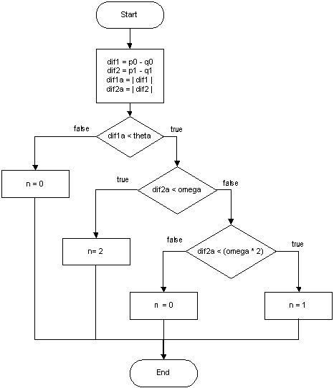
Figure 1: Concurrent determination of number of pixels to filter (0,1 or 3 pixels)
2.3 Filtering

The way to filter 3 pixels and 1 pixel are the same as in current implementation. The only difference with current implementation is that there are no 2 pixels filtering.

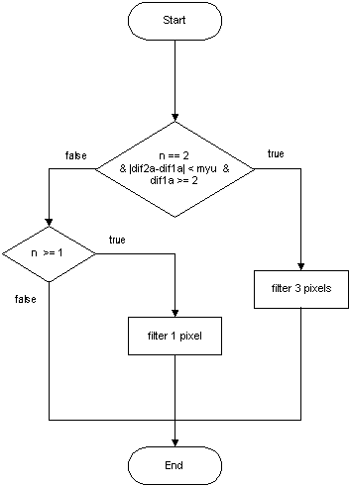

Figure 2: Filtering operation

The conditions for filtering 0, 1 or 3 pixels are as in Table 3.2.

Number of pixels to filter | Conditions
0 | n = 0
1 | Condition 1:  n==1  or  Condition 2:  n==2  and  dif2a-dif1a >=my  or  dif1a < 2
3 | n == 2  |dif2a – dif1a| < myu  dif1a >= 2
Table 3: Conditions for filtering 0, 1 or 3 pixels

The operations for filtering 1 and 3 pixels are the same as in the current implementation.
See Figure 2 for flow-chart of the above module.

- Experiments

Experiments were conducted following the conditions recommended in [1] but we used less frames (>100) instead of the number of frames stated in the document due to time constraint. The proposed loop-filter was integrated into the TML-8.5 software to compare against the TML-8.5 codec. Refer to Appendix for the rate distortion curve. More data is in the enclosed file allseq3.xls.

  - Subjective Viewing

The subjective quality of intra-coded frames (I frames) is generally comparable to TML8.5.

For inter-coded frames (like P and B frames), the visual quality is subjectively better than TML8.5.

Side-by-side comparison between TML8.5 and PSL will be shown during the meeting.

  - Complexity Reduction

The complexity for the new schemes was analysed and calculated as described in [2]. The new algorithm reduces the complexity from 50.4% to 32.9% for Intra coded frames, and from 31.0% to 19.9% for Inter coded frames.

Picture type | TML8.5 | PSL | Reduction
intra coded | 50.4 | 32.9 | 17.5
inter coded | 31.0 | 19.9 | 11.1

Table 4: Complexity of loop-filter in the overall decoding process according
to calculation methods described in [2].

See enclosed file for the complexity calculation (complexity.xls).

Table 5: Complexity study of TML8.5 Intra Coding
Table 6: Complexity Study of PSL Intra Coding
Table 7: Complexity Study of TML8.5 Inter Coding

Table 8: Complexity Study of PSL Inter Coding
  - Execution Speed

Overall complexity of the decode is measured using ANSI C clock() function. Complexity of loop-filter is measured using RDTSC instruction that can be found in Pentium and newer Intel x86 CPUs as used. Reduction of 6% to 30% is recorded for the new in-loop filter. Kindly refer to exespeed.xls for comparison of execution speed of TML8.5 and PSL in-loop filter.

See attached file (exespeed.xls) for details.

Platform used:
Pentium III 1 GHz
256 MB RAM
30 GB hard disk

- Summary and Suggestion

We have demonstrated the advantages of the proposed loop-filter with its significantly reduced complexity when compared with the original loop-filter, and the picture quality close to the latter. With the proposed loop-filter, real-time implementation could be easily achieved and at the same time contributing to the reduced bit usage and better quality video.

However there is a balance between complexity and coding quality gain, especially to the implementation for the portable device where the cost effective would be the key factor.

As for in-loop filter, its coding gain is not coming from many bits saving or much higher PSNY, but from subjective quality, especially in the case of very low bit rate coding.

In the case of the low bit rate, QP is large enough to result in subjective quality drop so much that lost information cannot be recovered. Even a perfect and deliberate in-loop filter also cannot help, but the cost of such filter is extremely large to a portable device. On the other hand, it is felt that removing the annoying blocking noise with certain extent is enough in such case.

What we suggest that if we can define profiles, the proposed medium in-loop filter can be used in Simple Profile targeting on low-end devices. The current TML filter is used in Main profile, and the current TML filter with deringing filter is used in High profile for MPEG2 like bitrate, as shown in the following table.

Profiles/Filter | PSL Medium In-loop Filter | TML8.5 In-loop Filter | Deringing Filter | Notes
Simple Profile | X |  |  | No 1/8 pel interpolation
Main Profile | X* | X |  | With 1/8 pel interpolation
High Profile | X* | X | X | With 1/8 pel interpolation
Other profiles
Table 9: Profiling with Different Inloop Filter

Note:
X* -- only a small sub-set unit used for filter determination is required to implement on top of the current TML8.5 Inloop filter in the case of Main Profile and High Profile.

References

[1] Gisle Bjontegaard, “Recommended Simulation Conditions for H.26L”, document VCEG-M75, ITU-T Video Coding Experts Group (VCEG) Meeting, Austin, TX, USA, 2-4 April 2001.

[2] Minhua Zhou, “Benchmark Analysis of H.26L Decoder Functional Blocks”, document VCEG-N23, ITU-T Video Coding Experts Group (VCEG) Meeting, Santa Barbara, CA, USA, 24-28 September 2001.

Appendix

