    Joint Collaborative Team on Video Coding (JCT-VC)  of ITU-T SG16 WP3 and ISO/IEC JTC1/SC29/WG11  3rd Meeting: Guangzhou, CN, 7-15 October, 2010 | Document: JCTVC-C222  WG11 Number: m18262

Title: | In-loop filtering using temporal pixel trajectories
Status: | Input Document to JCT-VC
Purpose: | Proposal
Author(s) or  Contact(s): | Marko Esche, Andreas Krutz, Alexander Glantz and Thomas Sikora  Technische Universität Berlin, Sekr. E-N 1 Einsteinufer 17, 10587 Berlin, Germany | Email: | esche@nue.tu-berlin.de krutz@nue.tu-berlin.de glantz@nue.tu-berlin.de sikora@nue.tu-berlin.de
Source: | Technische Universität Berlin
_____________________________

Abstract
This document presents a new in-loop filter for hybrid video coding environments. The filter determines trajectories for individual image points over a number of frames and uses this information to reduce block artifacts by averaging the luminance-components along the trajectories. The Temporal Trajectory Filter (TTF) requires an additional overhead of nine bits per slice to control the behavior of the filter.
The method has been integrated into the test model under consideration (TMuC 0.7) and tested on all CfP-sequences for the low-delay case. For these sequences the filter provides an average gain of xx%.

Proposed Filter

General Concept

The main idea of the method presented here is the denoising of individual pixels by determining an individual motion trajectory for every pixel. A pixel trajectory can be defined as 2D-locations through which a certain image point moves from frame to frame. In the low-delay case (IBBB) every pixel in a B-picture is either predicted from one or two previous frames or by using intra prediction. Starting with frame currently to be deblocked the trajectory is retrieved for a pixel 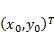 inside that frame with an associated luma component . The location occupied by the pixel in the reference frame 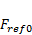 for reference list 0 can be calculated by adding the motion vector associated with 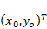 to that location as given in

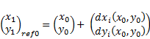

where 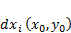 and 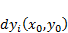 are the - and -components of the motion vector field for list 0 for frame. The luminance component for pixel 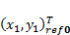 shall now be denoted by. In the same manner a possible pixel location 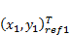 in frame 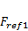for reference list 1 can be derived. Since both of these new locations are potentially also predicted using two motion vectors each, an entire list of luminance components 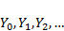 for the pixel can be assembled. The resulting trajectory with the associated luminance components is shown in the following figure.

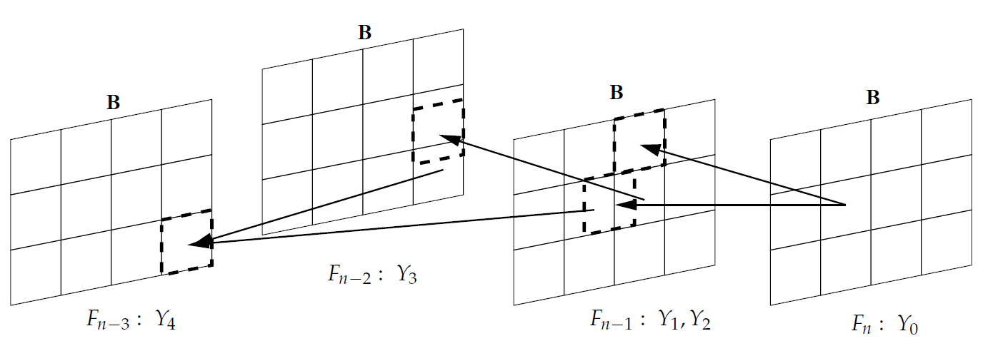

Since all of these luminance samples are assumed to be noisy representation of the same image point, noise reduction is achieved by computing an average luminance component along the trajectory which replaces the original component at location in the current frame.

Control of trajectory selection

Integration into the TMuC encoder

The proposed filter can be integrated into the decoder-loop of the TMuC 0.7 encoder as shown in the following figure.

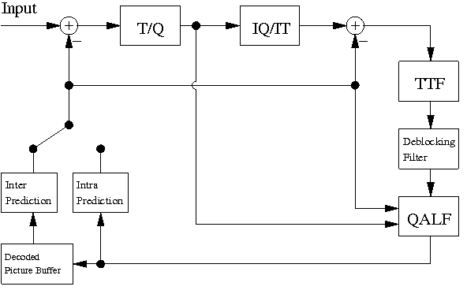
In order to calculate potential trajectories eight previously encoded frames together with their respective motion vector fields are stored at the decoder. The calculation of the optimal parameter combination is done during a single processing step and does not require any form of multi-pass encoding. The new filter is inserted in front of the deblocking filter, which performs its filter operation according to remaining block edges and does not reverse TTF-induced improvements.

Bit stream organization

Aside from the common bit stream, additional parameters as shown in the following table need to be transmitted.
Table 1 - Description of additional side information in the bit stream.
Name | Location | Description
TTF enable | Sequence Parameter Set | 1 bit: enables the Temporal Trajectory Filter globally once for the complete sequence
TTF Parameters | Slice header | 9 bit: TTF parameters per slice

The information in the slice header is inserted in front of the ALF parameters which results in the slice header data syntax shown in table 2.

Table 2 – Slice header data syntax.
if (!rpcSlice->isIntra())
{
if(rpcSlice->getSPS()->getUseTTF()){
xReadCode(3, uiCode); …
xReadCode(3, uiCode); …
xReadCode(3, uiCode); …
}

Experimental evaluation

Experimental conditions

The proposed in-loop filter has been implemented in C++ and integrated into TMuC 0.7. The filter has been tested with the low-delay settings for all CfP [2] sequences. The observed results have been evaluated using the BD-measures [3],[4]. Tables 3 to 6 show the results for all sequences as well as the average BD-measures per class.

Table 3 – BD-measures for class B.
Sequence | BD-Rate [%] | BD-PSNR [dB]

BasketballDrive

BQTerrace

Cactus

Kimono1

ParkScene

Average

Table 4 – BD-measures for class C.
Sequence | BD-Rate [%] | BD-PSNR [dB]

BasketballDrill

BQMall

PartyScene
RaceHorses | -0.1 | 0.0

Average

Table 5 – BD-measures for class D.
Sequence | BD-Rate [%] | BD-PSNR [dB]
BasketballPass | 0.1 | 0.0
BlowingBubbles | -0.1 | 0.0
BQSquare | -4.1 | 0.2
RaceHorses | 0.0 | 0.0
Average | -1.0 | 0.1

Table 6 – BD-measures for class E.
Sequence | BD-Rate [%] | BD-PSNR [dB]

Vidyo1

Vidyo3

Vidyo4

Average

Rate-distortion performance

Complexity

- Summary

Patent rights declaration(s)
(NOTE – Activities in the JCT-VC and contributions to the JCT-VC are subject to the common patent policy for ITU-T/ITU-R/ISO/IEC. A statement of that policy can be found at
http://www.itu.int/ITU-T/dbase/patent/patent-policy.html, with further information available at http://www.itu.int/ITU-T/ipr/index.html and in the ISO/IEC Directives. The form to be used for the formal reporting of patent rights to ITU-T/ITU-R/ISO/IEC can be found at http://www.itu.int/ITU-T/ipr/index.html. Contributions to the JCT-VC proposing normative technical content shall contain a non-binding informal notice of whether the submitter may have patent rights that would be necessary for implementation of the resulting standard. The provided informal notice shall indicate the category of anticipated licensing terms according to the ITU-T/ITU-R/ISO/IEC patent statement and licensing declaration form. This obligation to provide an informal notice is supplemental to, and does not replace, any existing obligations of parties with technology included in a final or draft standard to submit formal IPR declarations to ITU-T/ITU-R/ISO/IEC. An example of an informal IPR notification statement for a contribution is provided below.)

Technise Universität Berlin may have IPR relating to the technology described in this contribution and, conditioned on reciprocity, is prepared to grant licenses under reasonable and non-discriminatory terms as necessary for implementation of the resulting ITU-T Recommendation | ISO/IEC International Standard (per box 2 of the ITU-T/ITU-R/ISO/IEC patent statement and licensing declaration form).

References
[1] | M. Esche, A. Krutz, A. Glantz and T. Sikora, “A Novel Inloop Filter for Video-Compression based on Temporal Pixel Trajectories”, Proceedings of the 28th IEEE Picture Coding Symposium (PCS 2010), Nagoya, Japan, 12/07/2010 – 12/10/2010
[2] | ISO/IEC JTC1/SC29/WG11, “Joint Call for Proposals on Video Compression Technology,” MPEG Document N11113, Jan 2010
[3] | G. Bjontegaard, “Calculation of Average PSNR Differences between RD curves,” ITU-T SG16/Q6, 13th VCEG meeting, Austin, Texas, USA, Apr 2001, Doc. VCEG-M33
[4] | G. Bjontegaard, “Improvements of the BD-PSNR model,” ITU-T SG16/Q6, 35th VCEG meeting, Berlin, Germany, Jul 2008, Doc. VCEG-A111

