    Joint Collaborative Team on Video Coding (JCT-VC)  of ITU-T SG16 WP3 and ISO/IEC JTC1/SC29/WG11  3rd Meeting: Guangzhou, CN, 7-15 October, 2010 | Document: JCTVC-C188  WG11 Number: m18219

Title: | TE12.3: Results for planar prediction tests by Nokia
Status: | Input Document to JCT-VC
Purpose: | Proposal
Author(s) or  Contact(s): | Jani Lainema, Kemal Ugur, Oguz Bici  Nokia Research Center  Visiokatu 1  Tampere, Finland | Email: | jani.lainema@nokia.com  kemal.ugur@nokia.com  oguz.bici@nokia.com
Source: | Jani Lainema
_____________________________

Abstract
This document reports Nokia results for the TE12.3 experiment on disabling planar intra prediction in the TMuC 0.7 environment. Since planar prediction is a tool to improve subjective quality, rather than objective quality, visual examples demonstrating the claimed benefit of planar prediction are also included. Finally, the contribution also points out inefficiency in indication of the planar intra prediction mode in the low complexity entropy coding configurations and proposes a fix for that.
- Introduction
Section 2 summarizes the TE12.3 results for each test configuration and class of test sequences. Section 3 discusses the indication of the planar mode in the low complexity entropy coder environment and proposes to apply joint coding of the indication of planar mode and PU size indicator to better match the probabilities of different combinations of these two data elements. Section 4 shows examples of subjective performance of the planar prediction mode.
- TE12.3 results on Planar Prediction
The tables below summarize the objective performance of the planar prediction OFF configuration with respect to the TMuC 0.7 anchors where planar prediction is enabled. The full results are available in the accompanying Excel sheet (JCTVC-C188.xls). It should be noted that the results were generated on a cluster with nodes having different capabilities, and thus the reported encoder and decoder times are not comparable.
Intra configurations:
 | Intra |  |  | Intra LoCo
 | Y BD-rate | U BD-rate | V BD-rate | Y BD-rate | U BD-rate | V BD-rate
Class A | 0.0 | 0.0 | 0.0 | -0.9 | -0.8 | -0.7
Class B | 0.0 | 0.1 | 0.1 | -0.8 | -0.7 | -0.6
Class C | 0.0 | 0.0 | 0.0 | -0.9 | -0.8 | -0.7
Class D | -0.1 | 0.0 | 0.0 | -0.9 | -0.7 | -0.6
Class E | 0.0 | 0.0 | 0.1 | -0.8 | -0.2 | -0.6
All | 0.0 | 0.0 | 0.0 | -0.9 | -0.6 | -0.6
Enc Time[%] | 104 % |  |  | 121 %
Dec Time[%] | 80 % |  |  | 97 %

Random Access configurations:
 |  | Random access |  |  | Random access LoCo
 | Y BD-rate | U BD-rate | V BD-rate | Y BD-rate | U BD-rate | V BD-rate
Class A | 0.0 | 0.0 | 0.0 | -0.3 | -0.3 | -0.2
Class B | 0.0 | 0.0 | -0.1 | -0.2 | -0.2 | -0.2
Class C | 0.0 | -0.1 | 0.1 | -0.2 | -0.2 | -0.1
Class D | 0.0 | 0.0 | -0.1 | -0.2 | -0.3 | -0.2
Class E
All | 0.0 | 0.0 | -0.1 | -0.2 | -0.2 | -0.2
Enc Time[%] | 101 % |  |  | 67 %
Dec Time[%] | 78 % |  |  | 86 %

Low Delay configurations:
 | Low delay |  |  | Low delay LoCo
 | Y BD-rate | U BD-rate | V BD-rate | Y BD-rate | U BD-rate | V BD-rate
Class A
Class B | 0.0 | 0.1 | 0.0 | 0.0 | 0.0 | -0.1
Class C | 0.0 | -0.1 | 0.1 | 0.0 | 0.0 | 0.1
Class D | 0.0 | 0.2 | 0.2 | 0.0 | 0.1 | -0.1
Class E | 0.0 | 0.3 | -0.2 | 0.0 | -0.7 | 0.2
All | 0.0 | 0.1 | 0.0 | 0.0 | -0.1 | 0.0
Enc Time[%] | 99 % |  |  | 103 %
Dec Time[%] | 95 % |  |  | 79 %

Indication of planar prediction in low complexity entropy coding
The results in section 2 indicate there is roughly a 0.9% objective penalty associated with the planar mode in the Intra Low Complexity configuration. This is a result of the rather simplistic implementation of the indication of Planar mode in the TMuC 0.7 low complexity entropy coder where one bit is allocated for each Intra coded CU to indicate whether the Planar mode is used or not. As the probability of the planar mode is often significantly less than 50% in typical video sequences this leads into suboptimal objective results. In order to overcome this inefficiency we tested joint coding of the planar_flag and intra_split_flag syntax elements with the following variable length code:
codeword | planar_flag | intra_split_flag
1 | 0 | 0
01 | 0 | 1
00 | 1 | 0
The table below summarizes the gains with the joint coding of the planar_flag and intra_split_flag syntax elements. As one can see, majority of the inefficiency is compensated by the joint coding of the symbols and we propose this approach to be adopted to the next revisions of the TMuC/TM low complexity entropy coder. Full results are included in the JCTVC-C188-JointFlags.xls.

Intra configurations:
 | Intra LoCo
 | Y BD-rate | U BD-rate | V BD-rate
Class A | -0.6 | -0.9 | -0.8
Class B | -0.6 | -0.9 | -0.8
Class C | -0.6 | -0.8 | -0.8
Class D | -0.5 | -0.7 | -0.6
Class E | -0.7 | -0.8 | -1.0
All | -0.6 | -0.8 | -0.8
Enc Time[%] | 72 %
Dec Time[%] | 96 %
Random Access configurations:
 |  | Random access LoCo
 | Y BD-rate | U BD-rate | V BD-rate
Class A | -0.2 | -0.4 | -0.3
Class B | -0.1 | -0.3 | -0.3
Class C | -0.1 | -0.1 | -0.2
Class D | -0.1 | -0.1 | -0.2
Class E
All | -0.1 | -0.2 | -0.3
Enc Time[%] | 123 %
Dec Time[%] | 86 %
Low Delay configurations:
 | Low delay LoCo
 | Y BD-rate | U BD-rate | V BD-rate
Class A
Class B | 0.0 | 0.0 | 0.0
Class C | 0.0 | 0.1 | 0.1
Class D | 0.0 | 0.1 | 0.1
Class E | 0.1 | -1.6 | 0.3
All | 0.0 | -0.3 | 0.1
Enc Time[%] | 103 %
Dec Time[%] | 79 %

Examples of subjective performance of the planar prediction
The planar prediction is a coding tool to improve the visual quality of coded video at smooth areas, especially at mid and low bitrates. Therefore, some examples are included below to demonstrate visual quality improvement provided by the planar mode. Examples for both standard test sequences and other still pictures are provided.

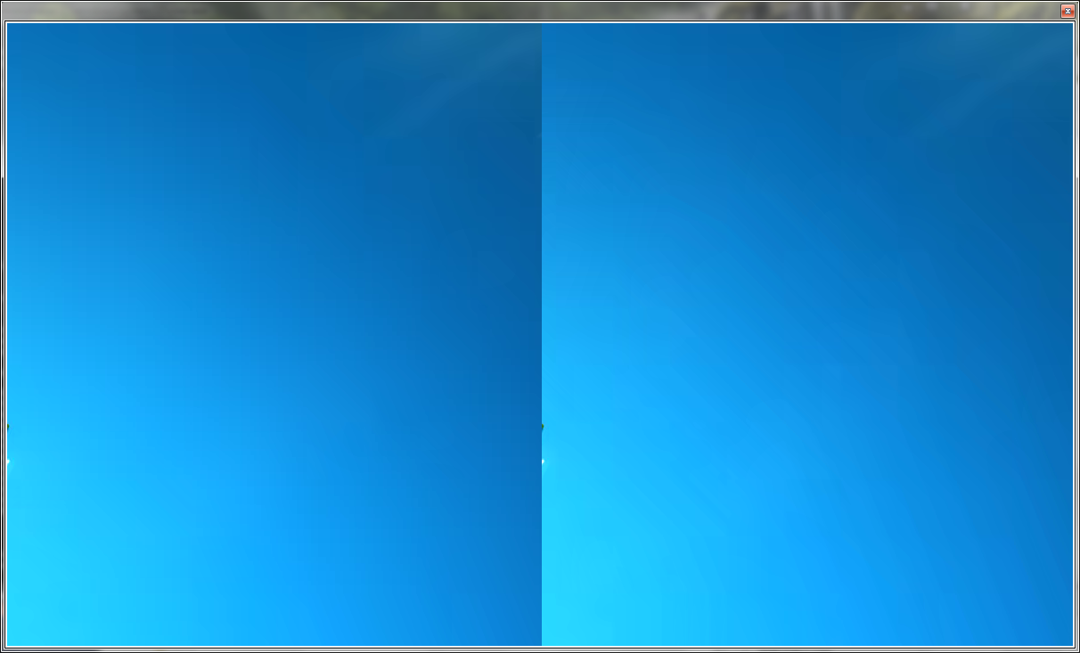
Picture 1: Extract from “logo” image, coded at QP 32 (intra_loco). Left: planar on. Right: planar off.

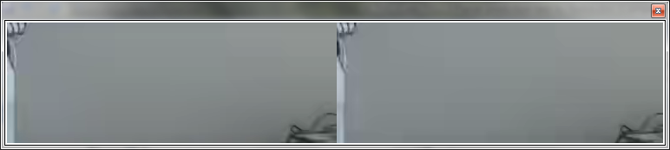
Picture 2: Extract from Vidyo3 (frame 1), coded at QP 37 (intra_loco). Left: planar on. Right: planar off.

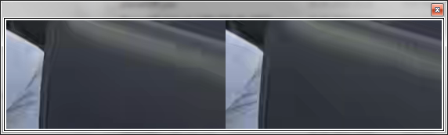
Picture 3: Extract from Vidyo4 (frame 0), coded at QP 37 (intra_loco). Left: planar on. Right: planar off.


Picture 4: Extract from “California5”, coded at QP 32 (intra_loco). Top: planar off. Bottom: planar on.

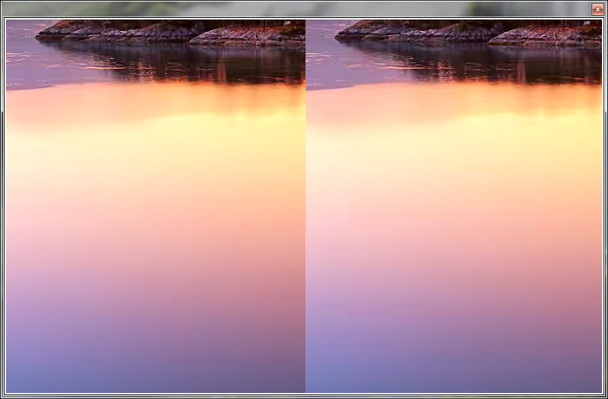
Picture 5: Extract from “California4” image, coded at QP 32 (intra_loco). Left: planar on. Right: planar off.
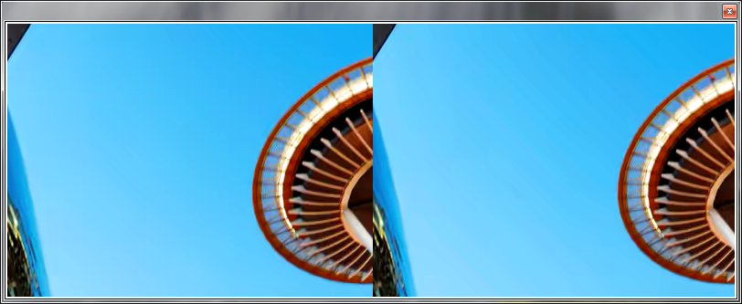
Picture 6: Extract from “tower” image, coded at QP 32 (intra_loco). Left: planar on. Right: planar off.

Patent rights declaration(s)
Nokia Corporation may have IPR relating to the technology described in this contribution and, conditioned on reciprocity, is prepared to grant licenses under reasonable and non-discriminatory terms as necessary for implementation of the resulting ITU-T Recommendation | ISO/IEC International Standard (per box 2 of the ITU-T/ITU-R/ISO/IEC patent statement and licensing declaration form).

