    Joint Collaborative Team on Video Coding (JCT-VC)  of ITU-T SG16 WP3 and ISO/IEC JTC1/SC29/WG11  3rd Meeting: Guangzhou, CN, 7-15 October, 2010 | Document: JCTVC-C176  WG11 Number: m18205

Title: | Analysis and improvement of differential coding of intra modes
Status: | Input Document to JCT-VC
Purpose: | Proposal
Author(s) or  Contact(s): | Tomoyuki Yamamoto  Yukinobu Yasugi  1-9-2 Nakase, Mihama-ku, Chiba-shi,  Chiba 261-8520 JAPAN | Tel:  Email: | +81-43-299-8526  yamamoto.tomoyuki@sharp.co.jp
Source: | SHARP Corporation
_____________________________

Abstract
Edge based intra prediction is the method to utilize the gradient of the neighboring pixels to decide the direction to predict the target partition. Since one of its variants has been incorporated in TMuC and the other variant (DCIM: Differential Coding of Intra Modes) is being evaluated in TE, the Edge based intra prediction is one of the actively researched areas. In this contribution some basic analysis of DCIM is presented for the better understanding of the technology. Also, some modification and experimental results are reported.

Overview of Edge based intra prediction
There are two proposed techniques related to so-called Edge based intra prediction, which are being investegated in JCT-VC in the context of Tool Experiment. One is proposed in JCTVC-A114 [1] and it has been incorporated in TMuC [2]. The other is called DCIM (Differential Coding of Intra Modes), and it was proposed in JCTVC-B109 [3]. DCIM is being evaluated in TE (TE6: Intra Prediction Improvement [4]).

The common feature of those two techniques is that they derive a direction by analyzing the gradient of each pixel in the part of the neighboring regions. The derived direction is used to derive one or more of the intra prediction modes available for the target partition. In A114, the prediction mode corresponding to the direction is used instead of DC mode when edge seems strong enough. In B109, several sub-directions are set around the derived direction (main direction), and intra prediction modes corresponding to the main and sub directions are added to the original intra prediction modes. A flag is introduced to indicate whether the additional or the original modes are used as the candidates of the intra prediction modes for the target partition.

In section 2 of this contribution includes the analysis of intra prediction modes of TMuC with DCIM. In section 3, we present the analysis of the relation between DCIM efficiency and number of additional predictors.

Intra modes distribution in DCIM
In order to understand the basic behaviour of TMuC when it is run with DCIM, we gathered the statistical information of intra prediction modes. The bitstreams used for the evaluation were encoded based on JCTVC-B300 condition (Intra only, High coding efficiency, 9 frames). The ratio of the number of partitions where angular prediction, DCIM (it is marked as ‘edge’), or planar predicition are selected, is shown in Figure 1. DCIM mode is used in nearly half partitions.
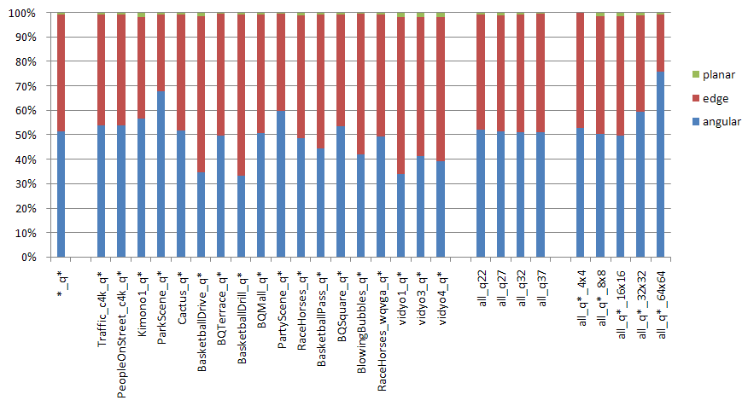
Figure 1: Ratio of the number of the each intra mode partition

Figure 2 shows the distributions of the selected directions when DCIM is used. ‘edge:0’ corresponds to the main direction derived using the neighboring reconstruction pixels. Other ‘edge:x’ corresponds to the sub-direction defined arround the main direction. It is understandable that the ratio of the main direction is high. It should be noted that the ratio of ‘edge:4’ or ‘edge:-4’ are also high. Since these directions are most appart from the main direction, it can be assumed that more number of sub-directions introduces further benefit. Please also note that the ratio of those fringe sub-directions are high for 4x4 partions compared to that for 32x32 partition.

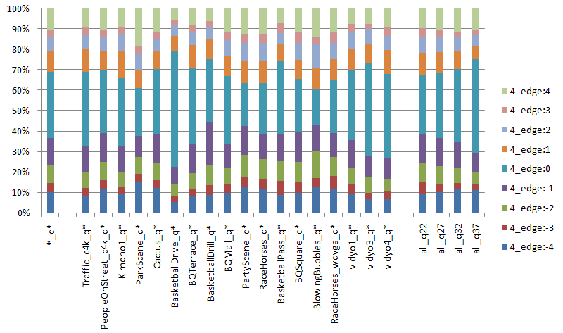
(a) 4x4 partition
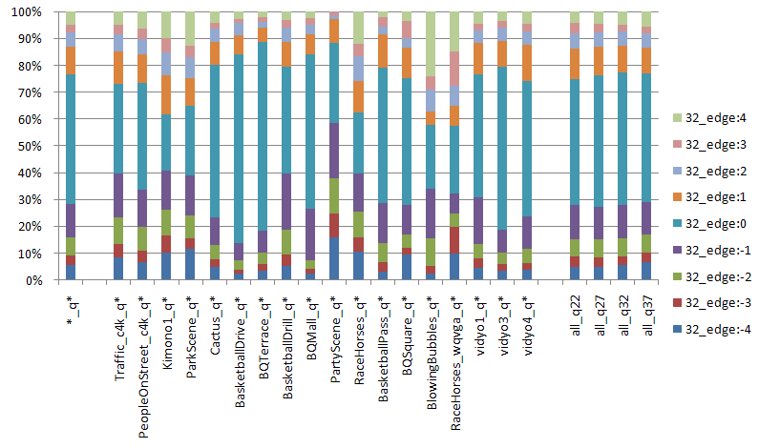
(b) 32x32 partition
Figure 2: Ratio of main/sub-directions used in the DCIM-partition.

Study on number of additional predictors in DCIM
In the current implementation of DCIM, 9 predictors are added to the conventional directional predictors. The 9 predictors include one main direction and 8 sub directions. Considering that number of the traditional directional predictors differs depending on the partition size, we assume it can also be applied for the additional predictors in DCIM. Therefore, we investigated the effect of changing the number of additional predictors depending on the partition size.

Experiments have been conducted using the software which is based on the one provided by Sony in TE6. In the original software, 9 predictors are added for each partition size. In the experiment, the number of additional predictors for a specific partition size was changed. The simulation conditions are shown in Table 2.

Table 3 and Figure 3 show the summary of the experimental results. The experimental results show that more additional predictors are needed to achieve higher gain in smaller paritions compared to the larger partitions. Since increasing the number of additional predictors leads to the increased encoding time, we suggest to use more additional predictors for the larger partitions and less additional predictors for the smaller partitions. With such configuration, coding gain can be achived without introducing much impact on encoding time.

Table 2: Test conditions
reference | Anchor provded in JCTVC-B300
sequence | Class A,B,C,D and E sequences
QP | 22,27,32,37
number of frames | 1 frame
Complexity setting | High Coding Efficiency configuration
GOP structure | I only
CU size | from 8x8 to 64x64

Table 3: BD-Rate increase [%] when the number of additional predictors
for one particular partition is modified.
(The number of additional predictors other than the target parition size is 9.)

 |  | number of additional predictos (sub-directions) for the target partition size
 |  | 0 | 2 | 4 | 6 | 8 | 10 | 12 | 14
target partition size | 4x4 | -1.89 | -1.82 | -1.91 | -1.96 | -1.94 | -2.03 | -1.96 | -2.02
target partition size | 8x8 | -1.65 | -1.83 | -1.96 | -1.98 | -1.94 | -1.98 | -2.00 | -2.02
target partition size | 16x16 | -1.81 | -1.95 | -1.92 | -2.00 | -1.94 | -1.93 | -2.00 | -1.94
target partition size | 32x32 | -1.91 | -1.94 | -1.94 | -2.00 | -1.94 | -1.96 | -1.95 | -1.93
target partition size | 64x64 | -1.90 | -1.92 | -1.92 | -1.96 | -1.94 | -1.95 | -1.99 | -1.96

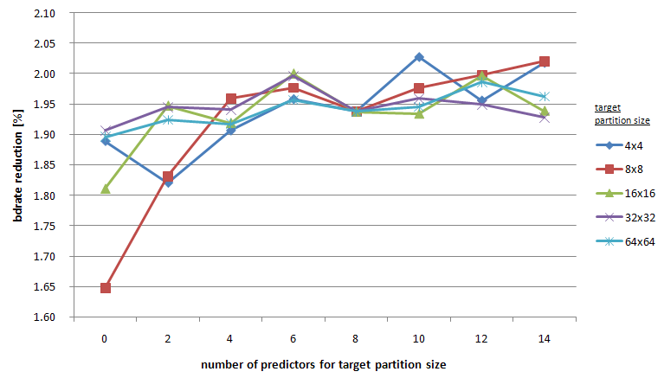
Figure 3: BD-Rate increase [%] when the number of additional predictors
for one particular partition is modified.

Conclusion
In this contribution some basic analysis of differential coding of intra modes (DCIM) is presented for the better understanding of the technology. The mode distribution indicates that DCIM are used in about a half of whole partitions. And a study on the number of additional predictors in DCIM shows that adding more predictors for smaller partitions improve the coding efficiency. We recommend continuing study of DCIM and Edge based intra prediction in the context of Tool Experiment.

Reference
- I. Amonou et al. “Video coding technology proposal by France Telecom, NTT, NTT DoCoMo, Panasonic and Technicolor,” JCTVC-A114, 1st JCT-VC Meeting, Dresden, April 2010.
- JCT-VC, “Test Model under Consideration”, JCTVC-B205, 2nd JCT-VC Meeting, Geneva, July 2010.
- Ehsan Maani et al. “Differential Coding of Intra Modes (DCIM),” 2nd JCT-VC Meeting, Geneva, July 2010.
- Ali Tabatabai et al. “Tool Experiment 6: Intra Prediction Improvement”, JCTVC-B306, 2nd JCT-VC Meeting, Geneva, July 2010.

Patent rights declaration(s)
SHARP Corporation may have IPR relating to the technology described in this contribution and, conditioned on reciprocity, is prepared to grant licenses under reasonable and non-discriminatory terms as necessary for implementation of the resulting ITU-T Recommendation | ISO/IEC International Standard (per box 2 of the ITU-T/ITU-R/ISO/IEC patent statement and licensing declaration form).

