    Joint Collaborative Team on Video Coding (JCT-VC)  of ITU-T SG16 WP3 and ISO/IEC JTC1/SC29/WG11  3rd Meeting: Guangzhou, CN, 7-15 October, 2010 | Document: JCTVC-C167

Title: | Proposal on Large Block Structure and Quantization
Status: | Input Document to JCT-VC
Purpose: | Proposal
Author(s) or  Contact(s): | Kazushi Sato  W12F 1-11-1 GCO Osaki, Shinagawa-ku, Tokyo 141-0032 Japan | Tel:  Email: | +81 3 5435 3308  Kazushi.Sato@jp.sony.com
Source: | Sony Corp.
_____________________________

Abstract

For common test conditions in video codec standardization, the value of quantization parameter is usually fixed within a picture, or sophisticated scheme like RDOQ is sometimes employed for coding efficiency improvement. However in the real applications, QP-changing scheme with macroblock-by-macroblock is usually employed for visual quality improvement.
Adaptive quantization defined in MPEG-2 Test Model is a very old technique but still is one of the effective techniques for subjective quality optimization. It determines QP according to the activity calculated from the values of original pixels within a macroblock. Basic concept is that human eyes are sensitive to degradation in flat areas, but insensitive to busy areas, so smaller QP is allocated for the former areas and bigger QPs are allocated for the latter areas. This works effectively especially when the size of the image is large like HD. One of the key applications of HEVC will be beyond-HD image coding, so any kind of techniques like adaptive quantization will also be useful for HEVC.
HEVC TMuC employs the concept of coding unit (CU). Largest coding (LCU) corresponds to marcoblock in the existing video codec standard like MPEG-2 or AVC. Main difference is that the size of the latter is fixed to 16x16 pixels while the one of the former can be up to 128x128. In the existing video codec standard QP can be set at macroblock-level.
However, as the size of LCU becomes large, it may contain both flat area and busy area and if QP can only be set at LCU-level, adaptive quantization will be difficult.
Therefore we propose to define the CU syntax so that QP can be changed not only with LCU level but with all CU levels. This modification will enable QP changing for subjective quality and will be useful for real applications.

- Introduction

For common test conditions in video codec standardization, the value of quantization parameter is usually fixed within a picture, or sophisticated scheme like RDOQ is employed for coding efficiency improvement. However in the real applications, QP-changing scheme with macroblock-by-macroblock is usually employed for visual quality improvement.
Adaptive quantization defined in MPEG-2 Test Model 5 is a very old technique but still is one of the effective techniques for subjective quality improvement. It modulates QP according to the activity within a macroblock, which is calculated from the original pixel values.
HEVC TMuC employs the concept of coding unit (CU), which greatly contributes to coding efficiency improvement. Largest coding (LCU) corresponds to marcoblock. Main difference is that the size of the latter is fixed to 16x16 pixels while the one of the former can be up to 128x128.
Current TMuC document QP can be defined at Slice Header and definition of QP in CU is not clear. In TMuC software, QP can be set only at LCU level, as it can be set at macroblock level in the current video codec standard like MPEG-2 or AVC.

Problem Statement

Coding Unit Structure and Quantization in Current TMuC Specification

In TMuC [1] Coding Unit (Coding Tree Block; CTB) is defined as shown in Fig 2.1.1.
CTB is a basic unit which has a square shape. Although it has a similar role to the macroblock and sub-macroblock in AVC, the main difference lies in the fact that CTB can have various sizes. Two special terms are defined: the largest coding unit (LCTB) and the smallest coding unit (SCTB). For convenient implementation, LCTB size and SCTB size are limited to values which are a power of 2 and which are greater than or equal to 8.
A picture consists of non-overlapped LCTBs. Since the CTB is restricted to be a square shape, the CTB structure within a LCTB can be expressed in a recursive tree representation adapted to the picture. That is, CTB is characterized by LCTB size and the hierarchical depth in the LCTB that the CTB belongs to.

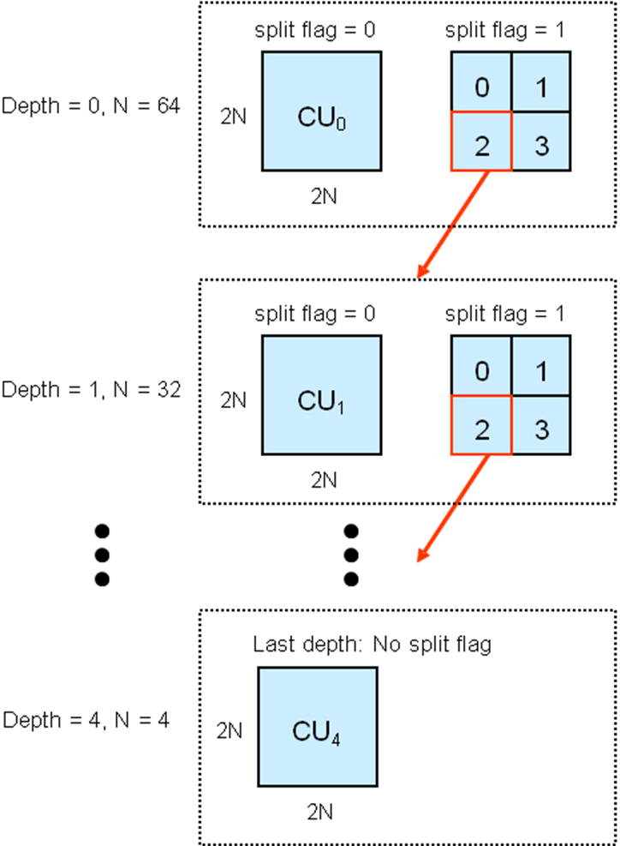

Fig 2.1.1

Current TMuC document [1] only slice_qp_delta is defined and definition of QP in CU is not clear. In TMuC software, QP can be set only at LCU level, as it can be set at macroblock level in the current video codec standard like MPEG-2 or AVC.

Adaptive Quantization

Human eyes are sensitive to degradation with flat areas and insensitive to the degradation with busy areas.
Therefore with adaptive quantization algorithm in MPEG-2 Test Model 5 [2] finer quantization is employed for the former areas and coarser quantization is employed for the latter areas as follows:
In MPEG-2 the size of a macroblock is 16x16 pixels and in MPEG-2 Test Model the size for variance calculation is 8x8.
Suppose that P_{k} (k=1,…,64) are pixels contained in a 8x8-block and the macroblock j consist of 8x8 blocks with index sblk=1,…,4.
The activity of the macroblock j is calculated as:

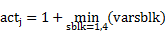
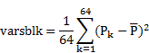
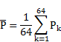

Activitiy of each macroblock j is normalized within a frame as:

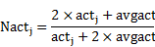

Where avgact is the average activity of the previous frame.

Mquant_{j}, quantization value of the macroblock j is calculated as:

Where Q_{j} is calculated from taget bit of the current frame.
This is an old technique but I believe similar technique is still used for real application encoders.

Normalized Activities of HEVC Test Sequences with Various Block Sizes

In Fig 2.3 distributions of normalized activities “Nact” with various block sizes within a frame of the sequence “vidyo1” are shown. For the case BlockSize=2Nx2N, variance values are calculated for BlockSize=NxN and minimum value of 4 variances are used as activities as done in adaptive quantization of MPEG-2 Test Model.
As we can see, the larger the size of block becomes, one block may contain both busy area and flat area. If large CU size like 64x64 or 128x128 is employed and QP can be defined only at LCU level, QP adaptation for visual quality improvement will be difficult.



- Original Image

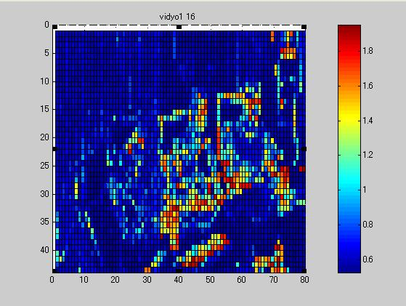

- Nact Distribution with BlockSize=16x16

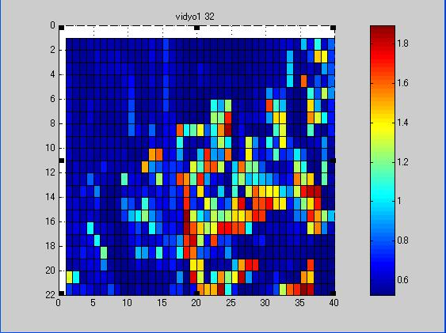

- Nact Distribution with BlockSize=32x32

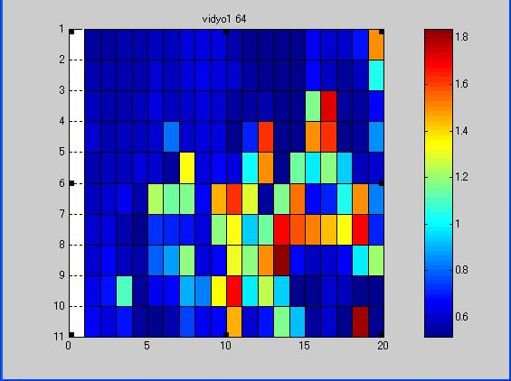

- Nact Distribution with BlockSize=64x64

Fig 2.3

Proposal

To solve the problem stated above, we propose to define cu_delta_qp as shown in Table 3.1. It can be defined not only with LCU but with all CU levels and for the all TUs contained in this CU, current_qp, the value of the qp should be calculated as:

current_qp = prev_qp + cu_qp_delta

Where prev_qp is the quantization parameter that is used for the previously-encoded or -decoded CU. The value of current_qp should be clipped in the range of

min_qp <= current_qp <= max_qp

where min_qp = 0 and max_qp=51.

Table 3.1
coding_unit( x0, y0, currCodingUnitSize ) { | C | Descriptor
if( x0+currCodingUnitSize < PicWidthInSamples_{L} && y0+currCodingUnitSize < PicHeightInSamples_{L} &&
currCodingUnitSize > MinCodingUnitSize )
split_coding_unit_flag | 2 | u(1) | ae(v)
if( split_coding_unit_flag ) {
splitCodingUnitSize = currCodingUnitSize >> 1
x1 = x0 + splitCodingUnitSize
y1 = y0 + splitCodingUnitSize
coding_unit( x0, y0, splitCodingUnitSize ) | 2 | 3 | 4
if( x1 < PicWidthInSamples_{L} )
coding_unit( x1, y0, splitCodingUnitSize ) | 2 | 3 | 4
if( y1 < PicHeightInSamples_{L} )
coding_unit( x0, y1, splitCodingUnitSize ) | 2 | 3 | 4
if( x1 < PicWidthInSamples_{L} && y1 < PicHeightInSamples_{L} )
coding_unit( x1, y1, splitCodingUnitSize ) | 2 | 3 | 4
} else {
prediction_unit( x0, y0, currCodingUnitSize ) | 2
if( PredMode != MODE_SKIP || !(PredMode == MODE_INTRA && planar_flag == 1) )
if( entropy_coding_mode_flag ) {
transform_unit_tree( x0, y0, currCodingUnitSize, 0 ) | 3 | 4
transform_unit_coeff( x0, y0, currCodingUnitSize, 0, 0 ) | 3 | 4
transform_unit_coeff( x0, y0, currCodingUnitSize, 0, 1 ) | 3 | 4
transform_unit_coeff( x0, y0, currCodingUnitSize, 0, 2 ) | 3 | 4
} else
transform_unit_vlc( x0, y0, currCodingUnitSize ) | 3 | 4
}
cu_qp_delta | 2 | se(v)
}

Conclusion

The concept of CU (coding unit) has been introduced for HEVC, and it greatly contributes to coding efficiency improvement by saving overhead bit like mode- or motion-information. Largest Coding Unit (LCU) corresponds to macroblock in MPEG-2 or AVC. The main difference is that the size of the latter is fixed to 16x16 but the one for the former is up to 128x128.
In the existing video codec like MPEG-2 or AVC, quantization parameter can be defined at macroblock-level. However, if it can be defined only at LCU level in HEVC, it would be hard to optimize the visual quality of the decoded image.
Therefore we would like it be defined not only at LCU but at all LCU levels. This syntax will give HEVC more freedom to encoder for subjective quality improvement.

References
[1] “Test Model under Consideration”, JCTVC-B205_draft005, July 2010
[2] “Test Model 5”, ISO/IEC, JTC/SC29/WG11/N0400, 1993

Patent rights declaration(s)

Sony Corp. may have IPR relating to the technology described in this contribution and, conditioned on reciprocity, is prepared to grant licenses under reasonable and non-discriminatory terms as necessary for implementation of the resulting ITU-T Recommendation | ISO/IEC International Standard (per box 2 of the ITU-T/ITU-R/ISO/IEC patent statement and licensing declaration form).

