    Joint Collaborative Team on Video Coding (JCT-VC)  of ITU-T SG16 WP3 and ISO/IEC JTC1/SC29/WG11  3rd Meeting: Guangzhou, CN, 7-14 October, 2010 | Document: JCTVC-C162

Title: | TE12.2: Results on MC interpolation filters
Status: | Input Document to JCT-VC
Purpose: | Proposal
Author(s) or  Contact(s): | Masaru Ikeda, Kenji Kondo and  Teruhiko Suzuki  Gate City Osaki West Tower East Tec,  1-11-1, Osaki,  Shinagawa-ku , Tokyo, 141-0032 JAPAN | Tel:  Email: | +81 3 5435 3308  Masaru.Ikeda@jp.sony.com  teruhikos@jp.sony.com
Source: | Sony Corp.
_____________________________

Abstract
This document reports the results of MC interpolation filter, specially the SIFO/DIF is compared with DCT-IF for interpolation filter, in TE12. In the test, the coding performance and complexity was measured under common test conditions, which is defined in JCTVC-B300. The coding performance and complexity of MOMS are reported in addition to DCT-IF. These results are shown in the second part. Detail results are summarized in the attached Excel sheet.

Introduction
Tool Experiment 12[2] aims to explore the performance of individual tools in the TMuC.
These results of this work contribute to improvements in the default operating points of the TMuC and to insight on how the various tools contribute to the overall performance of the TMuC, and hence should help inform the process of forming the first Test Model.
However, it should be noted that the various tools in TMuC interact in a complex non-linear manner, so that careful interpretation of the results will be required.
Only one tool at a time will take an alternative setting from that of the default configuration; combination of tools will not be exercised in this phase for testing.
Each tool in the TMuC will be tested individually such that some tools have direct alternatives either within the TMuC itself or else added to the software. In this case, SIFO/DIF will be tested against DCT-IF 12-tap/8-tap and 6-tap/4-tap, respectively.

Experiments for DCT-IF
The target for comparison is as follows.
- SIFO with 12-tap is compared with DCT-IF 12-tap for random access and low delay, high efficiency.
- SIFO with 12-tap is compared with DCT-IF 8-tap for random access and low delay, high efficiency.
- DIF with 6-tap is compared with DCT-IF 6-tap for random access and low delay, low complexity.
- DIF with 6-tap is compared with DCT-IF 4-tap for random access and low delay, low complexity.
The rest settings is default and is shown in detail in JCTVC-B300.

Coding performance
The performance measurements were evaluated by objective rate-distortion measurements using PSNR and BD-Rate. The result in detail is shown in attached exel file.
Figure 2.1-12 show BD-Rate for each test sequence with each condition against each type of anchor.
These results for DCT-IF 12-tap(LoCo:6-tap) show that average coding gains of Y are 0.27 % for random access, high efficiency, -0.78% for low delay, 2.77 % for random access, low complexity and 0.67 % for low delay, low complexity in Figure 2.1-4, respectively. DCT-IF 12-tap(LoCo:6-tap) except for case of low delay gains more than SIFO and DIF, in which the results of some of test sequences shows coding gains increase.
These results for DCT-IF 12-tap(LoCo:6-tap) show that average coding gains of U are 0.33 % for random access, high efficiency, 0.11% for low delay, 5.89 % for random access, low complexity and 8.73 % for low delay, low complexity in Figure 2.5-8, respectively.
These results for DCT-IF 12-tap(LoCo:6-tap) show that average coding gains of V are 0.33 % for random access, high efficiency, -0.04% for low delay, 6.57 % for random access, low complexity and 10.50 % for low delay, low complexity in Figure 2.9-12, respectively.
These results for DCT-IF 8-tap(LoCo:4-tap) show that average coding gains of Y are -0.22 % for random access, high efficiency, -1.08% for low delay, -0.77 % for random access, low complexity and -7.43 % for low delay, low complexity in Figure 2.1-4, respectively, so DCT-IF 8/4taps gains less than SIFO and DIF.
These results for DCT-IF 8-tap(LoCo:4-tap) show that average coding gains of U are 0.19 % for random access, high efficiency, -0.76% for low delay, 4.76 % for random access, low complexity and 3.33 % for low delay, low complexity in Figure 2.5-8, respectively.
These results for DCT-IF 8-tap(LoCo:4-tap)show that average coding gains of V are 0.04 % for random access, high efficiency, -0.73% for low delay, 5.37 % for random access, low complexity and 4.79 % for low delay, low complexity in Figure 2.9-12, respectively.

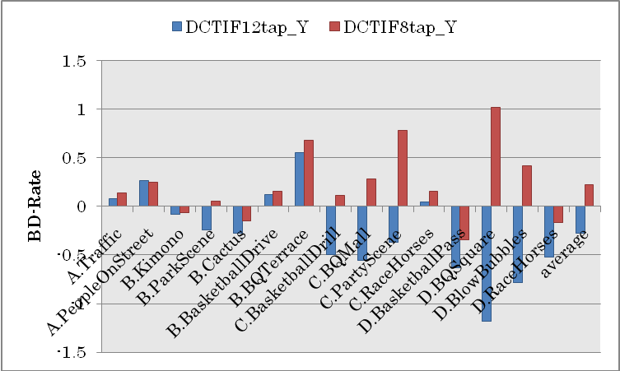
Figure 2.1: BD-Rate of Y for both DCT-IF 12-tap and 8-tap in random access

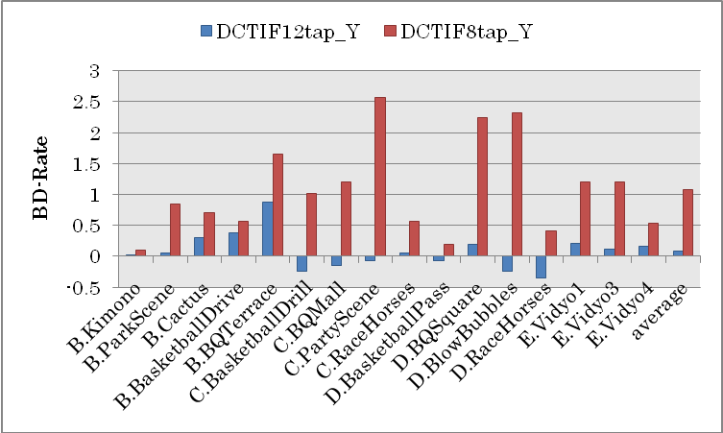
Figure 2.2: BD-Rate of Y for both DCT-IF 6-tap and 4-tap in low delay

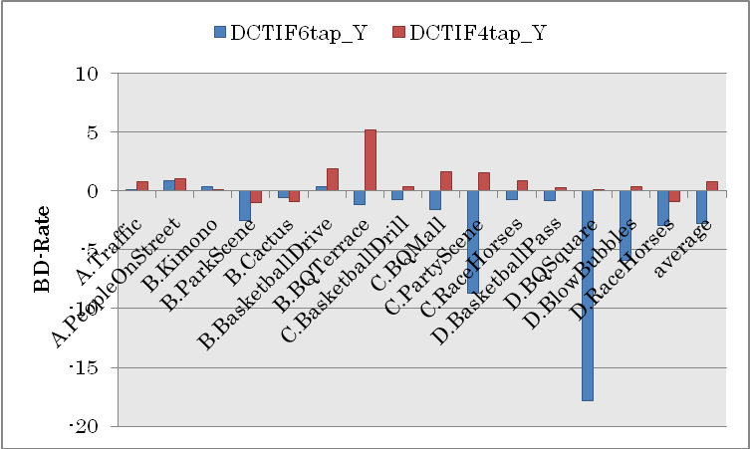
Figure 2.3: BD-Rate of Y for both DCT-IF 6-tap and 4-tap in random access, low complexity

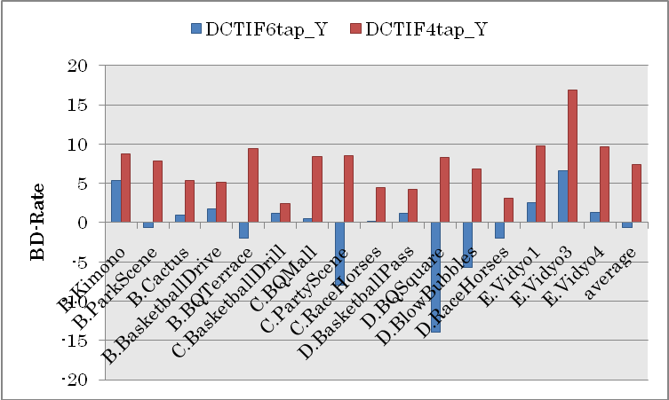
Figure 2.4: BD-Rate of Y for both DCT-IF 6-tap and 4-tap in low delay, low complexity

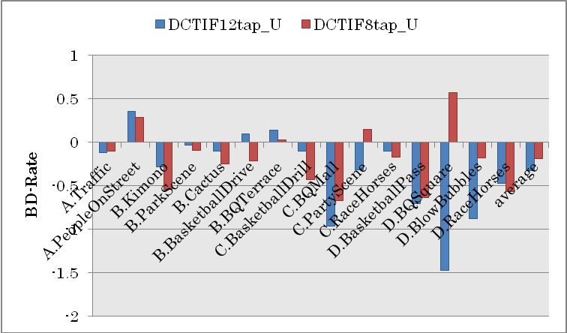
Figure 2.5: BD-Rate of U for both DCT-IF 12-tap and 8-tap in random access

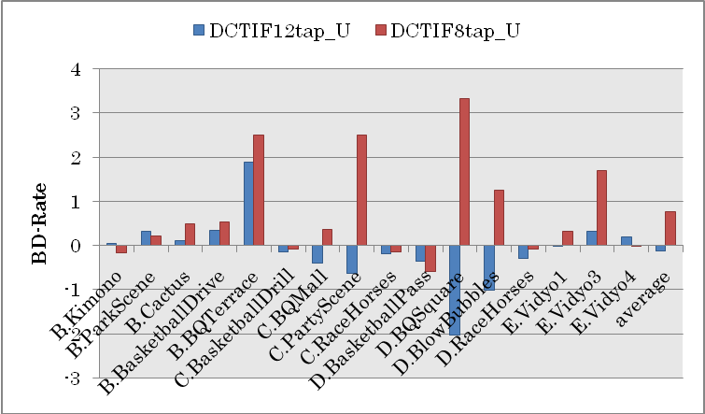
Figure 2.6: BD-Rate of U for both DCT-IF 6-tap and 4-tap in low delay

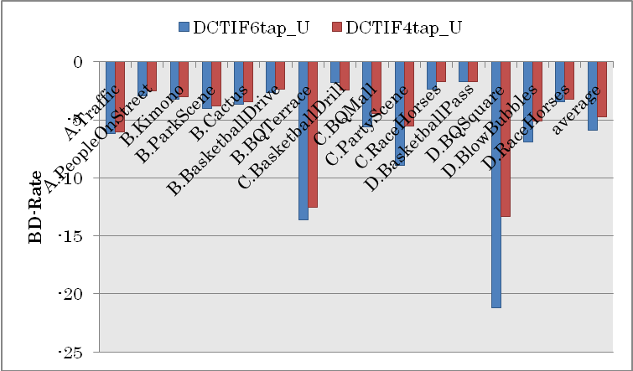
Figure 2.7: BD-Rate of U for both DCT-IF 6-tap and 4-tap in random access, low complexity

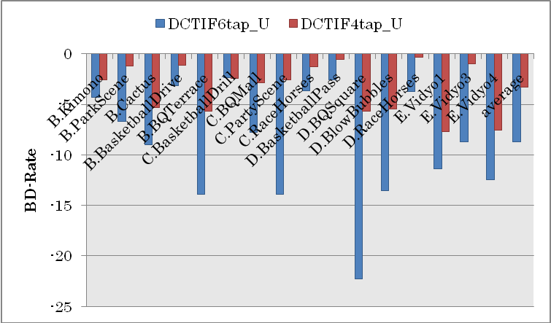
Figure 2.8: BD-Rate of U for both DCT-IF 6-tap and 4-tap in low delay, low complexity

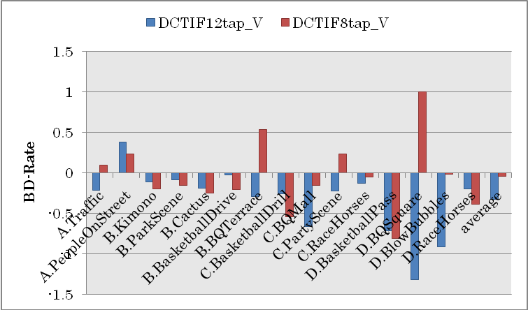
Figure 2.9: BD-Rate of V for both DCT-IF 12-tap and 8-tap in random access

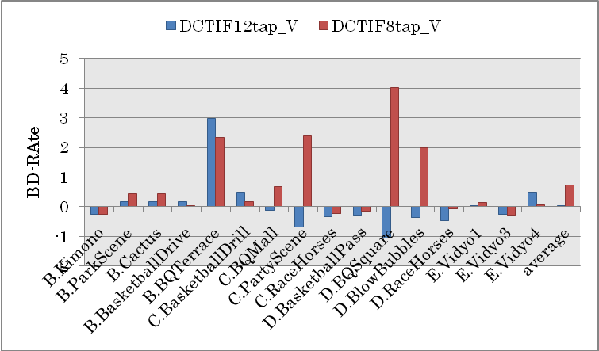
Figure 2.10: BD-Rate of V for both DCT-IF 6-tap and 4-tap in low delay

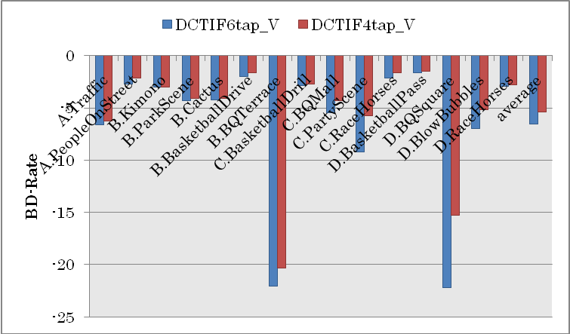
Figure 2.11: BD-Rate of V for both DCT-IF 6-tap and 4-tap in random access, low complexity

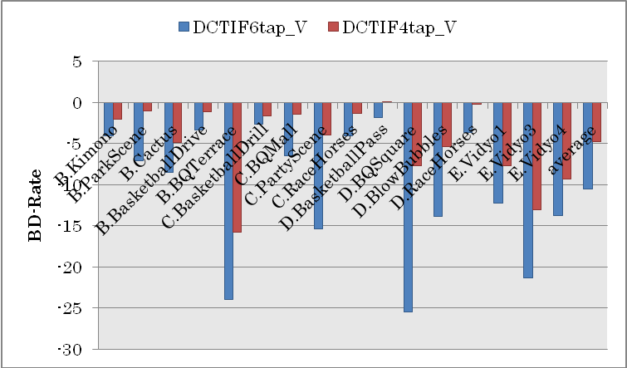
Figure 2.12: BD-Rate of V for both DCT-IF 6-tap and 4-tap in low delay, low complexity

Complexity
For complexity evaluation by encoding and decoding times, the executables compiled by Linux were run on following Linux-based computing platforms:
- OS: Linux2.6.18 64-bit, CPU: Intel(R) Core(TM) i7 860 2.80GHz, Memory: 16GB.
- OS: Linux2.6.18 64-bit, CPU: Intel(R) Core(TM) i7 870 2.93GHz, Memory: 16GB.
The platform (a) was used for encoding and decoding Class A, B(Kimono and ParkScene), C, D and E sequences. The platform (b) was used for encoding Class B(Cactus, BasketballDrive and BQTerrace) sequences. Figure 2.13-20 show the encoding and decoding times for each test case and each test sequence, by averaging results in four QP points.
It is observed that encoding time for DCT-IF 12-tap and 8-tap is much shorter than that of SIFO in random access and low delay, and the differences of decoding time between SIFO and DCT-IF (12-tap and 8-tap) is negligible for random access and low delay in figure 2.13-16, respectively.
It is observed that the differences of encoding time and decoding time between DIF and DCT-IF (6-tap/4-tap) is negligible for random access and low delay in figure 2.17-20, respectively.
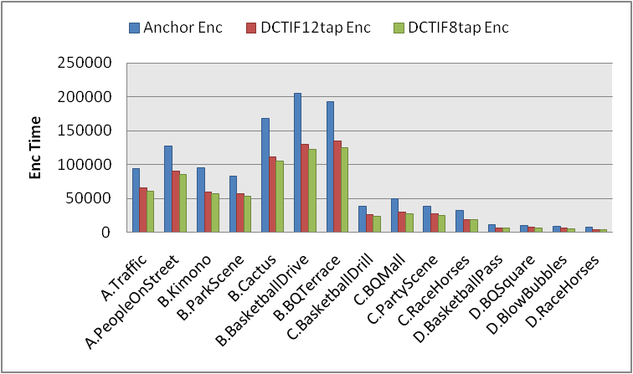
Figure 2.13: the encoding times for both DCT-IF 12-tap and 8-tap in random access

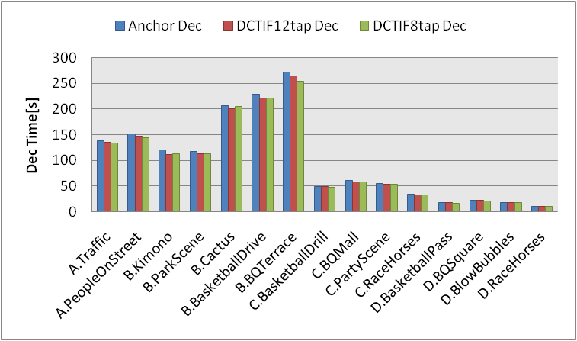
Figure 2.14: the decoding times for both DCT-IF 12-tap and 8-tap in random access

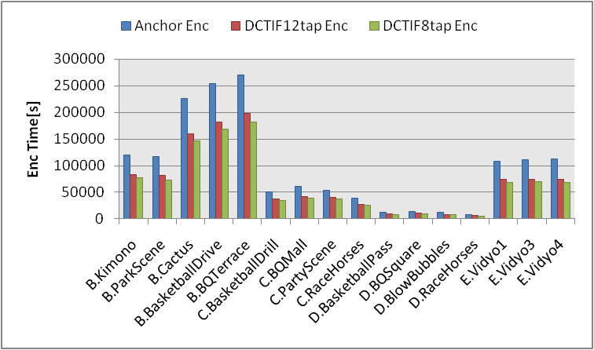
Figure 2.15: the encoding times for both DCT-IF 12-tap and 8-tap in low delay

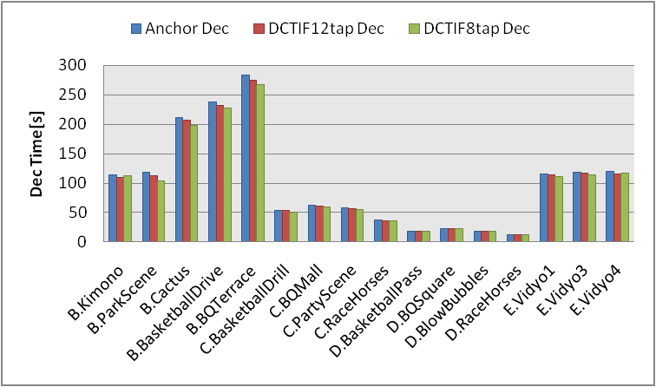
Figure 2.16: the decoding times for both DCT-IF 12-tap and 8-tap in low delay

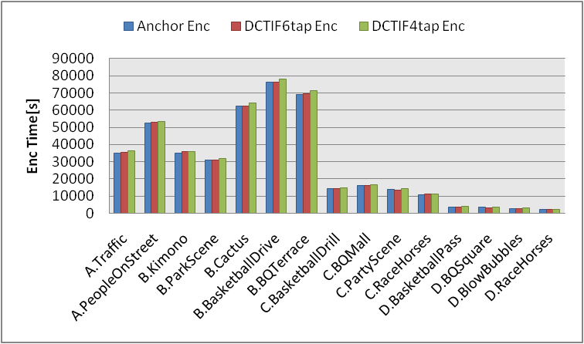
Figure 2.17: the encoding times for both DCT-IF 6-tap and 4-tap in random access, low complexity

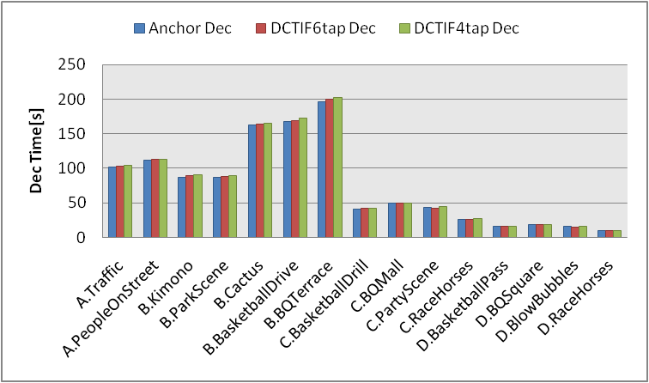
Figure 2.18: the decoding times for both DCT-IF 6-tap and 4-tap in random access, low complexity

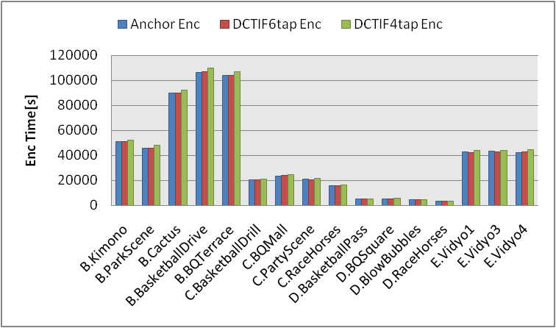
Figure 2.19: the encoding times for both DCT-IF 6-tap and 4-tap in low delay, low complexity

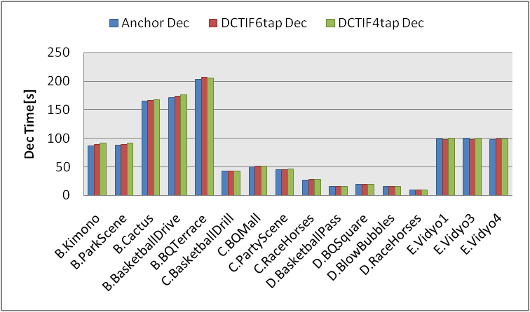
Figure 2.20: the decoding times for both DCT-IF 6-tap and 4-tap in low delay, low complexity

Bug fix in SIFO
After releasing TMuC 0.7 software, two bugs on ME (BUGFIX#48 and BUGFIX#50) are reported for SIFO. The impact on coding performance due to these bug fixes is investigated. The comparison is summarized in TE12_SIFO_BugFix.xls. The results are summarized in Figure 2.21 – 2.26. The difference of coding performance due to BUGFIX #48 and #50 is less than 0.1 % in Y, therefore the impact on the comparison between DCT-IF and SIFO is ignorable. The difference of encoding time and decoding time is also ignorable.

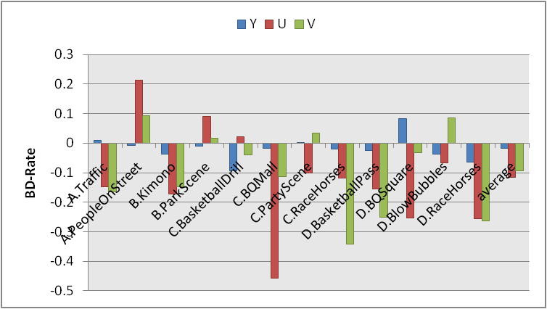

Figure 2.21: Coding performance comparison with bug fix (random access)

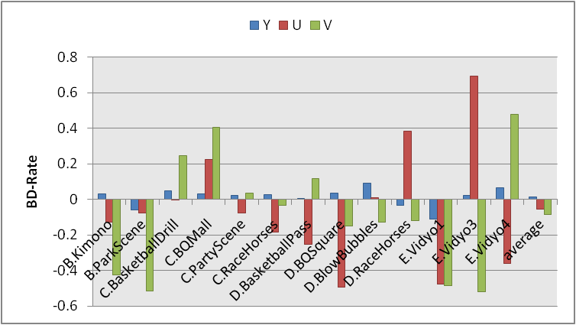
Figure 2.22: Coding performance comparison with bug fix (low delay)

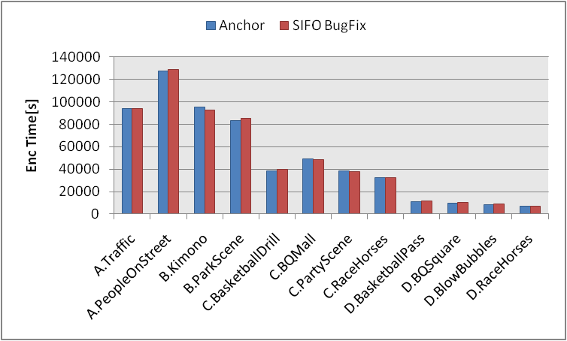
Figure 2.23: Encoding time comparison with bug fix (random access)

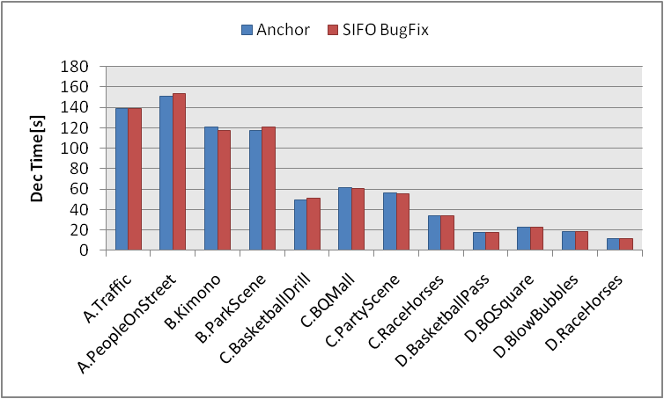
Figure 2.24: Encoding time comparison with bug fix (low delay)

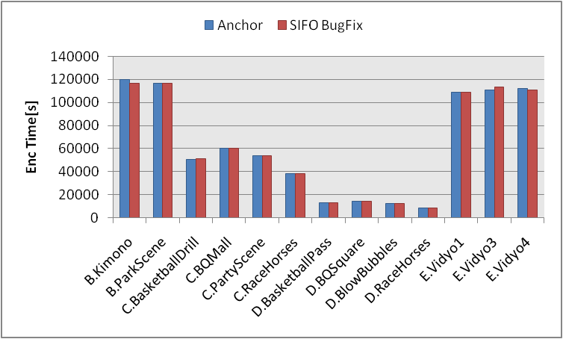
Figure 2.25: Decoding time comparison with bug fix (random access)

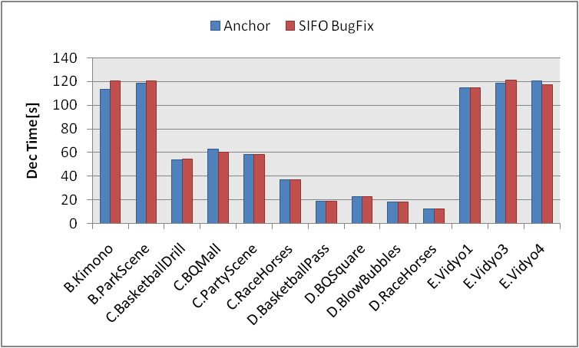
Figure 2.26: Decoding time comparison with bug fix (low delay)

Experiments for MOMS
The target for comparison is as follows.
- SIFO with 12-tap is compared with MOMS 6-tap for random access and low delay, high efficiency.
- SIFO with 12-tap is compared with DCT-IF 12-tap for random access and low delay, high efficiency.
- DIF with 6-tap is compared with MOMS 4-tap for random access and low delay, low complexity.
- DIF with 6-tap is compared with DCT-IF 6-tap for random access and low delay, low complexity.
The rest settings are default and are shown in detail in JCTVC-B300.

Coding performance
The performance measurements were evaluated by objective rate-distortion measurements using PSNR and BD-Rate. The result in detail is shown in attached excel-file.
Figure 3.1-12 show BD-Rate for each test sequence with each condition against each type of anchor.
These results for MOMS 6-tap(LoCo:4-tap) show that average coding gains of Y are 0.73 % for random access, high efficiency, -0.97% for low delay, high efficiency, 5.45 % for random access, low complexity and 6.06 % for low delay, low complexity in Figure 3.1-4, respectively. Though MOMS 6-tap(LoCo:4-tap) has more gain than DCT-IF 12-tap(LoCo:6-tap) for almost CSs(random access, random access, low complexity and low delay, low complexity), it has gain for the specific test sequences such as class-C and class-D.
These results for MOMS 6-tap(LoCo:4-tap) show that average coding gains of U are 4.86 % for random access, high efficiency, -10.70% for low delay, 13.54 % for random access, low complexity and -22.65 % for low delay, low complexity in Figure 3.5-8, respectively. Though MOMS 6-tap(LoCo:4-tap) has much gain for random access and random access, low complexity, it has much loss for low delay and low delay, low complexity than DCT-IF 12-tap(LoCo:8-tap).
These results for MOMS 6-tap(LoCo:4-tap) show that average coding gains of V are 5.12 % for random access, high efficiency, -15.68% for low delay, 14.80 % for random access, low complexity and -18.59 % for low delay, low complexity in Figure 3.9-12, respectively. MOMS 6-tap(LoCo:4-tap) has similar characteristic with that of U.

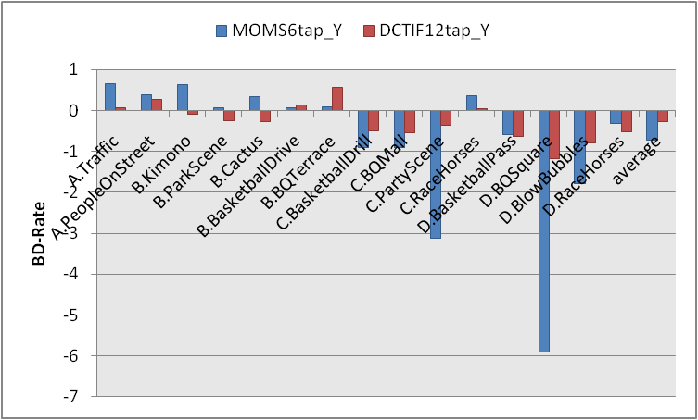
Figure 3.1: BD-Rate of Y for both MOMS 6-tap and DCT-IF 12-tap in random access

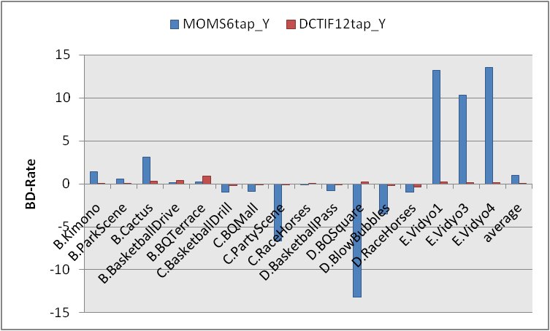
Figure 3.2: BD-Rate of Y for both MOMS 6-tap and DCT-IF 12-tap in low delay

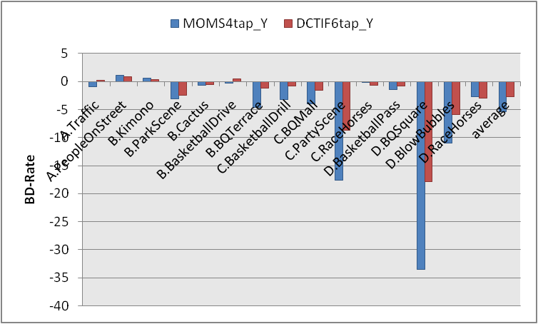
Figure 3.3: BD-Rate of Y for both MOMS 4-tap and DCT-IF 6-tap in random access, low complexity

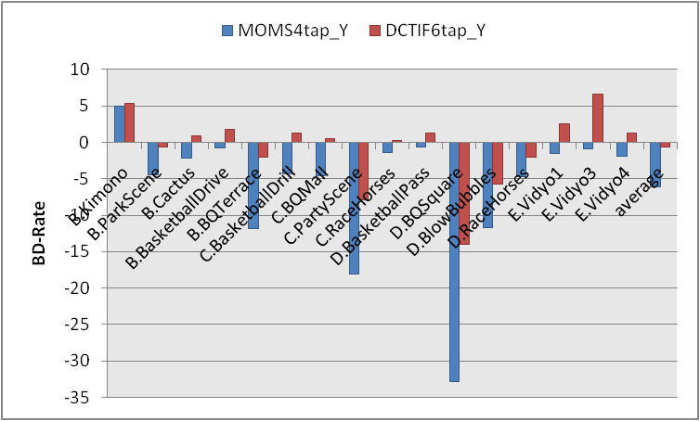
Figure 3.4: BD-Rate of Y for both MOMS 4-tap and DCT-IF 6-tap in low delay, low complexity

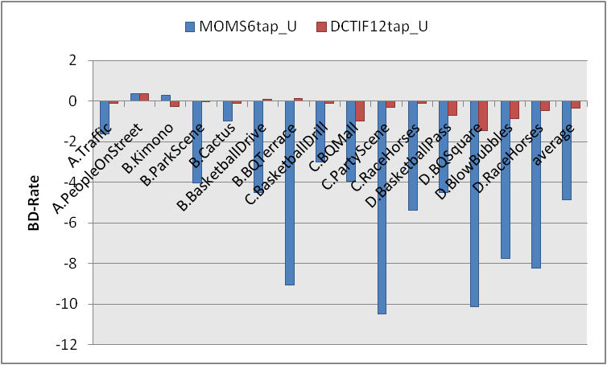
Figure 3.5: BD-Rate of U for both MOMS 6-tap and DCT-IF 12-tap in random access

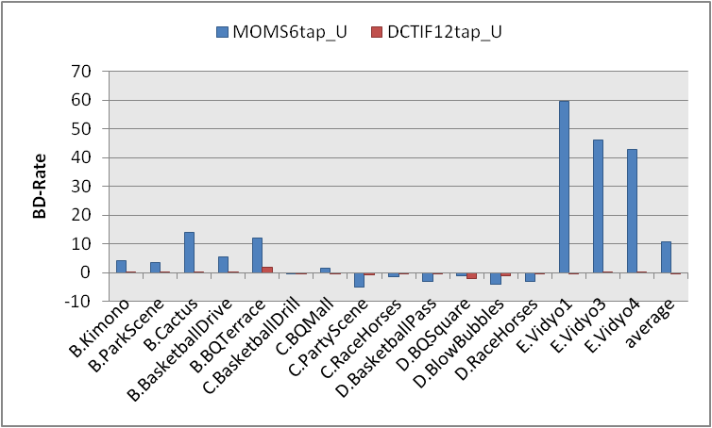
Figure 3.6: BD-Rate of U for both MOMS 6-tap and DCT-IF 12-tap in low delay

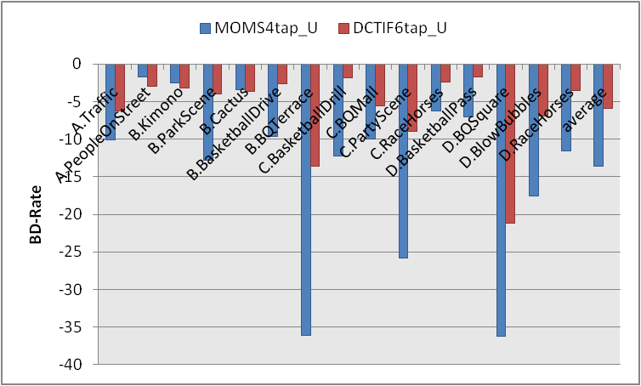
Figure 3.7: BD-Rate of U for both MOMS 4-tap and DCT-IF 6-tap in random access, low complexity

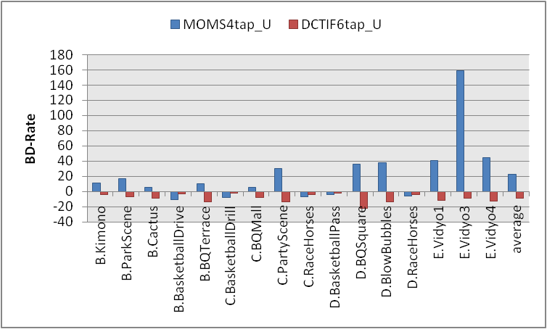
Figure 3.8: BD-Rate of U for both MOMS 4-tap and DCT-IF 6-tap in low delay, low complexity

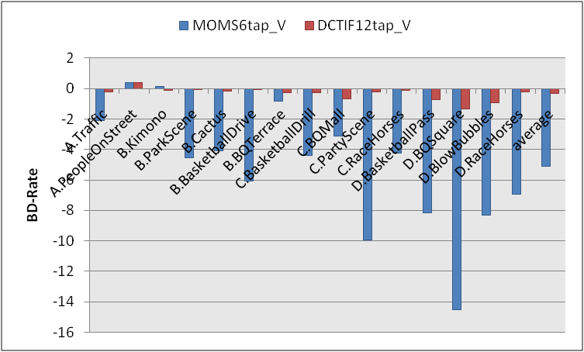
Figure 3.9: BD-Rate of V for both MOMS 6-tap and DCT-IF 12-tap in random access

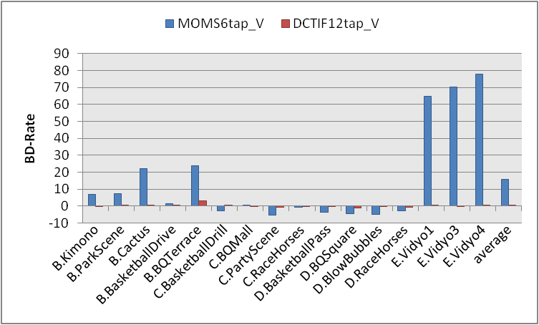
Figure 3.10: BD-Rate of V for both MOMS 6-tap and DCT-IF 12-tap in low delay

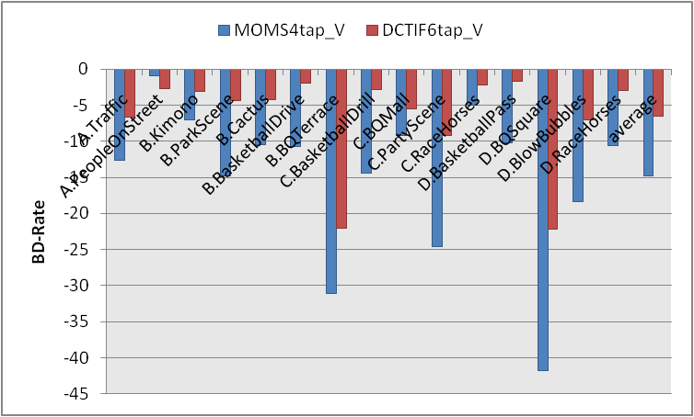
Figure 3.11: BD-Rate of V for both MOMS 4-tap and DCT-IF 6-tap in random access, low complexity

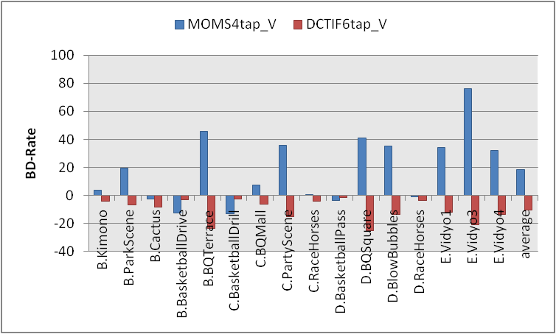
Figure 3.12: BD-Rate of V for both MOMS 4-tap and DCT-IF 6-tap in low delay, low complexity

Complexity
For complexity evaluation by encoding and decoding time, the executables compiled by Linux were run on following Linux-based computing platforms:
- OS: Linux2.6.18 64-bit, CPU: Intel(R) Core(TM) i7 860 2.80GHz, Memory: 16GB.
- OS: Linux2.6.18 64-bit, CPU: Intel(R) Core(TM) i7 870 2.93GHz, Memory: 16GB.
The platform (a) was used for encoding and decoding Class A, B(Kimono and ParkScene), C, D and E sequences. The platform (b) was used for encoding Class B(Cactus, BasketballDrive and BQTerrace) sequences. Figure 3.13-20 show the encoding and decoding time for each CS and each test sequence, by averaging results in four QP points (22, 27, 32 and 37).
It is observed that encoding time for MOMS 6-tap and DCT-IF 12-tap is much shorter than that of SIFO for random access and low delay, and that decoding time for MOMS 6-tap is much longer than that of SIFO and DCT-IF 12-tap for the same CS in figure 3.13-16, respectively.
It is observed that encoding and decoding time for MOMS 4-tap is longer than those of DIF and DCT-IF 6-tap for random access, low complexity and low delay, low complexity in figure 3.17-20, respectively.

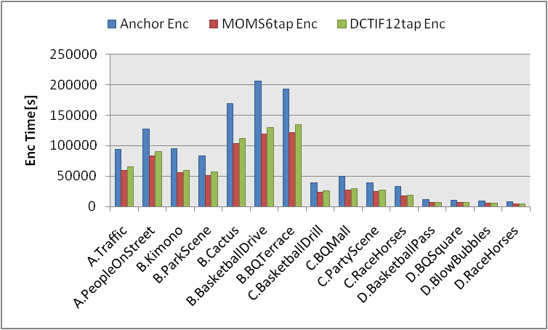
Figure 3.13: encoding times for both MOMS 6-tap and DCT-IF 12-tap in random access

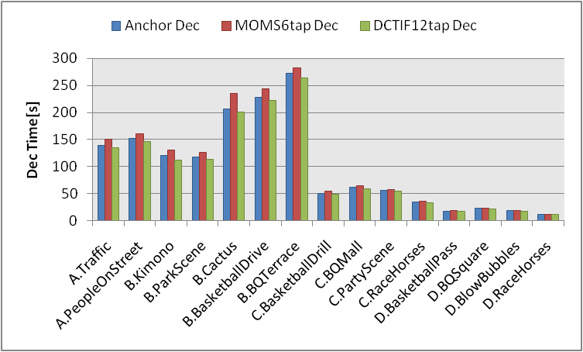
Figure 3.14: decoding times for both MOMS 6-tap and DCT-IF 12-tap in random access

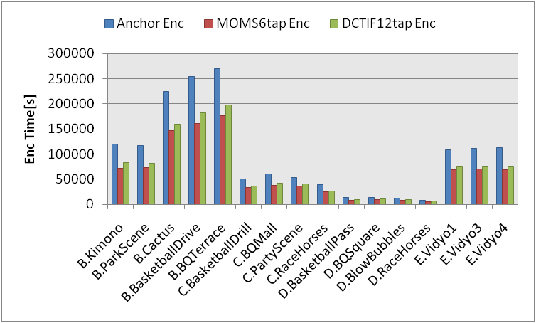
Figure 3.15: encoding times for both MOMS 6-tap and DCT-IF 12-tap in low delay

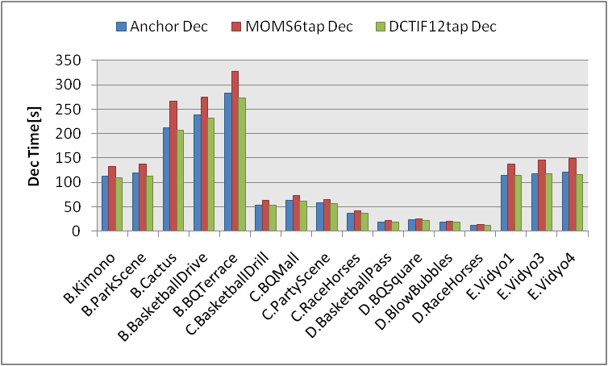
Figure 3.16: decoding times for both MOMS 6-tap and DCT-IF 12-tap in low delay

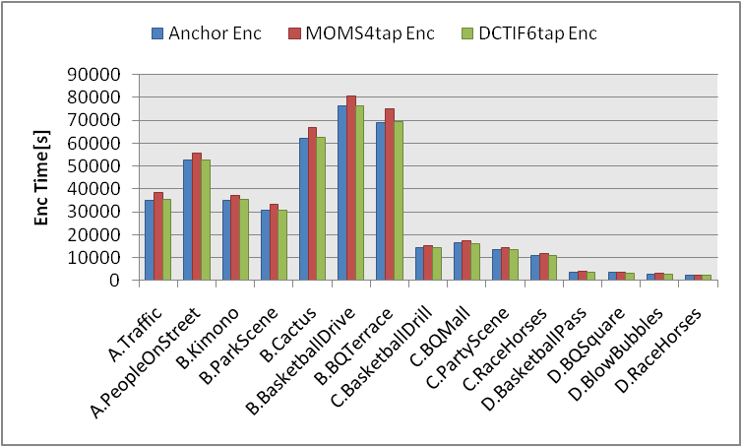
Figure 3.17: encoding times for both MOMS 4-tap and DCT-IF 6-tap in random access, low complexity

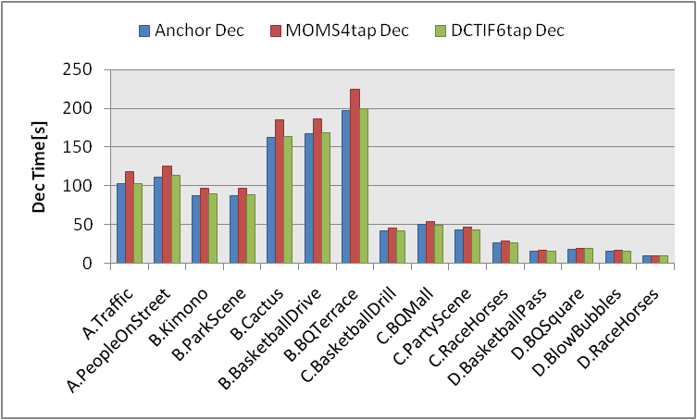
Figure 3.18: decoding times for both MOMS 4-tap and DCT-IF 6-tap in random access, low complexity

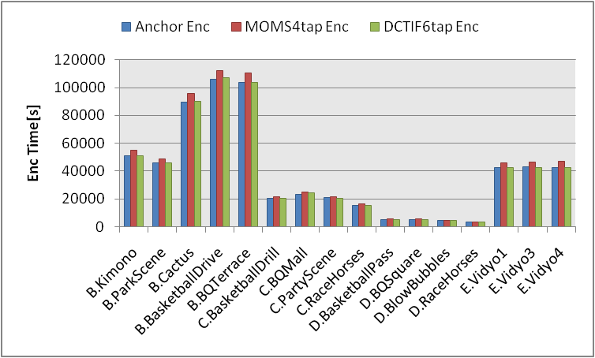
Figure 3.19: encoding times for both MOMS 4-tap and DCT-IF 6-tap in low delay, low complexity

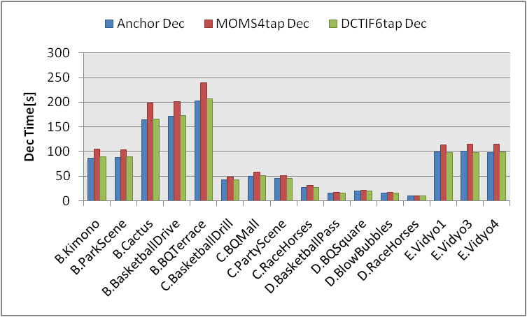
Figure 3.20: decoding times for both MOMS 4-tap and DCT-IF 6-tap in low delay, low complexity

Implementation
Some implementation concerns for MOMS are inferred. The concerns are as follows.
- The latency for the filtering is long.
- The traffic from memory in FIR filtering is great due to 16-bit accuracy for calculation.
- The size of memory to store is great due to 16-bit accuracy for calculation.

Firstly, IIR filtering in vertical direction is executed from top pixel toward bottom pixel, and then is executed from bottom pixel toward top pixel referring to figure 3.21. So the filtering for lower pixel is completed before that for upper pixel is completed. So IIR filtering of the upper left block isn’t completed unless the last line in the frame is filtered, and the latency for the filtering is long. In case of LSI design, pipeline becomes too long.

Figure 3.21: 1D IIR Filter in horizontal direction (refer to JCTVC-A116.ppt p14)
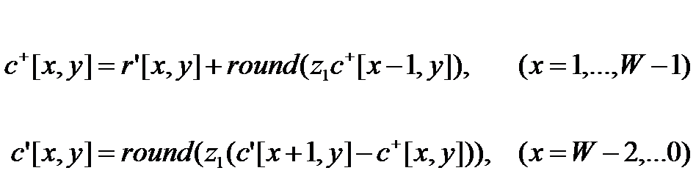

Secondly, the traffic from memory in FIR filtering for such as 8*8 block is calculated as follows. The green square shows 8*8 block and the red square shows traffic range in FIR filtering in figure 3.22. The traffic in FIR filtering for 8*8 block is 338 bytes(=13*13*2) due to 16-bit accuracy for calculation and greater than the traffic in the filtering with 8-tap and 8-bit accuracy for calculation(15*15=225bytes).
Finally, the amount of information increases because of 16-bit accuracy for calculation in FIR filtering, so the size of memory to store is twice as many as that in case of 8-bit.

Figure 3.22: 2D FIR Filter with 6-tap in case of 8*8 block
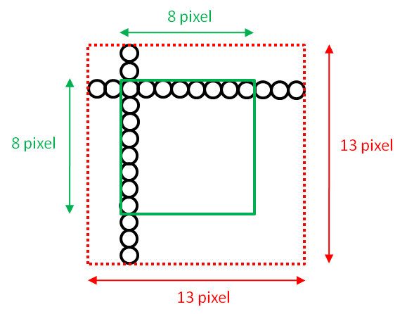
Therefore, the implementation complexity of MOMS is significantly higher than DCT-IF.

Conclusions
These experimental results for DCT-IF show that average coding gains of Y are 0.27 % for random access, high efficiency with 12-tap, -0.78% for low delay with 12-tap, 2.77 % for random access, low complexity with 6-tap and 0.67 % for low delay, low complexity with 6-tap, respectively. DCT-IF except for the case of low delay gains more than SIFO and DIF. the losses for low delay is small under 1.0% and the results also show coding gains increase for some of test sequences in the case of low delay.
It is observed that encoding time for DCT-IF 12-tap is much shorter than that of SIFO in random access and low delay, and that the difference between decoding time of SIFO and DCT-IF 12-tap is negligible for them, and that the difference between encoding time of DIF and DCT-IF 6-tap is negligible for random access, low complexity and low delay, low complexity, and that the difference between decoding time of DIF and DCT-IF 6-tap is similarly negligible for them.

The experimental results for MOMS show that average coding gains of Y are 0.73 % for random access, high efficiency with 6-tap, -0.97% for low delay, high efficiency with 6-tap, 5.45 % for random access, low complexity with 4-tap and 6.06 % for low delay, low complexity with 4-tap, respectively. MOMS 6-tap(LoCo:4-tap) has more gain than DCT-IF 12-tap(LoCo:6-tap) for almost CSs(random access, random access, low complexity and low delay, low complexity), it has gain for the specific test sequences such as class-C and class-D. The experimental results of U and V for MOMS 6-tap(LoCo:4-tap) has much gain for random access and random access, low complexity, it has much loss for low delay and low delay, low complexity than DCT-IF 12-tap(LoCo:8-tap). So it is concluded that the coding performance of MOMS is unstable depend on test sequences and test conditions.
It is observed that decoding time for high efficiency (random access and low delay) and encoding and decoding time for low complexity (random access, low complexity and low delay, low complexity) in MOMS is much longer than that DCT-IF’s. So it is concluded that the complexity of MOMS is higher than DCT-IF’s.
Implementation of MOMS is difficult because of delayed latency in IIR filtering, increased traffic and increased size of memory due to 16-bit accuracy for calculation.
Hence it is recommended that DCT-IF 12-tap for high efficiency and DCT-IF 6-tap for low complexity are used as tool for interpolation filter in Test Model.

References
[1] JCT-VC, “Draft Test Model under Consideration”, JCTVC-B205, JCT-VC Meeting, Geneva, July 2010.
[2] JCT-VC, “Tool Experiment 12: Evaluation of TMuC Tools”, JCTVC-B312, JCT-VC Meeting, Geneva, July 2010.

