    Joint Collaborative Team on Video Coding (JCT-VC)  of ITU-T SG16 WP3 and ISO/IEC JTC1/SC29/WG11  3rd Meeting: Guangzhou, CN, 7-15 October, 2010 | Document: JCTVC-C154  WG11 Number: m18180

Title: | Fine granularity slices
Status: | Input Document to JCT-VC
Purpose: | Proposal
Author(s) or  Contact(s): | Rickard Sjöberg  Per Wennersten  KI/EAB/TVV/V  164 80 Stockholm  Sweden | Tel:  Email: | rickard.sjoberg@ericsson.com  per.wennersten@ericsson.com
Source: | Ericsson
_____________________________

Abstract
In order to increase the granularity of possible slice boundary positions this contribution proposes to change the definition of slices from being a sequence of largest coding tree blocks (LCTB:s) to a sequence of the smallest coding tree blocks (SCTB:s) in order to increase the control of the slice sizes in terms of bytes.
This contribution also contains a proposal to replace UVLC for signaling of slice start positions with a fixed length code (FLC) with a one-bit shortcut for indicating the first block in a picture since this address is present in all pictures.
- Problem statement
The TMuC specification [1] currently support slice boundaries on largest coding tree block (LCTB) resolution. The current common conditions [2] specifies the LCTB size to be 64x64 which is 16 times larger than traditional 16x16 macroblocks. The problem with such coarse slice boundaries is that it becomes difficult to control the size of slices in terms of bytes. For highly active and hard-to-compress areas, one single LCTB may be larger than a target number of slice bytes.

Proposal

Proposal 1 - Slice granularity
In order to increase the granularity of slice boundaries for e.g. low delay video applications in error prone environments, we propose to define slices to be a sequence of the smallest coding tree blocks (SCTB) instead of a sequence of LCTB. Figure 1 shows a slice boundary example.
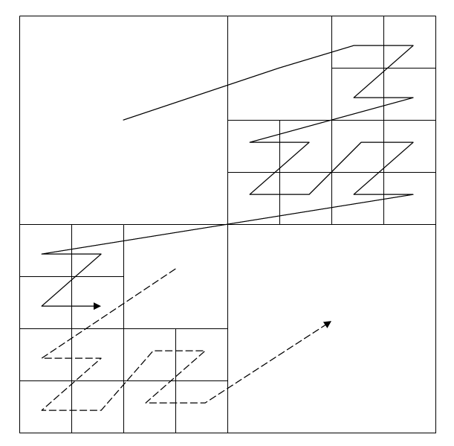
Figure 1 - LCTB with a SCTB slice boundary

Proposal 2 - Slice address signaling
Currently the TMuC specification uses UVLC to signal the slice start addresses. But the probability of the slice address does not match the UVLC codes very well. Therefore we propose to use a fixed length code (FLC) for the slice address with a one-bit shortcut for signaling the first block in a picture since this is signaled in all pictures.
The proposed slice address decoding is done as follows: First the decoder calculates the number of smallest coding tree blocks in the picture and determines the number of bits needed for the address FLC. Then one bit is read and if this bit is set, the slice address is set to 0. Otherwise a FLC is read to determine the address. The process is explained in pseudo-code below:

unsigned int nr_of_sctb_in_slice = nr_of_sctb_per_lctb * GetNumberOfLCTB();
unsigned int bits_to_use_for_slice_address = (int) ceil(log2(nr_of_sctb_in_slice-1));
if(GetBits(1) == 1)
first_sctb_in_slice = 0;
else
first_sctb_in_slice = 1 + GetBits(bits_to_use_for_slice_address);

Proposed slice syntax and semantics

slice_header( ) { | C | Descriptor
first_sctb_is_zero_flag | 2 | u(1)
if(first_sctb_is_zero_flag == 0) {
first_sctb_in_slice_minus_1 | 2 | u(v)
}

first_sctb_is_zero_flag indicates whether the slice address is 0 or not. If first_sctb_is_zero_flag is 1, the variable SliceAddress is set to 0 and the decoding starts with the first LCTB in the picture.
first_sctb_in_slice_minus_1 specifies the address of the first smallest coding tree block in the slice and shall be represented by Ceil(Log2(NumSCTBsInPicture-1)) bits in the bitstream where NumSCTBsInPicture is the number of SCTB:s in a picture. The slice decoding starts with the largest coding unit possible at the slice starting coordinate given by the address.
The slice address is specified as follows:
SliceAddress = first_sctb_in_slice_minus_1 + 1

Compression efficiency aspects
There are two compression efficiency aspects that are affected by the proposed changes. The first is the bit-cost for signaling slice addresses. The second is the bit-cost for increasing the number of end_of_slice_flag syntax elements.

Slice address
As an example, consider a 1920x1080 picture with LCTB=64x64 and SCTB=8x8 that is split into four slices. A 1920x1080 picture consist of 510 LCTB:s and 510*64 = 32640 SCTB:s. Assuming that the slice addresses expressed by LCTB indices are {0, 130, 260, 390} the total UVLC bit cost is 1+15+17+17 = 50 bits. The same slice addresses expressed in SCTB becomes {0, 8320, 16640, 24960} with a FLC bit cost of 1+16+16+16 = 49 bits. Although we have increased the slice start granularity by a factor of 64 when using FLC, the bit cost stays the same due to the inefficiency of the UVLC.

end_of_slice_flag - V2V/PIPE
An end_of_slice_flag is sent after each LCTB for V2V/PIPE in the TMuC specification [1]. Defining slices as a sequence of SCTB:s instead will increase the number of these bits that have to be sent, by up to a factor of 64 given a LCTB size of 64x64 and a SCTB size of 8x8. Experiments conducted on the first 9 frames of all common condition test sequences using CABAC showed a bitrate increase of 0.05% for both random access and low delay coding.

end_of_slice_flag for VLC coding
The end_of_slice_flag syntax element is not present for VLC coding in the TMuC specification [1]. However, it is still used in the TMuC version 0.8.1 source code. An experiment was conducted where the bits spent on end_of_slice_flag codewords were counted for the low complexity anchor bit streams. It was found that 0.5% and 0.7% of the bits were spent on end_of_slice_flag codewords for random access and low delay respectively.
However, the signaling of end_of_slice_flag can easily be removed from the TMuC encoder and decoder. Then there is no end_of_slice_flag overhead caused by the increase of slice granularity.
- References
- "Test Model under Consideration", JCTVC-B205_draft005, Geneva, Switzerland, July 2010.
- Frank Bossen, “Common test conditions and software reference configurations”, JCTVC-B300, Geneva, Switzerland, July 2010.

Patent rights declaration(s)
Ericsson AB may have IPR relating to the technology described in this contribution and, conditioned on reciprocity, is prepared to grant licenses under reasonable and non-discriminatory terms as necessary for implementation of the resulting ITU-T Recommendation | ISO/IEC International Standard (per box 2 of the ITU-T/ITU-R/ISO/IEC patent statement and licensing declaration form).

