    Joint Collaborative Team on Video Coding (JCT-VC)  of ITU-T SG16 WP3 and ISO/IEC JTC1/SC29/WG11  3nd Meeting: Guangzhou, P.R.CHINA, 7-15 October, 2010 | Document: JCTVC-C112  WG11 Number: m18135

Title: | Fast Transforms for HEVC Test Model
Status: | Input Document to JCT-VC
Purpose: | Proposal
Author(s) or  Contact(s): | Wei Dai  Madhu Krishnan  Pankaj Topiwala  5840 Banneker Rd,  Columbia, MD 21044 USA | Tel:  Email: | 410-730-6922  pankaj@fastvdo.com
Source: | FastVDO LLC
_____________________________

Abstract
The use of block transforms has been a fundamental tool in all video compression standards. And it has been demonstrated that the coding efficiency of high resolution video can be improved by the use of large transforms as well as large block sizes [1]. Beyond the 4x4 and 8x8 transform sizes already found in AVC/H.264, larger transform sizes of 16x16, 32x32 and even 64x64 are also included as core components of the current Test Model under Consideration (TMuC) for HEVC. However, since large transform sizes do entail some non-trivial computational complexity, one may ask what is the cost-benefit analysis of their inclusion in the forthcoming Test Model. In fact, the larger transforms in TMuC [1] are all based on Chen's fast DCT algorithm because of its regular butterfly structure and its extensibility to any desired transform sizes of order N=2^{m} with m>=1. Even then, for complexity reasons, one prefers integer rather than floating-point versions of Chen's DCT. Indeed, fast integer transforms based on Chen's factorization are already in the current TMuC (0.8). However, in this document, we show that the complexity can be reduced even further with NO loss of performance. We propose fast transforms of each candidate size that not only provide virtually identical coding performance, but offer useful gains in computational complexity. In this way, the complexity of the transforms can be kept to a minimum, even when using large transform sizes, thus effectively eliminating concerns in considering their use in the Test Model. Thus, attention can be focused purely on their coding efficiency benefits.

Introduction
The current Test Model under Consideration (version 0.8) derives from proposal A124 and its associated software [6] of Samsung and BBC, but incorporating various other inputs. In particular, A124 proposed the use of transforms up to size 64. The document itself discussed the transform notionally as floating-point transforms with rotations, while the software implementation contained two versions – both integer – one generic (default) and the other a fast approximation, with potentially lower performance. Perhaps for perceived reasons of efficiency, to avoid duplication only one transform per size has been retained in the TMuC – the default integer transform. Yet the fast transform has lower complexity and performs equally well. In this proposal, we indeed show that there is NO loss of performance, and a useful complexity gain, in using fast transforms of each size. Since the 4-pt and 8-pt transforms retained from AVC/H.264 are already well understood, we focus on transforms of size 16 and higher.

DCT Representation Methodology
As is well-known, the DCT and its approximations can be studied in terms of their signal-flow representations, see for example [7]. By systematic analysis of the structure of the Fast Fourier Transform and its associated sub-transforms, an entire industry has developed to create fast and efficient implementations of larger transforms based on smaller ones (e.g., split-radix). So much so, that today, we understand the DCT can be represented purely in terms of three basic components: (a) butterflies, (b) scaling factors, and (c) planar rotations. (It is already remarkable that higher-dimensional rotations can be represented as concatenations of a finite number of planar rotations.) Of these components, the butterfly is already efficient, while the scaling factors may be irrational but can be approximated by rational (and even dyadic-rational ones). However, the rotations continue to be problematic for efficient representation, on account of using transcendental functions and numbers.
Yet it is a valuable theorem that a planar rotation can be representated in terms of three shears, or lifting steps [2, 5]; see figures 1 and 2. These shears still contain parameters that are generally irrational, but again, these can now be approximated by rational (or dyadic-rational) coefficients.

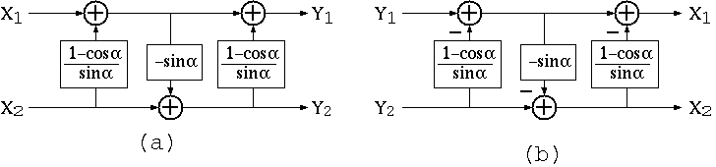
Fig 1. (a) Representation of a plane rotation by 3 lifting steps. (b) Inverse transform.
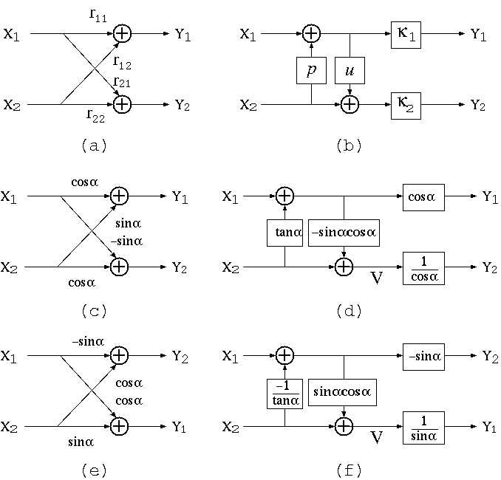
Fig. 2. (a) A general rotation; (b) The scaled lifting structure for (a); (c) An orthogonal plane rotation; (d) The scaled lifting structure for (c); (e) The permuted version of (c); (f) The scaled lifting structure for (e).

In terms of counting computational complexity in representing Chen's fast DCT, we have the following calculations.

When N=2^{m}, m >= 3, the number of butterflies is
(m-1)*2^{(m-1)} for m>=3.
Furthermore, the number of rotations is
(m-1)*2^{(m-2)}+1.
Of these, the number of type I rotations is
2^{(m-2)}
while the number of type II rotations is
(m-2)*2^{(m-2)}+1.
Since type I rotation needs only two multiplications, the number of multiplications is
4* ((m-2)*2^{(m-2)}+1) +2*2^{(m-2)}= (2m-3)*2^{(m-1)} +4.
The number of addition operations is
2*(m-1)*2^{(m-1)}+2* ((m-2)*2^{(m-2)}+1) +2*2^{(m-2) =}3*(m-1)*2^{(m-1)}+2.
It is well-known that a plane rotation can be performed by 3 shears [2, 5]. That representation has direct complexity consequences. A rotation, which notionally needs 4 multiplications and 2 additions, can be implemented by 3 multiplications and 3 additions. In many cases (see figure 2), this can be reduced to 2 multiplications and 2 additions. Finally, the computational complexity can be further reduced by taking into account the complexity of the individual lifting coefficients (e.g., dyadic rational) as well as their interdependency. It can be shown that the parametrization of each rotation angle can be limited to no more than two dyadic lifting steps, by approximating rotation angles jointly [3]; see again figure 2.
So with these weapons in our arsenal, the fast integer approximations can be developed. In fact, it is unnecessary to do much work, as good transforms are already at hand. For convenience, we reuse the size 16 and 32 fast transforms already incorporated in the A124 proposal software [6]. For size 64, we use the X32 x H2, where H2 is the 2x2 Hadamard matrix:
H2 = [1, 1; 1, -1].
We obtain the following computational simplifications compared to the integer transforms in TmuC 0.8.

Table 1 Number of operations of 16 point one dimensional transforms
Transform | Operations | Number | Number of
Chen's Fast DCT | + | 74 | 118
Chen's Fast DCT | * | 44 | 118
Table 2 Number of operations of 32 point one dimensional transforms
Transform | Operations | Number | Total operations
Chen's Fast DCT | + | 194 | 310
Chen's Fast DCT | * | 116 | 310

Table 3 Number of operations of 16 point one dimensional transforms
Transform | Operations | Number | Total operations | Total Ops/sample
TMuC 8.0 | + | 150 | 268 | 16.75
TMuC 8.0 | >> | 118 | 268 | 16.75
Proposed | + | 106 | 167 | 10.43
Proposed | >> | 55 | 167 | 10.43

Table 4 Number of operations of 32 point one dimensional transforms
Transform | Operations | Number | Total operations | Total Ops/sample
TMuC 8.0 | + | 484 | 871 | 27.22
TMuC 8.0 | >> | 387 | 871 | 27.22
Proposed | + | 353 | 507 | 15.84
Proposed | >> | 154 | 507 | 15.84

Table 5 Number of operations of 64 point one dimensional transforms
Transform | Operations | Number | Total operations | Total Ops/sample
TMuC 8.0 | + | 1416 | 2600 | 40.63
TMuC 8.0 | >> | 1184 | 2600 | 40.63
Proposed | + | 706 | 1014 | 15.84
Proposed | >> | 308 | 1014 | 15.84

Test Results
Our test results are included in a separate spreadsheet. In brief, the tests conducted to date confirm (CS2) that there is NO loss of performance relative to the current TMuC transforms. On the other hand, the computational complexity savings can be 60% on the 16-pt, nearly 2:1 on the size 32, and nearly 3:1 on the size 64 transforms. Further complexity gain will likely be achieved by further detailed analysis of computational paradigms. Further testing is on-going and additional results will be presented at the meeting as they become available.

References
[1] JCT-VC, “Test Model under Consideration (TMuC),” JCT-VC B205, Geneva, CH, July 2010.
[2] I. Daubechies and W. A. Pearlman, “Factoring wavelet transforms into lifting steps,” J. Fourier Anal. Appl., vol. 4, pp. 247-269, 1998.
[3] J. Liang and T. D. Tran, "Fast multiplierless approximations of the DCT with the lifting scheme," IEEE Trans. on Signal Processing, vol. 49, pp. 3032-3044, Dec. 2001.
[4] T. D. Tran, "The BinDCT: fast multiplierless approximation of the DCT," IEEE Signal Processing Letters, vol. 7, pp. 141-145, Jun. 2000.
[5] J. Liang, T. Tran, P. Topiwala, “A 16-bit architecture for H.26L, treating DCT transforms and quantization,” ITU VCEG doc M16, Austin, TX, April, 2001.
[6] K. McCann et al, “Samsung's Response to the Call for Proposals on Video Compression Technology,” JCTVC-A124, Dresden, April, 2010.
[7] P. P. Vaidyanathan, Multirate Systems and Filter Banks, Prentice-Hall, 1993.

Patent rights declaration(s)
FastVDO LLC may have IPR relating to the technology described in this contribution and, conditioned on reciprocity, is prepared to grant licenses under reasonable and non-discriminatory terms as necessary for implementation of the resulting ITU-T Recommendation | ISO/IEC International Standard (per box 2 of the ITU-T/ITU-R/ISO/IEC patent statement and licensing declaration form).

