    Joint Collaborative Team on Video Coding (JCT-VC)  of ITU-T SG16 WP3 and ISO/IEC JTC1/SC29/WG11  3rd Meeting: Guangzhou, CN, 7-15 October, 2010 | Document: JCTVC-C108  WG11 Number: m18131

Title: | Jointly optimal intra prediction and adaptive primary transform
Status: | Input Document to JCT-VC
Purpose: | Proposal
Author(s) or  Contact(s): | Ankur Saxena, Felix C. Fernandes | Tel:  Email: | 1-9727617761, 1-9727617427  asaxena@sta.samsung.com,  felix.f@sta.samsung.com
Source: | Samsung Electronics, Co., Ltd.
_____________________________

Abstract
This document proposes applying either the conventional Discrete Cosine Transform (DCT) or a derived Discrete Sine Transform (DST) for intra prediction as a primary transform in TMuC 0.7. For each of the upto 34 modes in unified intra-prediction in TMuC 0.7, the derived transform (separable along the horizontal and vertical directions) is shown to be theoretically optimal with performance close to KLT. The proposed primary transform is based on the intra-prediction modes with no additional signaling information, works in a single-pass and does not incur any additional computational complexity. No training was required to derive the transform and it requires the storage of only one sine matrix in addition to the conventional DCT at each block size. Comparison is performed in TMuC 0.7 between the proposed adaptive DCT/DST primary transform and the conventional DCT for two cases, viz., when the secondary transform in intra prediction, i.e., Rotational Transform is OFF and ON. Simulation results show a BD Rate improvement of 0.2% and 0.1% averaged over all the video sequences, when the Rotational Transform is OFF and ON respectively.
- Introduction
Most image and video-coding standards such as JPEG, H.264/AVC, VC-1 employ block-based transform coding as a tool to efficiently compress the input image and video signals. The pixel domain data is transformed to frequency domain using a transform process on a block-by-block basis. For typical images, most of the energy is concentrated in the low-frequency transform coefficients. Following the transform, a bigger step-size quantizer can be used for higher-frequency transform coefficients in order to compact energy more efficiently to attain better compression. Hence it is required to devise the optimal transform for each image block to fully decorrelate the transform coefficients. The Karhunen Loeve Transform (KLT) possesses several attractive properties, e.g., in high resolution quantization of Gaussian signals and full decorrelation of transform coefficients. However, practical use of KLT is limited due to its high computational complexity and it has been shown in [5] that DCT provides an attractive alternative to KLT in terms of energy compaction and performance close to KLT. But with the advent of intra prediction, this is no longer the case and the optimal transform should be adaptive to inter or intra prediction mode
In the current Test Model under Consideration (TMuC) [6], following intra prediction, various different intra prediction transforms are being used. The conventional DCT or Mode Dependent Directional Transform (MDDT) is being used as the primary transform and is followed by the Rotational Transform as the secondary transform.

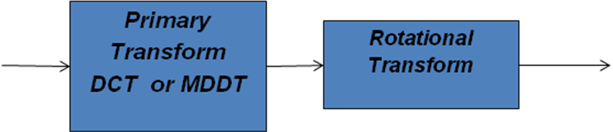

Fig. 1 : Transform structure for intra prediction in TMuC 0.7

Han et al. in [2] analytically derived a DST with frequency and phase components different from the conventional DCT to be the actual KLT along the prediction direction for intra modes in H.264/AVC. They also showed that if prediction is not performed along a particular direction, then DCT performs close to KLT. The idea was applied to the vertical and horizontal modes in intra-prediction in H.264/AVC and a combination of the proposed DST and conventional DCT was used adaptively. Yeo et al. in [3] extended similar ideas by applying the combination of DST and DCT to other prediction modes in H.264/AVC and showed that there is only a minor loss in performance in comparison to MDDT.
For block sizes 16*16 to 64*64, DCT is the only primary transform being used in TMuC. In this work, we propose an adaptive combination of the derived DST and DCT as the first primary transform for these block sizes and compare the performance under various conditions: when the secondary transform : Rotational Transform is ON or OFF. We first derive the separable optimal transform along the horizontal and vertical directions for all the modes in Unified Intra Directional Prediction [7] at large block sizes such as 16*16, 32*32, 64*64 and then show performance comparison of the proposed schemes with current TMuC 0.7 under various settings.

- Algorithm Description
In TMuC 0.7, unified intra prediction is used and there can be upto 34 different modes at a particular block size. These 34 intra-prediction directional modes can be divided into 3 categories as follows:
1. Category 1 oblique modes (Fig. 2): Here prediction is performed completely from the decoded pixels from either one of the following: the top row or the left column. The vertical mode 0 and the horizontal mode 1 in [6] are special cases of this oblique mode.
2. Category 2 oblique modes (Fig. 3): Here prediction is performed from both the top row and left column pixels.
3. DC mode (Fig. 4): Here prediction is performed from an average value of the all the available decoded pixels similar to H.264/AVC [6].

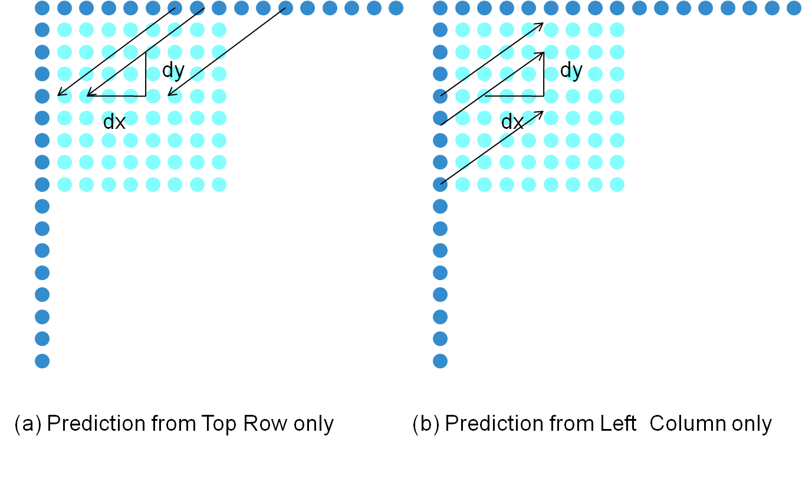

Fig. 2 Category 1 oblique modes: Here prediction is from one direction only: either the top row or left column

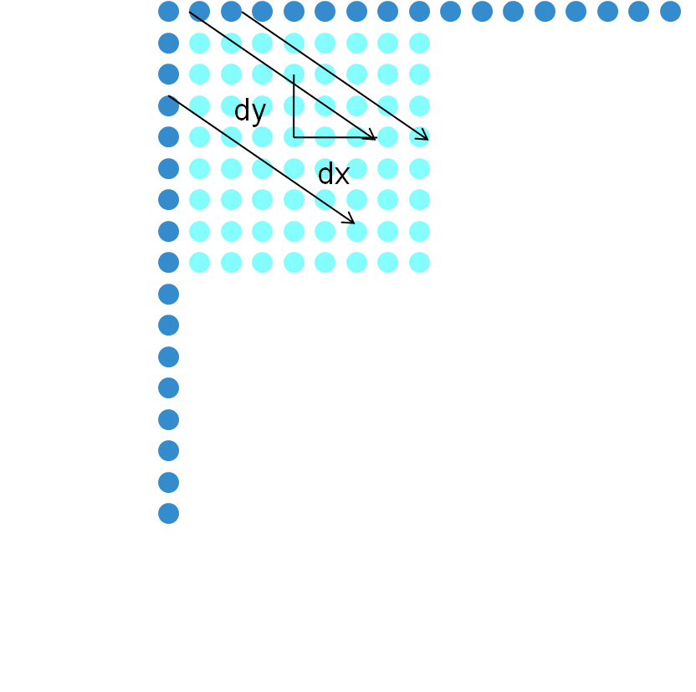
Fig. 3 Category 2 oblique modes: Here prediction is from both the directions: top row and left column
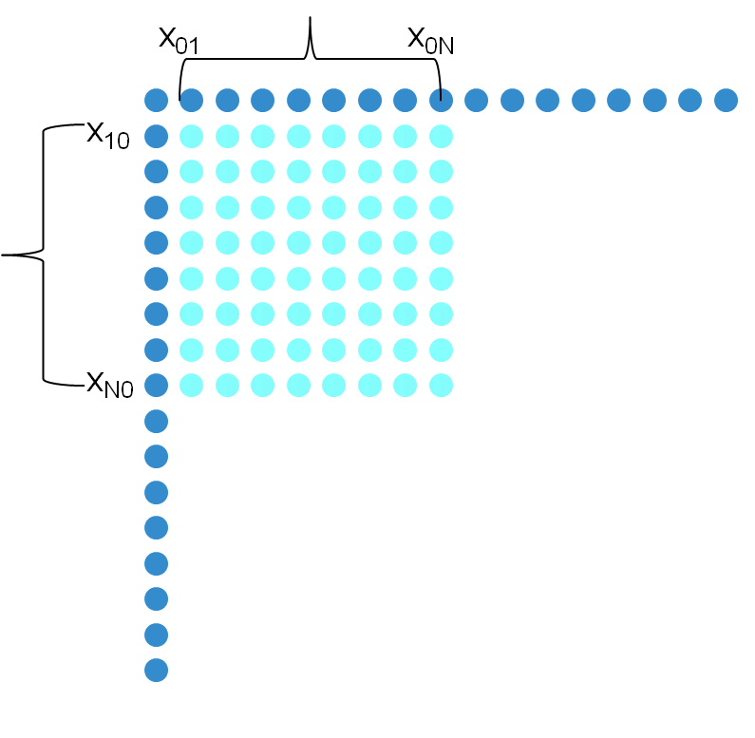

Fig. 4 DC Prediction Mode: Prediction is performed from the average of pixels x₀₁ to x_{0N} and x₁₀ to x_{N0} or a subset of these when they are available similar to H.264/AVC.

1. Analysis for Category 1 Oblique Modes

Consider a Category 1 oblique mode in Fig. 5. Here prediction is performed from the top row in the direction showed by the arrows. Specifically a (dx,dy) pair denotes the horizontal and vertical distance respectively [6] and can indicate the prediction direction.
We assume the same Gauss-Markov model for the image pixels as in Han et al.’s work in [2], i.e., in the context of 1-d:
$$x_{k}={ρx}_{k−1}+e_{k}$$
where $ρ$ is the correlation coefficient between the pixels, e_{k} is a white-noise process with zero mean, and variance $1−ρ^{2}$, and k=0..N. Here x₀ denotes the boundary pixel and x₁ to x_{N} are the pixels to be encoded. The correlation between pixels x_{k} and x_{l} is given by R_{kl} = $ρ^{|k−l|}$. For the 2-d image case, we assume a separable model along the horizontal and vertical directions. Hence the correlation between pixels x_{ij} and x_{mn} is$ρ^{|i−m|}\text{.}ρ^{|j−n|}=ρ^{|i−m|+|j−n|}$.

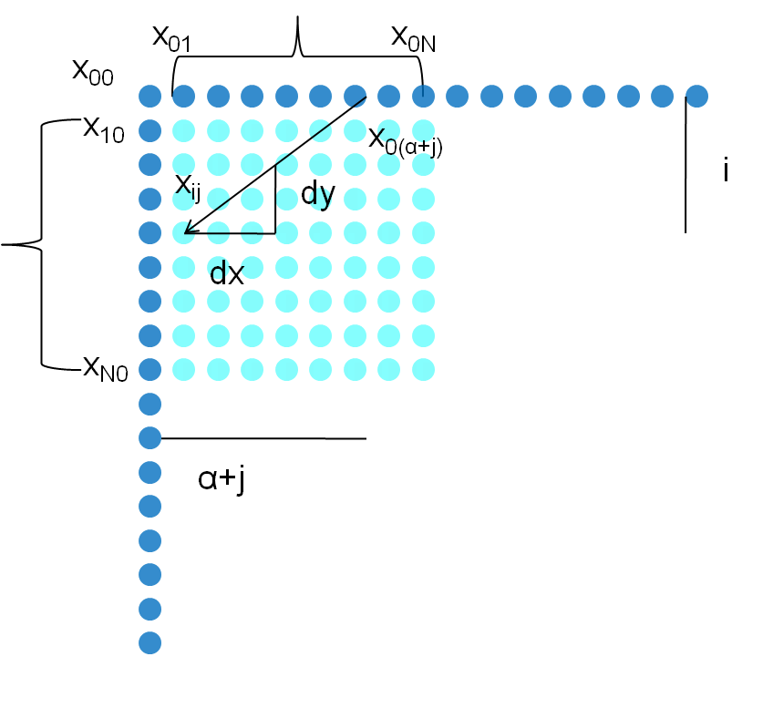
Fig. 5: Derivation of the transforms for category 1 oblique modes

In Fig. 6, the pixels x₀₀, x₀₁, x_{02…} and x₁₀, x₂₀… denote the boundary pixels that have already been encoded. Pixels x_{ij} ($i,j∈\left\{1\text{.}\text{.}N\right\}$) denote the pixels to be encoded. Let the prediction for a pixel x_{ij} be given by ${\tilde{x}}_{\text{ij}}=x_{0(α+j)}$as shown in Fig. 6 where $α>0$. In the case when $α$is not an integer, the pixel $x_{0(α+j)}$is interpolated from its adjacent two neighboring pixels as specified in [6], but for simplicity, we keep the predictor as $x_{0(α+j)}$only for analysis purposes. From the property of similar triangles, we can derive:
$$α=({\text{dx}}/{\text{dy}})\text{.}i$$
Hence the prediction error residue for a pixel is given as $e_{\text{ij}}=x_{\text{ij}}−{\tilde{x}}_{\text{ij}}=x_{\text{ij}}−x_{0(α+j)}$
The overall matrix for the error-residues for the N*N image block is:
$$E=X−\tilde{X}$$
where $X$is the original N*N image block and $\tilde{X}$is its prediction. Element ‘ij’ of matrix E is given by :$e_{\text{ij}}=x_{\text{ij}}−{\tilde{x}}_{\text{ij}}=x_{\text{ij}}−x_{0(α+j)}$.

Assuming the separable pixel model, we seek to find the optimal transforms in both the vertical and horizontal directions for the above prediction residue matrix. Specifically for finding the vertical transform of a column of E, we require to find a matrix which diagonalizes the autocorrelation matrix of the corresponding columns. Similar for the horizontal transform for a particular row of E, we seek a matrix which diagonalizes the autocorrelation matrix of that particular row. We first consider column ‘j’ of E:

$$E_{j}=\left[\begin{matrix}e_{1j} \\ e_{2j} \\ \text{.} \\ \text{.} \\ e_{\text{Nj}}\end{matrix}\right]=\left[\begin{matrix}x_{1j}−x_{0(j+1\frac{\text{dx}}{\text{dy}})} \\ x_{2j}−x_{0(j+2\frac{\text{dx}}{\text{dy}})} \\ \text{.} \\ \text{.} \\ x_{\text{Nj}}−x_{0(j+N\frac{\text{dx}}{\text{dy}})}\end{matrix}\right]$$

The autocorrelation matrix of column E_{j} is a N*N matrix given by:

$$R_{\text{Col}}=E(E_{j}E_{j}^{T})=E(\left[\begin{matrix}e_{1j} \\ e_{2j} \\ \text{.} \\ \text{.} \\ e_{\text{Nj}}\end{matrix}\right][\begin{matrix}e_{1j} & e_{2j} & \text{.} & \text{.} & e_{\text{Nj}}]\end{matrix})$$

where E(.) denotes the Expectation operator. We denote term ‘ik’ of the above matrix by R_{Col,ik} :

$$\begin{aligned}R_{\text{Col},\text{ik}}=E(e_{\text{ij}}\text{.}e_{\text{kj}})=E[(x_{\text{ij}}−x_{0(j+i\frac{\text{dx}}{\text{dy}})})(x_{\text{kj}}−x_{0(j+k\frac{\text{dx}}{\text{dy}})})] \\ =E[x_{\text{ij}}x_{\text{kj}}+x_{0(j+i\frac{\text{dx}}{\text{dy}})}x_{0(j+k\frac{\text{dx}}{\text{dy}})}−x_{\text{ij}}x_{0(j+i\frac{\text{dx}}{\text{dy}})}−x_{\text{kj}}x_{0(j+k\frac{\text{dx}}{\text{dy}})}] \\ =ρ^{|i−k|}+ρ^{|(i−k)\frac{\text{dx}}{\text{dy}}|}−ρ^{i+k|\frac{\text{dx}}{\text{dy}}|}−ρ^{k+i|\frac{\text{dx}}{\text{dy}}|}\end{aligned}$$

From the above expression, it can be seen that $ρ=1$ is a factor of all the terms in the matrix R_{Col}. We can factorize a constant
$c≡1−ρ$ from R_{Col}. Note that$ρ$is the correlation coefficient between the image pixels and, in general, it is typically near but not equal to 1. With this assumption, we can approximate R_{Col,ik} as follows:
$$R_{\text{Col},\text{ik}}=c\text{.}\underset{ρ→1}{\text{lim}}\frac{R_{\text{Col},\text{ik}}}{1−ρ}=c\text{.}(−1)\text{.}[|i−k|+|(i−k)\frac{\text{dx}}{\text{dy}}|−(i+k|\frac{\text{dx}}{\text{dy}}|)−(k+i|\frac{\text{dx}}{\text{dy}}|$$

where we applied the L’Hopital’s rule. This can be further simplified to:
$$R_{\text{Col},\text{ik}}=2c\text{.}(1+|\frac{\text{dx}}{\text{dy}}|)\text{min}(i,k)$$
To find a matrix which diagonalizes R_{Col}, we can ignore the constant terms $2c\text{.}(1+|\frac{\text{dx}}{\text{dy}}|)$, and find the matrix which diagonalizes the following matrix $M≡\text{min}(i,k)$ or equivalently $M^{−1}$ :

$M≡\left[\begin{matrix}1 & 1 & 1 & 1 & \text{.} & \text{.} & \text{.} & 1 \\ 1 & 2 & 2 & 2 & \text{.} & \text{.} & \text{.} & 2 \\ 1 & 2 & 3 & 3 & \text{.} & \text{.} & \text{.} & 3\text{.} \\ 1 & 2 & 3 & 4 & \text{.} & \text{.} & \text{.} & 4 \\ \text{.} & \text{.} & \text{.} & \text{.} & \text{.} & \text{.} & \text{.} & \text{.} \\ \text{.} & \text{.} & \text{.} & \text{.} & \text{.} & \text{.} & \text{.} & \text{.} \\ \text{.} & \text{.} & \text{.} & \text{.} & \text{.} & \text{.} & \text{.} & \text{.} \\ 1 & 2 & 3 & 4 & \text{.} & \text{.} & \text{.} & N\end{matrix}\right]$ $M^{−1}≡\left[\begin{matrix}2 & −1 & 0 & \text{.} & \text{.} & \text{.} & \text{.} & 0 \\ −1 & 2 & −1 & \text{.} & \text{.} & \text{.} & \text{.} & \text{.} \\ 0 & −1 & 2 & \text{.} & \text{.} & \text{.} & \text{.} & \text{.} \\ \text{.} & 0 & −1 & 2 & \text{.} & \text{.} & \text{.} & \text{.} \\ \text{.} & \text{.} & \text{.} & \text{.} & \text{.} & \text{.} & \text{.} & \text{.} \\ \text{.} & \text{.} & \text{.} & \text{.} & \text{.} & \text{.} & \text{.} & \text{.} \\ \text{.} & \text{.} & \text{.} & \text{.} & \text{.} & \text{.} & \text{.} & −1 \\ 0 & \text{.} & \text{.} & \text{.} & \text{.} & 0 & −1 & 2\end{matrix}\right]$

From [8], the KLT of the matrix is the following sine transform:

$$[T_{S}]_{i,j}=\frac{2}{\sqrt{2N+1}}\text{sin}\frac{(2i−1)jπ}{2N+1}$$
Note that the above expression is independent of column ‘j’ of the error residue and is identical to the one derived in [2] and [3]. Hence, the above DST can be applied as the vertical transform on all the columns of the intra-prediction residue E.
Next we consider the horizontal transform to be applied to row ‘i’ of E. The autocorrelation matrix for row ‘i’ is:

$$R_{\text{row}}=E(\left[\begin{matrix}e_{i1} \\ e_{i2} \\ \text{.} \\ \text{.} \\ e_{\text{iN}}\end{matrix}\right][\begin{matrix}e_{i1} & e_{i2} & \text{.} & \text{.} & e_{\text{iN}}]\end{matrix})$$
Term ‘mn’ of the above matrix is denoted by R_{row,mn} ,

$$\begin{aligned}R_{\text{row},\text{mn}}=E(e_{\text{im}}\text{.}e_{\text{in}})=E[(x_{\text{im}}−x_{0(m+i\frac{\text{dx}}{\text{dy}})})(x_{\text{in}}−x_{0(n+i\frac{\text{dx}}{\text{dy}})})] \\ =E[x_{\text{im}}x_{\text{in}}+x_{0(m+i\frac{\text{dx}}{\text{dy}})}x_{0(n+i\frac{\text{dx}}{\text{dy}})}−x_{\text{in}}x_{0(m+i\frac{\text{dx}}{\text{dy}})}−x_{\text{im}}x_{0(n+i\frac{\text{dx}}{\text{dy}})}] \\ =ρ^{|m−n|}+ρ^{|(m−n)\frac{\text{dx}}{\text{dy}}|}−ρ^{i+|m−n+i\frac{\text{dx}}{\text{dy}}|}−ρ^{i+|m−n−i\frac{\text{dx}}{\text{dy}}|}\end{aligned}$$

Again $ρ=1$ is a factor of all the terms in the matrix R_{row} . We can use a similar procedure to simplify term ‘mn’ of R_{row} as we did for R_{col} :

$$\begin{aligned}R_{\text{row},\text{mn}}=c\text{.}\underset{ρ→1}{\text{lim}}\frac{R_{\text{row},\text{mn}}}{1−ρ}=c\text{.}(−1)\text{.}[|m−n|+|(m−n)\frac{\text{dx}}{\text{dy}}|−(i+|m−n+i\frac{\text{dx}}{\text{dy}}|)−(i+|m−n−i\frac{\text{dx}}{\text{dy}}|) \\ c\text{.}[2i+|m−n+i\frac{\text{dx}}{\text{dy}}|+|m−n−i\frac{\text{dx}}{\text{dy}}|−|m−n|]\end{aligned}$$

Term ‘mn’ of the matrix R_{row} is dependent on (m-n), given the row ‘i’ and hence the matrix R_{row} is Toeplitz. It has been shown in [5] that DCT performs close to the KLT for the case of Toeplitz matrices. So DCT can be applied as the horizontal transform for all the rows. To summarize, we should apply:
(a) DST as the vertical transform and
(b) DCT as the horizontal transform
for the Category 1 oblique modes shown in Fig. 2(a). By symmetry, we conclude that the DST should be applied as the horizontal transform and DCT as the vertical transform when prediction is applied in the horizontal direction as shown in Fig. 2(b)
Next we move to the analysis of category 2 oblique modes.

2. Analysis for Category 2 Oblique Modes:
Consider a sample oblique mode 2 in Fig. 3. Here the prediction is performed from both the left column and the top row of pixels.
While a similar analysis can be performed to calculate the prediction residue matrix E, and the autocorrelation matrix for a column j (respectively row i) of the matrix E, the resulting autocorrelation matrix for column j (respective row i) does not have a nice structure as the ones for Category 1 oblique modes. Further, the autocorrelation matrix is dependent on column ‘j’ implying a different KLT for each column. While it is possible to compute a separate KLT for each of the N columns of the prediction residue E matrix, the computational complexity for N different transforms per direction is huge. We propose to use the transform structure as shown in Table 1 for category 2 modes. In the current implementation, however, for category 2 modes, we have used the conventional DCT along both the horizontal and vertical directions and this can be improved further.

3. Analysis for DC Mode
In DC mode, the predictor is the mean of pixels from the top-row and left-column. Yeo et al. in [3] showed that DCT is optimal along both the vertical and horizontal directions for DC mode. Their analysis can be straight-forwardly extended to the DC mode in TMuC 0.7 for all the image block sizes from 16*16 to 64*64.

Summary for the various categories of optimal Transform for Unified Directional Intra Prediction
In the current TMuC 0.7, there are upto 34 different unified directional prediction modes for the 16*16 and 32*32 block size and 5 for the 64*64 size. The first 3 columns of the following table are from Table 5.1 in [6] and the last column denotes how we have divided the prediction modes in Category 1 (prediction only from top row in the case of Intra_Vertical or only from left column in the case of Intra_Horizontal); Category 2 (prediction from both the top row and left columns) and the DC mode. The optimal transforms in each case is a combination of DST and DCT. Note that while we show the angles for Angular Directional Prediction [6,7] in Table 1, i.e., from -8 to 8, a one-to-one mapping exists between these angles to the various modes to unified intra prediction as specified in [6].

Table 1: Categorization of various intra prediction modes in [6] and the proposed transforms along the vertical and horizontal directions
IntraPredMode  [ puPartIdx ] | IntraPredType [ puPartIdx ] | IntraPredAngleID  [ puPartIdx ] | Category of Oblique Mode | Vertical  Transform | Horizontal  Transform
0 | Intra_Vertical | 0 | 1 | DST | DCT
1 | Intra_Horizontal | 0 | 1:Prediction from Left Column | DCT | DST
2 | Intra_DC | - | DC Mode | DCT | DCT
3 | Intra_Vertical | -8 | 2 | DST | DCT
4 | Intra_Vertical | -4 | 2 | DST | DCT
5 | Intra_Vertical | +4 | 1 | DST | DCT
6 | Intra_Vertical | +8 | 1 | DST | DCT
7 | Intra_Horizontal | -4 | 2 | DCT | DST
8 | Intra_Horizontal | +4 | 1 | DCT | DST
9 | Intra_Horizontal | +8 | 1 | DCT | DST
10 | Intra_Vertical | -6 | 2 | DST | DCT
11 | Intra_Vertical | -2 | 2 | DST | DCT
12 | Intra_Vertical | +2 | 1 | DST | DCT
13 | Intra_Vertical | +6 | 1 | DST | DCT
14 | Intra_Horizontal | -6 | 2 | DCT | DST
15 | Intra_Horizontal | -2 | 2 | DCT | DST
16 | Intra_Horizontal | +2 | 1 | DCT | DST
17 | Intra_Horizontal | +6 | 1 | DCT | DST
18 | Intra_Vertical | -7 | 2 | DST | DCT
19 | Intra_Vertical | -5 | 2 | DST | DCT
20 | Intra_Vertical | -3 | 2 | DST | DCT
21 | Intra_Vertical | -1 | 2 | DST | DCT
22 | Intra_Vertical | +1 | 1 | DST | DCT
23 | Intra_Vertical | +3 | 1 | DST | DCT
24 | Intra_Vertical | +5 | 1 | DST | DCT
25 | Intra_Vertical | +7 | 1 | DST | DCT
26 | Intra_Horizontal | -7 | 2 | DCT | DST
27 | Intra_Horizontal | -5 | 2 | DCT | DST
28 | Intra_Horizontal | -3 | 2 | DCT | DST
29 | Intra_Horizontal | -1 | 2 | DCT | DST
30 | Intra_Horizontal | +1 | 1 | DCT | DST
31 | Intra_Horizontal | +3 | 1 | DCT | DST
32 | Intra_Horizontal | +5 | 1 | DCT | DST
33 | Intra_Horizontal | +7 | 1 | DCT | DST

- Testing Conditions & Simulation Results
The derived DST matrices for the 16*16, 32*32 and 64*64 cases respectively, that we have used in the TMuC 0.7 implementation are given in Appendix 1. We tested our proposed adaptive DCT/DST scheme and compared it with the conventional DCT for the 16*16, 32*32 and 64*64 block sizes. The encoding conditions were as specified in the common testing conditions for tests in TMuC 0.7 in [11] and the intra-high efficiency encoder_intra.cfg file was used.
For the first test case, the anchor was TMuC 0.7 with all the tools ON except Rotational Transform which was switched OFF. In the proposed scheme, the adaptive DCT/DST was used as the primary transform instead of the conventional DCT for the 16*16 and higher block sizes. Simulation results for the video sequences for first 25 frames across all classes are shown in Table 2. Here we obtain a BD Rate improvement of about 0.2% when averaged across all the video sequences.
In the second test case, the anchor was TMuC 0.7 with all the tools including Rotational Transform ON and the conventional DCT as the primary transform. The proposed scheme had adaptive DCT/DST as the primary transform for block sizes 16*16 and higher. Simulation results for the video sequences for the first 25 frames across all the classes are shown in Table 3. Here we obtained a BD Rate improvement of about 0.1% when averaged across all the video sequences.

Table 2: Comparison of the proposed adaptive DCT/DST scheme with conventional DCT as the primary transform in TMuC 0.7. Here the secondary transform: Rotational Transform was OFF.

Class Name | Sequence Name | BD Rate (in %)
Class A
 | Traffic | -0.3
 | PeopleOnStreet | -0.3
Class B
 | Kimono | -1.3
 | ParkScene | -0.3
 | Cactus | -0.2
 | BasketballDrive | -0.2
 | BQTerrace | 0.1
Class C
 | BasketballDrill | -0.1
 | BQMall | 0.0
 | Partyscene | 0.1
 | RaceHorsesC | -0.1
Class D
 | BasketballPass | 0.5
 | BQSquare | 0.0
 | BlowingBubbles | -0.1
 | RaceHorses | 0.0
Class E
 | Vidyo1 | -0.3
 | Vidyo3 | -0.3
 | Vidyo4 | -0.2
Average
 | Class A | -0.3
 | Class B | -0.4
 | Class C | 0.0
 | Class D | 0.1
 | Class E | -0.3
 | All | -0.2

Table 3: Comparison of the proposed adaptive DCT/DST scheme with conventional DCT as the primary transform in TMuC 0.7. Here the secondary transform: Rotational Transform was ON.

Class Name | Sequence Name | BD Rate (in %)
Class A
 | Traffic | -0.2
 | PeopleOnStreet | -0.3
Class B
 | Kimono | -1.0
 | ParkScene | -0.3
 | Cactus | -0.1
 | BasketballDrive | 0.4
 | BQTerrace | 0.1
Class C
 | BasketballDrill | -0.1
 | BQMall | 0.1
 | Partyscene | 0.1
 | RaceHorsesC | -0.1
Class D
 | BasketballPass | 0.5
 | BQSquare | 0.0
 | BlowingBubbles | -0.1
 | RaceHorses | -0.1
Class E
 | Vidyo1 | -0.2
 | Vidyo3 | -0.2
 | Vidyo4 | 0.1
Average
 | Class A | -0.3
 | Class B | -0.2
 | Class C | 0.0
 | Class D | 0.1
 | Class E | -0.1
 | All | -0.1

- Conclusions
In this proposal, an adaptive DST/DCT is presented as the primary transform in TMuC for intra prediction instead of the conventional DCT. The proposed primary transform is analytically derived without any training and has similar computational complexity as the conventional DCT. It requires the storage of only one additional transform matrix at a particular block size, is based on the intra prediction mode and does not require any explicit signaling. We propose to investigate this transform as part of a Tool Evaluation Experiment/Core Experiment for all the block sizes in TMuC/TM.

References
1. Y. Ye and M. Karczewicz, “Improved Intra coding,” ITU-T Q.6/SG-16 VCEG, VCEG-AG11, Shenzhen, China, October 2007.
2. J. Han, A. Saxena and K. Rose, “Towards jointly optimal spatial prediction and adaptive transform in video/image coding,” IEEE International Conference on Acoustics, Speech and Signal Processing (ICASSP), March 2010, pp. 726-729.
3. C. Yeo, Y. H. Tan, Z. Li and S. Rahardja, “Mode-dependent fast separable KLT for block-based intra coding,” ITU-T JCTVC-B024, Geneva, Switzerland, July 2010.
4. K. McCann et al. , “Video coding technology proposal by Samsung (and BBC),” ITU-T JCTVC-A124, Dresden, Germany, April 2010.
5. K. R. Rao and P. Yip , “Discrete cosine transform-algorithms, advantages and applications,” Academic Press-1990.
6. Test Model under Consideration, ITU-T JCTVC-B205_draft002, Geneva, Switzerland, July 2010
7. Min et al., “Unification of the Directional Intra Prediction Methods in TMuC,” ITU-T JCTVC-B100_revision02, Geneva, Switzerland, July 2010
8. W.C.Yueh, “Eigenvalues of several tridiagonal matrices,” Applied Mathematics E-Notes, vol. 5, pp. 66-74, April 2005.
9. A.K. Jain , “ A fast karhunen-loeve transform for a class of random processes,” IEEE Transactions on Communication , vol. 43, pp. 1023-1029, Sept 1976.
10. T. Wiegland, G. J. Sullivan, G. Bjontegaard and A. Luthra, “Overview of the H.264/AVC video coding standard,” IEEE Transactions on Circuits and Systems for Video Technology, July 2003
11. F. Bossen, “Common test conditions and software reference configurations,” ITU-T JCTVC-B300, Geneva, Switzerland, July 2010

Patent rights declaration(s)
Samsung Electronics Co., Ltd., may have IPR relating to the technology described in this contribution and, conditioned on reciprocity, is prepared to grant licenses under reasonable and non-discriminatory terms as necessary for implementation of the resulting ITU-T Recommendation | ISO/IEC International Standard (per box 2 of the ITU-T/ITU-R/ISO/IEC patent statement and licensing declaration form).
- Appendix: Derived Matrices

The derived sine matrices (shifted by 10 bits) used in the TMuC 0.7 implementation for the 16*16, 32*32 and 64*64 cases respectively are:

16*16 Case

