    Joint Collaborative Team on Video Coding (JCT-VC)  of ITU-T SG16 WP3 and ISO/IEC JTC1/SC29/WG11  3rd Meeting: Guangzhou, CN, 7-15 October, 2010 | Document: JCTVC-C102  WG11 Number: m18125

Title: | TE7: Symmetry-based simplification of MDDT
Status: | Input Document to JCT-VC
Purpose: | Tool Experiment Report
Author(s) or  Contact(s): | Haitao Yang  Jiantong Zhou  Haoping Yu  Section B1, Huawei Industrial Base,  Bantian Longgang Shenzhen, China | Tel:  Email: | +86 755 28789935  haitaoyang@huawei.com  zhoujiantong@huawei.com  haopingyu@huawei.com
Source: | Huawei Technologies Co., Ltd.
_____________________________

Abstract
In the last meeting, symmetry-based simplification of MDDT (SMDDT) [1] was proposed to reduce the number of transform matrices in the current MDDT implementation. And the SMDDT technique was included in TE 7 for further investigation. According to the TE7 specification [2], SMDDT has been implemented in the TMuC software and evaluated under the common test condition [3] since the last meeting. This document reports the performance of the proposed SMDDT technique and discusses the complexity.

Algorithm description
In TMuC, the 9 directional intra prediction modes in AVC [4] are extended to 34 modes with finer prediction angles. To adapt to this change, the MDDT firstly maps the 34 prediction modes to 9 transform modes by grouping the modes with adjacent prediction directions together as shown in Fig. 1, and then applies different pairs of separable transforms for the residual of the 9 transform modes.
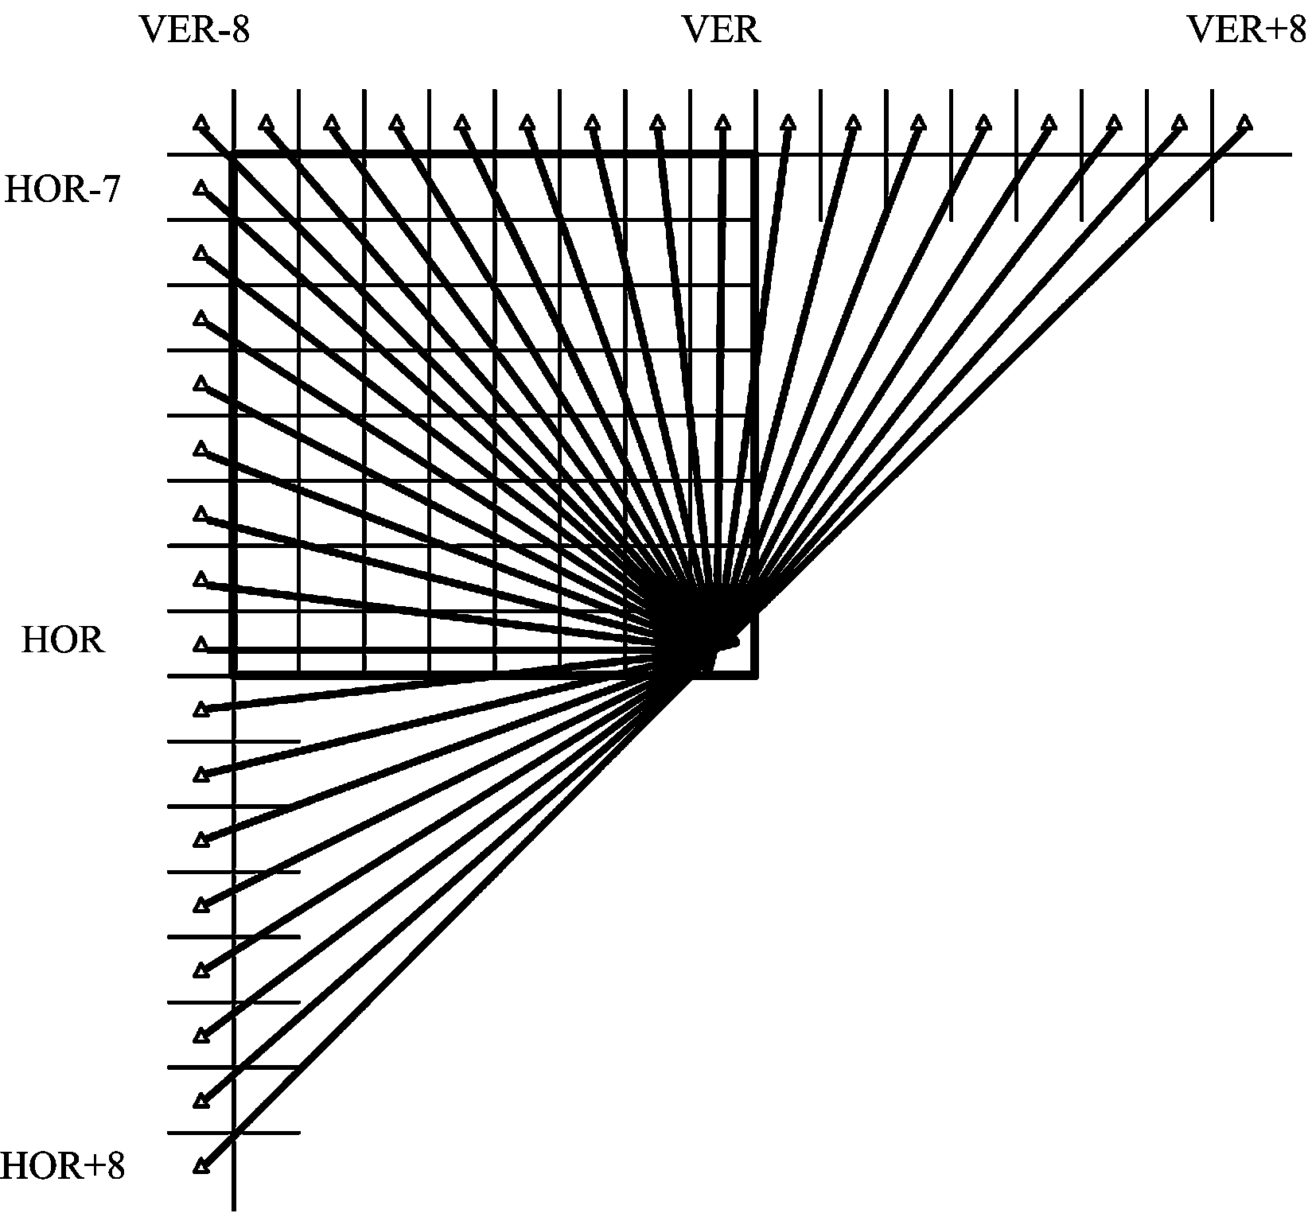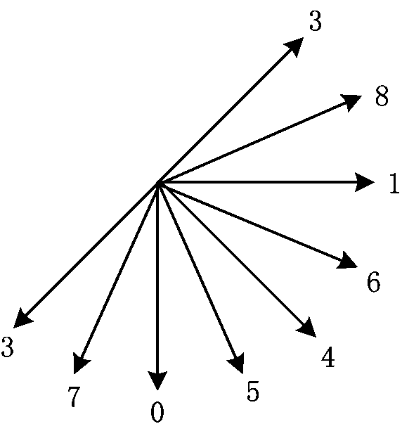
(a) Prediction modes (b) Transform modes
Fig. 1 Directional prediction modes (a) and corresponding transform modes (b) in TMuC

As described in [1], the transform modes shown in Fig. 1 (b) can be further reduced based on the symmetry. The mapping from the MDDT transform modes to the proposed SMDDT modes is specified in Table 1. For some modes, block operations such as flip and transpose are applied before the transform and after the inverse transform, which is also specified in Table 1. In table 1, X means no block operation, T means transpose operation, F_{V} and F_{H} means flip operation around the vertical and the horizontal axis respectively.

Table 1 Mapping relationship among prediction modes, MDDT modes and SMDDT modes, and the block operations.
Prediction mode  (Logical order) | 0 | 1 | 2 | 3 | 4 | 5 | 6 | 7 | 8 | 9 | 10 | 11 | 12 | 13 | 14 | 15 | 16
MDDT mode | 2 | 4 | 4 | 5 | 5 | 5 | 5 | 0 | 0 | 0 | 0 | 0 | 7 | 7 | 7 | 7 | 3
SMDDT mode | 3 | 2 | 2 | 1 | 1 | 1 | 1 | 0 | 0 | 0 | 0 | 0 | 1 | 1 | 1 | 1 | 2
Fwd blk operation | X | X | X | X | X | X | X | X | X | X | X | X | F_{V} | F_{V} | F_{V} | F_{V} | F_{V}
Inv blk operation | X | X | X | X | X | X | X | X | X | X | X | X | F_{V} | F_{V} | F_{V} | F_{V} | F_{V}
UIP mode  (Logical order) | 17 | 18 | 19 | 20 | 21 | 22 | 23 | 24 | 25 | 26 | 27 | 28 | 29 | 30 | 31 | 32 | 33
Mode mode | 6 | 26 | 14 | 27 | 7 | 28 | 15 | 29 | 1 | 30 | 16 | 31 | 8 | 32 | 17 | 33 | 9
SMDDT mode | 2 | 2 | 1 | 1 | 1 | 1 | 0 | 0 | 0 | 0 | 0 | 1 | 1 | 1 | 1 | 2 | 2
Fwd blk operation | F_{V} | X | T | T | T | T | T | T | T | T | T | F_{H}+T | F_{H}+T | F_{H}+T | F_{H}+T | F_{H} | F_{H}
Inv blk operation | F_{V} | X | T | T | T | T | T | T | T | T | T | T+F_{H} | T+F_{H} | T+F_{H} | T+F_{H} | F_{H} | F_{H}

For SMDDT mode 3, DCT is applied. For SMDDT modes 0 ~ 2, separable transform is trained for each. For SMDDT mode 2, the row transform and the column transform are the same.

Training of transforms
The training dataset is composed of intra prediction residuals of several CIF and 720P sequences. The sequences listed in the common test condition are excluded. The same mapping described in Table 1 is applied to get the subset of training data for each SMDDT mode. Then the eigen decomposition is applied to get the separable KLT from each subset separately. For SMDDT mode 2, the row and the column transform are forced to be the same.

Simulation results
As required in [2], the TMuC 0.7 is used as the software platform, and the common test condition specified in [3] is used in the tests. Two tests were done for the Intra high efficiency and random access high efficiency cases.

RD performance
The performance of SMDDT is given in Table 2. The anchor is the performance of TMuC7.0 using the default configurations, where MDDT is applied to 4x4 and 8x8 prediction blocks. The proposed SMDDT replaces the original MDDT implementation in the TMuC7.0.

Table 2. Coding performance in terms of BD-Rate
 | Intra |  |  | Random access
 | Y BD-rate | U BD-rate | V BD-rate | Y BD-rate | U BD-rate | V BD-rate
Class A | 0.3 | 0.4 | 0.4 | 0.1 | 0.0 | -0.1
Class B | 0.1 | 0.0 | 0.1 | 0.0 | -0.2 | -0.2
Class C | 0.2 | 0.1 | 0.2 | 0.1 | -0.1 | 0.0
Class D | 0.3 | 0.2 | 0.1 | 0.1 | 0.2 | 0.1
Class E | 0.3 | 0.3 | 0.3
Average | 0.2 | 0.2 | 0.2 | 0.1 | 0.0 | -0.1

As we can see from Table 2, the proposed SMDDT can achieve approximately the same coding performance compared with MDDT.

Complexity analysis
Memory requirements
8 directional transform modes are defined in the current MDDT implementation in TMuC. For a NxN transform mode, one pair of NxN transform matrices and one NxN scan order matrix need to be stored. Therefore, totally 8x2=16 NxN transform matrices and 8 NxN scan order matrix are required by MDDT. Supposing the number in the transform matrices and the scan order matrices is of 8-bits precision, totally 24N² bytes memory is consumed. As for the proposed SMDDT, only 5 transform matrices and 3 scan orders are needed. Therefore totally 8N² bytes memory is consumed.

Computational complexity
The transform is executed as matrix multiplication with integer precision. And the computational complexity is the same as MDDT. The flip and transpose of residual blocks can be easily implemented in the hardware design, and the complexity is negligible.

Conclusion
The simplified MDDT presented in this proposal can achieve approximately the same coding performance as MDDT with less transform matrices and less scan orders, thus reducing the complexity of MDDT. We suggest the proposed SMDDT be adopted as an improvement of the current MDDT in TMuC.

References

- H. Yang, J. Zhou, H. Yu, “Simplified MDDT (SMDDT) for Intra Prediction Residual”, JCTVC-B039, Geneva, July, 2010.
- R. Cohen, C. Yeo, R. Joshi, et.al., “Tool Experiment 7: MDDT Simplification”, JCTVC-B307, Geneva, July, 2010.
- F. Bossen, “Common test conditions and software reference configurations”, JCTVC-B300, Geneva, July, 2010.
- MPEG4-AVC/H.264 standard.

Patent rights declaration(s)
Huawei Technologies Co.,Ltd. may have IPR relating to the technology described in this contribution and, conditioned on reciprocity, is prepared to grant licenses under reasonable and non-discriminatory terms as necessary for implementation of the resulting ITU-T Recommendation | ISO/IEC International Standard (per box 2 of the ITU-T/ITU-R/ISO/IEC patent statement and licensing declaration form).

