    Joint Collaborative Team on Video Coding (JCT-VC)  of ITU-T SG16 WP3 and ISO/IEC JTC1/SC29/WG11  3rd Meeting: Guangzhou, CN, 7-15 October, 2010 | Document: JCTVC-C096

Title: | Low Complexity Rotational Transform
Status:
Purpose: | Proposal
Author(s) or  Contact(s): | Felix C. A. Fernandes | Tel:  Email: | 1-972-761-7427  felix.f@sta.samsung.com
Source: | Samsung Electronics Co., Ltd.
_____________________________

Abstract
The 8x8 Rotational Transform (ROT) is a secondary transform that improves coding efficiency and is implemented in the JCT-VC Test Model under Consideration (TMuC). This contribution proposes a lifting-factorization complexity reduction for the 8x8 ROT. The ROT is split into compound Given’s rotation matrices which are then each factored into a triplet of integer lifting matrices. The lifting-matrix coefficients can be implemented in hardware with fewer elemental adders than required for a TMuC ROT hardware implementation. With BD-rate of -0.003% this technique achieves 46% and 21% reduction in the elemental-adder count of forward and inverse ROT implementations, respectively.
- Introduction
The secondary 8x8 Rotational Transform (ROT) [1, 2, 3] is applied after the DCT as shown in Fig. 1.
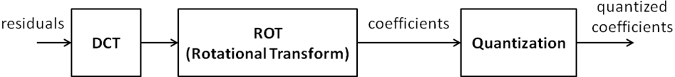
Figure 1: ROT as a secondary transform

The ROT-transformed coefficients, m_{o} are related to the input residuals m_{i} as follows:
where D, R_{h} and R_{v} are DCT, horizontal ROT and vertical ROT matrices, respectively.
The matrices R_{h} and R_{v} are defined as the following compound Given’s rotation matrix products:
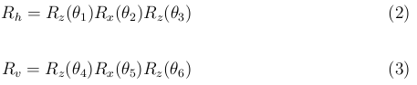

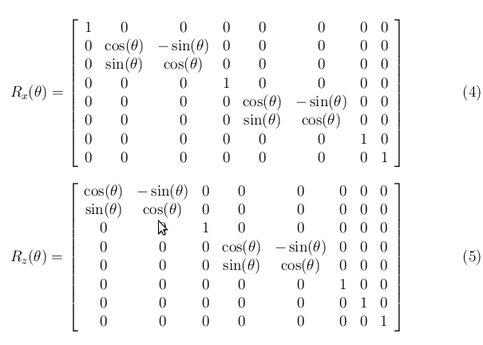
The matrices R_{x}(θ) and R_{z}(θ) are compound rotation matrices because they rotate simultaneously about 2 pairs of axes in 8-dimensional space.
Note that the TMuC contains four horizontal and four vertical ROT matrices R_{h}^{i} and R_{v}^{i} corresponding to four sets of rotation angles θ₁^{i}, θ₂^{i}, θ₃^{i}, θ₄^{i}, θ₅^{i}, θ₆^{i}, for i = 1,…,4.

Complexity-Reduction via Lifting Factorization
To reduce the complexity of the ROT, factorize each Given’s rotation matrix as shown below

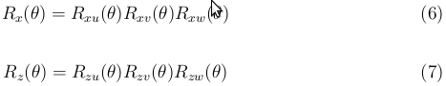
where
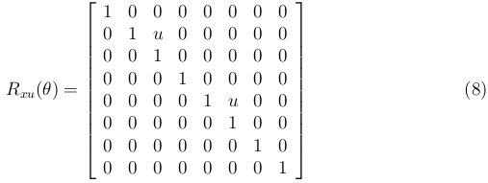

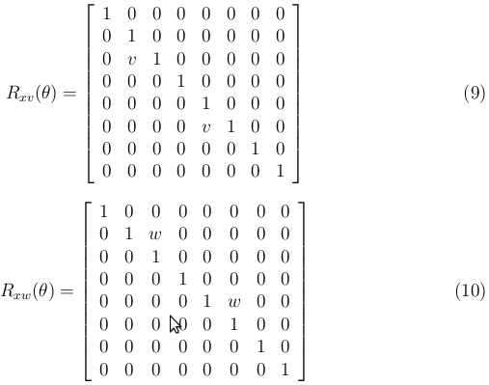

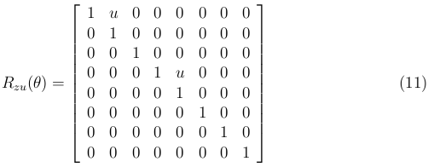
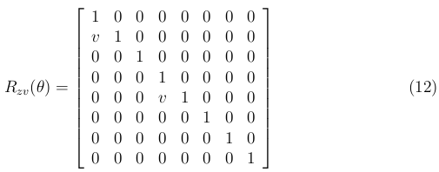

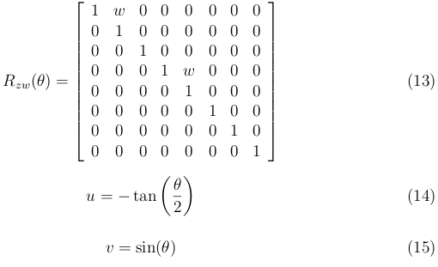
In the above identities, observe that u = w = -tan(θ/2). However, in an actual implementation better performance can be achieved by setting u and w to different approximations of –tan(θ/2), so that u and w are indeed distinct.
To achieve complexity reduction, the lifting multipliers u, v, w are approximated by rationals of the form k/2^{m}. With this particular approximation, each lifting multiplier is replaced by adders and shifters.

Complexity Analysis
In typical hardware implementations, multiplication of a variable x by a constant c is achieved with adders and shifters. For example, to multiply x by c = 50, one considers the binary representation of c, which is 110010 and implements x*(2⁵ + 2⁴ + 2¹) = x<<5 + x<<4 + x<<1, where << represents a left shift. In this case, multiplication is obtained using 2 elemental adders. When the binary representation of the constant c has more than 2 consecutive 1’s then subtraction reduces the number of elemental adders. For example, multiplication by c = 61 with binary representation 111101 would require 4 adders: x*111101 = x<<5 + x<<4 + x<<3 + x<<2 + 1. However realizing that 111101 = 1000001 – 000100, this operation is implementable with only 3 elemental adders: x<<6 – x<<2 + 1.
The preceding examples demonstrate that N_{adders} , the number of elemental adders, is given by
N_{adders} = N_{isolated} + 2*N_{consecutive} – 1,
where N_{isolated} is the number of isolated 1’s in the binary representation and N_{consecutive} is the number of groups of consecutive 1’s. In general, the product of x and c is usually added to some other quantity, in an algorithmic implementation. The following equation accounts for this extra addition:
N_{adders} = N_{isolated} + 2*N_{consecutive}.
To determine the complexity requirements for the TMuC ROT implementation, the binary representations of all 9 multipliers for rotation about one pair of axes are listed , along with the corresponding number of elemental adders in the “TMuC_ROT “ tab of the accompanying spreadsheet. From this tab, we observe that 334 elemental adders are required for the forward transform and 224 elemental adders are required for the inverse transform. Since compound rotations about two pairs of axes are needed, these counts must be doubled. Hence 668 and 448 elemental adders are needed for the forward and inverse TMuC ROT implementation, respectively.
Similarly, from the “LoComplx_ROT” tab of the accompanying spreadsheet, 178 elemental adders are required for the forward rotational transform about one pair of axes and 178 elemental adders are required for the inverse transform. Therefore 356 elemental adders are required for the proposed low-complexity forward ROT and 356 elemental adders are required for the low-complexity inverse ROT. These counts are summarized in Table I.

 | Forward Transform | Inverse Transform
TMuC | 668 | 448
Proposed | 356 | 356
Table I: Elemental Adder Requirements for TMuC 0.7 and Proposed Low-Complexity ROT
From the table, the proposed low-complexity ROT reduces the forward and inverse elemental-adder requirements by 46% and 21% respectively.

Test Conditions and Simulation Results
The anchor is TMuC 0.7 with encoding conditions specified in the common testing conditions for tests in TMuC 0.7 in [4] using the intra high-efficiency encoder_intra.cfg file. For the test case, we use the same settings as the anchor but replace the TMuC ROT implementation with the proposed reduced-complexity ROT implementation. Both encodings use the first 25 frames of Class A-E CfP test-sequences. Simulation results are shown in Table II. BD-Rates are -0.012%, -0.011%, 0.014%, -0.006%, -0.006%, respectively for Classes A-E and -0.003% averaged over all sequences.

Class Name | Sequence Name | BD Rate (in %)
Class A
 | Traffic | -0.01
 | PeopleOnStreet | -0.01
Class B
 | Kimono | -0.01
 | ParkScene | -0.01
 | Cactus | -0.01
 | BasketballDrive | 0.00
 | BQTerrace | -0.02
Class C
 | BasketballDrill | -0.02
 | BQMall | 0.02
 | Partyscene | 0.04
 | RaceHorsesC | 0.02
Class D
 | BasketballPass | 0.04
 | BQSquare | 0.02
 | BlowingBubbles | -0.04
 | RaceHorses | -0.03
Class E
 | Vidyo1 | 0.03
 | Vidyo3 | 0.04
 | Vidyo4 | 0.03
Average
 | Class A | -0.012
 | Class B | -0.011
 | Class C | 0.014
 | Class D | -0.006
 | Class E | -0.006
 | All | -0.003
Table II: Simulation results for intra-high efficiency configuration. The anchor has TMuC 0.7 ROT ON. The test case replaces TMuC 0.7 ROT with the proposed low-complexity ROT.

Conclusion
The proposed low-complexity ROT implementation achieves 46% and 21% reduction in the elemental-adder count of forward and inverse ROT implementations, respectively, with negligible coding-efficiency loss. We recommend that the JCT-VC evaluate this transform in a tool-evaluation experiment or a core experiment.

Patent rights declaration(s)
Samsung Electronics Co., Ltd., may have IPR relating to the technology described in this contribution and, conditioned on reciprocity, is prepared to grant licenses under reasonable and non-discriminatory terms as necessary for implementation of the resulting ITU-T Recommendation | ISO/IEC International Standard (per box 2 of the ITU-T/ITU-R/ISO/IEC patent statement and licensing declaration form).

References

- JCT-VC, “Test Model under Consideration”, JCTVC-B205, Joint Collaborative Team on Video Coding meeting, July 2010, Geneva, Switzerland.

- JCT-VC, TMuC-0.7 Reference Software, https://hevc.hhi.fraunhofer.de/svn/svn_TMuCSoftware/tags/0.7/ and http://hevc.kw.bbc.co.uk/git/w/jctvc-tmuc.git.

- “Samsung’s Response to the Call for Proposals on Video Compression Technology”, JCTVC-A124, Joint Collaborative Team on Video Coding Meeting, April 2010, Dresden, Germany.
- “Common test conditions and software reference configurations,”, F. Bossen, JCTVC-B300, July 2010, Geneva, Switzerland.

