    Joint Collaborative Team on Video Coding (JCT-VC)  of ITU-T SG16 WP3 and ISO/IEC JTC1/SC29/WG11  3rd Meeting: Guangzhou, CN, 7-15 October, 2010 | Document: JCTVC-C032  WG11 Number: m18053

Title: | Characteristics of Super Hi-Vision test sequences
Status: | Input Document to JCT-VC
Purpose: | Information
Author(s) or  Contact(s): | Yoshiaki Shishikui  Yasutaka Matsuo  Atsuro Ichigaya  Kazuhisa Iguchi  Shinichi Sakaida  NHK  Science & Technology Research Laboratories  1-10-11, Kinuta, Setagaya-ku, Tokyo, JAPAN | Tel:  Email: | +81-3-5494-3350  shishikui.y-hw@nhk.or.jp  matsuo.y-fg@nhk.or.jp  ichigaya.a-go@nhk.or.jp  iguchi.k-eq@nhk.or.jp  sakaida.s-gq@nhk.or.jp
Source: | NHK (Japan Broadcasting Corporation)
_____________________________

Abstract
This contribution presents the characteristics of Super Hi-Vision (SHV) test sequences, which differ from those of the other test sequences. The analysis of test sequences indicates that SHV test sequences contain an extremely large amount of motion that affects spectrum characteristics of the signal to a large extent. SHV test signals contain a larger noise component due to their high bandwidth, although this does not affect subjective picture quality as much as is expected by the objective amount.

Introduction
NHK provided two Super Hi-Vision (SHV) test sequences [1], “Steam locomotive train” and “Nebuta festival”, for the HEVC standardization activity. The sequences are in 7680 x 4320 / 60p format and are 5 seconds long as described in Table 1. Along with its high volume data rate, an SHV signal has distinctive properties from the viewpoint of video coding. This document describes the characteristics of SHV signals regarding several aspects compared with the conventional test sequences used in TE [2].
Table 1 Specification of 7680 × 4320 format sequences
Resolution | 7680 × 4320
Frame rate | 60fps, progressive
Bit depth | 10
Color format | YUV 4:2:0
Duration | 5 seconds (300 frames)

Image properties

Motion vector distribution
An SHV signal has four times higher pixel density than an HDTV signal in both vertical and horizontal directions, while it has almost the same density in the temporal direction. If an image is shot with the same viewing angle, an SHV sequence contains four times more motion than an HDTV sequence. However, this is not always the case because ordinary SHV content has a wider shot than HDTV content.
Figure 1 shows distributions of motion vectors for SHV and several conventional test sequences. A block matching algorithm was applied to two continuous frames as motion estimation, whose conditions are shown in Table 2. The block size was set to large to reduce motion vector estimation error the possibility of which increased as the search range increased. Because the magnitude of motion varied considerably with the steam locomotive train test sequence, four frames were selected for analysis in this sequence only.
Table 2 Conditions of motion analysis
 | Image size | Block size | Search range
SHV | 7680 x 4320 | 512 x 512 | (±256, ±128)
Class A | 2560 x 1600 | 192 x 192 | (±128, ±64)
Class B | 1920 x 1080 | 128 x 128 | (±64, ±32)

The results indicate that SHV sequences contain an extremely large amount of motion such as 150 pixels/ frame.

- SHV: Nebuta festival
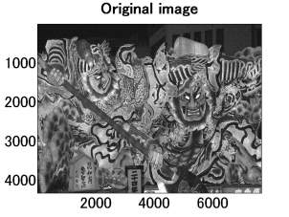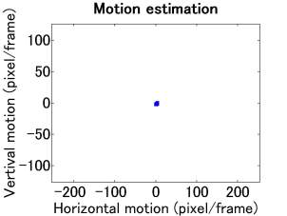

- SHV: Steam locomotive train
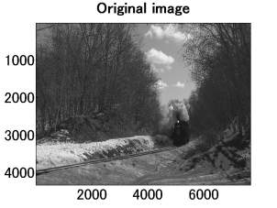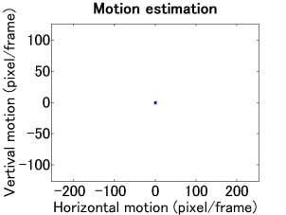
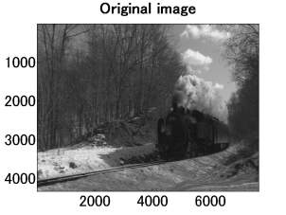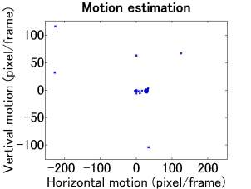
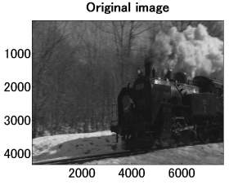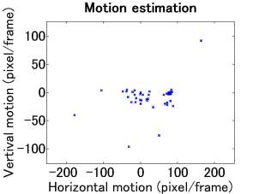
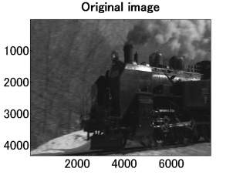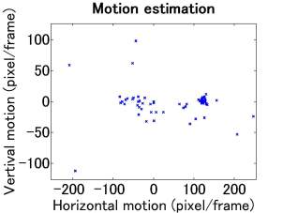

- Class A: PeopleOnStreet
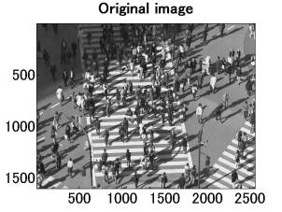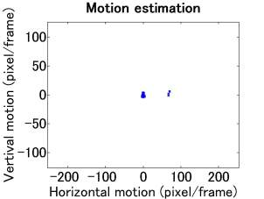

- Class A: Traffic
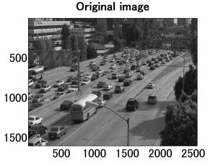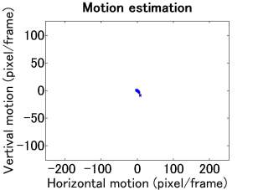

- Class B: BasketballDrive
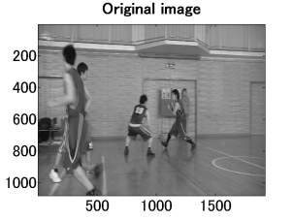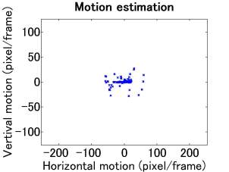

- Class B: BQTerrace
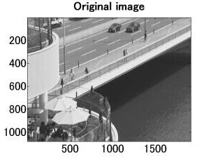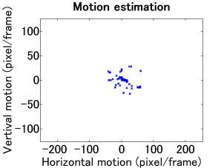

- Class B: Cactus
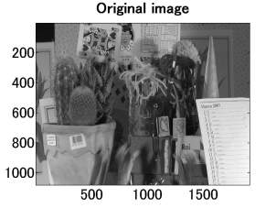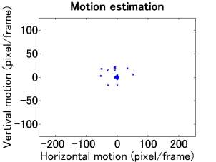

- Class B: ParkScene
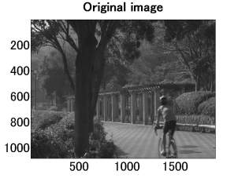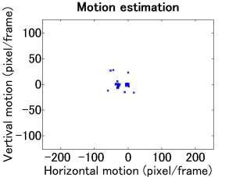

Figure 1 Motion analysis

Spectrum analysis
Horizontal and vertical one-dimensional FFT were applied on the same frames of the test sequences used in 2.1. Figure 2 shows the results. Note that a two-dimensional interpolation filter was applied to produce the SHV test sequences as indicated in [1], and the spectrum characteristics of the SHV sequences was affected by the filter response in the high frequency range.
With the steam locomotive train test sequence, spectrum characteristics varied drastically at the beginning of camera motion.
- SHV: Nebuta festival
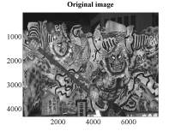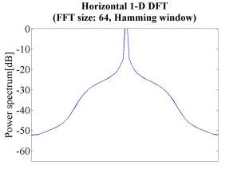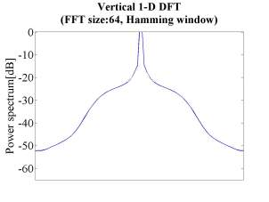

- SHV: Steam locomotive train
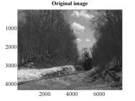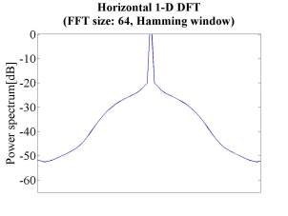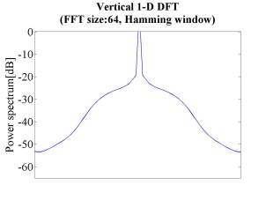
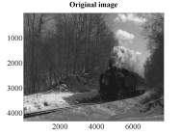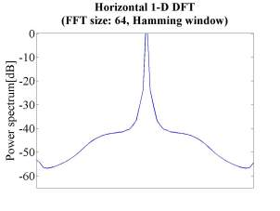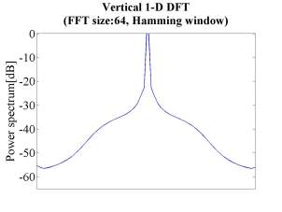
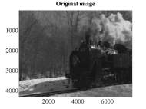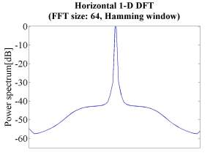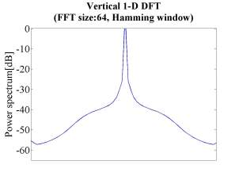
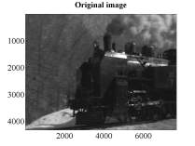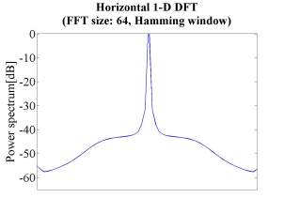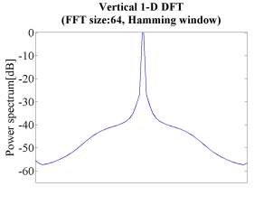

- Class A: PeopleOnStreet
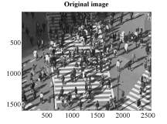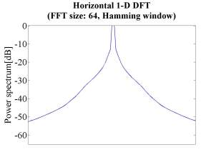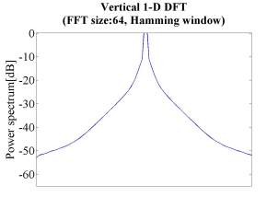

- Class A: Traffic
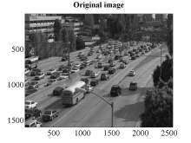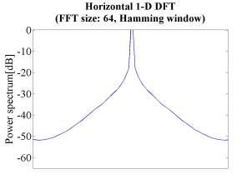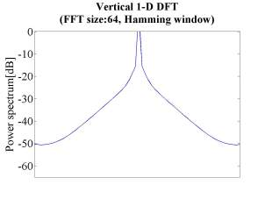

- Class B: BasketballDrive
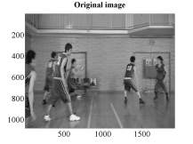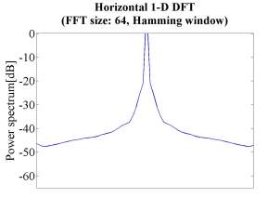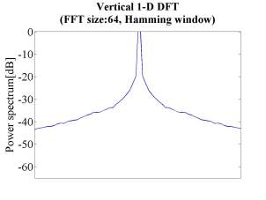

- Class B: BQTerrace
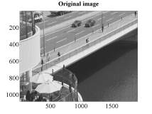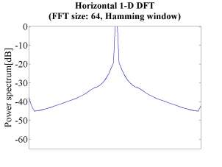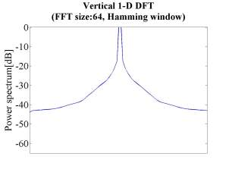

- Class B: Cactus
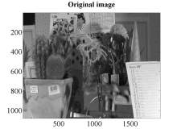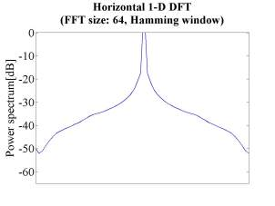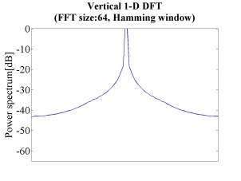

- Class B: ParkScene
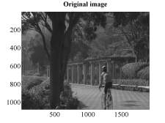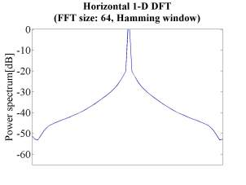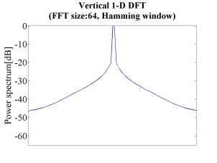
Figure 2 Spectrum analysis

Noise component
With its extremely wide bandwidth, an SHV signal contains a large noise component. Note that the lower SNR does not necessarily mean a lower picture quality because most of the noise component is practically invisible.
A typical value of the SNR of image sensors for an SHV and an HDTV camera is indicated in Table 3 [3].
An SHV sequence contains a larger noise component by 11 dB compared with HDTV. This means that the video coding scheme should be more noise-robust regarding the coding tool and control method.
Table 3 Typical SNR values of image sensors
SHV | HDTV
43 dB*  (2000 lux/F11) | 54 dB  (2000 lux/F11)
*Converted value from 55 dB with 2000 lux/F5.6

Coding results
The encoding performance of SHV using TMuC is reported in the other contribution [4]. The results indicate that TMuC achieves significant coding efficiency compared with JM for SHV sequences, but it takes a very long processing time using up-to-date computers. Furthermore, with the same Qp values, the output bitrates differ substantially between the two SHV sequences. A proper setting of Qp values is required depending on the sequences. The report also notes that SHV sequences cropped into Class A size have the same coding degradation as that of full-resolution SHV sequences in the cropped area.
No official subjective test was conducted. A viewing session of the coding results is planned at the Guangzhou meeting. As a result of provisional viewing by ourselves, it is indicated that subjective picture quality degradation appears with very low PSNR. The relation between subjective picture quality and PSNR for SHV sequences differ from that for HDTV.

Conclusion
The distinctive properties of Super Hi-Vision (SHV) test sequences were described. The analysis of test sequences indicates that SHV test sequences contain an extremely large amount of motion that affects spectrum characteristics of the signal to a large extent. SHV test signals contain a larger noise component due to their high bandwidth, although this does not affect subjective picture quality as much as is expected by the objective amount. According to the encoding experiments, cropped size sequences have the same coding performances as that of original size sequences.
We strongly recommend that SHV test sequences and/or cropped size sequences from SHV be used for TE/CE to develop an appropriate standard that works well with SHV.

References
[1] S. Sakaida, Y. Shishikui, A. Ichigaya, Y. Matsuo, K. Iguchi, T. Toyoda, "7680 × 4320 format test sequences for JCT-VC", JCTVC-A023, April 2010.
[2] F. Bossen, “Common test conditions and software reference configurations”, JCTVC-B300, July 2010.
[3] R. Funatsu, T. Tsukamoto, T. Imamura, T. Yamashita, K. Mitani, Y. Nojiri, “Development of a Real-time HDTV Zoom System Using Super Hi-Vision Video”, The Journal of The Institute of Image Information and Television Engineers, Vol.63, No.12, pp. 1868-1876 (2009) (in Japanese).
[4] K. Iguchi, A. Ichigaya, Y. Shishikui, S. Sekiguchi, A. Minezawa, “Performance report of TMuC for Super Hi-Vision”, JCTVC-C055/m18078, October 2010.

