    Joint Collaborative Team on Video Coding (JCT-VC)  of ITU-T SG16 WP3 and ISO/IEC JTC1/SC29/WG11  3rd Meeting: Guangzhou, CN, 7-15 October, 2010 | Document: JCTVC-C026  WG11 Number: m18037

Title: | Proposal of frame parameters FLCTB and FSCTB for video content adaptation
Status: | Input Document to JCT-VC
Purpose: | Proposal
Author(s) or  Contact(s): | Fuzheng Yang, Wei Li, Shuai Wan, Yilin Chang, Guangliang Ren | Tel:  Email: | fzhyang@mail.xidian.edu.cn  liwei_1098@yahoo.cn
Source: | Xidian University
_____________________________

Abstract
The size of CTBs in a frame in TmuC is limited by the parameters of LCTB and SCTB, which are set on the sequence level. However, the optimal CTB splitting mode for a frame depends on the frame content, the frame type, and the quantization parameter, which indicates that different LCTB and SCTB should be used for different frames. Therefore, two frame parameters of FLCTB and FSCTB are proposed to adapt CTB splitting to the frame content.

Introduction
In document [1], the concept of the coding tree block (CTB) has been proposed, which is defined as a squared block for flexible representation of the video content. The size of CTBs in a frame in TmuC is limited by the sequential parameters of the largest coding tree block (LCTB) and the smallest coding tree block (SCTB). The representation of the obtained CTB splitting of a certain frame is indicated by the split_coding_unit_flag.
On the other hand, the optimal CTB splitting for a frame varies with the frame content, the frame type, and the quantization parameter (QP). Therefore, the LCTB and SCTB should be different for different frames in order to efficiently represent the CTB splitting. Thus, two parameters are proposed as the FLCTB (frame largest coding tree block) and FSCTB (frame smallest coding tree block) on the frame level to adapt CTB splitting to the frame content.

Problem statement
Fig. 2 shows the optimal CTB splitting of the frames in a GOP for the “Claire” sequence with QCIF, as obtained by TmuC. The coding settings were: length of GOP was 8, QP was 32, the B hierarchical coding shown in Fig. 1, LCTB size was 128x128 and SCTB was 8x8.

I B3 B2 B3 B1 B3 B2 B3 P
Fig. 1 the structure of the coding.
Ignore the frame boundaries where CTB splitting is performed differently. From Fig. 2, we can observe that the CTB splitting is quite different for different frames. Apparently, the third frame and the fifth frame get the best CTB splitting when the LCTB size is 128. However, this LCTB size is not best for the other frames. For example, for the eighth frame which is less relative to the reference frame, the largest CTB size is 32x32, which is much less than the LCTB of 128x128. Representing such CTB splitting using the LCTB size of 128x128 is not efficient. Considering the SCTB, similar observations can be found. For example, for the sixth frame which is more relative to the reference frames, the smallest CTB is 32x32 and larger than the SCTB of 8x8. Accordingly, coding this frame using the SCTB size of 8x8 is not suitable. Therefore, the number of splitting flags can be saved if the LCTB and SCTB sizes are chosen adaptively on the frame level. Armed with this argument, we propose to adaptively set the numbers of LCTB and SCTB for different coding frames.

(a) (b) (c)
(d) (e) (f)
(g) (h) (i)
Fig. 2 the optimal CTB splitting for different frames. (a) the 0th frame, (b) the 8th frame, (c) the 4th frame, (d) the 2nd frame, (e) the 6th frame, (f) the 1st frame, (g) the 3rd frame, (h) the 5th frame, (i) the 7th frame.

Method description
In this document the frame parameters FLCTB and FSCTB are proposed to improve the coding efficiency. The FLCTB and FSCTB of the current frame can be adaptively determined according to the relativity between the current frame and the reference frame. If properly employed, the parameters of FLCTB and FSCTB may help in saving the bit number and represent video content efficiently.

Experiments
The experimental settings are: the size of LCTB was 128x128 and that of SCTB was 8x8. The B hierarchical coding was on and the length of GOP was 8. The QP was set to 32. Fig. 3 shows the CTBs modes in the 0th, 8th, 4th frame for the RaceHorse, with the video resolution of 416x240. The largest CTB is of size 32x32. Similarly, Fig. 4 shows the CTBs modes in 0th, 8th frame for BlowingBubbles, with the video resolution of 416x240. The smallest CTB size is 8x8. Fig. 5 shows the CTBs modes in 1st frame for Foreman, with the video resolution of 176x144. The largest CTB size is 64x64 and the smallest is 16x16. Table 1 shows the optimal LCTB size for a single frame in various video sequences. These data lead to a conclusion that the LCTB should be different for different frames. Therefore, the frame parameters of FLCTB and FSCTB should be adaptive to represent the video content efficiently.

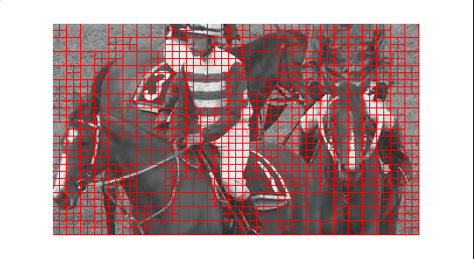
(a)
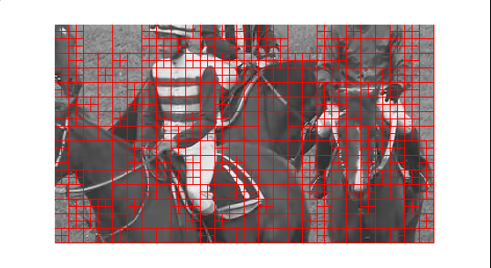
(b)
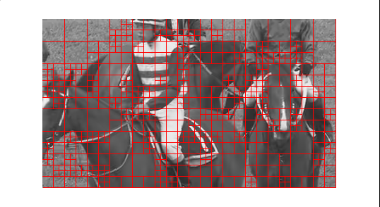
(c)
Fig. 3 The CTBs modes for the RaceHorse. (a) the 0th frame, (b) the 8th frame, (c) the 4th frame.
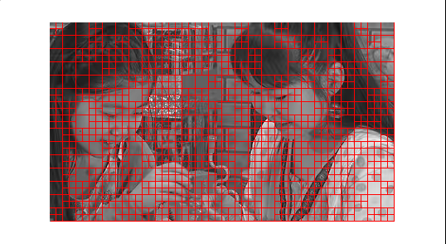
(a)
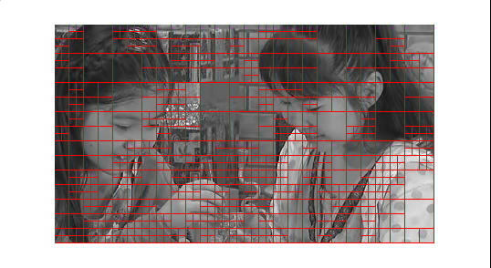
(b)
Fig. 4 The CTBs modes for BlowingBubbles. (a) the 0th frame, (b) the 8th frame.
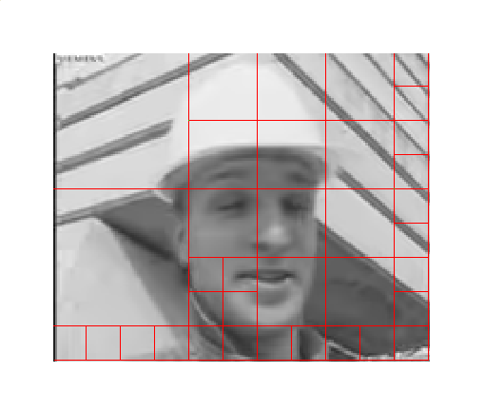
Fig. 5 The CTBs modes in 1st frame for Foreman.

Table. 1 the optimal LCTB for a single frame.
Sequence | Video resolution | Frame number | optimal LCTB
BQMall | 834x480 | the 8th frame | 64x64
BQMall | 834x480 | the 4th frame | 128x128
RaceHorse | 416x240 | the 8th frame | 128x128
RaceHorse | 416x240 | the 4th frame | 64x64
RaceHorse | 416x240 | the 2nd frame | 32x32
BasketballDrill | 1920x1080 | the 8nd frame | 128x128
BasketballDrill | 1920x1080 | the 4nd frame | 128x128
BasketballDrill | 1920x1080 | the 2nd frame | 64x64
Harbour | 1280x720 | the 8th frame | 64x64
Harbour | 1280x720 | the 4th frame | 128x128
ParkScence | 1920x1080 | the 8th frame | 64x64
ParkScence | 1920x1080 | the 4th frame | 128x128

Conclusion
The frame parameters of FLCTB and FSCTB are proposed for efficient representation of the video content for CTB splitting. The FLCTB and FSCTB should be dependent on the frame content, frame type and the quantization parameter.

Patent rights declaration(s)
Xidian University may have IPR relating to the technology described in this contribution and, conditioned on reciprocity, is prepared to grant licenses under reasonable and non-discriminatory terms as necessary for implementation of the resulting ITU-T Recommendation | ISO/IEC International Standard (per box 2 of the ITU-T/ITU-R/ISO/IEC patent statement and licensing declaration form).

Reference
[1] JCT-VC, “Draft Test Model under Consideration”, JCTVC-A205, 1. JCT-VC Meeting, Dresden, April 2010

