    Joint Collaborative Team on Video Coding (JCT-VC)  of ITU-T SG16 WP3 and ISO/IEC JTC1/SC29/WG11  2nd Meeting: Geneva, CH, 21-28 July, 2010 | Document: JCTVC-B309

Title: | Tool Experiment 9: Large Block Structure
Status: | Output Document
Purpose: | Tool Experiment Description
Author(s) or  Contact(s): | Munchurl Kim  Korea Advanced Institute of Science and Technology (KAIST)¹  Hui Yong Kim  ETRI²  Kazushi Sato  SONY³ | Tel:  Email: | +82-42-350-7419  mkim@ee.kaist.ac.kr  +82-42-860-5069  hykim5@etri.re.kr  +81-3-5435-3308  Kazushi.Sato@jp.sony.com
Source: | KAIST¹, ETRI², SONY³
_____________________________

Introduction
Enlarged coding blocks and large block-sized transforms are introduced in the HEVC Test Model under Consideration (TMuC) [1] as new coding tools to improve the coding efficiency. The structure of enlarged coding blocks is organized in terms of coding unit (CU), partition unit (PU) and transform unit (TU) in the HEVC TMuC. Furthermore, the CU, PU and TU are operated in conjunction with different transform kernel sizes. The transform kernel size in TMuC is maximally allowed up to 64 x 64.
The purpose of TE9 (Tool Experiment 9: Large Block Structure) is to investigate the coding efficiency for the large block structure in terms of CU, PU and TU in the HEVC TMuC version 0.6. Also, the non-square coding unit structure based on the proposal [6] at 2nd JCT-VC meeting is compared with the large block structure of the HEVC TMuC 0.6 in terms of BD-PSNR [3] and BD-BR [4] performances.

Participants List

Participants | Persons, Email addresses | P/C
KAIST | Munchurl Kim, mkim@ee.kaist.ac.kr  Jaeil Kim, jaeil1203@kaist.ac.kr  Bumshik Lee, lbs@kaist.ac.kr  Sangsoo Ahn, ssa@kaist.ac.kr | C
ETRI | Hui-Yong Kim, hykim5@etri.re.kr  Jongho Kim, pooney@etri.re.kr  Seyoon Jeong, jsy@etri.re.kr | C
SONY | Kazushi Sato, Kazushi.Sato@jp.sony.com | P
Zhejiang University | Lu Yu, yul@zju.edu.cn  Xiaolin Shen, babylion@zju.edu.cn | C
Motorola | Krit Panusopone, krit@motorola.com | C
Hanyang University | Kiho Choi, aikiho@dmlab.hanyang.ac.kr  Euee S. Jang, esjang@hanyang.ac.kr | C
HHI | Benjamin Bross, benjamin.bross@hhi.fraunhofer.de | C
Samsung Electronics | Woo-Jin Han, wjhan.han@samsung.com | C
Kwangwoon University | Seoung-Jun Oh, sjoh@kw.ac.kr  Jae-Kyu Jo, jaeku220@media.kw.ac.kr  Dong Gyu Sim, dgsim@kw.ac.kr  Sea-Nae Park, psea1118@kw.ac.kr
P/C = Proponent / Crosschecking TE partner

Tools under Test

Large Block Structure in TMuC
The test points are identified in the table below with respect to the sizes of CTUs, PUs and TUs up to the maximum partition depths of CTU and TU.

Table 1 Performance Tests for different CTU and TU sizes of TMuC 0.7.2
Configurations | Controlled Features | Codebase | Test points
TMuC 0.7.2 encoder_intra.cfg [2] | Unit Definition:  MaxCUWidth= MaxCUHeight=64  MaxPartitionDepth=4  QuadtreeTULog2MaxSize=2 | TMuC 0.7.2 reference SW | Max CU sizes: 16, 32, 64, 128  Variable TU sizes:  - 64×64, 32×32  - 32×32, 16×16  - 16×16, 8×8  - 8×8, 4×4
TMuC 0. 7.2  encoder_lowdelay.cfg [2] | Unit Definition:  MaxCUWidth= MaxCUHeight=64  MaxPartitionDepth=4  QuadtreeTULog2MaxSize=6 | TMuC 0.7.2 reference SW | Max CU sizes: 16, 32, 64, 128  Variable TU sizes:  - 64×64, 32×32, 16×16, 8×8, 4×4  - 64×64, 32×32, 16×16, 8×8  - 32×32, 16×16, 8×8, 4×4  - 32×32, 16×16, 8×8  - 16×16, 8×8, 4×4  - 16×16, 8×8  - 8×8, 4×4
TMuC 0. 7.2  encoder_randomaccess.cfg [2] | Unit Definition:  MaxCUWidth= MaxCUHeight=64  MaxPartitionDepth=4  QuadtreeTULog2MaxSize=6 | TMuC 0.7.2 reference SW | Max CU sizes: 16, 32, 64, 128  Variable TU sizes:  - 64×64, 32×32, 16×16, 8×8, 4×4  - 64×64, 32×32, 16×16, 8×8  - 32×32, 16×16, 8×8, 4×4  - 32×32, 16×16, 8×8  - 16×16, 8×8, 4×4  - 16×16, 8×8  - 8×8, 4×4

Table 2 Performance Tests for Different sets of PU modes of TMuC 0.7.2
Configurations | Controlled Features | Codebase | Test points
TMuC 0.7.2  encoder_lowdelay.cfg [2]  TMuC 0.7.2  encoder_randomaccess.cfg [2] | - - Use merging syntax for signaling rectangular and/or asymmetric shapes (with and without original syntax for signaling rectangular and/or asymmetric shapes removed)  - Force subdivision of residual quadtrees (RQTs) such that transform blocks don't span over PU borders (separately tested for square, rectangular, and asymmetric shapes as well as combinations)  - (virtually) redundant shapes on/off (e.g. four times 2Nx2N vs one time NxN for parent CU) | TMuC 0.7.2 reference SW | - PU’s with symmetric rectangular shapes on/off
TMuC 0.7.2  encoder_randomaccess.cfg [2]  TMuC 0.7.2  encoder_randomaccess.cfg [2] |  | TMuC 0.7.2 reference SW | - PU’s with asymmetric rectangular shapes on/off
TMuC 0.7.2  encoder_randomaccess.cfg [2]  TMuC 0.7.2  encoder_randomaccess.cfg [2] |  | TMuC 0.7.2 reference SW | - PU’s with geometric shapes on/off

Table 3 Performance Tests for Different sets of TU modes of TMuC 0.7.2
Configurations | Controlled Features | Codebase | Test points
TMuC 0. 7.2  encoder_lowdelay.cfg [2] | Unit Definition:  MaxCUWidth= MaxCUHeight=64  MaxPartitionDepth=4  QuadtreeTULog2MaxSize=6  QuadtreeTULog2MinSize=2  - Force subdivision of residual quadtrees (RQTs) such that transform blocks don't span over PU borders | TMuC 0.7.2 reference SW | Variable QuadtreeTUMaxDepth:  - 1, 2, 3, 4, 5
TMuC 0. 7.2  encoder_randomaccess.cfg [2] | Unit Definition:  MaxCUWidth= MaxCUHeight=64  MaxPartitionDepth=4  QuadtreeTULog2MaxSize=6  QuadtreeTULog2MinSize=2  - Force subdivision of residual quadtrees (RQTs) such that transform blocks don't span over PU borders | TMuC 0.7.2 reference SW | Variable QuadtreeTUMaxDepth:  - 1, 2, 3, 4, 5

Additional Tools

Non-Square Coding Unit Structure (SONY) [6]
In this TE, the method of non-square CTB will be investigated from low-cost implementation perspective with respect to the following two cases: In case 1, only the top layer is non-square; In case 2, the ratio of non-square CTB is fixed to 2:1 but the boundary between non-square and square CTB can vary. In either case, additional parameters will be conveyed in the Sequence Parameter Set for the simplicity of syntax.
The experimental results will be examined in the trade-off between coding efficiency improvement and computational cost.

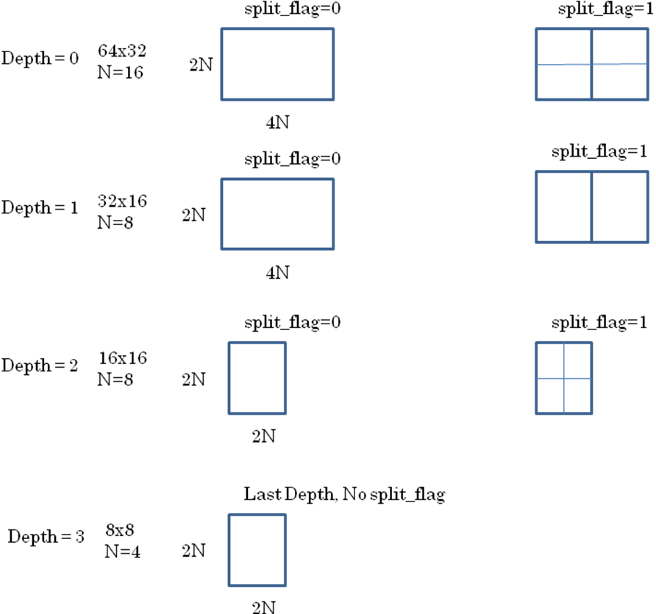

Tool Experiment Tasks
The following tasks shall be performed in this tool experiment.
- Identify performance of the TMuC large block structure based on the default configurations of common test conditions [2]
- Analyze the experimental results with respects to different sizes of CU, PU and TU in the TMuC 0.6 [1] (as present in the software used for the evaluation)
- Communicate with TE12 for experiment coordination on large transforms

Test Conditions
The TE experiments will be carried out based on the test conditions and reference configurations specified in [2].
As a codebase for TE9, the latest TMuC software version (TMuC 0.7.2) is used. For the analysis purpose of the expected experimental results, soe codes will be added into TMuC 0.7.2 to collect the selection statistics of CTUs, Pus and TUs, as well as CBF==0. Furthermore, in order to carry out the experiments for Table 2, some necessary code modification might be needed accordingly. In any case, high-efficiency configuration files are to be only used for this TE.

Time-line and Responsibilities
- 2010-08-27: Finalize and upload the TE description
- 2010-08-27: Assign the TE experiment works for TE Participants
- 2010-08-27: Distribute TMuC 0.7.2 reference SW with batch files to the TE participants for the experiments by KAIST
- 2010-09-15: Implement the proposed method [6] into TMuC 0.7.2 reference software for performance evaluation by the proponent (SONY)
- 2010-09-25: Complete all TE experiments in Section 3.1 by all participants
- 2010-09-25: Complete all TE experiments in Section 3.2 by the proponent (SONY) and a cross-checker(s)
- 2010-09-28: Provide visual subjective assessments on all TE results by the TE participants
- 2010-10-01: Upload input document for TE-9 activity

Definition of Performance Measurement Criteria
The performance measurements are evaluated in different combinations of coding unit sizes in conjunction with different partition and transform sizes. Moreover, the coding efficiency will be tested for different partition types of symmetric rectangular shapes, asymmetric rectangular shapes and geometric shapes turned on and off. Also, the performance of the proposed method [6] will be compared based on the same code base (TMuC 0.7.2) for the encoder configurations with encoder_intra.cfg, encoder_lowdelay.cfg and encoder_randomaccess.cfg released at the 2nd JCT-VC meeting in Geneva. The following measurements are considered to be used in this tool experiment.

Coding Performance Measurements
Objective rate-distortion measurements using PSNR, BD-PSNR, BD-Rate [3][4].
The visual subjective quality will be assessed by the involved experts.

References
- JCT-VC, “Draft Test Model under Consideration”, JCTVC-B205, 2nd JCT-VC Meeting, Geneva, CH, July 2010.
- JCT-VC, “Common Test Conditions and Software Reference Configurations”, JCTVC-B300, 2nd JCT-VC Meeting, Geneva, CH, July 2010.
- Gisle Bjøntegaard, “Calculation of Average PSNR Differences between RD curves”, ITU-T SG16/Q6, 13th VCEG Meeting, Austin, Texas, USA, April 2001, Doc. VCEG-M33.
- Gisle Bjøntegaard, “Improvements of the BD-PSNR model”, ITU-T SG16/Q6, 35th VCEG Meeting, Berlin, Germany, July 2008, Doc. VCEG-AI11.
- Minhua Zhou, “Coding efficiency test on large block size transforms in HEVC”, JCTVC-B028, 2nd JCT-VC meeting, Geneva, CH, July. 2010.
- Peng Wang and Kazushi Sato, “Proposal of Non-Square Coding Unit Structure”, JCTVC-B082, 2nd JCT-VC meeting, Geneva, CH, July. 2010.

